Assignment-1.

● Write a Java program named Car ● The Car class should have the following attributes: make (String), model (String) , year (short) , and price(int) . ● The car class should have a constructor that takes all the attributes. ● Add a main method to instantiate car objects. ● The program should allow the user to create and display objects of each Car Class.

package lab_2;  
  
public class Car {  
 private String make;  
 private String model;  
 private short year;  
 private int price;  
  
 public Car(String make, int price, short year, String model) {  
 this.make = make;  
 this.price = price;  
 this.year = year;  
 this.model = model;  
 }  
  
 public static void main(String[] args) {  
 Car car = new Car("Porsche",9610000 , (short) 2025,"718 cayman");  
 }  
}

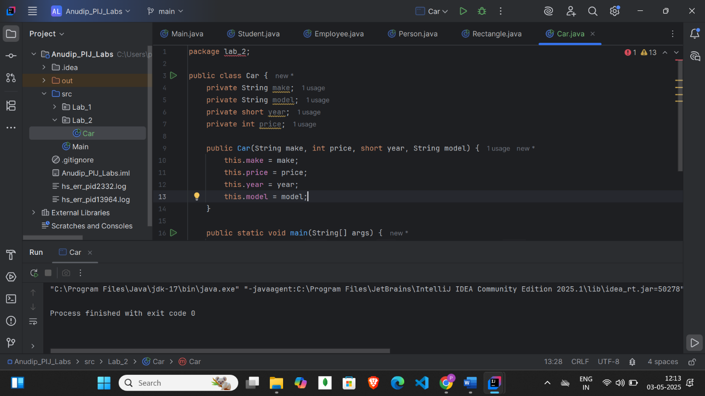

Assignment-2.

● Write a Java program that demonstrates method overloading by creating a class called Calculator. ● Add three methods called add(). ● The first add() method should take two int variables as arguments and return their sum as int. ● The second add() method should take three int variables as arguments and return their sum as int. ● The third add() method should take two doubles as arguments and return their sum as double. ● The program should allow the user to display the results of each method.

package lab_2;  
public class Calculator {  
 public int add(int val1, int val2){  
 int sum = val1+ val2;  
 System.*out*.println("addition of val1 and val2 is : " + sum);  
 return sum;  
 }  
 public int add(int val1, int val2,int val3){  
 int sum = val1+val2+val3;  
 System.*out*.println("addition of val1, val2 and val3 is : " + sum);  
 return sum;  
 }  
 public double add(double double_val1, double double_val2){  
 double sum = double_val1+double_val2;  
 System.*out*.println("addition of val1 and val2 is : " + sum);  
 return sum;  
 }  
 public static void main(String[] args) {  
 Calculator cal = new Calculator();  
 System.*out*.println(cal.add(10, 20));  
 System.*out*.println(cal.add(10, 20, 50));  
 System.*out*.println(cal.add(20.0, 50.0));  
  
 }}

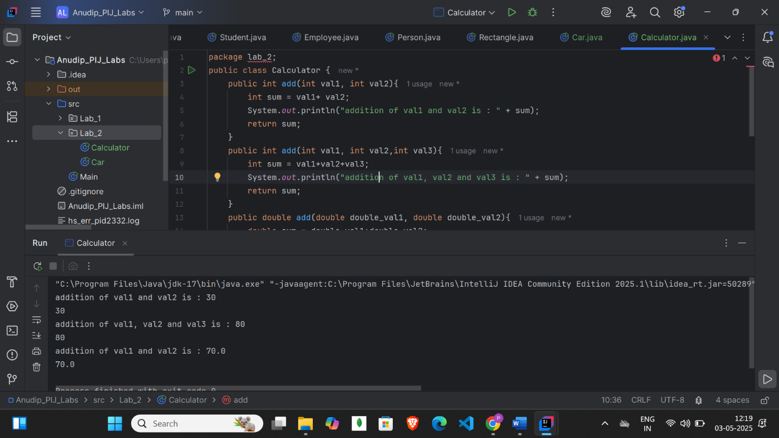

Assignment-3.

● Create a Java Bean Class Student. ● Add three attributes ○ private String name; ○ private int age; ○ private String department; ● Add a constructor that takes all three attributes as parameters. ● Add setter and getter methods ● C o m pile t h e p r o g r a m

package lab_2;  
  
public class Student {  
 private int studentId;  
 private String name;  
 private String department;  
  
 public Student() {  
 }  
  
 public Student(int studentId, String name, String department) {  
 this.studentId = studentId;  
 this.name = name;  
 this.department = department;  
 }  
 public int getStudentId() {  
 return studentId;  
 }  
 public void setStudentId(int studentId) {  
 this.studentId = studentId;  
 }  
 public String getName() {  
 return name;  
 }  
 public void setName(String name) {  
 this.name = name;  
 }  
 public String getDepartment() {  
 return department;  
 }  
 public void setDepartment(String department) {  
 this.department = department;  
 }  
 @Override  
 public String toString() {  
 return "Student{" +  
 "studentId=" + studentId +  
 ", name='" + name + '\'' +  
 ", department='" + department + '\'' +  
 '}';  
 }  
  
 public static void main(String[] args) {  
 Student s = new Student();  
 System.*out*.println(s);  
 }  
}

