Viral Video Production Form — Complete Guide

For AI Agent and Sub-Agent Creation

1. PROJECT OVERVIEW

What This Is
A 5-phase web-based production form that takes a content writer’s research (up to 40 pages) and converts it into a production-ready screenplay for short-form viral videos (30-60 seconds) for Instagram Reels, TikTok, and YouTube Shorts.

The Problem It Solves
- Content writers copy-paste AI-generated garbage into scripts
- 40 pages of research cannot be compressed into a 30-second video
- Editors don’t know camera angles, cuts, or transitions
- Actors don’t know expressions, tone, or body language
- Dialogue sounds robotic because it’s spoken, not demonstrated

The Solution
Structured constraints + AI assistance + Human validation
The form forces writers into 7 structured fields (no open-ended text). AI extracts viral nuggets from research. AI generates the production screenplay. Humans validate before filming.

Live Form URL
https://rbcm2h5ijpzgq.kimi.page

2. SYSTEM ARCHITECTURE
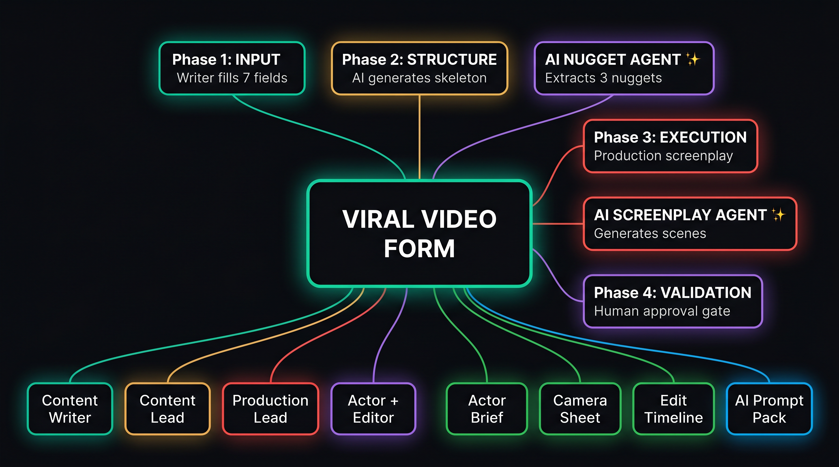
System Architecture Diagram
Central Hub: Viral Video Form
5 Phases: - Phase 1: INPUT (teal) — Writer fills 7 fields - Phase 2: STRUCTURE (amber) — AI generates skeleton - Phase 3: EXECUTION (red) — Production screenplay - Phase 4: VALIDATION (violet) — Human approval gate - Phase 5: OUTPUT (sky) — Export documents
2 AI Agents: - AI Nugget Agent (violet) — Extracts 3 nuggets from 40 pages of research - AI Screenplay Agent (red) — Generates scene-by-scene production brief
4 Team Roles: - Content Writer (teal) — Fills Phase 1 - Content Lead (amber) — Approves Phase 2 - Production Lead (red) — Approves Phase 3 - Actor + Editor (violet) — Validates Phase 4
4 Output Documents: - Actor Brief (green) — Dialogue + direction per scene - Camera Sheet (green) — Shot list + settings per scene - Edit Timeline (green) — Cut points + transitions + captions - AI Agent Prompt Pack (sky) — JSON data + 5 prompt templates

3. LINEAR WORKFLOW (Step-by-Step)
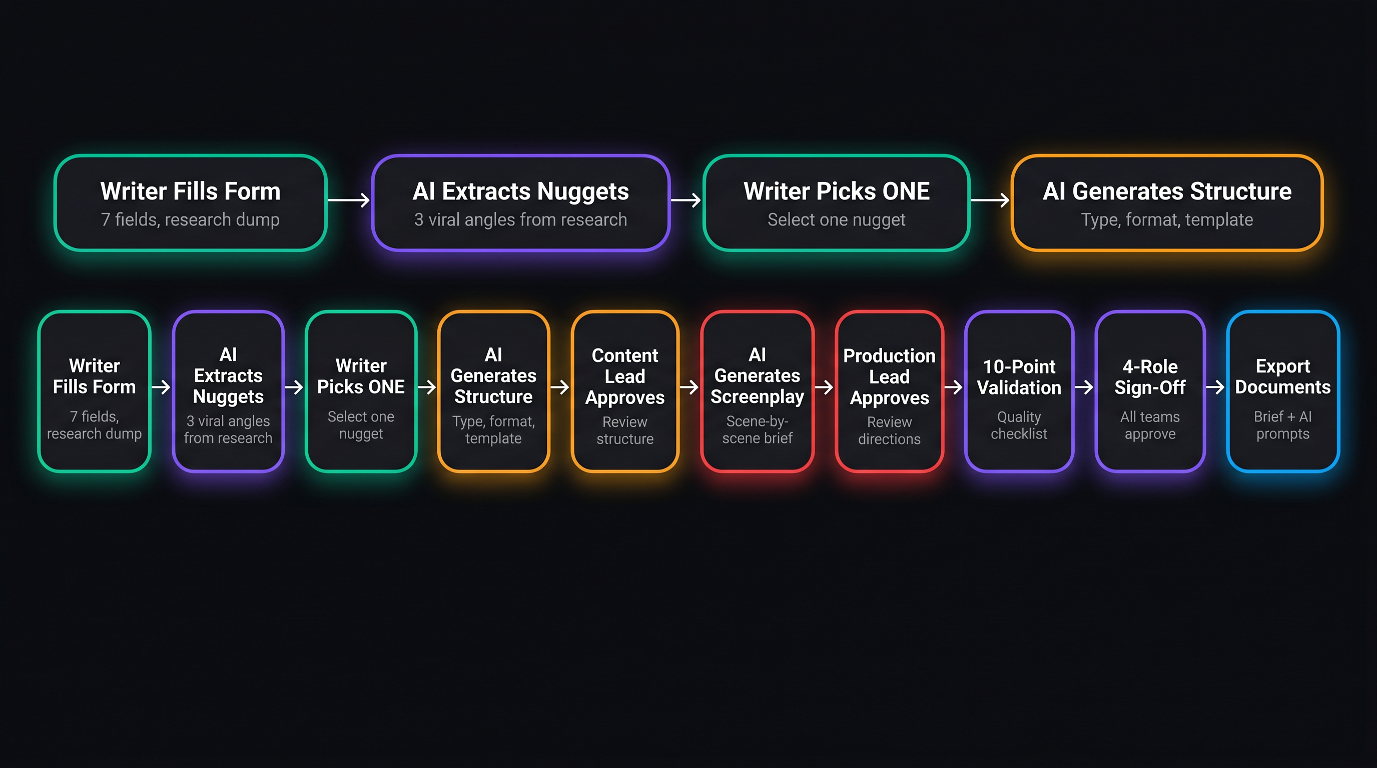
Linear Workflow Flow Chart
The 10-Step Execution Flow:
Step | Action | Who | Color
1 | Writer Fills Form | Content Writer | Teal
2 | AI Extracts Nuggets | AI Nugget Agent | Violet
3 | Writer Picks ONE | Content Writer | Teal
4 | AI Generates Structure | AI System | Amber
5 | Content Lead Approves | Content Lead | Amber
6 | AI Generates Screenplay | AI Screenplay Agent | Red
7 | Production Lead Approves | Production Lead | Red
8 | 10-Point Validation | Actor + Editor | Violet
9 | 4-Role Sign-Off | All Roles | Violet
10 | Export Documents | Auto-Generated | Sky

4. PHASE 1: INPUT — THE 7 FIELDS

4.1 Field 1: Video Identity
Field | Type | Example
Production Date | Date picker | 05/29/2026
Content Creator | Text | Sarah K.
On-Camera Actor | Dropdown | Sarah Chen, Marcus Johnson, Ava Kim, David Park
Brand / Company | Dropdown | GlowUp Beauty, FitLife Co, TechSimplify, Backero
Platform | Dropdown | Instagram, TikTok, YouTube Shorts, Facebook Reels
Estimated Length | Dropdown | 15-30s, 30-60s, 60-90s, 90-120s

4.2 Field 2: Raw Research Dump
Large textarea. Paste all research — articles, stats, notes, links, thoughts. Min 100 characters.
Example input: - Article: “73% of SaaS companies fail because of poor onboarding” - My experience: We reduced churn by 40% with one email change - Stat: Average user attention span on Reels is 1.7 seconds - Competitor video got 2M views with similar hook

4.3 Field 3: AI Nugget Extraction (AI-Generated)
After clicking “Extract Nuggets,” AI produces 3 selectable cards:
Nugget Type | Example
Shocking Fact | “70% of vitamin C serums oxidize before you finish the bottle”
Practical Hack | “Store serum in the fridge — doubles effectiveness”
Story Hook | “I spent $2,000 on serums before learning this one trick”

4.4 Field 4: One Point Selector
Radio cards to pick ONE nugget. Others saved as future topics.
Why This Nugget? (max 40 words, forced format): “A [target viewer] scrolling [platform] will stop because…”

4.5 Field 5: Topic — Forced Format
Niche: Free text (e.g., “Skincare”) Sub-Niche: Free text (e.g., “Anti-aging”)
Three forced-format sentences:
Sentence | Prefix | Max Words | Example
The Point | “This video teaches…” | 20 | “…how to keep your vitamin C serum from oxidizing”
Why They Care | “They care because…” | 20 | “…nobody wants to waste money on serums that stop working”
The Proof | “Trust me because…” | 20 | “…I’ve tested 20+ serums and the fridge trick always works”
Topic Validation Checkboxes (ALL must be checked): 1. Demand — People search for this 2. Relevance — Fits our niche 3. Interest — Trending or evergreen 4. Knowledge — We have credibility

4.6 Field 6: Value Delivery
Field | Type | Example
Actionable Takeaway | Text (25 words) | “After watching, the viewer will be able to store their vitamin C serum correctly”
Content Style | Dropdown | Demonstration, Reaction, Story, Comparison, Reveal, Challenge
Time to Value | Dropdown | 0-3s, 3-5s, 5-10s, 10s+
Fluff vs. Specific — Live Reference (3 Examples):
FLUFF (Bad) | SPECIFIC (Good)
“This serum is amazing” | “This serum reduced my dark spots in 14 days”
“Everyone is talking about this” | “This went viral on TikTok with 2.4M views”
“You need to follow these tips” | “Step 1: Put it in the fridge. That’s it.”
Self-Check Questions: 1. Does every word earn its place? (Yes/No) 2. Would a viewer save or share this? (Yes/No) 3. Is the takeaway actionable within 24 hours? (Yes/No)

4.7 Field 7: Reference Video
Field | Type | Example
Video URL | URL | https://www.tiktok.com/@creator/video/1234567890
What are we copying? | Dropdown | Full Structure, Hook Only, Visual Style, Energy, Tone, Format
Describe what we’re taking | Text | “The rapid-fire cut sequence from 0:08 to 0:15”
Viral Threshold Rule: Video views >= 5x creator’s subscriber count (3x for 1M+ subs)

5. PHASE 2: STRUCTURE

5.1 Content Type (5 Types)
Type | Frequency | CTA Match | When to Use
Educational | 3-5x/week | Follow/Save | Teaching a skill
Storytelling | 1-2x/week | Follow | Sharing experience
Authority/Trust | 1x/week | Comment then DM | Proving credibility
Personal/Relatable | 1-2x/week | Follow | Behind-the-scenes
Trending/Entertainment | As needed | Share/Comment | Riding trends

5.2 Format Selection (S/A/B/F Tiers)
Tier | Formats
S-Tier | Clone, Talking Back & Forth, Visual Prop Explainer, Carousel/Slide Deck
A-Tier | Voiceover + Visuals, Whiteboard
B-Tier | Trending Audio + B-roll
F-Tier | B-roll Only

5.3 Script Structure Templates (6 Templates)
Template | Type | Timing Flow
A | Step-by-Step | Hook -> Authority -> Framework -> Steps -> CTA
B | Comparison | Hook -> A -> B -> Test -> Results -> CTA
C | Storytelling | Context -> Pain -> Turning Point -> Lesson -> CTA
D | Shocking Fact | Hook -> Reaction -> Proof -> Implication -> Solution -> CTA
E | Practical Hack | Hook -> Problem -> Setup -> Steps -> Result -> CTA
F | Story Hook | Hook -> Story -> Low Point -> Discovery -> Lesson -> CTA

5.4 3-Hook Rule
Hook Layer | What | Max
Visual Hook | First 0.5 seconds seen | 1 sentence
Written Hook | On-screen text | 8 words
Audio Hook | First 1 second | 3-5 words

5.5 Visual Hook Quality Rating (GAP 7)
Rating | Criteria | Action
GREAT | Action happening, high contrast, result shown | Proceed
GOOD | Face visible, some action, predictable | Proceed with note
BAD | Static frame, talking head, no action | REJECT — rewrite

5.6 CTA Type Matching (GAP 3)
Content Type | CTA Type | Example
Educational | Follow/Save | “Save this for later”
Storytelling | Follow | “Follow if you relate”
Authority | Comment then DM | “Comment ‘GUIDE’ for my free checklist”
Rules: ONE CTA only. Max 5 words. Must match content type.

6. PHASE 3: EXECUTION — PRODUCTION SCREENPLAY

6.1 Golden Rules
- Show Don’t Tell — Every fact must be SHOWN (hold up the bottle, show the receipt), not just spoken
- No Talking Head >2s — After 2 seconds of talking, something must change
- Silent Moments — Reaction shots, product reveals, before/after cuts need no dialogue

6.2 Scene Card Format
Each scene contains: - Timing: Start-end seconds - Dialogue: With action parentheticals (Actor: does X while saying Y) - Camera Direction: Shot type, angle, movement, lens, framing - Actor Direction: Expression, eye contact, body language, energy 1-10, pace, tone - Visual Elements: On-screen text, props, background, graphic overlays - Audio Direction: Voice/music/SFX/transitions - Editing Markers: Cut point, transition type, caption style, speed ramp

6.3 Dialogue Engineering Rules
Rule | Spec
Max words per line | 15
Emphasis | 1-2 words marked for vocal stress
Pauses | Breathing points indicated
Forbidden words | “revolutionary”, “unlock”, “discover”
Contraction rule | Use contractions (conversational)
Bridge words | Every sentence must bridge to the next

6.4 Caption Specifications
Property | Spec
Max words per line | 5-7
Max lines on screen | 2
Font | Bold sans-serif, white with black outline
Animation | Pop-in per word or line
Position | Bottom third, centered

7. PHASE 4: VALIDATION

7.1 10-Point Checklist
# | Check | Pass Criteria
1 | Hook stops scroll | Stranger stops in 0.5s
2 | Value arrives fast | Within first 3-5 seconds
3 | Dialogue sounds human | Read aloud — sounds natural
4 | 10-year-old test | A child could understand
5 | Camera directions clear | Cameraman knows what to do
6 | Actor directions specific | Actor knows expression/pace/energy
7 | Cut points marked | Editor knows where every cut is
8 | ONE clear CTA | Exactly one, max 5 words, at end
9 | Captions for mute | Muted viewer understands everything
10 | Visual changes every 1-2s | Cut/text/graphic/movement every 2s
ALL 10 must pass before filming.

7.2 4-Role Approval
Role | Reviews | Sign-off
Content Lead | Phase 1 + 2 | Content on-brand
Production Lead | Phase 3 | Production executable
Actor | Their scenes | Acknowledges they can perform
Editor | Full Edit Timeline | Editing plan is clear

8. PHASE 5: OUTPUT

8.1 Simple Brief (Human-Readable)
Document | For Who | Contains
Actor Brief | Actor | Scenes + dialogue + direction
Camera Sheet | Cameraman | Shot list + settings
Edit Timeline | Editor | Cut points + transitions + captions
Clean Script | Everyone | Dialogue only, numbered lines

8.2 AI Agent Prompt Pack (For Future Automation)
Structured JSON + 5 prompt templates:
# | Agent | Purpose
1 | Script Writer Agent | Write viral scripts using the structure
2 | Scene Breakdown Agent | Convert script into shot-by-shot breakdown
3 | Actor Direction Agent | Generate actor direction for each scene
4 | Camera Direction Agent | Generate camera settings for each shot
5 | Edit Timeline Agent | Generate editing timeline with cut points

9. AI AGENT CREATION GUIDE

Agent 1: AI Nugget Agent
Input: Raw research text (up to 40 pages) Output: 3 nuggets (Shocking Fact, Practical Hack, Story Hook) Rules: - Each nugget max 25 words - Must contain a number, percentage, or specific claim - Must not contain generic phrases

Agent 2: AI Screenplay Agent
Input: Selected nugget + topic sentences + value + content style Output: Full scene-by-scene production brief (5-6 scenes, 30-60 seconds) Rules: - Follow the selected script template timing - Every dialogue line must have action parentheticals - Camera + Actor + Visual + Audio direction per scene - Show Don’t Tell — every fact demonstrated - No Talking Head >2 seconds - Bridge words between sentences - CTA max 5 words, one only

10. COMPLETE REQUIREMENTS CHECKLIST
# | Requirement | Status
1 | 10-year-old can write content | YES — forced formats, dropdowns
2 | 40-page research compression | YES — Raw Research -> 3 nuggets -> pick 1
3 | Editors know camera/cuts | YES — Phase 3 camera direction + edit markers
4 | Actors know expressions | YES — Phase 3 actor direction per scene
5 | Dialogue demonstrated, not spoken | YES — Action-integrated screenplay
6 | ChatGPT constraints | YES — 5 anti-AI guardrails
7 | Show Don’t Tell | YES — Global rule in Phase 3
8 | No Talking Head >2s | YES — Global rule in Phase 3
9 | Silent Moments | YES — Global rule in Phase 3
10 | One video = one point | YES — One Point Selector enforces
11 | 5x viral threshold rule | YES — Reference Video field
12 | Reference video multi-purpose | YES — 6-option dropdown
13 | Sentence flow (Chain Rule) | YES — Bridge words between lines
14 | Fluff check with 3 examples | YES — Live Reference table
15 | Simple form (7 fields) | YES — 7 cards, minimal free text
16 | Dual export (human + AI) | YES — Simple Brief + AI Agent Pack
17 | 10-point validation | YES — Phase 4 checklist
18 | 4-role approval | YES — Phase 4 sign-off workflow
19 | 5 AI agent prompt templates | YES — Phase 5 output
20 | Workflow mind map page | YES — /workflow route
21 | GAP 3: CTA Type Matching | YES — Phase 2 CTA card
22 | GAP 7: Visual Hook Quality | YES — Phase 2 Hook Framework
23 | GAP 16: Viral Structure Copy | YES — Phase 1 Reference Video
24 | Niche/Sub-niche free text | YES — Manual entry by creator
25 | Fluff table 3 examples only | YES — Exactly 3 rows

