Babbler-Cam Hardware
Version 1: 9 July.
Version 2: 24 July: no battery backup, possibly change SSD for a USB stick.
Version 3: 22 August. Drop all “external” storage and just use a larger SD card.

Hardware
In this section, I've put my rationale in the footnotes. This seemed like a good idea at the start, because I wanted it to look like a shopping list, but it has ended up looking more like Gibbon's "Decline and Fall".

Parts list
For each system, you will need:
- 1 × Raspberry Pi 2, model B and 1 × Camera Module, version 1.3 .
- 2 × 64GB SD cards.
https://www.amazon.co.uk/SanDisk-Endurance-Monitoring-Dashcams-MicroSDXC/dp/B07P3D6Y5B/
- 1 × Gooseneck mount ,
£6.00 at https://thepihut.com/products/camera-board-360-gooseneck-mount.
- 1 × Cable Extension Kit ,
£52.00 at https://thepihut.com/products/camera-board-360-gooseneck-mount.
- 1 × "longer" cable (5-10 metres?) ,
£6.99 for 7.5m at https://www.amazon.co.uk/gp/product/B08DCQGBTH/.
- 2 × USB energy banks ,
£61.99 each at https://www.amazon.co.uk/Anker-PowerCore-Portable-Double-Speed-Recharging/dp/B01JIWQPMW/
- 1 × USB mains adapter ,
£14.99 at https://www.amazon.co.uk/dp/B016LPMFUA
- 1 × USB-micro cable (short) ,
£7.99 for 3 at https://www.amazon.co.uk/SUNGUY-%E3%80%903-Pack-3%E3%80%91Micro-Charging-Android-0-3m-x-3/dp/B07G934SJ9/
- 1 × USB GPS receiver ,
£12.60 at https://thepihut.com/products/usb-gps-receiver-compatible-with-raspberry-pi-lattepanda-jetson-nano
- 1 × 1m USB extension cable ,
£2.00 at https://thepihut.com/products/usb-2-0-extension-cable
You'll also need a box to put the Rpi and battery in.

Additional tools
You'll want these, too, for assembly or testing. They aren't part of the system as deployed in the field though, so at least you don't need five of each!
- 1 × screw-driver set ,
£8.68 at https://www.amazon.co.uk/AmazonBasics-51-Piece-Precision-Screwdriver-Bit/dp/B07V843T2W/.
- 1 × tweezers ,
£10 at https://thepihut.com/products/engineer-ss-10-pcb-connector-extractor
- 1 × USB power meter ,
£14.59 at https://www.amazon.co.uk/dp/B07THZFDGH
Lastly, you need to be backing up this data.
- 2 × 8TB external drive ,
£153.99 each at https://www.amazon.co.uk/WD-Elements-Desktop-Hard-Drive/dp/B07FNK6QMT/

Parts you might struggle to source in South Africa
I'm sure there is a community of Raspberry Pi enthusiasts in South Africa, but I've no idea who their suppliers are and whether they have access to the same selection of add-ons and gizmos that I have here. Therefore,
- I suggest you get the cable extender kits before you arrive in SA. (The cables will be fine.) It's made by a US company and is probably as easy to get in Oz as it is in the UK. That said, there might be issues of stock, because they have a new model out in September and so they might be running down stock levels on the old (current) version.
- I suggest you get the additional tools before you arrive in SA. They'll almost certainly have them over there, but they aren't exactly "consumer electronics" so you'd have to find the right shop.

Parts you might need to source in South Africa
Conversely, there is one part that you probably have to purchase in SA…
- The USB energy banks are basically large lithium batteries and regulations limit carriage on passenger aircraft. I think you can carry one "up to 27Ah", so if you buy one in the UK then you might be able to carry it to Perth and onward to South Africa but I'm fairly certain you won't be allowed to carry ten. (Tom tells me that he once carried one by mistake in his hold luggage and it was picked up by the X-ray and fortunately was below the limit, but he did get questioned.)
As I write this, my suspicion is that 27Ah will just about let you get away with just one site visit per day. I'll carry on optimising, but I doubt that we'll be able to get away with anything smaller.
External hard discs, SD cards and such like will be available in South Africa if you can work out where to shop. https://onlinebusinessguide.co.za/how-to-buy-from-amazon-south-africa/ suggests that this is possible but there are pitfalls. Whatever you manage to buy in South Africa doesn’t count toward your 10,000 Rand limit on imports. On the other hand, I bet you can import a dozen micro-SD cards without anyone bothering to count them.

A note about discs
A disc failure is the easiest way to suffer a catastrophic loss of PhD data. It's rare, but catastrophic. If a hard drive fails then you typically lose access to everything on it, so storing data twice on a larger single disc doesn't count as a second backup. Ideally you keep your backups in separate physical locations. (When returning to Perth, put one of the backup discs in your hold luggage and the other one in your hand luggage.)
Spinning discs are still the cheapest safe way to store large amounts of data.
If you are going to shop for discs in Cape Town then you'll be presented with whatever brands the shop chooses to stock and you may wonder how you are supposed to choose, so here's some advice: stick to Samsung, Seagate, LaCie, or Western Digital.
Pricing is "interesting", since it is not just a simple "price per gigabyte". For spinning HDDs, you'll be looking for something in the 8TB and above range, where the pricing per gigabyte is probably fairly uniform but there could be all sorts of "deals" as vendors try to shift older stock. Since we are just using this as a backup, we aren't looking for bleeding edge performance, so "whatever Western Digital are offering a deal on this week" is probably OK.

Physical Assembly

Cable extender - Camera head
You will need your camera module and (from the cable extender kit), the smaller board, the 4 smallest screws, the 4 small brass pillars, the 4 hexagonal nuts, and a short ribbon cable.
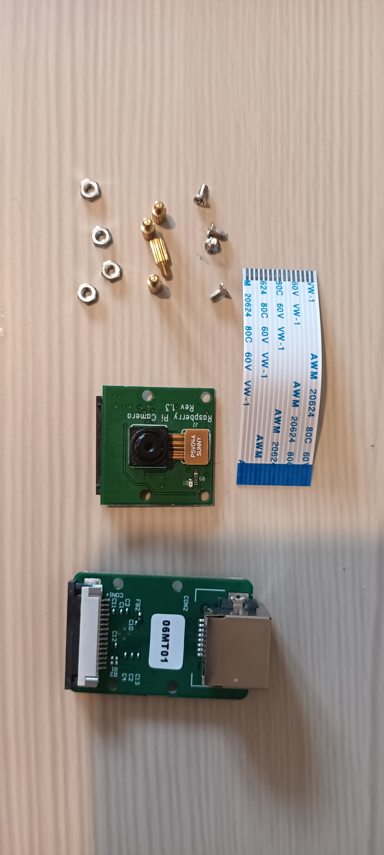
My kit had 5 nuts. In my experience if there is a mistake it is usually over-provision. Still, if your first kit only has 3 nuts then have a look in the others to see if they have a spare.
Attach the four pillars. With my fat fingers, I found it easiest to position the nut first and then hold both nut and board in one hand. I could then hold the (larger) pillar in the other hand and screw it in.
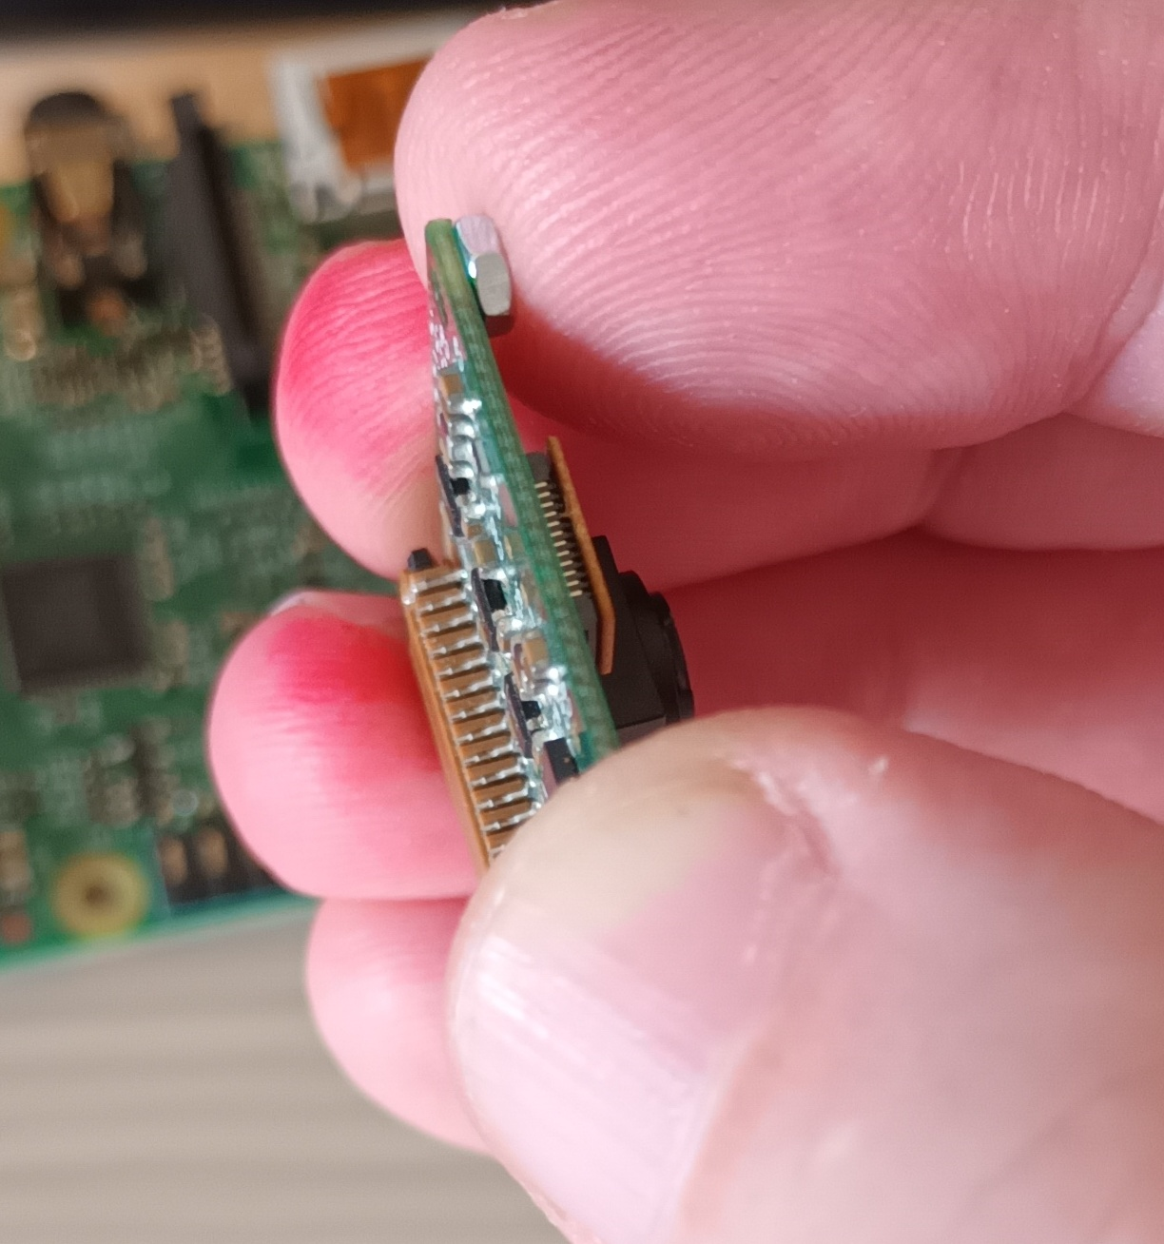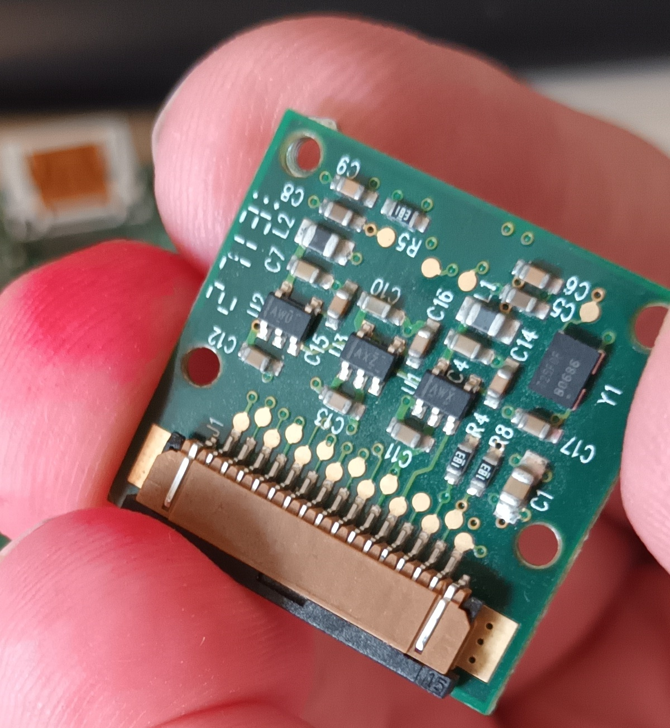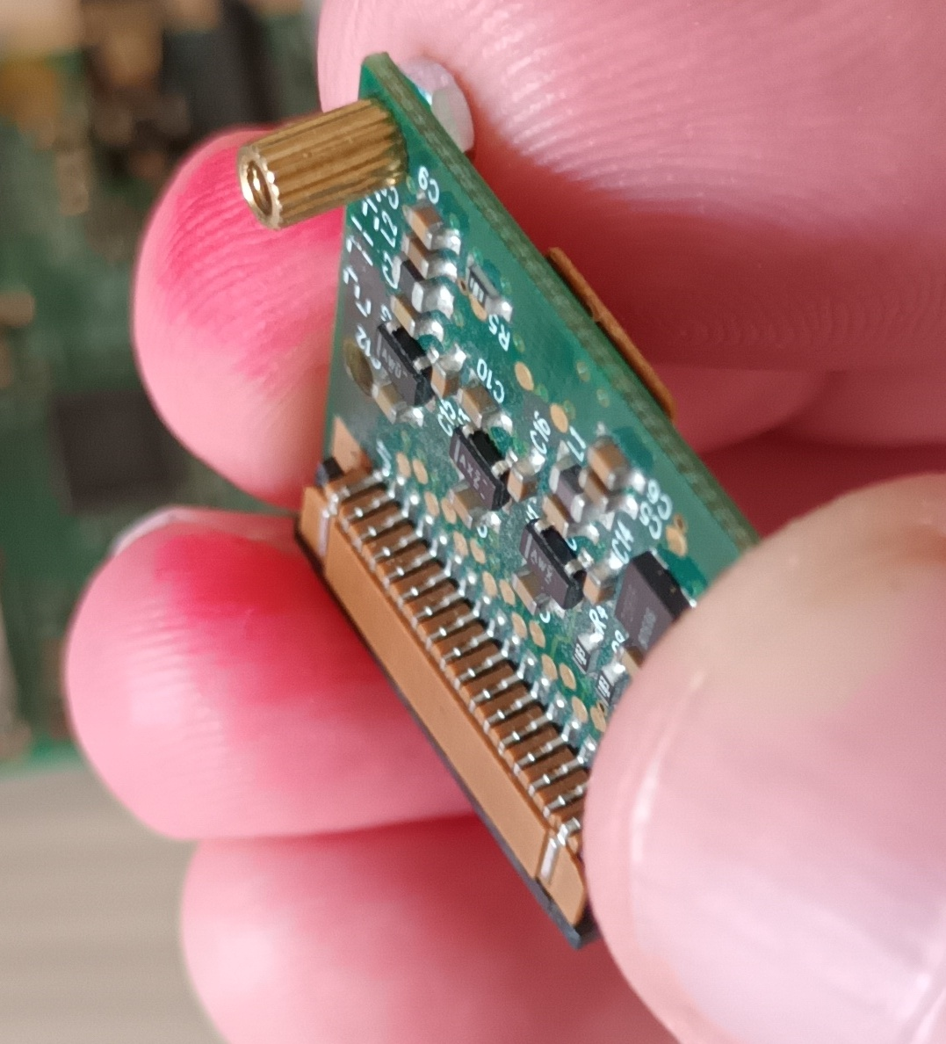
Now attach this board to the camera board. As a first step, put one of the tiny screws on the end of your screwdriver and press it gently against a finger of the same hand so that the screw doesn't fall off.
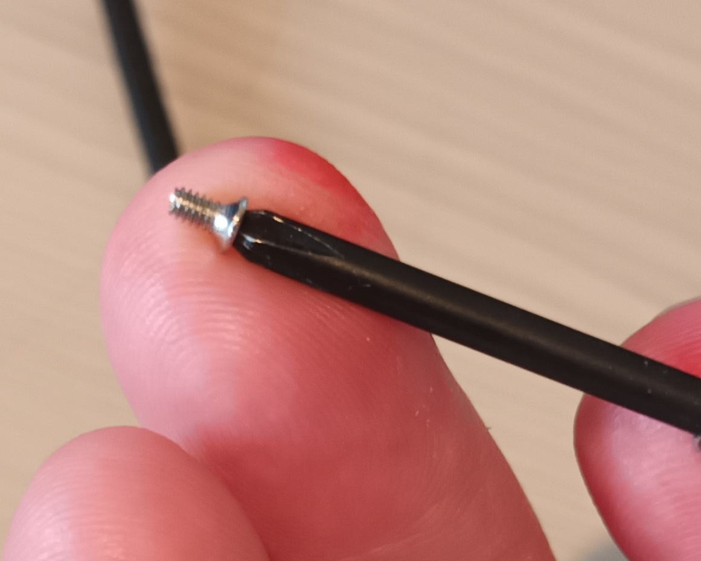
Then with you other hand, pick up the two boards and align at least one of the holes on the camera board with its corresponding pillar on the extender board. Be sure to attach the boards facing the correct way, or else the ribbon cable will be the wrong way up on one of its connectors!
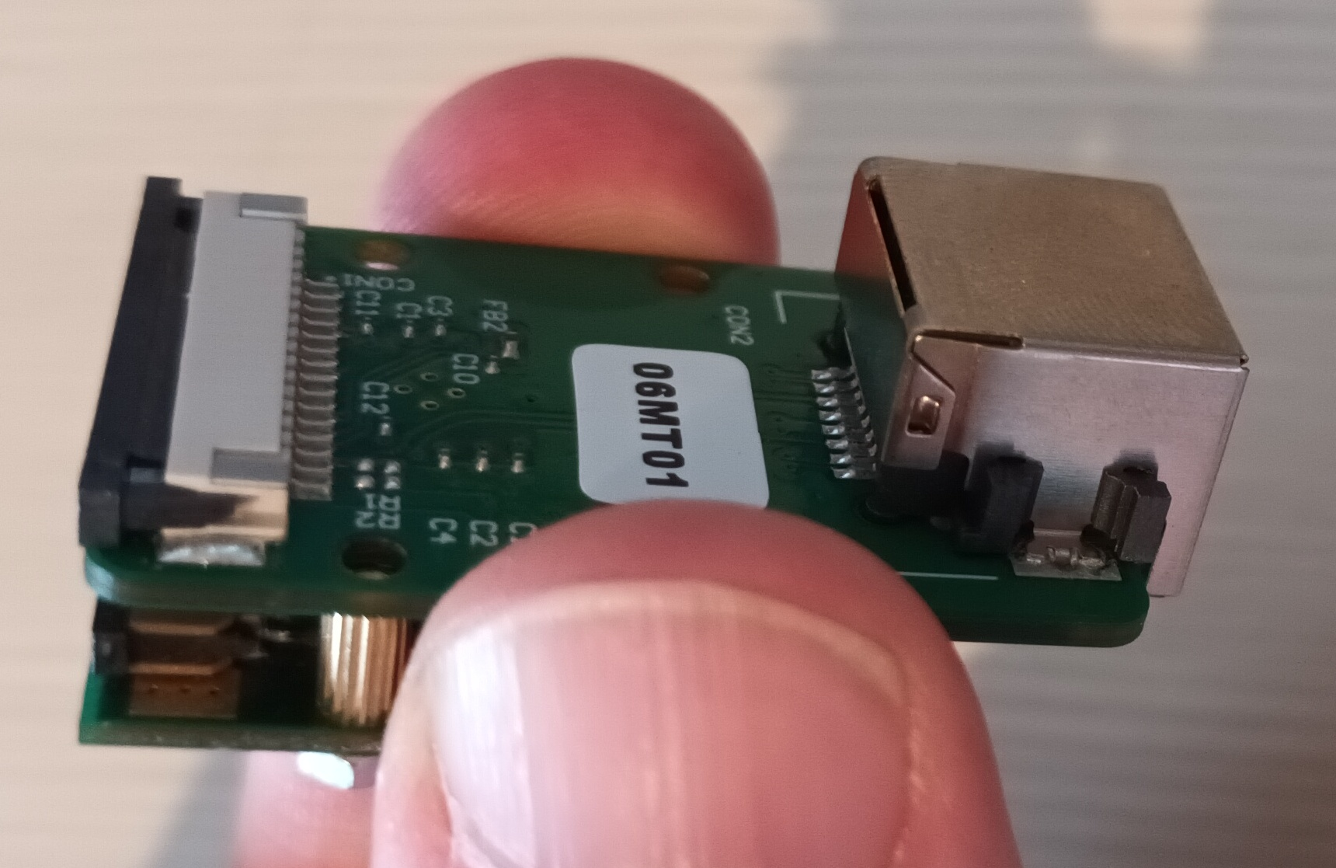
It should now be possible to bring your hands together and somehow get the screw in the right hole before the whole assembly explodes in your face and that tiny screw flies off the table never to be seen again.
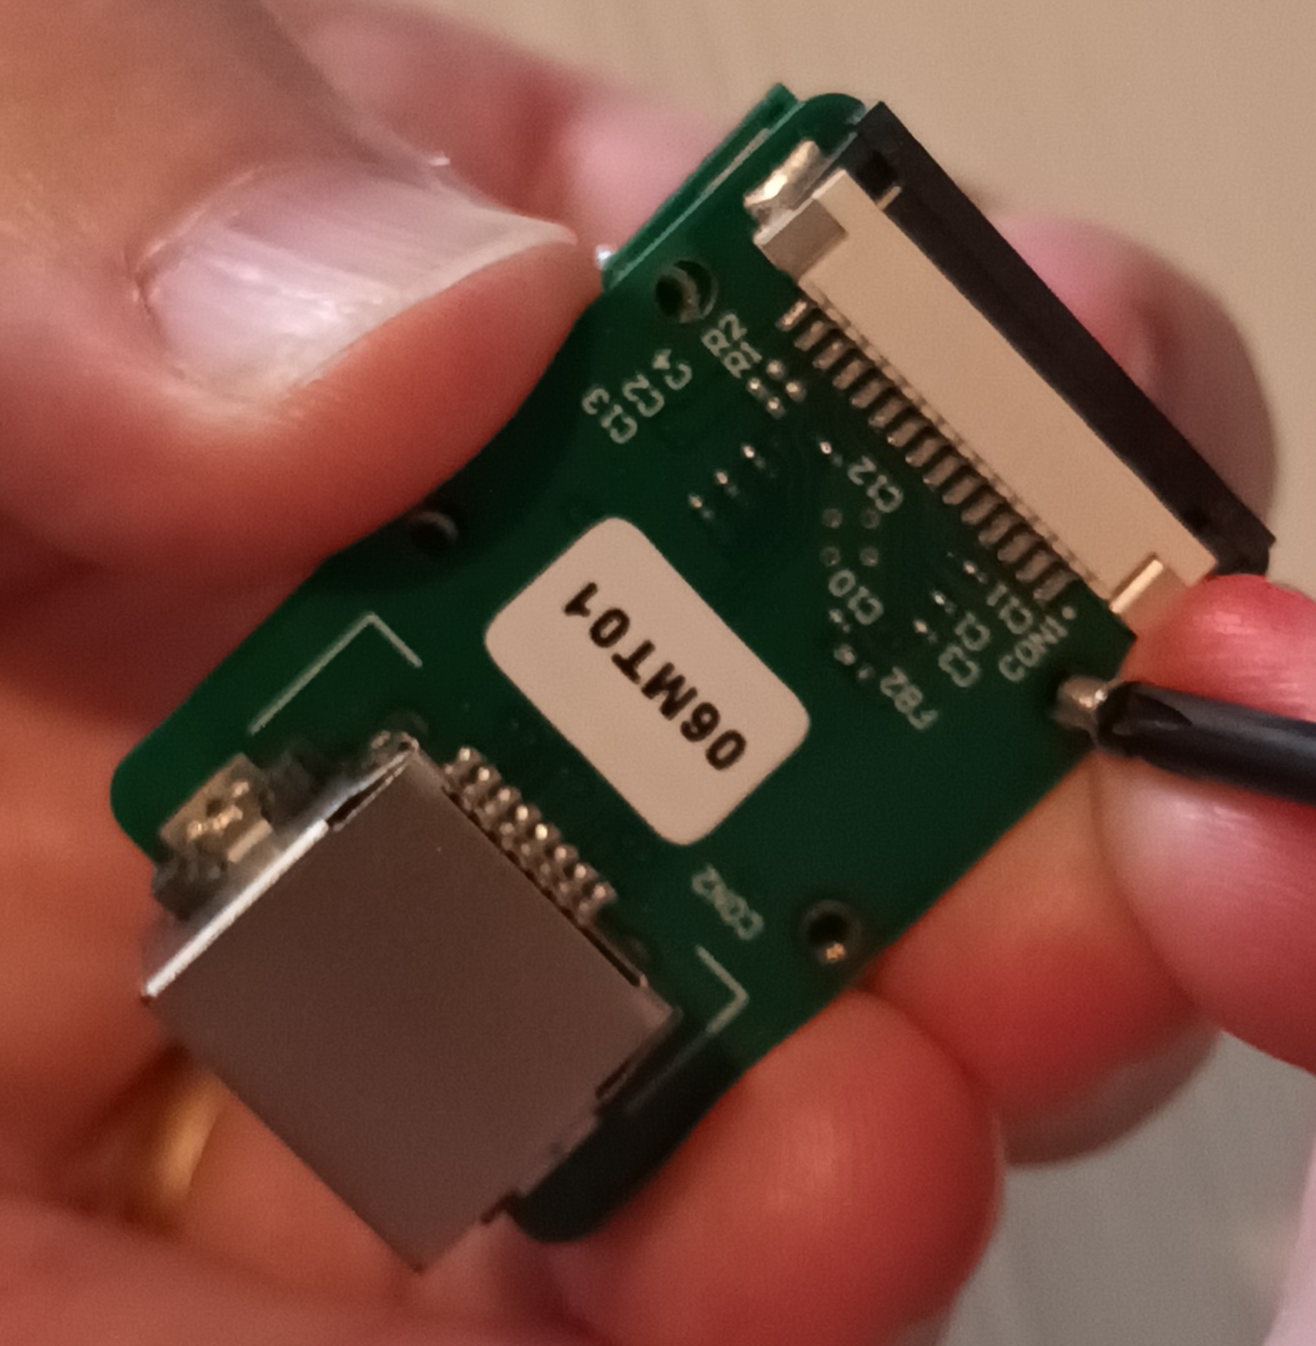
The next three screws are much easier, though I only fit two of them and use the final hole for the gooseneck mount.
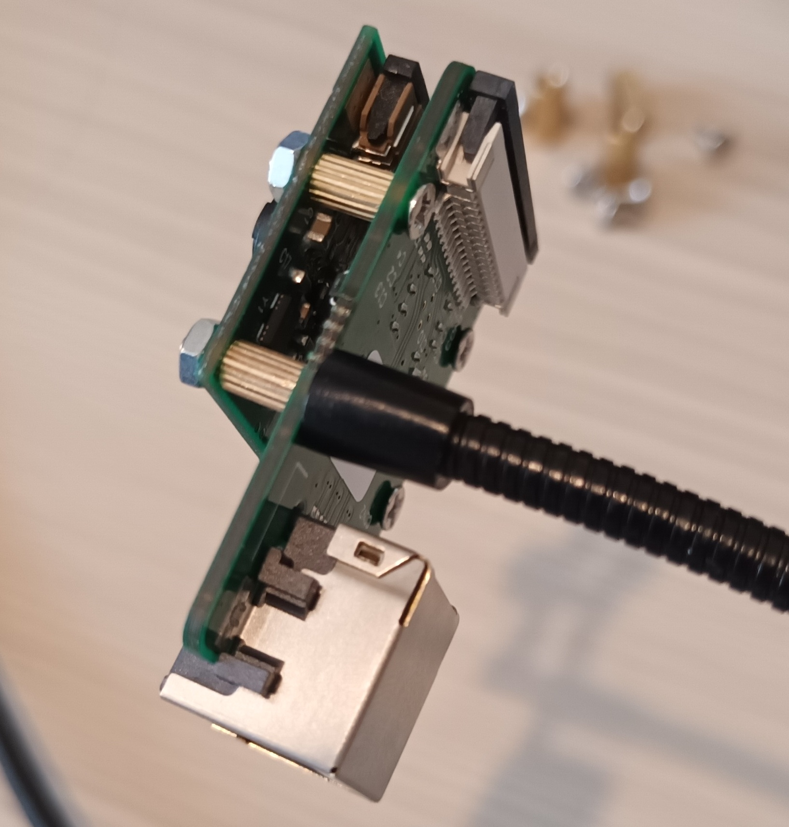
For most of this assembly, I think finger-tightness is sufficient and I didn't use a tool screwing in the pillars. The gooseneck mount is the one exception, because it actually gets moved about and could easily become unscrewed if it was loose to begin with. It is, however, a very fine pitch thread so it would be easy to over-tighten and shred the thread. My guess is that the brass pillar is the harder material and so it is only the gooseneck that would get damaged, so a spare gooseneck might be worth considering.
Now for the ribbon cable. I have acquired a little tool that has cunningly shaped end-pieces that perfectly grip the "gate". If you pull the gate to its "out" position, you should be able to convince yourself that it is possible to pull too hard and separate it from the connector, especially if you are using finger-nails rather than a nice tool. I've actually done this at work a couple of times (on a gate half the size, so more fragile) and the solution was to hand it over to an electronics engineer who could put it back on without causing more damage. I just got laughed at, but you won't have anyone to go to, so get the right tool for the job and practice gently opening and closing the gate. I find that it is slightly stiffer to close when the ribbon cable is in, so I prefer to use my fingers for closing.
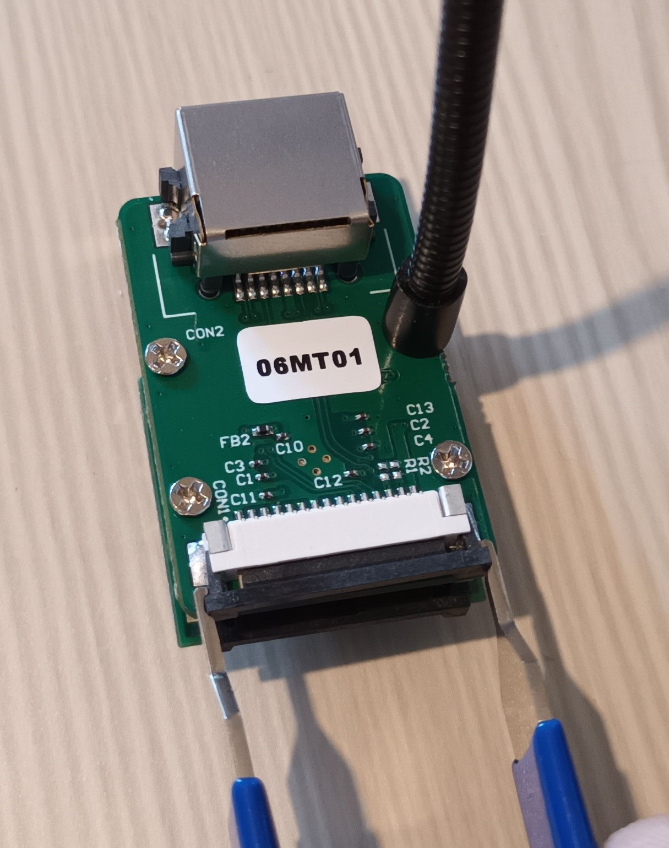
Then connect up the ribbon cable, as shown. (The silvered part of the cable faces the circuit board. The blue part is on top.)
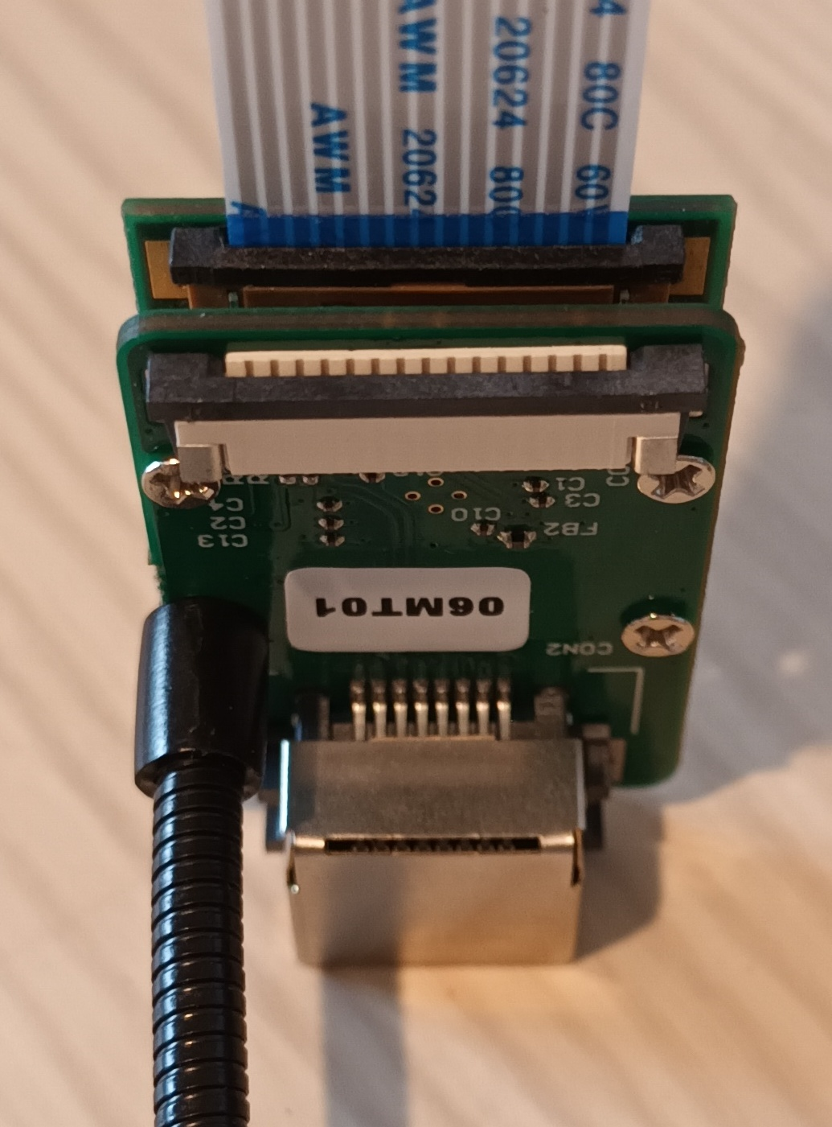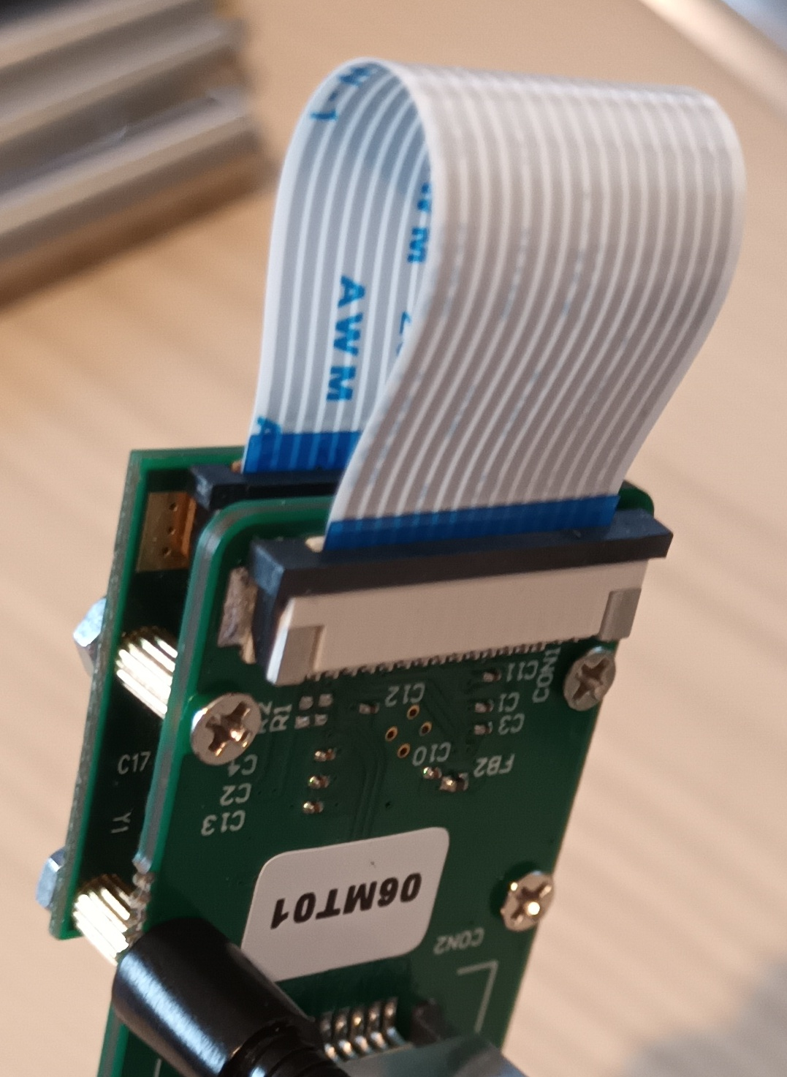
The camera head is now complete, except for being utterly unprotected from the elements.

Cable extender - Pi hat
Trivia: Boards that go on top of a pi are called "hats".
You will need your raspberry pi and the remain parts from the cable extender kit: the larger board, the 6 larger screws, the 3 larger brass pillars, and the other short ribbon cable.
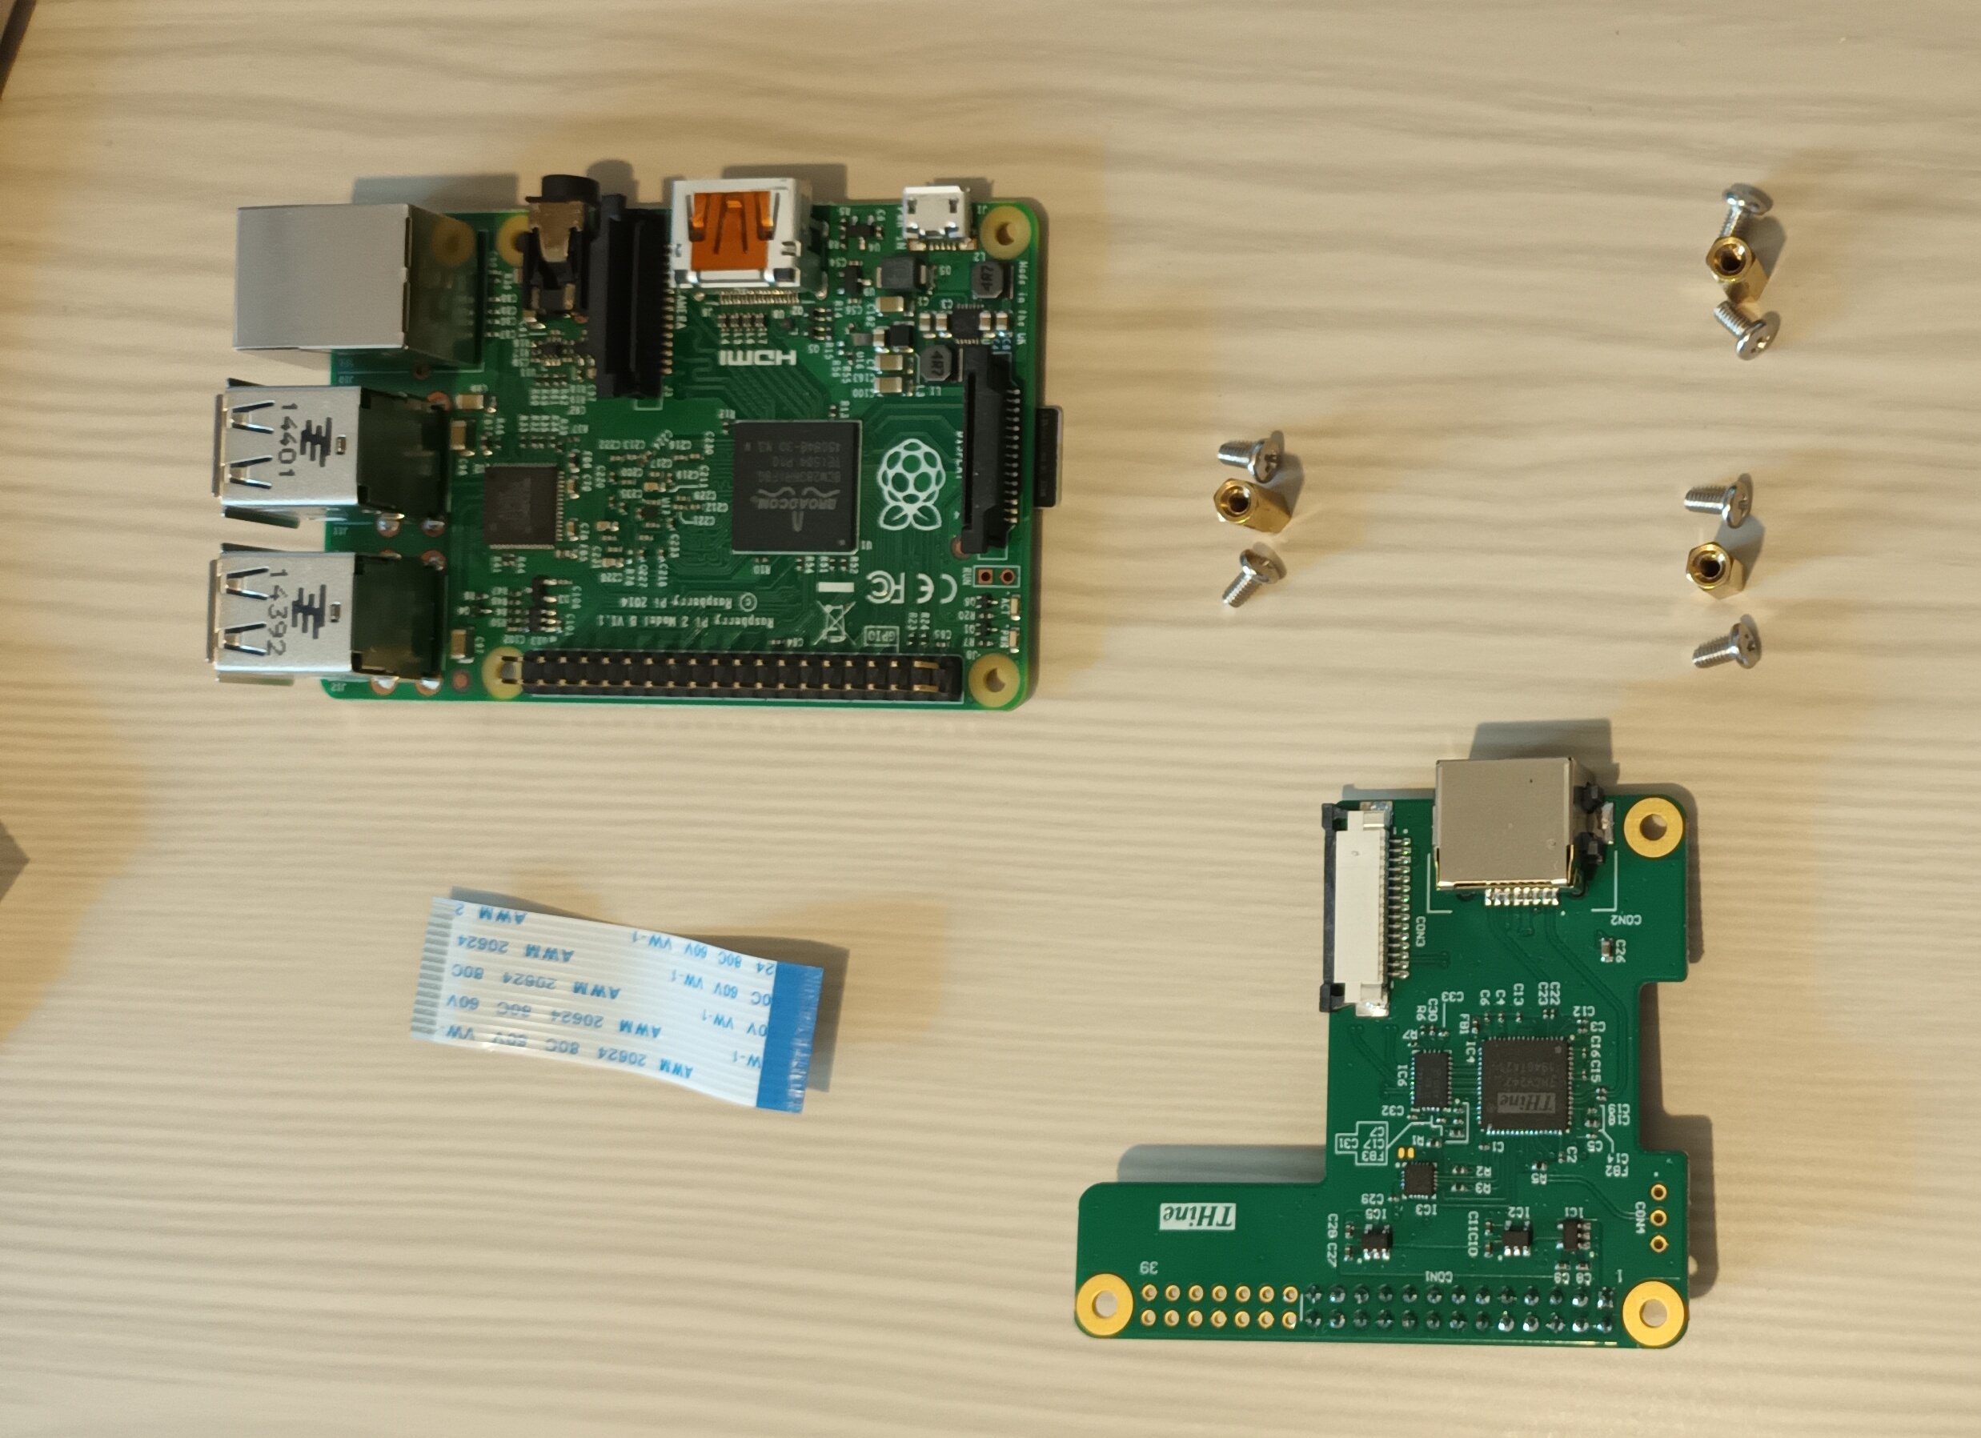
Poke a screw through the correct hole and screw on the pillar. Repeat for the other two pillars.
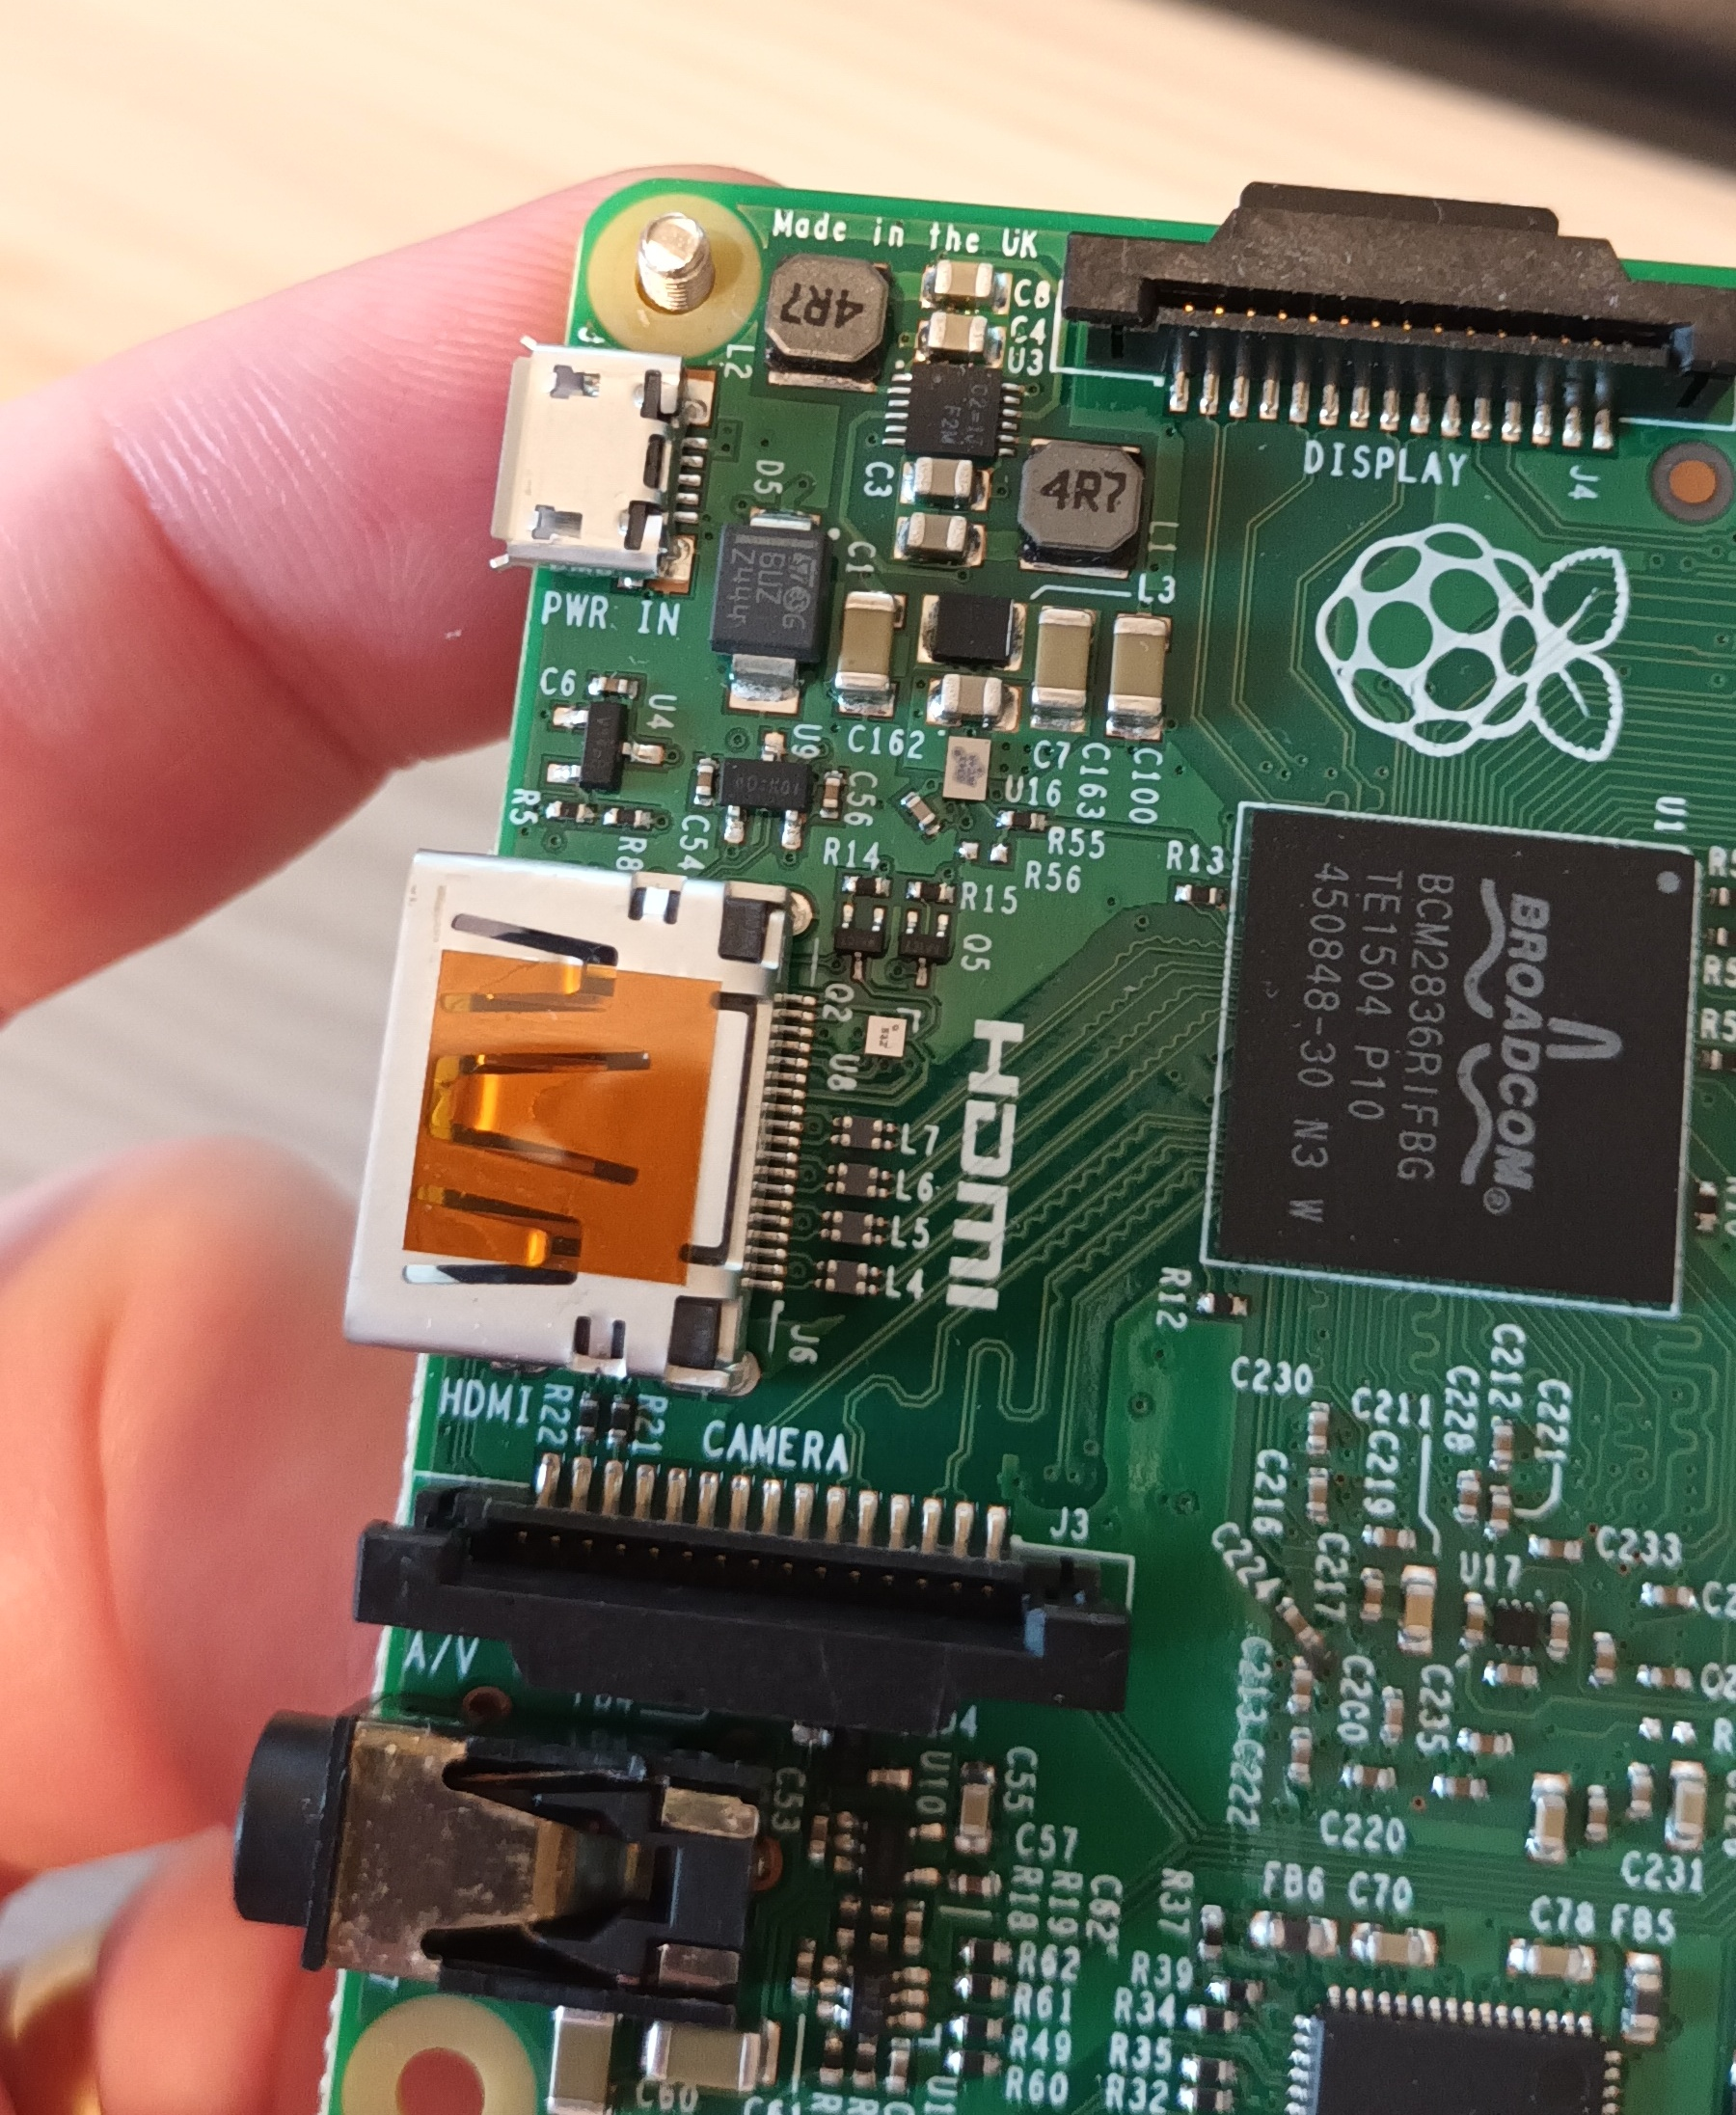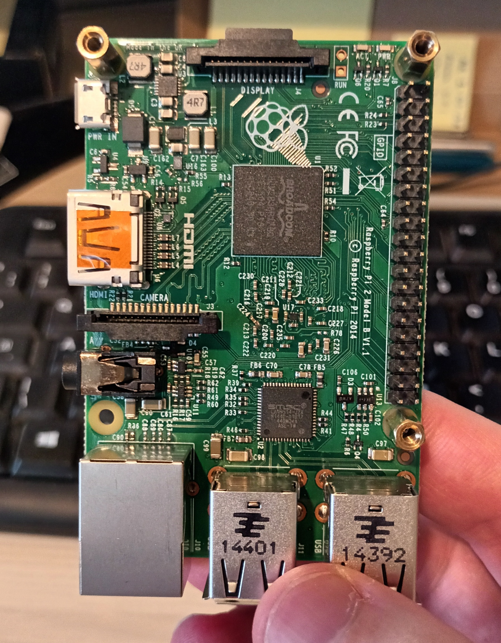
Now fit the ribbon cable to the connector on the raspberry pi. (There's less space to fiddle after you've added the hat.) The blue side faces the USB sockets and the silver side faces the SD card.
Then fit the other end to the connector on the (still unsecured) hat. Unlike the camera head connections, the ribbon goes above the gate, as you can see in this picture, taken before I closed the gate. The blue side faces down and the silver side faces up. (When the writing on the ribbon is visible depends on which end of the ribbon you first plugged into the raspberry pi, so pay no attention to that.)
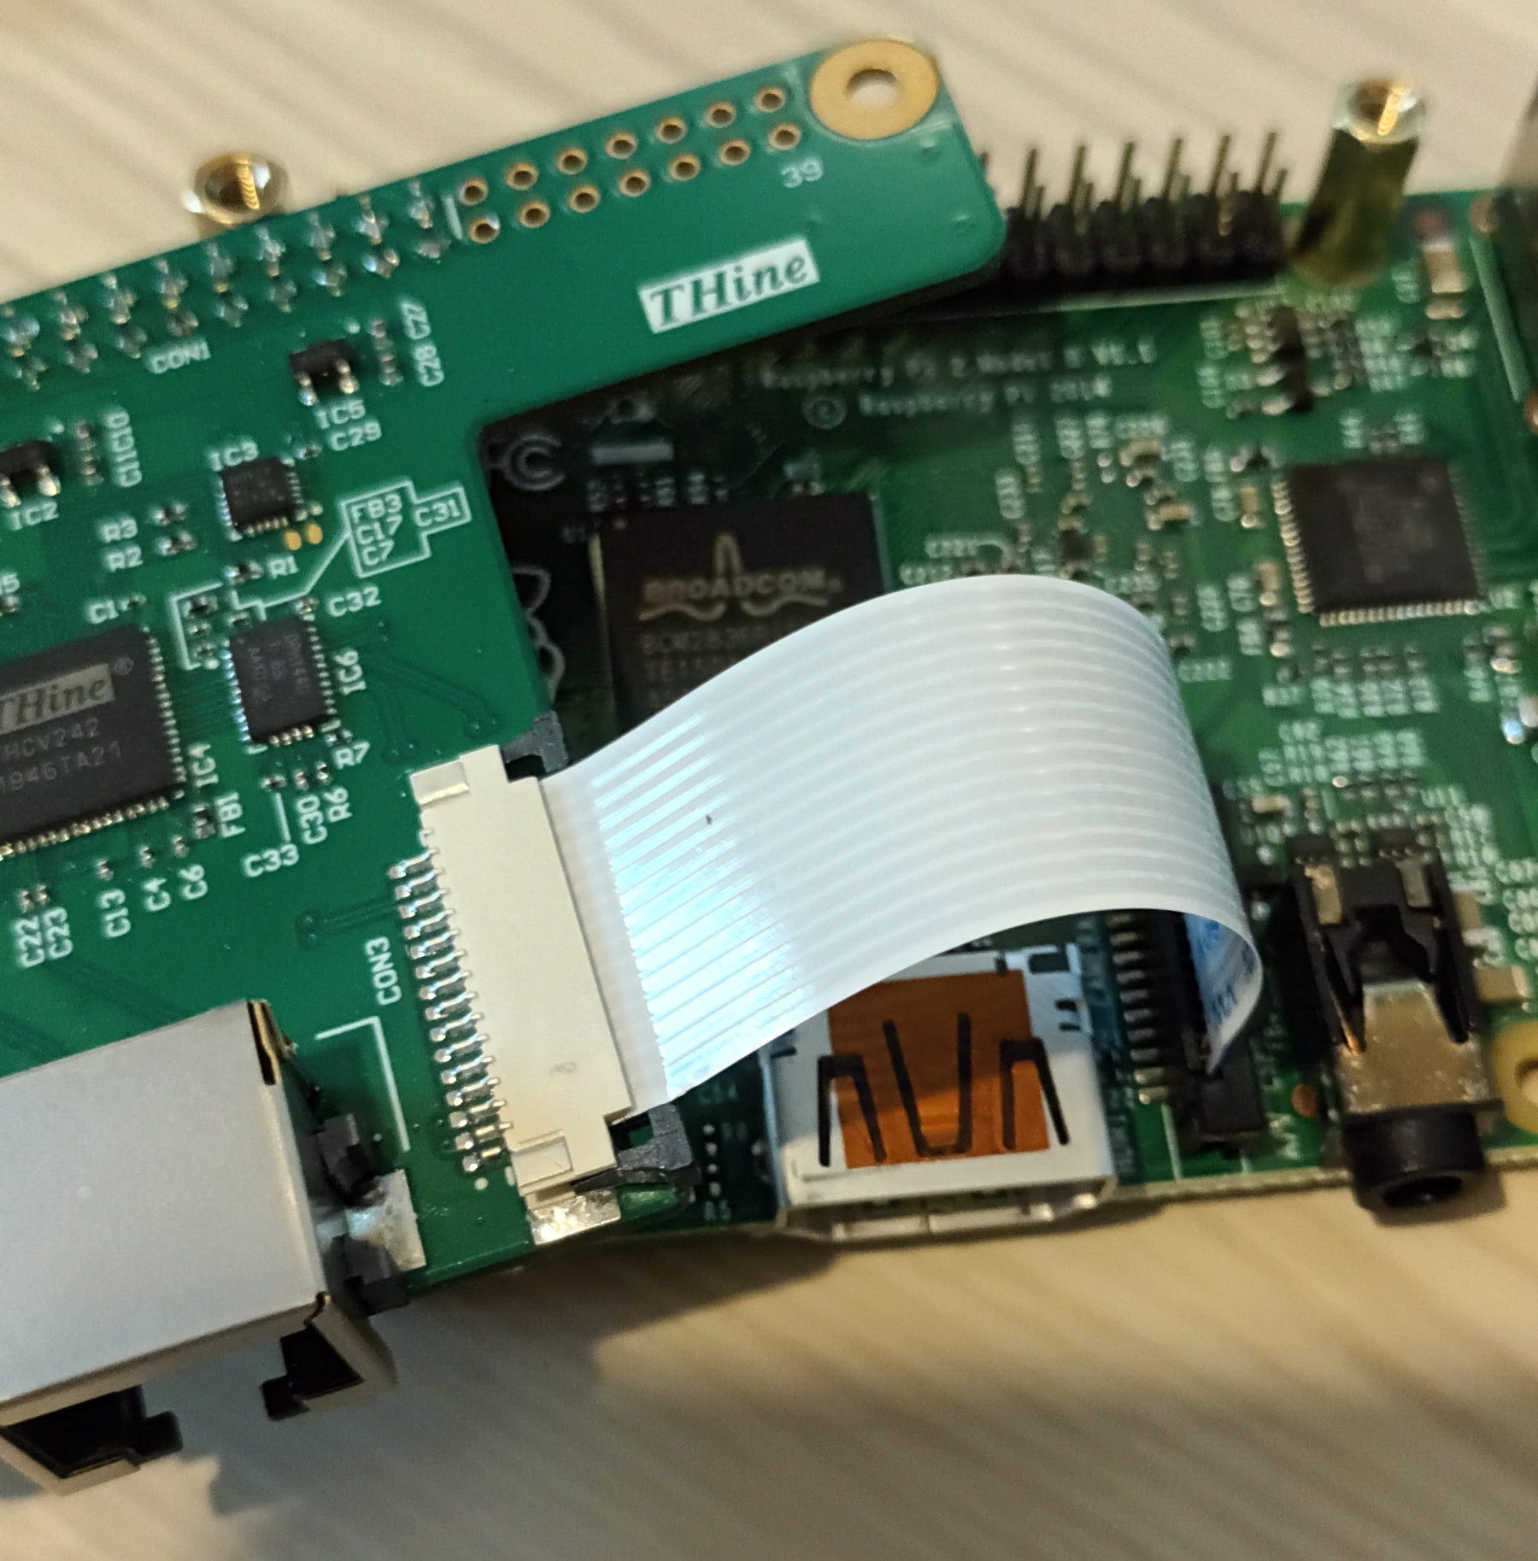
Now position the hat over the GPIO pins and gently push down into position. It's reasonably stiff, but you can't really go wrong at this point as long as you apply even pressure over the area of the 26 pins.
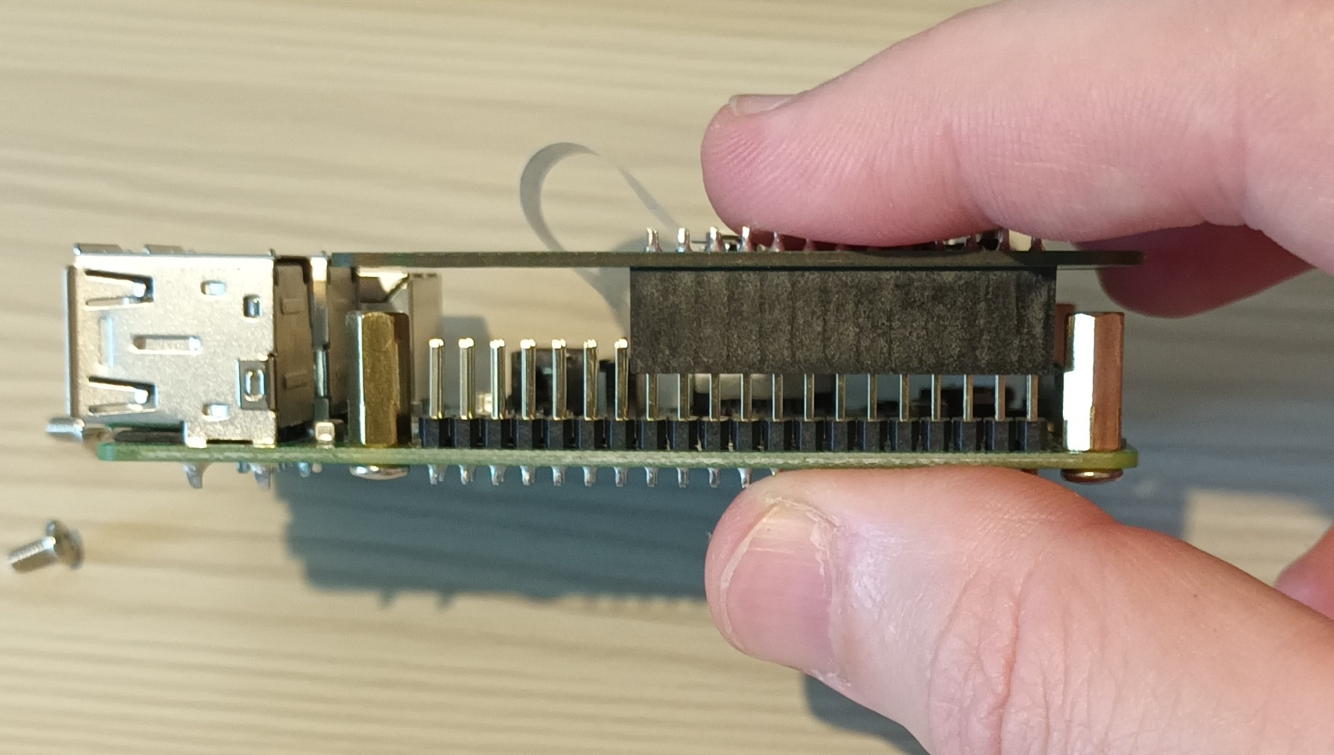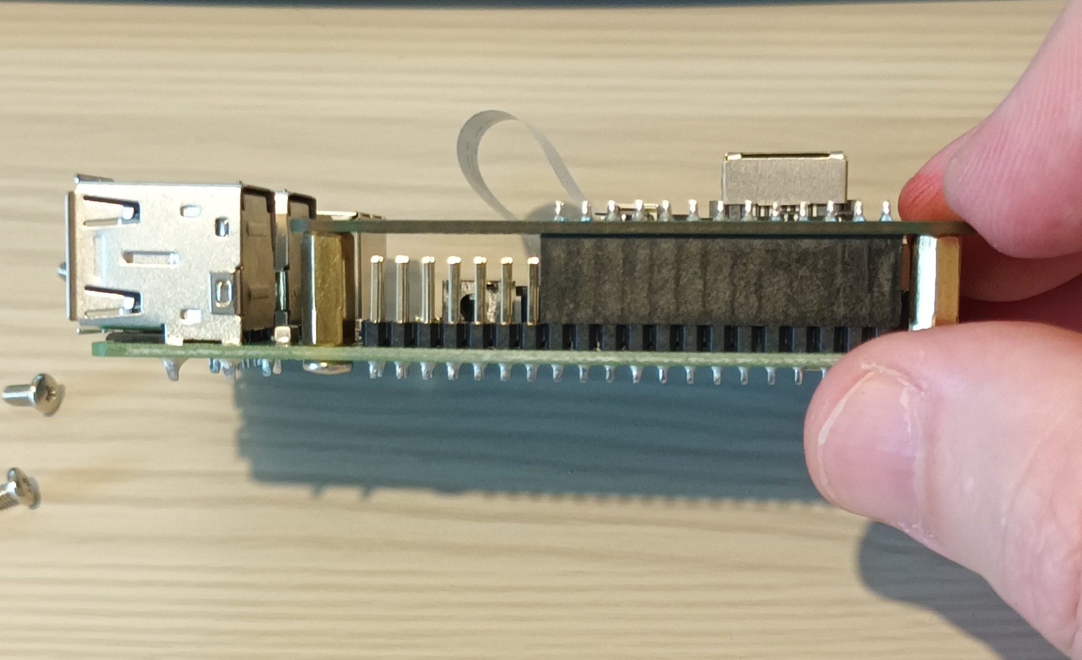
Don't forget the last three screws! You'll need the screwdriver this time, but finger-tightness is still sufficient.

Cabling up
That's all the "construction" and I think you can complete it in Perth. What remains is just plugging cables together and sticking it up a tree. The (slightly misleading) photo below gives me an excuse to mention a handful of things about cabling.
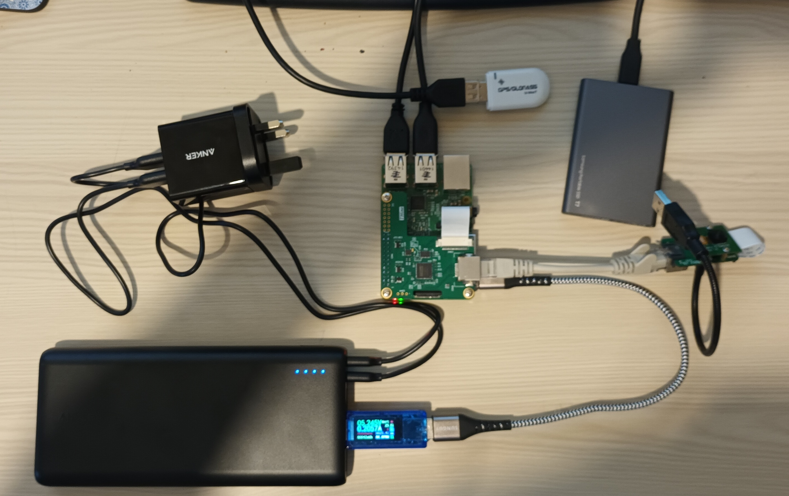
The battery pack has two charging wires. That's because the USB standard is (or was, until recently) limited in how much power it could carry and so the battery is designed to charge from two wires at the same time. Obviously you don't need the two charging cables in the field and you don't need the pi when charging! :)
I've connected the (blue) USB power meter gizmo, which is something you should do when you are assembling things on a bench but not in the field. You should find that the battery pack delivers a steady 5.2 volts and the system draws about 0.65 amps current. (It may spike over 1 amp from time to time, which is OK.)
A lesser battery might drop its voltage when supplying a larger current, but these USB energy banks are lithium batteries (which have low internal resistance) and this one is designed to be able to deliver much more power than we need. (We just need its longevity.)
I've used the shortest ethernet cable I can buy between the pi and the camera head, but that's just for this picture.
The GPS goes in any of the USB sockets. It doesn't matter which.
The picture also shows an SSD connected to a USB socket but that’s no longer part of the plan.
There is nothing in the pi's HDMI output or its ethernet connection, and there's no keyboard or mouse. However, there's nothing to stop you adding those when you are testing.

Protection from the Elements
The ethernet cables are probably fine against anything except curious vertebates. Everything else needs protection against direct sun (heat). The circuit boards and all USB cable connections also need protection against rain.
With its gooseneck mount, the camera head possibly needs to be camouflaged so that it looks less like a snake. Hopefully the long ethernet cable will just look like plant growth.
Down at ground level, the RPi, battery and SSD could live in a sealed box under a sun-shade. They'll generate a bit of heat by themselves, so there is some benefit in using an over-sized box, to allow for a little air flow.
I've suggested putting the GPS at the end of a wire. This allows you to put it a little distance away from the unshielded electronics and, depending on the material of your box, outside that too. If you do put it outside the box, wrap the exposed metal of the USB connectors in insulating tape. Don't wrap the rest of the device, since I've no idea what the radio characteristics of insulating tape are. (We can assume that the manufacturer has chosen a "RF transparent" plastic for the device's casing!)
The ribbon cables need protection from almost any mechanical disturbance. I'm not offering any help on this yet, but I'd like to 3D-print a small rigid enclosure for the camera head if I have time after sorting the software. (You could them add your own camouflage.) There are standards for 3D print files, so it is possible that I could send you a design later and you could find someone in Perth to print it. (There's https://artifactory.org.au/ as a last resort, but presumably the university has an engineering department who would be happy to do it for you.)
Everything is low voltage and inedible, so I suspect that invertebrates aren't going to be a problem, but we probably can't stop them getting into the camera head because it might overheat if we cut off all ventilation.

Transportation
If you are assembling the camera head and raspberry pi in Perth, you'll either need a way of packing them in your hold luggage that is "baggage handler resistant" or you'll have to carry them in hand-luggage. I don't do enough travelling to know, but I suspect they'd be OK as hold luggage. On the other hand, hold luggage occasionally goes missing. When I went to Norway in January, my company told me to take my laptop in hand-luggage on the grounds that if my laptop didn't turn up then I might as well not have turned up either. (With hindsight, they seemed startlingly unsympathetic about my hypothetical demise!)
You might also ask Mandy for a covering letter (with her contact number) to explain to Perth's check-in staff that these are legitimate scientific instruments. I've no idea whether that actually helps, but Ruth thinks it would do no harm. I gather you now have a visa that says you are a proper scientist, so that probably helps too.

Software
Now in a separate document.

I believe you already have 5 of both of these. They turn out to be rather good choices because the pi2 has plenty of ports and still a fairly low power-consumption. They are both no longer obtainable but you might be able to find them on eBay if your kit gets damaged in the field. Failing that, the RPi-3B might be an acceptable substitute for the RPi-2B, but the RPi-4 probably isn't because it burns too much power.
We need two for each camera system because this is what you swap over each day to recover the data. (You’ll set up all the raspberry pi software identically on both.)
For this particular one, I ticked a box (in Amazon) for “Temperature proof” and this one claims to be happy running anywhere from -25°C to +85°C. It probably costs about 50p more for this robustness, which makes it a no-brainer for us.
This gives you freedom in attaching the camera head to a branch in the tree. It's quite stiff and the camera head is quite light, so unless a bird chooses to sit on it, it shouldn't move or droop with time.
This uses normal network cable ("cat5e"). It comes with a 2-metre cable in the box, but I've also used an ordinary 5-metre cable that I happen to have. They claim that a "cat6a" cable (aka "better quality") can run up to 15 metres.
The required length here has to account for "along the branch" as well as "down the trunk", and possibly some looping around things if you want to avoid the need to pin it to the tree somehow.
You will eventually need two of these per system because one will always be charging. However, you probably can't carry more than one by air, so there's no point in buying more than one in the UK and if you already have something similar at home then you may not need to by even one.
This is the one I bought (and I actually got it for £50 because I have prime). Energy banks are fairly mainstream products and to a first approximation the cost scales with the Amp-hours number.
The key property here for us is the capacity. This one is 26800mAh and (as of 24 July) our system can just scrape 24 hours of operation on that (with 14 hours of recording). The air regulations have a limit of 27Ah and perhaps conincidentally I haven't yet found anyone offering a larger one, at least not honestly. (I've seen several scams.)
You can get them with little solar panels on, but this is just a gimmick because you'd need a panel of a square foot or two to deliver the power that we need. I priced up a solar option, but you spend well over £100 and you end up with an attractive climbing frame for the local wildlife.
It comes with 2 USB cables for charging, but no main adapter, so that's the next item on my list.
You might not need "one per system" since they claim to be able to re-charge in about 4 hours, but they only use 24W, so you aren't going to blow any fuses if you get an extension block and charge all your batteries at once. That's probably useful, since I'm still not completely sure we can manage on only one site visit each day.
I've chosen the shortest length I can get (to avoid voltage drop) and a braided cable because they are more flexible.
This turns out to be cheaper (and physically easier to connect) than a real-time-clock module. (The position is just a bonus!) Without it, the RPi will remember the time when it was last turned off (nicely), and will start its clock at that time when it is next powered on. The effect is that it gets the date roughly right but the time is random. Normally this doesn't matter because as soon as you connect to a network (cabled or wireless) it will pick up the time from there. Your desert has no network, so if we want to "record during the day" then we need a time source.
To ensure that we get a signal, we might need to dangle the GPS module outside the box on the end of a wire.
You may already have one. This one is massive overkill, but cheap and I've got one myself. I think the only thing I needed for this project was a tiny cross-head screwdriver.
This is for opening the "gate" on the ribbon cable connector. You can do it with finger-nails, but you really don't want to pull too hard and pull the gate clean out of the connector because that's fiddly to repair.
This lets you measure the supply voltage and current draw during operation, so you can compare your figures with mine and avoid unexpected surprises with battery life.
I've specified 8TB drives, since that's the minimum you need to put a complete copy of your data on each one. However, HDD prices are not linear and you might find a 10TB or 12TB unit for not much more.

