**LAB-4**

Create a database for a blog post system that containing a table with at least 6 columns. Insert records and submit screenshot of table.

Name : Rahin Arefin Ahmed

ID: 2022-1-60-263

Section-3

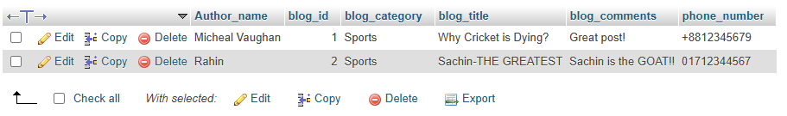

Query:

Blog_post CREATE TABLE `blog_post` (

`Author_name` varchar(20) NOT NULL,

`blog_id` int(10) NOT NULL AUTO_INCREMENT,

`blog_category` varchar(30) NOT NULL,

`blog_title` varchar(50) NOT NULL,

`blog_comments` varchar(50) NOT NULL,

`phone_number` varchar(11) NOT NULL,

PRIMARY KEY (`blog_id`)

) ENGINE=InnoDB AUTO_INCREMENT=3 DEFAULT CHARSET=utf8mb4 COLLATE=utf8mb4_general_ci