 East West University
Department of CSE

LAB 4
Introduction to Git and GitHub

Name: Rahin Arefin Ahmed
ID: 2022-1-60-263

Semester: Spring-2025
Course Code: CSE412
Section: 04

Course Instructor: Nishat Tasnim Niloy
Date of Submission: 20/03/2025

1. Setting Up GitHub

1.1 Creating a GitHub Account

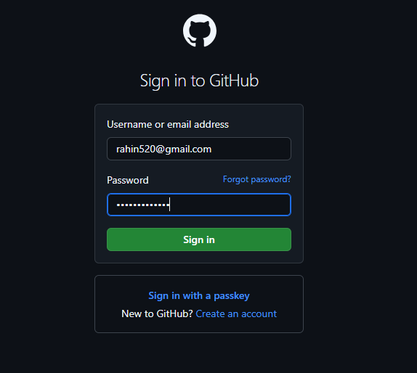

2. Creating and Managing Repositories:

2.1 Creating a New Repository
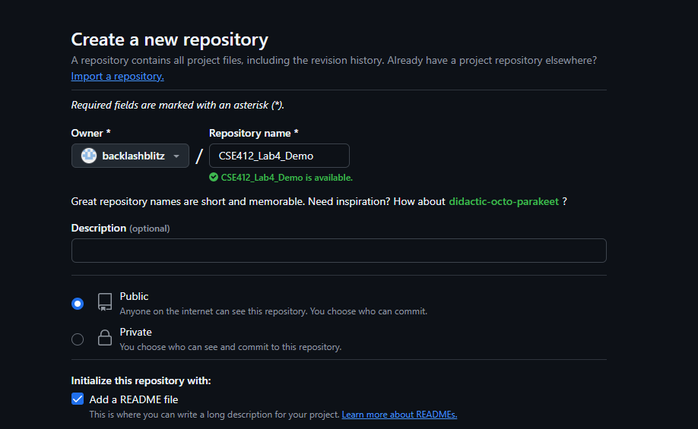

3. Adding and Managing Files:

3.1 Uploading a File
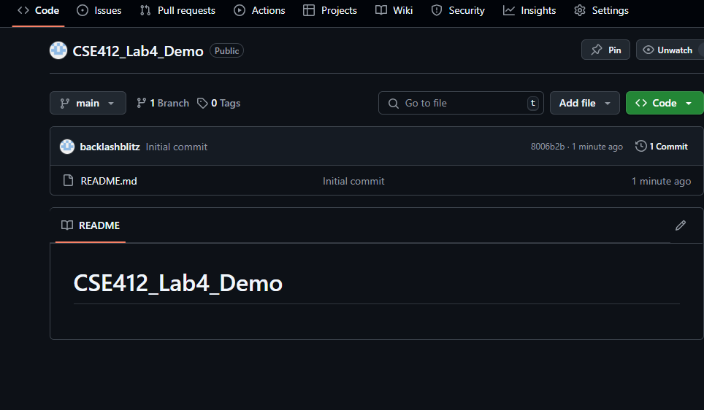

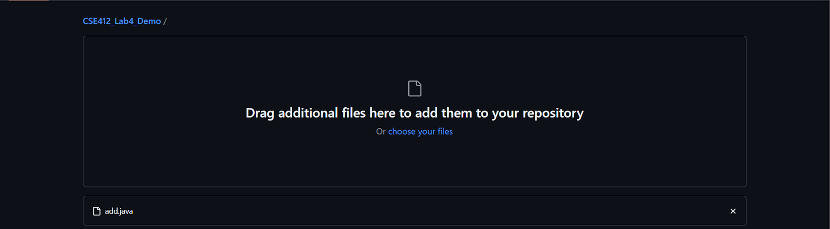

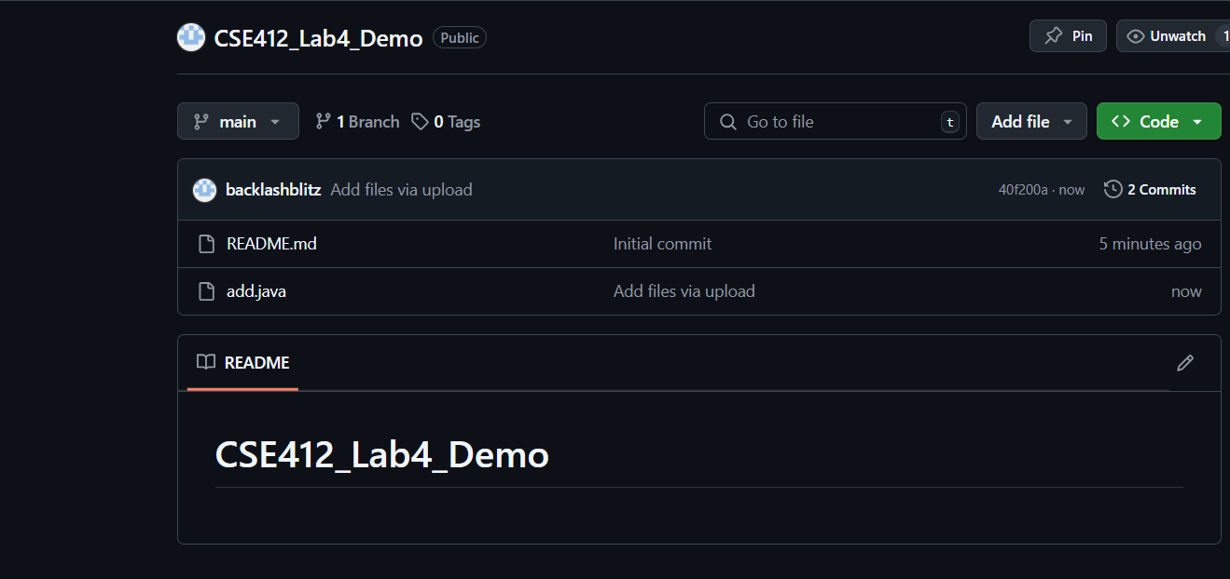

3.2 Creating a New File

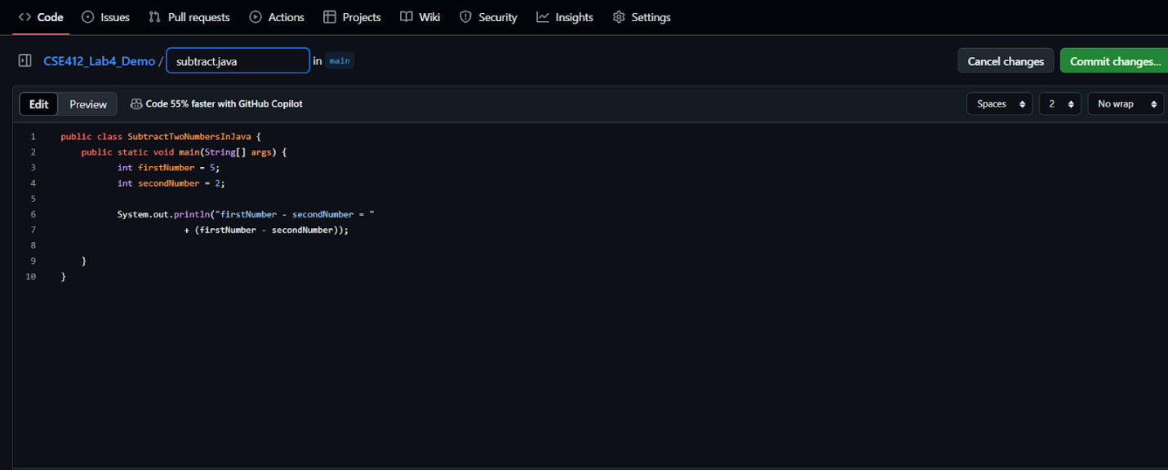

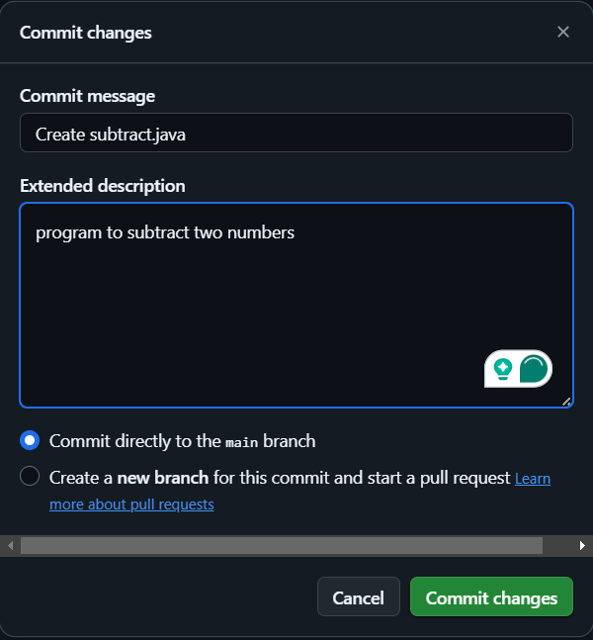

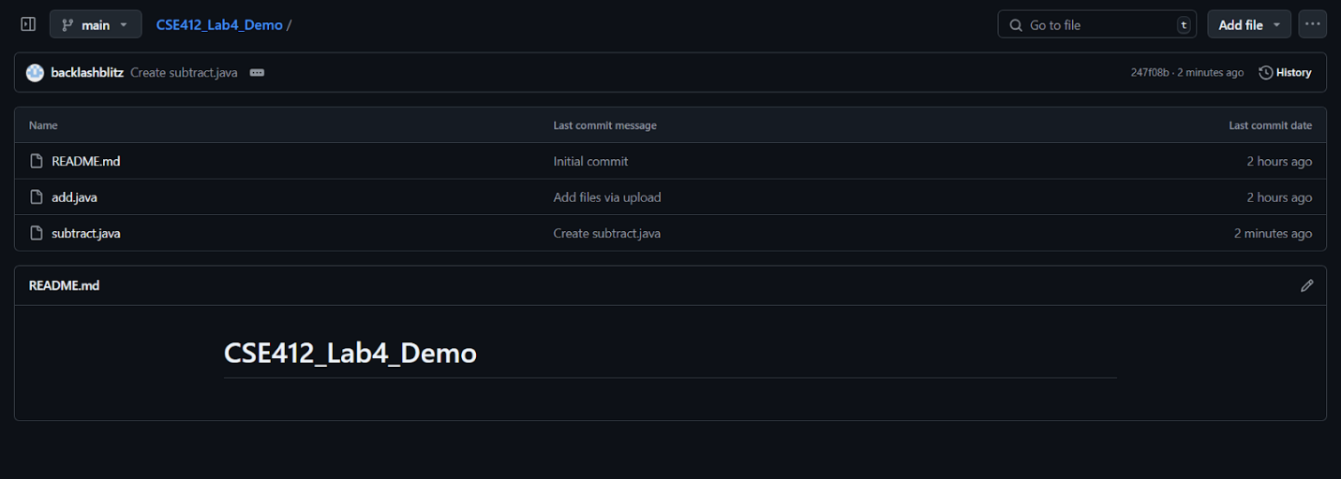

3.3 Editing an Existing File

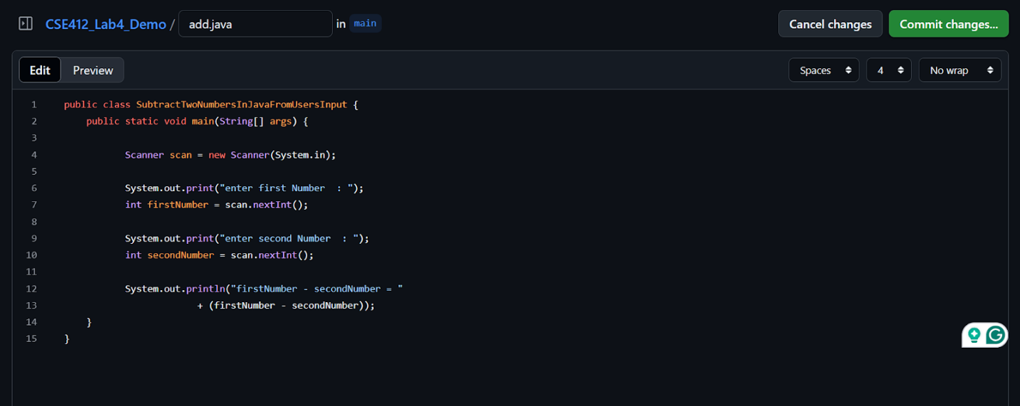

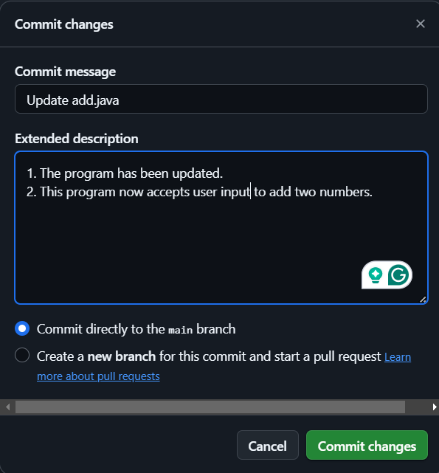

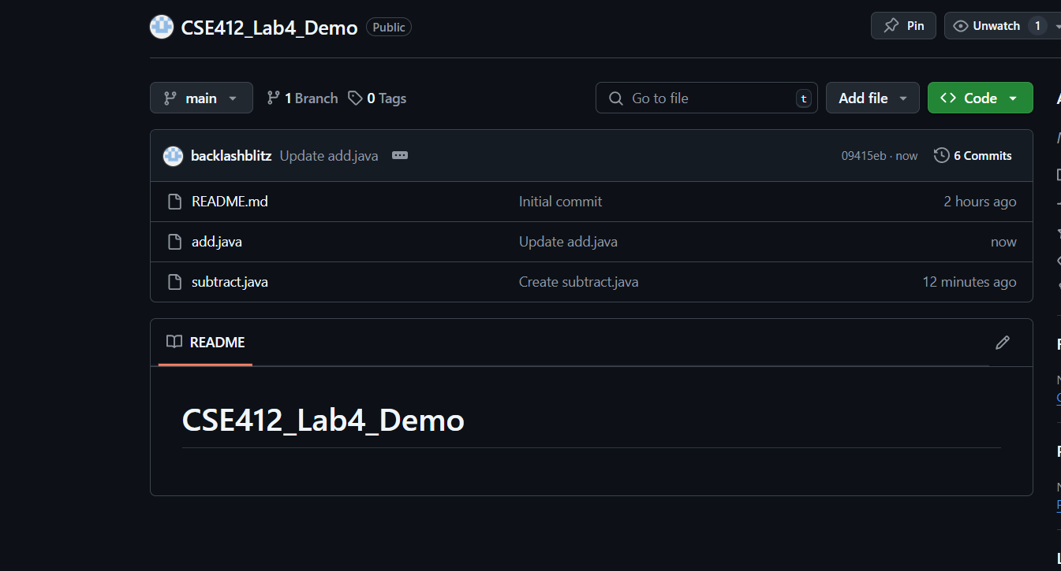

4. Branching in GitHub:

4.1 Creating a New Branch

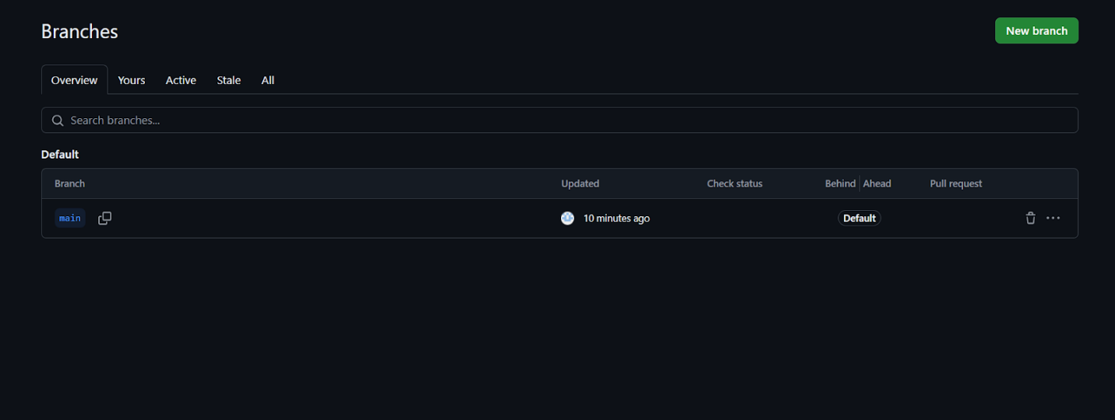

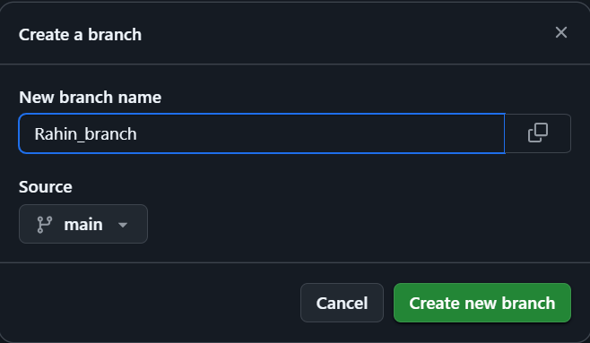

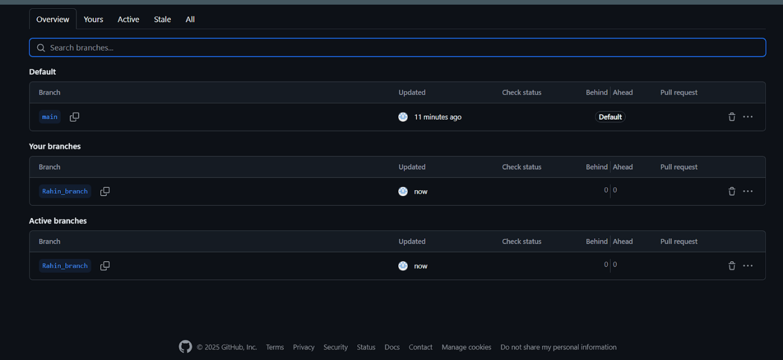

4.2 Switching Branches

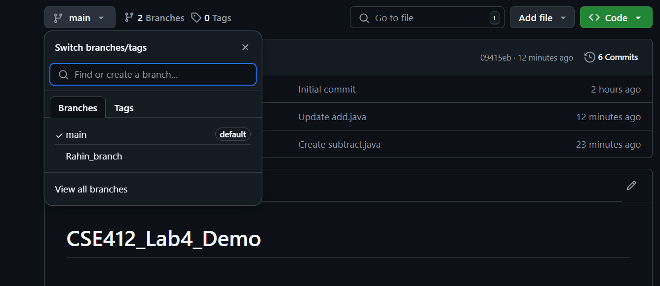

4.3 Merging a Branch (Using Pull Requests)

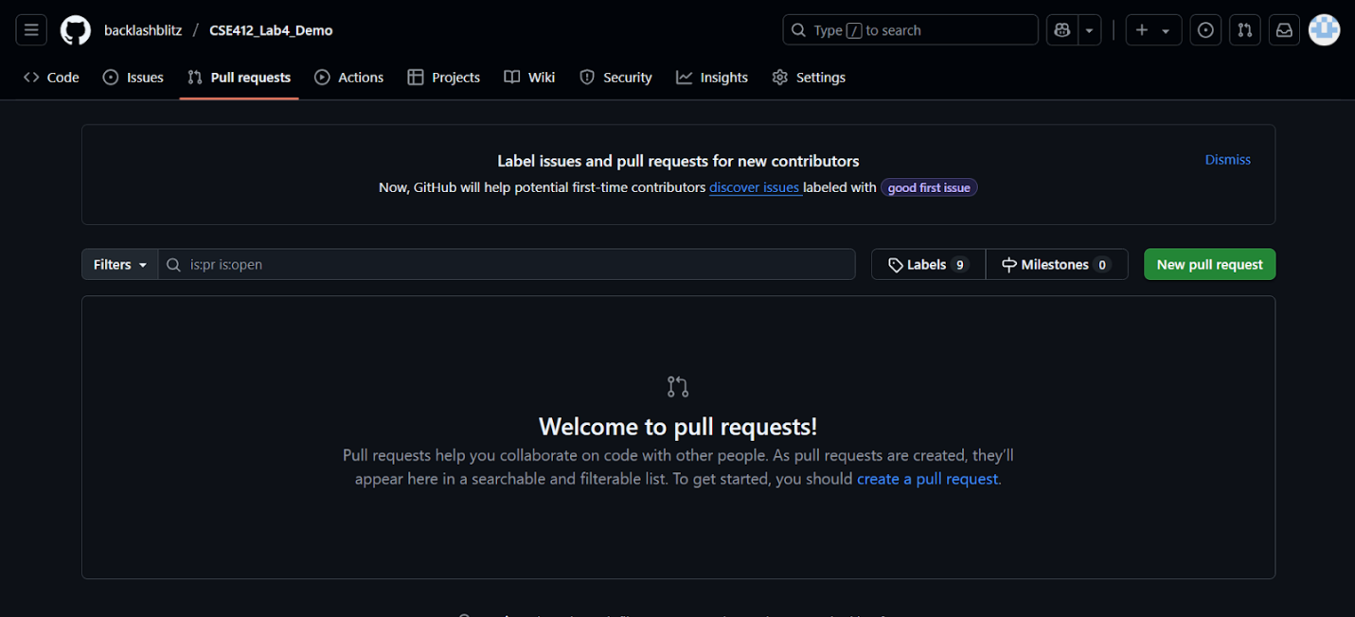

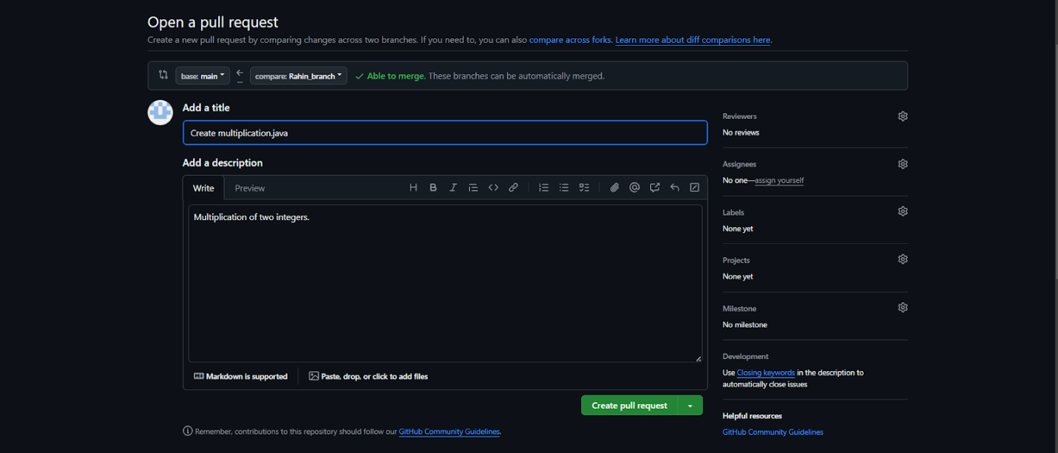

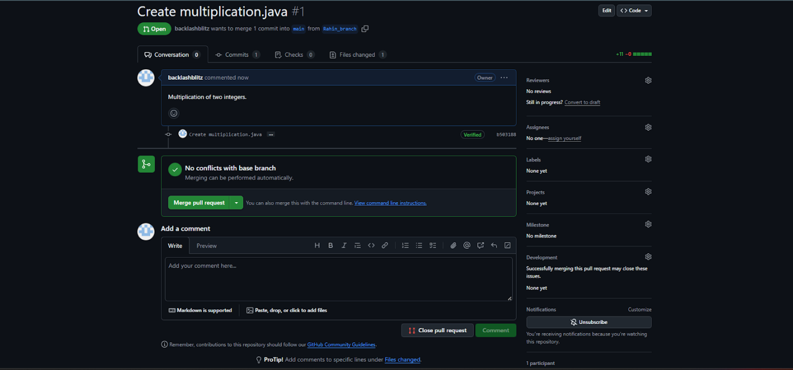
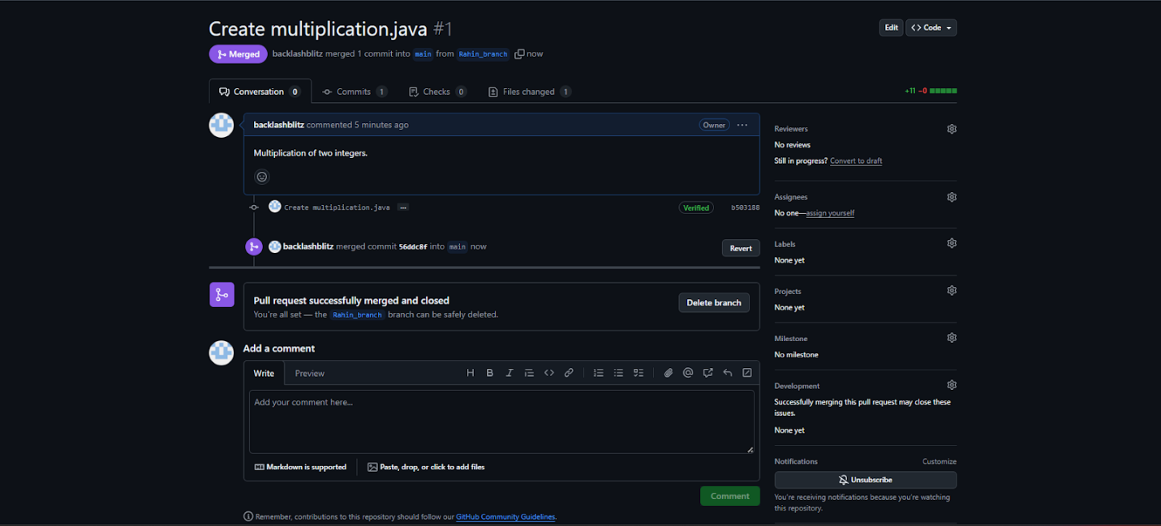

5. Working with GitHub Features:

5.1 Adding Collaborators


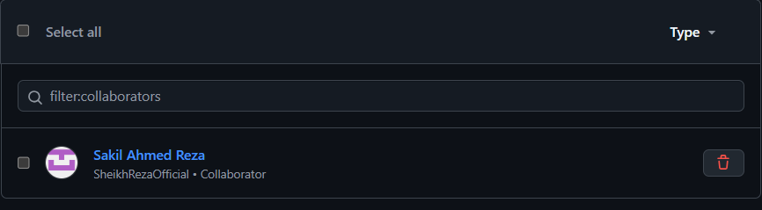

5.2 Creating an Issue

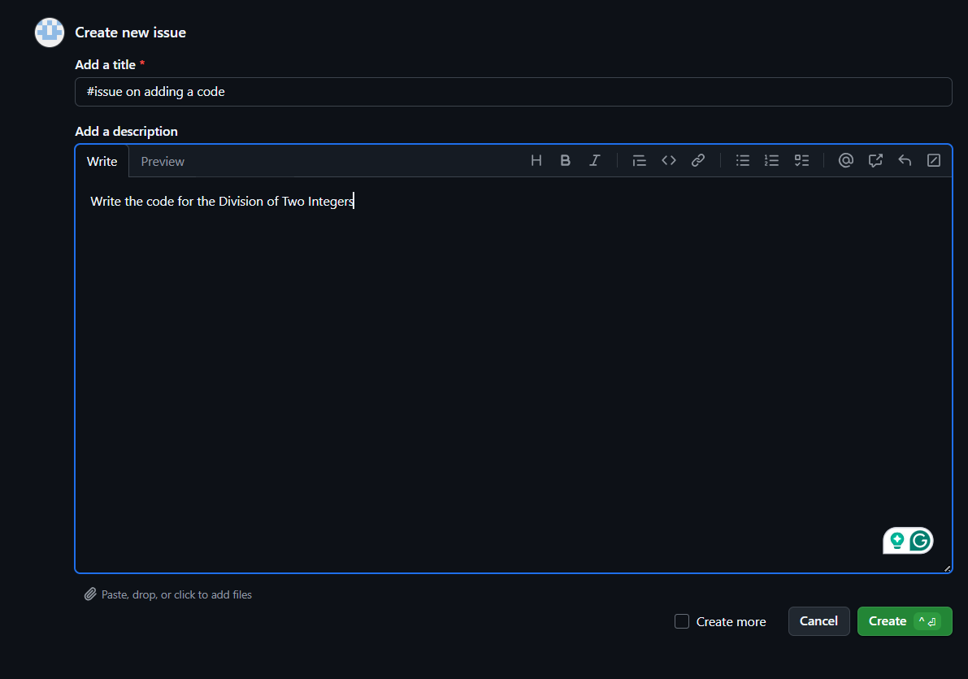

Assigned to my collaborator:

