**Generic Templates**

There are 3 major templates that will be helpful for you and your team to create when you go to competitions without looking at anything before. It is recommended that, when time starts, 1 person begins typing these three out, while the other 2 go and look over problems to divide up.

**Given Lines Template**

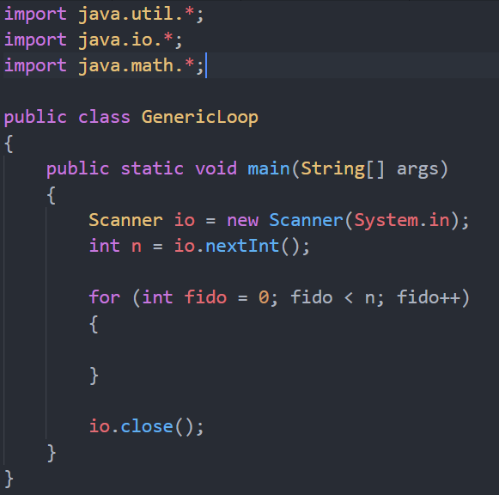This loop should be used when you are given the amount of lines of inputs that you should use. It is important to note that we import 3 entire libraries, but if your running over on time, you may want to comment out one of the imports.

**EOF Template**

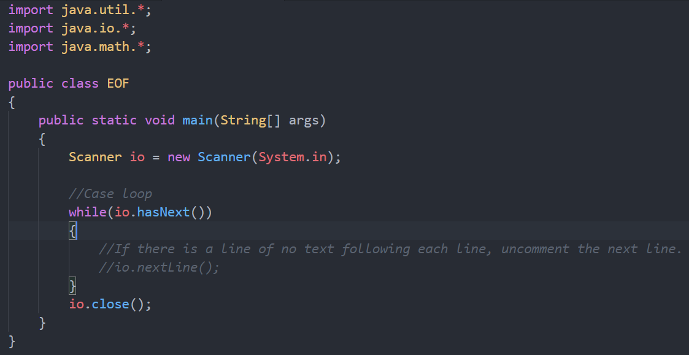This should be used when you are not necessarily given an amount of lines of input. It’s important to note that, to truly test it, you need to use the batch file to follow, because you yourself cannot enter a null string, only reading from a txt file can.

**Runner Batch**

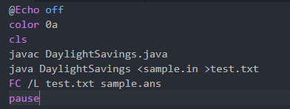This is how you should test all of your programs before you turn it in. This gives you the ability to test your program exactly like Kattis would. The FC line (line 6) will also automatically compare your output to the answer output, but if you want to look at your actual output, you can find it as test.txt. To exit the terminal window, pressing any button while it is open will close the window.