# HEN & CHICK

**The Marauders’ Island**

A YA Fantasy Adventure!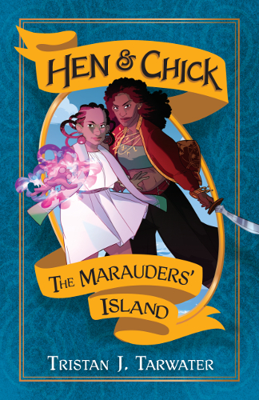

**Dateline**: Portland, OR/Kickstarter May 1st-May 30th, 2016

A new YA Fantasy series by Tristan J. Tarwater, aka backthatelfup, debuts this spring! The author of this diverse Young Adult novel is returning for her 4th Kickstarter to raise money for both softcover and hardcover editions of the book.

**Author Quote**: I didn’t want to do another fantasy story full of European backdrops and orphans.

**Author Info**: Tristan J. Tarwater is an author of speculative fiction, comics and RPGs. She resides in Portland, OR.

**Book Info**: Azria, a mage of Miz, is the key to revealing a long lost treasure trove: at least that’s what her mother, alleged pirate Captain Apzana says. Generations ago, THE MARAUDERS’ ISLAND was sunk by the greatest mage in Mizian history, Iyzani, as an act of war and revenge. If Azria can undo the magic of powerful mages who came before her, a vast treasure will be theirs for the taking. But more mysteries than riches surface as Azria approaches a part of Miz’ history meant to remain drowned by the waves. Those who would stop her warn her: reveal the past and destroy the lives of mages forever. Azria must decide if she will be the daughter her mother needs or protect her homeland’s secret.

HEN & CHICK: The Marauders’ Island is a swashbuckling fantasy story, where a wizard of immense talent and legacy must find her own place in the World of Mun. The power to control the elements is trumped by long grudges, old lies, and personal desires. Magic is for the bold, and surviving the ambitions of the powerful isn’t for the feint of heart.

**Contact**: [tristanjtarwater@gmail.com](mailto:tristanjtarwater@gmail.com)

**Call To Action**: The Hen & Chick: The Marauders' Island Kickstarter is running for the month of May and needs to meet goal to see print. Rewards such as a softcover book, hardcover book, an enamel pin and a custom handmade themed soap are meant to entice potential readers. Back today and be the first to get this swashbuckling tale of magic, adventure and vengeance!

**Hashtags**: #YA #diversesff #diverseYA #swordandsorcery #fantasy

**About the Author**: Tristan J. Tarwater is the author of fantasy novels, weird stories, comics and RPG bits. Her titles include Hen & Chick, The Valley of Ten Crescents and Shamsee: A Fistful of Lunars. Originally from New York City, she now considers Portland, OR her home, where she resides with her spouse, child, three ducks, an eater of souls, and an animal who knows it’s a multipass.

You can find more of her work on [www.backthatlefup.com](http://www.backthatlefup.com) or talk to her about food and books on Twitter as @backthatelfup