**How to Use this Template**

1. Make a copy [ File → Make a copy... ]
2. Rename this file: “**Capstone_Stage1**”
3. Replace the text in green

**Submission Instructions**

1. After you’ve completed all the sections, download this document as a PDF [ File → Download as PDF ]
2. Create a new GitHub repo for the capstone. Name it “**Capstone Project**”
3. Add this document to your repo. Make sure it’s named “**Capstone_Stage1.pdf**”

Description

Intended User

Features

User Interface Mocks

Screen 1

Screen 2

Key Considerations

How will your app handle data persistence?

Describe any corner cases in the UX.

Describe any libraries you’ll be using and share your reasoning for including them.

Next Steps: Required Tasks

Task 1: Project Setup

Task 2: Implement UI for Each Activity and Fragment

Task 3: Your Next Task

Task 4: Your Next Task

Task 5: Your Next Task

**GitHub Username**: Popnfresh234

I Love Youbike

# Description

I Love Youbike is a simple and straightforward way for you to make use of Taipei’s Youbike system. Quickly and easily locate Youbike stations and see how many bikes are available. I Love Youbike has a full English version as well as a full Chinese version.

# Intended User

I Love Youbike is intended for use specifically by travellers and residents in Taipei who are not fluent in written Chinese. Currently there is no application for accessing the Youbike system in English available.

# Features

* Fetches Youbike station data from Taipei City Government Open Data API and syncs to a local database
* Provides a listing of all Youbike stations and how many bicycles are available at each station
* Uses user’s location to determine nearest Youbike location
* Display a map showing the user’s location and nearby Youbike stations

# User Interface Mocks

## Screen 1 – Main Screen

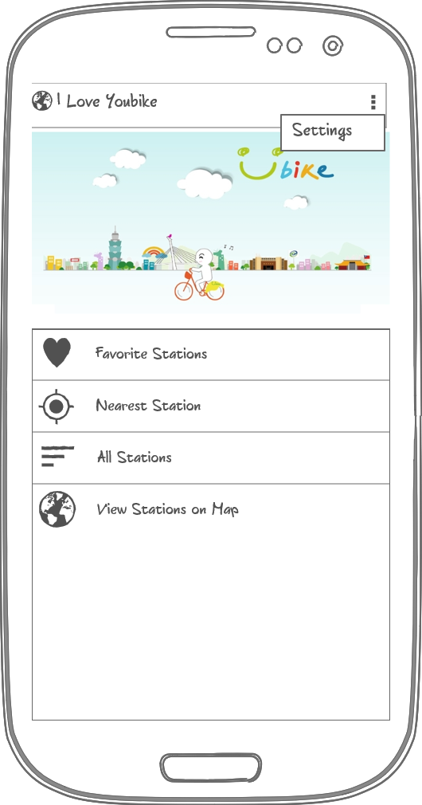

Provides list with items for favorite stations, nearest station by location, all stations, and view stations on map.  
Settings menu is available in the overflow menu to change languages

## Screen 2 – List of Stations / Favorite Stations

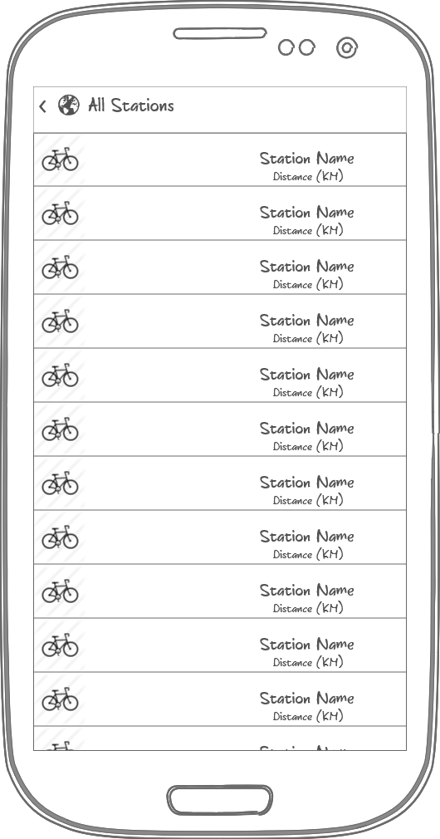

This screen provides a list of all stations in order of distance from user’s current location

Clicking on a list item will take the user to a station details screen

Icon will show a different color for status of station

* Green for bikes available
* Red for no bikes available
* Yellow for no spaces available to return bikes

This layout can be reused for the favorite stations screen

## Screen 3 – Map Screen

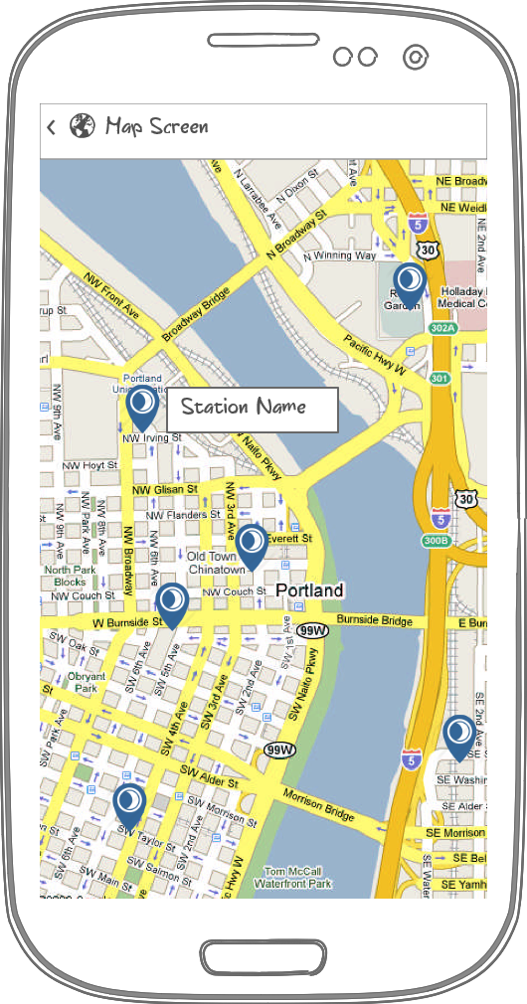

This screen shows a map with the user’s current location and Youbike stations

Icon will show a different color for status of station

* Green for bikes available
* Red for no bikes available
* Yellow for no spaces available to return bikes

## Screen 4 – Station Details Screen

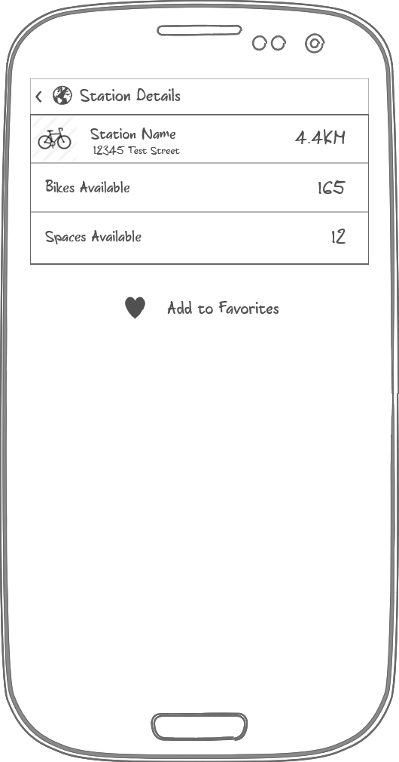

This screen contains details of the selected station

* Stations name, address, and distance from user
* Number of bikes available for rent
* Number of spaces available to return bikes
* Button to press to add station to list of favorites

# Key Considerations

### How will your app handle data persistence?

App data will be fetched from API and stored in an SQLite database. Sync will be handled by a sync adapter and content provider. An on demand refresh option will also be available as up to the moment data is needed.

### Describe any corner cases in the UX.

Rotation while viewing a station’s detail will cause the scroll position of the list of stations to be lost. Scroll position should be stored and restored on recreation of the list.

### Describe any libraries you’ll be using and share your reasoning for including them.

Appcompat library to ensure compatibility with as many versions of android as possible

Butterknife for reducing view boilerplate code

# Next Steps: Required Tasks

This is the section where you can take the main features of your app (declared above) and decompose them into tangible technical tasks that you can complete incrementally until you have a finished app.

## Task 1: Project Setup

Create a new Android project

Create four activities

* MainActivity
* StationListActivity
* StationDetailActivity
* StationMapActivity

Include needed libraries

* compile 'com.android.support:appcompat-v7:22.2.0'
* compile 'com.android.support:design:22.2.0'
* compile 'com.android.support:recyclerview-v7:22.2.0'
* compile 'com.google.android.gms:play-services:7.5.0'
* compile 'com.jakewharton:butterknife:6.1.0'

## Task 2: Implement UI for Each Activity and Fragment

Build UI for Main Activity

* Build UI for All Station List Activity/Favorite Stations List activity
* Build UI for Station Detail activity
* Build UI for View Stations on Map Activity

## Task 3: Implement Content Provider and Sync Adapter

Implement a database to store data retrieved from web API

* Create a database helper as well as a database contract to ensure data is entered into database correctly
* Create URIs for querying the databse. There will be two types of queries, a query for all stations and a query for specific stations based on a station ID number.

Implement a content provider and sync adapter to keep the database up to date

* Content provider need only be a stub since this app doesn’t share data with other apps
* Implement sync adapter to fetch data from web API and store in the database via content provider

## Task 4: Create All Stations activity

This activity will use a loader to query the database created by the sync adapter to return a list of all available stations. This activity can be reused as a favorite stations activity since the loader just needs to use a different query. The query parameter can be passed in as an extra with the intent.

* Implement RecyclerView to display data from the Loader
* Implement a RecyclerAdapter to fill the RecyclerView with data
* RecyclerView should implement an OnClickListener that calls through to the activity, passing back the clicked upon station’s ID
* Activity should then launch a Station Details activity with the selected station’s ID

## Task 5: Create Station Details Activity

This activity will display the details of a station selected from the All Stations List or Favorite Stations List

* Implement a loader to query the database based on station ID passed as an extra with the intent that launched the activity
* Display key data from query in TextViews

## Task 6: Create Settings Activity

The data from the web API contains values for each station’s details in Chinese and in English. As the data is returned from the web API it is not a string resource and thus not translatable and unaffected by the device’s language settings. This settings activity will allow the user to choose which language results from the query should display in. This is a useful feature as users may wish to display the station data in one language or the other, i.e. to show to a taxi driver or to a friend to ask for directions.

* Implement a settings activity to set the desired language
* When displaying data from a query, check the preference and fetch the correct string from the cursor returned by the query.

## Task 7: Create View Stations on Map Activity

The web API has data for each station’s coordinates. This activity will use that data to plot stations on a map along with the user’s current location

* Implement Google Maps API to add a map to the activity
* Implement Google Play Services in order to make use of device’s location

Add as many tasks as you need to complete your app.

**Submission Instructions**

1. After you’ve completed all the sections, download this document as a PDF [ File → Download as PDF ]
2. Create a new GitHub repo for the capstone. Name it “**Capstone Project**”
3. Add this document to your repo. Make sure it’s named “**Capstone_Stage1.pdf**”