LABORATORY RECORD
CSE1021 INTRODUCTION TO PROBLEM SOLVING AND PROGRAMMING

Student Name- Rajesh Paine
Student Regn. No:- 26BCE10453
Fall Semester- 2026-27
Year-1st
Batch- 2026-2030
Class ID: BL2026270100744
Slot: B11+B12+B13+C14+E11+E12
Class Room- AB02-217

Faculty Name- Dr. RUDRA KALYAN NAYAK
School of Computing Science Engineering and Artificial Intelligence
VIT Bhopal University



Sl No | Date | Experiment Name | Total (50M)  (Evaluation Metric: Logic, Execution, Result) | Remark
1. | AUG 24, 25 | PROBLEM SOLVING: Drawing flowchart  Using yED tool/Raptor tool
1.1 |  | Student Grade Analyzer – Input marks of 5 subjects, calculate total and percentage, and display the grade (A/B/C/D/F). Also display whether the student has passed or failed
1.2 |  | Electricity Bill Calculator – Calculate an electricity bill using slab rates: first100 units at ₹2/unit, next 200 at ₹3/unit, next 300 at ₹5/unit, and above 600 at ₹7/unit. Add a fixed charge of ₹100
1.3 |  | ATM Withdrawal System – Input account balance and withdrawal amount. Check whether the amount is valid, whether sufficient balance exists, and whether the amount is a multiple of ₹100. Display the updated balance
1.4 |  | Prime Number Analyzer – Input a positive integer and determine whether it is prime. If prime, display it; otherwise, display all its factor
1.5 |  | Number Statistics – Input N integers and determine the largest number, smallest number, average, number of positive numbers, and number of negative numbers
1.6 |  | Digital Number Reversal – Input an integer and reverse its digits. Also determine whether the original number is a palindrome
1.7 |  | Menu-Driven Calculator – Display a menu for addition, subtraction, multiplication, division, and modulus. Accept the user's choice and two numbers, perform the selected operation, and handle division by zero
1.8 |  | Fibonacci Series with Analysis – Input N and generate the first N Fibonacci numbers. Also calculate their sum and count how many generated numbers are even
1.9 |  | Student Attendance Eligibility – Input the total number of classes and classes attended. Calculate attendance percentage and determine whether the student is eligible for the examination (≥75%). If attendance is below 75%, calculate the minimum additional classes required to reach 75%
1.10 |  | Automated Shopping Bill – Input the price and quantity of multiple products until the user chooses to stop. Calculate the subtotal, apply discounts based on the total amount, add 5% tax, and display the final bill
2. | AUG 27 | Basic programs in Python: Input and output operations
3. | SEPT 1, 2 | Programs using basic commands and simple conditional statements
4. | SEPT 3, 15 | Programs using conditional statements and looping
5. | SEPT 16, 17 | Programs on methods and functions
6. | SEPT 18,21 | Programs using conditional statements, looping, and Functions
7. | SEPT 22, 23 | Programs using Factoring methods
8.0. | SEPT 24, 28 | Programs using Array Technique
8.1. | SEPT 29, 30 | Programs showing List operations
8.2. | OCT 9, 10 | Programs showing tuple operations
8.3. | OCT 12, 13 | Programs showing set operations
8.4. | OCT 14, 15 | Programs showing dictionary operations
9. |  | Practice Programs-List, Tuple, Set, Dictionary, Operator Precedence

School of Computing Science Engineering
…………………………………………………….. DIVISION
COURSE CODE: CSE1021
COURSE NAME: INTRODUCTION TO PROBLEM SOLVING AND PROGRAMMING

LAB-1: PROBLEM SOLVING: Drawing flowchart

Using yED tool/Raptor tool

Date of the Session: 24 / 08/ 2026, 25/8/2026

1.1 LABORATORY TASK: Student Grade Analyzer – Input marks of 5 subjects, calculate total and percentage, and display the grade (A/B/C/D/F). Also display whether the student has passed or failed

Solution (Hand written Executable Code and Output Screen):
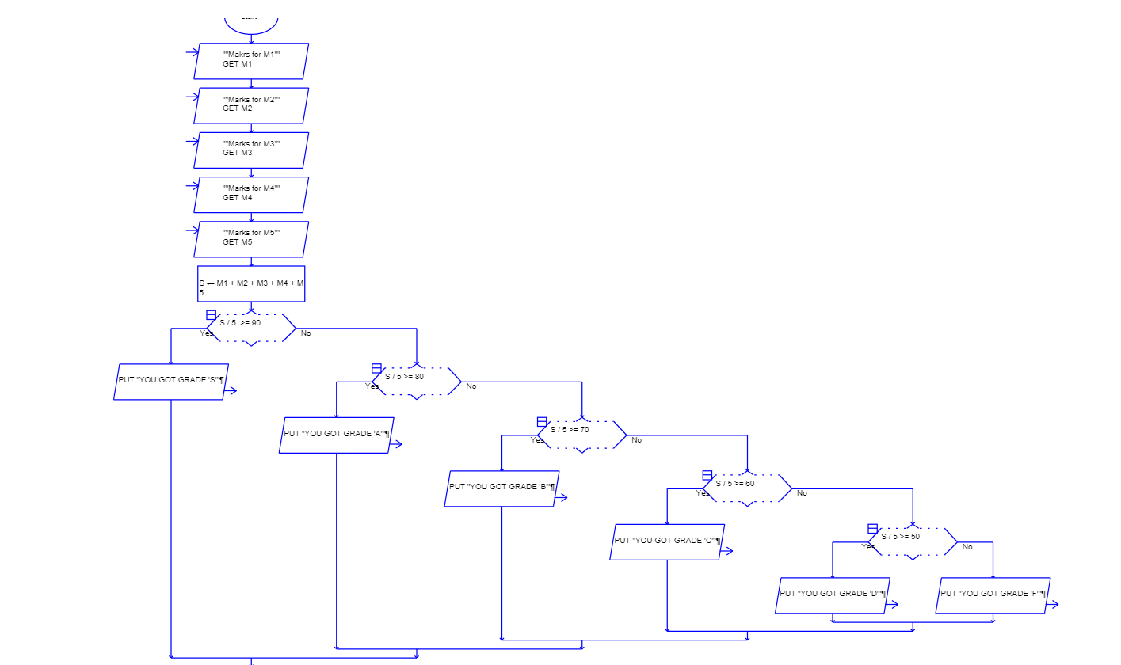

………………

1.2 LABORATORY TASK: Electricity Bill Calculator – Calculate an electricity bill using slab rates: first100 units at ₹2/unit, next 200 at ₹3/unit, next 300 at ₹5/unit, and above 600 at₹7/unit. Add a fixed charge of ₹100

Solution (Hand written Executable Code and Output Screen):

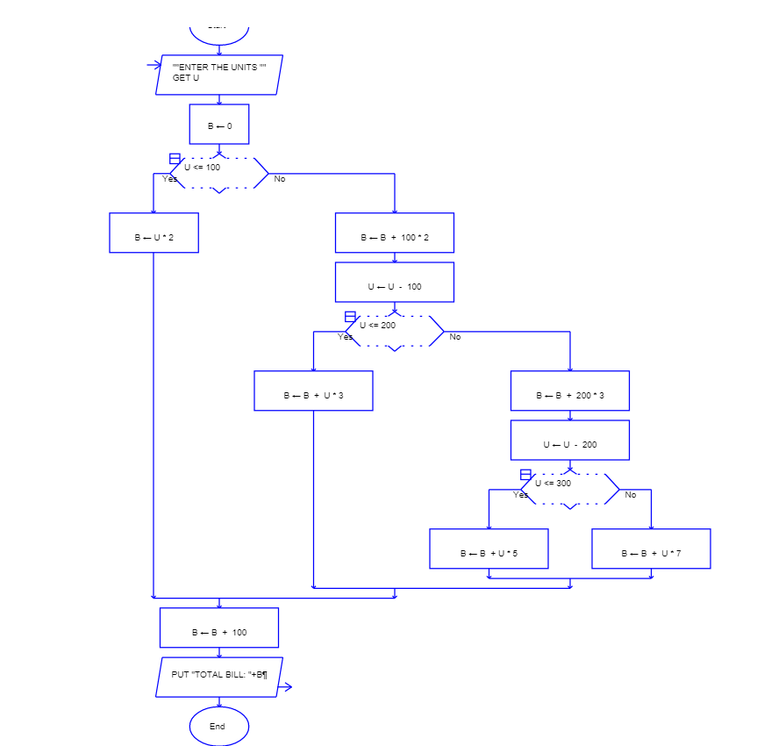

………………

1.3 LABORATORY TASK: ATM Withdrawal System – Input account balance and withdrawal amount.Check whether the amount is valid, whether sufficient balance exists, and whether the amount is a multiple of ₹100. Display the updated balance

Solution (Hand written Executable Code and Output Screen):

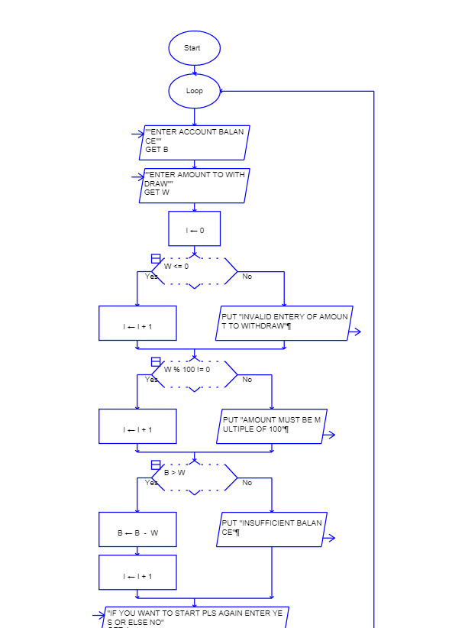
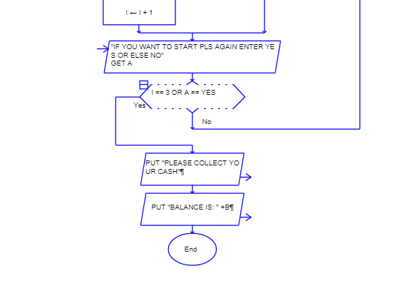

………………

1.4 LABORATORY TASK: Prime Number Analyzer – Input a positive integer and determine whether it is prime. If prime, display it; otherwise, display all its factors.

Solution (Hand written Executable Code and Output Screen):
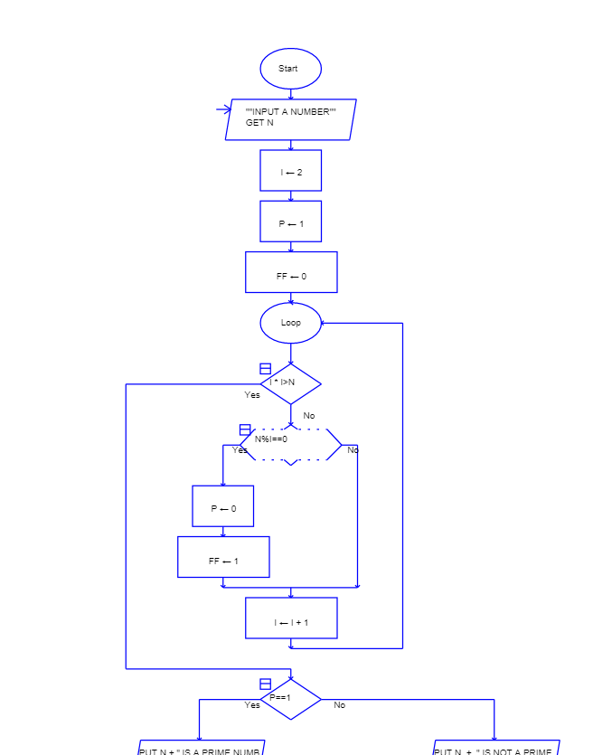
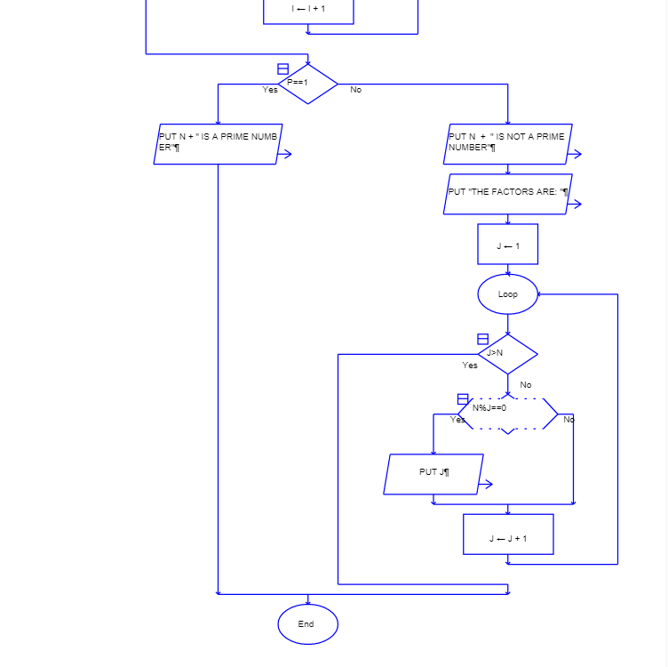

………………
1.5 LABORATORY TASK: Number Statistics – Input N integers and determine the largest number, smallest number, average, number of positive numbers, and number of negative numbers.

Solution (Hand written Executable Code and Output Screen):

………………
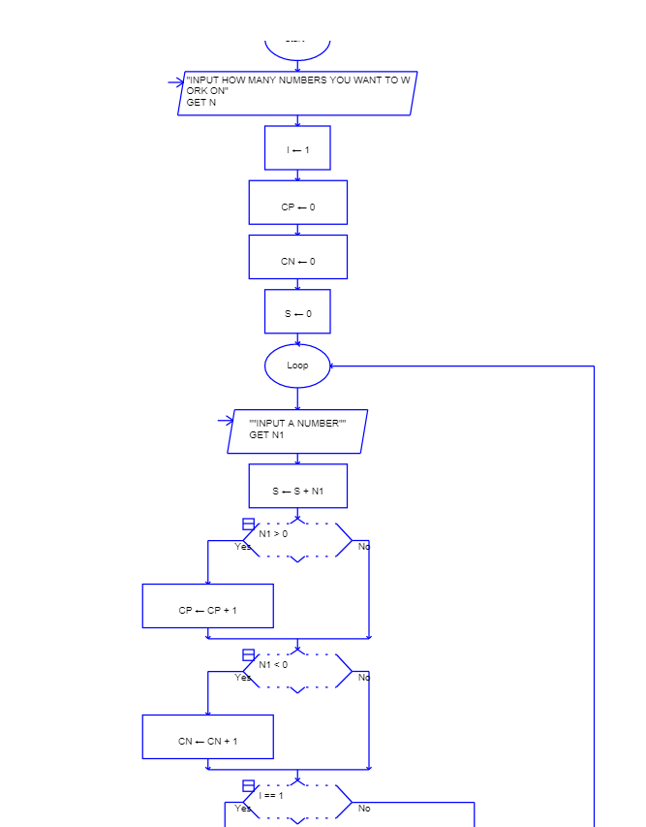
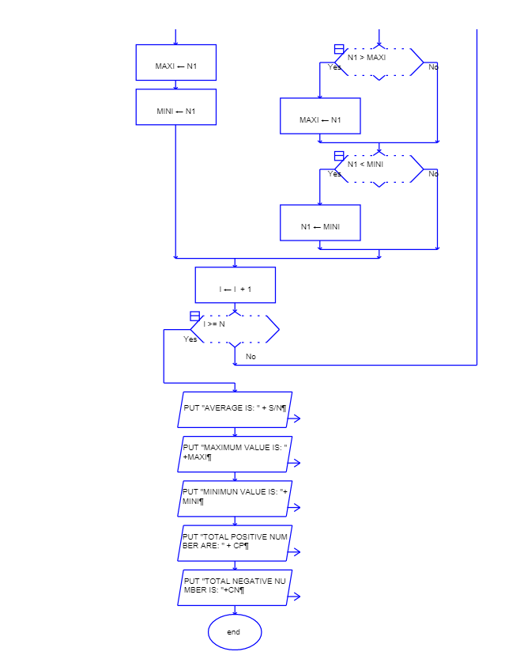
1.6 LABORATORY TASK: Digital Number Reversal – Input an integer and reverse its digits. Also determine whether the original number is a palindrome.

Solution (Hand written Executable Code and Output Screen):
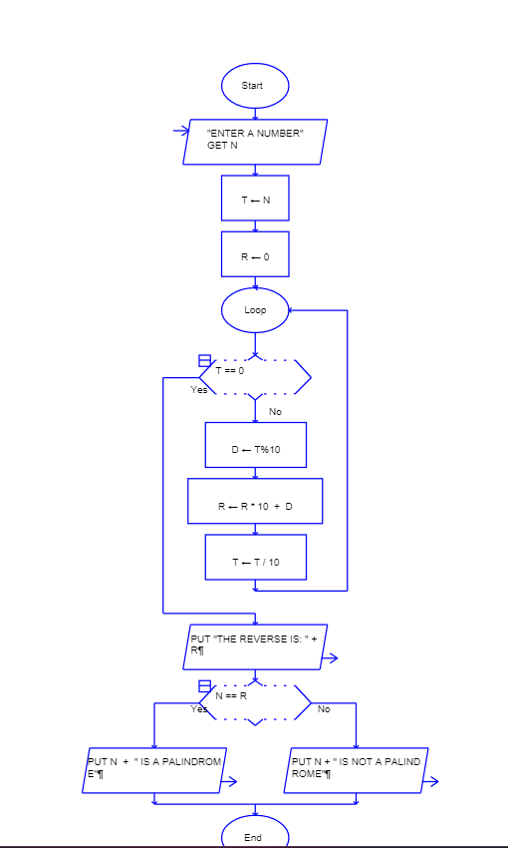

………………
1.7 LABORATORY TASK: Menu-Driven Calculator – Display a menu for addition, subtraction,multiplication, division, and modulus. Accept the user's choice and two numbers, perform the selected operation, and handle division by zero.

Solution (Hand written Executable Code and Output Screen):
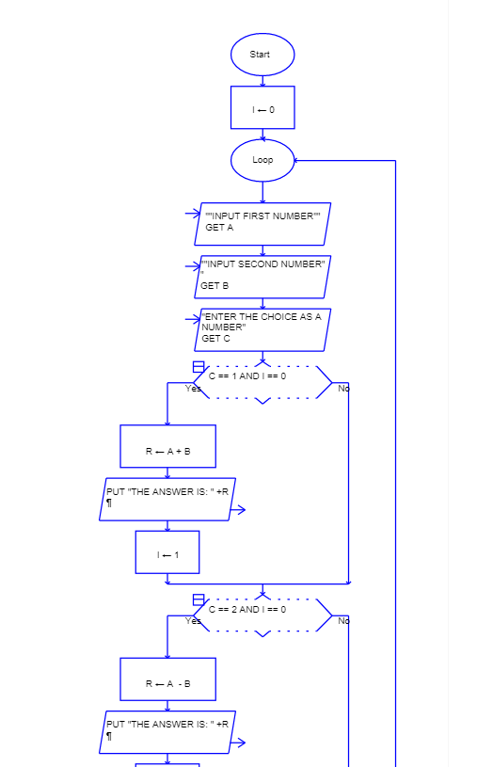
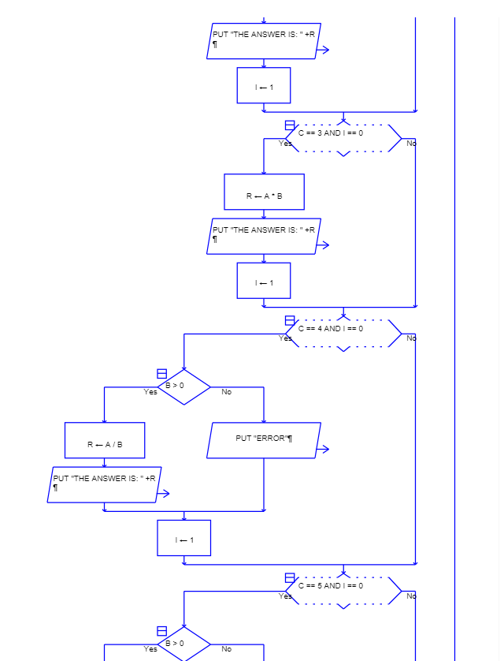
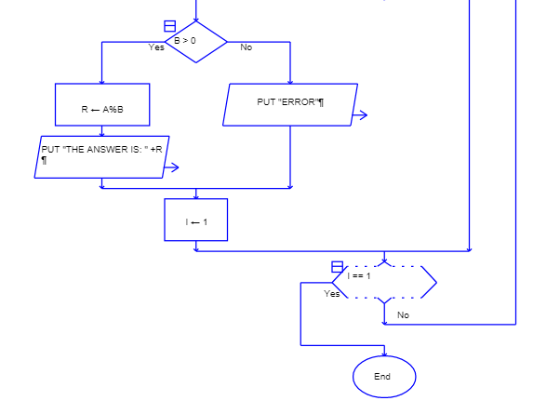

………………
1.8 LABORATORY TASK: Fibonacci Series with Analysis – Input N and generate the first N Fibonacci numbers. Also calculate their sum and count how many generated numbers are even.

Solution (Hand written Executable Code and Output Screen):
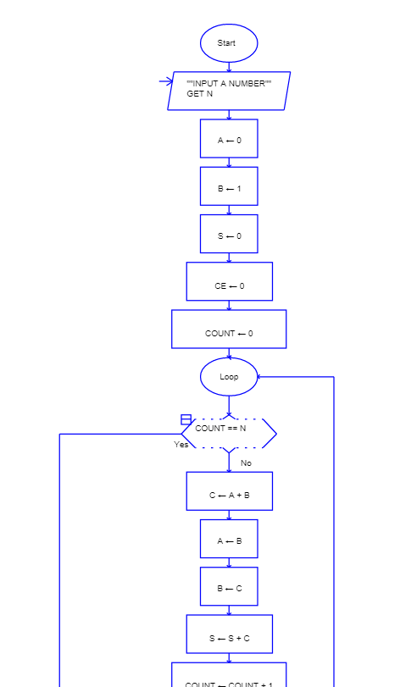
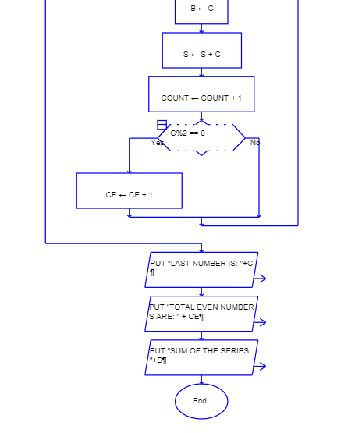

………………

1.9 LABORATORY TASK: Student Attendance Eligibility – Input the total number of classes and classes attended. Calculate attendance percentage and determine whether the student is eligible for the examination (≥75%). If attendance is below 75%, calculate the minimum additional classes required to reach 75%.

Solution (Hand written Executable Code and Output Screen):
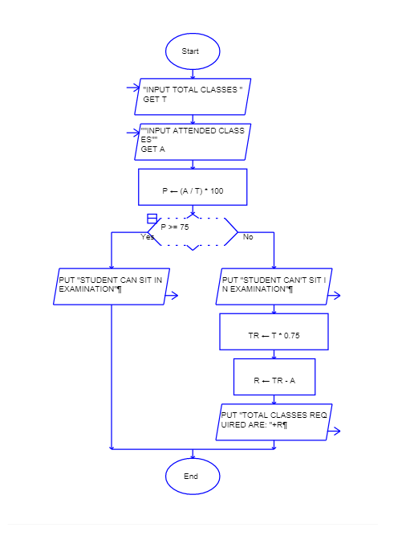

………………

1.10 LABORATORY TASK: Automated Shopping Bill – Input the price and quantity of multiple products until the user chooses to stop. Calculate the subtotal, apply discounts based on the total amount, add 5% tax, and display the final bill

Solution (Hand written Executable Code and Output Screen):
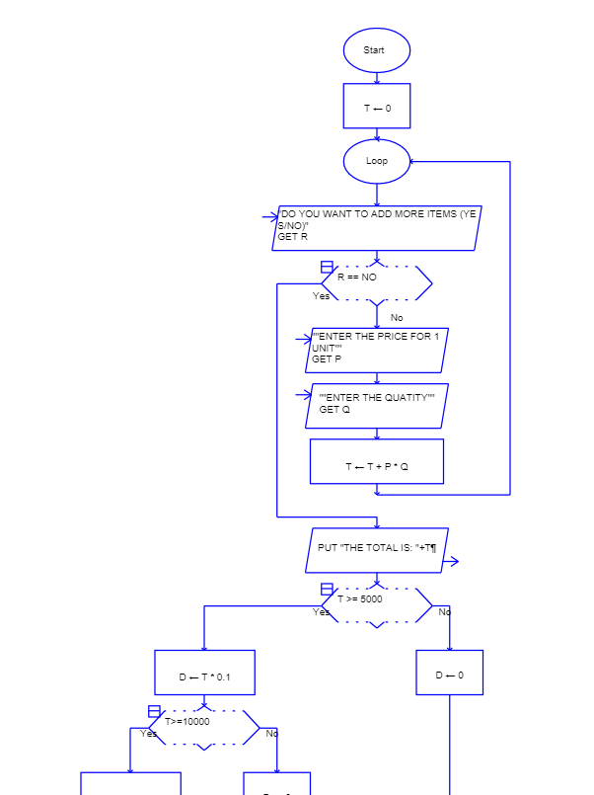
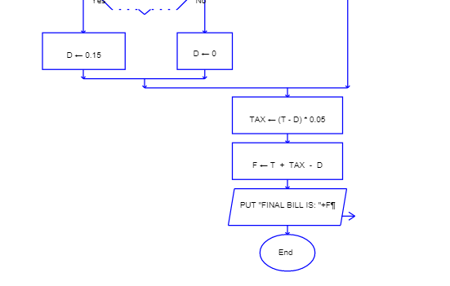

………………

School of Computing Science Engineering
…………………………………………………….. DIVISION
COURSE CODE: CSE1021
COURSE NAME: INTRODUCTION TO PROBLEM SOLVING AND PROGRAMMING

LAB-2: Basic programs in Python : Input and output Operations

Date of the Session: 27/08/2026

LABORATORY TASK:

2.1: To write a Python program to take two numbers as input and display their sum

Solution (Hand written Executable Code and Output Screen):

a = int(input("Enter first number: "))
b = int(input("Enter second number: "))
sum = a + b
print("Sum =", sum)

Output:
Enter first number: 10
Enter second number: 20
Sum = 30
………………

2.2: Display a Message

Solution (Hand written Executable Code and Output Screen):

print("Hello, World!")

Output:

Hello, World!

2.3: Accept and Display a Name

Solution (Hand written Executable Code and Output Screen):

name = input("Enter your name: ")
print("Hello,", name)

Output:

Enter your name: Rahul
Hello, Rahul

2.4: Calculate the Area of a Rectangle

Solution (Hand written Executable Code and Output Screen):

length = float(input("Enter length: "))
breadth = float(input("Enter breadth: "))

area = length * breadth
print("Area of rectangle =", area)

Output:

Enter length: 10
Enter breadth: 5
Area of rectangle = 50.0

2.5: Calculate Simple Interest

Solution (Hand written Executable Code and Output Screen):

p = float(input("Enter principal amount: "))
r = float(input("Enter rate of interest: "))
t = float(input("Enter time in years: "))

si = (p * r * t) / 100
print("Simple Interest =", si)

Output:

Enter principal amount: 5000
Enter rate of interest: 5
Enter time in years: 2
Simple Interest = 500.0

2.6: Calculate the Average of Three Numbers

Solution (Hand written Executable Code and Output Screen):

a = float(input("Enter first number: "))
b = float(input("Enter second number: "))
c = float(input("Enter third number: "))

average = (a + b + c) / 3
print("Average =", average)

Output:

Enter first number: 10
Enter second number: 20
Enter third number: 30
Average = 20.0

2.7: Convert Celsius to Fahrenheit

Solution (Hand written Executable Code and Output Screen):

celsius = float(input("Enter temperature in Celsius: "))

fahrenheit = (celsius * 9 / 5) + 32
print("Temperature in Fahrenheit =", fahrenheit)

Output:

Enter temperature in Celsius: 25
Temperature in Fahrenheit = 77.0

2.8: Calculate the Circumference of a Circle

Solution (Hand written Executable Code and Output Screen):

radius = float(input("Enter radius: "))

circumference = 2 * 3.14159 * radius
print("Circumference of circle =", circumference)

Output:

Enter radius: 7
Circumference of circle = 43.98226

2.9: Display Student Details

Solution (Hand written Executable Code and Output Screen):

name = input("Enter student name: ")
roll = input("Enter roll number: ")
age = int(input("Enter age: "))
marks = float(input("Enter marks: "))

print("\nStudent Details")
print("Name:", name)
print("Roll Number:", roll)
print("Age:", age)
print("Marks:", marks)

Output:

Enter student name: Rahul
Enter roll number: 101
Enter age: 18
Enter marks: 85.5

Student Details
Name: Rahul
Roll Number: 101
Age: 18
Marks: 85.5

2.10: Calculate the Total and Percentage of Five Subjects

Solution (Hand written Executable Code and Output Screen):

marks1 = float(input("Enter marks in English: "))
marks2 = float(input("Enter marks in Mathematics: "))
marks3 = float(input("Enter marks in Physics: "))
marks4 = float(input("Enter marks in Chemistry: "))
marks5 = float(input("Enter marks in Computer Science: "))

total = marks1 + marks2 + marks3 + marks4 + marks5
percentage = total / 5

print("Total Marks =", total)
print("Percentage =", percentage)

Output:

Enter marks in English: 80
Enter marks in Mathematics: 90
Enter marks in Physics: 85
Enter marks in Chemistry: 75
Enter marks in Computer Science: 95

Total Marks = 425.0
Percentage = 85.0

School of Computing Science Engineering
…………………………………………………….. DIVISION
COURSE CODE: CSE1021
COURSE NAME: INTRODUCTION TO PROBLEM SOLVING AND PROGRAMMING

LAB-3: Programs using basic commands and simple conditional statements

Date of the Session: 01/09/2026,
02/09/2026

LABORATORY TASK:
3.1: To write a Python program using basic commands and simple conditional statements to check whether a number is even or odd.

Solution (Hand written Executable Code and Output Screen):

num = int(input("Enter a number: "))

if num % 2 == 0:
print("The number is even")
else:
print("The number is odd")

Output:
Enter a number: 10
The number is even
………………

3.2: Check Whether a Number is Positive or Negative

Solution (Hand written Executable Code and Output Screen):

num = int(input("Enter a number: "))

if num >= 0:
print("The number is positive.")
else:
print("The number is negative.")

Output:

Enter a number: 25
The number is positive.

3.3: Find the Greater of Two Numbers

Solution (Hand written Executable Code and Output Screen):

a = int(input("Enter first number: "))
b = int(input("Enter second number: "))

if a > b:
print("First number is greater.")
else:
print("Second number is greater.")

Output:

Enter first number: 25
Enter second number: 18
First number is greater.

3.4: Check Voting Eligibility

Solution (Hand written Executable Code and Output Screen):

age = int(input("Enter your age: "))

if age >= 18:
print("You are eligible to vote.")
else:
print("You are not eligible to vote.")

Output:

Enter your age: 20
You are eligible to vote.

3.5: Check Whether a Number is Divisible by 5

Solution (Hand written Executable Code and Output Screen):

num = int(input("Enter a number: "))

if num % 5 == 0:
print("The number is divisible by 5.")
else:
print("The number is not divisible by 5.")

Output:

Enter a number: 35
The number is divisible by 5.

3.6: Find the Largest of Three Numbers

Solution (Hand written Executable Code and Output Screen):

a = int(input("Enter first number: "))
b = int(input("Enter second number: "))
c = int(input("Enter third number: "))

if a >= b and a >= c:
print("First number is largest.")
elif b >= a and b >= c:
print("Second number is largest.")
else:
print("Third number is largest.")

Output:
Enter first number: 15
Enter second number: 28
Enter third number: 20
Second number is largest.

3.7: Check Pass or Fail

Solution (Hand written Executable Code and Output Screen):

marks = float(input("Enter your marks: "))

if marks >= 40:
print("You have passed.")
else:
print("You have failed.")

Output:

Enter your marks: 67
You have passed.

3.8: Check Whether a Year is a Leap Year
Solution (Hand written Executable Code and Output Screen):

year = int(input("Enter a year: "))

if year % 4 == 0:
print("It is a leap year.")
else:
print("It is not a leap year.")

Output:

Enter a year: 2028
It is a leap year.
3.9: Calculate Grade Based on Marks

Solution (Hand written Executable Code and Output Screen):

marks = float(input("Enter your marks: "))

if marks >= 90:
print("Grade A")
elif marks >= 75:
print("Grade B")
elif marks >= 60:
print("Grade C")
elif marks >= 40:
print("Grade D")
else:
print("Grade F")

Output:

Enter your marks: 82
Grade B

3.10: Check Whether a Number is a Multiple of 3 and 5

Solution (Hand written Executable Code and Output Screen):

num = int(input("Enter a number: "))

if num % 3 == 0 and num % 5 == 0:
print("The number is a multiple of both 3 and 5.")
else:
print("The number is not a multiple of both 3 and 5.")

Output:

Enter a number: 30
The number is a multiple of both 3 and 5.

School of Computing Science Engineering …………………………………………………….. DIVISION
COURSE CODE: CSE1021
COURSE NAME: INTRODUCTION TO PROBLEM SOLVING AND PROGRAMMING

LAB-4: Programs using conditional statements and looping

Date of the Session: 03/09/2026,
15/09/2026

LABORATORY TASK:

4.1: To write a Python program using conditional statements and looping to print even numbers from 1 to 10.

Solution (Hand written Executable Code and Output Screen):

for i in range(1, 11):
if i % 2 == 0:
print(i)

Output:
2
4
6
8
10

………………

4.2: Check Even and Odd Numbers

Solution (Hand written Executable Code and Output Screen):

n = int(input("Enter the limit: "))

for i in range(1, n + 1):
if i % 2 == 0:
print(i, "is Even")
else:
print(i, "is Odd")

Output:

Enter the limit: 5
1 is Odd
2 is Even
3 is Odd
4 is Even
5 is Odd

4.3: Print Positive and Negative Numbers

Solution (Hand written Executable Code and Output Screen):

numbers = [10, -5, 8, -2, 0]

for n in numbers:
if n > 0:
print(n, "is Positive")
elif n < 0:
print(n, "is Negative")
else:
print(n, "is Zero")

Output:

10 is Positive
-5 is Negative
8 is Positive
-2 is Negative
0 is Zero

4.4: Find the Largest Number

Solution (Hand written Executable Code and Output Screen):

numbers = [12, 45, 23, 67, 34]
largest = numbers[0]

for n in numbers:
if n > largest:
largest = n

print("Largest number:", largest)

Output:

Largest number: 67

4.5: Print Multiplication Table

Solution (Hand written Executable Code and Output Screen):

n = int(input("Enter a number: "))

for i in range(1, 11):
result = n * i

if result % 2 == 0:
print(n, "x", i, "=", result, "(Even)")
else:
print(n, "x", i, "=", result, "(Odd)")

Output:

Enter a number: 5
5 x 1 = 5 (Odd)
5 x 2 = 10 (Even)
5 x 3 = 15 (Odd)
5 x 4 = 20 (Even)
5 x 5 = 25 (Odd)
5 x 6 = 30 (Even)
5 x 7 = 35 (Odd)
5 x 8 = 40 (Even)
5 x 9 = 45 (Odd)
5 x 10 = 50 (Even)

4.6: Count Even and Odd Numbers

Solution (Hand written Executable Code and Output Screen):

numbers = [1, 2, 3, 4, 5, 6, 7, 8]
even = 0
odd = 0

for n in numbers:
if n % 2 == 0:
even += 1
else:
odd += 1

print("Even numbers:", even)
print("Odd numbers:", odd)

Output:

Even numbers: 4
Odd numbers: 4

4.7: Check Prime Numbers

Solution (Hand written Executable Code and Output Screen):

n = int(input("Enter a number: "))
prime = True

if n < 2:
prime = False
else:
for i in range(2, n):
if n % i == 0:
prime = False
break

if prime:
print(n, "is a Prime number")
else:
print(n, "is not a Prime number")

Output:

Enter a number: 17
17 is a Prime number

4.8: Sum of Numbers Divisible by 3

Solution (Hand written Executable Code and Output Screen):

n = int(input("Enter the limit: "))
total = 0

for i in range(1, n + 1):
if i % 3 == 0:
total += i

print("Sum of numbers divisible by 3:", total)

Output:

Enter the limit: 10
Sum of numbers divisible by 3: 18

4.9: Student Grade Calculator

Solution (Hand written Executable Code and Output Screen):

marks = [85, 72, 58, 42, 30]

for mark in marks:
if mark >= 80:
grade = "A"
elif mark >= 60:
grade = "B"
elif mark >= 40:
grade = "C"
else:
grade = "Fail"

print(mark, "->", grade)

Output:

85 -> A
72 -> B
58 -> C
42 -> C
30 -> Fail

4.10: Print Numbers and Skip Multiples of 5:
Solution (Hand written Executable Code and Output Screen):

for i in range(1, 21):
if i % 5 == 0:
continue
else:
print(i)

Output:

1
2
3
4
6
7
8
9
11
12
13
14
16
17
18
19

School of Computing Science Engineering
…………………………………………………….. DIVISION
COURSE CODE: CSE1021
COURSE NAME: INTRODUCTION TO PROBLEM SOLVING AND PROGRAMMING

LAB-5: Programs on methods, and Functions

Date of the Session: 16/09/2026,
17/09/2026

LABORATORY TASK:

5.1: To write a Python program using a function to find the square of a number.

Solution (Hand written Executable Code and Output Screen):

def square(num):
return num * num

n = int(input("Enter a number: "))

result = square(n)

print("Square =", result)

Output:
Enter a number: 5
Square = 25

………………

5.2: Function to Add Two Numbers

Solution (Hand written Executable Code and Output Screen):

def add(a, b):
return a + b

x = int(input("Enter first number: "))
y = int(input("Enter second number: "))

print("Sum =", add(x, y))
Output:
Enter first number: 10
Enter second number: 20
Sum = 30

5.3: Function to Check Even or Odd

Solution (Hand written Executable Code and Output Screen):

def check_even_odd(n):
if n % 2 == 0:
return "Even"
else:
return "Odd"

num = int(input("Enter a number: "))
print("The number is", check_even_odd(num))
Output:
Enter a number: 15
The number is Odd

5.4: Function to Find the Largest of Three Numbers

Solution (Hand written Executable Code and Output Screen):

def largest(a, b, c):
return max(a, b, c)

x = int(input("Enter first number: "))
y = int(input("Enter second number: "))
z = int(input("Enter third number: "))

print("Largest =", largest(x, y, z))
Output:
Enter first number: 25
Enter second number: 42
Enter third number: 18
Largest = 42

5.5. Function to Calculate Factorial

Solution (Hand written Executable Code and Output Screen):

def factorial(n):
fact = 1
for i in range(1, n + 1):
fact = fact * i
return fact

num = int(input("Enter a number: "))
print("Factorial =", factorial(num))
Output:
Enter a number: 5
Factorial = 120

5.6 Function to Check Prime Number
def is_prime(n):
if n < 2:
return False

for i in range(2, n):
if n % i == 0:
return False

return True

num = int(input("Enter a number: "))

if is_prime(num):
print("Prime number")
else:
print("Not a prime number")
Output:
Enter a number: 17
Prime number

5.7: Function to Reverse a String

Solution (Hand written Executable Code and Output Screen):

def reverse_string(text):
return text[::-1]

word = input("Enter a string: ")
print("Reversed string =", reverse_string(word))
Output:
Enter a string: Python
Reversed string = nohtyP

5.8: Using String Methods

Solution (Hand written Executable Code and Output Screen):

text = input("Enter a string: ")

print("Uppercase:", text.upper())
print("Lowercase:", text.lower())
print("Length:", len(text))
Output:
Enter a string: Hello Python
Uppercase: HELLO PYTHON
Lowercase: hello python
Length: 12

5.9: Using List Methods

Solution (Hand written Executable Code and Output Screen):

numbers = [10, 20, 30, 40]

print("Original list:", numbers)

numbers.append(50)
print("After append:", numbers)

numbers.remove(20)
print("After remove:", numbers)

numbers.sort()
print("After sort:", numbers)
Output:
Original list: [10, 20, 30, 40]
After append: [10, 20, 30, 40, 50]
After remove: [10, 30, 40, 50]
After sort: [10, 30, 40, 50]

5.10: Function to Calculate the Average of Numbers

Solution (Hand written Executable Code and Output Screen):

def average(numbers):
return sum(numbers) / len(numbers)

marks = [80, 75, 90, 85, 70]

print("Marks:", marks)
print("Average =", average(marks))
Output:
Marks: [80, 75, 90, 85, 70]
Average = 80.0

School of Computing Science Engineering
…………………………………………………….. DIVISION
COURSE CODE: CSE1021
COURSE NAME: INTRODUCTION TO PROBLEM SOLVING AND PROGRAMMING

LAB-6: Programs using conditional statements, looping, and Functions

Date of the Session: 18/09/2026,
21/09/2026

LABORATORY TASK:

6.1: To write a Python program using conditional statements, looping, and functions to check whether a number is prime or not.

Solution (Hand written Executable Code and Output Screen):

def check_prime(n):
if n <= 1:
return False

for i in range(2, n):
if n % i == 0:
return False

return True

num = int(input("Enter a number: "))

if check_prime(num):
print("The number is prime")
else:
print("The number is not prime")

Output:
Enter a number: 8
The number is not prime

………………

6.2: Check Whether a Number is Even or Odd

Solution (Hand written Executable Code and Output Screen):

def check_even_odd(n):
if n % 2 == 0:
return "Even"
else:
return "Odd"

num = int(input("Enter a number: "))
print("The number is", check_even_odd(num))
Output:
Enter a number: 15
The number is Odd

6.3: Find the Largest of Three Numbers

Solution (Hand written Executable Code and Output Screen):

def largest(a, b, c):
if a >= b and a >= c:
return a
elif b >= a and b >= c:
return b
else:
return c

a = int(input("Enter first number: "))
b = int(input("Enter second number: "))
c = int(input("Enter third number: "))

print("Largest number:", largest(a, b, c))
Output:
Enter first number: 25
Enter second number: 48
Enter third number: 32
Largest number: 48

6.4: Print Multiplication Table

Solution (Hand written Executable Code and Output Screen):

def multiplication_table(n):
for i in range(1, 11):
print(n, "x", i, "=", n * i)

num = int(input("Enter a number: "))
multiplication_table(num)
Output:
Enter a number: 5
5 x 1 = 5
5 x 2 = 10
5 x 3 = 15
5 x 4 = 20
5 x 5 = 25
5 x 6 = 30
5 x 7 = 35
5 x 8 = 40
5 x 9 = 45
5 x 10 = 50

6.5: Check Whether a Number is Prime

Solution (Hand written Executable Code and Output Screen):
def check_prime(n):
if n < 2:
return False

for i in range(2, n):
if n % i == 0:
return False

return True

num = int(input("Enter a number: "))

if check_prime(num):
print(num, "is a prime number.")
else:
print(num, "is not a prime number.")
Output:
Enter a number: 17
17 is a prime number.

6.6: Find the Factorial of a Number

Solution (Hand written Executable Code and Output Screen):

def factorial(n):
result = 1

for i in range(1, n + 1):
result = result * i

return result

num = int(input("Enter a number: "))

if num < 0:
print("Factorial is not possible for negative numbers.")
else:
print("Factorial:", factorial(num))
Output:
Enter a number: 5
Factorial: 120

6.7: Print Fibonacci Series

Solution (Hand written Executable Code and Output Screen):

def fibonacci(n):
a = 0
b = 1

for i in range(n):
print(a, end=" ")
a, b = b, a + b

n = int(input("Enter the number of terms: "))

if n <= 0:
print("Enter a positive number.")
else:
fibonacci(n)
Output:
Enter the number of terms: 8
0 1 1 2 3 5 8 13

6.8: Calculate Sum of Natural Numbers

Solution (Hand written Executable Code and Output Screen):

def sum_natural(n):
total = 0

for i in range(1, n + 1):
total += i

return total

n = int(input("Enter a number: "))

if n > 0:
print("Sum:", sum_natural(n))
else:
print("Please enter a positive number.")
Output:
Enter a number: 10
Sum: 55

6.9: Check Whether a Number is a Palindrome

Solution (Hand written Executable Code and Output Screen):

def is_palindrome(n):
original = n
reverse = 0

while n > 0:
digit = n % 10
reverse = reverse * 10 + digit
n = n // 10

return original == reverse

num = int(input("Enter a number: "))

if is_palindrome(num):
print(num, "is a palindrome.")
else:
print(num, "is not a palindrome.")
Output:
Enter a number: 121
121 is a palindrome.

6.10: Calculate Grade Using Marks

Solution (Hand written Executable Code and Output Screen):

def calculate_grade(marks):
if marks >= 90:
return "A"
elif marks >= 80:
return "B"
elif marks >= 70:
return "C"
elif marks >= 60:
return "D"
else:
return "F"

for i in range(1, 4):
marks = int(input("Enter marks for student " + str(i) + ": "))

if 0 <= marks <= 100:
print("Grade:", calculate_grade(marks))
else:
print("Invalid marks")
Output:
Enter marks for student 1: 95
Grade: A
Enter marks for student 2: 76
Grade: C
Enter marks for student 3: 58
Grade: F

School of Computing Science Engineering
…………………………………………………….. DIVISION
COURSE CODE: CSE1021
COURSE NAME: INTRODUCTION TO PROBLEM SOLVING AND PROGRAMMING

LAB-7.0: Programs using Factoring methods

Date of the Session: 22/09/2026,
23/09/2026

LABORATORY TASK:.

7.1: Find all factors of a number

Solution (Hand written Executable Code and Output Screen):

n = int(input("Enter a number: "))

print("Factors of", n, "are:")
for i in range(1, n + 1):
if n % i == 0:
print(i, end=" ")
Output:
Enter a number: 12
Factors of 12 are:
1 2 3 4 6 12

7.2: Count the total number of factors

Solution (Hand written Executable Code and Output Screen):

n = int(input("Enter a number: "))
count = 0

for i in range(1, n + 1):
if n % i == 0:
count += 1

print("Total number of factors:", count)
Output:
Enter a number: 18
Total number of factors: 6

7.3: Find the sum of all factors

Solution (Hand written Executable Code and Output Screen):
n = int(input("Enter a number: "))
total = 0

for i in range(1, n + 1):
if n % i == 0:
total += i

print("Sum of factors:", total)
Output:
Enter a number: 10
Sum of factors: 18

7.4: Check whether a number is prime
A prime number has exactly two factors: 1 and itself.
Solution (Hand written Executable Code and Output Screen):

n = int(input("Enter a number: "))
count = 0

for i in range(1, n + 1):
if n % i == 0:
count += 1

if n > 1 and count == 2:
print(n, "is a prime number")
else:
print(n, "is not a prime number")

Output:
Enter a number: 13
13 is a prime number

7.5: Check whether a number is a perfect number
A perfect number equals the sum of its proper factors, excluding itself.
Solution (Hand written Executable Code and Output Screen):

n = int(input("Enter a number: "))
total = 0

for i in range(1, n):
if n % i == 0:
total += i

if n > 1 and total == n:
print(n, "is a perfect number")
else:
print(n, "is not a perfect number")

Output:
Enter a number: 28
28 is a perfect number

7.6: Find the prime factors of a number

Solution (Hand written Executable Code and Output Screen):

n = int(input("Enter a number: "))
i = 2

print("Prime factors are:")

while n > 1:
if n % i == 0:
print(i, end=" ")
n = n // i
else:
i += 1
Output:
Enter a number: 60
Prime factors are:
2 2 3 5

7.7: Find the greatest common divisor (GCD)
The GCD is the largest number that divides both numbers exactly.
Solution (Hand written Executable Code and Output Screen):

a = int(input("Enter first number: "))
b = int(input("Enter second number: "))

gcd = 1

for i in range(1, min(a, b) + 1):
if a % i == 0 and b % i == 0:
gcd = i

print("GCD:", gcd)
Output:
Enter first number: 24
Enter second number: 36
GCD: 12

7.8: Find the least common multiple (LCM)
The LCM is the smallest positive number divisible by both numbers.
Solution (Hand written Executable Code and Output Screen):

a = int(input("Enter first number: "))
b = int(input("Enter second number: "))

i = max(a, b)

while True:
if i % a == 0 and i % b == 0:
print("LCM:", i)
break
i += 1

Output:
Enter first number: 4
Enter second number: 6
LCM: 12

7.9: Find factor pairs of a number
Factor pairs are pairs of numbers whose product equals the given number.
Solution (Hand written Executable Code and Output Screen):

n = int(input("Enter a number: "))

print("Factor pairs are:")

for i in range(1, n + 1):
if n % i == 0:
j = n // i
if i <= j:
print(i, "x", j)

Output:
Enter a number: 24
Factor pairs are:
1 x 24
2 x 12
3 x 8
4 x 6

7.10: Check whether two numbers are co-prime
Two numbers are co-prime if their only common factor is 1.
Solution (Hand written Executable Code and Output Screen):

a = int(input("Enter first number: "))
b = int(input("Enter second number: "))
common = 0

for i in range(1, min(a, b) + 1):
if a % i == 0 and b % i == 0:
common += 1

if common == 1:
print("The numbers are co-prime")
else:
print("The numbers are not co-prime")

Output:
Enter first number: 8
Enter second number: 15
The numbers are co-prime

School of Computing Science Engineering
…………………………………………………….. DIVISION
COURSE CODE: CSE1021
COURSE NAME: INTRODUCTION TO PROBLEM SOLVING AND PROGRAMMING

LAB-8.0: Programs using Array Technique

Date of the Session: 24/09/2026,
28/09/2026

LABORATORY TASK:

8.0.1: To write a Python program using array technique to find the largest element in an array.

Solution (Hand written Executable Code and Output Screen):

arr = [10, 25, 7, 45, 18]

largest = arr[0]

for i in arr:
if i > largest:
largest = i

print("Largest element =", largest)

Output:
Largest element = 45

………………

8.0.2: Find the Largest Element in an Array Using Sorting

Solution (Hand written Executable Code and Output Screen):

arr = [25, 67, 12, 89, 34]

arr.sort()

largest = arr[-1]

print("Array:", arr)
print("Largest element:", largest)
Output:
Array: [12, 25, 34, 67, 89]
Largest element: 89

8.0.3: Find the Smallest Element in an Array

Solution (Hand written Executable Code and Output Screen):

arr = [25, 10, 45, 5, 30]

smallest = arr[0]

for i in arr:
if i < smallest:
smallest = i

print("Array:", arr)
print("Smallest element:", smallest)
Output:
Array: [25, 10, 45, 5, 30]
Smallest element: 5

8.0.4: Calculate the Sum of Array Elements

Solution (Hand written Executable Code and Output Screen):
arr = [10, 20, 30, 40, 50]

total = 0

for i in arr:
total += i

print("Array:", arr)
print("Sum:", total)
Output:
Array: [10, 20, 30, 40, 50]
Sum: 150

8.0.5: Calculate the Average of Array Elements

Solution (Hand written Executable Code and Output Screen):

arr = [10, 20, 30, 40, 50]

total = sum(arr)
average = total / len(arr)

print("Array:", arr)
print("Average:", average)
Output:
Array: [10, 20, 30, 40, 50]
Average: 30.0

8.0.6: Count Even and Odd Elements

Solution (Hand written Executable Code and Output Screen):

arr = [12, 7, 18, 25, 30, 11]

even = 0
odd = 0

for i in arr:
if i % 2 == 0:
even += 1
else:
odd += 1

print("Array:", arr)
print("Even elements:", even)
print("Odd elements:", odd)
Output:
Array: [12, 7, 18, 25, 30, 11]
Even elements: 3
Odd elements: 3

8.0.7: Reverse an Array

Solution (Hand written Executable Code and Output Screen):

arr = [1, 2, 3, 4, 5]

reverse = arr[::-1]

print("Original array:", arr)
print("Reversed array:", reverse)
Output:
Original array: [1, 2, 3, 4, 5]
Reversed array: [5, 4, 3, 2, 1]

8.0.8: Search for an Element in an Array

Solution (Hand written Executable Code and Output Screen):

arr = [10, 20, 30, 40, 50]

key = 30

if key in arr:
print("Element", key, "is found in the array.")
else:
print("Element", key, "is not found in the array.")
Output:
Element 30 is found in the array.

8.0.9: Sort an Array

Solution (Hand written Executable Code and Output Screen):

arr = [45, 12, 78, 23, 9]

print("Original array:", arr)

arr.sort()

print("Sorted array:", arr)
Output:
Original array: [45, 12, 78, 23, 9]
Sorted array: [9, 12, 23, 45, 78]

8.0.10: Remove Duplicate Elements from an Array

Solution (Hand written Executable Code and Output Screen):

arr = [10, 20, 10, 30, 20, 40, 30]

unique = []

for i in arr:
if i not in unique:
unique.append(i)

print("Original array:", arr)
print("Array without duplicates:", unique)
Output:
Original array: [10, 20, 10, 30, 20, 40, 30]
Array without duplicates: [10, 20, 30, 40]

School of Computing Science Engineering
…………………………………………………….. DIVISION
COURSE CODE: CSE1021
COURSE NAME: INTRODUCTION TO PROBLEM SOLVING AND PROGRAMMING

LAB-8.1: Programs showing List Operations
Date of the Session:29/09/2026,
30/09/2026

LABORATORY TASK:

8.1.1: Creating and displaying a list
numbers = [10, 20, 30, 40, 50]

print("List:", numbers)
Output:
List: [10, 20, 30, 40, 50]

8.1.2. Adding an element using append()
fruits = ["Apple", "Banana", "Mango"]

fruits.append("Orange")

print("After adding:", fruits)
Output:
After adding: ['Apple', 'Banana', 'Mango', 'Orange']

8.1.3. Inserting an element using insert()
numbers = [10, 20, 40, 50]

numbers.insert(2, 30)

print("After insertion:", numbers)
Output:
After insertion: [10, 20, 30, 40, 50]

8.1.4. Removing an element using remove()
fruits = ["Apple", "Banana", "Mango", "Orange"]

fruits.remove("Mango")

print("After removing:", fruits)
Output:
After removing: ['Apple', 'Banana', 'Orange']

8.1.5. Removing an element using pop()
numbers = [10, 20, 30, 40, 50]

removed = numbers.pop(2)

print("Removed element:", removed)
print("Updated list:", numbers)
Output:
Removed element: 30
Updated list: [10, 20, 40, 50]

8.1.6. Finding the length of a list
students = ["Amit", "Riya", "Karan", "Neha"]

print("Number of students:", len(students))
Output:
Number of students: 4

8.1.7. Accessing and modifying list elements
marks = [75, 82, 68, 90, 85]

print("First mark:", marks[0])
print("Last mark:", marks[-1])

marks[2] = 78

print("Updated marks:", marks)
Output:
First mark: 75
Last mark: 85
Updated marks: [75, 82, 78, 90, 85]

8.1.8. Sorting a list
numbers = [50, 20, 40, 10, 30]

numbers.sort()

print("Ascending order:", numbers)

numbers.sort(reverse=True)

print("Descending order:", numbers)
Output:
Ascending order: [10, 20, 30, 40, 50]
Descending order: [50, 40, 30, 20, 10]

8.1.9. Reversing a list
numbers = [10, 20, 30, 40, 50]

numbers.reverse()

print("Reversed list:", numbers)
Output:
Reversed list: [50, 40, 30, 20, 10]

8.1.10. Finding sum, maximum and minimum
numbers = [25, 10, 45, 30, 15]

print("Sum:", sum(numbers))
print("Maximum:", max(numbers))
print("Minimum:", min(numbers))
Output:
Sum: 125
Maximum: 45
Minimum: 10

School of Computing Science Engineering
…………………………………………………….. DIVISION
COURSE CODE: CSE1021
COURSE NAME: INTRODUCTION TO PROBLEM SOLVING AND PROGRAMMING

LAB-8.2:Program showing tuple Operations:
Date of the Session: 9/10/2026,
10/10/2026

LABORATORY TASK:

8.2.1. Create and Display a Tuple

fruits = ("Apple", "Banana", "Mango", "Orange")

print("Tuple:", fruits)
Output:
Tuple: ('Apple', 'Banana', 'Mango', 'Orange')

8.2.2. Find the Length of a Tuple

numbers = (10, 20, 30, 40, 50)

print("Tuple:", numbers)
print("Length of tuple:", len(numbers))
Output:
Tuple: (10, 20, 30, 40, 50)
Length of tuple: 5

8.2.3. Find Maximum and Minimum Elements

numbers = (25, 10, 45, 5, 30)

print("Tuple:", numbers)
print("Maximum:", max(numbers))
print("Minimum:", min(numbers))
Output:
Tuple: (25, 10, 45, 5, 30)
Maximum: 45
Minimum: 5

8.2.4. Count Occurrences of an Element

numbers = (10, 20, 10, 30, 10, 40, 20)

element = 10

print("Tuple:", numbers)
print("Occurrences of", element, ":", numbers.count(element))
Output:
Tuple: (10, 20, 10, 30, 10, 40, 20)
Occurrences of 10 : 3

8.2.5. Find the Index of an Element

students = ("Amit", "Riya", "Karan", "Neha", "Sonal")

element = "Karan"

print("Tuple:", students)
print("Index of", element, ":", students.index(element))
Output:
Tuple: ('Amit', 'Riya', 'Karan', 'Neha', 'Sonal')
Index of Karan : 2

8.2.6. Access Elements of a Tuple Using Indexing

Solution (Hand written Executable Code and Output Screen):

colors = ("Red", "Green", "Blue", "Yellow")

print("Tuple:", colors)
print("First element:", colors[0])
print("Last element:", colors[-1])

Output:
Tuple: ('Red', 'Green', 'Blue', 'Yellow')
First element: Red
Last element: Yellow

8.2.7. Concatenate Two Tuples

Solution (Hand written Executable Code and Output Screen):

tuple1 = (10, 20, 30)
tuple2 = (40, 50, 60)

result = tuple1 + tuple2

print("First tuple:", tuple1)
print("Second tuple:", tuple2)
print("Concatenated tuple:", result)

Output:
First tuple: (10, 20, 30)
Second tuple: (40, 50, 60)
Concatenated tuple: (10, 20, 30, 40, 50, 60)

8.2.8. Repeat Elements of a Tuple

Solution (Hand written Executable Code and Output Screen):

numbers = (1, 2, 3)

result = numbers * 3

print("Original tuple:", numbers)
print("Repeated tuple:", result)
Output:
Original tuple: (1, 2, 3)
Repeated tuple: (1, 2, 3, 1, 2, 3, 1, 2, 3)

8.2.9. Check Whether an Element Exists in a Tuple

Solution (Hand written Executable Code and Output Screen):

subjects = ("Python", "Mathematics", "Physics", "English")

element = "Physics"

print("Tuple:", subjects)

if element in subjects:
print(element, "is present in the tuple")
else:
print(element, "is not present in the tuple")

Output:
Tuple: ('Python', 'Mathematics', 'Physics', 'English')
Physics is present in the tuple

8.2.10. Slice a Tuple

Solution (Hand written Executable Code and Output Screen):

numbers = (10, 20, 30, 40, 50, 60)

print("Original tuple:", numbers)
print("First three elements:", numbers[:3])
print("Elements from index 2 to 4:", numbers[2:5])
print("Last three elements:", numbers[-3:])

Output:
Original tuple: (10, 20, 30, 40, 50, 60)
First three elements: (10, 20, 30)
Elements from index 2 to 4: (30, 40, 50)
Last three elements: (40, 50, 60)

School of Computing Science Engineering
…………………………………………………….. DIVISION
COURSE CODE: CSE1021
COURSE NAME: INTRODUCTION TO PROBLEM SOLVING AND PROGRAMMING

LAB-8.3:Programs showing set Operations:
Date of the Session: 12/10/2026,
13/10/2026

LABORATORY TASK:

8.3.1: University Course Registration Analysis
Question
A university has two groups of students registered for different workshops.
python_workshop = {"Amit", "Riya", "Karan", "Neha", "Sonal", "Vivek"}
ai_workshop = {"Riya", "Karan", "Rahul", "Neha", "Pooja"}
Write a Python program using sets and appropriate set operations to:
1. Display students registered for both workshops.
2. Display students registered only for the Python workshop.
3. Display all unique students registered in either workshop.
4. Display the students who are registered in exactly one workshop.
Sample Output
Students in both workshops: {'Riya', 'Karan', 'Neha'}
Only Python workshop: {'Amit', 'Sonal', 'Vivek'}
All unique students: {'Amit', 'Riya', 'Karan', 'Neha', 'Sonal', 'Vivek', 'Rahul', 'Pooja'}
Exactly one workshop: {'Amit', 'Sonal', 'Vivek', 'Rahul', 'Pooja'}

Solution (Hand written Executable Code and Output Screen):

python_workshop = {"Amit", "Riya", "Karan", "Neha", "Sonal", "Vivek"}
ai_workshop = {"Riya", "Karan", "Rahul", "Neha", "Pooja"}

def analyze_workshops():
both = python_workshop & ai_workshop
only_python = python_workshop - ai_workshop
all_students = python_workshop | ai_workshop
exactly_one = python_workshop ^ ai_workshop

print("Students in both workshops:", both)
print("Only Python workshop:", only_python)
print("All unique students:", all_students)
print("Exactly one workshop:", exactly_one)

analyze_workshops()

Output:
Students in both workshops: {'Riya', 'Karan', 'Neha'}
Only Python workshop: {'Amit', 'Sonal', 'Vivek'}
All unique students: {'Amit', 'Riya', 'Karan', 'Neha', 'Sonal', 'Vivek', 'Rahul', 'Pooja'}
Exactly one workshop: {'Amit', 'Sonal', 'Vivek', 'Rahul', 'Pooja'}

8.3.2: Hospital Blood Group Requirement

Question
A hospital maintains the following blood-group information:
available = {"A+", "B+", "O+", "AB+", "O-"}
required = {"O+", "O-", "A-", "B+"}
Write a program that:
1. Displays the required blood groups that are available.
2. Displays the blood groups that are still unavailable.
3. Displays whether all required blood groups are available.
4. Define a function check_blood_supply() to perform the analysis.
Sample Output
Available required groups: {'O+', 'O-', 'B+'}
Unavailable groups: {'A-'}
Some required blood groups are unavailable.

Solution (Hand written Executable Code and Output Screen):

available = {"A+", "B+", "O+", "AB+", "O-"}
required = {"O+", "O-", "A-", "B+"}

def check_blood_supply():
available_required = available & required
unavailable = required - available

print("Available required groups:", available_required)
print("Unavailable groups:", unavailable)

if required.issubset(available):
print("All required blood groups are available.")
else:
print("Some required blood groups are unavailable.")

check_blood_supply()
Output:
Available required groups: {'O+', 'O-', 'B+'}
Unavailable groups: {'A-'}
Some required blood groups are unavailable.

8.3.3: Cybersecurity Login Monitoring

Question
A security system records users who successfully logged in and users who triggered suspicious login
attempts.
successful = {"Rahul", "Aman", "Priya", "Neha", "Karan"}
suspicious = {"Karan", "Neha", "Vikas", "Aman"}
Write a program using a function and conditional statement to:
1. Find users appearing in both sets.
2. Find suspicious users who did not successfully log in.
3. Display "Investigate" if at least one suspicious-only user exists.
4. Display the total number of unique users involved.
Sample Output
Users in both records: {'Aman', 'Karan', 'Neha'}
Suspicious-only users: {'Vikas'}
Investigate
Total unique users: 6

Solution (Hand written Executable Code and Output Screen):

successful = {"Rahul", "Aman", "Priya", "Neha", "Karan"}
suspicious = {"Karan", "Neha", "Vikas", "Aman"}

def analyze_logins():
both = successful & suspicious
suspicious_only = suspicious - successful
all_users = successful | suspicious

print("Users in both records:", both)
print("Suspicious-only users:", suspicious_only)

if len(suspicious_only) > 0:
print("Investigate")

print("Total unique users:", len(all_users))

analyze_logins()
Output:
Users in both records: {'Aman', 'Karan', 'Neha'}
Suspicious-only users: {'Vikas'}
Investigate
Total unique users: 6

8.3.4: E-Commerce Product Comparison:
Question
An online customer compares products viewed on two days.
day1 = {"Laptop", "Mouse", "Keyboard", "Monitor", "Webcam"}
day2 = {"Laptop", "Keyboard", "Headphones", "Webcam", "Speaker"}
Write a program using a function to determine:
1. Products viewed on both days.
2. Products viewed only on Day 1.
3. Products viewed only on Day 2.
4. Products newly viewed on Day 2.
5. Number of products viewed across both days.
Sample Output
Viewed on both days: {'Laptop', 'Keyboard', 'Webcam'}
Only Day 1: {'Mouse', 'Monitor'}
Only Day 2: {'Headphones', 'Speaker'}
New products on Day 2: {'Headphones', 'Speaker'}
Total unique products: 7

Solution (Hand written Executable Code and Output Screen):

day1 = {"Laptop", "Mouse", "Keyboard", "Monitor", "Webcam"}
day2 = {"Laptop", "Keyboard", "Headphones", "Webcam", "Speaker"}

def compare_products():
both = day1 & day2
only_day1 = day1 - day2
only_day2 = day2 - day1
total = day1 | day2

print("Viewed on both days:", both)
print("Only Day 1:", only_day1)
print("Only Day 2:", only_day2)
print("New products on Day 2:", only_day2)
print("Total unique products:", len(total))

compare_products()
Output:
Viewed on both days: {'Laptop', 'Keyboard', 'Webcam'}
Only Day 1: {'Mouse', 'Monitor'}
Only Day 2: {'Headphones', 'Speaker'}
New products on Day 2: {'Headphones', 'Speaker'}
Total unique products: 7

8.3.5: Research Paper Keyword Analysis

Question
Two researchers extract keywords from two groups of research papers.
group1 = {"AI", "ML", "Python", "NLP", "DeepLearning", "DataScience"}
group2 = {"ML", "Python", "NLP", "ComputerVision", "DeepLearning"}
Write a program that:
1. Finds common research areas.
2. Finds topics unique to Group 1.
3. Finds topics unique to Group 2.
4. Calculates the percentage of Group 1 topics that are also present in Group 2.
Use a function.
Sample Output
Common topics: {'ML', 'Python', 'NLP', 'DeepLearning'}
Group 1 only: {'AI', 'DataScience'}
Group 2 only: {'ComputerVision'}
Group 1 overlap with Group 2: 66.67 %

Solution (Hand written Executable Code and Output Screen):

group1 = {"AI", "ML", "Python", "NLP", "DeepLearning", "DataScience"}
group2 = {"ML", "Python", "NLP", "ComputerVision", "DeepLearning"}

def analyze_topics():
common = group1 & group2
group1_only = group1 - group2
group2_only = group2 - group1

percentage = (len(common) / len(group1)) * 100

print("Common topics:", common)
print("Group 1 only:", group1_only)
print("Group 2 only:", group2_only)
print("Group 1 overlap with Group 2:", round(percentage, 2), "%")

analyze_topics()
Output:
Common topics: {'ML', 'Python', 'NLP', 'DeepLearning'}
Group 1 only: {'AI', 'DataScience'}
Group 2 only: {'ComputerVision'}
Group 1 overlap with Group 2: 66.67 %

8.3.6: Find Common Students

Question
Two classes have students registered for different courses. Write a Python program to find the students who are present in both classes.

Solution (Hand written Executable Code and Output Screen):

class_a = {"Amit", "Riya", "Karan", "Neha"}
class_b = {"Riya", "Karan", "Vivek", "Pooja"}

common = class_a & class_b

print("Students in both classes:", common)

Output
Students in both classes: {'Riya', 'Karan'}

8.3.7: Find Unique Products

Question
An online store has two sets of products. Write a program to find the products available only in Store A.

Solution (Hand written Executable Code and Output Screen):

store_a = {"Laptop", "Mouse", "Keyboard", "Monitor"}
store_b = {"Laptop", "Keyboard", "Headphones", "Speaker"}

only_a = store_a - store_b

print("Products only in Store A:", only_a)

Output
Products only in Store A: {'Mouse', 'Monitor'}

8.3.8: Combine Two Groups

Question
Two groups of students are participating in a college event. Write a program to display all unique students from both groups.
Solution (Hand written Executable Code and Output Screen):

group1 = {"Amit", "Riya", "Karan", "Neha"}
group2 = {"Karan", "Vivek", "Pooja", "Riya"}

all_students = group1 | group2

print("All unique students:", all_students)

Output
All unique students: {'Amit', 'Riya', 'Karan', 'Neha', 'Vivek', 'Pooja'}

8.3.9: Students Enrolled in Exactly One Course

Question
A college has two courses. Write a program to find students who are enrolled in exactly one of the two courses.

Solution (Hand written Executable Code and Output Screen):

python = {"Amit", "Riya", "Karan", "Neha"}
ai = {"Karan", "Neha", "Vivek", "Pooja"}

exactly_one = python ^ ai

print("Students in exactly one course:", exactly_one)

Output
Students in exactly one course: {'Amit', 'Riya', 'Vivek', 'Pooja'}

8.3.10: Check Required Skills

Question
A company requires the following skills from a candidate. Write a program to check whether the candidate has all the required skills.

Solution (Hand written Executable Code and Output Screen):

required = {"Python", "SQL", "Git"}
candidate = {"Python", "SQL", "Git", "HTML", "CSS"}

if required.issubset(candidate):
print("Candidate has all required skills.")
else:
print("Candidate is missing some required skills.")

Output
Candidate has all required skills.

School of Computing Science Engineering
…………………………………………………….. DIVISION
COURSE CODE: CSE1021
COURSE NAME: INTRODUCTION TO PROBLEM SOLVING AND PROGRAMMING

LAB-8.4:Programs showing Dictionary Operations :
Date of the Session: 14/10/2026,
15/10/2026

LABORATORY TASK:

8.4.1: Student Marks and Grade Analysis

Question:
A university stores student marks in a dictionary:
marks = {
"Amit": 78,
"Riya": 92,
"Karan": 67,
"Neha": 88,
"Vivek": 54
}
Write a program using a function and conditional statements to:
1. Display each student's marks.
2. Assign grades:
o 90+ → A+

o 80–89 → A
o 70–79 → B
o 60–69 → C
o Below 60 → D
3. Count the number of students obtaining grade A or above.
Sample Output
Amit : 78 -> B
Riya : 92 -> A+
Karan : 67 -> C
Neha : 88 -> A
Vivek : 54 -> D
Students with A or above: 2

Solution (Hand written Executable Code and Output Screen):

marks = {
"Amit": 78,
"Riya": 92,
"Karan": 67,
"Neha": 88,
"Vivek": 54
}

def analyze_marks():
count = 0

for name, mark in marks.items():

if mark >= 90:
grade = "A+"
count += 1
elif mark >= 80:
grade = "A"
count += 1
elif mark >= 70:
grade = "B"
elif mark >= 60:
grade = "C"
else:
grade = "D"

print(name, ":", mark, "->", grade)

print("Students with A or above:", count)

analyze_marks()
Output:
Amit : 78 -> B
Riya : 92 -> A+
Karan : 67 -> C
Neha : 88 -> A
Vivek : 54 -> D
Students with A or above: 2

8.4.2.Hospital Patient Record Analysis

Question
A hospital stores patient information using a nested dictionary.
patients = {
"P101": {"age": 65, "bp": 150, "temperature": 38.2},
"P102": {"age": 45, "bp": 118, "temperature": 36.8},
"P103": {"age": 72, "bp": 165, "temperature": 39.1},
"P104": {"age": 51, "bp": 130, "temperature": 37.2}
}
A patient requires attention if:
BP >= 140 OR temperature >= 38
Write a function that identifies such patients.
Sample Output
P101 requires attention: BP = 150 Temperature = 38.2
P103 requires attention: BP = 165 Temperature = 39.1

Solution (Hand written Executable Code and Output Screen):
patients = {
"P101": {"age": 65, "bp": 150, "temperature": 38.2},
"P102": {"age": 45, "bp": 118, "temperature": 36.8},
"P103": {"age": 72, "bp": 165, "temperature": 39.1},
"P104": {"age": 51, "bp": 130, "temperature": 37.2}
}

def check_patients():
for patient, data in patients.items():

if data["bp"] >= 140 or data["temperature"] >= 38:
print(patient, "requires attention:",
"BP =", data["bp"],
"Temperature =", data["temperature"])

check_patients()
Output:
P101 requires attention: BP = 150 Temperature = 38.2
P103 requires attention: BP = 165 Temperature = 39.1

8.4.3: E-commerce Product Inventory

Question
An online store maintains product inventory:

inventory = {
"Laptop": 12,
"Mouse": 45,
"Keyboard": 8,
"Monitor": 5,
"Webcam": 20
}
A product is considered low stock when its quantity is below 10.
Write a function that:
1. Displays all products.
2. Displays low-stock products.
3. Counts the number of low-stock products.
4. Calculates the total inventory quantity.
Sample Output
Low stock: Keyboard - 8
Low stock: Monitor - 5
Total inventory: 90
Number of low-stock products: 2

Solution (Hand written Executable Code and Output Screen):

inventory = {
"Laptop": 12,
"Mouse": 45,
"Keyboard": 8,
"Monitor": 5,
"Webcam": 20
}

def analyze_inventory():
low_stock_count = 0
total = 0

print("All products:")

for product, quantity in inventory.items():
print(product, "-", quantity)
total += quantity

if quantity < 10:
print("Low stock:", product, "-", quantity)
low_stock_count += 1

print("Total inventory:", total)
print("Number of low-stock products:", low_stock_count)

analyze_inventory()
Output:
All products:
Laptop - 12
Mouse - 45
Keyboard - 8
Low stock: Keyboard - 8
Monitor - 5
Low stock: Monitor - 5
Webcam - 20
Total inventory: 90
Number of low-stock products: 2

8.4.4: University Attendance Management

Question
A university stores attendance percentages:
attendance = {
"Amit": 82,
"Riya": 91,
"Karan": 68,
"Neha": 76,
"Vivek": 59,
"Pooja": 88
}
A student is considered a defaulter if attendance is below 75%.
Write a program using a function to:
1. Display defaulters.
2. Display eligible students.

3. Calculate the average attendance.
4. Count the number of defaulters.
Sample Output
Defaulters: ['Karan', 'Vivek']
Eligible students: ['Amit', 'Riya', 'Neha', 'Pooja']
Average attendance: 77.33
Number of defaulters: 2

Solution (Hand written Executable Code and Output Screen):

attendance = {
"Amit": 82,
"Riya": 91,
"Karan": 68,
"Neha": 76,
"Vivek": 59,
"Pooja": 88
}

def analyze_attendance():
defaulters = []
eligible = []

for student, percentage in attendance.items():

if percentage < 75:
defaulters.append(student)
else:
eligible.append(student)

average = sum(attendance.values()) / len(attendance)

print("Defaulters:", defaulters)
print("Eligible students:", eligible)
print("Average attendance:", round(average, 2))
print("Number of defaulters:", len(defaulters))

analyze_attendance()
Output:
Defaulters: ['Karan', 'Vivek']
Eligible students: ['Amit', 'Riya', 'Neha', 'Pooja']
Average attendance: 77.33
Number of defaulters: 2

8.4.5: Employee Salary Analysis
Question:
A company stores employee salaries in a dictionary:
salary = { "Amit": 35000, "Riya": 45000, "Karan": 28000, "Neha": 52000, "Vivek": 30000}
Write a program using a function to:
- Display each employee's salary.
- Identify employees earning more than ₹35,000.
- Calculate the total salary expenditure.
- Count the number of employees earning more than ₹35,000.
Solution (Hand written Executable Code and Output Screen):

salary = {
"Amit": 35000,
"Riya": 45000,
"Karan": 28000,
"Neha": 52000,
"Vivek": 30000
}

def analyze_salary():
total = 0
count = 0

for employee, amount in salary.items():
print(employee, ":", amount)
total += amount

if amount > 35000:
print("High salary:", employee, "-", amount)
count += 1

print("Total salary expenditure:", total)
print("Employees earning above 35000:", count)

analyze_salary()

Output:
Amit : 35000
Riya : 45000
High salary: Riya - 45000
Karan : 28000
Neha : 52000
High salary: Neha - 52000
Vivek : 30000
Total salary expenditure: 190000
Employees earning above 35000: 2

8.4.6: Shopping Cart Bill Calculation
Question:
A shopping cart stores product names and their prices in a dictionary:
cart = { "Book": 250, "Pen": 20, "Bag": 800, "Bottle": 150, "Notebook": 100}
Write a program using a function to:
- Display all products and their prices.
- Calculate the total bill.
- Apply a 10% discount if the total bill exceeds ₹1,000.
- Display the final bill after discount.

Solution (Hand written Executable Code and Output Screen):

cart = {
"Book": 250,
"Pen": 20,
"Bag": 800,
"Bottle": 150,
"Notebook": 100
}

def calculate_bill():
total = 0

for product, price in cart.items():
print(product, ":", price)
total += price

print("Total bill:", total)

if total > 1000:
discount = total * 0.10
else:
discount = 0

final_bill = total - discount

print("Discount:", discount)
print("Final bill:", final_bill)

calculate_bill()

Output:
Book : 250
Pen : 20
Bag : 800
Bottle : 150
Notebook : 100
Total bill: 1320
Discount: 132.0
Final bill: 1188.0

8.4.7: Dictionary Operations on Student Records
Question:
A college stores student names and their roll numbers in a dictionary:
students = { "Amit": 101, "Riya": 102, "Karan": 103, "Neha": 104}
Write a program using a function to:
- Display all student records.
- Add a new student, "Pooja": 105.
- Update Karan's roll number to 203.
- Remove Amit's record.
Solution (Hand written Executable Code and Output Screen):

students = {
"Amit": 101,
"Riya": 102,
"Karan": 103,
"Neha": 104
}

def manage_students():
print("Original records:", students)

students["Pooja"] = 105
students["Karan"] = 203
students.pop("Amit")

print("Updated records:", students)

manage_students()

Output:
Original records: {'Amit': 101, 'Riya': 102, 'Karan': 103, 'Neha': 104}
Updated records: {'Riya': 102, 'Karan': 203, 'Neha': 104, 'Pooja': 105}

8.4.8: Word Frequency Counter
Question:
A program stores words and their frequencies in a dictionary:
words = ["apple", "banana", "apple", "orange", "banana", "apple", "grapes", "orange"]
Write a program using a function to:
- Count the frequency of each word.
- Display each word and its frequency.
- Find the word with the highest frequency.
Solution (Hand written Executable Code and Output Screen):

words = [
"apple", "banana", "apple", "orange",
"banana", "apple", "grapes", "orange"
]

def count_words():
frequency = {}

for word in words:
if word in frequency:
frequency[word] += 1
else:
frequency[word] = 1

for word, count in frequency.items():
print(word, ":", count)

highest = max(frequency, key=frequency.get)
print("Most frequent word:", highest)
print("Frequency:", frequency[highest])

count_words()

Output:
apple : 3
banana : 2
orange : 2
grapes : 1
Most frequent word: apple
Frequency: 3

8.4.9: Department-Wise Student Count
Question:
A college stores student names and their respective departments in a dictionary:
departments = { "Amit": "CSE", "Riya": "ECE", "Karan": "CSE", "Neha": "IT", "Vivek": "CSE", "Pooja": "ECE", "Rahul": "IT"}
Write a program using a function to:
- Display all student names and departments.
- Count the number of students in each department.
- Display the department with the highest number of students.
Solution (Hand written Executable Code and Output Screen):

departments = {
"Amit": "CSE",
"Riya": "ECE",
"Karan": "CSE",
"Neha": "IT",
"Vivek": "CSE",
"Pooja": "ECE",
"Rahul": "IT"
}

def analyze_departments():
count = {}

for student, department in departments.items():
print(student, ":", department)

if department in count:
count[department] += 1
else:
count[department] = 1

print("Department-wise count:")

for department, total in count.items():
print(department, ":", total)

highest = max(count, key=count.get)
print("Largest department:", highest)
print("Number of students:", count[highest])

analyze_departments()

Output:
Amit : CSE
Riya : ECE
Karan : CSE
Neha : IT
Vivek : CSE
Pooja : ECE
Rahul : IT
Department-wise count:
CSE : 3
ECE : 2
IT : 2
Largest department: CSE
Number of students: 3

8.4.10: Library Book Inventory Management
Question:
A library stores book titles and their available quantities in a dictionary:
books = { "Python": 15, "Java": 8, "C Programming": 12, "Data Structures": 5, "Web Development": 10}
Write a program using a function to:
- Display all book titles and their quantities.
- Identify books with fewer than 10 copies.
- Calculate the total number of books available.
- Count the number of books with fewer than 10 copies.
Solution (Hand written Executable Code and Output Screen):

books = {
"Python": 15,
"Java": 8,
"C Programming": 12,
"Data Structures": 5,
"Web Development": 10
}

def analyze_books():
total = 0
count = 0

for title, quantity in books.items():
print(title, ":", quantity)
total += quantity

if quantity < 10:
print("Low stock:", title, "-", quantity)
count += 1

print("Total books available:", total)
print("Number of low-stock books:", count)

analyze_books()

Output:
Python : 15
Java : 8
Low stock: Java - 8
C Programming : 12
Data Structures : 5
Low stock: Data Structures - 5
Web Development : 10
Total books available: 50
Number of low-stock books: 2

School of Computing Science Engineering
…………………………………………………….. DIVISION
COURSE CODE: CSE1021
COURSE NAME: INTRODUCTION TO PROBLEM SOLVING AND PROGRAMMING

LAB-9: Practice Programs-List,Tuple,Set,Dictionary,OperatorPrecedence
Date of the Session: / / Time of the Session: to

LABORATORY TASK:

To write a Python program demonstrating List, Tuple, Set, Dictionary operations and operator precedence.

Solution (Hand written Executable Code and Output Screen):

# List
numbers = [10, 20, 30]
numbers.append(40)
print("List:", numbers)

# Tuple
colors = ("Red", "Green", "Blue")
print("Tuple:", colors)

# Set
set1 = {1, 2, 3}
set2 = {3, 4, 5}
print("Set Union:", set1 | set2)

# Dictionary
student = {"Name": "Vaibhav", "Age": 19}
student["Course"] = "B.Tech"
print("Dictionary:", student)

# Operator Precedence
result = 10 + 5 * 2
print("Result:", result)

Output:
List: [10, 20, 30, 40]
Tuple: ('Red', 'Green', 'Blue')
Set Union: {1, 2, 3, 4, 5}
Dictionary: {'Name': 'Vaibhav', 'Age': 19, 'Course': 'B.Tech'}
Result: 20

LABORATORY TASK:

Date of the Session: / / Time of the Session: to

Q1. Display the value and data type of different values
a = 25
b = 12.5
c = "Python"
d = True
print(a, type(a))
print(b, type(b))
print(c, type(c))
print(d, type(d))

Q2. Store student information in variables
name = "Rahul"
age = 20
marks = 85.5
print("Name:", name)
print("Age:", age)
print("Marks:", marks)

Q3. Calculate the area of a rectangle
length = 12
breadth = 8
area = length * breadth
print("Area =", area)

Q4. Calculate simple interest
principal = 10000
rate = 5
time = 2
si = (principal * rate * time) / 100
print("Simple Interest =", si)

Q5. Convert Celsius to Fahrenheit
celsius = 25
fahrenheit = (celsius * 9 / 5) + 32
print("Fahrenheit =", fahrenheit)

Q6. Calculate the average of three numbers
a = 10
b = 20
c = 30
average = (a + b + c) / 3
print("Average =", average)

Q7. Swap two variables
a = 10
b = 20
a, b = b, a
print("a =", a)
print("b =", b)

Q8. Calculate total and percentage of five subjects
m1 = 78
m2 = 85
m3 = 92
m4 = 88
m5 = 80
total = m1 + m2 + m3 + m4 + m5
percentage = total / 5
print("Total =", total)
print("Percentage =", percentage)

Q9. Calculate the perimeter and area of a circle
radius = 7
pi = 3.14159
area = pi * radius ** 2
perimeter = 2 * pi * radius
print("Area =", area)
print("Perimeter =", perimeter)

Q10. Convert seconds into hours, minutes and seconds
total_seconds = 7384
hours = total_seconds // 3600
remaining = total_seconds % 3600
minutes = remaining // 60
seconds = remaining % 60
print(hours, "hours", minutes, "minutes", seconds, "seconds")

STATEMENTS, ARITHMETIC & OPERATOR PRECEDENCE

Q11. Predict the result using operator precedence
result = 10 + 5 * 2
print(result)

Q12. Evaluate an expression involving brackets
result = (10 + 5) * 2
print(result)

Q13. Evaluate a mixed arithmetic expression
result = 20 - 4 * 3 + 10 / 2
print(result)

Q14. Compare two expressions
a = 10 + 5 * 2
b = (10 + 5) * 2
print(a)
print(b)

Q15. Calculate a shopping bill
price = 500
quantity = 3
discount = 10
total = price * quantity
discount_amount = total * discount / 100
final_amount = total - discount_amount
print("Final Amount =", final_amount)

Q16. Calculate salary after deduction
salary = 50000
tax = 10
insurance = 2000
tax_amount = salary * tax / 100
net_salary = salary - tax_amount - insurance
print("Net Salary =", net_salary)

Q17. Demonstrate floor division and modulus
a = 17
b = 5
print("Division =", a / b)
print("Floor Division =", a // b)
print("Remainder =", a % b)

Q18. Calculate the last digit of a number
number = 45678
last_digit = number % 10
print("Last digit =", last_digit)

Q19. Calculate square and cube
number = 6
square = number ** 2
cube = number ** 3
print("Square =", square)
print("Cube =", cube)

Q20. Evaluate a complex expression
result = 5 + 2 * 3 ** 2 - 8 / 4
print(result)

LISTS
---------

Q21. Create and display a list
marks = [78, 85, 92, 67, 88]
print(marks)

Q22. Find the length of a list
numbers = [10, 20, 30, 40, 50]
print("Number of elements =", len(numbers))

Q23. Find the sum and average of list elements
marks = [70, 80, 90, 60, 85]
total = sum(marks)
average = total / len(marks)
print("Total =", total)
print("Average =", average)

Q24. Find the largest and smallest element
numbers = [45, 12, 78, 34, 90, 23]
print("Largest =", max(numbers))
print("Smallest =", min(numbers))

Q25. Access specific elements from a list
cities = ["Delhi", "Mumbai", "Bhopal", "Indore", "Pune"]
print(cities[0])
print(cities[2])
print(cities[-1])

Q26. Add elements to a list
numbers = [10, 20, 30]
numbers.append(40)
numbers.insert(1, 15)
print(numbers)

Q27. Remove an element from a list
numbers = [10, 20, 30, 40, 50]
numbers.remove(30)
print(numbers)

Q28. Reverse a list
numbers = [10, 20, 30, 40, 50]
numbers.reverse()
print(numbers)

Q29. Sort a list
marks = [78, 45, 92, 67, 88]
marks.sort()
print(marks)

Q30. Find the second-largest number
numbers = [45, 12, 78, 34, 90, 23]
numbers.sort()
print("Second largest =", numbers[-2])

TUPLES
----------

Q31. Create and access a tuple
student = ("Rahul", 21, 85)
print(student[0])
print(student[1])
print(student[2])

Q32. Find the length of a tuple
numbers = (10, 20, 30, 40, 50)
print("Length =", len(numbers))

Q33. Find maximum and minimum in a tuple
numbers = (45, 12, 78, 34, 90)
print("Maximum =", max(numbers))
print("Minimum =", min(numbers))

Q34. Count occurrences in a tuple
numbers = (10, 20, 10, 30, 10, 40)
print(numbers.count(10))

Q35. Unpack a tuple
student = ("Amit", 21, "CSE")
name, age, branch = student
print(name)
print(age)
print(branch)

SETS
--------

Q36. Create a set and remove duplicate values
numbers = {10, 20, 10, 30, 20, 40}
print(numbers)

Q37. Add and remove elements from a set
numbers = {10, 20, 30}
numbers.add(40)
numbers.remove(20)
print(numbers)

Q38. Find union of two sets
A = {1, 2, 3, 4}
B = {3, 4, 5, 6}
print(A | B)

Q39. Find intersection of two sets
A = {1, 2, 3, 4}
B = {3, 4, 5, 6}
print(A & B)

Q40. Find elements present in one set but not another
A = {1, 2, 3, 4}
B = {3, 4, 5, 6}
print(A - B)

DICTIONARIES
----------------

Q41. Create and access a dictionary
student = {
"name": "Rahul",
"age": 21,
"marks": 85
}
print(student["name"])
print(student["marks"])

Q42. Add and modify dictionary values
student = {
"name": "Rahul",
"age": 21
}
student["marks"] = 85
student["age"] = 22
print(student)

Q43. Find the number of items in a dictionary
student = {
"name": "Rahul",
"age": 21,
"branch": "CSE",
"marks": 85
}
print(len(student))

Q44. Display all keys and values
student = {
"name": "Rahul",
"age": 21,
"marks": 85
}
print(student.keys())
print(student.values())

Q45. Calculate total marks from a dictionary
marks = {
"Python": 85,
"Maths": 78,
"AI": 90,
"DBMS": 82
}
total = sum(marks.values())
print("Total =", total)

SOME MORE PROBLEMS

Q46. Find common students in two classes
class_a = {"Amit", "Rahul", "Priya", "Neha"}
class_b = {"Priya", "Neha", "Karan", "Ravi"}
common = class_a & class_b
print("Common students:", common)

Q47. Remove duplicate marks from a list
marks = [85, 90, 85, 78, 90, 88, 78]
unique_marks = list(set(marks))
print(unique_marks)

Q48. Create a dictionary from two lists
names = ["Amit", "Rahul", "Priya"]
marks = [85, 90, 88]
students = dict(zip(names, marks))
print(students)

Q49. Find the student with the highest marks
marks = {
"Amit": 85,
"Rahul": 92,
"Priya": 88,
"Neha": 95
}
topper = max(marks, key=marks.get)
print("Topper:", topper)
print("Marks:", marks[topper])

Q50. Calculate the final bill using a list and operator precedence
prices = [500, 300, 200]
quantity = [2, 3, 1]
discount = 10
tax = 5
subtotal = prices[0]*quantity[0] + prices[1]*quantity[1] + prices[2]*quantity[2]
discount_amount = subtotal * discount / 100
amount_after_discount = subtotal - discount_amount
tax_amount = amount_after_discount * tax / 100
final_amount = amount_after_discount + tax_amount
print("Subtotal =", subtotal)
print("Discount =", discount_amount)
print("Tax =", tax_amount)
print("Final Amount =", final_amount)

Solution (Executable Code and Output Screen):

Q1.
25 <class 'int'>
12.5 <class 'float'>
Python <class 'str'>
True <class 'bool'>

Q2.
Name: Rahul
Age: 20
Marks: 85.5

Q3.
Area = 96

Q4.
Simple Interest = 1000.0

Q5.
Fahrenheit = 77.0

Q6.
Average = 20.0

Q7.
a = 20
b = 10

Q8.
Total = 423
Percentage = 84.6

Q9.
Area = 153.93791
Perimeter = 43.97966

Q10.
2 hours 3 minutes 4 seconds

Q11.
20

Q12.
30

Q13.
13.0

Q14.
20
30

Q15.
Final Amount = 1350.0

Q16.
Net Salary = 43000.0

Q17.
Division = 3.4
Floor Division = 3
Remainder = 2

Q18.
Last digit = 8

Q19.
Square = 36
Cube = 216

Q20.
21.0

Q21.
[78, 85, 92, 67, 88]

Q22.
Number of elements = 5

Q23.
Total = 385
Average = 77.0

Q24.
Largest = 90
Smallest = 12

Q25.
Delhi
Bhopal
Pune

Q26.
[10, 15, 20, 30, 40]

Q27.
[10, 20, 40, 50]

Q28.
[50, 40, 30, 20, 10]

Q29.
[45, 67, 78, 88, 92]

Q30.
Second largest = 78

Q31.
Rahul
21
85

Q32.
Length = 5

Q33.
Maximum = 90
Minimum = 12

Q34.
3

Q35.
Amit
21
CSE

Q36.
{10, 20, 30, 40}
(Order may vary.)

Q37.
{40, 10, 30}
(Order may vary.)

Q38.
{1, 2, 3, 4, 5, 6}

Q39.
{3, 4}

Q40.
{1, 2}

Q41.
Rahul
85

Q42.
{'name': 'Rahul', 'age': 22, 'marks': 85}

Q43.
4

Q44.
dict_keys(['name', 'age', 'marks'])
dict_values(['Rahul', 21, 85])

Q45.
Total = 335

Q46.
Common students: {'Priya', 'Neha'}
(Order may vary.)

Q47.
[78, 85, 88, 90]
(Order may vary; unique values are 78, 85, 88, 90.)

Q48.
{'Amit': 85, 'Rahul': 90, 'Priya': 88}

Q49.
Topper: Neha
Marks: 95

Q50.
Subtotal = 2000
Discount = 200.0
Tax = 90.0
Final Amount = 1890.0
Submitted by: Rajesh Paine (26BCE10453)
Student Signature: Rajesh Paine
Mark(s) Secured:
Faculty Name: Dr. RUDRA KALYAN NAYAK ,
School of CSE and AI

🡸🡸🡸🡺🡺🡺

