**Step 1 :** download ckeditor from its official website, i mean here : <http://ckeditor.com/download>

**Step 2 :** next download kcfinder for image uploading. here : [http://kcfinder.sunhater.com/download.](http://kcfinder.sunhater.com/download)

**Step 3 :** then create new folder like : 'templateEditor' in your public directory and put both folder there.(public/templateEditor/ckeditor and public/templateEditor/kcfinder).

**Step 4 :** open public/templateEditor/ckeditor/config.js and put code as i under :

* @license Copyright (c) 2003-2015, CKSource - Frederico Knabben. All rights reserved.

* For licensing, see LICENSE.md or http://ckeditor.com/license

CKEDITOR.editorConfig = **function**(config) {

// Define changes to default configuration here. For example:

// config.language = 'fr';

// config.uiColor = '#AADC6E';

config.filebrowserBrowseUrl = 'templateEditor/kcfinder/browse.php?opener=ckeditor&type=files';

config.filebrowserImageBrowseUrl = 'templateEditor/kcfinder/browse.php?opener=ckeditor&type=images';

config.filebrowserFlashBrowseUrl = 'templateEditor/kcfinder/browse.php?opener=ckeditor&type=flash';

config.filebrowserUploadUrl = 'templateEditor/kcfinder/upload.php?opener=ckeditor&type=files';

config.filebrowserImageUploadUrl = 'templateEditor/kcfinder/upload.php?opener=ckeditor&type=images';

config.filebrowserFlashUploadUrl = 'templateEditor/kcfinder/upload.php?opener=ckeditor&type=flash';

}

**Step 5 :** add code in your main blade file like as i give you under :

**<head>**

**<title>**Laravel**</title>**

**<script** **src**="http://cdnjs.cloudflare.com/ajax/libs/jquery/2.1.3/jquery.min.js"**></script>**

**<script** **src**="/templateEditor/ckeditor/ckeditor.js"**></script>**

**</head>**

**<body>**

**<textarea** **id**="editor1" **class**="ckeditor"**></textarea>**

**<script** **type**="text/javascript"**>**

CKEDITOR.replace( 'editor1' );

**</script>**

**</body>**

Fix:

Ckeditor=>Config.php

Disable => false (ko yeu cau permistion)

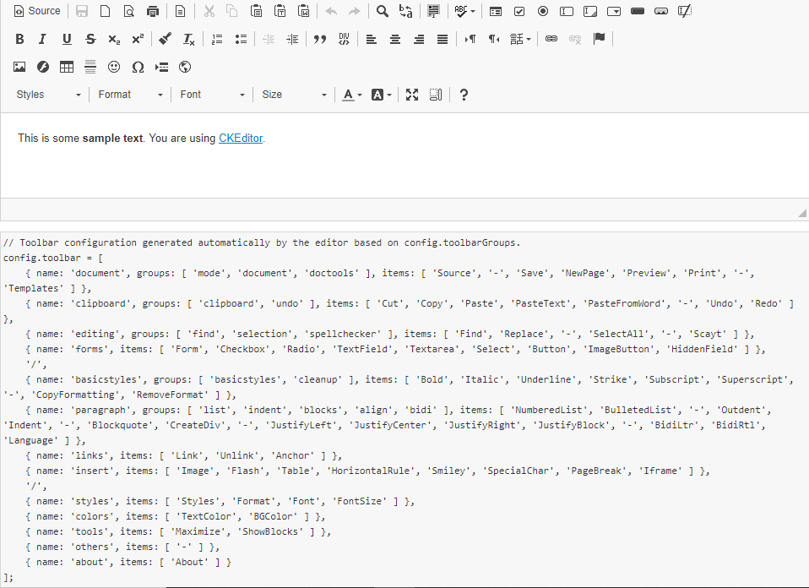

Cấu hình toolbar

CKEDITOR.replace( *'textarea_id'*, {

**toolbar:** [

{ name: 'document', items: [ 'Source', '-', 'NewPage', 'Preview', '-', 'Templates' ] }, // Defines toolbar group with name (used to create voice label) and items in 3 subgroups.

[ 'Cut', 'Copy', 'Paste', 'PasteText', 'PasteFromWord', '-', 'Undo', 'Redo' ], // Defines toolbar group without name.

'/', // Line break - next group will be placed in new line.

{ name: 'basicstyles', items: [ 'Bold', 'Italic' ] }

]

});