November 9, 2009





Computer Sciences Corporation | North Carolina Replacement MMIS User Interface Style Guide

Document Revision History
Version | Date | Description of Changes
1.0 | November 09, 2009 | Initial submission

Table of Contents
Document Revision History 2
Table of Contents 3
List of Exhibits 6
1. Introduction 7
2. Quality Assurance, Usability and Accessibility 8
2.1 Quality Assurance 8
2.2 Usability 8
2.3 Section 508 Accessibility 8
2.4 W3C Markup 9
3. Branding and Visual Identity 10
3.1 Brand Identity 10
3.2 Copy Writing Specifications 10
3.3 NCTracks Logo Specifications 10
3.4 Color Palette 10
3.5 Layout 11
3.6 Text 13
3.6.1 HTML 13
3.6.2 Scaling 13
3.6.3 Readability 13
3.7 Styling 14
4. Navigation and Site Structure 22
4.1 Headings, Titles and Labels 22
4.2 Hyperlinks 22
4.3 Breadcrumb Trails 23
4.4 Subnavigation 23
4.5 Scrolling, Tabbing and Paging 24
4.5.1 Pagination 24
4.6 User Controls 25
4.6.1 Tabs 25
4.6.2 Buttons 25
4.6.3 Icons 26
4.6.4 Page Tools 27
4.6.5 Access/Shortcut Keys 27
4.7 Tables and Forms 27
4.7.1 Tables 27
Table Styles 27
Basic Table Structure 27
4.7.2 Forms 28
Required Fields 29
Labels 29
Tabindex 29
Grouping Fields 29
Radio Button Group 30
Combo/Select Box 31
Checkbox Group 31
Selections Requiring More Detail 31
4.8 Search and Metadata 33
4.9 Error Messages 33
4.10 Help 34
Form-Field Level Help 34
Inline Help 34
Tooltips 35
4.11 Legend 36
4.12 Site Map 36
4.13 Printing 37
5. Scripts and Tools 38
5.1 Load Order 38
5.2 jQuery 38
5.2.1 jQuery Tools 38
5.2.2 jQuery Coolinput 38
5.3 javascript 38
5.3.2 DD_Roundies 38
5.3.3 general_init and form_init 38
6. Data Requirements and Specifications 39
6.1 Data Validation and Formatting 39
6.1.1 Calendars and Dates 39
6.1.2 Zip Codes 39
6.1.3 Social Security Numbers 39
6.1.4 Phone Numbers 39
6.1.5 Negative Numbers 40
6.1.6 Addresses 40
6.2 Required Fields 40
7. Technical Specifications 41
Screen Resolution: 41
Supported Browser Versions: 41
Target Connection Speeds: 41
Appendix A: Validation Standards 42
1. Section 508 42
1.1 Section 508 Overview 42
1.2 AccVerify 42
1.2.1 Settings 42
1.2.3 Verifying Files with AccVerify 44
1.2.4 AccVerify Validation Results 44
1.2.4 AccVerify Reports 44
1.3 Total Validator 45
1.3.1 Total Validator Settings 45
Desktop Tool 45
Firefox Extension 46
1.3.2 Verifying Files with Total Validator 48
1.3.3 Total Validator Validation Results 48
1.4 PDF Accessibility 48
1.4.1 Adobe Acrobat 48
1.4.2 Acrobat Validation Results 50
2. W3C 51
2.1 W3C Overview 51
2.2 W3C Markup Validation service 51
2.2.1 W3C Markup Validation Results 51
2.3 Total validator 51
Appendix B: jQuery Best Practices 52
Appendix C: Naming Styles and Conventions 53
Appendix D: CSC Contact Information 54

List of Exhibits
Exhibit 3.5-1. Content Page Layout 11
Exhibit 3.5-2. Home Page Layout 12
Exhibit 3.6.1. HTML Font Information 13
Exhibit 3.7-1. CSS Hierarchy 14
Exhibit 3.7-2. Home Page CSS Key 20
Exhibit 3.7-3. Content Page CSS Key 21
Exhibit 4.4. Subnavigation 24
Exhibit 4.5.1-1. Pagination for Table Data 24
Exhibit 4.5.1-2. Pagination for Navigation 24
Exhibit 4.6.1. Tabs 25
Exhibit 4.6.2-1. Buttons 26
Exhibit 4.6.2-2. In-line Form Search Button 26
Exhibit 4.6.2-3. Previous/Next Buttons 26
Exhibit 4.6.4. Page Tools 27
Exhibit 4.7.2-1. Required Input Field 29
Exhibit 4.7.2-2. Radio Button Group 31
Exhibit 4.7.2-3. “singleQ” Radio Button Group 31
Exhibit 4.7.2-3. Combo/Select Box 32
Exhibit 4.7.2-4. Checkbox Group 32
Exhibit 4.8. Search Box 33
Exhibit 4.9-1. Inline Error message example 34
Exhibit 4.9-2. Summary Error Box example 34
Exhibit 4.10-1. Help Icon 35
Exhibit 4.10-2. Field-specific Help Example 35
Exhibit 4.10-3. Inline Help Example 35
Exhibit 4.10-4. Off-Site Link Indicator 36
Exhibit 4.10-5. File Link Indicator 37
Exhibit 4.11. Legend 37
Exhibit 6.1.1. Date Field Format 41
Exhibit 6.1.2. Zip Code Field Format 41
Exhibit 6.1.3. Social Security Number Format 41
Exhibit 6.1.4. Phone Number Format 42

1. Introduction
The purpose of the Style Guide is to document the visual design and technical specifications for the NCTracks application. In addition, this document provides guidelines for graphics development and HTML programming.

2. Quality Assurance, Usability and Accessibility

2.1 Quality Assurance
NCTracks is first and foremost a system for facilitating the flow of information to and from users. The principal tasks of the system’s user interfaces (UIs) are to present information in a clear, obvious way and to receive new input accurately and easily. Effective UI design helps users work efficiently, complete transactions, and get useful information when they need it, even in the midst of distractions.
CSC ensures accessibility by implementing design standards that allow maximum user access, including access to people with disabilities who may be accessing the Web site with the aid of assistive technologies including magnifiers, screen readers, closed captioning, keyboard enhancements, and highlighting software.
Developers will adhere to industry standards concerning proper W3C markup and accessibility for disabled individuals. These standards apply to all pages within NCTracks, including dynamic web application pages and static pages. The basis of these standards consists of Section 508 and W3C Markup compliance. All content in the MMIS will be validated to ensure optimal accessibility.

2.2 Usability
CSC ensures usability by designing NCTracks in accordance with common industry workflows, employing standard Web page elements that are familiar and intuitive to most users, including hyperlinks, submit and reset buttons on forms, radio buttons and dropdown menus. Hyperlinks are displayed in underlined text.
The system will allow users to accomplish any operation available to them with a minimum of thought and movement. It is important to position likely user targets close to likely user origin points, and make the targets large and visible.

2.3 Section 508 Accessibility
NCTracks complies with Section 508 of the Rehabilitation Act Amendments, as amended by the Workforce Investment Act of 1998, which requires that to develop, procure, maintain, or use electronic and information technology, assurances must be made that the electronic and information technology allows employees with disabilities to have access to and use of information and data. This access must be comparable to the access to and use of information and data by non-disabled individuals.
High-level best practices for Section 508 compliance:
- All new pages will have a skip-navigation link
- All input fields will have appropriate label tags
- All images and non-text elements will have alt tags or appropriate text descriptions
- All page headers/subheaders will have appropriate header tags that reinforce information hierarchy
- All tables will be accessible so that data is organized in an understandable way and each cell corresponds to a table header if applicable
- All PDF files are Section 508 accessible
All content will be designed considering persons with disabilities. Developers will use best judgment and common sense solutions to accommodate those with disabilities. Many accessibility issues can be resolved with proper best-practice W3C code markup. All content will be validated with specified software. Any additional errors or warnings after Section 508 validation will be corrected.
See detailed §508 compliance information in NC MMIS Replacement System User Interface Design, PMO_NCMMIS_DELV_USI_07.15.09_V1.0_FINAL_CDRL D0005.pdf

2.4 W3C Markup
To ensure valid page code markup, all content will be validated against W3C coding standards for specified DOCTYPE (XHTML 1.0 Transitional). Markup validation ensures code is future-proof, eases maintenance, helps teach good practices, aids in accessibility compliance, and is a sign of professionalism (http://validator.w3.org/docs/why.html).
See Appendix A: Validation Standards for validation specifics concerning Section 508 and W3C.
3. Branding and Visual Identity

3.1 Brand Identity
When the organization is referred to in documentation it should always be presented in upper and lower case as follows: NCTracks.

3.2 Copy Writing Specifications
When the organization is referred to in documentation it should always be presented in upper and lower case as follows: NCTracks.
Phone numbers should always be bold.

3.3 NCTracks Logo Specifications
Basic Type and Color Specifications
[To be added]

3.4 Color Palette
The following color palette was created from the colors used on the NCTracks Web Site. Major colors conform to the 4,096 “web-smart” color palette for maximum compatibility.
255,238,204  #FFEECC | 0,51,85  #003355 | 102,102,102  #666666 | 34,136,221  #2288DD
Layout background  Links on dark bg | Logo bar background  Fieldset legend | Portal-independent elements (quick login, bottom links bar) | Accent  links on light bg

255,255,255  #FFFFFF | 68,68,68  #444444 | 221,68,85  #DD4455 | 102,136,221  #6688DD | 85,204,51  #55CC33 | 255,204,0  #FFCC00
Content bg  Input bg | Standard text | Recipient portal | Provider portal | Agent portal | State portal
 |  | 238,85,102  #EE5566 | 119,153,238  #7799EE | 102,221,68  #66DD44 | 255,221,17  #FFDD11
 |  | Highlight | Highlight | Highlight | Highlight
 |  | 255,136,153  #FF8899 | 170,204,255  #AACCFF | 153,238,102  #99EE66 | 255,255,68  #FFFF44
 |  | Accent | Accent | Accent | Accent

Forms and Tables
221,221,221  #DDDDDD | 255,255,255  #FFFFFF | 231,235,239  #E7EBEF | 215,219,223  #D7DBDF | 0,51,85  #003355 | 204,204,204  #CCCCCC
Table header bg | table: even row  table title bar text | Table: odd row | Table row hl | Table title bg  legend text | border

3.5 Layout
The NCTracks design is comprised of two core layouts: a home page (exhibit 3.5-2) for introductory and light-weight content, and a content page (exhibit 3.5-1) for the denser bulk of the site. Both layouts share the same visual framework and differ only in navigation and the handling of content.

Persistent elements include:
- site header
  - logo
  - site-wide search
  - site-wide help
  - language selection
  - account administration
- sub-header
  - portal title
  - navigation bar
- page header
  - breadcrumb navigation
  - page tools
  - page title
- main content
- footer

The entire site is designed for a base screen resolution of 1024x768. The layout assumes a maximized browser window and specifies a minimum width of 979px, allowing for borders, margins and scrollbars. The layout is fluid up to a maximum width of 1419px (home page excepted), to prevent stretch content to the point that it negatively affects readability, particularly on high-resolution widescreen monitors.

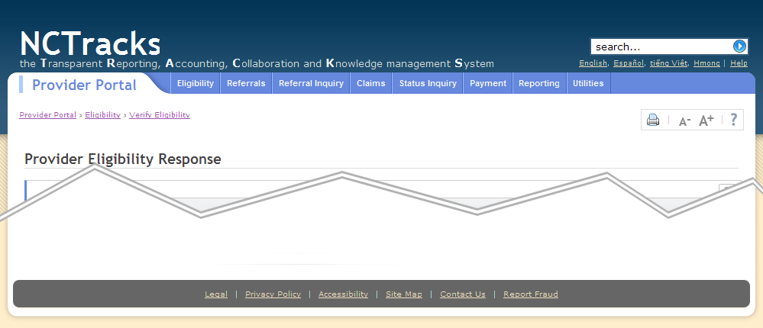
1
2
3
5
4
height: 60px
height: 28px
Exhibit 3.5-1. Content Page Layout

The home page layout differs slightly from the rest of the site. It does not contain the sub-header or page header, and page tools are limited to text scaling. Account administration is also not available, as the user has not logged in at this point. Max-width is set to 1259px to preserve the flow of the page.
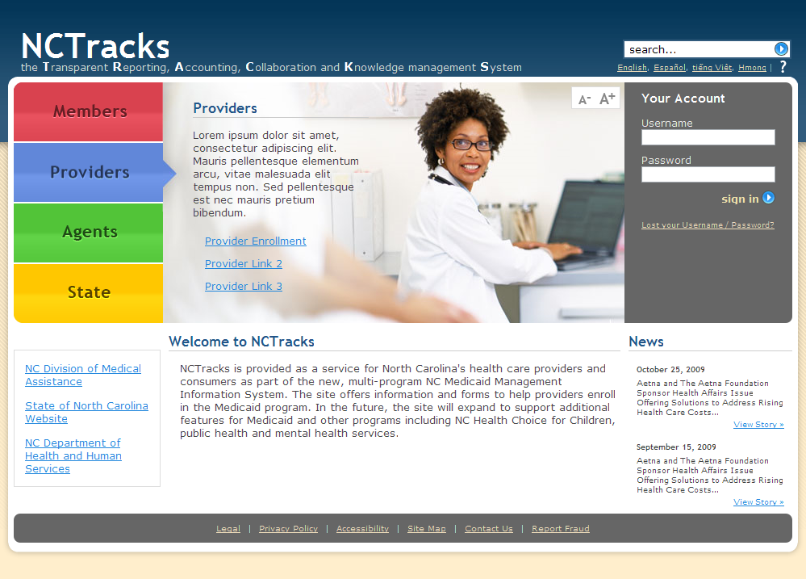
1
4
5
height: 60px

Exhibit 3.5-2. Home Page Layout
3.6 Text
This section of the document outlines the type specifications for both graphical text and HTML typography documented in the Cascading Style Sheet (CSS).
3.6.1 HTML
  - font size should be specified in “em” units for scaling compatibility across platforms
  - pixel units should only be used on non-critical text that would break the layout if scaled

Content type | Font-family | Font-size
Portal title | Trebuchet MS / Helvetica, bold | 1.2em / 14pt / 19px
Main navigation | Arial, bold | 0.7em / 8pt / 11px
Page title | Trebuchet MS / Helvetica, bold | 1.75em / 18pt / 24px
Textual content | Verdana | 0.8em / 10pt / 12px
Fine print | Verdana | 0.7em / 8pt / 11px
Links | Underlined, styled according to context
Exhibit 3.6.1. HTML Font Information
3.6.2 Scaling
Within the page body, text will be scalable to increase accessibility. Text scaling controls will be located in the Page Tools area in the upper right of each page to which they apply.

3.6.3 Readability
Text will be broken into manageable portions. Important terms or phrases will be highlighted. Primary and secondary navigation or elements will clearly lead the reader through the text.
TIP: To facilitate Search best practice, always make sure important terms or phrases are also included in meta data keywords for static pages.

3.7 Styling
The CSS structure for the NCTracks home page and all subsequent portals utilizes a master style sheet (master.css) to handle site-wide layout, font and color standards. Each page loads the style sheet for its respective portal – containing portal-specific branding or application styling – which then imports the master style sheet and any other necessary documents, such as for forms. Additional style sheets may sometimes be used to correct for specific browser issues, but this should be kept to a minimum.
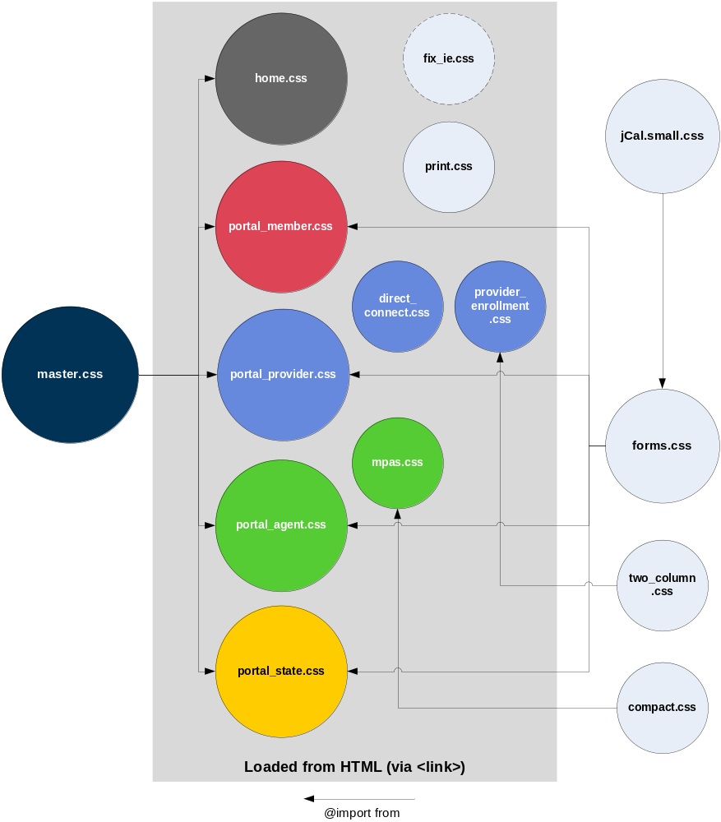
Exhibit 3.7-1. CSS Hierarchy

For readability and consistency, attributes are ordered according to the following hierarchy:
element
display
width
dimensions
height
positioning
float
clear
position
top
left
z-index
appearance
margin
padding
visibility
list-style
text
font
text-align
vertical-align
line-height
letter-spacing
white-space
text-decoration
color
background
border
cursor

The following is a list of the core styles in the NCTracks master style sheet. Numbered styles are indicated in Exhibits 3.7-2 and 3.7-3 later in this section. Brackets have been removed for readability.
html
padding-bottom: 25px;
background: #FFEECC url("../images/layout/bg_tile.gif") repeat-x;
body
width: 98%;
min-width: 959px;
max-width: 1419px;
position: relative;
margin: 0 auto 30px;
font-family: Verdana, sans-serif;
font-size: 0.8em;
color: #444444;

/* generic styles */
h1,h2,h3,h4,h5
font-family: Trebuchet MS, Helvetica, sans-serif;
font-weight: bold;
a
color: #2288DD;
text-decoration: underline;
a:visited
color: #9955AA;
a:hover
color: #BB9955;
- .linkColor2 a, a.linkColor2
color: #EEDDBB;
.linkColor2 a:hover, a.linkColor2:hover
color: #FFFFFF;

/* page styles from top to bottom */
#skipNav
position: absolute;
top: 5px;
left: -999em;
font-size: 0.7em;
#skipNav:focus, #skipNav:active
left: 15px;
- #header
height: 90px;
margin-bottom: 5px;
color: #FFFFFF;
- #logo
position: absolute;
margin-top: 29px;
- #siteSearch
float: right;
clear: right;
margin-top: 11px;
margin-right: 7px;
#siteSearch .searchBox
width: 11.1em;
height: 18px;
float: left;
padding: 2px 32px 0 5px;
border: 2px solid #315B7C;
#searchBtn
width: 27px;
height: 24px;
margin-left: -4px;
background: url(“../images/icons/search.gif”) no-repeat;
border: 2px solid #315B7C;
border-left: none;
cursor: pointer;
#searchBtn:hover
{
background: url("../images/icons/search_hover.gif") no-repeat;
}
- #languages
float: right;
clear: right;
margin-right: 10px;
vertical-align: middle;
white-space: nowrap;
#languages li
display: inline;
font-size: 0.7em;
- #portalTitle
height: 20px;
float: left;
margin: 4px 0 20px 15px;
padding: 0 0 4px 1.2%;
font-size: 14pt;
border-left: 5px solid #AAAAAA;

/* portal drop-down navigation */
- #navStrip
width: 77.5%;
height: 28px;
float: right;
padding-left: 39px;
background-image: url("../images/layout/nav_left_curve.png");
background-repeat: no-repeat;
background-position: left;
- #mainNav
height: 28px;
background: url("../images/layout/round_top_right.png") no-repeat top right;
#mainNav li
float: left;
#mainNav a
display: block;
padding: 3px 7px;
font-family: Arial;
font-size: 8pt;
text-decoration: none;
color: #FFFFFF;
#mainNav a:hover
color: #333333;
#mainNav ul a
width: 10em;
border-bottom: 1px solid;
#contentBackground
width: 100%;
background: #FFFFFF url("../images/layout/round_top_left.gif") no-repeat;

/* breadcrumb navigation */
- #breadcrumb
clear: both;
margin: 0 15px 20px;
font-size: 0.7em;
white-space: nowrap;
#breadcrumb li
display: inline;
#breadcrumb b
font-family: Trebuchet MS, Helvetica, sans-serif;
color: #777777;
/* site tools: print, text scaling, etc. */
- #pageTools
float: right;
padding: 1px 3px;
color: #CCCCCC;
background-color: #FFFFFF;
border: 1px solid #DDDDDD;
#pageTools li
display: inline;
#pageTools a
display: inline-block;
vertical-align: middle;
#pageTools a:hover
background-color: #DDEEFF;
- #leftColumn
width: 18%;
float: left;
clear: both;
padding-left: 15px;
- #subNav
margin: 0 15px;
padding: 10px 0;
#subNav h2
margin-top: -3px;
padding: 0 0 5px 10px;
#subNav a
display: block;
padding: 5px 10px;

- #mainContent /* MAIN CONTENT DIV */
clear: left;
float: left;
margin: 0 15px 20px;
#pageTitle
height: 2.2em;
margin-bottom: 6px;
border-bottom: 1px solid #DDDDDD;
#pageTitle h1
float: left;
font-size: 1.75em;
/* site tools: print, text scaling, etc. */
#pageTools
float: right;
clear: right;
padding: 1px 3px;
color: #CCCCCC;
#pageTools li
display: inline;
#pageTools a
display: inline-block;
vertical-align: middle;
#pageTools a:hover
background-color: #DDEEFF;
- #footer
clear: both;
margin: 7px 7px 0;
padding: 12px;
font-size: 0.75em;
text-align: center;
background-color: #666666;
#footer li
display: inline;
color: #FFFFFF;
#footer a
padding: 5px;

2
1
5
4
10
3
13
14
1
Exhibit 3.7-2. Home Page CSS Key

- .linkColor2
- #header
- #logo
- #siteSearch
- #languages
- #portalTitle
- #navStrip
- #mainNav
- #breadcrumb
- #pageTools
- #leftColumn
- #subNav
- #mainContent
- #footer

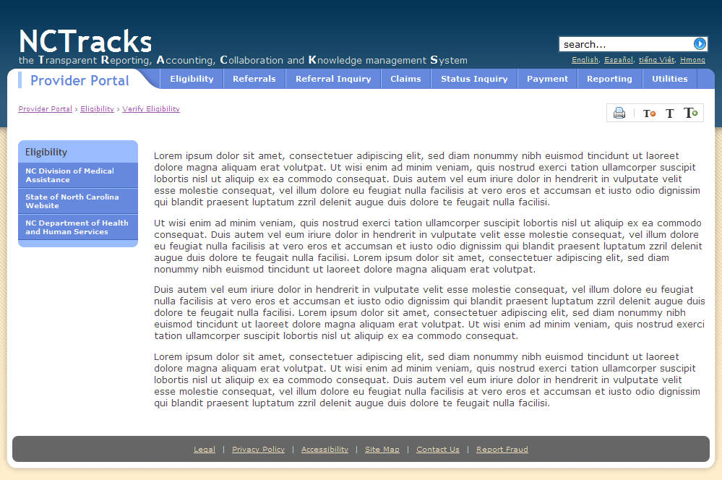
1
2
3
1
5
4
6
7
8
10
11
14
14
12
9
Exhibit 3.7-3. Content Page CSS Key

- .linkColor2
- #header
- #logo
- #siteSearch
- #languages
- #portalTitle
- #navStrip
- #mainNav
- #breadcrumb
- #pageTools
- #leftColumn
- #subNav
- #mainContent
- #footer

4. Navigation and Site Structure
Users navigate through NCTracks using text-based links. In cases where graphical links are used, text-based links are provided. This ensures that users can navigate freely throughout the site regardless of whether their browser is set to display images. Navigation between pages is simple and does not require the user to extensively drill-down to successively deeper levels. Attempts to get to a particular Web page are limited to no more than three mouse clicks. NCTracks is not overly graphic-intensive. The reasons for this are two-fold: (1) too many images dilute the Web page content and can be distracting to the user, and (2) images can negatively impact download times when used in too large numbers or when a particular image is too detailed.

4.1 Headings, Titles and Labels
Consistency in the display of titles, field labels, and other business area specific information will occur through the use of specified elements within structured CSSs, which ensure consistency in rendering these elements through styles applied to rendered content.
Page headings should always be unique to the content of the page. Avoid using repetitive words or phrases that are used on all pages. Page headings should be included in meta keywords. See further details in section 4.8, Search and Metadata.

4.2 Hyperlinks
All hyperlinks are displayed in underlined text so the user knows they are links. Visited links will change color using the browser default colors or a similar intuitive color structure. Styles of links will be specified in the Cascading Style Sheet. Links will be used in text and to show movement within the site as opposed to buttons which will demonstrate action items or navigation (see Navigation – Buttons).
Off-site links will open in a new browser window and have a link indicator icon inline after the link text [ file: new_window.gif ]. For accessibility, identifying icon will have an alt and title attribute, both stating, “Exit NCTracks.”
File links will have a link indicator icon depending on the file type (see Section 4.6.3 Icons). The file link indicator icon will be inline before the link text. The alt and title attributes will be specified as, “Download [file type].” Additionally, the file size will be specified.
Each page will contain a “Page Tools” area in the upper right of the screen which will have context-sensitive icons for each applicable page including print, text scaling and other user controls. See Section 4.6.4 for further details.
A skip-navigation link will be added to each page immediately following the body tag. Skip-navigation link will not be viewable on the page, but the first link accessible to screen reader software. Skip navigation link will be viewable on the screen on focus.
Section 508 Note: Skip-navigation link will have an absolute position of -999em to position it off the viewable page.
Please note that “display: none;” will not be picked up by some screen readers.
#skipNav
{
position: absolute;
top: 5px;
left: -999em;
font-size: 0.7em;
}
#skipNav:focus, #skipNav:active
{
left: 15px;
}

This technique can also be used to position text off the screen by using “text-indent: -999em;”

4.3 Breadcrumb Trails
A breadcrumb trail is a navigational tool that shows the user the path of displays they have visited from the homepage. This breadcrumb consists of links so the user can return to displays on this path.
A breadcrumb trail will look like this in mPas:
Provider/License Search > Tom Jones - Provider Details 00013098 > Claim Detail TCN: 081420
And this for the remainder of the site:
Provider/License Search > Provider Details > Claim Detail
This breadcrumb trail shows that the user started by doing a provider/license search and selected a Provider from the search results and then selected a claim, and the user is currently looking that the details for that claim. Both the “Provider/License Search” and the “Provider ID” sections of the breadcrumb trail are links back to those displays in the application.
Breadcrumb trails are a helpful navigational tool when the page displayed is within a hierarchy of pages and is not the topmost page or when the user cannot easily navigate through the hierarchy via other local navigation methods. For example, if the page is fairly deep in a hierarchy, the breadcrumb maybe the simplest way to provide navigation. Also, the page may be arrived at from an external source (e.g., a search results page) and the breadcrumb trail provides a sense of context.
The breadcrumb trail resets when a display is selected from the menu bar or the user utilizes the history dropdown functionality.

4.4 Subnavigation
A subnavigation menu may be used in the left column on some content pages, primarily the recipient portal and other sections where screen real-estate is not at a premium. Each Subnav header will correspond with the global menu items. Subnav links will correspond to the global navigation dropdown links. Each global navigation item will have its own Subnav.
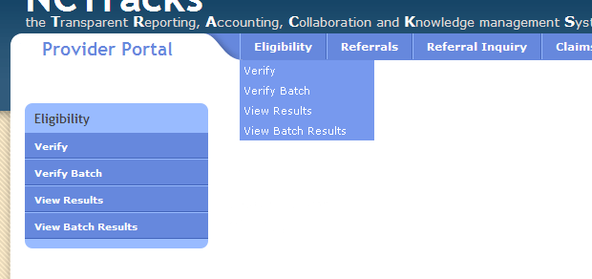
Exhibit 4.4. Subnavigation

4.5 Scrolling, Tabbing and Paging
Vertical scrolling provides ease of use to users filling in forms. Proper tab order policies facilitate auto-scrolling of forms as users tab through page form fields. When possible, NCTracks applications that have high-speed data entry requirements are designed to fit the application data on one full-screen page. Forms that scroll for numerous pages leverage anchor tag references allowing the user to quickly jump to another area of the form. (See Section 4.7.2)
Horizontal scrolling will not be present in any general public content and will only be employed in other areas where it is unavoidable, for example, a user generated a report presented in landscape mode to be printed on 8.5” x 14” (legal) format paper.

4.5.1 Pagination
When there is too much data to be displayed on a single page, pagination links will be employed. They will list the total number of pages, the page number of the currently displayed page, clickable links for next page, previous page, and several page before and after the currently displayed page. This pagination will remain visible at all times to ensure consistency in navigation.
In areas of the application where table data like search results are returned, a multi-page option pager will be displayed.
Exhibit 4.5.1-1. Pagination for Table Data
In areas of the application that require a user to move through pages for navigation, a previous/next option pager will be displayed:

Exhibit 4.5.1-2. Pagination for Navigation

4.6 User Controls
4.6.1 Tabs
Presenting a persistent single-line row of tabs in a horizontal bar provides high-level navigation for the website. The tab row spans across the entire width of the page using limited as well as short and predictable titles with the current selected tab clearly highlighted to maintain the metaphor of file folders as well as providing navigational context.
Tabs are constructed by using unordered lists outside of the formSection DIVs. The <ul> tag must have a class of "tabs" and the subsequent formSection DIVs must all be enclosed in a single <div class="panes">. jQuery will take care of the rest. "#first" refers to the first <div> under the panes parent, "#second" to the second, and so on.
<ul class="tabs">
<li><a href="#first">Tab 1</a></li>
<li><a href="#second">Tab 2</a></li>
<li><a href="#third">Tab 3</a></li>
</ul>
<div class="panes">
<div class="formSection">
...
</div>
<div class="formSection">
...
</div>
<div class="formSection">
...
</div>
</div>
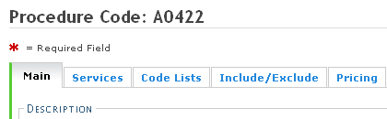
Exhibit 4.6.1. Tabs
4.6.2 Buttons
Buttons will be constructed for maximum usability. They will be a uniform size, color and will reside in logical locations in proximity to their intended action. Primary action buttons (i.e.: Submit) are highlighted via a border element styled according to the portal’s branding color, so that they stand out from secondary action buttons (i.e.: Reset). Button clicks will result in an action that is indicated by the text on each button face (i.e. Submit, Clear, Next, etc.)
The browser’s back button will be disabled in order to ensure stability of each web application. The user will be warned before navigating away from any page using the browser’s back button so that data may be retained.
The font, background-image, hover state, etc. are automatically set for all <button> elements through CSS. Important action buttons such as Submit, Sign In or Search should also include the "submitBtn" class, which adds the portal brand color as a border on the left to draw attention to those buttons. Secondary action buttons such as Clear or Reset should not include this class. The final class "btnRow" can be applied to a <div> containing multiple buttons to right-align them and provide the necessary margins.
<div class="btnRow">
<button class="submitBtn">Last Name:</button>
<button>Clear</button>
</div>
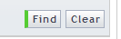
Exhibit 4.6.2-1. Buttons
Special buttons have been created for unique circumstances. “Previous” and “Next” are for overall application progressions (used in Provider Enrollment and some tabbed browsing progressions). These buttons get a class of “prevBtn” and “nextBtn”, respectively. An in-line form search button has also been created for in-line form search capabilities. This button comes after a text input field. These buttons are automatically important action buttons so they receive both “submitBtn” and “formSearchBtn” classes.
<input type="text" name="baName_0_0" maxlength="40" value="" id="baName_0_0" class="medium" />&nbsp;<button type="submit" class="submitBtn formSearchBtn">Search Billing Agents</button>
Exhibit 4.6.2-2. In-line Form Search Button
<div class="btnRow">
<button type="button" id="prevBtn" accesskey=",">Previous</button>
<button type="submit" id="nextBtn" accesskey=".">Next</button>
</div>
Exhibit 4.6.2-3. Previous/Next Buttons
4.6.3 Icons
Icons will be used to represent commonly used functions and user tools. A standard icon library will be used to simplify choices and ensure a consistent look and feel. The FamFamFam Silk Icon set will be available in the shared code repository (/image/icons/) for use across interfaces.

Required Field: , “ icon_required.gif”
New Window / Offsite Link: , “new_window.gif”
Downloadable PDF: , “page_white_acrobat.png”
Downloadable Excel Doc: , “page_white_excel.png”
Downloadable Word Doc: , “page_white_word.png”
Print: , “printer.png”
Font Size Up: , “font_up.gif”
Font Size Down: , “font_down.gif”
Audit Trail: , “audit.png”
4.6.4 Page Tools
A page tools area, located in the upper right of the screen, will consolidate user functions based on availability. This section will include items like printing and text-scaling as applicable to the page content.

Exhibit 4.6.4. Page Tools
4.6.5 Access/Shortcut Keys
Access or shortcut keys will be used to add additional keyboard functionality for power users as well as additional accessibility features for screen reader software and users who are unable to use a mouse. Key combinations of ALT + (for Windows users) or CONTROL + (for Mac users) will be indicated by an underscore beneath the applicable letter in the control. For example, File would indicate an access key of ATL + F (or CONTROL + F) to activate the file menu without using the mouse. Access keys can also be employed to focus the users cursor in a form field. Access keys are specified by the addition of the “accesskey=” attribute. Access keys are constructed by using the first letter of the word if not already in used. Links to the homepage are created using accesskey=”1” and a skip navigation link is created using accesskey=”2”.

4.7 Tables and Forms
4.7.1 Tables
Tables will be used only to display tabular data and not for page formatting. All tables will have identifiable header rows and be zebra-striped to increase readability. Columns should be limited to no more than eight whenever possible. This standard will also serve to meet §508 compliance. See Section 4.5 for detailed table navigation controls.
Table Styles
All table styles should be controlled through CSS.
Basic Table Structure
<table summary=”Detailed description for this table for screen reader accessibility.”>
<thead>
<tr>
<th scope="col">Name</th>
<th scope="col">Age</th>
<th scope="col">Birthday</th>
</tr>
</thead>
<tbody>
<tr>
<th scope="row">Jackie</th>
<td>5</td>
<td>April 5</td>
</tr>
<tr>
<th scope="row">Beth</th>
<td>8</td>
<td>January 14</td>
</tr>
</tbody>
</table>

Section 508 Notes:
Screen readers read everything in the order that it appears in the source markup. This is important to keep in mind while building tables.
Table cells should be associated with a corresponding table header if applicable. This can be accomplished in more than one way. The easiest is to assign a scope attribute of “row” or “col” to the table header element.
The summary attribute can be added to the table element for a longer description for visually impaired if necessary.
See http://www.webaim.org/techniques/tables/data.php for more information.

4.7.2 Forms
Form elements are organized into logical groups for speed of entry and ease of use. Outer groups for the purpose of dividing sections of the form are DIVs. Inner groups that create a relationship between form elements are fieldsets. Every fieldset contains its own context-sensitive help tab and every DIV a button to return to the top of the page. Long forms that scroll for numerous pages will leverage anchor tag references that allow the user to quickly forward to another area of the form.
Both form inputs and form results are structured within definition lists (<dl>). Each <dl> is a column pair, with the layout allowing for 2 pairs across (or 4 columns). All labels are contained with <dt> tags and all values or inputs within <dd> tags. This is done for ease of styling and semantic meaning.
Two-column layouts are handled automatically through the use of the <dl>, <dt> and <dd> tages. Three-column need the "ThreeColumnLayout" class added to the <dl> tag. There is also a "FourColumnLayout" class, but it's currently only set up for checkbox or radio inputs.
Required Fields
All forms will have fields in which user input is required in order to continue to the next step in the input process. Required fields will be marked with a red asterisk to the left of the input field, before the form label. This indicator will be in the form of an icon image with an alt attribute of “Required Field”. [ file: icon_required.gif ]
<label for="lName">
<img src="/images/icons/icon_required.gif" width="14" height="9" alt="Required Field" title="Required Field" />Last Name:
</label>
Exhibit 4.7.2-1. Required Input Field
Labels
Labels appear in 3 forms:
- Input Form labels - should appear to the left of the input field for regular text input and should be followed by a colon character.
- Input form labels for radio buttons and checkboxes - should go to the right of the input and should not be followed by a colon. The “.labelToRight” class should be added to an element containing the radio or checkbox input and labels.
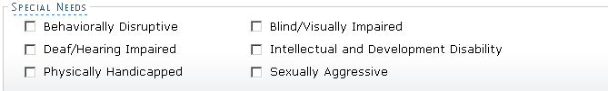
- Results labels should not be bold, the values to the right should be bold.
Section 508 Note: All text input fields except buttons with a specified value attribute need a label element to be fully accessible.
Input fields that don’t have a viewable inline label will need a label with the “.hideLabel class”. This class will position the label off the page but still be accessible to screen readers. An example of a hidden label would be for an input field that is located in a table cell. The visual label for these inputs would be the table header, but each input will still need a hidden label.

Tabindex
The tabindex attribute can be used to ensure proper page flow for browsing a page with a keyboard. With or without this attribute, the form tabbing order will automatically begin with the first form element on the page. Adding the attribute is only necessary if the tabbing order would not flow logically otherwise, such as when tables are used.
Section 508 Note: All forms should be tested with tabbing navigation to ensure it is fully accessible.

Grouping Fields
All definition lists should be inside of fieldsets. Every fieldset should have a legend and a help tab. The help tab comes after the legend. If you don't include them, you may have margin issues. Here's an example:
<fieldset>
<legend>This is a group of form elements</legend>
<a href="help.html" rel="#overlay" class="formHelpTab"><img src="../images/icons/help_tab.gif" width="22" height="22" alt="Help" title="Help"/></a>
<dl>
<dt><label for="input1">Form Input 1:</label></dt>
<dd><input type="text" name="input1" id="input1"/></dd>
</dl>
</fieldset>
All fieldsets should be inside of a <div class="formSection">. This create groupings with a colored border on the left which serves to group related fieldsets for logic and speed of data entry. Short forms or forms with tabs may only require one formSection DIV. Longer forms should have two or more DIVs. Each DIV has a "return to top" button at the bottom.
<div class="formSection">
<fieldset>...</fieldset>
<fieldset>...</fieldset>
<a href="#header"><img src="../images/icons/return_top.gif" class="returnTop" width="6" height="13" alt="Back to top" title="Return to the top of the page"/>
</div>
</form>
Section 508 Note: Fieldset form structure should be used where applicable for optimal accessibility. The legend element relates all elements in the fieldset to a common topic. Screen readers will read the legend content along with every input field in that fieldset.

Radio Button Group
Radio button groups should be used for less than 5 options or where it makes sense visually. If there are more than 5 options, consider using a select (also called combo) box. The “.labelToRight” class is used for the radio input labels.
<fieldset class="labelToRight">
<legend><span>Provider Type</span></legend>
<dl>
<dt>
<input type="radio" name="providerType" id="providerTypeInd" />
<label for="providerTypeInd">Individual</label>
</dt>
<dt>
<input type="radio" name="providerType" id="providerTypeOrg" />
<label for="providerTypeOrg">Group/Organization</label>
</dt>
</dl>
</fieldset>

Exhibit 4.7.2-2. Radio Button Group
Styles are created specifically for yes/no questions with radio inputs. These form questions are constructed as their own fieldset to relate each input (yes/no answer) to the legend (question). The “.singleQ” class is added to the fieldset to remove the fieldset border. The “.labelToRight” style is also applied for the radio input labels.
<fieldset><legend><span>Employer Identification Number (EIN)</legend>
<fieldset class="singleQ labelToRight">
<legend><span>Will your income be reported to an EIN?</span></legend>
<dl>
<dt>
<input type="radio" name="EINQuestion1" id="einYes" title="Alters page content" value="Yes"/>
<label for="einYes">Yes</label>
</dt>
<dt>
<input type="radio" name=" EINQuestion1" id="einNo" value="No"/>
<label for="einNo">No</label>
</dt>
</dl>
</fieldset>…

Note: A “singleQ” fieldset is always a nested fieldset.

Exhibit 4.7.2-3. “singleQ” Radio Button Group
Combo/Select Box
The first option available should be blank, and no option should be set as selected for example:
<select name=”name” id=”id”>
<option> </option>
<option value=”XX”>XX - White</option>
<option value=”YY”>YY - Black</option>
<option value=”ZZ”>ZZ - American Indian</option>
</select>
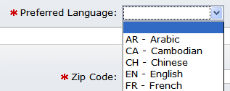
Exhibit 4.7.2-3. Combo/Select Box
Checkbox Group
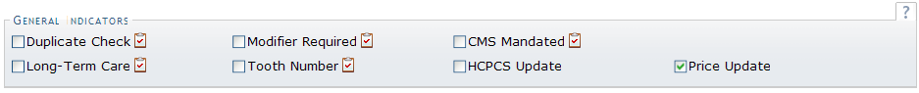
Generally, checkboxes should be used for on/off switches or “yes/no” questions depending on context and need. Fieldsets containing exclusively checkbox groups should have the class “labelToRight,” which will ensure proper layout.

Exhibit 4.7.2-4. Checkbox Group
Selections Requiring More Detail
There are instances when a selection, especially in the registration process, requires further clarification depending on the answer.
To this end, a method has been created to hide or show the details in an element below the form element.
Below is a simplified example with a radio button group:
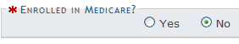
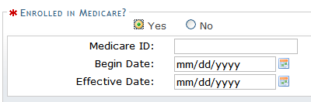
<dl class=”labelToRight”>
<dt>
<input name="group" type=”radio” class="showDetail"/>
<label for="a_yes" >Yes</label>
</dt>
<dt>
<input name="group" type=”radio” />
<label for="a_no">No</label>
</dt>
</dl>
<fieldset id="a-details" class="hidden">
<legend class="required">More Detail Required</legend>
<dl>
<dt><label for="a_name">Name:</label></dt>
<dd><input name="a_name" /></dd>
</dl>
</fieldset>

Below is a simplified example with a checkbox:
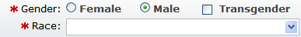
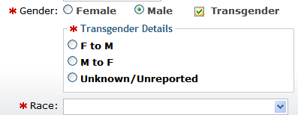
<dl class=”labelToRight”>
<dt>
<input name="group" type=”checkbox” class="showDetail"/>
<label for="a_yes" >Yes</label>
</dt>
</dl>
<fieldset id="a-details" class="hidden">
<legend class="required">More Detail Required</legend>
<dl>
<dt><label for="a_name">Name:</label></dt>
<dd><input name="a_name" /></dd>
</dl>
</fieldset>

4.8 Search and Metadata
Standard search boxes will be incorporated into the permanent navigation features of the page, where possible, in the upper right-hand corner.
Exhibit 4.8. Search Box
Search results will be ranked in order of relevance based on keywords contained in returned documents. Search results will contain links directly to the referenced material. The option to search within returned results will be offered as well as suggestions for related terms and misspellings.
All static pages should have meta “keywords” and “description” defined. Keywords should be unique tags that also show up in the content of the page. Page headings (i.e., <h1>, <h2>, … should also be contained within the meta keywords. This aids in search optimization.
Avoid using repetitive terms as keywords and page headings. These should be unique to the content on each page.

4.9 Error Messages
Error messages must always address these three questions: 1) What is the problem? 2) How do I fix the problem? 3) How do I avoid the problem in the future?
There are two types of error messages—inline error messages and summary error boxes. Inline error messages are typically for client-side errors, and appear in-line. Summary error boxes provide error descriptions for server-side errors, and appear as a summary at the top of the page. Summary error boxes contain links to the the IDs of error elements on the page. If the solution to the problem requires significant explanation, a link to help documentation is provided in both types of error messages. Forms will be validated in such a way as to preserve previously entered information. (See examples of each below.)

Exhibit 4.9-1. Inline Error message example

Exhibit 4.9-2. Summary Error Box example
NCTracks will employ both client side and server side form validation for maximum usability. Complex form entry will be validated throughout as well as on submit.
Further details can be found in NC MMIS Replacement System User Interface Design, PMO_NCMMIS_DELV_USI_07.15.09_V1.0_FINAL_CDRL D0005.pdf

Section 508 Note: All error messages should be accessible in an intuitive way for persons with disabilities.

4.10 Help
Help is provided throughout the application in the following ways: system level help, indicated by the ‘Help’ link on each page; page level help (contained within the page tools), data/form group help and hover-over or tooltip help on form elements.

Exhibit 4.10-1. Help Icon
Help documents are easy to navigate, clearly written and accessible via tables of contents as well as bookmarked areas.

Form-Field Level Help
An additional level of help will be made available at the form field level.
Field-specific help will be made available via a popup box that appears slightly above the page element when user focuses on that element
Text with an available tooltip will have a dashed underline. Hovering over the text will reveal the popup “tooltip”. Elements containing a tooltip will have a class of “tip”. The title attribute will provide the content of the tooltip. (Functionality is provided by jQuery)
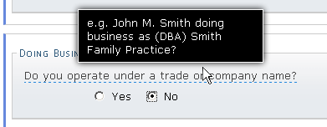
Exhibit 4.10-2. Field-specific Help Example
<legend><span class="tip" title="e.g. John M. Smith doing business as (DBA) Smith Family Practice?">Do you operate under a trade or company name?</span></legend>

Inline Help
Inline information that is more useful when always displayed, such as when data from one field references another or the user needs to know details about that area when focused on another section. Inline Help can also be referred to as an “Info Box”. Info Box contents should always be contained in a <p> element (see code example below).
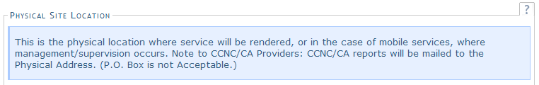
Exhibit 4.10-3. Inline Help Example
<div class="info">
<p>Help information here.</p>
</div>

Tooltips
Tooltip messages must be short, helpful messages that do not require further clarification.
Link Indicators for special links will be used to signify links to files or links that open in a new browser window. Link indicator icons will be placed directly after the anchor tag. Corresponding alt and title attributes will provide accessibility. (Also see 4.2 Hyperlinks and 4.6.3 Icons.)
Form element tooltips are described in “Form-Field Level Help”, above.
Off-site links will specify, “Navigate away from NCTracks” as a title value (“off-site link” being the alt value), and open in a new window. The link indicator icon will follow the link text for off-site links. jQuery functionality has been added to make the link indicator icon automatically show up after any link that is entered as an absolute URL (starts with “http://”). Offsite links should open in a new window.
<h2>More Information</h2>
<p>
<a href="http://www.ncdhhs.gov/dma/" target="_blank">Division of Medical Assistance</a>
</p>
<ul>
<li>Medicaid <a href="http://www.ncdhhs.gov/dma/provider/" target="_blank">DMA Provider Information</a></li>
<li><a href="http://www.ncdhhs.gov/dma/providerhc/" target="_blank">NC Health Choice for Children Provider Information</a></li>
</ul>
Note: jQuery adds the icon automatically because [href=”http://...”]; [target=”_blank”] for off-site links.

Exhibit 4.10-4. Off-Site Link Indicator
File links will be followed by a link indicator, then the file size in parenthesis. The file indicator icon will specify, “Download [file type]” as an alt and title value. If third-party software is needed to open a downloadable file, a link to get the needed software will be provided at the top of the main content area. jQuery functionality will be used to dynamically insert file indicator icon and file size.
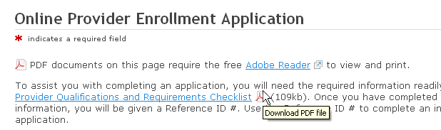
Exhibit 4.10-5. File Link Indicator
Section 508 Note: All help resources should be accessible to persons with disabilities.
Accessibility Notes
Accessibility notes are available for visually impaired individuals. These notes are to further explain current functionality or to explain special instructions for screen reader users. Accessibility notes can be inserted anywhere by adding the “.accessibilityNote” class, but are not represented visually on the page. A default Accessibility note will be present at the top of each page after the Skip Navigation link in the html. This default message primarily offers acknowledgement for screen reader users, and gives general site navigation instructions.
<body>
<a href="#mainContent" class="linkColor2" id="skipNav">skip navigation</a>
<div class="accessibilityNote">
Note for screen reader users: Some links on this page may cause changes to the page's content. These links are marked "Alters page content." Older screen readers may need to be prompted to recognize and read the content. JAWS users may try Insert + Escape.
</div>
Section 508 Note: A similar class for hiding labels in forms is also available. To hide form labels but maintain accessibility, add the “.hideLabel” class to the <label> tag in a form.

4.11 Legend
A legend of all helpful icons will be presented on pages as needed to explain the relevant meanings. This will help the user become familiar with any new icon representations in context with the form or page as it is used.
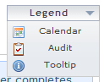
Exhibit 4.11. Legend

4.12 Site Map
A site map will be available throughout the site from the footer of each page. The sitemap will include a high-level, hierarchical text-based overview of the site. Navigable areas will be accessible via text links. The site map will help navigation for all users as well as provide important accessibility to assistive technologies. The site map will be structured as hierarchical lists of hyperlinks, generally two or three levels deep depending on the relevant section.
Section 508 Note: It is important that persons with disabilities can access all sections of the website when they need to.

4.13 Printing
All printable pages will provide ‘Printer Friendly’ versions accompanied by a recognizable printer icon [ file: printer.png ] in the Page Tools area of the page. A separate CSS style sheet for print (media=”print”) will make all necessary changes such as removing the header and footer, navigational items and any background images. Clicking the print icon will initiate the print dialogue page with no further steps necessary by the user.

5. Scripts and Tools

5.1 Load Order
External script files should be loaded in the appropriate order to ensure complete functionality. The current order is as follows:
- jQuery Tools – a jQuery library that includes overlay, tooltips, tabs and scrollable regions (includes the latest, stable version of jQuery).
- DD_Roundies – a small script that creates rounded corners.
- Suckerfish – a small script that provides focus on form elements and hovering over elements other than links in Internet Explorer.
- jCal – a jQuery plugin that creates the dynamic calendars used for date entry fields.
- jQuery Coolinput – a jQuery plugin that enables form hinting, data masks and tooltips.
- general_init – a small script that enables text sizing, calculations and other site-wide functions.
- form_init – a small script that handles dynamic form functions such as show/hide.

5.2 jQuery
jQuery will be used as the standard scripting library for ease of use as well as compactness of code. Whenever possible, jQuery plug-ins will be employed to speed delivery and stability. Minified or compacted code will be used whenever possible. The most stable release will be available in the code repository. The most current version available is 1.3.2.
5.2.1 jQuery Tools
The jQueryTools plug-in is a lightweight collection of useful interface features including Expose, Tabs and Overlay. Overlay in particular is used to generate the modal windows used for contextual help.
5.2.2 jQuery Coolinput
The jQuery CoolInput plug-in is an extremely lightweight hinting tool which allows text or images to be placed in line into text input boxes.

5.3 javascript
Standalone JavaScript functions will be used when there is no suitable jQuery plug-in/function available. These functions will be tested to ensure they work with all other scripts and plug-ins and add style or functionality without adding greatly to page overhead.
5.3.2 DD_Roundies
The DD_Roundies script is a compact method of rounding corners without adding additional images or extensive CSS markup.
5.3.3 general_init and form_init
These two files hold small functions written by the UI team including text scaling, computations, input focus and other form functions.

6. Data Requirements and Specifications

6.1 Data Validation and Formatting
All form input data will be validated based on input requirements and standards provided by the state of North Carolina. Entries will be checked for valid length, format and ineligible characters (i.e. letters in a Zip Code field).
6.1.1 Calendars and Dates
All calendars provided for input will start with the current date and be navigable in both past and future directions with jumps for month and year as necessary.
All dates will be entered in MM/DD/YYYY format. All forms requiring dates will normalize the date through tooltips and data masks as appropriate.
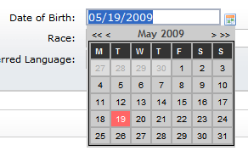
Exhibit 6.1.1. Date Field Format
6.1.2 Zip Codes
All forms requiring Zip Code input will accommodate USPS Zip +4 entry. All Zip Code fields will be validated against the USPS standard and include a Zip Code lookup function for the state of North Carolina.
Exhibit 6.1.2. Zip Code Field Format
6.1.3 Social Security Numbers
All forms requiring Social Security Numbers will accommodate standard formatting NNN-NN-NNNN. All forms requiring Social Security numbers will normalize the number through tooltips and data masks as appropriate.
Exhibit 6.1.3. Social Security Number Format
6.1.4 Phone Numbers
All forms requiring phone numbers will accommodate standard formatting (NNN) NNN-NNNN with an optional extention. Only numbers will be allowable input and phone number format will be normalized through tooltips and data masks as appropriate.
Exhibit 6.1.4. Phone Number Format
6.1.5 Negative Numbers
All negative numbers should be displayed using the accounting standard of:
($123.45)
6.1.6 Addresses
Where applicable, a service will be used to validate and normalize addresses, i.e. USPS.

6.2 Required Fields
All forms will have fields in which user input is required in order to continue to the next step in the input process. Required fields will be marked with a red asterisk to the left of the input field, before the form label. This indicator will be in the form of an icon image [ file: icon_required.gif ] with an alt attribute of “Required Field.” Any form with required fields will not be submitted without all required fields supplied. Any missing field will be identified with a logically placed error indicator noting their absence and a helpful error message in order to help the user provide the correct required information. See Section 4.7.2, Forms and Section 4.8 Error Messages for additional information about usage and placement.

7. Technical Specifications
In general, Web page file sizes are limited to a maximum of 50K, including all HTML, graphics, JavaScript, and other page content. A total file size of 30K is optimal for quickest load times.

Screen Resolution:
- designed for 1024 x 768
- min-width: 959px
- max-width: 1419px

Supported Browser Versions:
- Internet Explorer 7.x +
- Firefox 3.x +

Target Connection Speeds:
- Dial-up to Broadband

Appendix A: Validation Standards

1. Section 508

1.1 Section 508 Overview
NCTracks complies with Section 508 of the Rehabilitation Act Amendments, as amended by the Workforce Investment Act of 1998, which requires that to develop, procure, maintain, or use electronic and information technology, assurances must be made that the electronic and information technology allows employees with disabilities to have access to and use of information and data. This access must be comparable to the access to and use of information and data by non-disabled individuals.
With the Section 508 compliance requirement, developers must use best-practice coding techniques and validate all work with validation software before being sent for testing. Developers must keep in mind that validation software will not catch all issues, and take steps to test questionable content manually.

1.2 AccVerify
AccVerify is the official validation software chosen by North Carolina. All work must pass AccVerify validation and be accompanied by an AccVerify report which will be saved in an assigned folder in SharePoint.
1.2.1 Settings
To comply with federal guidelines, Section 508 validation settings for validation software will be set to strict.
Choose Settings > Report Settings
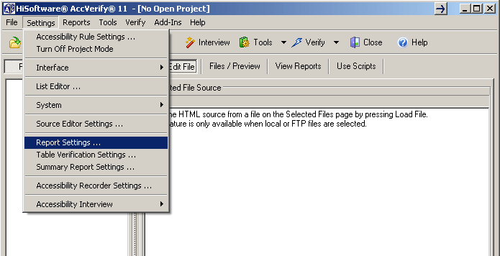

Select “Section 508 Reports Mode (US Only)”
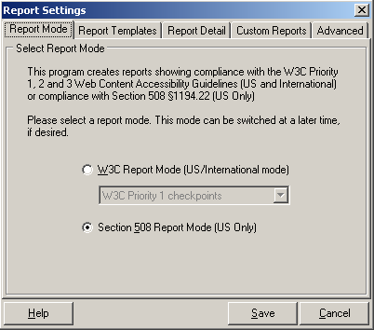

Choose Settings > Accessibility Rule Settings
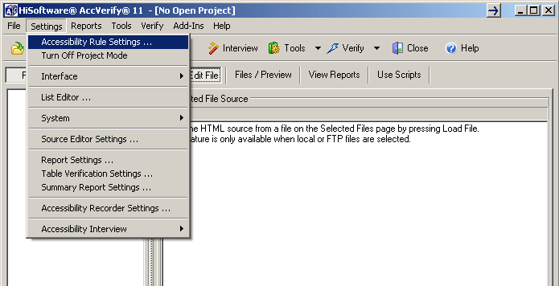

At the bottom in the “Non W3C” section, make sure boxes are checked next to:
“Ensure form controls are accessible for use with assistive technology.”
and
“All pages are required to contain a bookmark link to skip navigation that has the specified text in either the link text or the ‘title’ attribute value.”
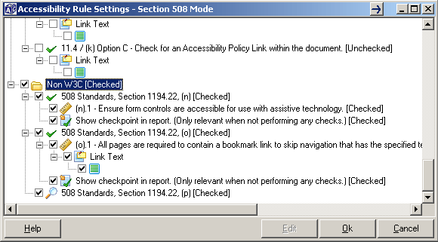
1.2.3 Verifying Files with AccVerify
Verify All
Choose this option to run an accessibility test using the selected rules in all the rule settings menus. (Only the rules that are selected in the rule settings menus are included.)
Verify All as Report Group
Choose this option to run an accessibility test using the selected rules in all the rule settings menus. (Only the rules that are selected in the rule settings menus are included.) Accessibility reports are generated in a separate directory, or report group, located with the program files.3
Use this setting when generating reports. The default report directory can be changed in the Advanced tab in the Report Settings menu.
1.2.4 AccVerify Validation Results
All failed checkpoints will need to be fixed and revalidated.
1.2.4 AccVerify Reports
Default AccVerify Reports are generated as an HTML page that uses frames. Specific individual pages in a report can be accessed in the report output directory structure.
All final passed reports will be stored in a specified folder in SharePoint.

1.3 Total Validator
Total Validator is an alternative validation tool for developers. This tool can be added as a plug-in for the Firefox browser. Total Validator is useful for testing pages on the fly. It has a number of options for validating Section 508 accessibility as well as W3C markup, spell check, and broken link checker. The desktop version is needed to validate local pages, but can still be used through the browser plug-in. Total Validator is available for download at www.totalvalidator.com.
Desktop Tool – http://www.totalvalidator.com/tool/index.html
Firefox Extension – http://www.totalvalidator.com/tool/extension.html
1.3.1 Total Validator Settings
Desktop Tool
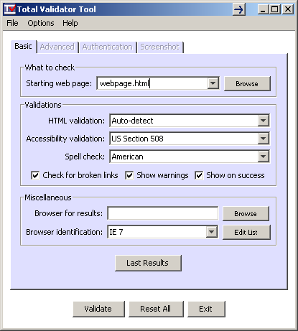

Firefox Extension
http://www.totalvalidator.com/support/extension.html - Details of Total Validator Firefox extension settings.
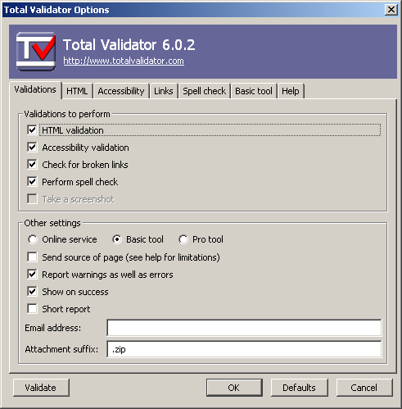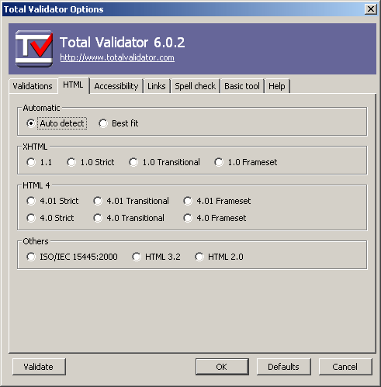

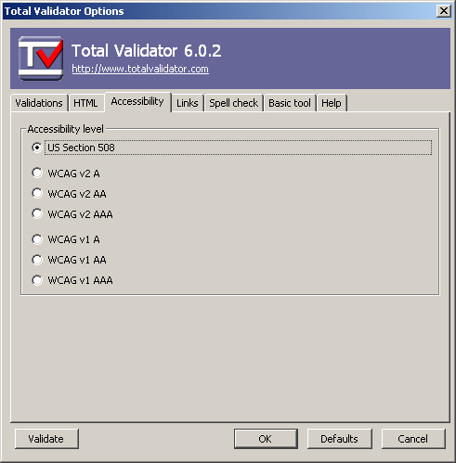

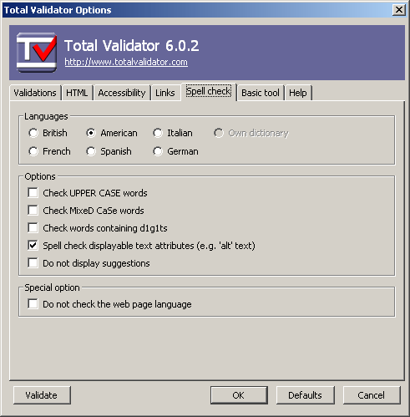
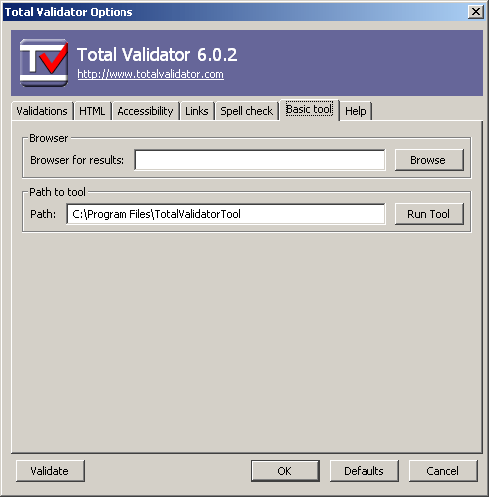
(Note the file path to the desktop utility. This is needed to check local files.)
1.3.2 Verifying Files with Total Validator
Files can be verified one at a time with Total Validator by running the desktop tool alone or by clicking the TV icon at the bottom left in Firefox.
1.3.3 Total Validator Validation Results
Total Validator results are displayed as a page in your default browser. The source code is displayed with validation suggestions inline. Descriptions of all issues are then displayed at the bottom. All failed checkpoints will need to be fixed and revalidated.
Errors
All Section 508 and W3C markup errors will need to be fixed and revalidated.
Warnings
All Section 508 and W3C warnings should be corrected to the best of your ability.

1.4 PDF Accessibility
All downloadable pdf files on the NCMMIS are also required to be Section 508 accessible. The same standards hold true for pdf files. Scanned images of text are not allowed. All image elements need to have a text equivalent.
1.4.1 Adobe Acrobat
Adobe Acrobat will be used to validate pdf files for Section 508 Accessibility

Choose Advanced > Accessibility > Full Check
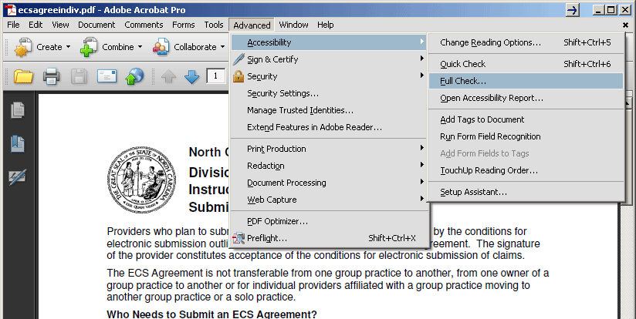
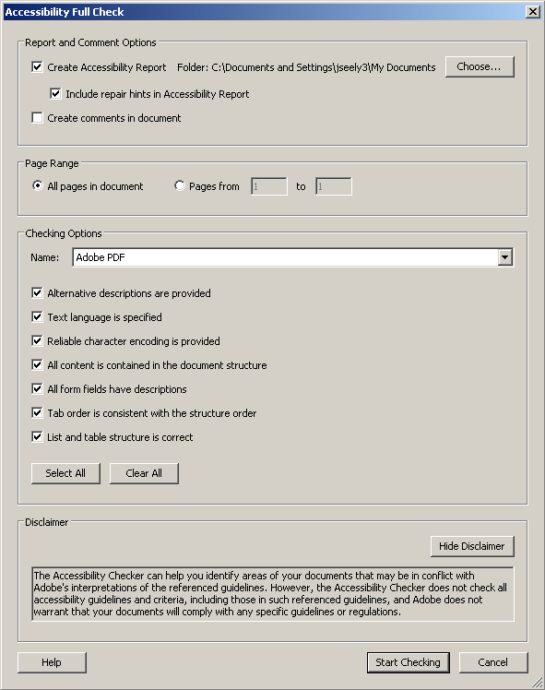

1.4.2 Acrobat Validation Results
Acrobat lists accessibility issues and gives suggestions to fix problems. All pdf files need to pass Acrobat validation.

2. W3C

2.1 W3C Overview
The World Wide Web Consortium (W3C) provides industry standards and guidelines for web development. These standards provide compatibility across all web technologies avoiding proprietary standards and market and web fragmentation. It is important to conform to these standards to ensure full accessibility and future compatibility.
All MMIS code must comply with W3C Markup standards for XHTML 1.0 Transitional. With the W3C compliance requirement, developers must use best-practice coding techniques and validate all work with validation software before being sent for testing.

2.2 W3C Markup Validation service
(X)HTML markup can be validated online at http://validator.w3c.org. Local files can be uploaded for validation, or code can be entered directly to be validated for W3C markup compliance.
2.2.1 W3C Markup Validation Results
W3C Markup Validation Service results list all errors and warnings with a description and helpful information. Each description tells what line of code the error/warning occurred.
Errors
All W3C markup errors will need to be fixed and revalidated.
Warnings
All W3C warnings should be corrected to the best of your ability.

2.3 Total validator
The settings described in Section 2.3.1 automatically validate for W3C Markup compliance. Total Validator may be the quickest way for developers to validate accessibility and standard markup. Total Validator tests true (X)HTML validation against official W3C published DTDs.
Appendix B: jQuery Best Practices
- Separate JavaScript functionality
- Bad: <a onclick=”doSomething()” href=”#”>Click</a>
- Good: <a href=”backup_link.html” class=”doSomething”>Click</a>
- Then with jQuery: $(‘#doSomething’).click(function() { … } );
- NEVER depend on JavaScript
- Code should be written so that page validates and works when JavaScript is disabled.
- Good markup first
- Never use tables for layout of non-tabular data. Use the proper HTML elements and style them accordingly.
- Use proper selectors
- $('#mydiv') // Element with ID "mydiv"
- $('p.first') // P tags with class first.
- $('p[title="Hello"]') // P tags with title "Hello"
- $('p[title^="H"]') // P tags title starting with H
- BAD:
- $('p#mydiv') // will iterate over all <p> tags and then look for the mydiv id, it is much faster and more efficient to only look for the id of the item. If your code passes validation, only one item should have that id.
- $(document).ready is your friend, but $(window).load is your soul mate
- Although $(document).ready is incredibly useful, it occurs during page render while objects are still downloading. If you notice your page stalling while loading, all those $(document).ready functions could be the reason why.
- You can reduce CPU utilization during the page load by binding your jQuery functions to the $(window).load event, which occurs after all objects called by the HTML (including <iframe> content) have downloaded.
- Use jQuery to hide objects, not CSS
- Use jQuery tools to make your life better
- Always descend from an #id
- Cache jQuery objects
- Leverage Bubbling
- Limit validation to specific events and fields.
- If you are validating email input, there is no reason to validate unrelated fields.
- Form validation should occur on the client and the server side, refer to item #2.
- The client side validation is helpful for the user and scrubs the data before the server gets it, but the form should work properly with all JavaScript and CSS disabled.
- An ID can only contain a-z, 0-9, or a dash '-', and be terminated by a non-ascii character or an escape.

Sources
http://www.smashingmagazine.com/2008/09/16/jquery-examples-and-best-practices/
http://www.artzstudio.com/2009/04/jquery-performance-rules/
Appendix C: Naming Styles and Conventions
File
All files in the sandbox area should follow the camelCaseConvention, as will the supporting .js and .css files. Those that do not may be renamed to support this convention.

Element ID and Name
- Because support is so inconsistent between current browsers as well as older releases, we will not use underscores or periods in class and ID names. A common substitute is the hyphen character (-), as in:
element-name-0 vs. element.name[0] or element_name[0]
ideally, this would be elementName
- According to the CSS selector spec, they don't allow the period '.'
character, for the obvious reason. I'm not sure how familiar you are
with language grammars, but the important parts are:
"#"{name} {return HASH;}
which refers to:
name {nmchar}+
which refers to:
nmchar [a-z0-9-]|{nonascii}|{escape}
Which states that an ID can only contain a-z, 0-9, or a dash '-', and
be terminated by a non-ascii character or an escape.

References:
https://developer.mozilla.org/en/Underscores_in_class_and_ID_Names
http://groups.google.com/group/jquery-en/msg/ca6ecd94ad4a23bd
http://www.w3.org/TR/REC-CSS2/grammar.html
Appendix D: CSC Contact Information
If you have any inquires about this guide or CSC, please feel free to contact us.

http://code.google.com/p/jqueryjs/downloads/detail?name=jquery-1.3.2.min.js
http://flowplayer.org/tools/index.html
http://plugins.jquery.com/project/CoolInput
http://www.dillerdesign.com/experiment/DD_roundies/#download

