Improving principal component analysis through dynamic components

Introduction and Background
A central question of air quality studies is to determine what chemical and/or meteorological processes contributed to measured pollutants. The question is important because determining what explains pollutant concentrations measured at a given monitor enables appropriate enforcement to lower those concentrations to occur.
Since it is practically impossible to know the position of every particle from when it is emitted to when it hits the monitor, many have turned to mathematical models to address the question of where pollutants come from.^{15,16} One such statistical model is Principal Component Analysis (PCA). An early use of PCA was by Blifford et al. in 1967 to explain air pollutant concentrations taken by the U.S. Public Health Service. Blifford et al. argued that around 70% of the measured pollutant concentrations could be explained by heavy industry, automobiles, fuel burning, and petroleum refining from their PCA results.¹⁷ After it was realized that other statistical techniques such as Ordinary Least Squares regression were unsuitable due to air quality data having inherent uncertainties in both dependent and independent variables,¹⁶ PCA was taken up in earnest, being used by Henry and Hidy to analyze particulate sulfate sources in New York and Los Angeles,¹⁸ Buhr et al. to assess emission ratios from different sources in a field in Pennsylvania,¹⁹ and Hopke et al. to analyze sources of particulate material in Boston’s urban aerosol.²⁰ More recently, it has been used to study different contributions to ozone concentrations.^{21,22}, identify potential relationships between health outcome and air quality variables,²³ and as inputs into artificial neural networks to predict hourly ozone concentrations.²⁴
However, it was recognized that PCA had many limitations that needed to be addressed in air quality applications.¹⁶ One limitation is that PCA is ill-suited for quantitative apportionment applications due to the necessity of scaling the data to ensure all variables are equally weighted in the solution. Another limitation is the lack of non-negativity constraints, which made results derived from the method not suitable for explaining chemical and physical data. Finally, to perform the analysis one assumes uniform uncertainty across all samples of a given variable, when uncertainties in many air quality data applications are more complex.¹⁶
These limitations made Positive Matrix Factorization (PMF) a more popular technique for addressing source apportionment question, first described by Paatero and Tapper.²⁵ PMF can be viewed as solving the apportionment problem as a regression problem with a weighted objective function. Instead of assuming that each sample for a given variable would have the same defined uncertainty, each sample would be inverse weighted by its respective uncertainty. Values with larger uncertainties would play a much smaller role in determining the decomposition. To address concerns over interpretability, the final solution would be constrained to have non-negative coefficients, which Paatero and Tapper argued were more reflective of physical reality.²⁵ PMF is currently a popular technique utilized in many air quality applications.¹⁶ However, there are air quality data applications in which full specification of the uncertainties of every single measurement is unfeasible. Larson et al. argued that specifying uncertainty was unfeasible for their application and proceeded to use Absolute Principal Component Scores to perform quantitative analysis with derived factors.¹⁰ PCA should still be utilized in situations in which characterizing measurement uncertainty is practically impossible and still finds use in these settings today.
A glaring issue with both PMF and PCA is that both are linear models when air quality data can exhibit non-linear behavior on extended time scales.²⁶ Additionally, both PMF and PCA are frequently constructed in a way that does not address how relationships between air quality variables change over time. There is a need for statistical models that address the reality that air quality data variables can exhibit non-linear, temporally dependent relationships to one another which is not adequately addressed in either PCA or PMF frameworks.
In this chapter, I discuss a method called Dynamic Principal Component Analysis (DPCA) and apply it to 9 pollutant/meteorological variables in the Houston area. This work builds off the ideas of Melnikov et al. which were originally uploaded to a preprint server.²⁷ They defined DPCA as PCA employed on a moving time window. DPCA has been used in a wide variety of contexts, such as chemical process analysis and control,^{28–30} climate,³¹ and electroencephalography analysis.³² Implementing PCA on a moving window can address many of its issues, such as creating a set of statistics that capture time dependence, formulating non-linearity through a set of linear models that change throughout time, and addressing uneven uncertainties. While recent work in a related dimension reduction technique, Positive Matrix Factorization (PMF), has incorporated a moving time window in its analysis in recognition of the temporal complexity of air pollution measurements,^{6,7} it has not been implemented (to my knowledge) in PCA until the preprint authored by Melnikov et al. Some in the past have approached issues with time complexity either through analyzing data segregated by season^{33,34} or by hour of the day,³⁵ but have not implemented a moving window. In this chapter, I will summarize the efforts of Melnikov et al. to implement a moving time window, showcase the results of applying DPCA to stationary monitor measurements of 9 different variables taken across the span of 4 years in the Houston area, and conclude by comparing performance of DPCA to applications of static PCA that were previously published.

Overview of Melnikov et al.

Methodology and Notation Definition
Here I will discuss the methodology used in Melnikov et al. and employed here for consistency. I will start off by briefly discussing PCA, then explain the notation of DPCA. I will then talk about the results in Melnikov et al. briefly.
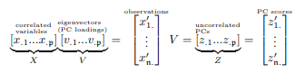
Principal Component Analysis (PCA) is a dimension reduction technique used to interpret large data sets while preserving as much original information as possible.³⁶ Following the notation of Melnikov et al., we define a centered data matrix $X=\left[x_{np}\right]∈R^{n×p}$ with $n$ observations and $p$ variables, each row following the same multivariate distribution with fixed mean and variance parameters, estimated as $\left(0,Σ\right).$ A (static) principal component analysis (PCA) is defined as a linear transformation of these correlated variables to uncorrelated principal components, $z_{.k}, k=1,…,p$, which we take from Melnikov et al.:

Equation 1. A centered data matrix with $p$ variables and $n$ observations. Taken from Melnikov et al.²⁷
$v_{.p}∈R^{n}$ are the loading coefficients, $x_{n.}^{'}∈R^{p}$ are the $n$ multivariate observations, and $z_{n.}^{'}∈R^{p}$ are the corresponding scores. The objective of PCA is to decompose a data matrix $X$ into these two matrices $V$ and $Z$ which correspond to the loadings and scores, respectively. To achieve this decomposition, one either employs a singular value decomposition (SVD) on the data matrix $X$ or an eigenvalue decomposition on its covariance matrix, $Σ_{pxp}$. The squared eigenvalues in the decomposition of $Σ_{pxp}$ are thought to represent the variances representative in each component. The larger the variance, the more information retained in that component, whereas the smaller the variance, the less information retained in that component. Thus, to circle back to the original objective of PCA, components with small variances provide little information and are frequently tossed, whereas the larger components are retained.
As mentioned in the introduction, drawbacks of PCA are that it is scale-dependent and that loading coefficients can take negative values which are inconsistent with physical models of reality.^{16,37} To combat these issues, some have implemented transformations of PC loadings,^{10,15} while other have implemented a priori constraints.^{38,39} A more detailed discussion of the mathematics in PCA is established in Melnikov et al., Mardia et al., Jolliffe et al., and Jackson.^{27,36,37,40} A detailed discussion of the use of PCA and other dimension reduction techniques in atmospheric applications is given in Hopke,¹⁶ and a fitting introduction given in Seinfeld and Pandis.¹⁵
As mentioned previously, Melnikov et al. defined DPCA as application of static PCA on a rolling time window. In their work, they assumed a time window $l=45$ days, which we use in follow-up work here. 45 days was chosen because it is assumed that the variables would be approximately cyclostationary on that time interval.
To denote the time dependencies of statistics determined, Melnikov et al. defined the following notation:
$${\text{EV}}_{h.k}≔{\left[{\text{EV}}_{hdk}\right]}_{∀d}∈R_{+}^{d}$$
$${\text{EV}}_{..k}≔{\left[{\text{EV}}_{hdk}\right]}_{∀h,d}∈R_{+}^{24×d}$$
Equation 2. Notation for Dynamic Principal Components.
where $h$ is an hour of a day, $d$ is a day of the time period, and $k$ identifies the corresponding $k^{th}$ PC. A dot in place of an index signifies for all values of that index. One dot would designate a vector, two dots a matrix, and three dots a three-dimensional (3D) array. Similarly, dynamic PC loadings are defined via a four-dimensional array $V=\left[v_{hdpk}\right]∈R^{24×d×p×p}$ with analogous definitions $v_{h.pk}∈R^{d}$, $v_{hdp.}∈R^{p}$, $v_{hd..}∈R^{p^{2}}$, $v_{.dp.}∈R^{24×p}$, and $v_{h…}∈R^{d×p×p}$ and dynamic PCs $\left[{\text{PC}}_{hdk}\right]∈R^{24×d×p}$, ${\text{PC}}_{h.k}∈R^{d}$, ${\text{PC}}_{..k}∈R^{24×d}$, etc. Observations across all monitors are aggregated with the median and are indexed by hour $h=0,…,23$, by day $d=1,…,1460$, and by measured variable $p=1,…,9$, representing ${\text{O}}_{3}$, $\text{CO}$, ${\text{NO}}_{2}$, ${\text{SO}}_{2}$, ${\text{PM}}_{2.5}$, $\text{Temp}$, $\text{WS}$, $\text{RH}$, and $\text{P}$, respectively. These would form the related matrix ${\text{SAO}}_{h}≔{\text{SAO}}_{h..}={\left[\tilde{x_{hdp}}\right]}_{∀dp}=∈R_{+}^{1460×9}$, where $\tilde{x}$ is used to signify the median.

Summary of results from Melnikov
Melnikov et al. employed their DPCA methodology on hourly spatial medians of Houston stationary monitor hourly averages of 5 pollutants: ozone, carbon monoxide, nitrogen dioxide, sulfur dioxide, and fine particulate matter. The spatial medians were transformed to be log differenced due to exhibiting greater multivariate normal behavior. They proceeded to show plots of moving window averages of their hourly spatial medians, as well as dynamic correlation plots of their spatial medians, to justify the use of DPCA. Using 3D heatmaps and compact boxplots, they were able to explore seasonal and diurnal variations in EVs of their dynamic principal components. They concluded by arguing for the implementation of a dynamic approach because it made apparent seasonal and diurnal patterns which were not obvious in static PCA applications.²⁷

DPCA: Current Efforts

Data
The Texas Commission on Environmental Quality (TCEQ) provides access to a wide variety of measurements from Texas air quality monitoring stations (sites). Used monitoring sites were located in the Houston-Galveston-Brazoria TCEQ region (12); see Figure 1. We follow Melnkov et al. in using the same 5 pollutants (ozone (${\text{O}}_{3}$ in ppb), carbon monoxide ($\text{CO}$ in ppm), nitrogen dioxide (${\text{NO}}_{2}$ in ppb), sulfur dioxide (${\text{SO}}_{2}$ in ppb), and fine particulate matter (${\text{PM}}_{2.5}$ in $μ\text{g}/{\text{m}}^{3}$)), but choose to incorporate 4 additional meteorological variables, which were temperature ($\text{Temp}$ in ${}^{∘}$F), wind speed ($\text{WS}$ in mph), relative humidity ($\text{RH (\%})$), and barometric pressure ($\text{P}$ in mb). We use and update Melnikov’s algorithms for running DPCA published in $R$ (version 4.x) and utilizing core (base, stats), xts, lattice, and magick packages. We choose to update the time period of the analysis, using dates which spanned a recent 4 year period (1/1/2016 00:00 CST to 12/31/2019 23:00 CST, 1460 total days). We elect to use the same strategy to address transitions between standard time and daylight savings time as Melnikov, which is to remove one of the duplicate observations taken in November (CDT to CST) and interpolate between 12 AM and 2 AM for the measurement at 1 AM in March (CST to CDT). It is important to note that not all sites measured all parameters used in this study. Table 1 describes the sites used and the parameters they measured.
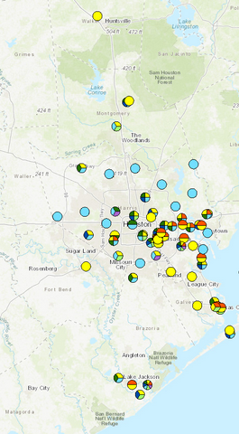
Figure 1. Map of TCEQ monitors used in this analysis. Map depicts the TCEQ Houston-Galveston-Brazoria regulatory region.
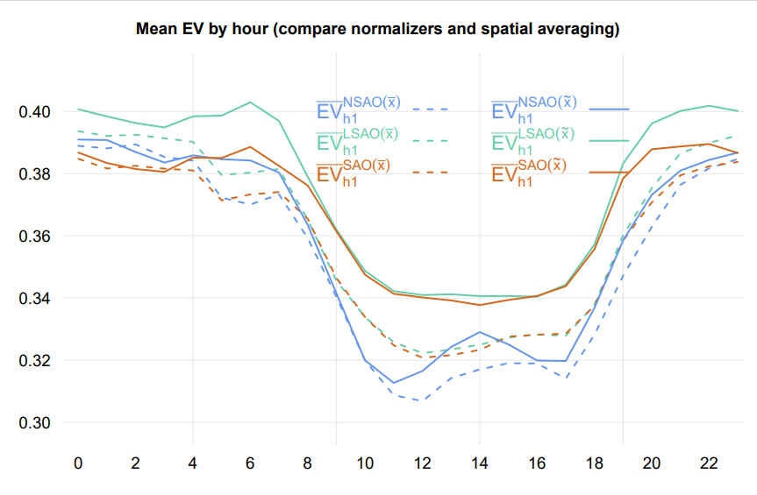
In using algorithms originally written by Melnikov et al., we note that we elect to log transform rather than log difference transform the derived hourly spatial medians of the 9 measured variables. We acknowledge that PCA is sensitive to outliers and that some transformation is necessary; however, we follow conventional environmental practice and log transform the hourly spatial medians instead of log differencing them.¹⁵ We also note that the EVs returned by log transformed observations is consistently higher than the log differenced transformed observations, as shown in Figure 2.
Figure 2. Mean EV plotted by each hour for non-transformed (SAO), log-transformed (LSAO), and log-differenced-transformed (NSAO) observations. $\overline{x}$ designates the spatial mean, while $\tilde{x}$ designates the spatial median. Log-transformed spatial medians consistently return higher values of EV across all hours of the day.
Missing observations were imputed with monotone Hermitian splines for up to 4 consecutive missing observations, as done in Melnikov et al. Table 2 gives the percentages of observations interpolated for each pollutant throughout the study period.

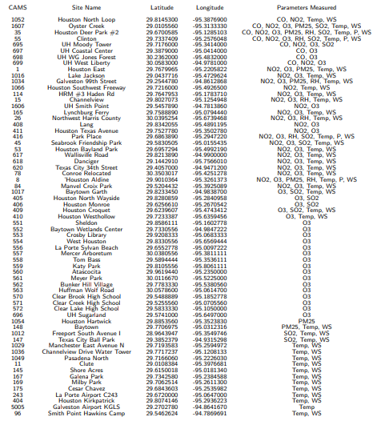
Table 1. TCEQ monitors, along with their latititude/longitude coordinates and measured parameters, used in the analysis.

 | $$O_{3}$$ | $$CO$$ | $$NO{}_{2}$$ | $$SO_{2}$$ | $$PM_{2.5}$$ | $$Temp$$ | $$WS$$ | $$RH$$ | $$P$$
% Interpolated | 0.85 | 0.83 | 1.89 | 1.45 | 0.42 | 0.09 | 0.11 | 0.25 | 0.1
# Sites | 47 | 8 | 26 | 12 | 7 | 39 | 38 | 7 | 4
Table 2. Summary of percentage of points interpolated for a given pollutant, as well as the total number of sites in the study that measured them.

Updated plots of Dynamic Correlation, EVs, and Loading Coefficients
I take the updated data and algorithms and replot the dynamic correlations, EV heatmaps, and loading coefficients to probe new relationships between the pollutant and meteorological variables. Figure 3 shows the dynamic correlations between all sets of variables used in the updated study. Figure 4 shows the updated heat maps. Figure 5 shows the dynamic loading coefficients plotted for the 7 AM hour in Houston, chosen due to the high values of EV in the first component.

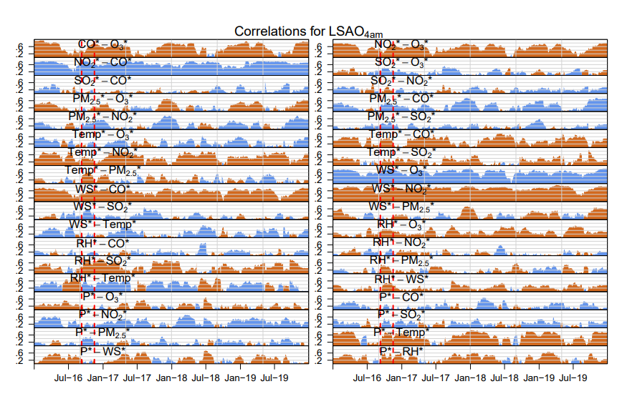
Figure 3. All time-varying correlations between the variables exhibited for the 4AM hour during the study period. Orange color denotes a negative correlation; blue color denotes a positive correlation. The time-varying correlations justify the use of DPCA.
In Figure 3, we note the existence of strong relationships between ${\text{O}}_{3}^{*}$ (i.e. normalized and standardized ${\text{O}}_{3}$), ${\text{CO}}^{*}$ and ${\text{NO}}_{2}^{*}$, consistent with the titration of ${\text{O}}_{3}^{*}$ in traffic-related emissions. Both ${\text{CO}}^{*}$ and ${\text{NO}}_{2}^{*}$ exhibit strong anticorrelations with ${\text{WS}}^{*}$, consistent with higher values of wind speed diluting these particular traffic related pollutants. There are also seasonal patterns apparent in certain correlations between variables. ${\text{CO}}^{*}$ and ${\text{O}}_{3}^{*}$ are more negatively correlated in winter than in summer. Correlations between ${\text{RH}}^{*}$ and ${\text{Temp}}^{*}$ switch between being positive and being negative throughout the year. These plots establish how correlations between the sets of variables presented are time sensitive and serve to further justify the use of DPCA as previously established in Melnikov.²⁷
Figure 4 displays the gridded heatmaps updated from Melnikov et al. The heatmaps display similar temporal patterns previously discussed in Melnikov, with a notable exception. The EV of the first dynamic component exhibits apparent diurnal and seasonal patterns, peaking at 7 AM, receding into the late afternoon hours, and going up in earnest starting at 6 PM. The seasonal pattern is similar to what was previously shown in Melnikov, with contributions of the component increasing in winter time and decreasing in summer time. The EV of the second component serves to mostly complement the EV of the first complement, apart from notable episodic bursts. One such burst (the burst with highest value of EV in the 2nd component) is denoted by black lines in Figure 4 and ,with the same time period highlighted with red lines in Figure 3. Possible interpretations are discussed in
Figure 5 shows the dynamic loading coefficients for the first 3 components, separated by normalized pollutant for the 7 AM hour. The loading coefficients were smoothed with a 45-d window similar to Melnikov. Loadings in the first component show consistent positive contributions from ${\text{O}}_{3}^{*}$, ${\text{CO}}^{*}$, and ${\text{NO}}_{2}^{*}$ and a consistent negative contribution from ${\text{WS}}^{*}$. Loadings in the second component are influenced by ${\text{SO}}_{2}$, ${\text{Temp}}^{*}$, ${\text{RH}}^{*}$, and ${\text{P}}^{*}$. Further interpretation of these components is given in Section 2.3.3.

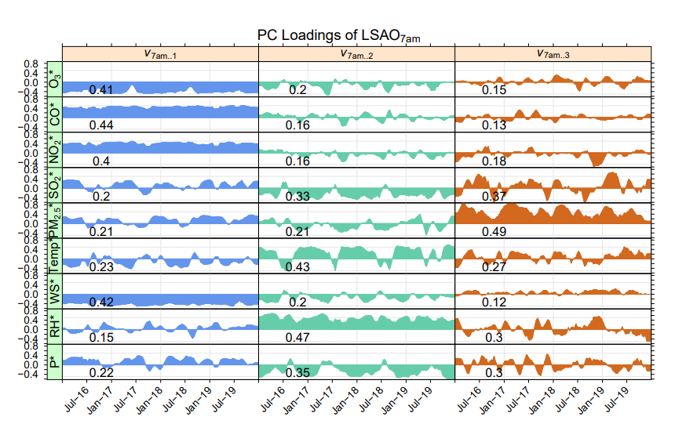
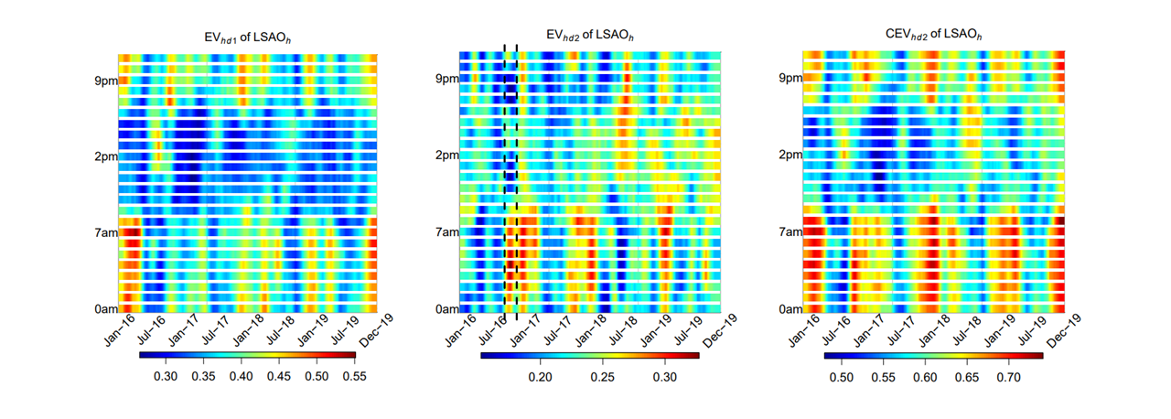
Figure 4. Heatmaps of EV for each of the dynamic components. The black lines designate a period of heightened EV in the 2nd component, which is from September 9, 2016 to November 16, 2016.
Figure 5. Dynamic loading components for the first component at the 7 AM hour in the Greater Houston area.

Interpretation
In this section, we provide potential explanations for the derived results. It is worth noting that in the absence of additional modeling, it is difficult to determine the specific relationships between the variables from PCA alone.¹⁵ Nonetheless, we argue that a DPCA application is superior to PCA application in the information it retrieves and allows the user to ask questions about the data which would not be apparent in a static use case alone.
As mentioned above, the first component exhibits heightened EV in the evening to early morning hours, peaking around 7 AM, before receding into the late morning afternoon hours. The EVs are higher in the winter period compared to the summer period. These patterns are consistent with the temporal patterns of the mixing height, defined by Seinfeld and Pandis as the height of an unstable layer of air in contact with the surface.¹⁵ Observations from Houston suggest that the height contracts during nighttime hours and winter months and are consistent with the patterns described above.⁴¹ Additionally, the loadings in the first dynamic component shown in Figure 5 are consistently elevated in ${\text{CO}}^{*}$and ${\text{NO}}_{2}^{*}$, two traffic-related emission variables whose contributions to the observed concentrations would be modulated by variations in the mixing height.
The interpretation of the 2nd dynamic component is trickier. Figure 4 illustrates EV patterns in the 2nd component mirroring those in the 1st component, with increases in the late morning to early afternoon hours and recessions into the evening hours. However, as mentioned previously, there are notable episodic bursts which shatter this pattern of behavior. The black lines in Figure 4, as well as the red lines in Figure 3, capture an episode from September to November in 2016 in which this second principal component explains > 30% of the variance. To explore the episode further, we plot the hourly dynamic loading coefficients at the 4 AM hour, the hour in which this component has maximum EV, in Figure 6 and the dynamic correlations for the ’16 year with a paneled background colored by hourly averaged wind direction in Figure 7.
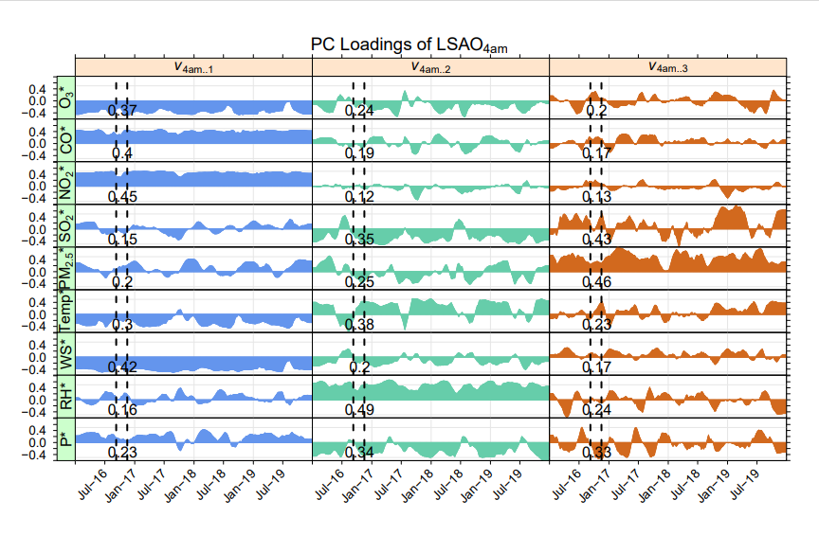
In the second component dynamic loadings plotted in Figure 6, we observe the dominance of ${\text{SO}}_{2}^{*}$, ${\text{Temp}}^{*}$, ${\text{RH}}^{*}$, and ${\text{P}}^{*}$ with average absolute values of 0.33, 0.43, 0.47, and 0.35, respectively. In general, the ${\text{RH}}^{*}$ loadings appear to be largely anticorrelated with ${\text{SO}}_{2}^{*}$ and ${\text{P}}^{*}$ loadings and correlated with ${\text{Temp}}^{*}$ loadings, though there are noticeable blips that occur primarily in the summertime. Zooming in on the time period of heightened EV, we observe steady increases in ${\text{P}}^{*}$, ${\text{Temp}}^{*}$, and ${\text{SO}}_{2}^{*}$ and a blip in ${\text{RH}}^{*}$, suggesting that the 2nd dynamic component is placing increased importance on these variables during this time period. Looking at the dynamic correlations plotted in Figure 7, we denote abrupt changes in the relationships exhibited between meteorological variables and ${\text{SO}}_{2}^{*}$. The shift in correlation between ${\text{RH}}^{*}$ and ${\text{Temp}}^{*}$ is not entirely unexpected; previous work has shown that there can exist a negative relationship between these two variables at high temperatures,^{42,43} while during the cooler months cold fronts advect dry, cool air masses into Houston. It is apparent that the component is marking a shift in meteorological conditions, but the implications of these changes on ${\text{SO}}_{2}^{*}$ concentrations cannot be determined through this analysis alone. For example, the exhibited relationship between these variables could suggest a shift between warm, summertime meteorological conditions and drier, cooler conditions brought in from winds advecting from the north which also happen to have ${\text{SO}}_{2}^{*}$ sources. The exhibited relationship could also signal changing meteorological conditions which affect ${\text{SO}}_{2}^{*}$ chemistry. This scenario is a common problem in PCA applications, as described in Seinfeld and Pandis.¹⁵
Figure 6. Dynamic loadings for the first three components in the 4 AM hour. The black lines denote an interesting episode that took place between September 9 – November 16, 2016.

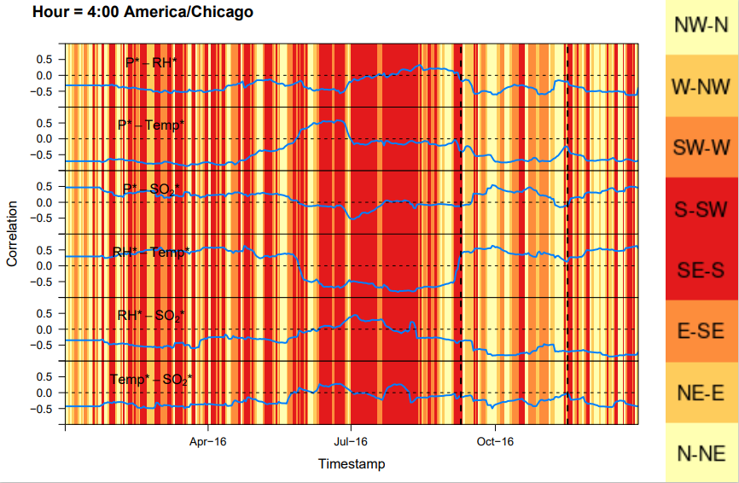
Figure 7. Dynamic correlation plot with colored background corresponding the hourly averaged wind direction. Wind direction colors are denoted in the color bar on the far right.
While our DPCA analysis still leaves open questions which may be unsatisfactory to an atmospheric scientist, it is worth noting that a static application of PCA would fail to capture these diurnal and seasonal dynamics. Figure 8 illustrates a side-by-side comparison between the EV of a static PCA and a dynamic PCA. The left panel in Figure 8 is what would result if no rolling window were applied and the static assessment were performed on each hour separately. As is evident in Figure 8, dynamic PCA reveals temporal patterns throughout the year that its static counterpart cannot do. The application of DPCA allows the user to ask questions about the data which would not be apparent in a static application alone, making it more suitable for analyzing atmospheric data on extended time scales.
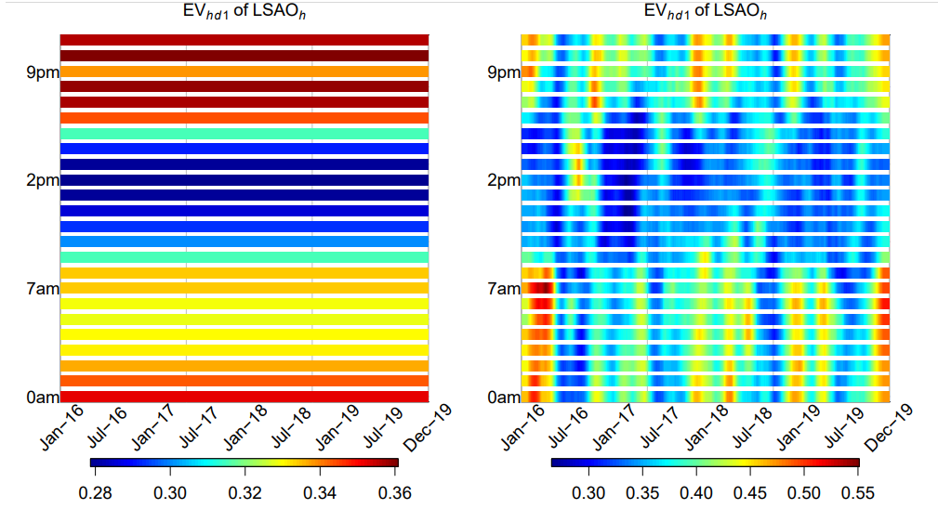
Figure 8. Side-by-side comparison of static and dynamic principal components. Static components fail to capture the temporal variations evident in a dynamic approach.

Discussion and Future Directions
In this chapter, I have built off the work first done by Melnikov et al. and applied DPCA to stationary monitor hourly averages of 9 different variables in the Houston area. In doing so, I illustrate that DPCA is superior to a static PCA because it allows the user to see temporal variations in their derived components which would not be apparent in a static assessment alone. This would allow the user to ask more interesting questions about temporal variations in their data instead of being left in the dark.
I briefly compare performance of these dynamic components to static assessments of the past,^{35,44} as was done in Melnikov et al., for the updated data set. In short, I calculate the overall average ${\overline{\overline{\text{EV}}}}_{1}$ (averaged across all hours and days, or the average of all entries in Figure 4) and the overall average of ${\overline{\overline{\text{CEV}}}}_{2}$ and compare these values to the ${\text{EV}}_{1}$ and ${\text{CEV}}_{2}$ of the static assessment strategies described in Statheropolous et al. and Abdul-Wahab et al. applied on our Houston dataset. These values are provided in Table 3.
 | $$EV_{1}$$ | $$CEV_{2}$$
Summer (Statheropolous) | 0.50 | 0.71
Winter (Statheropolous) | 0.47 | 0.65
Daytime (Abdul-Wahab) | 0.34 | 0.53
Nighttime (Abdul-Wahab) | 0.37 | 0.57
This study (${\overline{\overline{EV}}}_{1}$ , ${\overline{\overline{CEV}}}_{1}$) | 0.38 | 0.60
Table 3. Results from published methods Abdul-Wahab et al. and Statheropoulous applied to the same log-transformed dataset for comparison.

The higher values derived by the Statheropolous technique presented in Table 3 suggest that it has better performance, on average, compared to the DPCA technique. However, it is worth noting that ${\text{EV}}_{1}$ returned by DPCA is higher for some time periods than the 0.50 returned by the Statheropolous technique (range is $≈ 24\%$ to $≈59\%$). Additionally, we note that Melnikov et al. consistently derived higher values of ${\text{EV}}_{k}$ in their work compared with ours. Reasons for this need further exploration.
In this chapter, I show how employing dynamic PCA offers advantages over its static counterpart. In static PCA assessments, assumptions of stationarity are often employed that are not suitable for air quality applications, and temporal dynamics present in air quality data are not often considered. This is evident in the results we present here, in which our dynamic components showed clear temporal trends and that would not have been yielded in a static application. Using a dynamic approach allows researchers to ask interesting questions about atmospheric processes occurring on finer time scales that would otherwise not be apparent in a static application.

