GoLens for GitLab

Application Design Review

STATUS  Proposed |  | OWNER  GoLens maintainer |  | LAST UPDATED  July 17, 2026

Authors | Codex
Reviewers | GoLens maintainer
Related docs | README.md and shipped screenshots
Scope | Current GoLens user-interface surfaces.

1. Abstract
GoLens already delivers a compact, local-first review workflow inside GitLab. The design is functional and unusually well tested, but its four user-facing surfaces have evolved as separate visual systems: a warm branded onboarding and control rail, a dense popup, and a cooler IDE-like semantic popover. The result is coherent within each surface but inconsistent as one product.
This review recommends a GitLab-native direction with restrained GoLens branding. Shared tokens, one icon language, explicit component states, and a clearer popup hierarchy should improve trust and legibility without changing behavior, storage, permissions, Shadow DOM isolation, or same-origin source handling. This document is a specification only; it does not modify application code.

2. Goals and Non-Goals
Goals | Non-goals
Make all shipped surfaces read as one product while remaining at home inside GitLab. | Rebuild the extension, migrate frameworks, or replace vanilla HTML and CSS.
Give every control a clear hierarchy and complete keyboard, pointer, loading, success, and failure states. | Change semantic navigation, caching behavior, storage keys, worker messages, or permissions.
Centralize a small visual contract for color, type, spacing, radii, icons, shadows, and motion. | Turn an embedded developer tool into a marketing-style interface or over-brand GitLab content.
Keep rollout incremental, reviewable, reversible, and covered by current tests plus visual checks. | Promise automatic support for GitLab themes or DOM variants that are not currently tested.

3. Background, Evidence, and Findings
The extension uses dependency-light vanilla JavaScript and CSS. The popup has its own stylesheet; the control rail and onboarding embed CSS in separate Shadow DOM templates; the semantic popover embeds a third stylesheet; and focus-mode additions live in global CSS. No shared CSS custom properties connect these surfaces. Current assets include two 1254 × 1254 PNGs of roughly 1 MB each, although the control rail displays them at 32 px.
Evidence came from the current committed UI source, rendered screenshots, shipped screenshots, asset inspection, and regression tests. The review sampled key text contrast and found comfortable ratios, including 7.14:1 for popup helper text, 7.81:1 for onboarding card copy, and 6.08:1 for popover secondary text. Functional baseline: 99 unit tests passed and the headless browser injection smoke test passed.

What is already strong
• The control rail mounts beside GitLab’s AI control instead of floating over the diff, preserving spatial context.
• The semantic popover has strong information hierarchy, monospace location context, clear loading feedback, and distinct in-diff versus new-tab destinations.
• Onboarding is replayable, responsive, keyboard trapped, dismissible with Escape, and exposed as an ARIA modal.
• Status copy is direct, privacy messaging is specific, sampled text contrast is strong, and tests cover the most important interaction contracts.

Prioritized findings
P1 — Replace the photorealistic eye image used for focus mode. At 32 px it is visually ambiguous, stylistically incompatible with the adjacent line icon, and heavier than the action warrants. Use a custom focus-frame SVG with the same 1.5–2 px stroke language as preload. Evidence: content.js:522–550 and assets/golens-eyestrain.png.
P1 — Introduce shared design tokens. Popup, onboarding, controls, popover, and global focus CSS currently hard-code separate neutral and accent palettes. Centralize token names, then expose them to each Shadow DOM surface by a shared CSS string or build-time constant. Evidence: popup.css:1–29, content.js:519–611, go-navigation.js:1091–1126.
P1 — Clarify popup hierarchy and interaction states. The 260 px popup gives equal visual weight to onboarding, caching, and destructive cache clearing; toggles have no authored focus-visible treatment; buttons lack pressed feedback. Preserve compactness but separate primary status, preferences, support, and destructive actions.
P2 — Replace the onboarding’s equal three-card row with one compact vertical workflow or numbered rail. The current row is generic and forces uneven text density at desktop widths even though the mobile layout already becomes more readable. Evidence: content.js:595–610.
P2 — Resolve typography by using GitLab/system UI fonts for interface text and a single system monospace stack for code and metrics. “Inter” is referenced but not bundled, so actual rendering depends on the host machine.
P2 — Optimize raster assets to display size and keep the mascot for identity-bearing moments only. A 1 MB source image is unnecessary for a 32 px rail button; ship small responsive variants and retain the large original only where onboarding needs it.
P2 — Remove obsolete #gitlab-lens-focus-button rules. The current implementation uses the sidebar focus-toggle, but gitlab-lens.css:45–76 still carries an older floating pill visual system.
P2 — Keep the popover’s IDE density, but align neutral surfaces, corner radii, focus color, shadows, and header actions with the rest of GoLens. Preserve syntax-kind colors because they communicate semantics rather than brand.

4. Proposed Visual Architecture
A small semantic token layer should sit between GitLab and each isolated UI surface. The token contract provides product consistency; surface-specific component rules preserve the density appropriate to a rail, modal, popup, or code popover. GitLab content and syntax colors remain outside the brand layer.
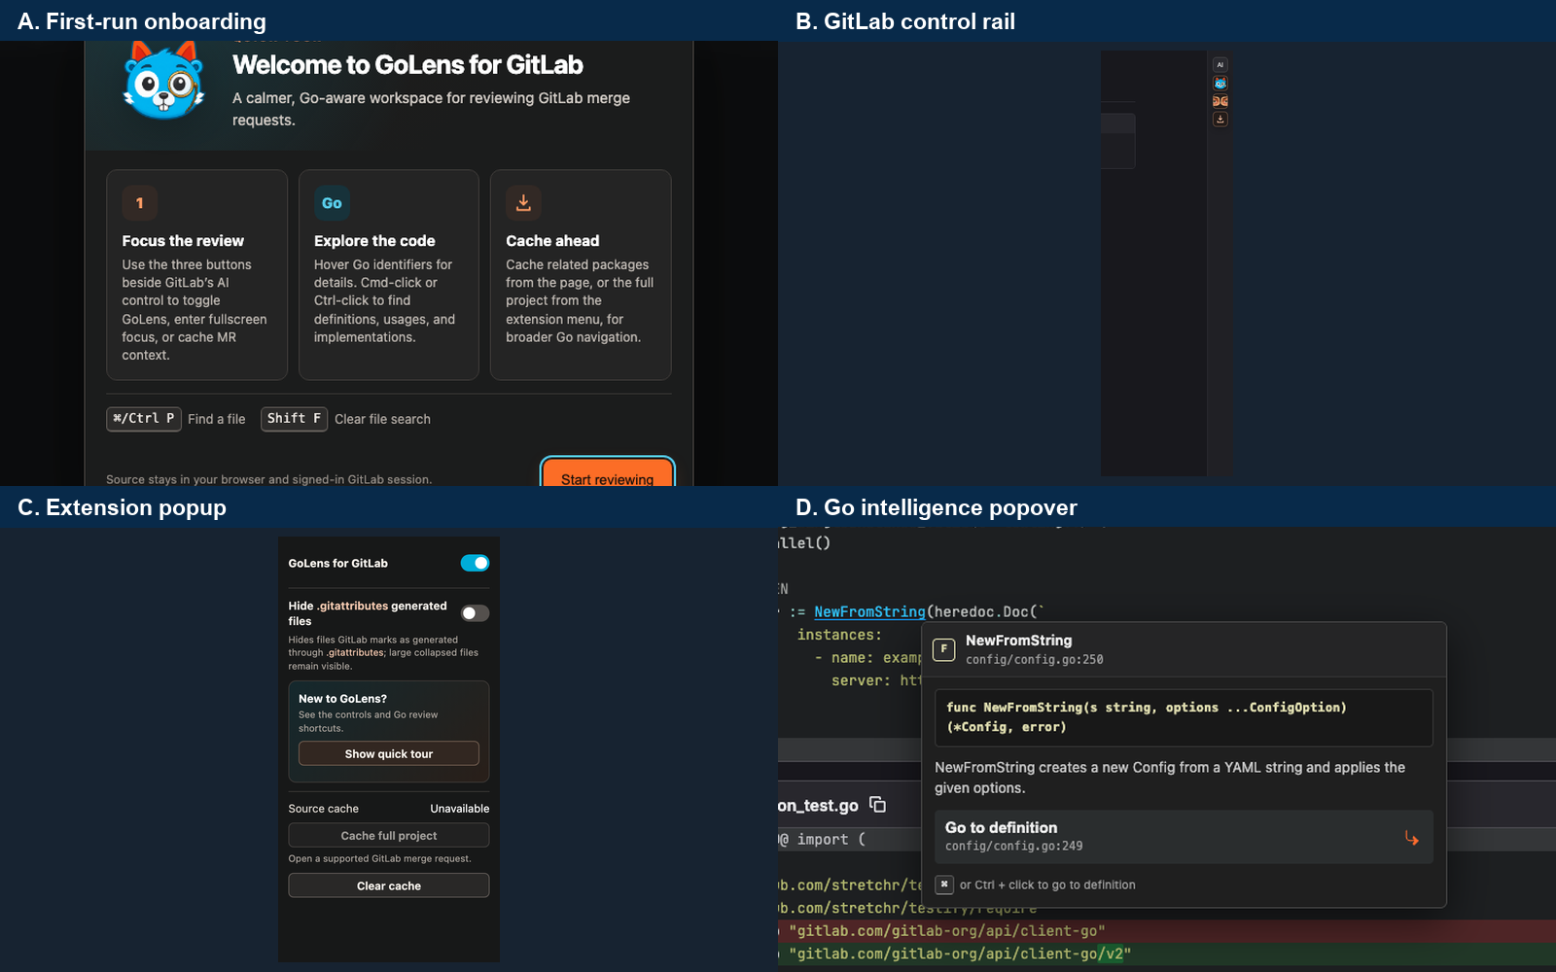
Figure 1. Current visual architecture: four capable surfaces with independent styling decisions.
Target architecture: shared semantic tokens → surface adapters → component states. Brand orange identifies primary GoLens actions; cyan is reserved for focus and informational feedback; green and red communicate terminal success and failure; GitLab and Go syntax colors retain their native meaning.

Core components

Component | Responsibility | Primary storage | Failure behavior
Semantic token contract | Defines surfaces, text, accents, spacing, type, radii, shadows, z-index, and motion. | Shared CSS/JavaScript constants; no persistent data. | Fall back to explicit system-safe defaults; never inherit unreadable host colors.
GitLab control rail | Global enablement, focus mode, and related-package caching beside GitLab’s AI control. | Existing chrome.storage and in-memory cache state. | Remain mounted but show disabled or error state; never obstruct GitLab.
Onboarding | Explains the three controls, semantic navigation, shortcuts, and local-source guarantee. | Existing local onboarding version. | Dismiss safely, return focus, and remain replayable from the popup.
Extension popup | Owns global state, review preferences, full-project cache controls, clearing, and tour replay. | Existing sync/local storage and worker/tab messages. | Expose inline status; keep unrelated controls operable when one operation fails.
Go intelligence popover | Presents symbol identity, signature, docs, destinations, copy action, and progress. | Transient DOM state plus existing semantic worker results. | Show missing or ambiguous outcomes without speculative navigation.

5. Interaction Lifecycle
- 1. Entry — A user opens the popup, triggers onboarding, selects a control-rail action, or interacts with a recognized Go symbol.
- 2. Boundary — The existing GitLab/MR checks, ARIA semantics, keyboard handling, and enabled state determine whether the action is available.
- 3. Configuration — The surface loads existing storage and cache state, then maps it to semantic component states such as idle, busy, success, error, or disabled.
- 4. Presentation — Shared tokens provide visual hierarchy while the surface adapter selects compact rail, modal, popup, or popover layout behavior.
- 5. Durable state — Only existing preferences, onboarding version, and cache data are written; visual state itself remains derived and transient.
- 6. Execution — Existing worker, tab, and same-origin requests continue unchanged. Progress updates use tabular figures and stable geometry to prevent layout shift.
- 7. Completion — The control announces the terminal state, restores focus where appropriate, preserves retryability, and emits no new telemetry.

6. Design Token and Component Contracts

Proposed visual contract

Contract | Type | Required | Description
surface.* | CSS color | Yes | Cool-neutral canvas, raised surface, overlay, border, and hover layers; no pure black.
text.* | CSS color | Yes | Primary, secondary, muted, inverse, and code text with WCAG AA targets.
accent.* | CSS color | Yes | Orange primary; cyan focus/info; green success; red error. Syntax-kind colors stay separate.
space.* / radius.* | rem or px scale | Yes | 4 px spacing rhythm; tighter inner controls and softer modal containers.
type.* | font stack and metrics | Yes | GitLab/system UI stack; system monospace for locations, code, counts, and tabular figures.
icon.* / shadow.* | SVG and shadow token | Yes | Custom 1.5–2 px line icons; one top-left light model; no photorealistic action imagery.
motion.* / z.* | duration, easing, layer | Yes | 120–200 ms transform/opacity feedback, reduced-motion alternative, and named overlay layers.

Contract guarantees

- Every actionable control exposes idle, hover, focus-visible, pressed, disabled, and busy states; terminal operations also expose success and error.
- State is identified by existing ARIA attributes and data-state values. Styling must not create a second source of behavioral truth.
- All surfaces use the same token version in one release. Screenshot evidence and the extension version identify the reviewed implementation.
- The token contract is the source of truth for GoLens-owned UI only. GitLab layout, theme values, and Go syntax semantics remain host or parser concerns.
The proposed contract should live beside the existing vanilla UI code as a shared, dependency-free token definition.
A later implementation may expose it as CSS custom properties plus a reusable Shadow DOM style string; this review does not introduce that interface.

7. Consistency, State, and Recovery

Visual feedback must be a deterministic projection of existing application state. Reconciliation after Turbo/PJAX navigation, storage changes, tab changes, or cache completion must update all mounted surfaces without duplicating controls. Reloads may reset transient hover and pressed feedback, but persisted enablement, preferences, onboarding, and cache completion retain their current behavior.
Scenario | Expected behavior | Reasoning
Repeated mount or GitLab navigation | Reuse or remount one control set with the same state and tokens. | Prevents duplicate controls and visual drift during Turbo/PJAX updates.
Storage change in another tab | Update relevant toggles and dependent disabled states in every open tab. | The visual model must follow chrome.storage.sync, not local DOM history.
Cache timeout or worker error | Keep the last stable state, show a concise error, and preserve a clear retry path. | Failure stays observable without disabling unrelated review features.
Theme or GitLab DOM changes | Keep isolated GoLens surfaces legible and decline unsafe mounting. | A missing control is safer than a misplaced or unreadable overlay.

8. Accessibility, Security, and Privacy

- Preserve the existing signed-in GitLab session, same-origin requests, commit-pinned source access, and current extension permissions. The visual redesign adds no authentication or authorization surface.
- Do not add analytics, remote fonts, externally hosted images, or repository-content uploads. UI screenshots in this review use a synthetic fixture or existing public project evidence.
- Do not introduce secrets. All proposed icons, fonts, and tokens must ship locally under the extension content security policy.
- Keep focus-visible rings, ARIA labels, modal focus trapping, Escape dismissal, status announcements, and reduced-motion behavior as launch gates rather than polish items.
- Cache retention and clearing remain unchanged. Visual state is transient and must not create additional stored user or repository data.

9. Operational Readiness
Signal | SLO or alert | Owner | Launch gate
Functional regression | npm test remains 100% green; browser injection smoke passes. | Maintainer | Required
Keyboard and screen-reader path | All controls reachable; focus visible; names, roles, and state announced. | Maintainer | Required
Visual regression | Approved screenshots for popup, onboarding, rail states, and semantic popover. | Maintainer | Required
Contrast and motion | WCAG AA for normal text; no essential animation under reduced motion. | Maintainer | Required
Asset and package size | No 1 MB image decoded for a 32 px action; packaged extension growth reviewed. | Maintainer | Recommended
Rollout constraint: implement surface by surface in reviewable commits; preserve current behavior, keep CSS and asset rollback trivial, and validate supported GitLab variants before release.

10. Alternatives Considered

Alternative | Why it was considered | Why it was not selected
Brand-forward mascot system | Creates strong recognition across every surface. | Overpowers GitLab’s developer-tool context and makes small actions less legible.
IDE-native everywhere | The current semantic popover is dense, familiar, and effective. | Makes onboarding and settings feel like an editor imitation and weakens GoLens identity.
Keep independent surface styles | Lowest immediate implementation cost. | Continues token drift, inconsistent states, duplicate CSS decisions, and maintenance cost.
Adopt a UI framework or icon library | Could standardize components quickly. | Adds runtime and dependency weight and conflicts with the dependency-light extension architecture.

11. Decisions to Confirm During Implementation
- Mascot scope — Recommended default: onboarding, extension identity, and the enable control only; never use character imagery for operational actions.
- Theme strategy — Recommended default: stable isolated dark GoLens surfaces first, then add tested GitLab-theme adaptation only when reliable host tokens are available.
- Token delivery — Recommended default: one dependency-free shared token definition copied into Shadow DOM style roots, with popup CSS consuming the same values.
- Screenshot approval — Recommended default: require maintainer approval of popup, onboarding, rail, popover, focus, loading, error, and reduced-motion states before release.

12. Decision and Next Steps
Adopt the GitLab-native direction with restrained GoLens branding. Start with tokens and iconography, then align interaction states and popup hierarchy, simplify onboarding, and finish with asset optimization and cleanup. Each milestone must preserve existing behavior and pass both automated and visual acceptance criteria before the next surface changes.
Milestone | Deliverable | Exit criteria
M1 | Shared token contract, system typography, and custom focus and preload icon set. | No behavioral diff; token mapping reviewed; rail states legible at 32 px.
M2 | Popup hierarchy and complete component interaction states. | Keyboard path, destructive-action hierarchy, busy and error states, and compact layout approved.
M3 | Simplified onboarding and aligned semantic popover surfaces. | ARIA and replay behavior preserved; responsive and reduced-motion screenshots approved.
M4 | Optimized assets, obsolete CSS removal, full regression and GitLab variant pass. | 99-test baseline stays green, browser smoke passes, package impact reviewed, rollback documented.

Use footnotes for definitions, assumptions, or terms that need precision without interrupting the main narrative.

