Protostar: Heap3

Introduction
This challenge was HARD. It is the first challenge to introduce exploiting the heap algorithm through heap metadata corruption. It looks at exploiting a vulnerability in dlmalloc which allows arbitrary write through the unlink macro.

The attack
Have a look at the structure of an in-use and free chunk in Figure 2 before starting.
We have 3 chunks in the heap and we can put in some input to each. No bounds checking so we can overflow the buffer on the heap. First things to note, free works differently with fastbins (small chunks) than with a considerably larger chunk. Fastbins can’t exploit this vulnerability. The memory must be malloc-ed for this to work. This is verified by checking the 2nd least significant bit in the size word in the chunk. So that means when we overflow the heap metadata, we want the size to be above 80B and have the second bit 0. Unlink only runs if the previous chunk’s (which is the chunk whose metadata we’re corrupting) size is even - So that means the first bit is also 0. The next thing we need to craft is the prevsize word (the word before the size word). We need it to lead into the fake chunk which we will write into the second real chunk given to us. In dlmalloc’s code, it gets to the “previous” chunk by subtracting the previous chunk’s size from the ptr to the current chunk.
So how do we lead it forward? Give it negative numbers. We want to put our chunk right inside our second allocated chunk. So we’ll tell it -8 (ptr + 8).
But won’t it realize we’re giving it a size smaller than 80B and treat it as a fastbin? Nope, it converts to an unsigned int before comparing to 80. So we will pass this test.
We also need to note that later on in the code, the heap metadata is used, even past our unlink macro. So we need to make sure this metadata makes sense, else we segfault. Something to do with the next chunk after our current chunk. It finds the next chunk by adding current chunk ptr with the size. If the size is -4, it just points to itself. So lets do that.
Now we’re done with the heap metadata corruption, lets move onto making our fake heap. We just have the first two words to write, first one is FD and the last one is BK. The basic rule is this
- Go to FD.
  - Make its bk (+12) = BK (our BK).
- Go to BK.
  - Make its fd (+8) = FD (our FD).
So now we can just make FD equal to some address in the heap we have control over where our shellcode to call winner exists. Then we make BK equal to the GOT entry for puts (the last function called in main). That way we overwrite the GOT entry in puts to our shellcode and when main calls it we’ll have it run and win.
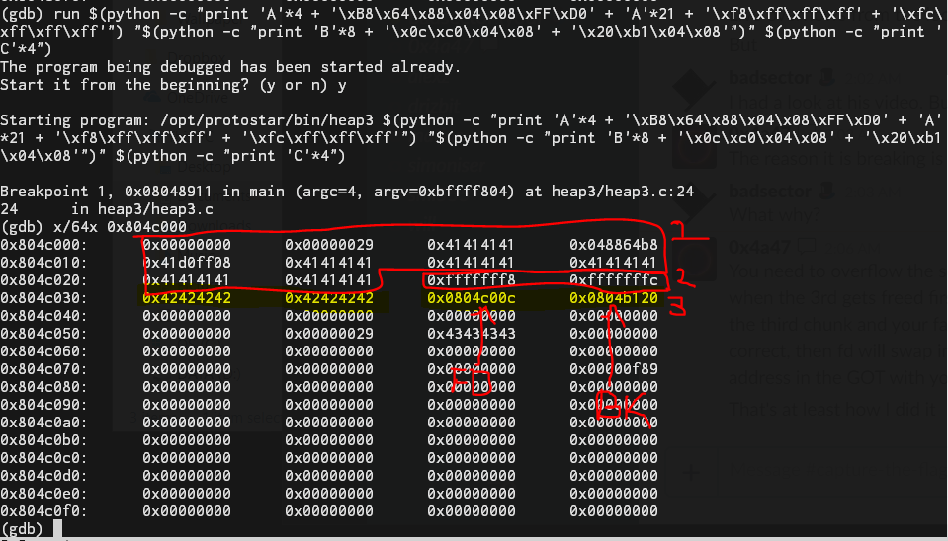
Figure 1: How the heap looks right before.
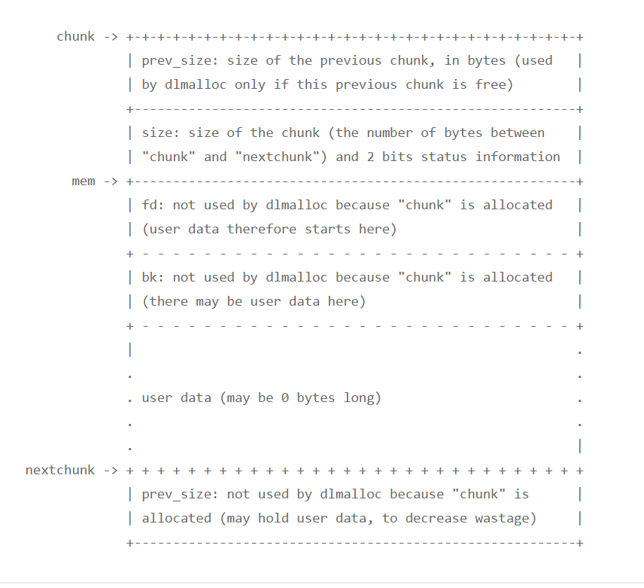
Figure 2.1: An in-use chunk in dlmalloc.
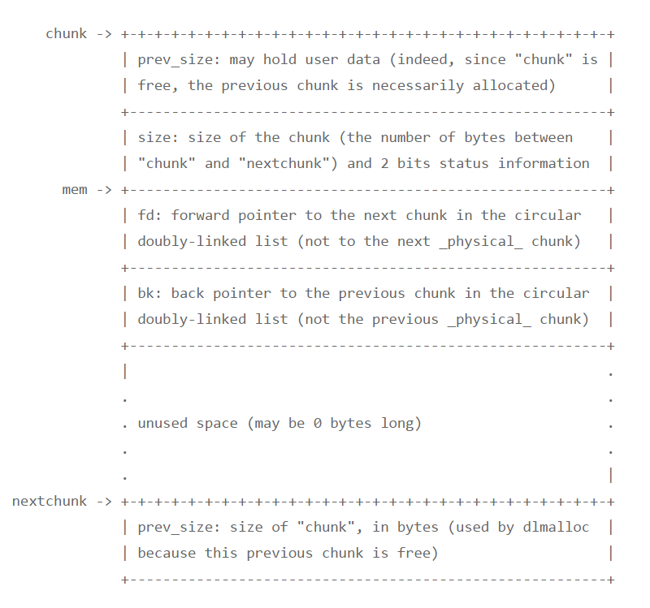
Figure 2.2: A free chunk in dlmalloc.

Problems encountered
Initial attempts weren’t working because the heap metadata that I corrupted was incorrect and later code in the free function noticed and segfaulted.

Lessons learned
Persistence is key…

