HealthConnect Week 7 Analytics Testing and Refinement Report
Data Analytics track | Prepared by Bada Oluwagbade | 28 September 2026
Purpose: This report tests the accuracy and consistency of the HealthConnect analytical outputs, reconciles the available Data Science evidence, records unresolved issues, and identifies the work required before Week 8.
Overall conclusion. Source-data KPI calculations and the major lead-time findings were reproduced successfully. The supplied confusion matrix supports the reported accuracy, precision, recall, and F1-score. Dashboard validation and several Data Science checks remain pending because the current PBIX, screenshots, prediction-level identifiers, and full model outputs were not supplied.

Executive summary
Measure | Verified result | Meaning
Eligible appointments | 4,737 | Attended plus No-Show; cancellations excluded
Overall no-show rate | 51.15% | 2,423 of 4,737 eligible appointments
41-60-day no-show rate | 68.49% | 1,028 of 1,501 appointments
Combined segment rate | 83.33% | 130 of 156 appointments with 41-60 days and 2+ prior no-shows
Refined model performance | Accuracy 0.641; ROC-AUC 0.689 | Data Science reported; four confusion-matrix metrics reconciled

The attached source produced 86 eligible records with missing distance, while the analyst reported 39 in the current working dataframe. This is treated as a data-version or cleaning discrepancy and must be resolved before final submission.

Scope and testing approach
The review covered source integrity, denominator rules, KPI recalculation, lead-time and history segments, exploratory categorical associations, reported model metrics, threshold assumptions, cross-track consistency and Week 8 readiness. The dashboard itself was not available for direct testing.
- Recalculate important KPIs independently from the attached CSV.
- Use only Attended and No-Show appointments in the no-show-rate denominator.
- Apply the shared lead-time bands: 0-7, 8-21, 22-40 and 41-60 days.
- Show sample sizes beside rates and distinguish full-population analysis from model test-set results.
- Classify every result as verified, reported, pending or unresolved.

Data quality validation
Check | Result | Status
Total appointment rows | 5,000 | Verified
Eligible appointments | 4,737 | Verified
Duplicate appointment IDs | 0 | Pass
Previous no-shows exceeding previous appointments | 0 | Pass
Unparseable dates | 0 | Pass
Lead-time discrepancies | 0 | Pass
Eligible records outside agreed lead-time bands | 0 | Pass
Eligible appointments missing distance | 86 | Open discrepancy
Eligible appointments with zero previous appointments | 228 | Verified

Missing distance records remain in overall KPI calculations. Analyses requiring distance should either use an explicit Unknown category or state the reduced known-distance denominator. The 228 zero-history records receive a previous no-show rate of zero under the Data Science convention, while the separate no_previous_history flag preserves their distinct meaning.

KPI recalculation and reconciliation
KPI | Result | Definition
Total appointments | 5,000 | All source rows
Eligible appointments | 4,737 | Attended + No-Show
Attended appointments | 2,314 | Eligible outcome = Attended
No-show appointments | 2,423 | Eligible outcome = No-Show
Cancelled appointments | 263 | Outcome = Cancelled
Overall no-show rate | 51.15% | No-shows / eligible
Attendance rate | 48.85% | Attended / eligible

The counts reconcile: 2,314 attended plus 2,423 no-shows equals 4,737 eligible appointments; adding 263 cancellations returns the 5,000 source rows.

Finding reassessment

Booking lead time
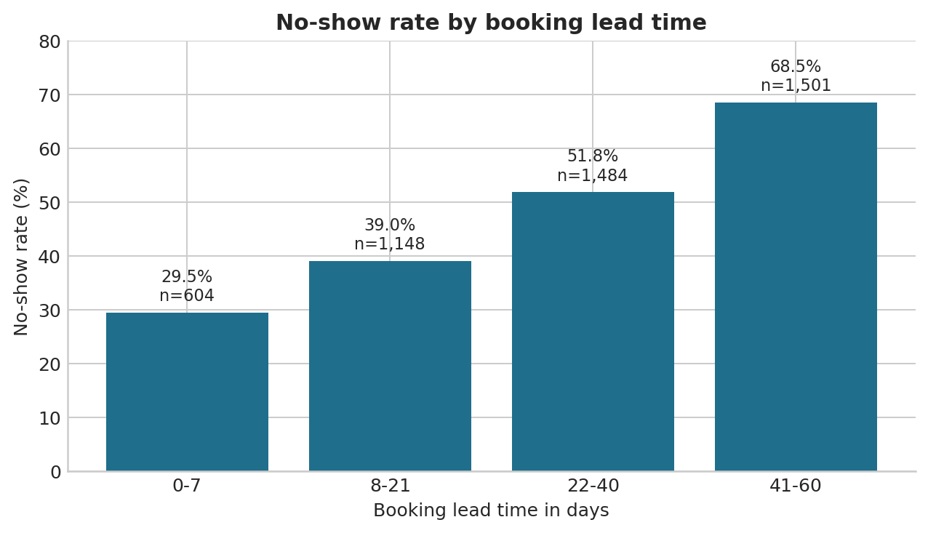
No-show rates rise across the agreed bands from 29.47% at 0-7 days to 68.49% at 41-60 days. The exploratory chi-square result is statistically significant and Cramer's V is 0.276, indicating the largest categorical association among the tested operational variables. Because patients can appear more than once, this appointment-level test should not be treated as cluster-adjusted population inference.

Previous no-show history
Previous no-shows | Appointments | No-shows | Rate
0 | 2,745 | 1,271 | 46.30%
1 | 1,482 | 828 | 55.87%
2+ | 510 | 324 | 63.53%

The observed rate increases from 46.30% with no prior no-show to 63.53% with two or more. This supports using attendance history as a prioritisation input, not as a basis for restricting access.

Combined analytical segment
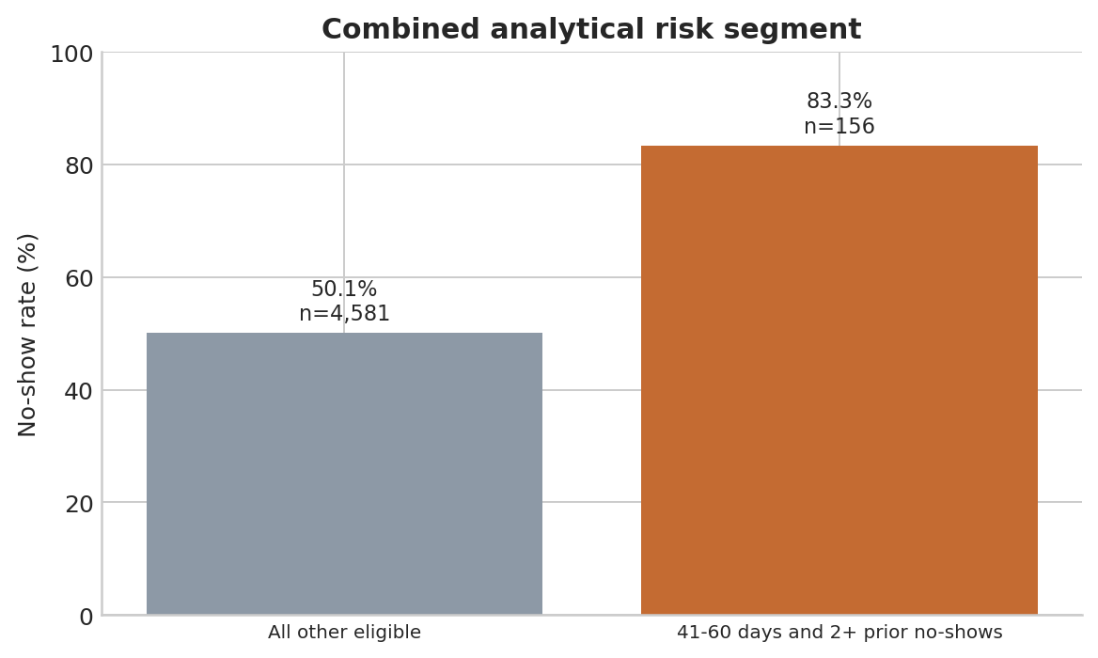
The combined segment has an 83.33% no-show rate, 33.28 percentage points above all other eligible appointments. It contains 156 appointments and 130 no-shows, so it identifies a high-rate group but captures only 5.37% of all observed no-shows. A targeted pilot should therefore complement, not replace, broader attendance management.

Reminder and appointment type results
Variable | Group | Appointments | Rate
Reminder | No | 1,285 | 54.63%
Reminder | Yes | 3,452 | 49.86%
Appointment type | Diagnostic Test | 567 | 52.03%
Appointment type | Follow-up | 1,344 | 54.17%
Appointment type | General Consultation | 1,980 | 49.14%
Appointment type | Specialist Consultation | 846 | 50.47%

Reminder status and appointment type have small exploratory effect sizes, both around Cramer's V = 0.042. These relationships may help design pilots, but the observational data does not show that reminders cause better attendance.

Statistical and practical validation
Variable | Chi-square | p-value | Cramer's V | Interpretation
Lead-time band | 362.01 | <0.001 | 0.276 | Moderate practical signal
History group | 70.31 | <0.001 | 0.122 | Small signal
Reminder sent | 8.55 | 0.003 | 0.042 | Very small signal
Appointment type | 8.42 | 0.038 | 0.042 | Very small signal

P-values are reported with sample sizes and effect sizes. Statistical significance alone is not sufficient for an operational recommendation. Repeated patients, observational assignment and multiple exploratory tests limit causal interpretation.

Cross track validation with Data Science
Item | Available evidence | Assessment
Eligible population | DS reports 4,737; DA reproduces 4,737 | Count agreement; record membership unverified
Definitions | Lead-time bands and history rules supplied | DA implementation aligned; DS code evidence pending
Headline rates | DA reproduces 51.15% and 68.49% | DS same-population reproduction pending
Combined segment | DA finds 130/156 = 83.33% | Not available in DS output
Patient split | GroupShuffleSplit and GroupKFold reported | Method reported; overlap evidence pending
Model metrics | TN 327, FP 156, FN 191, TP 292 | Accuracy, precision, recall and F1 reconciled
Prediction traceability | appointment_id omitted | Unresolved; do not infer IDs from row order

The supplied confusion matrix recalculates to accuracy 0.6408, precision 0.6518, recall 0.6046 and F1 0.6273, matching the reported values after rounding. ROC-AUC, calibration, leakage controls and threshold optimisation cannot be reproduced without predictions, group assignments and model outputs.

Model refinement and threshold interpretation
Model stage | Accuracy | ROC-AUC | Evidence status
Baseline | 0.616 | 0.671 | DS reported
Before refinement | 0.626 | 0.684 | DS reported
Final refined | 0.641 | 0.689 | Metrics partly reconciled

Data Science reports reducing maximum depth from 8 to 5 and applying isotonic calibration. The train-test gap reportedly decreased from 0.073 to 0.026, but the underlying metric was not specified. The stated 0.82% Brier improvement requires before-and-after scores and clarification of whether it is absolute or relative.
At threshold 0.50, the supplied matrix produces a hypothetical cost of 538 at a 2:1 false-negative to false-positive ratio and 1,111 at 5:1. Candidate thresholds of 0.35 and 0.25 remain reported rather than independently verified because their confusion matrices were not supplied.

Dashboard testing and refinement status
Dashboard testing is not complete because the PBIX file, screenshots and observed filter results were not supplied. The evidence workbook contains expected values and editable fields for actual Power BI results.
Scenario | Expected eligible | Expected no-shows | Expected rate | Status
Default | 4,737 | 2,423 | 51.15% | Pending
41-60 days | 1,501 | 1,028 | 68.49% | Pending
41-60 days and 2+ prior no-shows | 156 | 130 | 83.33% | Pending
Clear filters | 4,737 | 2,423 | 51.15% | Pending

- Confirm default KPIs and exclusion of cancellations from the rate denominator.
- Test single and combined filters, clearing filters, visual interactions and refresh.
- Check chronological sorting for day and appointment time.
- Capture before-and-after screenshots only for genuine refinements.
- Keep tests pending rather than recording unobserved results as passed.

Updated recommendations
Area | Recommendation
Immediate monitoring | Track no-show rate and missed-appointment volume using a documented eligible denominator.
Targeted pilot | Test reconfirmation for 41-60-day bookings and supportive outreach for the combined high-risk segment.
Reminder experiment | Evaluate timing and channel through a controlled pilot rather than inferring causality from the existing association.
Model operations | Use predictions to prioritise support, preserve stable appointment identifiers and monitor weaker subgroups.
Threshold governance | Choose a threshold only after defining outreach capacity and real false-positive and false-negative costs.
Data governance | Resolve the 86-versus-39 missing-distance discrepancy and record the source version used by Python and Power BI.

Limitations and unresolved issues
- The dataset is synthetic and observational; it does not establish intervention effects.
- Appointment rows may repeat patients, while simple chi-square tests assume independent observations.
- The attached source has 86 eligible missing-distance records, while the working notebook reportedly returned 39.
- The current Power BI file and test screenshots were unavailable.
- Prediction-level appointment identifiers and complete threshold outputs were unavailable.
- Data Science segment reproduction, exact distance preprocessing and full calibration evidence remain pending.

Week 8 readiness
Area | Status | Remaining action
Source KPIs | Ready | Reconcile with Power BI
Analytical findings | Ready for descriptive reporting | Maintain causal qualifications
Dashboard | Not verified | Run and evidence all manual tests
Cross-track consistency | Partially ready | Obtain segment and preprocessing evidence
Prediction integration | Not ready | Receive ID-preserving scoring output
Operational threshold | Not ready | Agree costs, capacity and validation method
Documentation | Partially ready | Add screenshots and close or carry forward open issues

Final assessment. The analytical calculations are ready to support the Week 8 story. The submission should not claim end-to-end dashboard or model validation until the pending evidence is completed.

