HealthConnect Final Analytics and Decision Support Report
  - Week 8
  - Prepared by: Bada Oluwagbade
  - Data Analytics track

Executive summary
HealthConnect can use booking lead time and previous attendance history to prioritise supportive appointment confirmation. The supplied synthetic dataset contains 5,000 appointments, including 4,737 attended or no-show appointments. Of these, 2,423 were no-shows, giving a baseline no-show rate of 51.15%. Cancellations remain a separate operational outcome.
Decision measure | Verified result
Overall no-show rate | 2,423 / 4,737 = 51.15%
Bookings made 41–60 days ahead | 1,028 / 1,501 = 68.49%
41–60 days and at least two previous no-shows | 130 / 156 = 83.33%
Share of all no-shows in the combined segment | 130 / 2,423 = 5.37%

The combined segment is suitable for a focused outreach pilot, but it represents only 5.37% of observed no-shows. Broader reconfirmation for long-lead bookings and a controlled reminder pilot would address a larger part of the problem. These recommendations describe actions to test; the dataset does not establish that any intervention has already improved attendance.

Current readiness
The analytical calculations and reporting are ready for descriptive presentation. Full solution readiness remains partial. The Week 7 report leaves dashboard testing, prediction identifiers, model validation details, and a missing-distance discrepancy unresolved. This report preserves those limits and provides an evidence package for completing the remaining checks.
Prepared for AnalystLab Africa and the HealthConnect HC-POD. Analysis period: scheduled appointments from 1 January 2025 to 30 June 2026. Verification date: 29 September 2026. Sources and evidence references appear on the final page.

Scope and calculation rules
My Data Analytics contribution is to explain appointment attendance patterns, validate the main KPIs and translate findings into operational recommendations. This final report continues the Week 5 exploratory work and the Week 6–7 integration and testing records.
KPI | Count or rate | Calculation
Total appointments | 5,000 | All source appointment rows
Eligible appointments | 4,737 | Attended + No-Show
Attended | 2,314 | Outcome = Attended
No-shows | 2,423 | Outcome = No-Show
Cancelled | 263 | Outcome = Cancelled
No-show rate | 51.15% | 2,423 / 4,737
Attendance rate | 48.85% | 2,314 / 4,737
Cancellation rate | 5.26% | 263 / 5,000

The counts reconcile: 2,314 + 2,423 + 263 = 5,000. The analytical unit is an appointment, not a unique patient. The source contains 1,696 patient IDs, so repeated patients must be considered when interpreting statistical tests.

Preparation and shared definitions
Booking lead time uses the inclusive bands 0–7, 8–21, 22–40 and 41–60 days. High previous no-show history means at least two previous no-shows. Previous no-show rate is previous_no_shows divided by previous_appointments, with zero used when no prior appointment exists. A separate no_previous_history flag identifies those 228 eligible records.
Distance summaries use a known-distance median of 8.7 km. Missing distances remain Unknown rather than being silently treated as short distance. All 86 eligible records with missing distance remain in the main KPI denominator. This descriptive treatment does not certify the model preprocessing pipeline.
The original CSV remains unchanged. The evidence archive contains a separate derived dataset, an executed verification notebook, a reusable analysis script and the underlying summary tables. No waiting-time variable enters the prioritisation rule because its availability before attendance is unclear.

Longer booking lead time has the clearest association
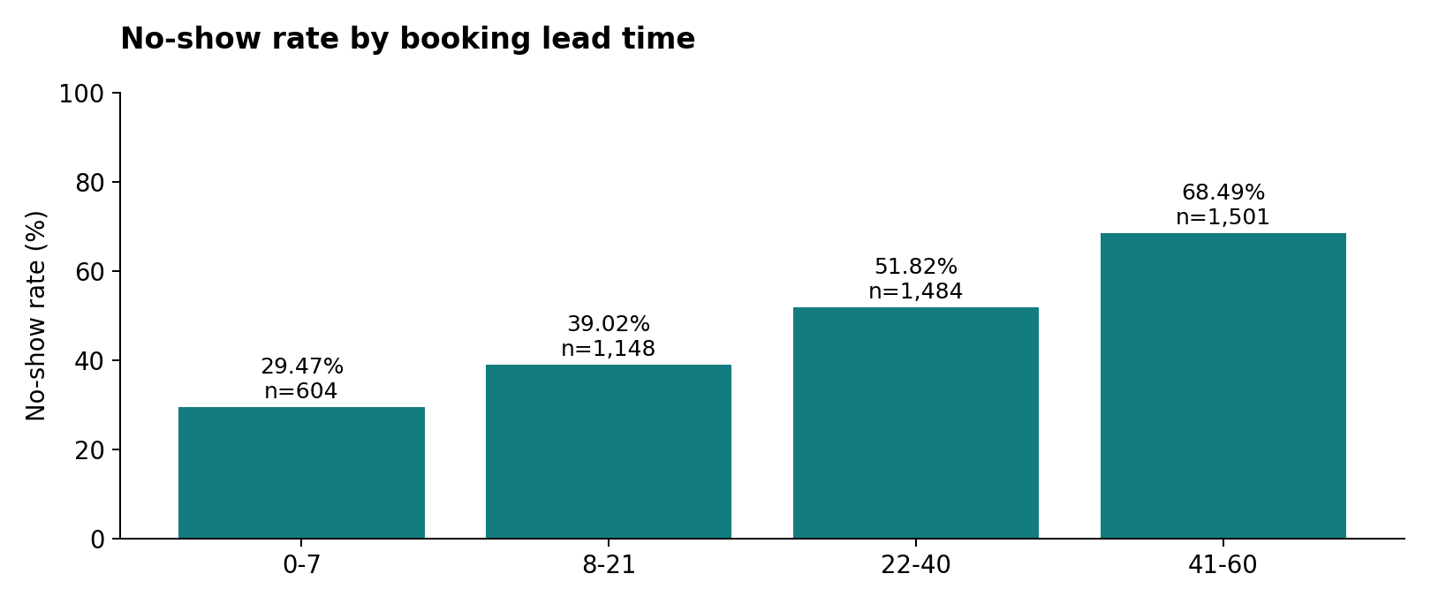
Lead time | Appointments | No-shows | Rate
0-7 | 604 | 178 | 29.47%
8-21 | 1148 | 448 | 39.02%
22-40 | 1484 | 769 | 51.82%
41-60 | 1501 | 1028 | 68.49%

The observed no-show rate increases from 29.47% at 0–7 days to 68.49% at 41–60 days, a difference of 39.02 percentage points. The longest-lead group accounts for 1,028 of 2,423 no-shows, or 42.43%, making it relevant by both rate and volume.
Lead time has the largest exploratory association among the tested categorical variables: Cramér’s V = 0.276, compared with 0.122 for previous no-show history and about 0.042 for reminder status and appointment type. These appointment-level tests do not adjust for repeated patients and do not establish causation.
Operational interpretation: test reconfirmation closer to the appointment date for bookings made far in advance. Offer a clear route to confirm, cancel or reschedule. Avoid assuming that shortening every booking interval is clinically appropriate or operationally feasible.

Previous history sharpens the priority segment
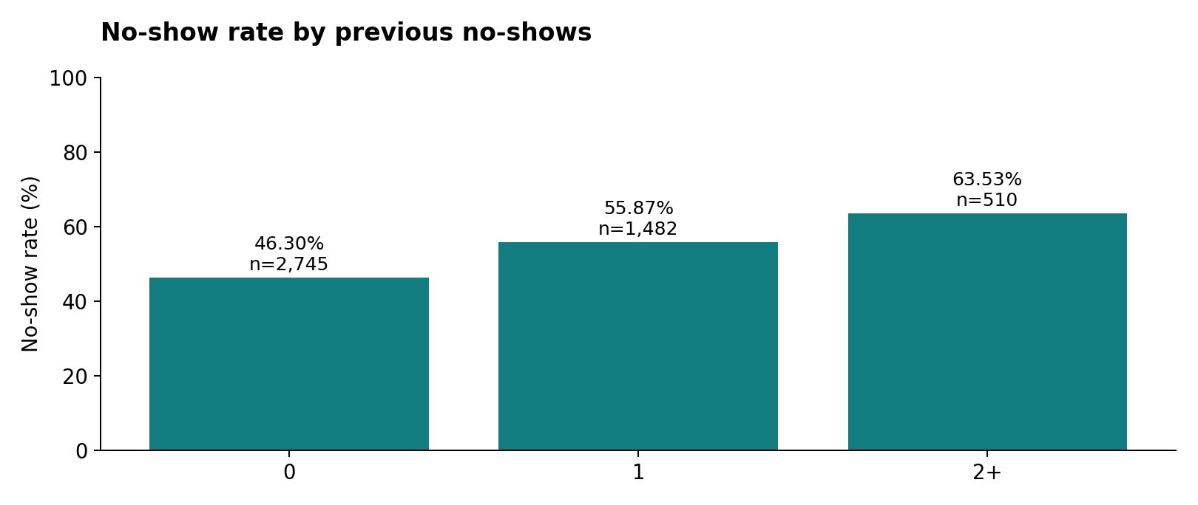
Appointments with two or more previous no-shows have a 63.53% no-show rate, compared with 46.30% among appointments with zero previous no-shows. Combining history with long lead time identifies a smaller group with a substantially higher observed rate.
Segment | Appointments | No-shows | Rate
41–60 days and 2+ prior no-shows | 156 | 130 | 83.33%
All other eligible appointments | 4,581 | 2,293 | 50.05%

The difference is 33.28 percentage points. However, the combined segment covers only 3.29% of eligible appointments and 5.37% of all no-shows. It is an explicit Data Analytics segment, not a calibrated prediction or a confirmed final model feature.

Recommended use
Use the segment to test supportive outreach where capacity is limited. Begin with reconfirmation and assistance with rescheduling. Evaluate whether attendance improves relative to a suitable comparison group, while tracking staff effort. Preserve ordinary booking access for every patient.
Interpret the 83.33% as a historical group rate within this synthetic dataset. It is not the probability that a particular patient will miss an appointment and it is not an intervention success estimate.

Secondary findings and business recommendations
Comparison | Observed no-show rate | Interpretation
No reminder versus reminder sent | 54.63% versus 49.86% | 4.78 percentage-point difference
Distance above versus at or below 8.7 km | 53.39% versus 48.83% | Known-distance records only
Follow-up versus general consultation | 54.17% versus 49.14% | Review follow-up communication

Reminder assignment may reflect patient or appointment characteristics. The observed difference supports a controlled pilot, not a causal claim about reminders or a ranking of channel effectiveness. Distance and appointment type can guide investigation, but lead time provides the stronger descriptive signal.
Proposed action | Suggested owner | How to measure it
Reconfirm bookings made 41–60 days ahead | Clinic scheduling team | No-show rate, confirmation rate and cancellations received in time to refill slots
Offer extra support to the combined segment | Patient support team | Attendance, contacts per appointment and staff minutes
Test reminder timing or channel against usual practice | Operations with Analytics | Difference in no-show rates, delivery success and outreach cost
Track a consistent weekly KPI set | Analytics with PM | Eligible volume, no-show rate, attendance and cancellation rate

Pilot evaluation
A proposed four-week pilot should use a comparison group and a prespecified outreach capacity. Where feasible, assign patients rather than appointments to groups to reduce crossover from repeat visits. Report rates with counts and uncertainty, and review whether groups are comparable. Agree the success target with the clinic before launch.
Business value remains prospective. For illustration only, a five-percentage-point reduction across a future cohort of 1,501 comparable long-lead appointments would correspond to roughly 75 fewer no-shows. This is a scenario calculation, not a forecast or a measured project outcome.

Testing and final integration readiness
The Week 7 Analytics Testing Report reproduced source KPIs and major segments, aligned shared definitions, and reconciled four model metrics from a supplied confusion matrix. The Week 8 verification reruns those source calculations and confirms all 15 specified data checks. The key unresolved issue is evidence consistency across the analytical source, working notebook, dashboard and model outputs.
Component | Status | Remaining action
Source KPIs and main segments | Verified | Maintain the same source and denominator
Final analytical report and evidence | Prepared | Review the submission narrative
Power BI dashboard | Not verified | Run filter, reset, sorting and refresh checks
Distance data version | Unresolved | Reconcile 86 source missing values against the reported 39
DA and DS shared definitions | Partially aligned | Confirm record membership and model preprocessing
Prediction integration | Pending | Receive scoring output with appointment_id
Operational model threshold | Pending | Agree costs, capacity and threshold evidence
HC-POD final walkthrough | Pending evidence | Record final exchange, changes and acceptance

Cross track contribution
The Week 6 integration record documents receipt of model-related outputs and provision of validated patterns to Data Science. That exchange focused Analytics on lead time and previous history, and exposed the missing-ID issue. The Week 7 record confirms agreement on the 4,737-row count, while exact membership and downstream segment reproduction remain unverified.
For the final handoff, Analytics provides the KPI definitions, lead-time and history tables, recommendations and limitations. Data Science should return ID-preserving predictions and confirm shared preprocessing. Project Management should use the findings in the business narrative and retain open dependencies in the readiness record. This package is prepared for that handoff; it does not document a newly completed exchange.
The presentation demonstrates the analytical evidence, proposed actions and readiness boundaries. The overall proposed workflow connects descriptive analysis, DS risk scoring, MLE processing, approved administrative assistance and PM coordination. Completion of the other tracks remains for those owners to demonstrate.

Limitations and evidence references
The dataset is synthetic and observational. Results cannot establish real-clinic performance, causality or intervention impact.
Repeated patients limit independence assumptions in the exploratory chi-square tests. No cluster-adjusted inference or confirmatory multiple-testing procedure is claimed.
The source contains 90 missing distances overall and 86 among eligible appointments. The Week 7 working-notebook count of 39 remains unexplained.
The current PBIX and observed dashboard test results were not provided for this review. Source-data checks do not establish that visual interactions or refresh work.
The Week 7 report records final model accuracy of 0.641 and ROC-AUC of 0.689. Only accuracy, precision, recall and F1 are arithmetically reproducible from its reported confusion matrix. ROC-AUC, calibration, threshold optimisation and leakage controls require underlying evidence.
An integer scoring index is not a verified appointment identifier. Predictions must not be joined to appointments by assumed row order.
No actual decrease in missed appointments, financial return, deployment or completed Week 8 team walkthrough is claimed.

