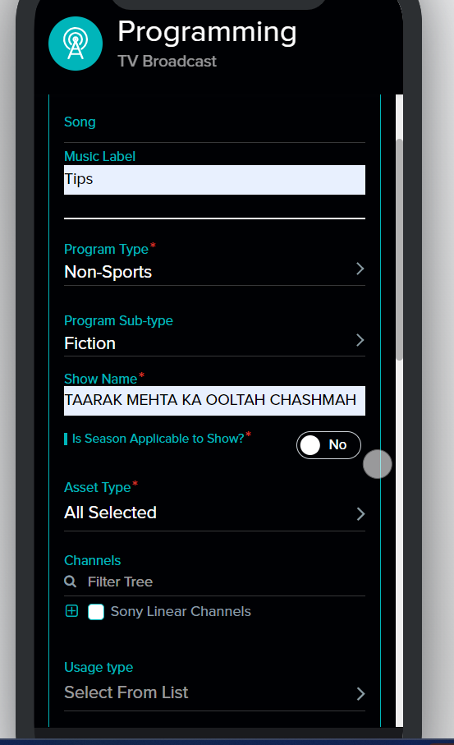

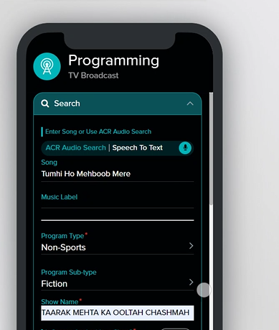

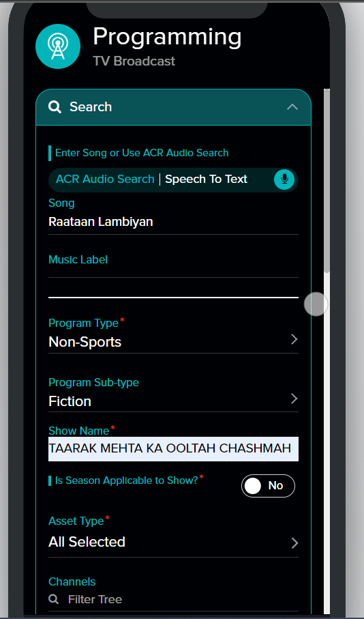

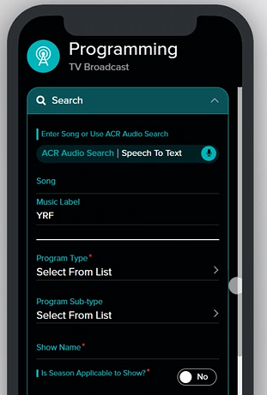

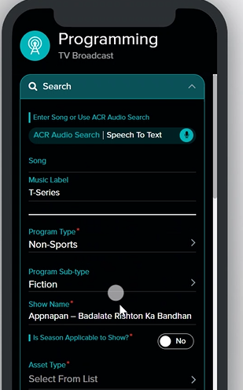

Note : Negative test, Kunal will be sharing details

Note :Kunal will delete all test entries

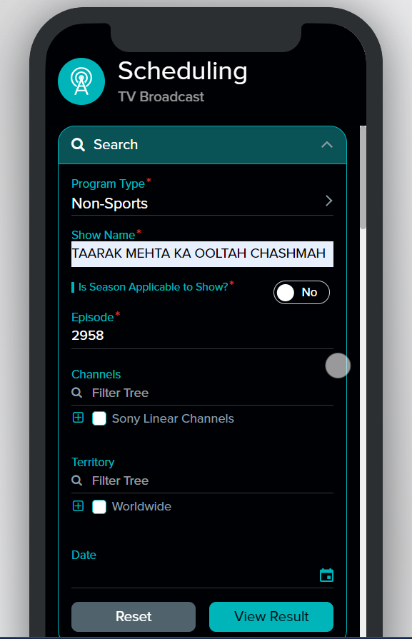

Issue : Ganna deva , genda phool (remix) and dewangi dewangi music cue sheet shown in red colour

Note :We have to put log messages while fetching results



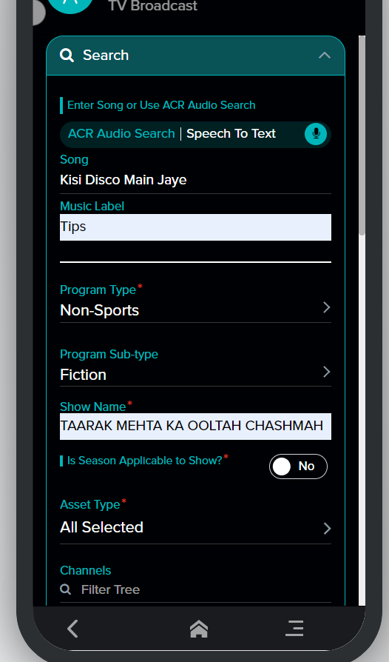

T series lable we have six rights in rightsline but only 2 rights are visible

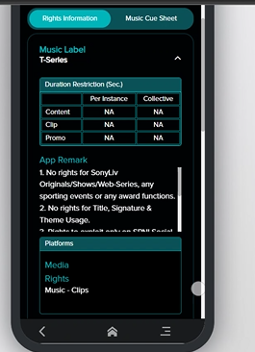

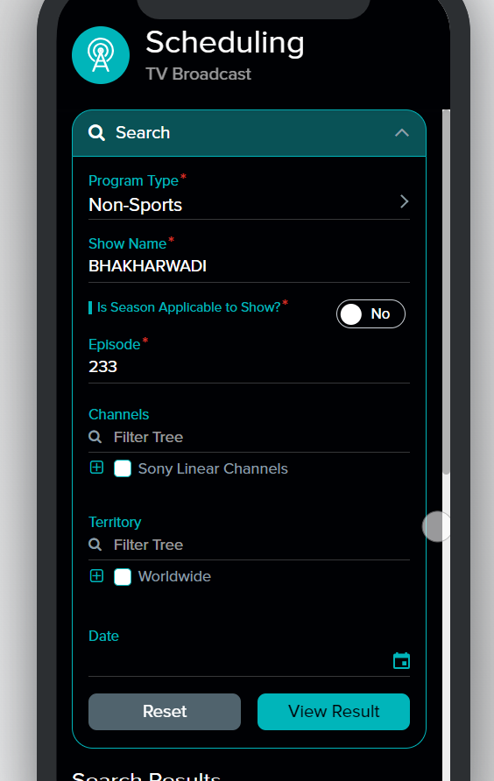

In scheduling use case issue : Same song in two different music labels.

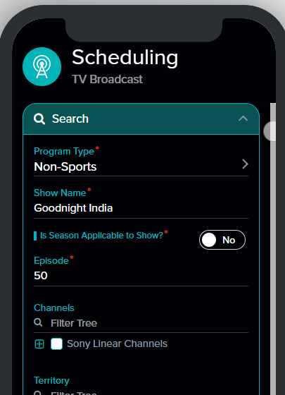

Note : No cue sheet available

Note :Ignore inhouse songs in bhakharwadi episode 233

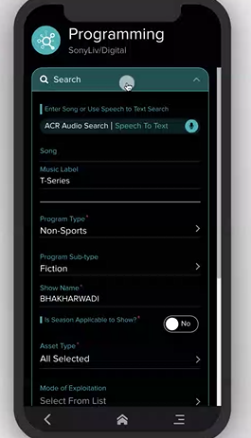

Digital programming Since dont have Bhakarwadi in 499 deal table hence show restricted

Issue Digital pprogramming showing Show restricted for kaun banega crore pati instead of having allowance (search by Music label : T series and Show Kaun Banega crorpati and EP 15)