1. A site property can be set to
2. Structure
3. List
4. Binary Data
5. Entity Identifier

2. In which order data actions and screen aggregates will execute while loading the mobile/web screen?

A. Aggregate would execute first followed by the Data action

B. Data action would execute first followed by the Aggregate

C. Aggregate and Data Action would run asynchronously.

D. All the aggregates have to be fetched on demand and data actions would run at the start.

3. Which of the attributes are returned by the following aggregate?

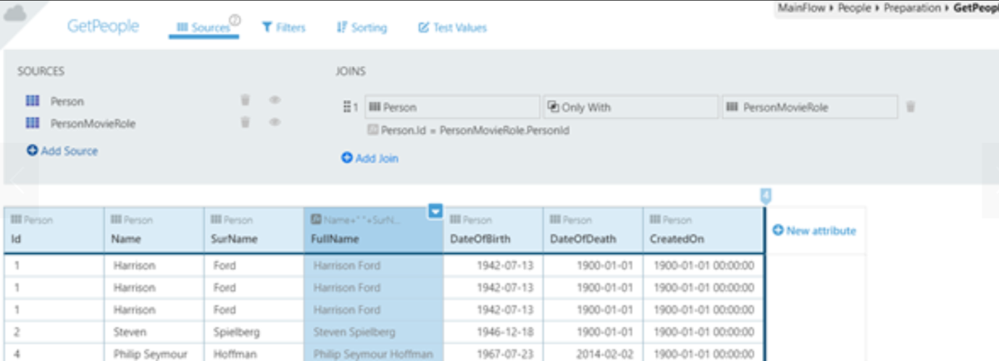

A. The Person and PersonMovieRole entity attributes, plus a Calculated attribute.

B. Not yet defined. You need to add an Output Structure/Entity to the Aggregate

C. Only the Person and PersonMovieRole entity attributes.

D. Only the Calculated attribute.

4. What needs to be changed in the following Aggregate to obtain the number of comments per Movie for movies with one or more comments?

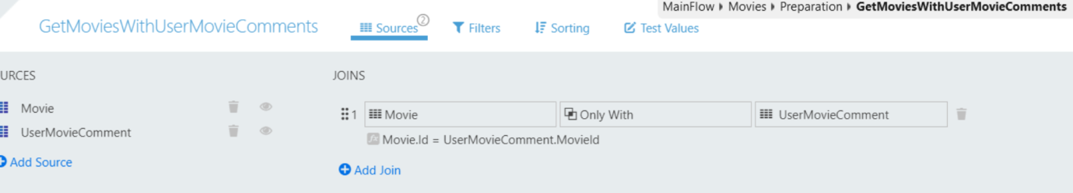

A. Change the join between Movie and UserMovieComment Entities to With or Without and create a Count over the UserMovieComment Id attribute.

B. Change the join between Movie and UserMovieComment Entities to With or Without and create a Group By over the UserMovieComment Id attribute.

C. Create a Group By over the Movie Id attribute and Count over the UserMovieComment Id attribute.

D. Create a Count over the UserMovieComment Id attribute.

5. A client action has its Function and Public property set to ‘No’. This client action --------------

A. Can be called in a Screen Action.

B. Can be called from a Server Action.

C. Can be called from other modules.

D. Can be used in an Expression.

1. Which of the following is not possible to fetch data when the screen is initializing?
2. Rest API in the data action flow.
3. Aggregates in the screen level.
4. Advanced SQL in the screen level.
5. Aggregates inside the data action flow.

7. Setting the Function property of a Server Action to Yes?

A. Restricts it to be used only in Expressions.

B. Restricts it to have exactly one Output Parameter.

C. Restricts it to have exactly one Input Parameter.

D. Restricts it from being referenced by other modules.

8. Considering Button and Link widgets, which of the following options is true with respect to their ‘On click’ property?

A. Both Link and Button widgets don’t differ with respect to ‘On Click’ property.

B. Button widgets on click property can be set to external URL but Link widgets cannot.

C. Link widget’s on click property can be set to a client action as the Destination. Button widgets can’t.

D. Button widgets’ on click property can be set to an event while Link widgets can’t.

9. When is the OnParametersChange event triggered?

1. When the parent of the Block changes the value of at least one of the Block’s Input Parameters.
2. If the value of a Block’s Input Parameters changes inside a Client Action of the Block.
3. The On Parameters Changed must be explicitly triggered by the parent of the Block.
4. When the parent of the Block changes the value of all the block’s Input Parameters.

10. The following screen has two Dropdowns, one to select a Country and one to select a City. The GetCountries and GetCities Aggregates provide the countries and the cities to be displayed in the respective dropdowns. Which of the following options is a valid step if we want to just fetch the cities only after the user selects a country?

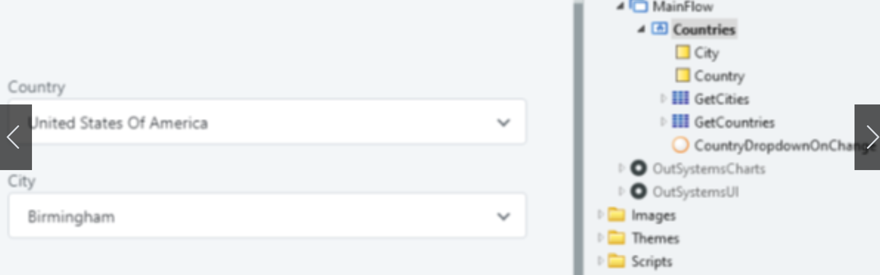

a. Set the Fetch property of the GetCities Aggregate to Only on Demand.

b. Refresh the GetCountries Aggregate in the OnChange Action of the City Dropdown.

c. Filter the GetCountries Aggregate by the selected city.

d. Call the GetCities Aggregate in the GetCountries On After Fetch Event handler.

11. Regarding Blocks in OutSystems reactive apps, which of the following options is correct?

A. Blocks can only be instantiated on Screens.

B. Blocks can be instantiated on Screens and other Blocks

C. Blocks can be instantiated on Client Actions on the Screen.

D. Blocks can be instantiated on Screens and external HTML pages, using a special HTML tag.

12. Which of the following is a use case for ‘For each’ variable?

1. Generic loop
2. Traversing over variable of type list.
3. Bulk insert into a static entity.

13. Which exception handler would execute when a database exception is thrown in the ‘CreateOrUpdate’ entity action from the ‘MovieCreateOrUpdate’ server action?

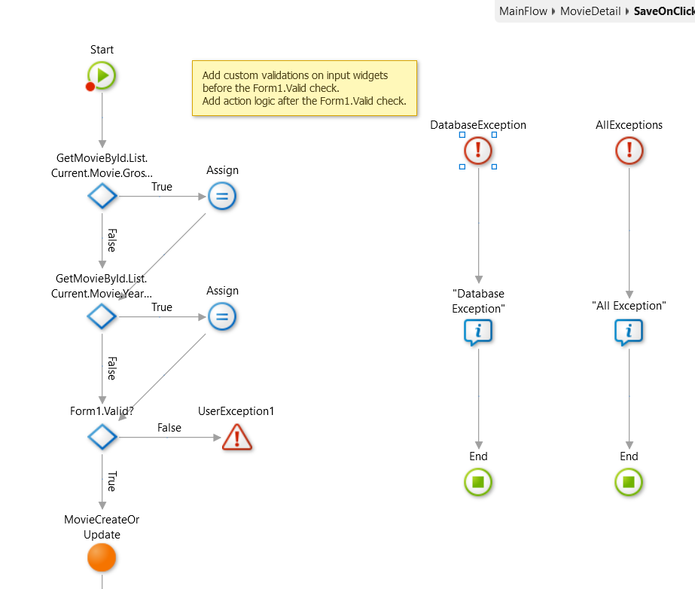

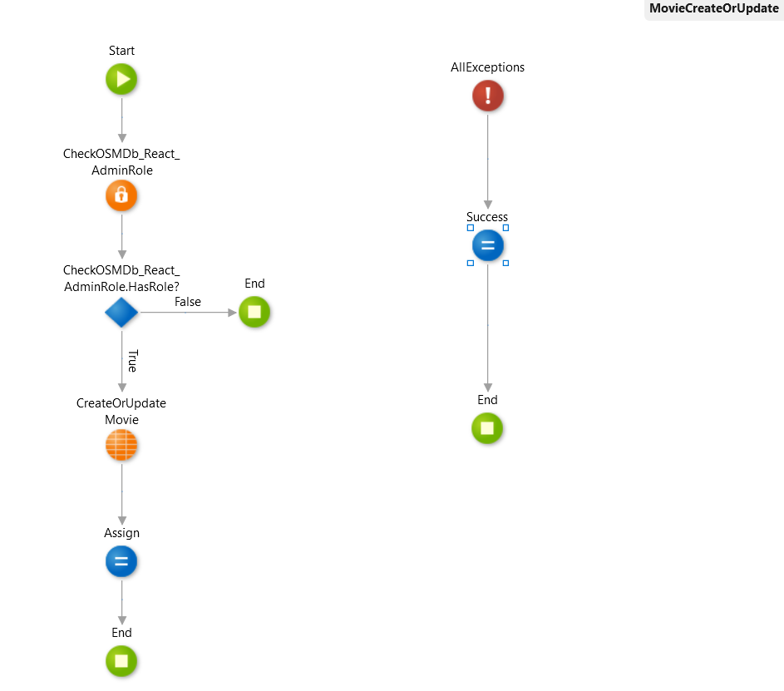

1. AllExceptions handler from ‘MovieCreateOrUpdate’ will be executed.
2. DatabaseException handler in the ‘SaveOnClick’ action.
3. AllExceptions handler from ‘SaveOnClick’ will be executed.
4. AllExceptions handler from ‘MovieCreateOrUpdate’ will be executed, followed by DatabaseException handler in the ‘SaveOnClick’ action, AllExceptions handler from ‘SaveOnClick’.

14. Consider the following Action, that calculates the square root (sqrt) of a positive decimal number (N). Knowing that the function was called with N = -1, and the debugger is available at the Start node, what will happen when the developer selects the **Continue (F9)** option highlighted in the picture?

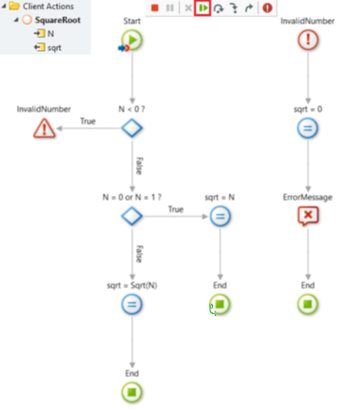

1. The Action will end, with sqrt = 0 and an error message would be shown.
2. The debugger will stop at Raise ‘Invalid Number’ exception node.
3. The debugger will stop in the N < 0 If node.
4. The debugger will stop at the breakpoint in the End node.

15. Which of the following is true about ‘On Render’ event?

1. OnRender event is the first to be triggered when we navigate from one screen to another.
2. OnRender event is triggered before ‘OnReady’ event.
3. OnRender event is re-run every time when there is any change in the data of the screen.
4. OnRender event is triggered only once when the page is ready to be rendered.
5. What is true about Blocks from the following?
6. Changes made in the block will be automatically reflected in all its instances.
7. An event is required in the Parent to catch the notification sent by the block on the change.
8. An event is required to notify all the other instances about the changes made in the block.
9. The change has to be done manually on each instance of the block.
10. Which of the following can’t be used on an expression?
11. Strings concatenated using operators.
12. Output of server actions.
13. Output of data action of the screen.
14. Both B and C.
15. Which of the following is true with respect to the below screen setting?

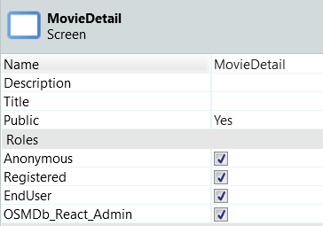

1. No authentication is required.
2. Only users with username and password can access the screen.
3. A user with both ‘End User’ and ‘OSMDb_React_Admin’ role can access the screen.
4. None of the above.
5. What is true about ‘CreateOrUpdate’ entity action?
6. Returns only the id of the created or updated record.
7. Throws error when the record already exists.
8. Updates the record when the record identifier is NullIdentifier().
9. Returns the id and the created or updated record.
10. To ensure that the incorrect data doesn’t reach the server, what is to be done? Note: Built-In validation property is set to True.
11. Nothing. Since the built-in validation is set to true.
12. Form.valid property has to be checked before adding the data to the database.
13. Form.valid property has to be set to false in the action flow.
14. Which of the following is true?

A. We need to call screen aggregates and DataAction explicitly.

B. DataAction executes before the aggregates.

C. Aggregates and DataActions execute in the same order as they are defined in screen.

D. There is no order of aggregates and DataAction execution.

1. While navigating from Movie Screen to MovieDetail Screen, when will a call be made to the server?

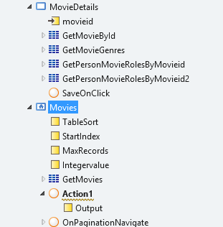

A. To trigger the on initialise event

B. To trigger the on destroy event.

C. Fetch data from database

1. What is the value of output?

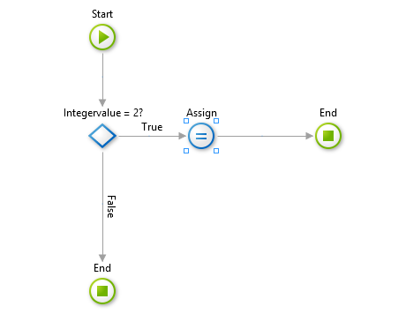 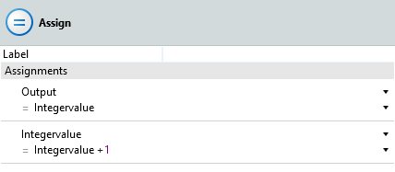

A. The value of Output is always 2.

B. The value of the Output will be greater than 2.

C. The Output Value will be the default value assigned to it.

D. Output value will be default value or equal to the ‘IntegerValue’.

1. If there are 2 entities, Contact and Group. If one Contact belongs to only one Group, how can we create the one-to-many mapping in between them?

A. Create attribute in Group with datatype as Contact identifier.

B. Create only with join in between them.

C. Create attribute in Contact with datatype as Group identifier.

1. When the built-in validation is set to true, form will be submitted when the?

A. Input expecting date is filled with Integer.

B. Input expecting the Integer is filled with Text.

C. All non-mandatory inputs are not filled.

1. Complete the below sentence, “One of the inputs valid property is false..."

A. form.valid property automatically becomes false.

B. explicitly need to set the form.valid property to false.

C. form.valid property is still true.

27. 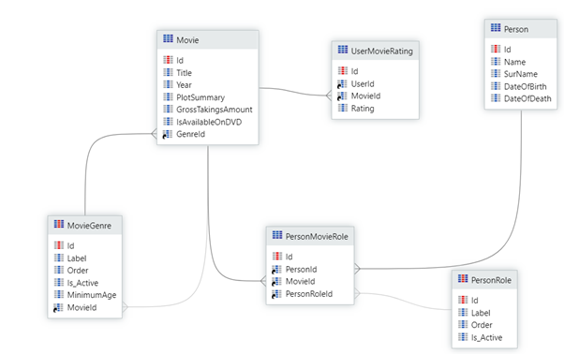

A. Entity ‘UserMovieRating’ can’t have the ‘Rating’ attribute since it is a junction entity.

B. Static Entity ‘MovieGenre’ can’t have the ‘MovieId’ reference attribute of type ‘Movie’ identifier.

C. Entity ‘Movie’ can’t have the ‘GenreId’ attribute of type MovieGenre Identifier.

D. Both (B) and (A).

28. While debugging a server action, which of the following isn’t possible at all?

A. Inspect and view the input parameters.

B. Inspect and view the widgets.

C. Inspect and view the local variables.

D. Inspect and view the server actions.

29. To restrict the access of a portion of screen to certain roles, which of the following is true?

1. Enclose the portion inside an ‘If’. Check the role in the If condition.
2. That portion of the screen can be made a block and we can provide access to certain roles accordingly to that block.
3. Either A or B can be done.
4. Access can’t be restricted for a portion of a screen alone.

30. I have a **server action** called 'CalculateInterest' with Public property and Function property set to yes. Can I use this server action as a direct expression in the screen?

a. No

b. Yes

31. There are 2 modules. ‘OSMDb’ and ‘OSMb Core’. OSMDb is referencing one of the entities in ‘OSMDb Core’. This entity has been changed and it’s published in ‘OSMDb Core’. But that change doesn’t reflect in ‘OSMDb’. What should be done to fix this?

A. Refresh the dependencies in the ‘OSMDb’ module.

B. Publish ‘OSMDb’ module.

C. Refresh dependencies in ‘OSMDb Core’ module.

D. Re-publish the ‘OSMDb Core’ module.

32. If one of the input widget’s valid property is set to false, then

a. We need to set the form.valid property to false manually.

b. All the input widget valid properties in form are set to false.

c. The form.valid property is automatically set to false.

33. There are two modules OSMDb and OSMDb_Core. OSMDb is referencing one of the entities in ‘OSMDb Core’. What does the below image indicate?

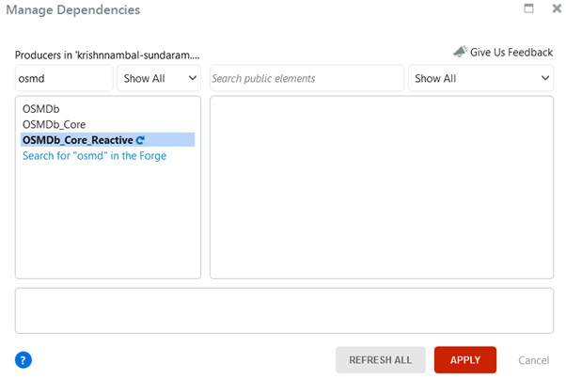

Note: Consider the ‘Refresh’ icon to be present in the ‘OSMDb_Core’ module

a) OSMDb Core module has been deleted.

b) Nothing has changed.

c) One or more referenced elements have been changed in the OSMDb core module

d) OSMDb module has been changed.

34. If user enter the age of the employee as 17, what will be the output? Note: Ignore the red borders indicating error

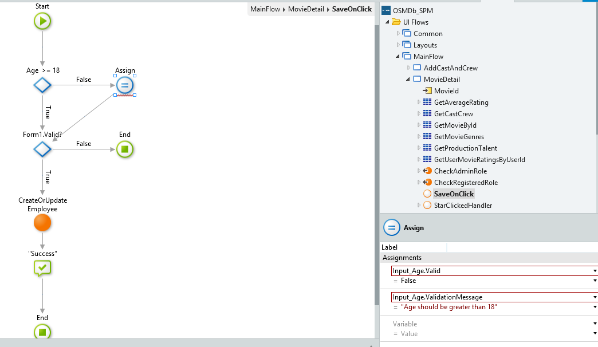

a) Create or update employee action is executed, and the success message appears

b) Create or update employee action is not executed, and a validation message will be displayed below the input element.

c) Create or update employee action is executed, and error is thrown at run time.

35. The client action public property is set to No then,

a. The client action can be used in that application

b. The client action can be used in that module.

c. The client action can be used in the server action.

36. There is a button group whose variable is set to local variable of data type Priority Identifier. What should be filled in the value property corresponding to the highlighted button in the below picture? If the priority static entity has (Low, medium, high) records.

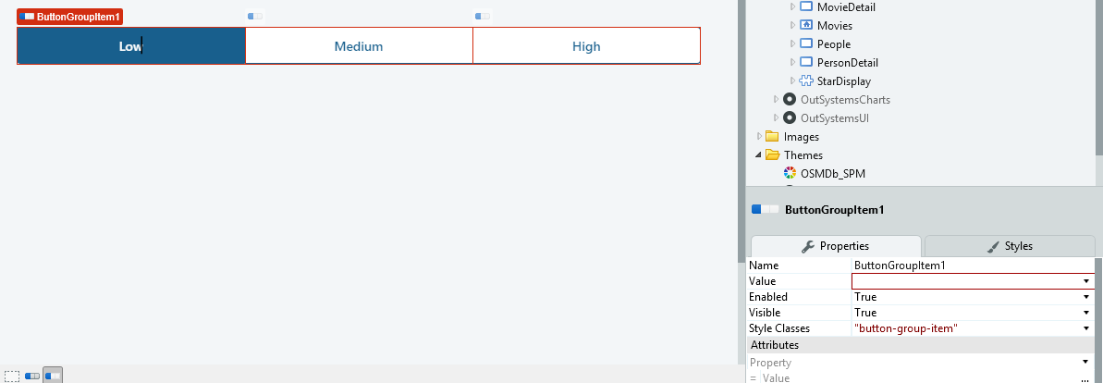

a. Entity.Priority.Id

b. Entity.Priority.Low

c. Entity.Priority.Label

d. Priority.Label

37. In the below image, what should be the data type of the value in the Source property?

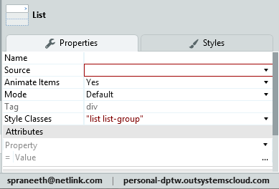

a. Structure

b. Entity

c. Record

d. List

38. What should be given in the variable property in the below image.

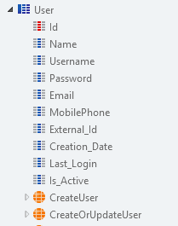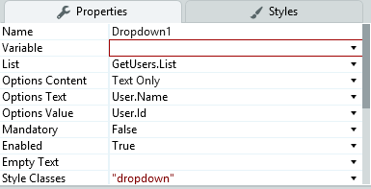

a. User Identifier

b. Long Integer

c. Text

39. When user clicks on the button in the button group to sort the list, the order of the list is not changed,

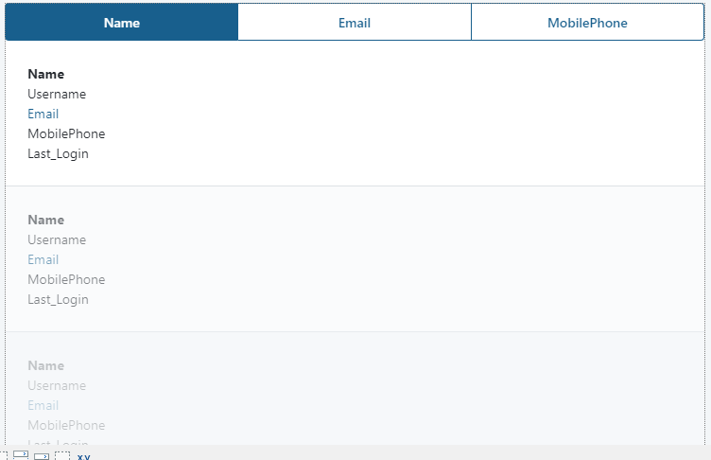

Ans) Refresh the employee data is not mentioned in the screen action

1. While using bootstrap to add data to the entity, which of the following is correct with respect to the given scenario

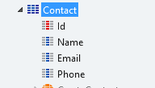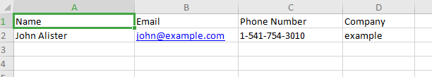

a. Since not all attributes are matched, bootstrap would not occur.

b. Name and Email will be part of the bootstrap while phone number and company would be ignored.

c. Name, Email, Phone number will be part of the bootstrap, only company would be ignored.

1. This action has an integer as input and Text as output. The conditions of the switch and the assign statements are self-explanatory in the diagram. Which one is true among the following?

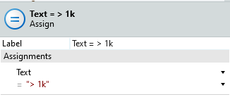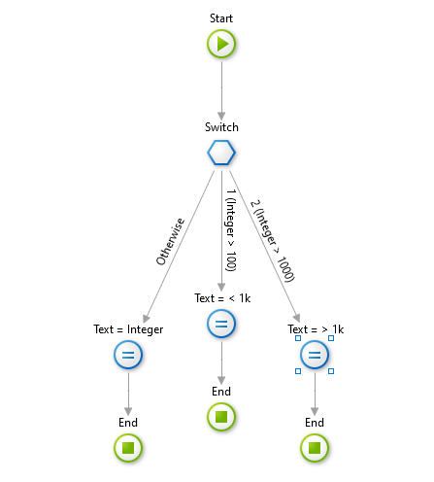

a. If Integer is greater than 2000, the text will always be “> 1k”

b. If Integer is greater than 1000, the text will be “< 1k”

c. If integer is exactly 1000, the text will be “Integer”

d. If integer is greater than 1000, the text will be “> 1k”

1. In the following aggregate, it is sorted based on CreatedDate. What would happen on adding another sort on the Name attribute?

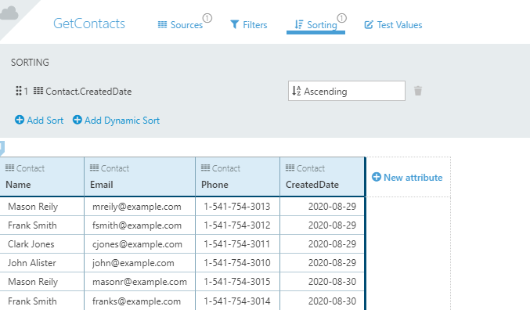

1. The second sort would replace the first sort
2. It is not possible to have more than one sort
3. The records with the same value in the 'Created Date' attribute, will be sorted based on 'Name' attribute
4. For records with the same value in the 'Name' attribute will be sorted based on 'Created Date' attribute.
5. What needs to be changed in the following Aggregate to obtain the count of comments per movie for **all** the movies in the database?



A. Change the join between Movie and UserMovieComment Entities to With or Without and create a Count over the UserMovieComment Id attribute.

B. Change the join between Movie and UserMovieComment Entities to With or Without and create a Group By over the Movie Id attribute and Count over the UserMovieComment Id attribute.

C. Create a Group By over the Movie Id attribute and Count over the UserMovieComment Id attribute.

D. Create a Count over the UserMovieComment Id attribute.

1. A developer is debugging a client action in the scope of a screen. The execution stops at the Start node of the action. Which of the following is false?

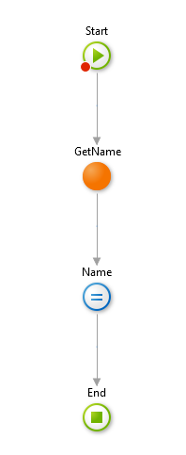

1. He can inspect and view the local variables of the screen always
2. He can inspect and view the screen widget always.
3. He can inspect and view the input variable of the action always.
4. He can inspect and view the variables in the GetName action always.
5. Consider there are two entities (Entity1 and Entity2) that are related. Entity2 has a reference attribute of type Entity1 identifier. The IsMandatory property of this reference attribute is set to Yes. In an aggregate, Entity1 is added as a source. Now on dragging and dropping Entity2 into the source of the aggregate, what would happen?
6. The entities will be joined automatically using “With” condition
7. The entities will be joined automatically using “Only With” condition
8. The entities will be joined automatically using “With or Without” condition
9. Both the entities will be there in sources, but no join condition would be specified.
10. When the drag and drop action in the image below is complete, the MovieGenre Static Entity is added to the Aggregate. Which of the following statements is correct?

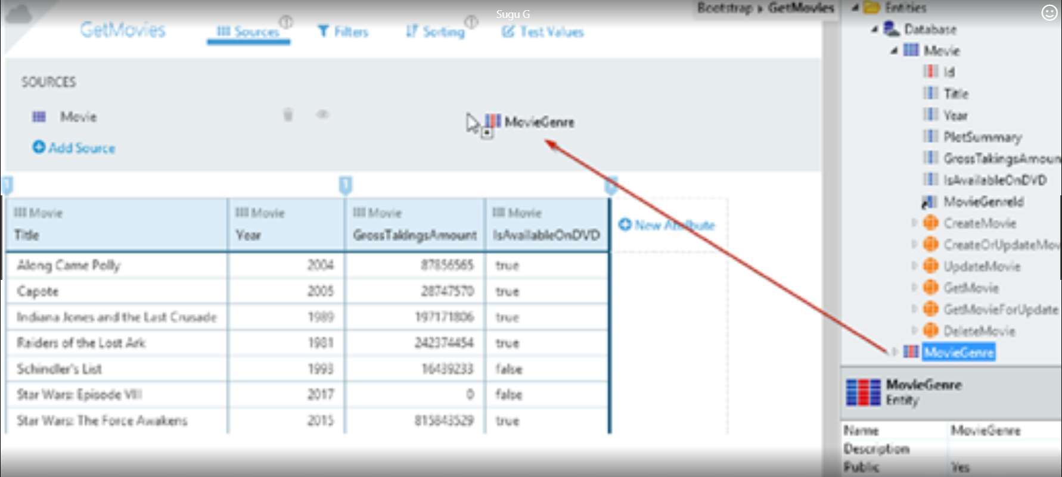

A. The Join must be created manually, if the MovieGenreId attribute in the Movie Entity is non-mandatory.

B. A With or Without join is created, if the MovieGenreId attribute in the Movie Entity is mandatory.

C. A With join is created, if the MovieGenreId attribute in the Movie Entity is non-mandatory.

D. An Only With join is created, if the MovieGenreId attribute in the Movie Entity is mandatory.

47)* What will be the output of the below aggregate?

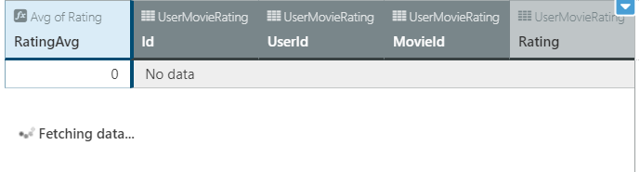

a) All attributes of UserMovieRating Entity

b) All attributes of UserMovieRating entity with RatingAvg attribute

c) Only RatingAvg attribute

48. Entities and Attributes are created in the database as,

1. Tables and Columns
2. List and Enumeration
3. Indexes and Columns
4. Tables and Constraints

49) What is true about site property?

a) Cannot be modified outside of Service Studio

b) Only changed at Runtime.

c) Cannot be a record data

50) In the below entity, a filter has to be added to check if the term "John" is present anywhere in the Person.Name attribute, what should be the condition to be added?

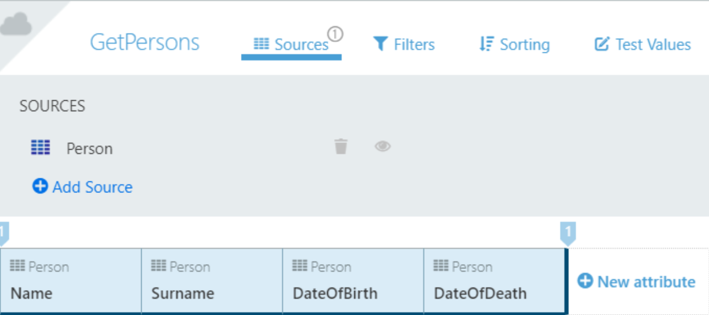

a) person.name=” %john%”

b) Person.name like=” john”

c) person.name like “%john%”

51) Considering the scenario given below, what happens when the user clicks on ”APPLY” button?



1. Refreshes the OSMDb_Core_Reactive module
2. Shows a confirmation for proceeding with outdated modules
3. Throws an error for not refreshing the OSMDb_Core_Reactive module.
4. Refreshes the OSMDb_Core_Reactive module and start publishing

52) Considering the static entities which of the following is true?

1. Cannot modify the default created attributes
2. Possible to add attribute with mandatory property set to yes
3. Cannot add more than one reference attribute
4. Possible to update the static entities in the SQL query.

53) Which of the following cannot be used directly in screen expression?

1. Static Value
2. Numeric calculated attribute from aggregate output
3. Output of a Data Action
4. Output of a Server action.

54) Consider there are two entities (Entity1 and Entity2) that are related. Entity2 has a reference attribute of type Entity1 identifier. Entity1 is added as source in the attribute. What happens if Entity2 is drag & dropped in the Aggregate?

1. A “With or Without” join will be created, if the reference attribute in Entity2 is non-mandatory
2. A “With” join will be created, if the reference attribute in Entity2 is mandatory
3. A “With” join will be created, if the reference attribute in Entity2 is non-mandatory
4. A “Only With” join will be created, if the reference attribute in Entity2 is non-mandatory

55) A developer is debugging a client action in the scope of a screen. The debugger points at the Start node of the action. Which of the following is false?



1. It is possible to view the local variables
2. It is possible to view the screen widgets
3. It is possible to view the GetName action.
4. It is possible to view input of the action.

56) Based on the CheckRegisteredRole action, which of the following implementation is true?

1. Can be used in client action.
2. Can be used to hide particular screen widgets or a screen content.
3. Can be used in Data Action Flow.
4. Can be used in the screen expression.

**Answers:**

|  |  |  |  |  |  |  |  |  |  |  |  |
| --- | --- | --- | --- | --- | --- | --- | --- | --- | --- | --- | --- |
| 1(D) | 6(C) | 11(B) | 16(A) | 21(D) | 26(A) | 31(A) | 36(B) | 41(B) | 46(D) | 51(B) | 56(C) |
| 2(C) | 7(B) | 12(B) | 17(B) | 22(C) | 27(B) | 32(C) | 37(D) | 42(C) | 47(C) | 52(B) |  |
| 3 (A) | 8(A) | 13(A) | 18(A) | 23(D) | 28(B) | 33(C) | 38(A) | 43(B) | 48(A) | 53(D) |  |
| 4(C) | 9(A) | 14(A) | 19(A) | 24(C) | 29(A) | 34(B) | 39() | 44(D) | 49(C) | 54(A) |  |
| 5 (A) | 10(A) | 15(C) | 20(B) | 25(C) | 30(A) | 35(B) | 40(B) | 45(B) | 50(C) | 55(C) |  |

**Points to Remember:**

* Using Forms, we can validate all the inputs of the widgets inside it.
* Static Entity cannot have reference attribute of a non-static entity identifier.
* The sort doesn’t seem work. Identify the reason, the second image shows the action being called on clicking any of the buttons in the button group. The third image shows the GetEmployees aggregate which is refreshed in the action.

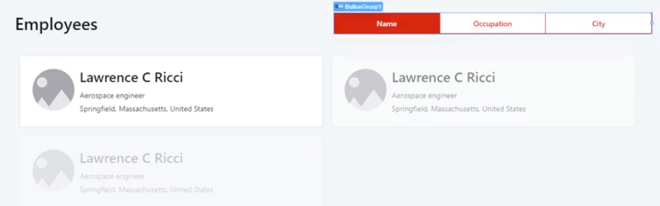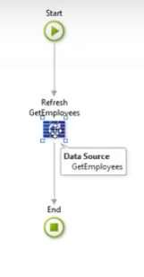

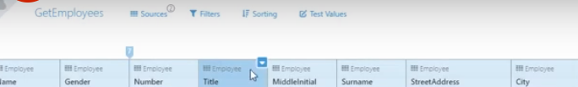

Answer: No dynamic sort has been added in the ‘Get Employees’ aggregate.

* The purpose of ‘Max. Records’ in the Pagination block sets the number of records shown in a page.
* It is not mandatory to set the ‘Validation message’ property of a widget when setting the ‘Valid’ property to ‘False’
* There will be one mandatory question on entity relationship. In today’s exam, the question came on ‘One to Many’ relationship.
* While debugging a screen action, we can inspect the values of locals, widgets, client, and Aggregates.
* If we have a calculated attribute inside an aggregate, all the attributes of the entities added in the source + the calculated attribute will be returned by the aggregate.
* If we use any of the aggregate functions such as Sum, Average etc., the aggregate will return only that aggregated column. This is shown in the preview when only the aggregated column will be in blue and the other columns will be in grey.

Bootcamp Quiz

1. **Regarding Reactive Web Apps in Outsystems, which of the following options is false?**
   1. A Reactive Web app is a cross-device app.
   2. Data requests are executed synchronously.
   3. The code generated by Outsystems results in a single-page application.
   4. A developer builds the Reactive Web App in Service Studio.
2. **What happens when a developer publishes a module?**
   1. The Outsystems platform compiles it and generates the HTML, CSS, and JavaScript.
   2. The browser opens.
   3. Nothing.
   4. The code is uploaded but only compiled when a user accesses the application.
3. Which of the following options is false regarding Modules and Applications?
   1. An application is composed of a set of modules.
   2. Modules can be of different types such as Reactive Web App, Blank or Extension.
   3. Elements can be exposed and reused, but only within the same application.
   4. A module that reuses an element from another module is called a Consumer.