A REPORT ON
AI DATA ANALYTICS —
NGO IMPACT & DONATION ANALYTICS
Submitted in partial fulfilment of the requirements for the award of the degree of
BACHELOR OF TECHNOLOGY
in
COMPUTER SCIENCE AND ENGINEERING
School of Computer Science and Engineering
IILM University, Greater Noida, Uttar Pradesh
Submitted by
BADAL KUMAR
Roll Number: ____________________
Section: ____________________ | Batch: 2026–27
Internship: AI Data Analytics — InAmigos Foundation
Project: NGO Impact & Donation Analytics
Synthetic demonstration datasets are used; no confidential InAmigos records are represented.

CANDIDATE'S DECLARATION
I, BADAL KUMAR, student of Bachelor of Technology in Computer Science and Engineering at IILM University, Greater Noida, Uttar Pradesh, hereby declare that the internship report entitled “AI Data Analytics — NGO Impact & Donation Analytics” is an original academic documentation of my project work.
The report documents an analytics implementation covering data validation, cleaning, exploratory analysis, visualization, dashboard development, and exploratory machine learning. The datasets used in the public implementation are synthetic demonstration datasets and are not presented as confidential or proprietary InAmigos Foundation records.
All external libraries, documentation, and project resources used in the implementation have been acknowledged in the references.

ACKNOWLEDGEMENT
The successful development of this internship project and the preparation of this report would not have been possible without the academic environment, guidance, and encouragement received throughout the work. I express my sincere gratitude to IILM University, Greater Noida, and the School of Computer Science and Engineering. I acknowledge InAmigos Foundation for the internship context in AI Data Analytics. I am grateful to faculty members, mentors, peers, and family for their support.

INTERNSHIP SELECTION CERTIFICATE
Authentic certificate of selection available for this internship. It is reproduced without alteration. It is a selection certificate, not a completion certificate.
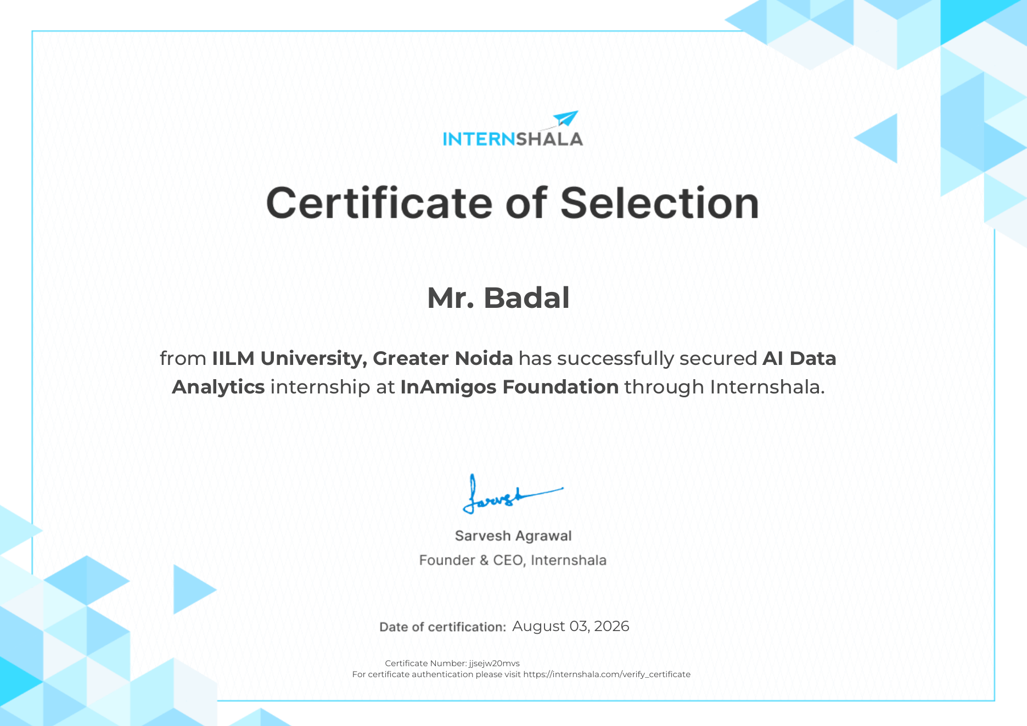

TABLE OF CONTENTS
Candidate's Declaration i
Acknowledgement ii
Internship Selection Certificate iii
List of Figures v
List of Tables v
4. PROJECT DESCRIPTION 1
4.1 Introduction 1
4.2 Organization Profile 1
4.3 Problem Statement 2
4.4 Project Objectives 2
4.5 Scope of the Project 3
4.6 Technologies and Tools Used 3
4.7 System Architecture 4
4.8 Methodology 5
4.9 Expected Outcomes 9
4.10 Internship Documentation and Project Evidence 10
5. BIBLIOGRAPHY / REFERENCES 11
APPENDIX A — PROJECT DOCUMENTATION 12

LIST OF FIGURES
Figure 4.1: System Architecture of the NGO Impact & Donation Analytics System
Figure 4.2: Data-processing and analytical workflow
Figure 4.3: Streamlit dashboard presentation layer

LIST OF TABLES
Table 4.1: Technology Stack and Project Usage
Table 4.2: Dataset Inventory and Principal Attributes
Table 4.3: Primary Data Preprocessing Operations
Table 4.4: Analytical Modules Overview
Table 4.5: Machine-Learning Feature Set
Table 4.6: Summary of Learning Outcomes
Table 4.7: Technical and Operational Limitations

4. PROJECT DESCRIPTION

4.1 Introduction
Data analytics is the systematic process of collecting, validating, cleaning, transforming, exploring, and interpreting structured information to identify patterns and support measurable decisions. In an NGO or social-impact context, relevant information can span donations, programmes, beneficiaries, volunteers, attendance, outcomes, and operational budgets.
The project AI Data Analytics — NGO Impact & Donation Analytics implements an end-to-end analytical workflow using Python. It combines descriptive analytics, interactive Plotly visualizations, exploratory K-Means donor segmentation, and a Streamlit dashboard.

4.2 Organization Profile
The project is documented in the context of an AI Data Analytics internship with InAmigos Foundation. The available internship selection documentation identifies Badal from IILM University, Greater Noida as having secured the internship through Internshala on August 03, 2026. The technical project is an original NGO/social-impact analytics implementation and does not claim that synthetic outputs are actual InAmigos organizational findings.

4.3 Problem Statement
NGO operations can involve multiple information streams. Donation records describe funding activity, beneficiary records describe participation and outcomes, volunteer records describe human-resource contributions, and programme records describe budgets and intended reach. The project addresses the problem of building a reproducible analytics workflow that transforms structured NGO-style records into comparable KPIs, visual trends, programme summaries, efficiency indicators, and exploratory donor segments.

4.4 Project Objectives
1. Build a Python analytics workflow.
2. Validate and clean four datasets.
3. Analyse donation patterns.
4. Measure beneficiary attendance and outcomes.
5. Evaluate programme budgets and efficiency indicators.
6. Analyse volunteer contribution.
7. Demonstrate K-Means donor segmentation.
8. Analyse monthly trends.
9. Create Plotly visualizations.
10. Integrate outputs into Streamlit.
11. Document reproducibility, ethics, limitations, and future scope.

4.5 Scope of the Project
Donation and donor analytics; beneficiary impact analytics; programme efficiency analytics; volunteer analytics; exploratory donor segmentation; time-series analysis; and interactive Streamlit presentation.

4.6 Technologies and Tools Used
Python, Pandas, NumPy, Scikit-learn, Plotly, Streamlit, Jupyter, and Git/GitHub are used across data preparation, analysis, machine learning, visualization, dashboard development, exploration, and version control.

4.7 Dataset Design
The implementation uses donations.csv, beneficiaries.csv, volunteers.csv, and programs.csv. These are synthetic demonstration datasets designed to support funding, participation, volunteer, programme, and efficiency analysis.

4.8 System Architecture
Synthetic NGO-style data → validation and cleaning → feature engineering and aggregation → EDA and KPI analytics → exploratory K-Means → Plotly visualizations → Streamlit dashboard.

4.8 Methodology
The workflow is data acquisition/generation → validation → cleaning → transformation → EDA → analytical modules → machine learning → visualization → dashboard presentation. Cleaning includes duplicate handling, numeric conversion, date parsing, missing-value treatment, positive-donation validation, and monthly feature creation. Derived features support donation, repeat-donor, volunteer, programme-efficiency, and time-series analysis.

4.9 Expected Outcomes
The project provides a reusable example of how NGO-style operational data can be transformed into structured analytical views, exploratory machine-learning outputs, and an interactive dashboard. Learning outcomes include Python/Pandas skills, KPI design, visualization, feature engineering, K-Means fundamentals, Streamlit development, Git/GitHub, reproducibility, and responsible synthetic-data use.

4.10 Internship Documentation and Project Evidence
The available authentic internship documentation is an Internshala Certificate of Selection dated August 03, 2026. It identifies the AI Data Analytics internship at InAmigos Foundation. Only authentic documents should be attached to the final academic report. No altered or fabricated completion certificate is included.

5. BIBLIOGRAPHY / REFERENCES
1. Python Software Foundation — Python Documentation.
2. Pandas Development Team — pandas documentation.
3. NumPy Developers — NumPy documentation.
4. Scikit-learn Developers — scikit-learn documentation.
5. Plotly Technologies Inc. — Plotly Python documentation.
6. Streamlit — Streamlit documentation.
7. Badal — 2026-Badal-IILM-AI-Data-Analytics-NGO-Impact GitHub repository.
8. Project data dictionary and repository documentation.
9. Internshala Certificate of Selection — AI Data Analytics internship at InAmigos Foundation.

APPENDIX A — PROJECT DOCUMENTATION
A.1 Repository Structure
README.md, data/, src/, notebooks/, dashboard/, reports/, and .github/workflows/ are maintained as separate project components.
A.2 Reproducibility
A fixed random seed supports reproducible synthetic-data generation. Requirements and workflow documentation are included.
A.3 Data Ethics Statement
No personal donor or beneficiary information is intended to be exposed. Authorized real-data integration would require minimization, anonymization where appropriate, secure storage, access control, and organizational governance.
A.4 Suggested Evidence to Attach
Authentic internship documentation, dashboard screenshots, GitHub repository screenshot, notebook/output screenshots, and genuine project/task documents if available.

