Experiment 1 : Combinational Circuits – I

Part 1: To Check the 4-bit input number is BCD

Badal Varshney, Roll Number 19D070015

EE-214, WEL, IIT Bombay

February 18, 2021

## Overview of the experiment:

|  |
| --- |
| Design a combinational circuit block to check if the 4-bit input number is a BCD digit (a3a2a1a0) that varies from 0-9. The number is to be inputted through the four on-board slide switches (S4-S1) with MSB bit on S4.  (a) a BCD number, display the same number on four on-board LEDs: LED4-LED1.  (b) not a BCD number, LED4-LED1 (l4l3l2l1) should be turned ON. |

## Approach to the experiment:

|  |
| --- |
| The approach was to somehow partition the bits and store the information as we go along higher levels of execution.  In this way the information got carried in each stage to the next stage. |

## Design document and VHDL code if relevant:

|  |
| --- |
| The design broadly included using 5 AND gate,2 OR gates and 1 NOT gate.  VHDL code for BCD CHECKER-    VHDL code for Dut file- |

## RTL View:

|  |
| --- |
| RTL view of the combinational circuit |

## DUT Input/Output Format:

|  |  |  |  |  |  |  |  |  |  |  |  |  |  |  |  |  |  |  |  |  |  |  |  |  |  |  |  |  |  |  |  |  |  |  |  |  |  |  |  |  |  |  |  |  |  |  |  |  |
| --- | --- | --- | --- | --- | --- | --- | --- | --- | --- | --- | --- | --- | --- | --- | --- | --- | --- | --- | --- | --- | --- | --- | --- | --- | --- | --- | --- | --- | --- | --- | --- | --- | --- | --- | --- | --- | --- | --- | --- | --- | --- | --- | --- | --- | --- | --- | --- | --- |
| Mention the format (LSB/MSB of input and output) and few test cases from trace-file.   |  |  |  |  |  |  |  |  |  |  |  |  | | --- | --- | --- | --- | --- | --- | --- | --- | --- | --- | --- | --- | | Input |  |  |  | Output |  |  |  | Mask |  |  |  | | MSB |  |  | LSB | MSB |  |  | LSB | MSB |  |  | LSB | | X3 | X2 | X1 | X0 | O3 | O2 | O1 | O0 | M3 | M2 | M1 | M0 | | 0  1 | 1  1 | 0  1 | 0  1 | 0  0 | 1  1 | 0  0 | 01 | 1  1 | 1  1 | 1  1 | 1 | |

## RTL Simulation:

|  |
| --- |
| RTL simulation screen shot |

## Gate-level Simulation:

|  |
| --- |
| Gate-level simulation screen shot |

## Krypton board*:

|  |
| --- |
| (a) a BCD number, display the same number on four on-board LEDs: LED4-LED1.  (b) not a BCD number, LED4-LED1 (l4l3l2l1) should be turned ON. |

## Observations*:

|  |
| --- |
| - |

## References:

|  |
| --- |
| No references |

* To be submitted after the tutorial on ”Using Krypton.

Experiment 1 : Combinational Circuits – I

Part 2: BCD ADDER

Badal Varshney, Roll Number 19D070015

EE-214, WEL, IIT Bombay

February 18, 2021

## Overview of the experiment:

Design a block which adds two 2-digit BCD numbers D1 and D2. Note that each of them is 8 bit wide packed with 2 BCD digits. The output will be valid a 2-digit BCD number and carry.

To BCD adjust the two digit sum obtained for BCD output for all possible cases of

invalid BCD sum due to binary addition.

## Approach to the experiment:

The approach was to somehow partition the bits and store the information as we go along higher levels of execution.

In this way the information got carried in each stage to the next stage.

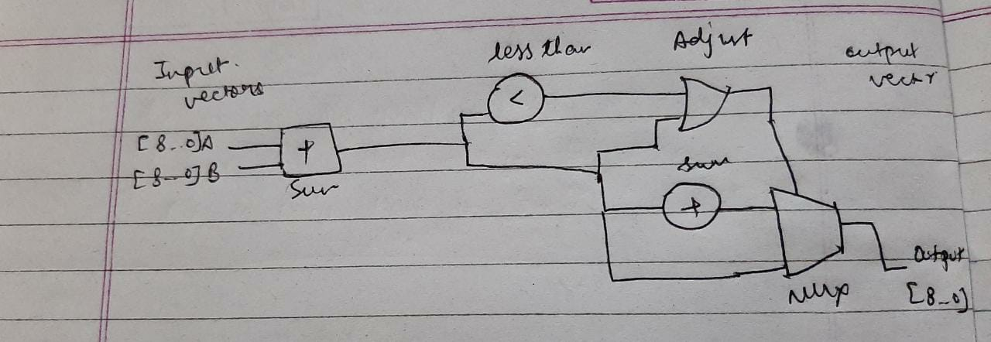

## Design document and VHDL code if relevant:

The design broadly included using MUX, OR gates and less than operation.

VHDL code for BCD ADDER-

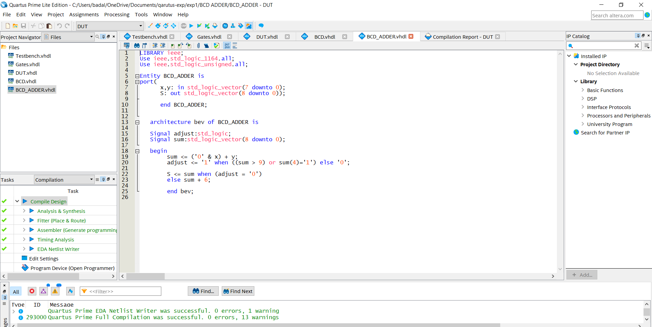

VHDL code for Dut file-

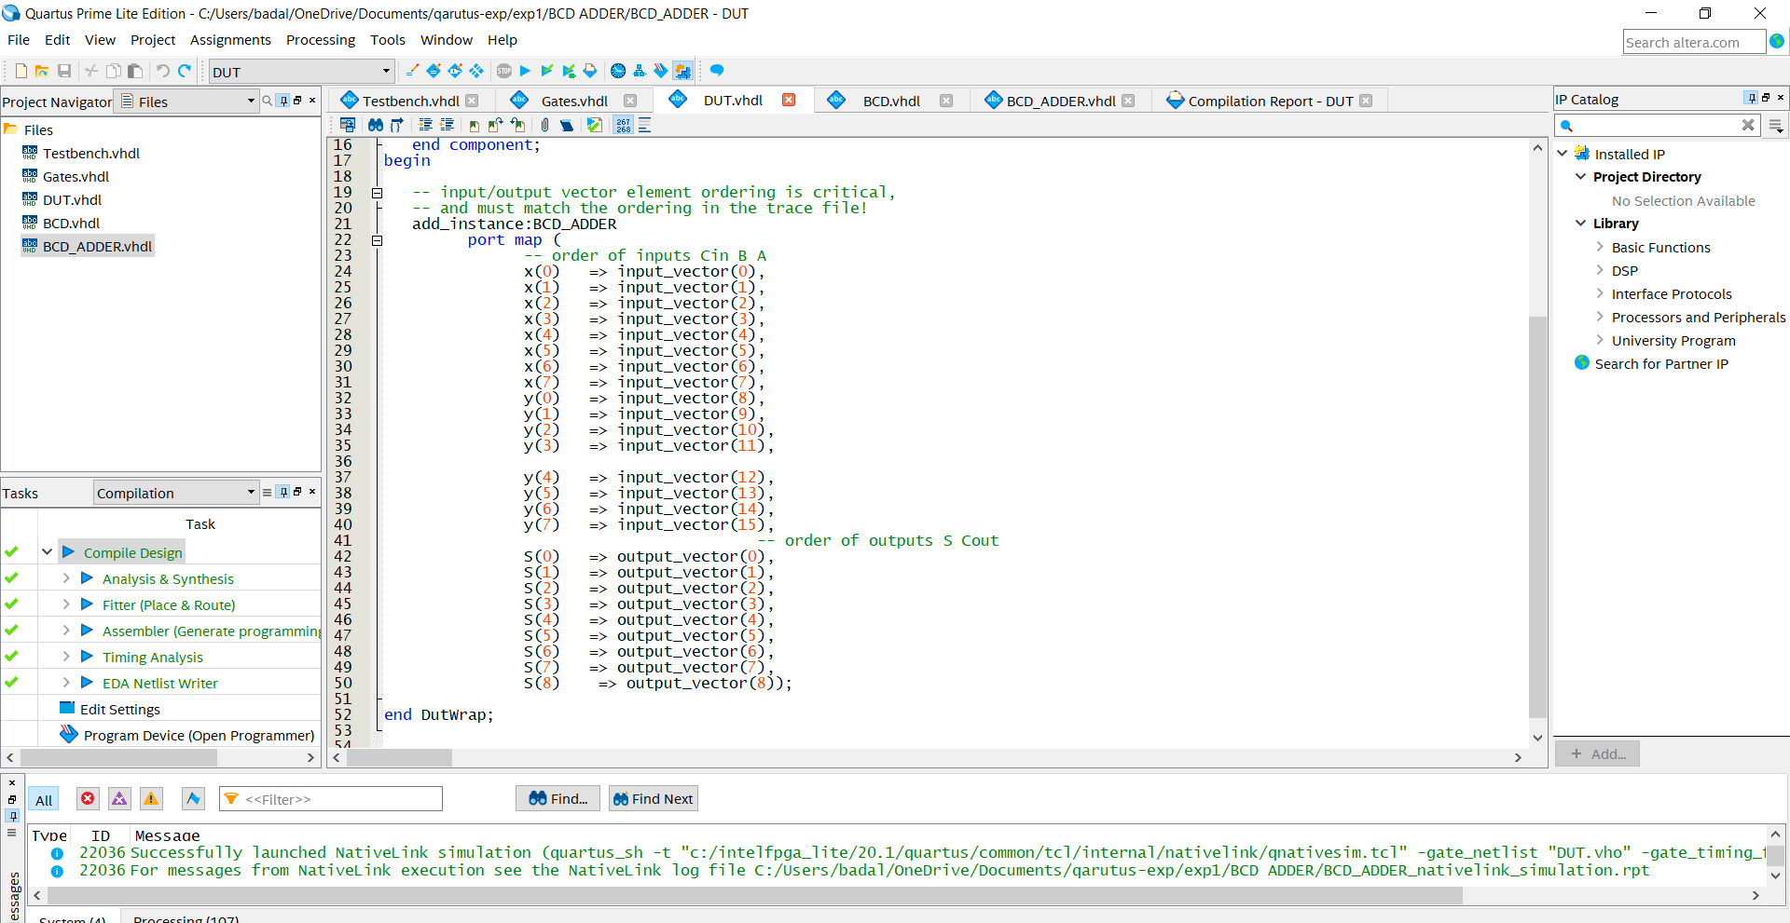

## RTL View:

RTL view of the combinational circuit

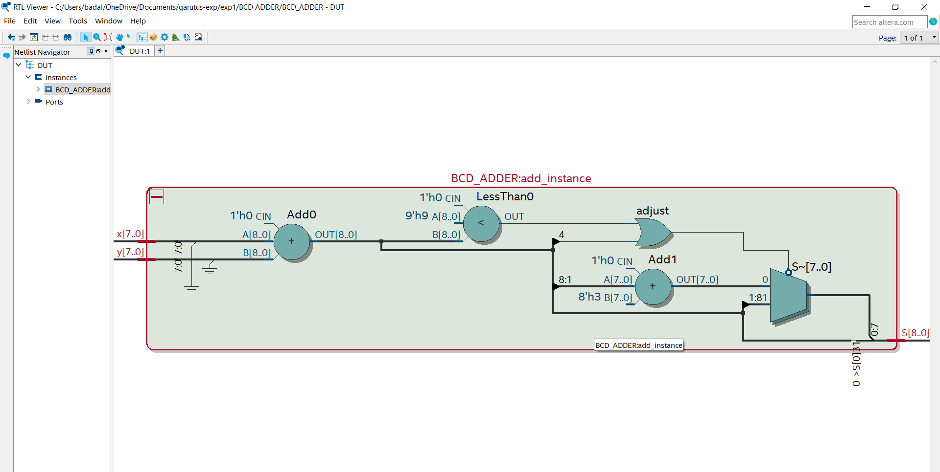

## DUT Input/Output Format:

Mention the format (LSB/MSB of input and output) and few test cases from trace-file.

|  |  |  |  |  |
| --- | --- | --- | --- | --- |
| input |  | output |  | mask |
| 0000000000010101 |  | 000010101 |  | 111111111 |
| 1001100110011000 |  | 110010111 |  | 111111111 |

## RTL Simulation:

RTL simulation screen shot

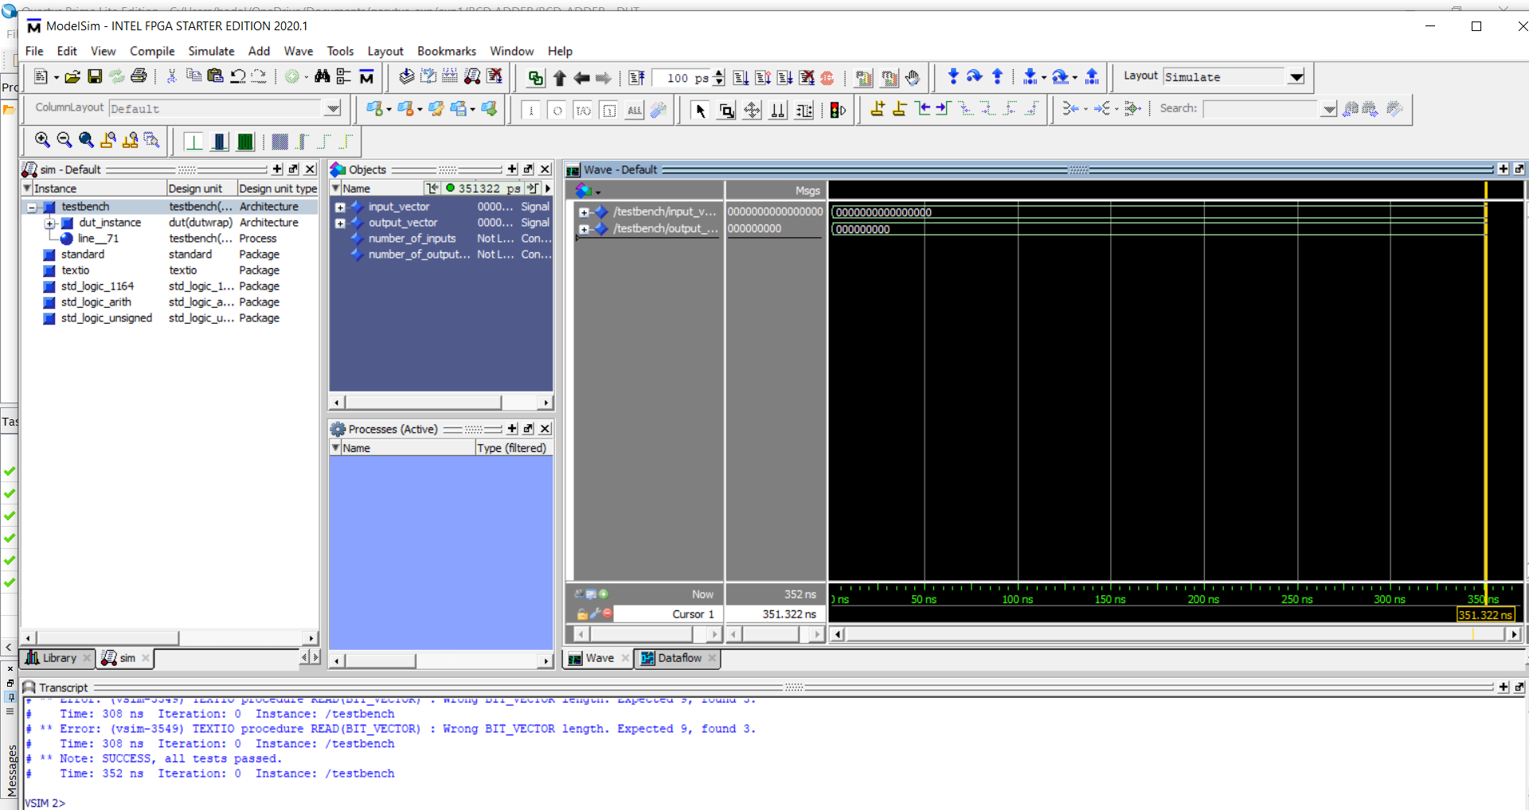

## Gate-level Simulation:

Gate-level simulation screen shot

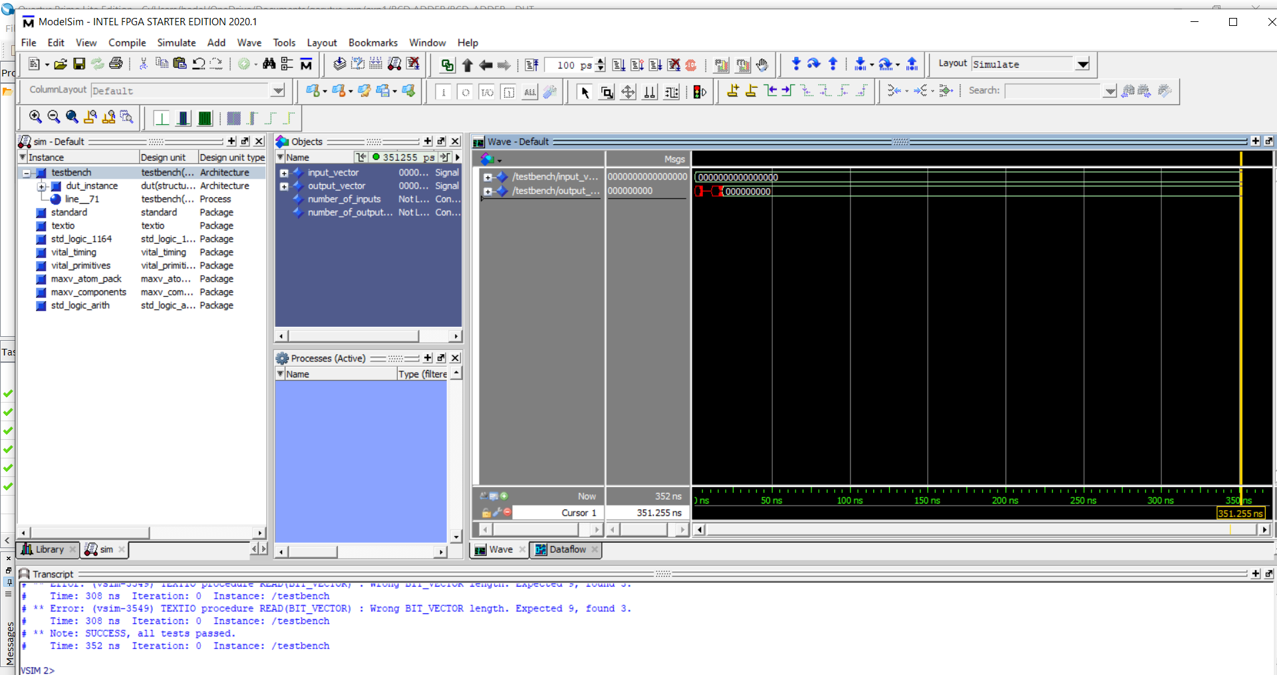

## Krypton board*:

-

## Observations*:

-

## References:

No references

* To be submitted after the tutorial on ”Using Krypton.

Experiment 1 : Combinational Circuits – I

Part 3: CHECK AND ADDER

Badal Varshney, Roll Number 19D070015

EE-214, WEL, IIT Bombay

February 18, 2021

## Overview of the experiment:

Accept a two digit BCD number (AB with A as most signi cant digit and B as lower significant digit) using eight on-board switches (S8-S5 for A :< a3a2a1a0 >) and (S4-S1 for B: < b3b2b1b0 >) respectively.

Check if the input number is a valid two digit BCD number AB. You are advised to use the block

you designed in Part 1.

If the input number is a 2-digit BCD, using the block in Part 2 add this 2-digit BCD number to 29,a fixed number.

Final output should be displayed on eight on-board LEDs (LED8-LED1) (l8l7l6l5l4l3l2l1) and is the BCD addition result or obtained as mentioned in table below. You may ignore the nal carry bit to be displayed as there are only eight LEDs on board.

## Approach to the experiment:

The approach was to somehow partition the bits and store the information as we go along higher levels of execution.

In this way the information got carried in each stage to the next stage.

## Design document and VHDL code if relevant:

The design broadly included using MUX, logic gates, Part 1 BCD checker, Part 2 BCD adder and Decimal adjust

VHDL code for BCD3-

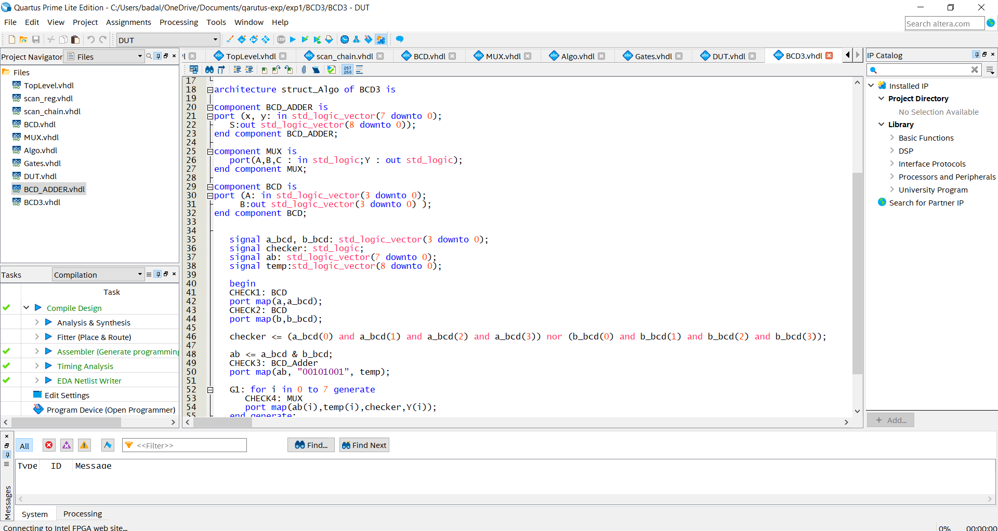

VHDL code for Dut file-

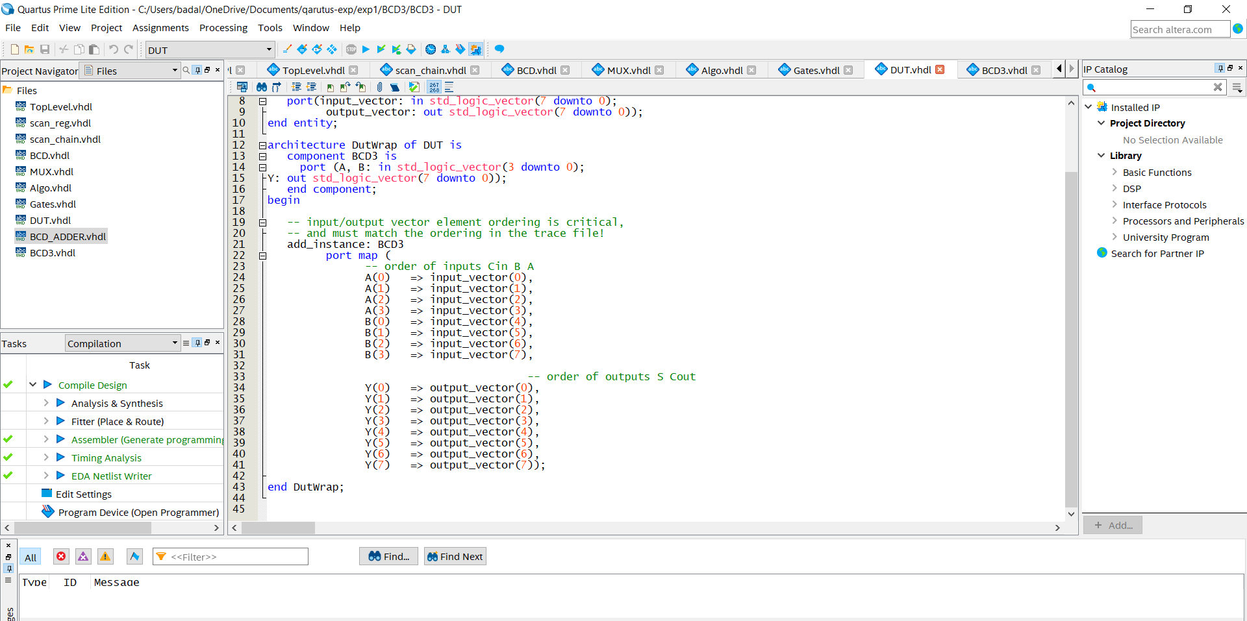

## RTL View:

RTL view of the combinational circuit

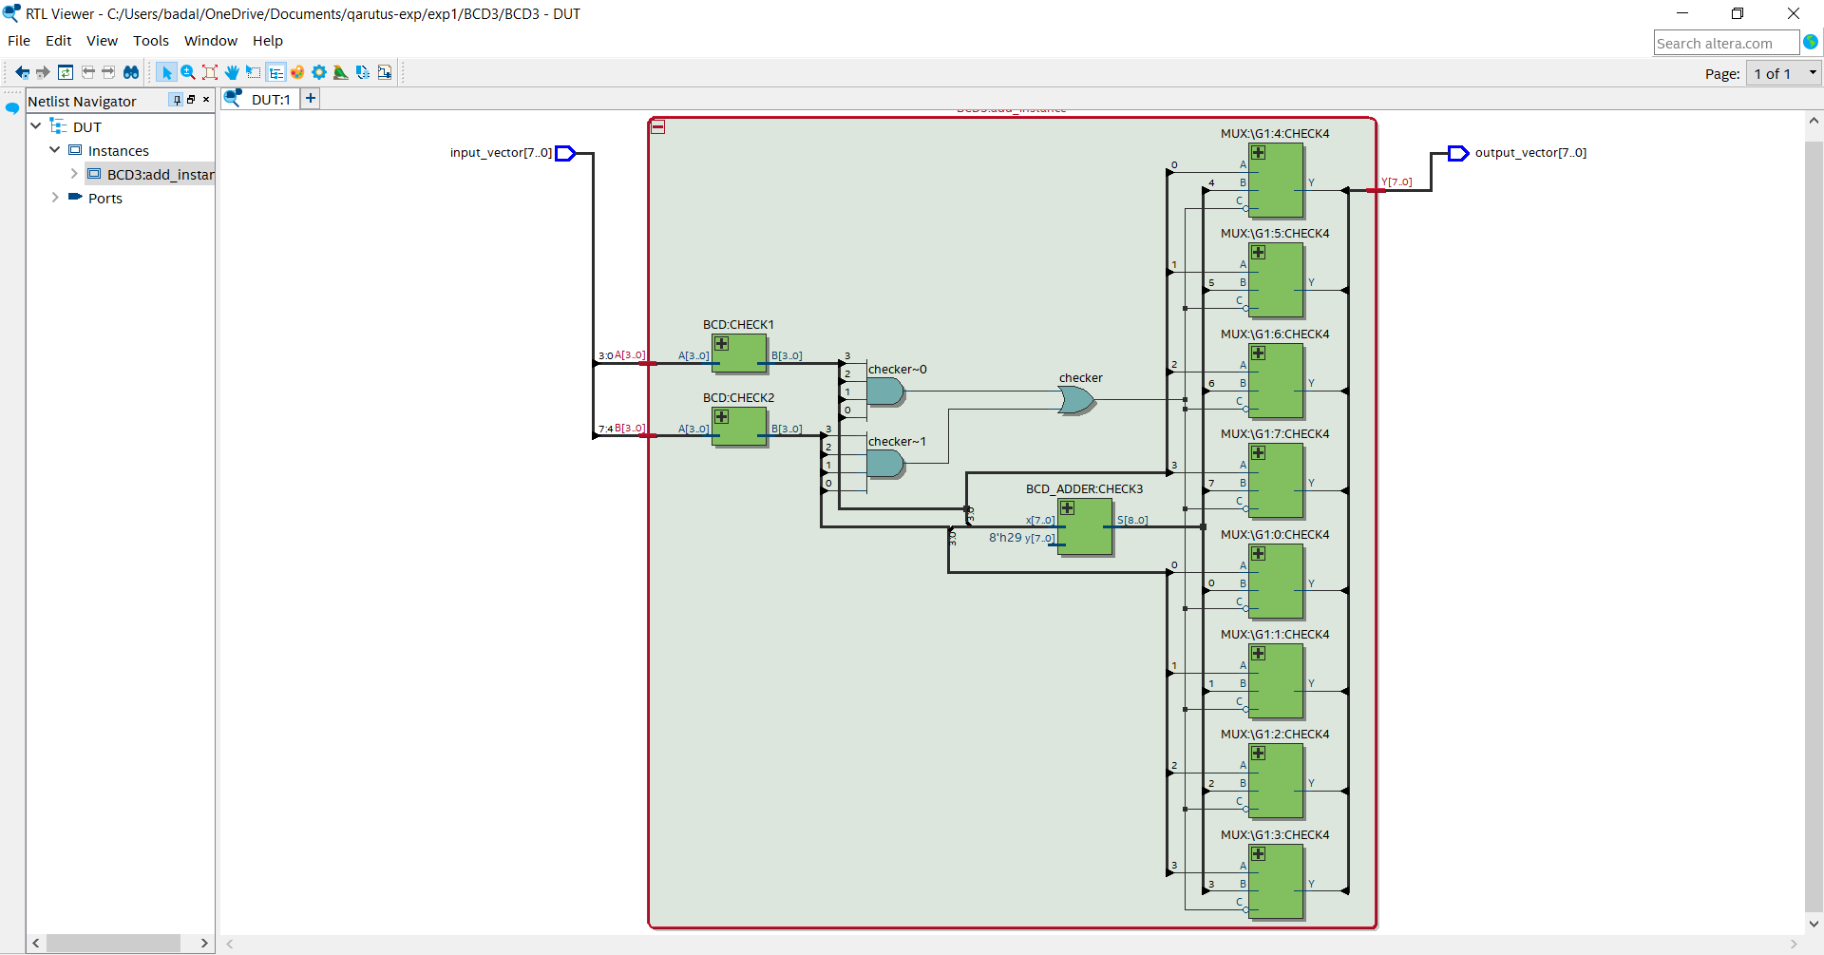

MUX RTL viewer

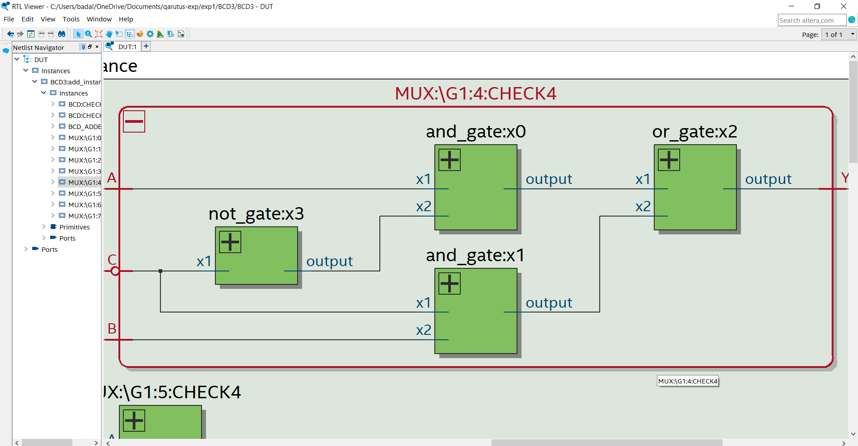

## DUT Input/Output Format:

Mention the format (LSB/MSB of input and output) and few test cases from trace-file.

|  |  |  |  |  |
| --- | --- | --- | --- | --- |
| input |  | output |  | mask |
| 00001101 |  | 00001111 |  | 11111111 |
| 00100010 |  | 01010001 |  | 11111111 |

## RTL Simulation:

RTL simulation screen shot

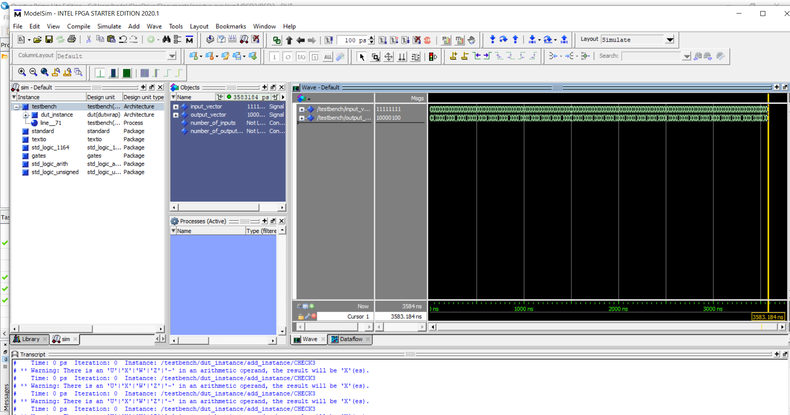

## Gate-level Simulation:

Gate-level simulation screen shot

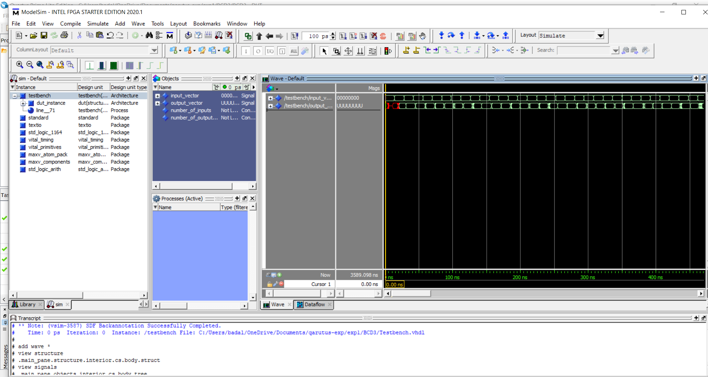

## Krypton board*:

|  |  |  |
| --- | --- | --- |
| Digit A | Digit B | Expected display on LEDs |
| Valid BCD | Valid BCD | (29+AB) |
| Valid BCD | not BCD | A 1111 |
| not BCD | Valid BCD | 1111 B |
| not BCD | not BCD | 1111 1111 |

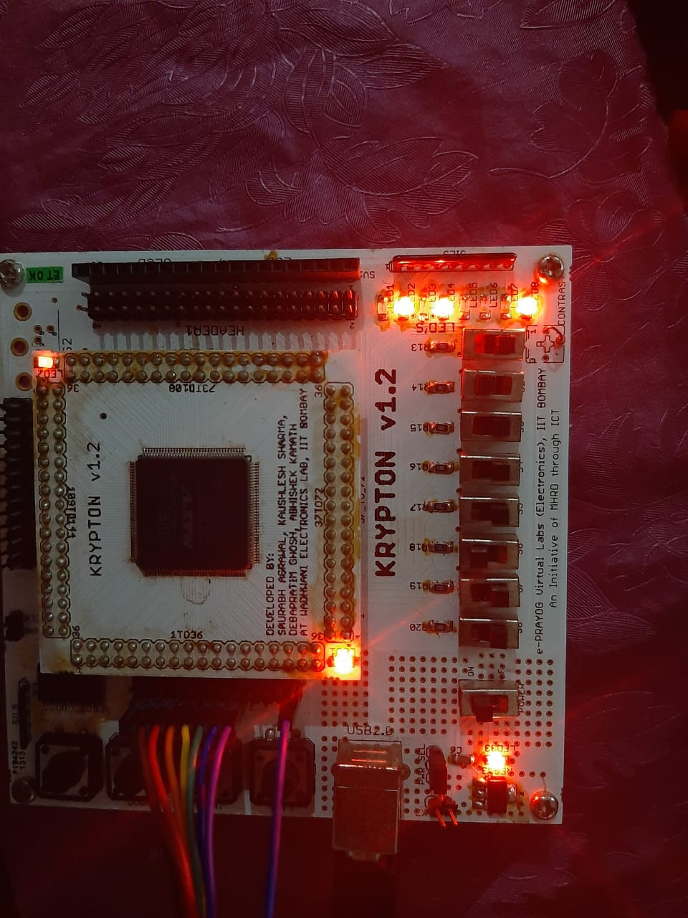

## Observations*:

-

## References:

No references

* To be submitted after the tutorial on ”Using Krypton.