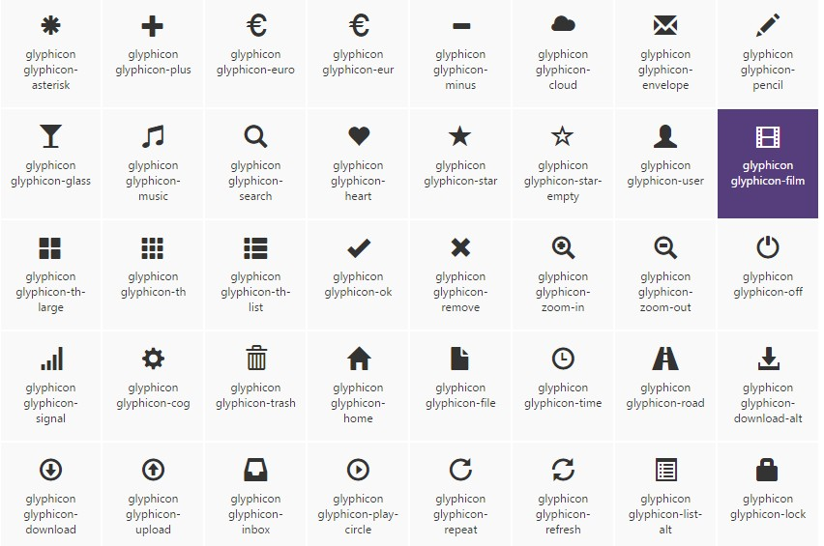

glyphicon glyphicon-asterisk

glyphicon glyphicon-plus

glyphicon glyphicon-euro

glyphicon glyphicon-eur

glyphicon glyphicon-minus

glyphicon glyphicon-cloud

glyphicon glyphicon-envelope

glyphicon glyphicon-pencil

glyphicon glyphicon-glass

glyphicon glyphicon-music

glyphicon glyphicon-search

glyphicon glyphicon-heart

glyphicon glyphicon-star

glyphicon glyphicon-star-empty

glyphicon glyphicon-user

glyphicon glyphicon-film

glyphicon glyphicon-th-large

glyphicon glyphicon-th

glyphicon glyphicon-th-list

glyphicon glyphicon-ok

glyphicon glyphicon-remove

glyphicon glyphicon-zoom-in

glyphicon glyphicon-zoom-out

glyphicon glyphicon-off

glyphicon glyphicon-signal

glyphicon glyphicon-cog

glyphicon glyphicon-trash

glyphicon glyphicon-home

glyphicon glyphicon-file

glyphicon glyphicon-time

glyphicon glyphicon-road

glyphicon glyphicon-download-alt

glyphicon glyphicon-download

glyphicon glyphicon-upload

glyphicon glyphicon-inbox

glyphicon glyphicon-play-circle

glyphicon glyphicon-repeat

glyphicon glyphicon-refresh

glyphicon glyphicon-list-alt

glyphicon glyphicon-lock

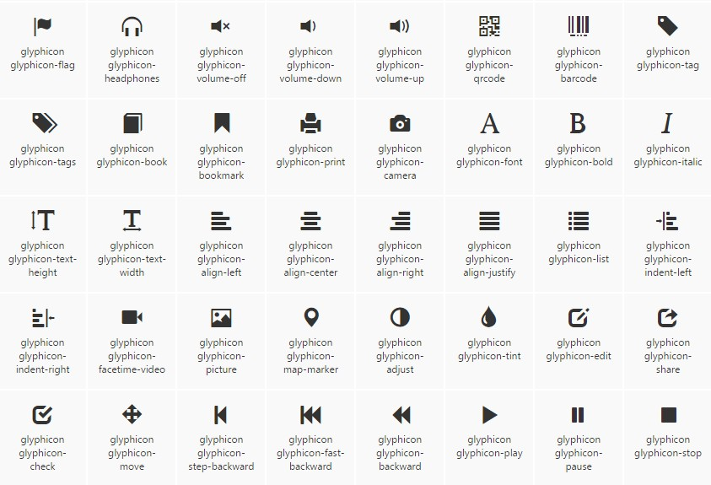

glyphicon glyphicon-flag

glyphicon glyphicon-headphones

glyphicon glyphicon-volume-off

glyphicon glyphicon-volume-down

glyphicon glyphicon-volume-up

glyphicon glyphicon-qrcode

glyphicon glyphicon-barcode

glyphicon glyphicon-tag

glyphicon glyphicon-tags

glyphicon glyphicon-book

glyphicon glyphicon-bookmark

glyphicon glyphicon-print

glyphicon glyphicon-camera

glyphicon glyphicon-font

glyphicon glyphicon-bold

glyphicon glyphicon-italic

glyphicon glyphicon-text-height

glyphicon glyphicon-text-width

glyphicon glyphicon-align-left

glyphicon glyphicon-align-center

glyphicon glyphicon-align-right

glyphicon glyphicon-align-justify

glyphicon glyphicon-list

glyphicon glyphicon-indent-left

glyphicon glyphicon-indent-right

glyphicon glyphicon-facetime-video

glyphicon glyphicon-picture

glyphicon glyphicon-map-marker

glyphicon glyphicon-adjust

glyphicon glyphicon-tint

glyphicon glyphicon-edit

glyphicon glyphicon-share

glyphicon glyphicon-check

glyphicon glyphicon-move

glyphicon glyphicon-step-backward

glyphicon glyphicon-fast-backward

glyphicon glyphicon-backward

glyphicon glyphicon-play

glyphicon glyphicon-pause

glyphicon glyphicon-stop

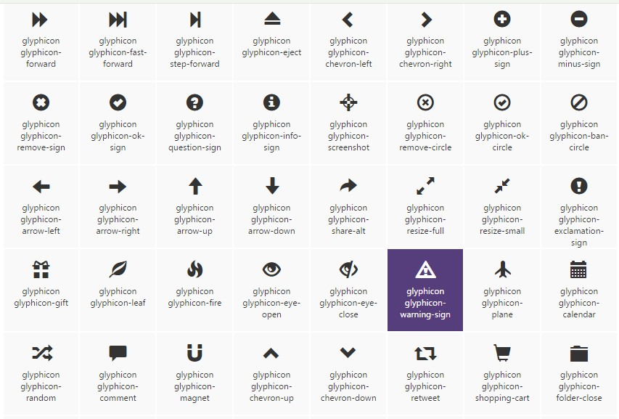

glyphicon glyphicon-forward

glyphicon glyphicon-fast-forward

glyphicon glyphicon-step-forward

glyphicon glyphicon-eject

glyphicon glyphicon-chevron-left

glyphicon glyphicon-chevron-right

glyphicon glyphicon-plus-sign

glyphicon glyphicon-minus-sign

glyphicon glyphicon-remove-sign

glyphicon glyphicon-ok-sign

glyphicon glyphicon-question-sign

glyphicon glyphicon-info-sign

glyphicon glyphicon-screenshot

glyphicon glyphicon-remove-circle

glyphicon glyphicon-ok-circle

glyphicon glyphicon-ban-circle

glyphicon glyphicon-arrow-left

glyphicon glyphicon-arrow-right

glyphicon glyphicon-arrow-up

glyphicon glyphicon-arrow-down

glyphicon glyphicon-share-alt

glyphicon glyphicon-resize-full

glyphicon glyphicon-resize-small

glyphicon glyphicon-exclamation-sign

glyphicon glyphicon-gift

glyphicon glyphicon-leaf

glyphicon glyphicon-fire

glyphicon glyphicon-eye-open

glyphicon glyphicon-eye-close

glyphicon glyphicon-warning-sign

glyphicon glyphicon-plane

glyphicon glyphicon-calendar

glyphicon glyphicon-random

glyphicon glyphicon-comment

glyphicon glyphicon-magnet

glyphicon glyphicon-chevron-up

glyphicon glyphicon-chevron-down

glyphicon glyphicon-retweet

glyphicon glyphicon-shopping-cart

glyphicon glyphicon-folder-close

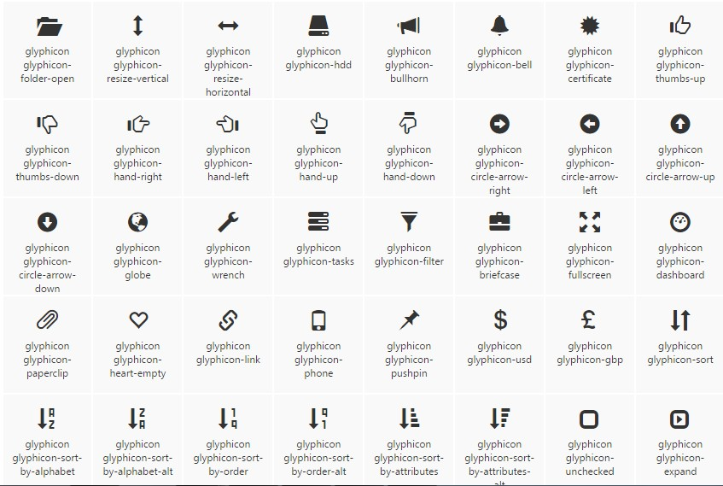

glyphicon glyphicon-folder-open

glyphicon glyphicon-resize-vertical

glyphicon glyphicon-resize-horizontal

glyphicon glyphicon-hdd

glyphicon glyphicon-bullhorn

glyphicon glyphicon-bell

glyphicon glyphicon-certificate

glyphicon glyphicon-thumbs-up

glyphicon glyphicon-thumbs-down

glyphicon glyphicon-hand-right

glyphicon glyphicon-hand-left

glyphicon glyphicon-hand-up

glyphicon glyphicon-hand-down

glyphicon glyphicon-circle-arrow-right

glyphicon glyphicon-circle-arrow-left

glyphicon glyphicon-circle-arrow-up

glyphicon glyphicon-circle-arrow-down

glyphicon glyphicon-globe

glyphicon glyphicon-wrench

glyphicon glyphicon-tasks

glyphicon glyphicon-filter

glyphicon glyphicon-briefcase

glyphicon glyphicon-fullscreen

glyphicon glyphicon-dashboard

glyphicon glyphicon-paperclip

glyphicon glyphicon-heart-empty

glyphicon glyphicon-link

glyphicon glyphicon-phone

glyphicon glyphicon-pushpin

glyphicon glyphicon-usd

glyphicon glyphicon-gbp

glyphicon glyphicon-sort

glyphicon glyphicon-sort-by-alphabet

glyphicon glyphicon-sort-by-alphabet-alt

glyphicon glyphicon-sort-by-order

glyphicon glyphicon-sort-by-order-alt

glyphicon glyphicon-sort-by-attributes

glyphicon glyphicon-sort-by-attributes-alt

glyphicon glyphicon-unchecked

glyphicon glyphicon-expand

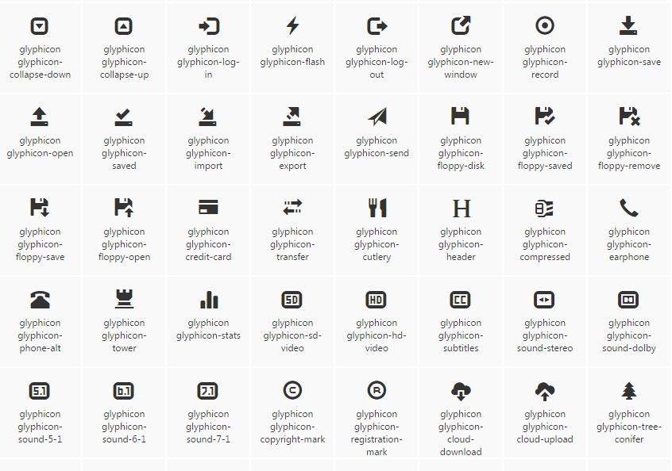

glyphicon glyphicon-collapse-down

glyphicon glyphicon-collapse-up

glyphicon glyphicon-log-in

glyphicon glyphicon-flash

glyphicon glyphicon-log-out

glyphicon glyphicon-new-window

glyphicon glyphicon-record

glyphicon glyphicon-save

glyphicon glyphicon-open

glyphicon glyphicon-saved

glyphicon glyphicon-import

glyphicon glyphicon-export

glyphicon glyphicon-send

glyphicon glyphicon-floppy-disk

glyphicon glyphicon-floppy-saved

glyphicon glyphicon-floppy-remove

glyphicon glyphicon-floppy-save

glyphicon glyphicon-floppy-open

glyphicon glyphicon-credit-card

glyphicon glyphicon-transfer

glyphicon glyphicon-cutlery

glyphicon glyphicon-header

glyphicon glyphicon-compressed

glyphicon glyphicon-earphone

glyphicon glyphicon-phone-alt

glyphicon glyphicon-tower

glyphicon glyphicon-stats

glyphicon glyphicon-sd-video

glyphicon glyphicon-hd-video

glyphicon glyphicon-subtitles

glyphicon glyphicon-sound-stereo

glyphicon glyphicon-sound-dolby

glyphicon glyphicon-sound-5-1

glyphicon glyphicon-sound-6-1

glyphicon glyphicon-sound-7-1

glyphicon glyphicon-copyright-mark

glyphicon glyphicon-registration-mark

glyphicon glyphicon-cloud-download

glyphicon glyphicon-cloud-upload

glyphicon glyphicon-tree-conifer

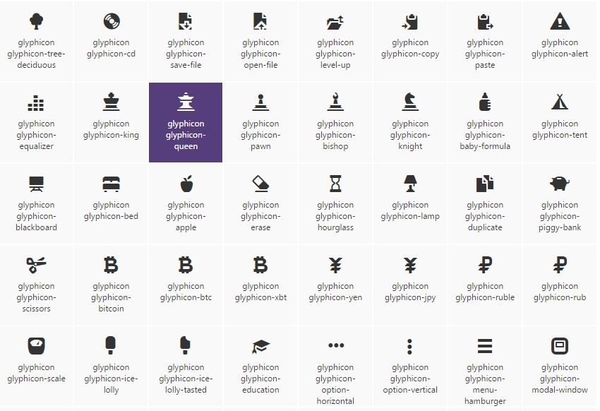

glyphicon glyphicon-tree-deciduous

glyphicon glyphicon-cd

glyphicon glyphicon-save-file

glyphicon glyphicon-open-file

glyphicon glyphicon-level-up

glyphicon glyphicon-copy

glyphicon glyphicon-paste

glyphicon glyphicon-alert

glyphicon glyphicon-equalizer

glyphicon glyphicon-king

glyphicon glyphicon-queen

glyphicon glyphicon-pawn

glyphicon glyphicon-bishop

glyphicon glyphicon-knight

glyphicon glyphicon-baby-formula

glyphicon glyphicon-tent

glyphicon glyphicon-blackboard

glyphicon glyphicon-bed

glyphicon glyphicon-apple

glyphicon glyphicon-erase

glyphicon glyphicon-hourglass

glyphicon glyphicon-lamp

glyphicon glyphicon-duplicate

glyphicon glyphicon-piggy-bank

glyphicon glyphicon-scissors

glyphicon glyphicon-bitcoin

glyphicon glyphicon-btc

glyphicon glyphicon-xbt

glyphicon glyphicon-yen

glyphicon glyphicon-jpy

glyphicon glyphicon-ruble

glyphicon glyphicon-rub

glyphicon glyphicon-scale

glyphicon glyphicon-ice-lolly

glyphicon glyphicon-ice-lolly-tasted

glyphicon glyphicon-education

glyphicon glyphicon-option-horizontal

glyphicon glyphicon-option-vertical

glyphicon glyphicon-menu-hamburger

glyphicon glyphicon-modal-window

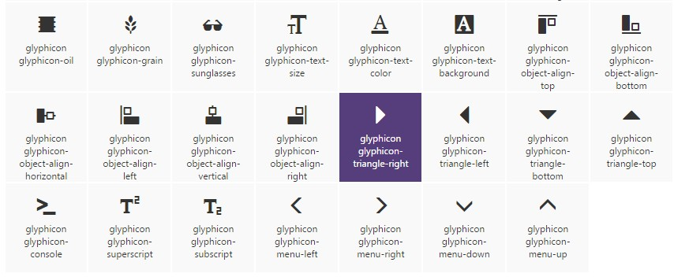

glyphicon glyphicon-oil

glyphicon glyphicon-grain

glyphicon glyphicon-sunglasses

glyphicon glyphicon-text-size

glyphicon glyphicon-text-color

glyphicon glyphicon-text-background

glyphicon glyphicon-object-align-top

glyphicon glyphicon-object-align-bottom

glyphicon glyphicon-object-align-horizontal

glyphicon glyphicon-object-align-left

glyphicon glyphicon-object-align-vertical

glyphicon glyphicon-object-align-right

glyphicon glyphicon-triangle-right

glyphicon glyphicon-triangle-left

glyphicon glyphicon-triangle-bottom

glyphicon glyphicon-triangle-top

glyphicon glyphicon-console

glyphicon glyphicon-superscript

glyphicon glyphicon-subscript

glyphicon glyphicon-menu-left

glyphicon glyphicon-menu-right

glyphicon glyphicon-menu-down

glyphicon glyphicon-menu-up