1. Creating and Renaming Files/Directories Create a directory named test_dir using mkdir.Inside test_dir, create an empty file called example.txt.Rename example.txt to renamed_example.txt using mv

**soln**:

mkdir test_dir # Creates a directory named test_dir

cd test_dir # Navigates into the directory

touch example.txt # Creates an empty file named example.txt

mv example.txt renamed_example.txt # Renames example.txt to renamed_example.txt

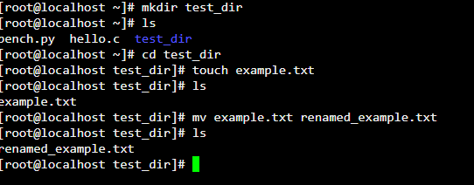

2. Viewing File Contents Use cat to display the contents of /etc/passwd.Display only the first 5 lines of /etc/passwd using head.Display only the last 5 lines of /etc/passwd using tai

**Soln:**

cat /etc/passwd # Displays the entire contents of /etc/passwd

head -n 5 /etc/passwd # Displays the first 5 lines of /etc/passwd

tail -n 5 /etc/passwd # Displays the last 5 lines of /etc/passwd

l.

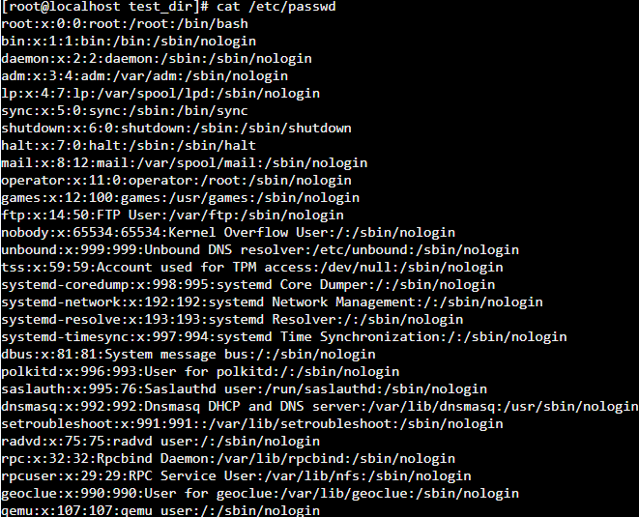

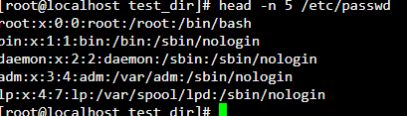

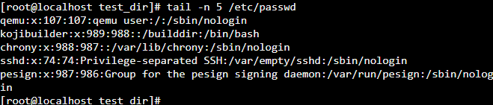

3.Searching for Patterns Use grep to find all lines containing the word "root" in /etc/passwd.

**soln:**

grep "root" /etc/passwd # Finds all lines containing the word "root" in /etc/passwd

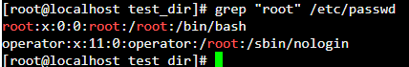

4. Zipping and Unzipping Compress the test_dir directory into a file named test_dir.zip using zip.Unzip test_dir.zip into a new directory named unzipped_dir.

**Soln:**

cd .. # Go back to the parent directory if still in test_dir

zip -r test_dir.zip test_dir # Compresses test_dir into test_dir.zip

unzip test_dir.zip -d unzipped_dir # Unzips test_dir.zip into unzipped_dir

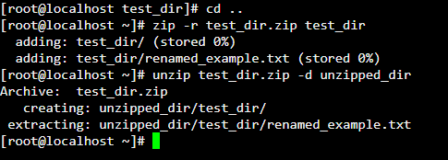

5. Downloading Files Use wget to download a file from a URL (e.g., <https://example.com/sample.txt>).

**Soln:**

wget https://example.com/sample.txt # Downloads a file from the specified URL

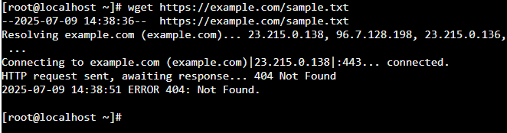

6. Changing Permissions

Create a file named secure.txt and change its permissions to read-only for everyone using chmod.

**soln:**

touch secure.txt # Creates a file named secure.txt

chmod 444 secure.txt # Sets read-only permissions for everyone

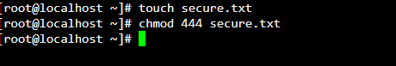

7. Working with Environment Variables

Use export to set a new environment variable called MY_VAR with the value "Hello, Linux!".

**Soln:**

export MY_VAR="Hello, Linux!" # Sets a new environment variable MY_VAR

