1. Grade Checker

Take a score as input and print the grade based on the following:

90+ : "A"

80-89 : "B"

70-79 : "C"

60-69 : "D"

Below 60 : "F"

here we used a basic if else statement to carry out marks and all.

**Soln:**

**marks = int(input("Enter your marks :"))**

**if marks >= 90:**

**print("Grade:A")**

**elif marks >= 80:**

**print("Grade:B")**

**elif marks >= 70:**

**print("Grade:C")**

**elif marks >= 60:**

**print("Grade:D")**

**else:**

**print("Grade:F")**

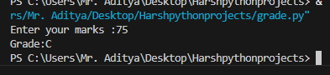

2 Student Grades Create a dictionary where the keys are student names and the values are their grades. Allow the user to:Add a new student and grade.Update an existing student’s grade.Print all student grades.Used dictionary and basic operations. Using if else:

**Soln:**

**student_grades = {**

**"Alice": 85,**

**"Bob": 92,**

**"Charlie": 78,**

**"Diana": 90**

**}**

**while True:**

**print("\nMenu:")**

**print("1. Add a new student and grade")**

**print("2. Update an existing student's grade")**

**print("3. Print all student grades")**

**print("4. Exit")**

**choice = input("Enter your choice (1-4): ")**

**if choice == "1":**

**name = input("Enter the student's name: ")**

**if name in student_grades:**

**print("Student already exists.")**

**else:**

**grade = input("Enter the student's grade: ")**

**student_grades[name] = grade**

**print(f"Added {name} with grade {grade}.")**

**elif choice == "2":**

**name = input("Enter the student's name to update: ")**

**if name in student_grades:**

**grade = input("Enter the new grade: ")**

**student_grades[name] = grade**

**print(f"Updated {name}'s grade to {grade}.")**

**else:**

**print("Student not found.")**

**elif choice == "3":**

**if not student_grades:**

**print("No student grades to show.")**

**else:**

**print("\nStudent Grades:")**

**for name, grade in student_grades.items():**

**print(f"{name}: {grade}")**

**elif choice == "4":**

**print("Exiting program.")**

**break**

**else:**

**print("Invalid choice. Please enter a number between 1 and 4.")**

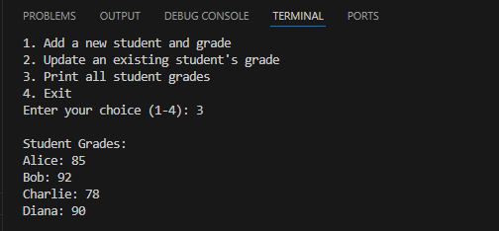

3.Write to a File Write a program to create a text file and write some content to it.

Using file functions like write and open.

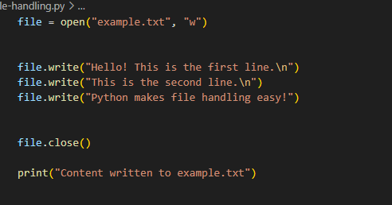

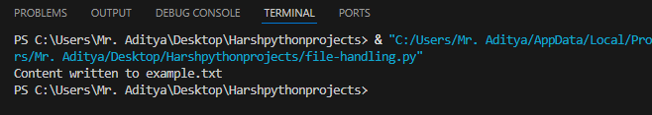

4. Read from a File

We used open in read mode and file.read to read and print to display.

