**Assignment-6**

1. Deploy Your flask backend and express frontend in amazon single ec2 instance.

1. Launched an Ubuntu 22.04 t2.micro instance.
2. Opened ports 22 (SSH), 5000 (Flask), and 3000 (Express).
3. SSH into instance:

ssh -i key.pem ubuntu@<public-ip>

1. Installed Python, pip, Node.js, npm, Git.
2. Cloned GitHub repo.
3. Installed backend requirements and started Flask on port 5000.
4. Installed frontend dependencies and started Express on port 3000.

**Output:**

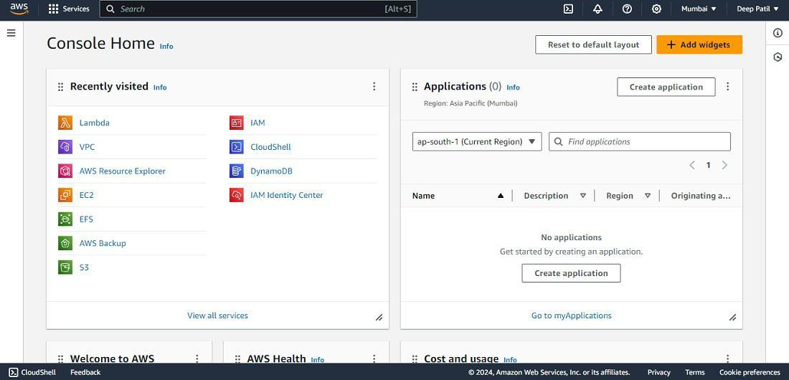

2. Deploy Your flask backend and express frontend in separate ec2 instances.

**Steps:**

**Flask Instance:**

* Same setup as above, deployed only Flask.

**Express Instance:**

* Deployed only Express app.
* Updated frontend API calls to Flask's public IP.

**Output:**

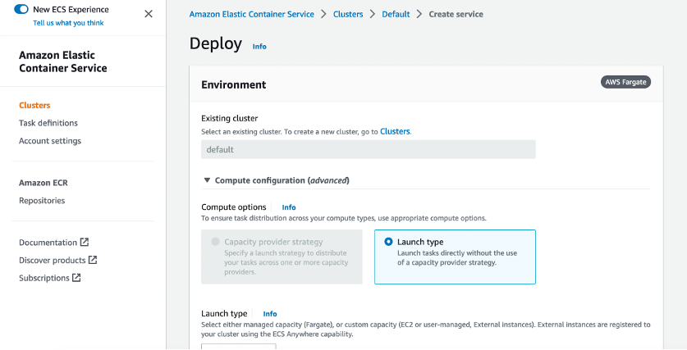

3. Deploy Your flask backend and express frontend Docker Container using aws ecr, ecs and vpc services

**Steps:**

1. Created Dockerfiles in both backend and frontend folders.
2. Built images and pushed to ECR:

docker build -t flask-app .

docker tag flask-app <ecr-url>/flask-app

docker push <ecr-url>/flask-app

1. Created ECS Fargate cluster.
2. Created task definitions for Flask and Express.
3. Created services with Load Balancers.
4. Deployed in custom VPC with public subnet and internet gateway.

**Output:**

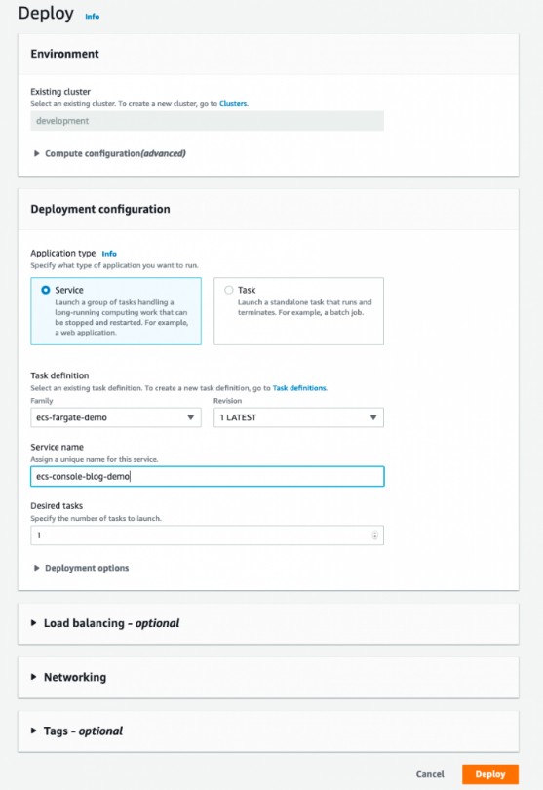

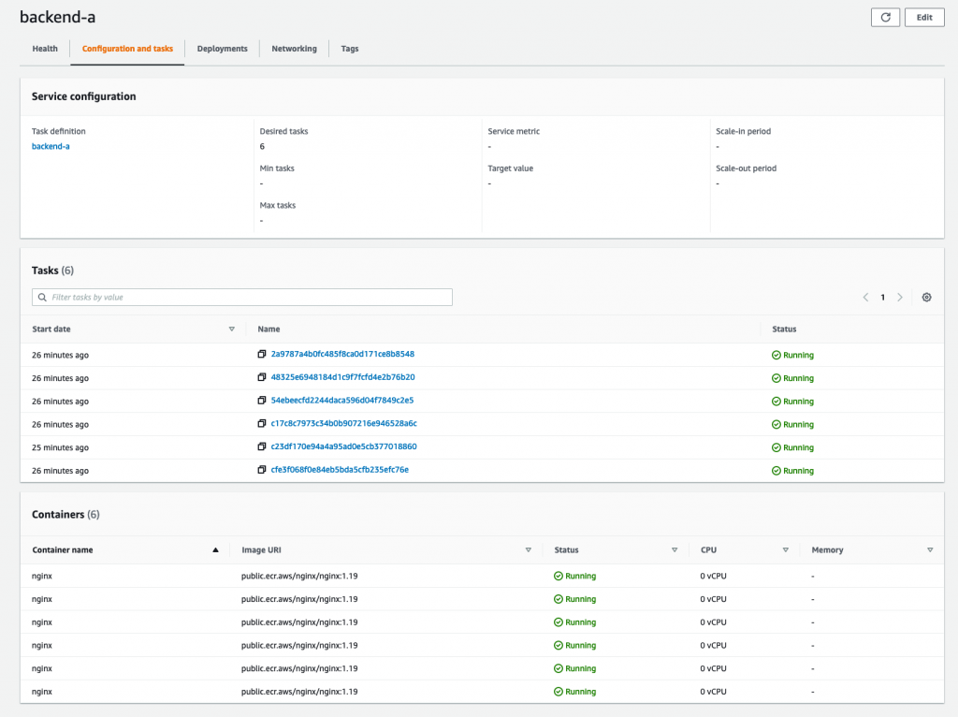

REPO: https://github.com/badapure/TuteDude-Devops-Assignment/tree/main/AWSAssignment