**Assignment-7**

1. Deploy your your previous assignment flask frontend and express backend in kubernetes cluster locally with minikube.

Start Minikube and use its Docker daemon:

minikube start

eval $(minikube docker-env)

Output:

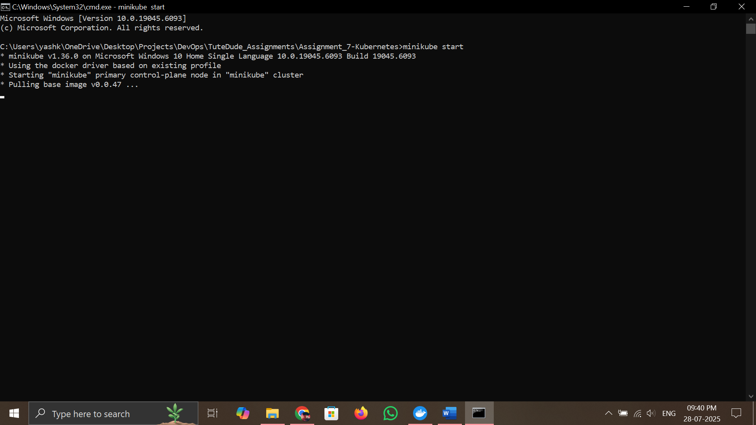

Then build the images:

docker build -t flask-backend ./backend

docker build -t express-frontend ./frontend

Output:

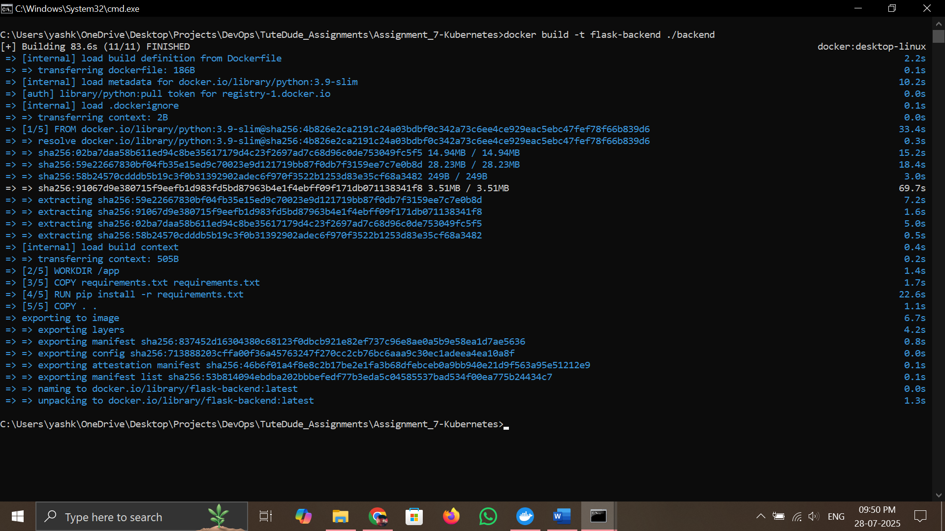

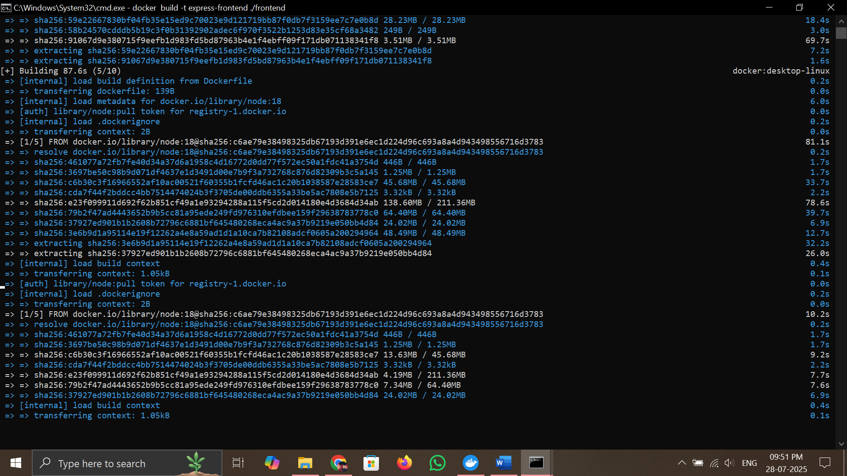

APPLY K8S MANIFESTS

kubectl apply -f k8s/backend-deployment.yaml

kubectl apply -f k8s/backend-service.yaml

kubectl apply -f k8s/frontend-deployment.yaml

kubectl apply -f k8s/frontend-service.yaml