**Assignment-8**

**Part 1: Deploy Both Flask and Express on a Single EC2 Instance**

terraform init

terraform plan

terraform apply curl http://localhost:5000

curl http://localhost:3000

Output:

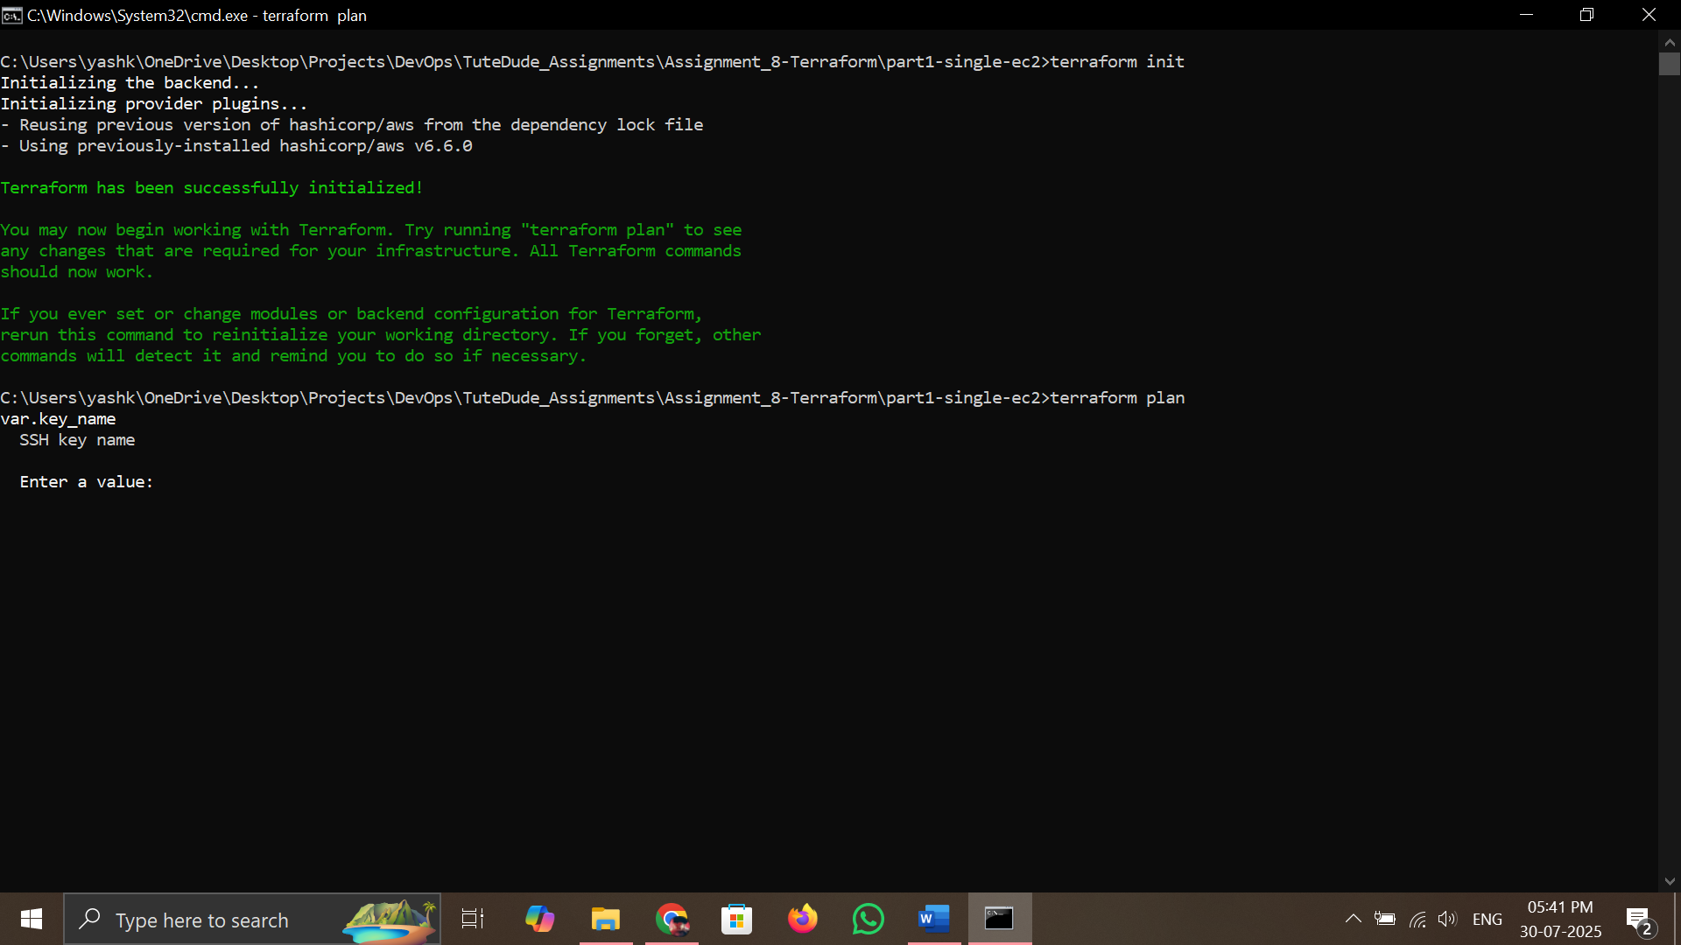

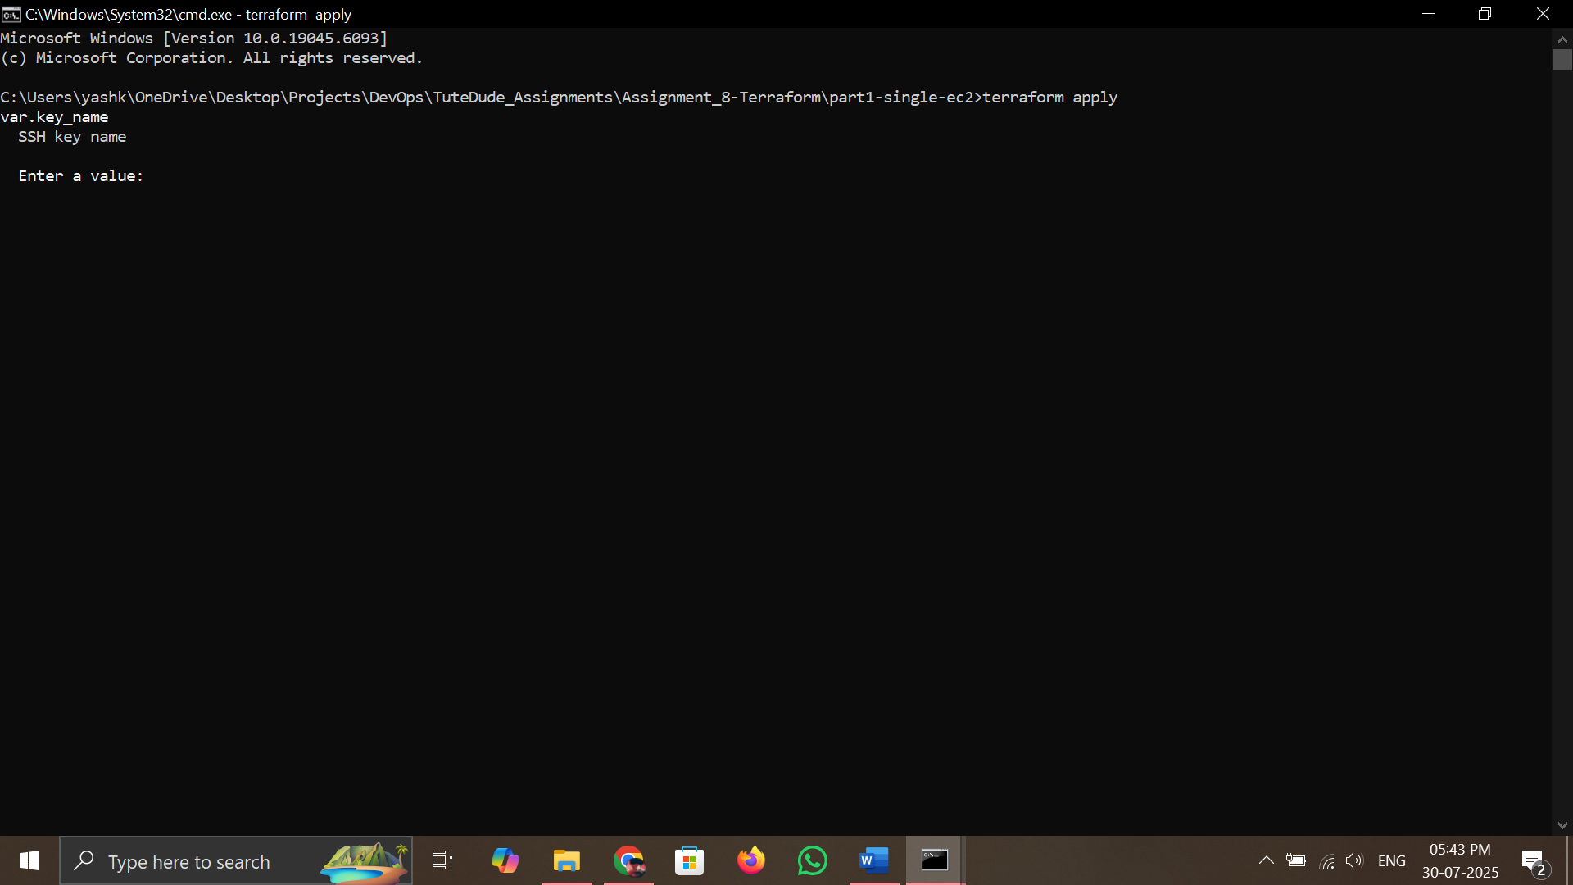

**Part 2: Deploy Flask and Express on Separate EC2 Instances**

terraform init

terraform plan

terraform apply

terraform output flask_instance_ip

terraform output express_instance_ip

Output:

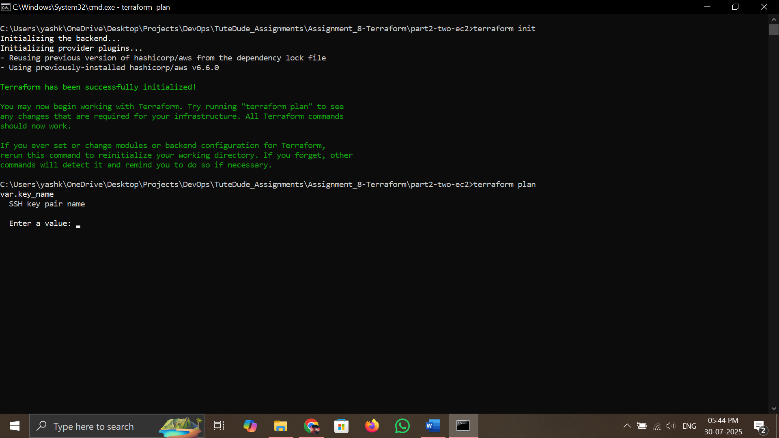



**Part 3: Deploy Flask and Express Using Docker and AWS Services**

**Docker & AWS CLI Commands:**

docker build -t flask-app ./docker/backend

docker build -t express-app ./docker/frontend

aws ecr get-login-password --region ap-south-1 |

docker login --username AWS --password-stdin <ACCOUNT_ID>.dkr.ecr.ap-south-1.amazonaws.com

docker tag flask-app:latest <ECR_FLASK_REPO_URI>:latest

docker push <ECR_FLASK_REPO_URI>:latest

docker tag express-app:latest <ECR_EXPRESS_REPO_URI>:latest

docker push <ECR_EXPRESS_REPO_URI>:latest

**Terraform Infrastructure Commands:**

terraform init

terraform plan

terraform apply

terraform output load_balancer_dns_name

Output:

