Abstract—Hexagonal structure is different from the traditional square structure for image representation. The geometrical arrangement of pixels on hexagonal structure can be described in terms of a hexagonal grid. Spiral Architecture is a relatively new and powerful approach to machine vision system. However, all the existing hardware for capturing image and for displaying image are produced based on rectangular architecture. It has become a serious problem affecting the advanced research on Spiral Architecture. In this paper, a new approach to Spiral Architecture is presented using MATLAB.
A New Simulation of Spiral Architecture
Badar Abbas, Student, EME College, badar@linuxmail.org

Index Terms— Hexagonal structure, Spiral Architecture.

INTRODUCTION
THE advantages of using a hexagonal grid to represent digit images have been investigated for more than thirty years. The importance of the hexagonal representation is that it possesses special computational features that are pertinent to the vision process. The hexagonal image structure has features of higher degree of circular symmetry, uniform connectivity, greater angular resolution, and a reduced need of storage and computation in image processing operations. The main problem that limits the use of hexagonal image structure is believed due to lack of hardware for capturing and displaying hexagonal-based images. In hexagonal grid each unit is a set of seven hexagons compared with the traditional rectangular image architecture using a set of 3× 3 vision unit as shown in Fig 1. On a hexagonal image structure, each pixel has only six neighbouring pixels which have the same distance to the central pixel.
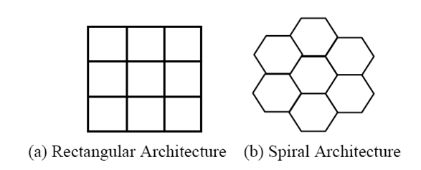
Fig. 1. Unit of vision in two image architectures.
In the past years, there have been various attempts to simulate a hexagonal grid on a regular rectangular grid device. The simulation schemes include those using rectangular pixels, pseudo hexagonal pixels, mimic hexagonal pixels and virtual hexagonal pixels.
In this paper, we will construct a hexagonal structure that is converted from the traditional square structure easily and quickly using MATLAB. Based on the structure, we will present an easy and fast way to compute the location of each hexagonal pixel.

Virtual hexagonal structure
Using virtual Spiral Architecture, images on rectangular structure can be smoothly converted to Spiral Architecture. The Virtual Spiral Architecture exists only during the procedure of image processing. Finally, the resulted data can be mapped back to rectangular architecture for display as shown in Fig 2. The main disadvantage of using this approach is that the computation cost is high when converting between the square based images and hexagon based images.

Spiral Architecture
Apparently, the hexagonal pixels cannot be labelled in row and column order as in the traditional rectangular structure. In order to properly address and store hexagonal images data, Sheridan proposed a one-dimensional addressing scheme for a hexagonal structure. The addresses of these hexagons are referred to as the hexagons. This is achieved by a process that is initially applied to a collection of seven hexagons. The pattern of growth of addresses generates the Spiral as illustrated in Fig 3.
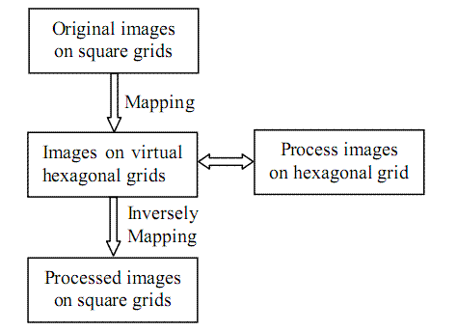
Fig. 2. Image processing on virtual Spiral Architecture.
The location of the pixel with a given spiral address
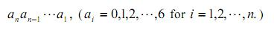
can be found from the locations of
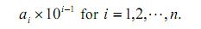
For example, to find the location of the pixel with spiral address 43, we need only know the locations of the pixels with spiral addresses 40 and 3

Simulation of Spiral Architecture
In this section, we introduce the construction of this new virtual hexagonal structure and perform the algorithms that convert between the pixels on the traditional square structure and the virtual hexagonal structure.

Construction of Hexagonal Pixels
To construct hexagonal pixels, each square pixel is first separated into 7×7 smaller pixels, called sub-pixels with the light intensity for each of these sub-pixels the same as that of the pixel from which the sub-pixels are separated. Each virtual hexagonal pixel is formed by 56 sub-pixels arranged as shown in Figure 4. The light intensity of each constructed hexagonal pixel is computed as the average of the intensities of the 56 sub-pixels forming the hexagonal pixel. A hexagonal pixel, called a hyperpel, is simulated using a set of many square pixels as shown in Fig 4.
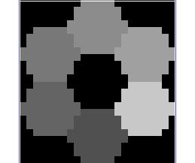

Fig. 5. A cluster of seven hexagonal pixels.
Note that the size of each constructed pixel is (56-49)/56 = 12.5% bigger than each square pixel. Hence, the number of hexagonal pixels is 12.5% less than the number of square pixels to cover the same image. Because of this percentage, the hexagonal pixels constructed in the way above will not lose image resolution if proper light intensities of hexagonal pixels are assigned or interpolated.
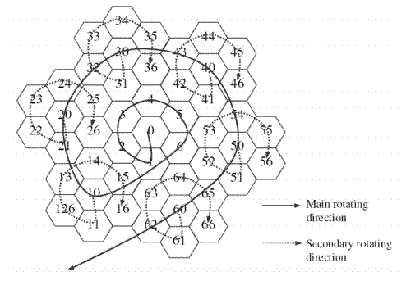
Fig. 3. Spiral Architecture with spiral addressing.
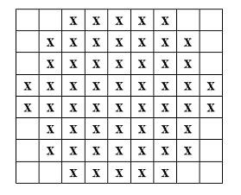
Fig. 4. The structure of a single hexagonal pixel.
Figure 5 shows a collection of seven hexagonal pixels constructed in MATLAB with spiral addresses from 0 to 6. From Figure 5, it is easy to see that the feature of equal distance is almost retained and hence this construction hardly introduces image distortion. Moreover the hexagonal pixels constructed in this way tile the whole plane without spaces nd overlaps

Locating Hexagonal Pixels
To simulate spiral architecture, we only need to derive the way to locate the pixel with spiral address in the form of
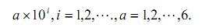
Let us use vector [0 0] to denote the location of the hexagonal with spiral address 0, and vector [j k] (j, k are integers) to denote the location of a pixel that is obtained by moving from [0 0] down (or up if j is negative) for |j| sub-pixels and towards right (or left if k is negative) for |k| sub-pixels and. If we also use L(a) to denote the location of the hexagonal pixel with spiral address a, then we have L(0) = [0 0]. Moreover
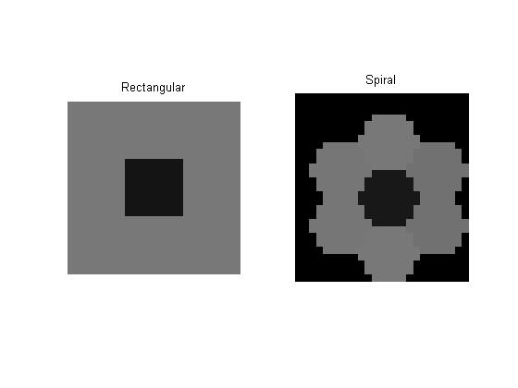
Fig. 7. A simple conversion from rectangular to spiral architecture.

L(1) = [8 0], L(2) = [4 -7], L(3) = [-4 -7],
L(4) = [-8 0], L(5) = [-4 7] and L(6) = [4 7]

The location of hexagonal pixel with address 10 is obtained by moving from pixel 1 in the direction from pixel 6 towards pixel 1 for two pixels. The shift for addresses 0 to 6 are base cases for the recursive algorithm. The algorithm for multiples of 10 is given by
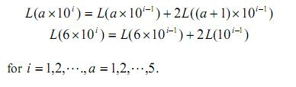
While the location of the pixel with a given spiral address
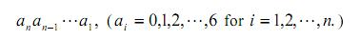
can be computed by
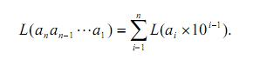

MATLAB Simulations
The Fig 6 shows the MATLAB rendering of a hexagonal image given in spiral addressing.


Fig. 6. A cluster of 72 = 49 hexagonal pixels.
The Fig 7 shows a simple conversion of an image from rectangular architecture to spiral architecture. More complex examples are not considered due to high computation power requirement.

Conclusion
In this paper, a novel method to construct or mimic the Spiral Architecture has been implemented in MATLAB. This constructed hexagonal structure does not change the image resolution and introduce image distortion. It retains the advantages of the real hexagonal system such as higher degree of symmetry, uniformly connected and closed-packed form. This structure together with the light intensities cannot be displayed and it exists only in the computer memory during the procedure of image processing. Image processing based on a hexagonal structure can be implemented using this structure. The location of each pixel can be easily and quickly determined and computed using mathematical formula.

References
- Xiangjian He, Wenjing Jia, Qiang Wu, Namho Hur, Tom Hintz, Huaqing Wang and Jinwoong Kim, ” Basic Transformations on Virtual Hexagonal Structure”, Proceedings of the international conference on Computer Graphics, Imaging and Visualization, 2006.
- H. Wang, M. Wang, T. Hintz, et al., “VSA-based Fractal Image Compression, Journal of WSCG”, 2005.
- Xiangjian He, Tom Hintz, Qiang Wu, Huaqing Wang and Wenjing Jia, “A New Simulation of Spiral Architecture” Proc. of International Conference on Image Processing, Computer Vision, and Pattern Recognition, 2006.
- P. Sheridan, T. Hintz, and D. Alexander, "Pseudo-invariant Image Transformations on a Hexagonal Lattice," Image and Vision Computing, 2000.
- Lee Middleton and Jayanthi Sivaswamy, “Hexagonal Image Processing: A Practical Approach” Springer-Verlag London Limited, 2005.

 

