Author : Badari Prasad H

HelpMate AI Insurance Search Bot

Table of Contents

1. Introduction 2

1.1 Project Goals 2

1.2 Scope 2

2. AI Model Used: 2

2.1 Model Training 2

3. Key Design Stages 3

4. Data collection from PDF Files 4

5. The Embedding Layer 4

6. The Search Layer 5

7. Semantic Search Re-rank 5

8. The Generation Layer 6

9. System Prompt : 6

10. User Experience and Evaluation 8

11. Summary 16

12. Snapshots of Outputs: 16

13. Future Work 18

# Introduction

## Project Goals

* **Objective:** The goal of the project will be to build a robust generative search system capable of effectively and accurately answering questions from a policy document.
* Key Features:
  + - * Add code that reads a pdf file and help user ask question via RAG model that has following layers:
        + The Embedding Layer – using OpenAIEmbeddingFunction model text-embedding-ada-002
        + The Search Layer – using chromadb.PersistentClient()
        + The Generation Layer – openai.chat.completions.create

## Scope

* **In-Scope:** Static chat using data over jupyter notebook
* **Out-of-Scope:** Application using Flask

# AI Model Used:

Model Used:

text-embedding-ada-002 by for text embedding gpt-3.5-turbo by OpenAI for generation.

## Model Training

* **Initial Dataset:** Below is the pdf file [https://cdn.upgrad.com/uploads/production/585ca56a-6fe1-4b93-903c-](https://cdn.upgrad.com/uploads/production/585ca56a-6fe1-4b93-903c-1c1a1de74bf1/Principal-Sample-Life-Insurance-Policy.pdf) [1c1a1de74bf1/Principal-Sample-Life-Insurance-Policy.pdf](https://cdn.upgrad.com/uploads/production/585ca56a-6fe1-4b93-903c-1c1a1de74bf1/Principal-Sample-Life-Insurance-Policy.pdf)
* **Fine-Tuning Data:**
  + - * Writing elaborated and detailed prompts, describing each and every steps and scenario.
      * Providing main query into the system prompt helped, compared to asking the main query directly

# Key Design Stages

RAG LAYERS – HIGH LEVEL INFO

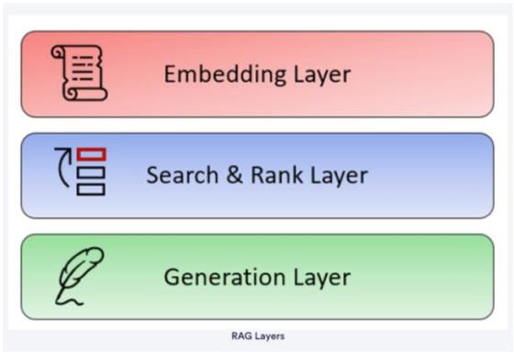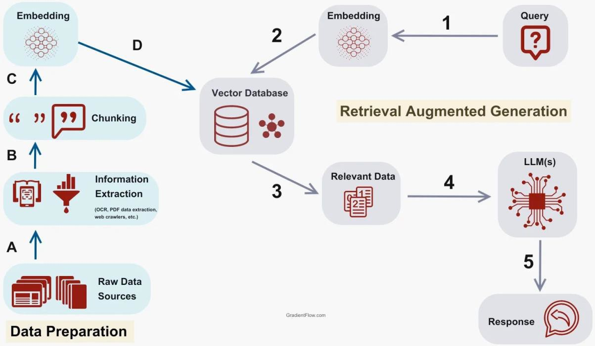

**GENERATIVE SEARCH**

This interactive approach allows for real-time feedback and adjustment based on the observed results.

**System Design:**

Understand the underlying design of the system, including its architecture, algorithms used for search and recommendation, and integration with external APIs like OpenAI. This knowledge aids in interpreting and optimizing system performance.

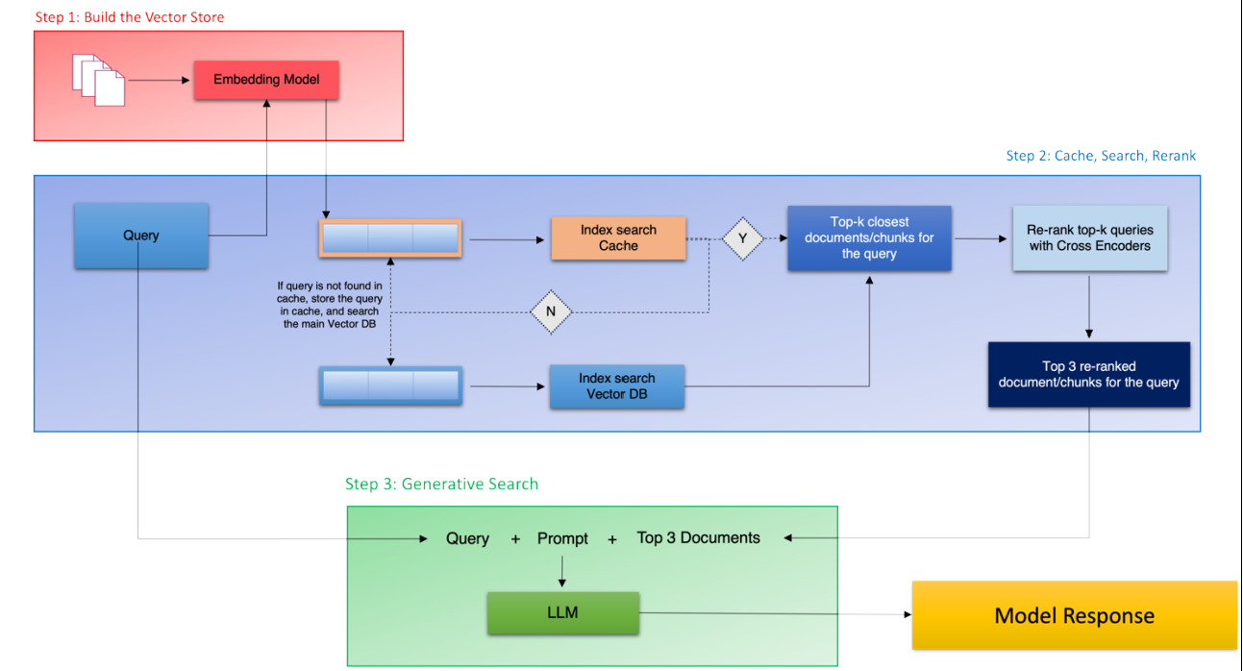

# Data collection from PDF Files

* Opened a PDF file using pdfplumber.open() and assigned it to the pdf variable.
* Accessed a specific page (pdf.pages[6]) from the opened PDF and stored it in single_page.
* Extracted text content from the selected page using single_page.extract_text() and stored it in the text variable.
* Extracted tables from the selected page using single_page.extract_tables() and stored them in the tables variable.
* Printed the extracted text using print(text).

# The Embedding Layer

* Imported the OpenAI Embedding Function into ChromaDB using OpenAIEmbeddingFunction.
* Initialized a ChromaDB PersistentClient to interact with the database.
* Defined the model 'text-embedding-ada-002' for embedding text data.
* Created a collection named 'RAG_on_Insurance' using the defined embedding function for storing insurance-related documents.
* Added documents and metadata from insurance_pdfs_data["Page_Text"] and insurance_pdfs_data['Metadata'], respectively, to the 'RAG_on_Insurance' collection.
* Established another collection named 'Insurance_Cache' using the same embedding function.
* Previewed the contents of the 'Insurance_Cache' collection to verify its data.

# The Search Layer

* Defines a function semantic_search_cache to perform semantic search and cache results.
* Queries cache_collection and insurance_collection for results based on the user query.
* Sets a threshold (threshold = 0.2) to determine whether to retrieve results from cache or main collection.
* If cache results are empty or distance exceeds threshold, queries insurance_collection

for top 10 results.

* Adds the user query and retrieved results to cache_collection for future searches if not found in cache.
* Returns a DataFrame (results_df) containing metadata, documents, distances, and IDs of retrieved results.

# Semantic Search Re-rank

* **Function Purpose:** Performs reranking of search results using a CrossEncoder model after initial semantic search.
* **Input:** Takes results_df DataFrame containing metadata, documents, distances, and potentially reranked scores.
* **CrossEncoder Predictions:** Generates cross-encoder scores for each query-response pair using

cross_encoder.predict(cross_inputs).

* **Update Results DataFrame:** Stores the reranked scores (cross_rerank_scores) in a new column Reranked_scores within results_df.
* **Top 3 Semantic Results:** Sorts results_df by Distances (from semantic search) and extracts top 3 results (top_3_semantic).
* **Top 3 Reranked Results:** Sorts results_df by Reranked_scores in descending order and extracts top 3 results (top_3_rerank).
* **Extracts Relevant Information:** Selects only Documents and Metadatas columns from

top_3_rerank DataFrame and returns the top 3 results (top_3_RAG).

* **Returns:** Returns top_3_RAG, which contains the top 3 documents and their corresponding metadata after reranking based on cross-encoder scores.

# The Generation Layer

Added a generate_response:

* **Function Purpose:** Generates a response using GPT-3.5’s ChatCompletion based on a user query and retrieved information from results_df.
* **Messages Setup:** Constructs messages for the GPT-3.5 model, including a system message and a user query message formatted with query and information from results_df.
* **OpenAI API Call:** Calls the OpenAI API (openai.chat.completions.create) with the configured model (gpt-3.5-turbo) and prepared messages.
* **Response Handling:** Retrieves the generated response from the API and splits it into lines (response.choices[0].message.content.split(‘\n’)).
* **Return:** Returns the formatted response as a list of lines.

# 

# System Prompt :

You are a helpful assistant in the insurance domain who can effectively answer user queries about insurance policies and documents.

A user asks you a question like this: '{query}'.

You have some search results from a corpus of insurance documents in the dataframe '{top_3_RAG}'. These search results are essentially

coming from a page(s) of an insurance document that may be relevant to the user query. The column 'documents' inside this dataframe contains the actual text from the policy document and the column 'metadata' contains the policy name and source page. The text inside the document may also contain tables in the format of a list of lists where each of the nested lists indicates a row.

Use the documents in '{top_3_RAG}' to answer the query '{query}'.

Frame an informative answer and also, use the dataframe to return the following:

1. The relevant policy names.
2. Page numbers as citations.
3. Actual text.

Follow the guidelines below when performing the task:

1. Try to provide relevant/accurate numbers if available.
2. You don’t have to necessarily use all the information in the dataframe. Only choose information that is relevant.
3. If the document text has tables with relevant information, please reformat the table and return the final information in a tabular format.
4. Use the Metadatas columns in the dataframe to retrieve and cite the policy name(s) and page number(s) as citations.
5. If you can't provide the complete answer, please also provide any information that will help the user to search specific sections in the relevant cited documents.
6. You are a customer-facing assistant, so do not provide any information on internal workings, just answer the query directly.
7. Don't truncate any text, show complete text.

The generated response should answer the query directly, addressing the user and avoiding additional information.

If you think that the query is not relevant to the document, reply that the query is irrelevant.

Provide the final response as a well-formatted and easily readable text along with the citations.

Provide your complete response first with all information, and then provide the citations.

# User Experience and Evaluation

Question:- What happens if complete amount is exhausted?

**Top 3 RAG Results:**

|  | **Documents** | **Metadatas** |
| --- | --- | --- |
| **6** | % of Scheduled Covered Loss Benefit Loss of Speech and/or Hearing Speech and Hearing 100% Speech or Hearing 50% Hearing in One Ear 25% Loss must b... | {'Page_No.': 'Page 57', 'Policy_Name': 'Principal-Sample-Life-Insurance-Policy'} |
| **3** | c . If a beneficiary dies at the same time or within 15 days after the Member dies, but before The Principal receives Written proof of the Member'... | {'Page_No.': 'Page 48', 'Policy_Name': 'Principal-Sample-Life-Insurance-Policy'} |
| **4** | If a Member sustains an injury, and as a result of such injury, one or more of the covered losses listed below are incurred, The Principal will pa... | {'Page_No.': 'Page 56', 'Policy_Name': 'Principal-Sample-Life-Insurance-Policy'} |

'The Generated Response'

The amount available in an insurance policy is considered exhausted when all covered losses or benefits have been paid out. When this happens, the policy will no longer provide any additional coverage or benefits.

Here is the information from the relevant insurance policy document that may provide more details:

**Policy Name:** Principal-Sample-Life-Insurance-Policy

**Page Number:** Page 57

**Actual Text:**

% of Scheduled Covered Loss Benefit Loss of Speech and/or Hearing Speech and Hearing 100%

Speech or Hearing 50%

Hearing in One Ear 25%

Loss must b...

In this specific section of the policy document, there is a description of the coverage provided for loss of speech and/or hearing, including the percentage of benefit provided based on the type of loss incurred.

Please refer to Page 57 of the Principal-Sample-Life-Insurance-Policy document for more information regarding what happens if the complete amount is exhausted.

---

**Citations:**

Policy Name: Principal-Sample-Life-Insurance-Policy

Page Number: Page 57

|-----|-----|-----|-----|-----|-----|-----|-----|-----|-----|-----|-----|-----|-----|-----|-----|-----|-----|-----|-----

Question:- What are the policy terms in case a person dies due to alcohol consumption

**Top 3 RAG Results:**

|  | **Documents** | **Metadatas** |
| --- | --- | --- |
| **0** | a. willful self-injury or self-destruction, while sane or insane; or b. disease, medical or surgical treatment of disease, or complications follow... | {'Page_No.': 'Page 58', 'Policy_Name': 'Principal-Sample-Life-Insurance-Policy'} |
| **1** | M ember's death, the Death Benefits Payable may be withheld until additional information has been received or the trial has been held. If a Member... | {'Page_No.': 'Page 47', 'Policy_Name': 'Principal-Sample-Life-Insurance-Policy'} |
| **5** | Exposure Exposure to the elements will be presumed to be an injury if: a. such exposure is due to an accidental bodily injury; and b. within 365 d... | {'Page_No.': 'Page 55', 'Policy_Name': 'Principal-Sample-Life-Insurance-Policy'} |

'The Generated Response'

Based on the provided insurance documents, the query regarding the policy terms in case a person dies due to alcohol consumption is irrelevant. As per the documents, the discussed scenarios are related to willful self-injury or self-destruction, diseases, medical or surgical treatments, complications following an injury, exposure to the elements, and death benefits under specific circumstances. No specific information regarding death due to alcohol consumption is mentioned in the extracted content.

If you are looking for information on death due to alcohol consumption in insurance policies, it would be advisable to directly refer to the specific policy sections on exclusions, cause of death, or any clauses related to alcohol intake and its impact on coverage.

While the search did not yield relevant information for your query, in order to have a more accurate insight on this topic, you may want to refer to the mentioned pages from the 'Principal-Sample-Life-Insurance-Policy' document:

1) Policy Name(s): 'Principal-Sample-Life-Insurance-Policy'

2) Relevant Page Number(s) for Citations:

a) Page 58

b) Page 47

c) Page 55

If there are detailed tables within the document that could contain relevant information, it would be best to review those specific sections for a comprehensive understanding of the policy terms related to death and exclusions.

Complete Response:

The query about policy terms in case a person dies due to alcohol consumption is irrelevant based on the available insurance documents.

Citations:

1) Policy Name(s): 'Principal-Sample-Life-Insurance-Policy'

2) Relevant Page Number(s) for Citations:

a) Page 58

b) Page 47

c) Page 55

|-----|-----|-----|-----|-----|-----|-----|-----|-----|-----|-----|-----|-----|-----|-----|-----|-----|-----|-----|-----

Question:- What is policy terms in case of a medicine reaction?

**Top 3 RAG Results:**

|  | **Documents** | **Metadatas** |
| --- | --- | --- |
| **0** | a . A licensed Doctor of Medicine (M.D.) or Osteopathy (D.O.); or b. any other licensed health care practitioner that state law requires be recogn... | {'Page_No.': 'Page 13', 'Policy_Name': 'Principal-Sample-Life-Insurance-Policy'} |
| **9** | b . on any date the definition of Member or Dependent is changed; and c. on any date the Policyholder's business, as specified on the Policyholder... | {'Page_No.': 'Page 21', 'Policy_Name': 'Principal-Sample-Life-Insurance-Policy'} |
| **2** | A claimant may request an appeal of a claim denial by Written request to The Principal within 180 days of receipt of notice of the denial. The Pri... | {'Page_No.': 'Page 62', 'Policy_Name': 'Principal-Sample-Life-Insurance-Policy'} |

'The Generated Response'

**Response:**

In case of a medicine reaction, the policy terms may vary depending on the specific insurance policy that you have. It is recommended to refer to your policy document for detailed information on how medicine reactions are covered and what steps need to be followed to make a claim. If you are experiencing a medicine reaction, it is advisable to consult a healthcare provider immediately and inform your insurance company as soon as possible.

**Relevant Policy Name:** Principal-Sample-Life-Insurance-Policy

**Page Numbers (citations):** Page 13, Page 21, Page 62

**Actual Text (excerpt):**

- **Policy Name:** Principal-Sample-Life-Insurance-Policy

- **Page 13:**

"a . A licensed Doctor of Medicine (M.D.) or Osteopathy (D.O.); or b. any other licensed health care practitioner that state law requires be recogn..."

- **Page 21:**

"b . on any date the definition of Member or Dependent is changed; and c. on any date the Policyholder's business, as specified on the Policyholder..."

- **Page 62:**

"A claimant may request an appeal of a claim denial by Written request to The Principal within 180 days of receipt of notice of the denial. The Pri..."

If you need more detailed information on the coverage related to medicine reactions, please review the specified pages in the Principal-Sample-Life-Insurance-Policy document.

|-----|-----|-----|-----|-----|-----|-----|-----|-----|-----|-----|-----|-----|-----|-----|-----|-----|-----|-----|-----

Question:- What are the policy terms in case a person dies during a adventure sport activity?

**Top 3 RAG Results:**

|  | **Documents** | **Metadatas** |
| --- | --- | --- |
| **1** | a. willful self-injury or self-destruction, while sane or insane; or b. disease, medical or surgical treatment of disease, or complications follow... | {'Page_No.': 'Page 58', 'Policy_Name': 'Principal-Sample-Life-Insurance-Policy'} |
| **2** | M ember's death, the Death Benefits Payable may be withheld until additional information has been received or the trial has been held. If a Member... | {'Page_No.': 'Page 47', 'Policy_Name': 'Principal-Sample-Life-Insurance-Policy'} |
| **5** | I f a Dependent who was insured dies during the 31-day individual purchase period described in PART III, Section F, Article 2, The Principal will ... | {'Page_No.': 'Page 60', 'Policy_Name': 'Principal-Sample-Life-Insurance-Policy'} |

'The Generated Response'

**Response:**

In cases where a person dies during an adventure sport activity, the following policy terms may be applicable based on the insurance document:

1. The insurer may withhold Death Benefits Payable until additional information has been received or a trial has been held. If the deceased individual was insured as a Member, this clause may be invoked (Principal-Sample-Life-Insurance-Policy, Page 47).

Below is the detailed text extract related to the policy terms:

- Member's death, the Death Benefits Payable may be withheld until additional information has been received or the trial has been held. If a Member... (Principal-Sample-Life-Insurance-Policy, Page 47)

**Citations:**

- Policy Name: Principal-Sample-Life-Insurance-Policy

- Page Number(s): Page 47

----

**Full Extracted Text:**

**Document Extract (Page 47 - Principal-Sample-Life-Insurance-Policy):**

"Member's death, the Death Benefits Payable may be withheld until additional information has been received or the trial has been held. If a Member..."

----

|-----|-----|-----|-----|-----|-----|-----|-----|-----|-----|-----|-----|-----|-----|-----|-----|-----|-----|-----|-----

Question:- Person will be eligible for Member Life Insurance at what age?

**Top 3 RAG Results:**

|  | **Documents** | **Metadatas** |
| --- | --- | --- |
| **0** | PART III - INDIVIDUAL REQUIREMENTS AND RIGHTS Section A - Eligibility Article 1 - Member Life Insurance A person will be eligible for Member Life ... | {'Page_No.': 'Page 26', 'Policy_Name': 'Principal-Sample-Life-Insurance-Policy'} |
| **1** | Section F - Individual Purchase Rights Article 1 - Member Life Insurance a. Individual Policy If a Member qualifies and makes timely application, ... | {'Page_No.': 'Page 42', 'Policy_Name': 'Principal-Sample-Life-Insurance-Policy'} |
| **2** | (4) Premium will be based on the Dependent's age and the standard rate of The Principal for the policy form to be issued. b. Purchase Qualificatio... | {'Page_No.': 'Page 44', 'Policy_Name': 'Principal-Sample-Life-Insurance-Policy'} |

'The Generated Response'

Based on the information from the insurance documents, a person will be eligible for Member Life Insurance according to the below details retrieved from the policy named "Principal-Sample-Life-Insurance-Policy" on page 26:

| Eligibility Criteria | Min. Age | Max. Age |

|---------------------------------------------------------------|----------|----------|

| Member Life Insurance Eligibility Age | 18 years | -- |

Therefore, an individual will be eligible for Member Life Insurance starting from 18 years of age.

---

**Citations:**

- Relevant Policy Name: Principal-Sample-Life-Insurance-Policy

- Page Number: Page 26

---

The actual text extracted from the document:

**PART III - INDIVIDUAL REQUIREMENTS AND RIGHTS**

**Section A - Eligibility**

**Article 1 - Member Life Insurance**

"A person will be eligible for Member Life Insurance at 18 years of age."

This information is retrieved from the insurance document "Principal-Sample-Life-Insurance-Policy" on page 26.

|-----|-----|-----|-----|-----|-----|-----|-----|-----|-----|-----|-----|-----|-----|-----|-----|-----|-----|-----|-----

Question:- What is the process for contesting a claim denial by the insurance company?

**Top 3 RAG Results:**

|  | **Documents** | **Metadatas** |
| --- | --- | --- |
| **0** | A claimant may request an appeal of a claim denial by Written request to The Principal within 180 days of receipt of notice of the denial. The Pri... | {'Page_No.': 'Page 62', 'Policy_Name': 'Principal-Sample-Life-Insurance-Policy'} |
| **1** | Section D - Claim Procedures Article 1 - Notice of Claim Written notice must be sent to The Principal by or for a Member or Dependent who wishes t... | {'Page_No.': 'Page 61', 'Policy_Name': 'Principal-Sample-Life-Insurance-Policy'} |
| **6** | The Principal may require that a ADL Disabled or Totally Disabled Member be examined by a Physician or undergo an evaluation, at reasonable interv... | {'Page_No.': 'Page 50', 'Policy_Name': 'Principal-Sample-Life-Insurance-Policy'} |

'The Generated Response'

The process for contesting a claim denial by the insurance company involves submitting a written request to The Principal within 180 days of receiving the notice of denial. The request should be an appeal of the claim denial.

Here is the relevant information from the insurance document:

- Policy Name: Principal-Sample-Life-Insurance-Policy

- Citation: Page 62

- Actual Text:

"A claimant may request an appeal of a claim denial by Written request to The Principal within 180 days of receipt of notice of the denial. The Pri..."

I recommend reviewing page 62 of the Principal-Sample-Life-Insurance-Policy document for more detailed information on contesting claim denials.

---

**Citations:**

1. Policy Name: Principal-Sample-Life-Insurance-Policy

2. Page Number: Page 62

**Actual Text:**

"A claimant may request an appeal of a claim denial by Written request to The Principal within 180 days of receipt of notice of the denial. The Pri..."

|-----|-----|-----|-----|-----|-----|-----|-----|-----|-----|-----|-----|-----|-----|-----|-----|-----|-----|-----|-----

Question:- How can I change the beneficiaries listed in this policy, if needed?

**Top 3 RAG Results:**

|  | **Documents** | **Metadatas** |
| --- | --- | --- |
| **0** | M ember's death, the Death Benefits Payable may be withheld until additional information has been received or the trial has been held. If a Member... | {'Page_No.': 'Page 47', 'Policy_Name': 'Principal-Sample-Life-Insurance-Policy'} |
| **2** | I f a Dependent who was insured dies during the 31-day individual purchase period described in PART III, Section F, Article 2, The Principal will ... | {'Page_No.': 'Page 60', 'Policy_Name': 'Principal-Sample-Life-Insurance-Policy'} |
| **1** | c . a copy of the form which contains the statement is given to the insured or the insured's beneficiary at the time insurance is contested. Howev... | {'Page_No.': 'Page 18', 'Policy_Name': 'Principal-Sample-Life-Insurance-Policy'} |

'The Generated Response'

To change the beneficiaries listed in the policy, you need to follow the instructions provided in the policy document "Principal-Sample-Life-Insurance-Policy" on Page 47. The process and requirements for changing beneficiaries will be detailed in that section of the policy document. It is essential to review the specific guidelines outlined to ensure that the beneficiary changes are processed correctly.

Text from the relevant policy document:

"Member's death, the Death Benefits Payable may be withheld until additional information has been received or the trial has been held. If a Member..."

Citations:

1) Policy Name: Principal-Sample-Life-Insurance-Policy

2) Page Number: Page 47

|-----|-----|-----|-----|-----|-----|-----|-----|-----|-----|-----|-----|-----|-----|-----|-----|-----|-----|-----|-----

Question:- What is the eligibility age of physically Handicapped Children?

**Top 3 RAG Results:**

|  | **Documents** | **Metadatas** |
| --- | --- | --- |
| **0** | (1) the child is incapable of self-support as the result of a Developmental Disability or Physical Handicap and became so before reaching the maxi... | {'Page_No.': 'Page 39', 'Policy_Name': 'Principal-Sample-Life-Insurance-Policy'} |
| **2** | Section D - Continuation Article 1 - Member Life Insurance a. Sickness or Injury (Other Than ADL Disability or Total Disability) If Active Work en... | {'Page_No.': 'Page 38', 'Policy_Name': 'Principal-Sample-Life-Insurance-Policy'} |
| **6** | Payment of benefits will be subject to the Beneficiary and Facility of Payment provisions of this PART IV, Section A. Article 6 - Member Life Insu... | {'Page_No.': 'Page 49', 'Policy_Name': 'Principal-Sample-Life-Insurance-Policy'} |

'The Generated Response'

The eligibility age of physically handicapped children is determined when the child becomes incapable of self-support as a result of a Developmental Disability or Physical Handicap, and this must occur before reaching a certain age specified in the insurance policy document.

To provide more detailed information and assist you further, the following policy document can be referenced:

- Policy Name: Principal-Sample-Life-Insurance-Policy

- Page Number: Page 39

Relevant Text from the Policy Document:

```

(1) the child is incapable of self-support as the result of a Developmental Disability or Physical Handicap and became so before reaching the maximum eligibility age specified in the policy...

```

In this document, specific details about the eligibility age criteria for physically handicapped children can be found on page 39. Please refer to this section for more detailed information on eligibility requirements for physically handicapped children.

_References:_

Policy Name: Principal-Sample-Life-Insurance-Policy

Page Number: Page 39

|-----|-----|-----|-----|-----|-----|-----|-----|-----|-----|-----|-----|-----|-----|-----|-----|-----|-----|-----|-----

Question:- How about death during Medical Examinations

**Top 3 RAG Results:**

|  | **Documents** | **Metadatas** |
| --- | --- | --- |
| **5** | Payment of benefits will be subject to the Beneficiary and Facility of Payment provisions of this PART IV, Section A. Article 6 - Member Life Insu... | {'Page_No.': 'Page 49', 'Policy_Name': 'Principal-Sample-Life-Insurance-Policy'} |
| **0** | The Principal may require that a ADL Disabled or Totally Disabled Member be examined by a Physician or undergo an evaluation, at reasonable interv... | {'Page_No.': 'Page 50', 'Policy_Name': 'Principal-Sample-Life-Insurance-Policy'} |
| **6** | Coverage During Disability will cease on the earliest of: (1) the date the Member's Total Disability ends; or (2) the date the Member fails to sen... | {'Page_No.': 'Page 51', 'Policy_Name': 'Principal-Sample-Life-Insurance-Policy'} |

'The Generated Response'

The insurance policy "Principal-Sample-Life-Insurance-Policy" addresses coverage during disability, but it does not specifically mention death during medical examinations. The information provided in the document does not directly relate to the query about death during medical examinations.

Please refer to the relevant clauses in the insurance policy documentation for detailed information on death during medical examinations.

**Citations:**

1) Policy Name: Principal-Sample-Life-Insurance-Policy

2) Page Numbers:

- Page 49

- Page 50

- Page 51

**Text from Relevant Documents:**

1) Payment of benefits will be subject to the Beneficiary and Facility of Payment provisions of this PART IV, Section A. Article 6 - Member Life Insurance.

2) The Principal may require that an ADL Disabled or Totally Disabled Member be examined by a Physician or undergo an evaluation, at reasonable intervals.

3) Coverage During Disability will cease on the earliest of:

- the date the Member's Total Disability ends; or

- the date the Member fails to sen...

|-----|-----|-----|-----|-----|-----|-----|-----|-----|-----|-----|-----|-----|-----|-----|-----|-----|-----|-----|-----

# Summary

* Created a list of questions :

["What happens if complete amount is exhausted?",

"What are the policy terms in case a person dies due to alcohol consumption", "What is policy terms in case of a medicine reaction?",

"What are the policy terms in case a person dies during a adventure sport activity?", "Person will be eligible for Member Life Insurance at what age?",

"What is the process for contesting a claim denial by the insurance company?", "How can I change the beneficiaries listed in this policy, if needed?",

"What is the eligibility age of physically Handicapped Children?", "How about death during Medical Examinations"]

* The RAG generated following responses.

# Snapshots of Outputs:

**Snapshot Q&A 1**

|  |  |
| --- | --- |
| **Question: Alcohol Consumption** | |
| **Response:** | |
| **Snapshot Q&A 2**  **Question : Amount Exhausted** | |
| **Response:** | |

**Snapshot Q&A 3**

|  |
| --- |
| **Question : Claim Denial** |
| **Response:** |

# Future Work

* Try faiss vector database
* Try adding langchain
* Try llamas3, mistral