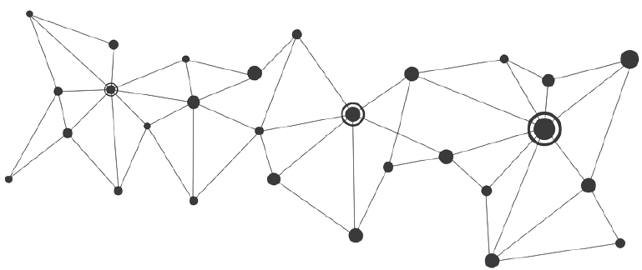

**Rohit Kumar**

**Python Programmer**

8219262176 C:\Users\badarpurboom\AppData\Local\Microsoft\Windows\INetCache\IE\XLNFIXCM\Email-PNG[1].png [badarpurboom@gmail.com](mailto:badarpurboom@gmail.com)



Badarpur, New Delhi C:\Users\rahul\AppData\Local\Microsoft\Windows\INetCache\Content.Word\GitHub+Icon+500.png github.com/badarpurboom

**EDUCATION PASSIONS**

Bachelor of Computer Applications music production



Indira Gandhi National Open University Coding and programming



C:\Users\rahul\AppData\Local\Microsoft\Windows\INetCache\IE\92VS1R54\1200px-Calendar_Icon_v1.svg[1].png **2018 - Ongoing ** **Delhi**

# EXPERIENCE FIND ME ONLINE



Badarpurboom

/Badarpurboom

## Quality Analyst

### ICCS BPO

C:\Users\rahul\AppData\Local\Microsoft\Windows\INetCache\IE\92VS1R54\1200px-Calendar_Icon_v1.svg[1].png**AUG 2019 - NOV 2019 ** **Delhi**

* Audits and offer suggestions for improvement.
* Conduct coaching sessions with associates and provide **LANGUAGES**

feedback .



**Hindi**

**English**

* Conduct monthly calibration sessions with call center team Leaders to develop scoring consistency and best practices.
* Complete analysis of results to identify root causes that will lead to efficiency and quality gains in the contact center.

# SKILLS

## Customer Care Executive Python Django HTML CSS

### ICCS BPO

C:\Users\rahul\AppData\Local\Microsoft\Windows\INetCache\IE\92VS1R54\1200px-Calendar_Icon_v1.svg[1].png**FAB 2018 - JUL 2019 Delhi** Selenium SQL Machine Learning

* Respond to customers’ enquiries relating to information,

product and fault calls resolving as many queries. **MY LIFE PHILOSOPHY**

* Logging and classifying all calls and requests for assistance

In the customer relationship management system (CARE). *The stupid people are not the ones that fail*

*an exam, the stupid people are the ones that*

* Track enquiry resolution progress with a status update or *doesn’t know the dimension of their stupidity.*

resolution if queries cannot be resolved.

* Accept additional projects or areas of responsibility that

will improve the team’s performance. *Albert Einstein*