Family is everything we know, and so is the Universe. ELLIPSES is an original musical that follows the Galaxy family and their dog Gravity as they face the Big Bang. Created by astronomer-turned-writer David Quang Pham, this universal coming-of-age story is about living as a family and leaving as anomalies.

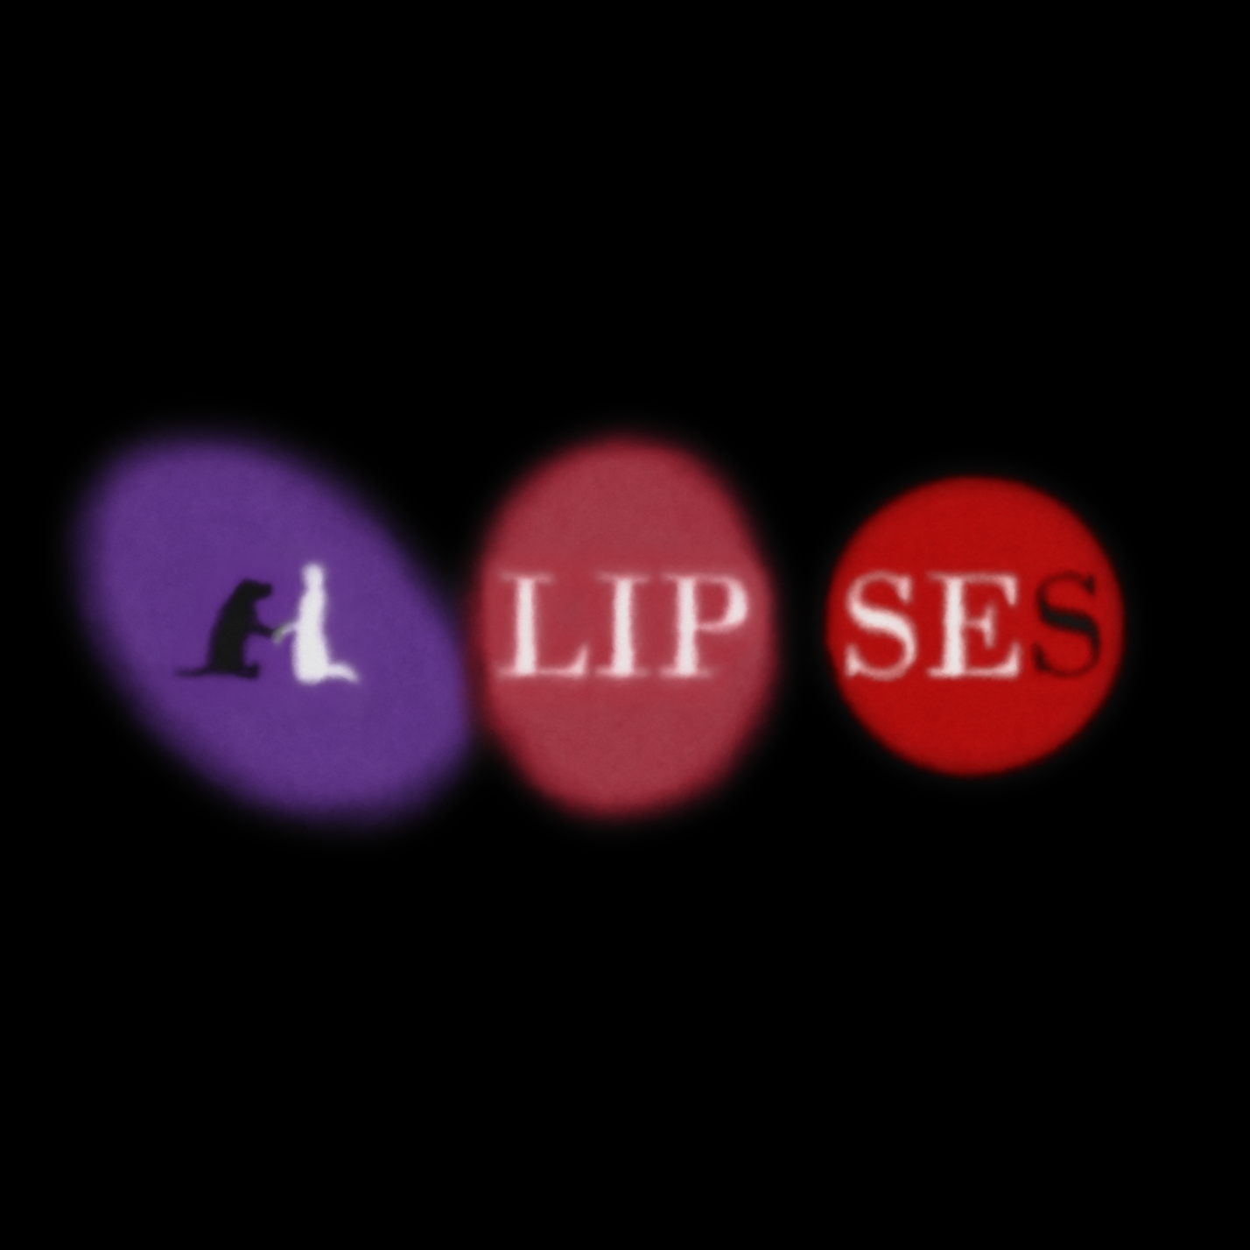



**PRESS RELEASE**

July 1, 2021

**For Immediate Release**

Contact: David Quang Pham

Apprentice of Working Title Playwrights

616 818 5413

davidquangpham@outlook.com

Working Title Playwrights presents

**ELLIPSES**

A Family Musical

by David Quang Pham, Founding Member of CreateTheater ETC

Directed by Aliyah Curry

Thursday, July 15, 2021 at 6:30PM ET via Zoom

“I love stories about families and this is truly the most unique I've seen.” – John Mabey

Spend an eternity in the family musical of epic proportions: ELLIPSES is a cosmology mythology that stars the Galaxy family and their dog Gravity as they face a life-changing event known as the Big Bang. Before the world that we have come to know, there lived a remote family of Galaxies. Singularity is the single parent who locked their six kids in the house. Milky Way is the baby sibling going through galactic puberty. JD is the oldest sibling looking to explore the Universe. This outgrown young adult is perfect for Gravity's manipulation. In a violent altercation, JD shoots Singularity to run away from home with Gravity (aka the Big Bang). Without their parent, the teenage Galaxies must fend for themselves in the vastness of the cosmos. The chronology of our Universe is a family drama in play. The heart of its coming-of-age story is self-discovery as an anomaly.

ELLIPSES is developed under the 2020-2021 WTP New Play Development and Dramaturgy Apprenticeship with a team of over a dozen Atlantan professionals. This love letter to science is written and composed by WTP apprentice and astrophysicist, David Quang Pham. Several prerecorded songs are featured and visualized through animation. The talkback is led by Jordan Alexandria Ealey, the Dramaturg, and moderated by Amber Bradshaw, the Managing Director of Working Title Playwrights.

For more details and to register, visit *ELLIPSES* website at [www.ellipsesplay.com](http://www.xyzlibrary.org/).