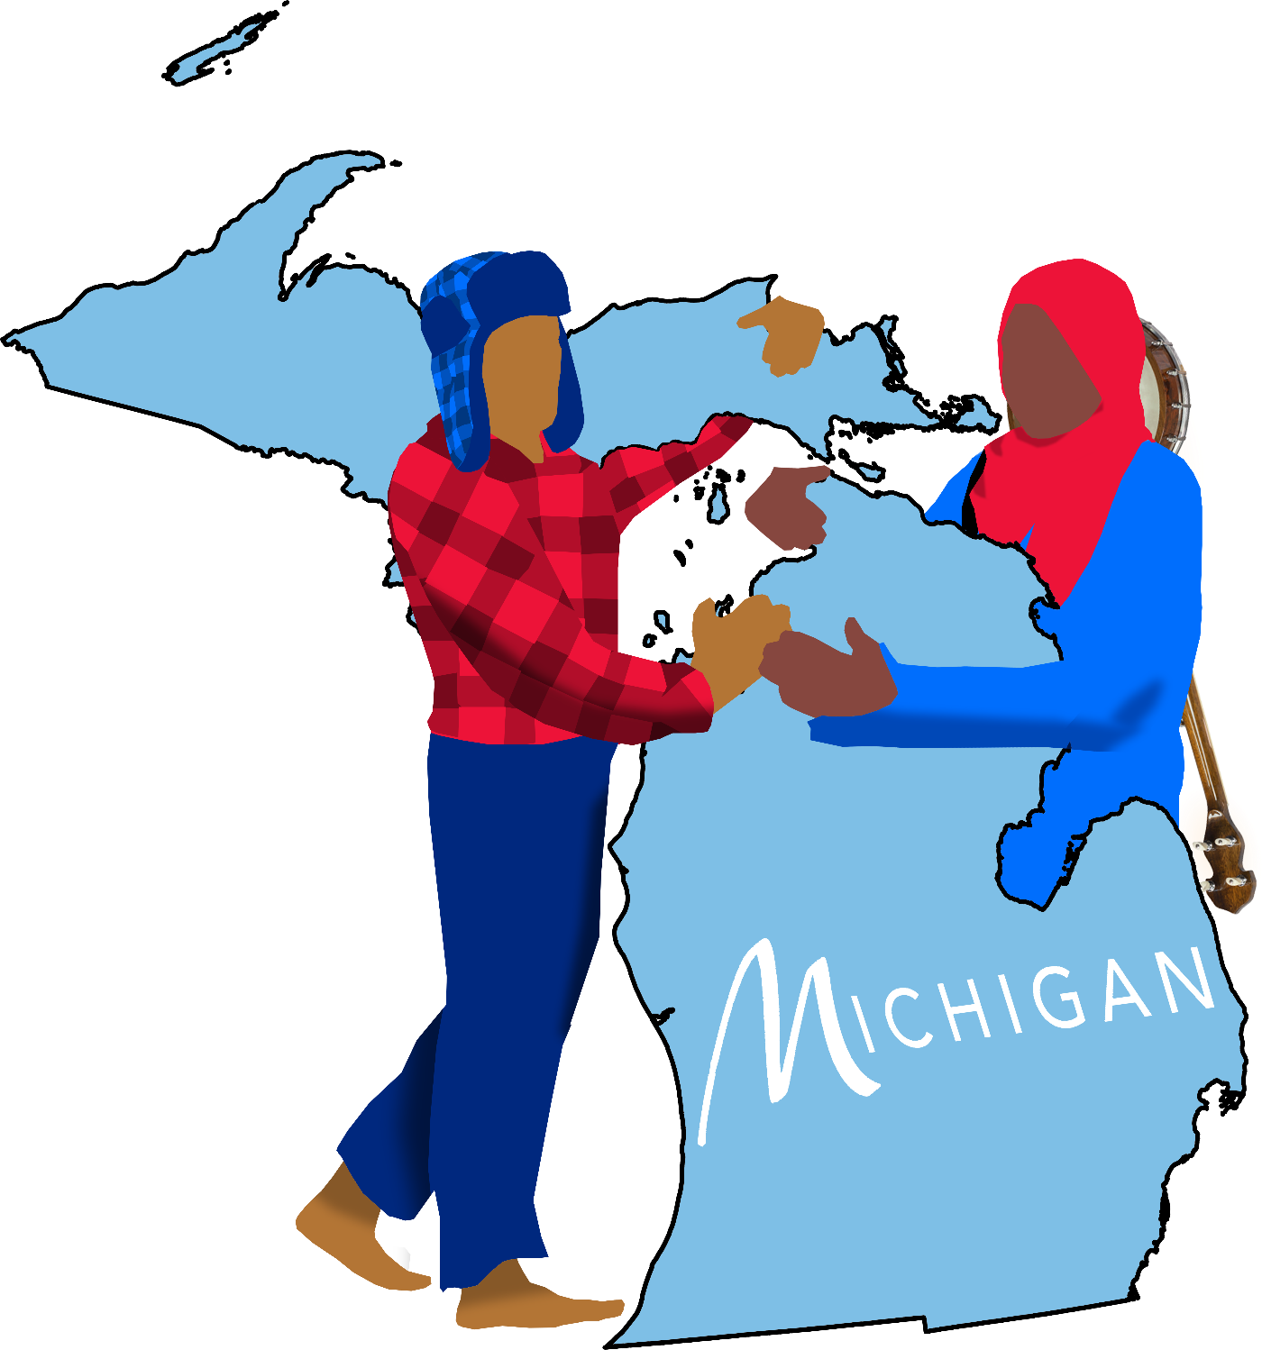

MICHIGAN
________________THE MUSICAL________________
When a data center threatens their grandparents' lake house, Lulu and Petoskey – a fierce Dearborn city girl and hopeful Yooper farm boy – must conquer years of grief to save their home... and the world.

Inspired by
The MacGregor Family
David Quang Pham’s Childhood
&
In Loving Memory of
Carly Glynn
September 24, 1992 – February 10, 2011
Gerald Fick
November 29, 1962 – May 11, 2017
Jeremy Swiatek
April 23, 1996 - September 15, 2019
Tiffany Marie Emmert
April 29, 1996 – January 19, 2026
James Emmert
May 5, 1991 – January 19, 2026
Andrew Van Otteren
March 17, 1994 - July 12, 2026

Because of you, David and many others love musicals and Michigan.

THANK YOU
Dramaturgy _{2026-Now}
Ynika Yuag
Feedback _{2026-Now}
Marilyn Chau, Lukas Jacob, Dionne O’Dell, May Perez, Mia Soriano, Dr. Daniel Smith, Camille Thomas
Harlem Writers United ₂₀₂₆
Alexandra Williams-Fleck, Karen Chien, Michael
Theatre People Party & Salon with Jen & Matt Coogan ₂₀₂₆
Beth Barton, Denise Gillott, Kayla Katona, Andrea Rae, Jake Sheffer

SYNOPSIS
Set during a family reunion in Elk Rapids, this coming-of-age musical follows two rival cousins: Lulu, a city girl from Dearborn, and Petoskey, a farm boy from the Upper Peninsula. The Van Otterloo family tradition is the annual Harbor Days, where they camp, canoe, and march in a parade. Lulu dreams of having a spiritual connection to the land. Meanwhile, Petoskey hopes to get to know his father and help his mother heal through water. Lulu, “pearl” in Arabic, is a metaphor for those who try to break out of their shells. Petoskey, the state stone and native fossil that reveals its true pattern in water, serves as a metaphor for ancestry, memory, and grief.
Michigan is inspired by David Quang Pham’s upbringing and the MacGregors who invite him to celebrate Harbor Days at their lake house in Elk Rapids since being college roommates with their family member Lukas Jacob in 2014. In 2026, after a series of tragedies of his hometown and college theatre friends, he wrote this musical as a love letter to his family and communities in our home Mitten.

WHY NOW?
Michigan champions creativity, connections, and the environment against the rise of harmful technologies, symbolized by data centers taking over Michigan towns. By focusing on collective loss, the musical addresses today’s mental health crisis, offering ways to heal through open communication and community. And it uses science and folklore to engage audiences in environmental and cultural literacy.
Michigan is Oklahoma craziness meets Fun Home tenderness meets Bright Star folksiness.

READ THE PITCH DECK
THEMES
Collective Grief and Emotional Healing
The story explores the long-term impact of grief after some family members’ passings, demonstrating how silence fractures families while open communication fosters generational healing.
Community versus Corporation
The central conflict pits hand-made tradition against corporate greed, with data centers erasing local heritage, such as the family’s lake house.
Geographic and Cultural Disconnection
The narrative highlights how families can become polarized by peninsulas, symbolized by the physical (and spiritual) barrier of the Mackinac Bridge separating the Upper and Lower Peninsula. The story leans into subcultures, pitting Yoopers against the Trolls.
Belonging and Identity
Through Lulu's competitive drive to outshine her cousins, the musical examines the painful adolescent struggle to fit into a Midwest family dynamic and find one's own sense of worth.
Nature, Folklore, and Science Literacy
The musical teaches paleontology, folklore, and what it means to be a Michigander through song.
The Immigrant Experience
This manifests through multiple layers, such as Shelby marrying an Arab man, Jasper Vinh Chin’s Vietnamese restaurant (Banh MIchigan), and his realization that his refugee family stayed united across continents while local families are divided by peninsulas. It deals heavily with how different minority communities interact within the Midwest.
Economic Displacement and Xenophobia
The backstory reveals the harsh realities of blue-collar job loss during the 2008 recession, like David’s own family in the automotive industry. It directly addresses the displaced anger that can arise from automated or immigrant replacement (Petey being fired and replaced by a migrant worker), showing the tragic intersection of economic desperation, racial tension, and family fallout.
The Power of Hand-Made Artistry
The family’s century-old Ford Model T, their decades of hand-made costumes, and the town's rally around them showcase art and weirdness as a form of liberation.
Healing through Artistry, Spirituality, or Technology
Due to sharing the same tragedy involving the Mackinac Bridge. Amanda and Liz never crossed that bridge for years. Amanda also has disdain for water, so she makes more data centers to drain them. Amanda processes grief by losing artistry through AI while Cherry becomes more artistic and less tech-savvy.

PLOT SUMMARY
Michigan is a folksy musical dramedy set at a family reunion where two rival cousins fight a data center to save their grandparents’ lake house and world. The themes explore grief, cultural disconnection of the peninsulas, and what it means to be a Michigander.
Grampy Willy and Granny Milly live in Elk Rapids on the north tip of the Lower Peninsula. They have four adult children – Cherry, Perry, Shelby, and the only son Petey, and some grandchildren. Every August, their Lake House lodges them for the annual Harbor Days. The Van Otterloo family is known for their century-old Ford Model T, wearing themed costumes for the parade, and winning every Most Creative Award (“The Mitten Song”).
In 2008, Petey lives with his pregnant wife Lizzie in the Upper Peninsula. His childhood friend is Jasper Vinh Chin, who runs the Elk Rapids Vietnamese restaurant, BANH MIchigan. On a swim, he jokily promises to name their kid after the first rock he picks up, which turns out to be a heart-shaped Petoskey with an elk symbol (“Life is Complete”).
With the recession, their shipyard job fires and replaces Petey and Liz with migrants. He then hurts his little sister Shelby due to her Arab husband. In a storm, he drives off the Mackinac Bridge to save their house on his life insurance. A detective finds his Petoskey. Ever since, Liz refuses to cross bridges, missing all family gatherings (“Body of Water”).
For family reunions, the aunts take turns driving Petoskey to Elk Rapids then Milly drives him home. Jasper becomes his godfather. For every Mackinac Bridge crossing, he can hear his dad sing. And then there’s his bright cousin from Dearborn, Lulu Abughosh. She always competes to find the rarest stones on their swims (“Yoopers and Trolls”).
In 2020, Milly passes away, cancelling the 2020 and 2021 family reunions. Soon, data center agent Amanda Wayland tricks a grieving Willy into signing away the deed to his house by using Afterlife.AI to bring Milly and Petey back to life (“It Would Be a Shame”).
In 2022, to honor Milly, 13-year-old Petoskey’s mom returns for the first time since ‘08. They drive the long way through Wisconsin. Jasper helps the kids set up camp. He takes their snacks as “dad tax.” The aunties take even more with “mom taxes” (“Dad Tax”).
Though the family gather by the bonfire, 13-year-old Lulu is in her tent finishing a song. She revisits a time when she ran away and was saved from a car accident by deer. She thinks everyone sees her as a loser. She’d do anything to win their hearts (“Dearborn”).
They realize Amanda tricked Willy into trading the Lake House for her AI that “brings loved ones back to life.” She tours the home and sees a photo of Petoskey’s heirloom. She wants it more than anything. So, he promises to trade it for the deed (“AI Does the Work for Me”).
They need to find it in Pine River (“Wild Midwest”). He revisits a memory of Lulu losing the heirloom while canoeing in 2019, severing his dad’s spiritual ties. So, he gathers everyone to find it. No one does (“Fish for Mom and Dad”).
Later that night on a dune, Lulu witnesses a deer pass by their bonfire. Next day, while Perry teaches fossils to the kids (“Time Does Heal”), Lulu separates and discovers a deer dropping off the heirloom and other rare rocks on the shore (“Gichigamiin”).
After successfully bulldozing Ypsilanti, Amanda revisits a time when she and her techy brother were artists until his suicide killed her creative spirit (“The Starving Artist”).
For Harbor Days’ parade, Broadway actor cousin Jacob Jacobowitz is the Grand Marshal. So, the theme is theatre. Petoskey dresses as Oklahoma’s Jud Fry while Lulu plays Evan Hansen. Before marching, she shows her rare findings to the family. To spite Petoskey, she breaks his father's necklace, unaware it was their only chance to save the Lake House from Amanda. The parade goes wrong as Petoskey beats up Lulu, disqualifying them for the first time (“Fraudway”). After his mom lectures him, he runs off (“Kick Rocks”).
In the following act, Liz revisits a memory of Lulu and Petoskey at a talent show (“Hands Come in Handy”). Presently, she searches for him while Lulu tries to find him at Banh MI (“Petoskey”). Jasper shares his refugee family stayed united despite continents dividing them as well as a time when a Lebanese family bought out his family’s failing restaurant but did not resort to blame as Petey had. The Van Otterloos are only divided by peninsulas. They realize Petoskey is at the Mackinac Bridge (“North South East West”). Meanwhile, Liz revisits her marriage proposal to Petey on a boat under it (“Natural Beauty”).
They drive up to find him. She offers the broken stone as a truce, but he tosses it into the water (“Rock Bottom”). This causes the bridge to fog up where Michilimackinac, the Great Turtle appears. They share that stones are like family as they come and go to leave a mark. And they ask the kids to stop the data centers around Michigan due to its harm on the environment and its noisiness (“Family’s in the Fossils”).
They return to the fair where Amanda exhibits data center models for the oligarchs. Jasper offers his restaurant for the Lake House. The Van Otterloos return with years of costume while Amanda shows how much “better” AI is. But the town rallies for this creatively weird family, against AI’s goal of turning lakes into data centers. Amanda and the crew steal the Ford, causing the town to chase after them. Liz, on her way to the Mackinac Bridge, tricks Amanda’s GPS AI to go there. Her trauma causes her to crash off the side of the bridge. Everyone gets off, but the Ford falls into the strait below (“Leave No Stones Unturned”).
It has been years since the death of their loved ones that Liz and Amanda have visited the Mackinac Bridge. In unison, the Van Otterloos and Amanda cross it, where they reunite with the souls of Petey and Conor. Amanda cancels her agreement to keep the Lake House. Elk Rapids is spared from a data center (“Water to My Soul”).
Years later, Willy passes away. Lulu and Petoskey buy and fix up the Lake House. On January 26, 2037, Lansing holds a parade to celebrate the 200th anniversary of MI’s statehood with representatives from every city marching. The theme is Pure Michigan. Representing Elk Rapids, the Van Otterloo family resembles the state’s best (“Michigan”).
CAST OF CHARACTERS
THE VAN OTTERLOO FAMILY
LULU VAN OTTERLOO ABUGHOSH describes herself as a Middle Eastern girl in the middle of the Midwestern world. A 13-year-old born and raised in Dearborn, she wears solid colors, hoping to collect better rocks than Cousin Petoskey every year. She is writing Dearborn, a musical about deer navigating the talking Great Lakes. She plays banjo and is Iggy Pop’s biggest fan. Her name is Arabic meaning “pearl.”
PETOSKEY VAN OTTERLOO describes himself as a rocky Yooper farm boy skipping the Great Lakes water. A 13-year-old from Skandia, he wears patterns and trapper hats. He connects with his ancestors through his heart-shaped Petoskey heirloom with an elk symbol. He loves to go fishing; he just needs a parent to do it with.
LIZZIE GLYNN VAN OTTERLOO is Petoskey’s mother and narrator in Skandia. After a tragedy in 2008, she stops crossing the Mackinac Bridge to attend Harbor Days and family gatherings. Liz is a proud Yooper and shipbuilder. Michigan State.
PETEY VAN OTTERLOO is Petoskey’s father, Liz’s husband, and Willy and Milly’s only son of four. Every Harbor Days, he wakes everyone up. During the recession, his and Liz’s blue-collar shipyard job replaces them with migrants. Michigan State.
SHELBY VAN OTTERLOO ABUGHOSH is Petoskey’s aunt, Petey’s little sister, and Lulu’s mother in Dearborn. She is a Ford Motor worker. As the family member who broke the mold by being a Midwesterner who fell in love with a Middle Easterner, she and Petey had a tumultuous relationship. Kettering University.
PERRY VAN OTTERLOO is Petoskey’s aunt and Petey’s campy sister in Lansing. Her heart is in science, yet she has a conspiracy theory mindset and plotted to kidnap the governor. Michigan Technological University and Eastern Michigan dropout.
CHERRY VAN OTTERLOO JACOBOWITZ is Petoskey’s aunt and Petey’s oldest sister in Kalamazoo. She arranges the theme and costumes for the annual Harbor Days parade. She is married to a Grand Rapids Griffins hockey manager. Hope College.
JACOB VAN OTTERLOO JACOBOWITZ is Cherry’s son who is a Broadway actor in New York. He is the 2022 Grand Marshal for the Harbor Days Grande Parade where he is dressed as Wednesday from The Addams Family. He recently performed on the national tour of this show. Western Michigan University.
LIBERTY AND BAILEY VAN OTTERLOO are twin siblings and Petoskey, Lulu, and Jacob’s little cousins removed from reality. They are from Hell… Michigan.
MILLY VAN OTTERLOO is Petoskey’s bold grandmother and inventor. She invented the auto-toilet. With Willy, she owns a Lake House by Elk Lake in Elk Rapids. She and Willy stumble into the audience every so often. Central Michigan.
WILLY VAN OTTERLOO is Petoskey’s chill grandfather and gardener. With Milly, he owns a Lake House by Elk Lake in Elk Rapids. He and Milly stumble into the audience every so often. Northern Michigan University.

MICHIGANDERS
JASPER VINH CHIN is Petey’s resourceful childhood friend and Petoskey’s godfather/godmother who runs the BANH MIchigan Vietnamese restaurant and a golf course. As a teen, they once looked down on the migrant community when a Lebanese family bought out his family’s original struggling restaurant. Ferris State.
AMANDA WAYLAND is the CEO of Turkey Ventures from Muskegon with the goal of turning every lake city into a data center. Following her brother Conor’s death, she loses her creative spirit and takes over her brother’s business to create Afterlife.AI to bring late loved ones back as avatars. She was an art school rival of Cherry, before getting expelled. Hope College dropout. University of Michigan.
DETECTIVE is an investigator along the Mackinac Bridge.
THE GHOST OF HENRY FORD returns from Hell.
MICHILIMACKINAC, the Mackinac spirit resembling the Great Turtle.
THE KEEPERS OF FAITH, FIRE, TRADE are the original people of the land
MICHIGANDERS, RESIDENTS, LAWMAKERS, OLIGARCHS, RADIO, anyone who speaks in “ope.”
MUSICAL NUMBERS
ACT I
1. Overture / The Mitten Song _{Petey}
2. Life is Complete _{Michiganders}
3. Body of Water Petey, Lizzie, Detective, Mackinac Ghosts
4. Yoopers and Trolls Petoskey, Lulu, Cherry, Perry, Shelby, Milly, Willy
5. It Would Be a Shame _{Amanda, Willy, Milly, Petey}
6. Dad Tax Jasper, Lizzie, Cherry, Perry, Shelby, Lulu, Petoskey, Jacob, Liberty, Bailey
7. Dearborn _{Lulu, Van Otterloos, Deer}
8. AI Does the Work for Me _{Amanda, Van Otterloos}
9. Wild Midwest Jacob, Petoskey, Lulu, Liberty, Bailey, Cousins
10. Fish for Mom and Dad Jacob, Petoskey, Lulu, Liberty, Bailey, Cousins
11. Time Does Heal _{Perry, Lulu, Petoskey, Cousins}
12. Gichigamiin (The Great Lakes Ballet) _{Lulu, Keepers, Explorers}
13. The Starving Artist _{Amanda}
14. Fraudway _{Van Otterloos}
15. Kick Rocks Van Otterloos, Keepers of Faith Fire Trade
ACT II
16. Hands Come in Handy _{Lulu, Petoskey}
17. Petoskey _{Lizzie, Amanda, Van Otterloos}
18. North South East West _{Jasper, Lulu, Jacob}
19. Natural Beauty _{Lizzie, Petey}
20. Rock Bottom Petoskey, Lulu, Jasper, Mackinac Ghosts
21. Family’s in the Fossils Michilimackinac, Petoskey, Lulu
22. Leave No Stones Unturned Amanda, Van Otterloos, Michiganders
23. Water to My Soul Lizzie, Petey, Van Otterloos, Amanda, Michilimackinac, Mackinac Ghosts
24. Michigan _{Michiganders}

MICHIGAN THEMES
Nayaano | Water Spirits | Lake Giants
_{Main Theme} | _{Childhood Theme} | _{Adulthood Theme}
Pine Monsters | Wind Hoppers | Michilimackinac
_{Troublesome Theme} | _{Migration Theme} | _{Nature Theme}

