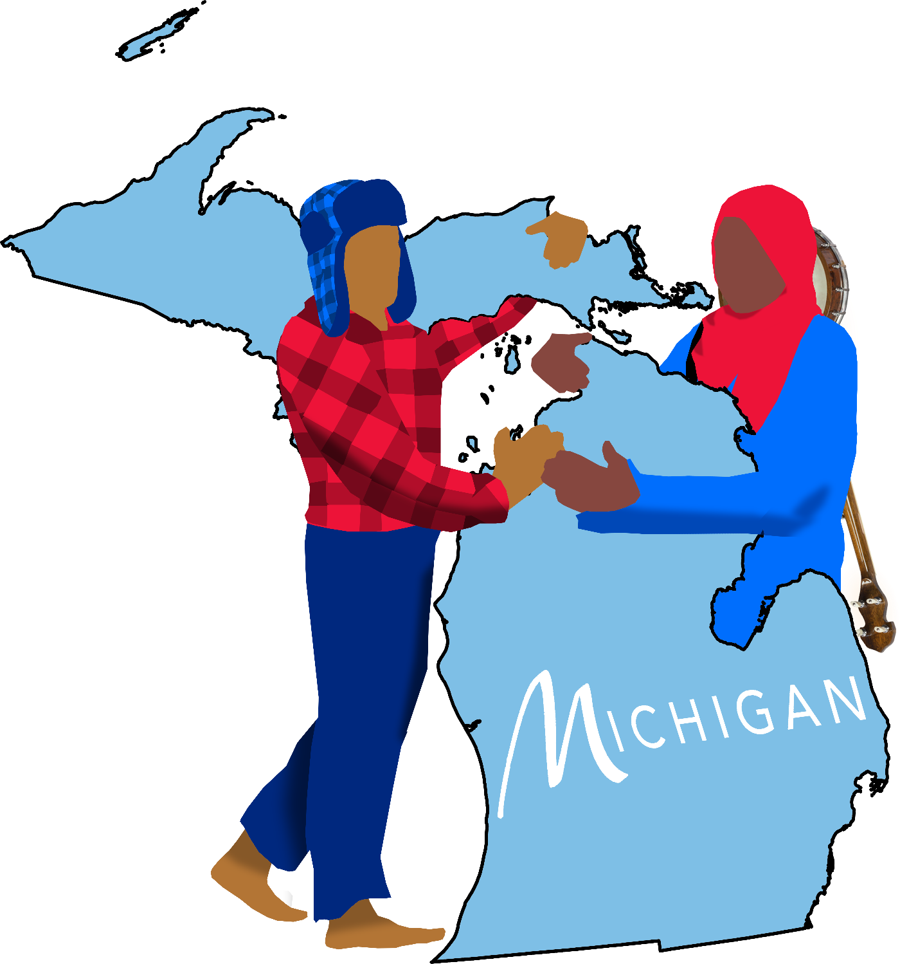

WINTER IN OUR BONES
WATER TO OUR SOULS

Michigan is a folksy pop rock musical that follows Petoskey Vandam and Lulu Abughosh, a grieving Yooper boy and Dearborn girl, fight a data center to save their grandparents’ historic lake house.

Inspired by
The MacGregor Family
David Quang Pham’s Childhood

&

In Loving Memory of
Carly Glynn
September 24, 1992 – February 10, 2011
Jeremy Swiatek
April 23, 1996 - September 15, 2019
Tiffany Marie Emmert
April 29, 1996 – January 19, 2026
James Emmert
May 5, 1991 – January 19, 2026
Andrew “Andy” Van Otteren
March 17, 1994 - July 12, 2026

Thanks to you all, David and countless others love musical theatre and Michigan.
SYNOPSIS
To save their grandparents' lake house from becoming a data center, a Dearborn girl and her grieving Yooper cousin must bridge their peninsula-sized rivalry, proving blood is thicker than the Mackinac Strait. To buy back the home, they must trade Petoskey’s late father’s treasured heirloom (a heart-shaped Petoskey necklace with an elk symbol) which Lulu lost in Pine River years ago. Petoskey, a native fossil that reveals its true pattern when wet, serves as a metaphor for hidden grief and emotional depth.
Michigan is inspired by David Quang Pham’s upbringing and the MacGregors who invite him to their Elk Rapids lake house on Harbor Days since being roommates with their family member Lukas Jacob in 2014. In 2026, after a series of suicides of his hometown and college friends in musical theatre, he began writing this musical as a love letter to his family and communities in our home Mitten.

WHY NOW?
Michigan champions human creativity, connections, and nature against the rise of harmful technologies, symbolized by the threat of a data center replacing a small-town family’s lake house. By centering the narrative on the impacts of suicide and collective loss, the play addresses today’s mental health crisis, offering ways to heal through open communication and community. And it uses science and folklore to bridge regional cultural divides, reminding audiences to protect both the natural environments and our shared heritages that keep us rooted.
Michigan is Oklahoma craziness meets Fun Home tenderness meets Bright Star folksiness.

THEMES
Collective Grief and Emotional Healing
The story explores the long-term impact of grief after Petey’s suicide and Grandma Milly's death, demonstrating how silence fractures families while open communication fosters generational healing.
Community versus Technology
The central conflict pits a warm hand-made tradition against cold corporate greed, by keeping AI data centers from erasing local heritage, such as the family’s lake house.
Geographic and Cultural Disconnection
The narrative highlights how families can become polarized by peninsulas, symbolized by the physical and emotional barrier of the Mackinac Bridge separating the Upper and Lower Peninsula identities. The story leans into subcultures, contrasting Yooper (Upper Peninsula) against suburban Dearborn/Lower Peninsula dynamics.
Belonging and Identity
Through Lulu's competitive drive to outshine her cousins, the musical examines the painful adolescent struggle to fit into a Midwest family dynamic and find one's own sense of worth.
Nature, Folklore, and Science Literacy
By embedding paleontology into the musical numbers, the narrative uses the natural history of the Petoskey stone fossil to teach environmental appreciation and show how memories attach themselves to physical landscapes.

The Immigrant Experience
This manifests through multiple layers, such as Shelby marrying an Arab man, Jasper Tran’s Vietnamese restaurant (Banh MIchigan), and Jasper's realization that his refugee family stayed united across continents while local families are divided by peninsulas. It deals heavily with how different minority communities interact within the Midwest.
Economic Displacement and Xenophobia
The backstory reveals the harsh realities of blue-collar job loss during the 2008 recession, like David’s family in the automotive industry. It directly addresses the displaced anger that can arise from automated or immigrant replacement (Petey being fired and replaced by a migrant worker), showing the tragic intersection of economic desperation, racial tension, and family fallout.
The Power of Hand-Made Artistry
The family’s century-old Ford Model T, their decades of hand-made costumes, and the town's rally around them showcase art and weirdness as a form of liberation.

PLOT SUMMARY
Michigan is a folksy musical dramedy set at a family reunion where two rival cousins fight a data center to save their grandparents’ historic lake house. The themes explore grief, cultural disconnection of the peninsulas, and what it means to be a Michigander.
Grampy Willy and Granny Milly live in Elk Rapids on the north tip of the Lower Peninsula. They have four adult children – Cherry, Perry, Shelby, and the only son Petey, and some grandchildren. Every August, their lake house lodges them for the annual Harbor Days. The Vandam family are known for their century-old Ford Model T, wearing themed costumes for the parade, and winning every Most Creative Award (“The Mitten Song”).
In 2008, Petey lives with his pregnant wife Lizzie in the Upper Peninsula. His childhood friend is Jasper Tran, who runs the Elk Rapids Vietnamese restaurant, BANH MIchigan. On a swim, he jokily promises to name their kid after the first rock he picks up, which turns out to be a heart-shaped Petoskey with an elk symbol (“Life is Complete”).
With the recession, their shipyard job fires and replaces Petey and Liz with migrants. He then hurts his little sister Shelby due to her Arab husband. In a storm, he drives off the Mackinac Bridge to save their house on his life insurance. A detective finds his Petoskey. Ever since, Liz refuses to cross bridges, missing all family gatherings (“Body of Water”).
For family reunions, the aunts take turns driving Petoskey to Elk Rapids then Milly drives him home. Jasper becomes his godfather. For every Mackinac Bridge crossing, he can hear his dad sing. And then there’s his bright cousin from Dearborn, Lulu Abughoush. She always competes to find the rarest stones on their swims (“Yoopers and Trolls”).
In 2020, Milly passes away, cancelling the 2020 and 2021 family reunions. Soon, data center agent Amanda Wayland tricks a grieving Willy into signing away the deed to his house by using afterlife.ai to bring Milly and Petey back to life (“It Would Be a Shame”).
In 2022, to honor Milly, 13-year-old Petoskey’s mother returns for the first time since the 2008 tragedy. They drive the long way through Wisconsin. Jasper helps Petoskey, Lulu, and the other kids set up camp and go canoeing with them. He often takes some of their snacks as “dad tax.” The aunties take even more with “mom taxes” (“Dad Tax”).
As Willy believes Milly and Petey stayed alive by AI, they discover Wayland's plot to turn Elk Lake into a data center. She and Cherry were art school rivals. She tours the home and sees a photo of baby Petoskey with his hearty stone. She wants it. Worth more than the city itself, the boy promises to trade it for the deed (“AI Does the Work for Me”).
They have a day to find the necklace along Pine River (“Wild Midwest”). He revisits a memory of Lulu dropping the heirloom while they canoed in 2019, severing his dad’s spiritual ties. So, he enlists the cousins to help find it, promising whoever finds the heirloom gets to decide what he wears next year. But no one finds it (“More than Fine”).
Later that night on a dune, Lulu and Petoskey witness deer pass by their bonfire. He wishes to see his dad while she hopes to beat Petoskey (“Dearborn”). Next day, while Perry teaches fossils to the kids (“Fossils in the Stones”), Lulu separates and discovers a deer dropping off the heirloom and other rare rocks on the shore (“Gichigamiin”).
For Harbor Days’ parade, Broadway actor cousin Jacob Jacobowitz is the Grand Marshal. So, the theme is theatre. Petoskey dresses as Oklahoma’s Jud Fry while Lulu plays Evan Hansen. Before marching, she shows her rare findings to the family. To spite Petoskey, she breaks his father's necklace, unaware it was their only chance to save the lake house from Wayland. The parade goes wrong as Petoskey beats up Lulu, disqualifying them for the first time (“Fraudway”). After his mom lectures him, he runs off (“Kick Rocks”).
In the following act, the family revisits a memory of Lulu and Petoskey meeting (“Hands Come in Handy”). Presently, they search for him while Lulu tries to find him at Banh MI (“Petoskey”). Jasper shares his refugee family stayed united despite continents dividing them as well as a time when a Lebanese family bought out his family’s failing restaurant but did not resort to blame as Petey had. The Vandams are only divided by peninsulas. Lulu realizes Petoskey is most likely at the Mackinac Bridge (“North South East West”).
They drive up to find him. She offers the broken stone as a truce, but he tosses it into the water (“Rock Bottom”). This causes the bridge to fog up where his father’s ghost emerges as a giant elk. Petey shares that stones are special only when rocks are packed together. Like family, rocks come and go to leave a mark (“Family’s in the Fossils”).
They return to the fair where Wayland is exhibiting data center models with other developers. Petoskey offers the Ford which she scoffs but is interested in. Jasper then offers his restaurant. The Vandams return with decades of themed costume while Wayland shows how much “better” AI is. But the town rallies for this genuinely creative and weird family, against AI’s goal of turning lakes into data centers. Wayland and the developers refuse and steal the Ford, causing the town to chase after them. She drives it off a bridge, then gets thrown into an asylum by Traverse City. Their contracts are declared void as their party is declared insane (“Leave No Stones Unturned”).
After Harbor Days conclude, Liz takes the Ford for a spin and go the short way to the Mackinac Bridge, the first time since Petey’s death. Liz and Petey’s ghost have their own reunion as lovers once more (“Water to My Soul”).
Years later, Willy passes away. Lulu and Petoskey buy and fix up the lake house. On January 26, 2037, Lansing holds a parade to celebrate the 200th anniversary of MI’s statehood with representatives from every city marching. The theme is Pure Michigan. Representing Elk Rapids, the Vandam family resembles the state’s best (“Michigan”).

CAST OF CHARACTERS
THE VANDAM FAMILY
PETOSKEY VANDAM is a 13-year-old farm boy from Skandia and the goofiest of Willy and Milly’s grandkids. Besides his mom Liz, his only connection to extended family happens on Harbor Days in Elk Rapids. He never met his late father. To honor Petey, he wears his heart-shaped Petoskey heirloom with an elk symbol.
LIZZIE VANDAM is Petoskey’s mother and narrator in Skandia. After her husband Petey’s suicide in 2008, she stops crossing the Mackinac Bridge to attend Harbor Days and all family gatherings. Liz is a proud farm girl Yooper. Michigan State.
PETEY VANDAM is Petoskey’s father, Liz’s husband, and Willy and Milly’s only son of four. Every Harbor Days, he would be the first to get up to wake everyone up. During the recession, his blue-collar shipyard job fires and replaces him and Liz with migrants, leading to a fight with his little sister Shelby for marrying an Arab. He drives off the Mackinac Bridge to save their house with his life insurance. His ghost visits Petoskey whenever he crosses the bridge. Michigan State.

LULU ABUGHOUSH is a 13-year-old city girl from Dearborn and the brightest of Willy and Milly grandkids, yet she is trollface personified. She hopes to beat cousin Petoskey in their annual rare rocks collection. She is writing a musical titled Dearborn, about a family of deer navigating the anthropomorphic Great Lakes. She plays banjo and is Iggy Pop’s biggest fan. Her name is Arabic meaning “pearl.”
SHELBY ABUGHOUSH is Petoskey’s aunt, Petey’s little sister, and Lulu’s mother who lives in Dearborn. She is an automotive worker for Ford Motor Company. As the sister who broke the mold by falling in love with an Arab, she and Petey had a tumultuous relationship. She tries to respect Petoskey. Kettering University.
PERRY VANDAM is Petoskey’s aunt and Petey’s older sister in Lansing. Her campy mind loves science. Michigan Technological University dropout.
CHERRY JACOBOWITZ is Petoskey’s aunt and Petey’s oldest sister in Kalamazoo. She arranges the theme and costumes for the annual Harbor Days parade. She is married to a Grand Rapids Griffins hockey manager. Hope College.
JACOB JACOBOWITZ is Cherry’s son who is a Broadway actor in New York. He is the 2022 Grand Marshal for the Harbor Days Grande Parade where he is dressed as Wednesday from The Addams Family. He recently performed on the national tour of this show. Western Michigan University.
LIBERTY AND BAILEY are twin siblings and Petoskey, Lulu, and Jacob’s little cousins removed from reality. They are from Hell… Michigan. Liberty is allergic to sand and Bailey is allergic to pine. They make poison ivy bouquets.
MILLY VANDAM is Petoskey’s bold grandmother and inventor. She invented the automatic toilet. With Willy, she owns a house by Elk Lake in Elk Rapids. She and Willy stumble into the audience every so often. Central Michigan University.
WILLY VANDAM is Petoskey’s chill grandfather and gardener. With Milly, he owns a lake house by Elk Lake in Elk Rapids. Grieving Milly’s death in 2020, he leaves the garden unattended and accidentally signs away the deed. He and Milly stumble into the audience every so often. Northern Michigan University.

ELK RAPIDS RESIDENTS
JASPER TRAN is Petey’s resourceful childhood friend and Petoskey’s godfather who runs the BANH MIchigan Vietnamese restaurant and a golf course. As a teen, he once looked down on the Arab community when a Lebanese family bought out his family’s previous struggling restaurant. After Petey’s death with his last memory being his prejudice towards Arabs for “stealing American jobs,” he vows to help migrants no matter what. Ferris State. Red Wings fan.
AMANDA WAYLAND is the CEO of Turkey Ventures from Muskegon who created afterlife.ai with the goal of turning every city into a data center. At Hope College, she was an art school rival of Cherry Vandam, before getting expelled for using Photoshop. So, she sees the Vandam family’s hands-on creativity as inferior to the efficiency of AI. The Vandams describe her as a turkey vulture. But like most of the world, there is one thing she likes more than data and that is a cool rock, which Petoskey holds. Hope College dropout. University of Michigan (ew).

MICHIGANDERS
DETECTIVE is an investigator along the Mackinac Bridge.
THE GHOST OF HENRY FORD returns from Hell.
COPS, OLIGARCHS
MUSICAL NUMBERS
ACT I
1. Overture / The Mitten Song _{Petey}
2. Life is Complete _{The Vandams}
3. Body of Water _{Petey, Lizzie}
4. Yoopers and Trolls _{Petoskey, Lulu}
5. It Would Be a Shame _{Wayland, Willy, Milly, Petey}
6. Dad Tax Jasper, Lizzie, Cherry, Perry, Shelby, Lulu, Petoskey, Kids
7. AI Does the Work for Me _{Wayland, The Vandams}
8. Wild Midwest Jacob, Petoskey, Lulu, Liberty, Bailey, Cousins
9. More than Fine (I’m Pine) Jacob, Petoskey, Lulu, Liberty, Bailey, Cousins
10. Dearborn (Dear Deer) _{Petoskey, Lulu, Deer}
11. Fossils in the Stones✋ _{Perry, Kids}
12. Gichigamiin (The Great Lakes Ballet) _{Company}
13. Fraudway _{Company}
14. Kick Rocks _{The Vandams}

ACT II
15. Hands Come in Handy _{Lulu, Petoskey}
16. Petoskey _{Company}
17. North South East West _{Jasper, Lulu}
18. Rock Bottom _{Petoskey, Lulu}
19. Family’s in the Fossils _{Petey, Petoskey}
20. Leave No Stones Unturned Wayland, The Vandams, Residents
21. Water to My Soul _{Lizzie, Petey}
22. Michigan _{Michiganders}
✋“Fossils in the Stones” is a David Quang Pham signature science song teaching paleontology.

Nayaano | Water Spirits | Lake Giants
^{Main Theme} | ^{Childhood Theme} | ^{Adulthood Theme}
Pine Monsters
^{Troublesome Theme}

