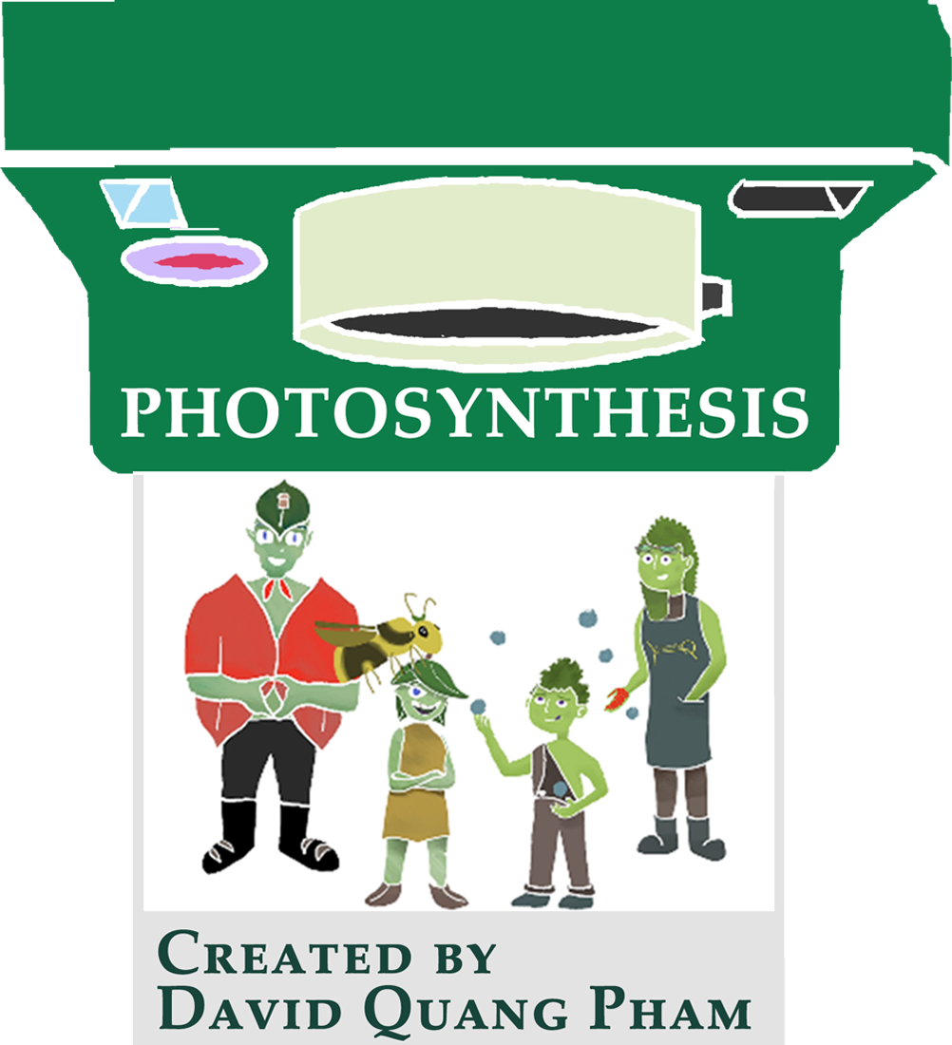

PHOTOSYNTHESIS
An Animated Comedy Feature
Written by and Music by
David Quang Pham

Based on the musical Turnover: A New Leaf by
David Quang Pham




Contact:
616 818 5413
davidquangpham@outlook.com
512 W 158th St #2 New York, New York 10032

