PHOTOSYNTHESIS
Photosynthesis is a plant-based animated musical comedy set in a world inhabited by photogenic plants. The feature follows Rau Ram (“cilantro” in Vietnamese), owner of Salontro salon, who must earn her green card to not get uprooted and lose custody of her son Parsley. The series is a sequel to the feature and centers more on the kids, Parsley and Pyrus (a good-natured herb and free-spirited pear), as they navigate Dirty City and create chaos with their naive antics and innocent friendship.
The series logline: In the heart of Dirty City, a photogenic young herb and his pear best friend navigate the musical misadventures hidden underneath the soil while trying to keep his mother’s salon, Salontro, from getting uprooted.

PHOTOSYNTHESIS (THE MOVIE)
LOGLINE
In a vibrant garden nation of photogenic plants, a determined cilantro must navigate a ruthless weeding-out process to earn her green card before she gets uprooted and loses custody of her curious son, Parsley.

SYNOPSIS
Set in the garden nation of Woodwork, Photosynthesis follows Rau Ram, a cilantro transplant striving for a better life for her son, Parsley. In this world, citizenship is literally visible: natural-born plants or transplants with green cards have green hands, while transplants like Rau have red hands that mark them as outsiders. After years of struggling to run a salon in the urban sprawl of Dirty City, Rau faces her greatest threat: the newly ratified Weed Out Act, which authorizes the uprooting of any undocumented plant. To secure her family's future, Rau must decide how much of her cultural roots she is willing to sacrifice to blend in, all while her son discovers a community of "Figs" and outsiders who believe true belonging isn't found in a color, but in a shared garden.

PLOT SUMMARY
Act I (Root): Rau Ram arrives in Woodwork as a young, pregnant transplant fleeing her home, Paddy Kingdom. Eleven years later in Dirty City, she runs Salontro, a salon for plants. She raises Parsley to be "picture perfect" to avoid the attention of Secretary of Garden Security Rhizo Blomquist. The status quo is shattered when Rhizo announces a crackdown on all "invasive species," leaving Rau no time to get her pending green card.
Act II (Growth): Rau enters an alliance with her flamboyant landlord, Malus Crabapple, who runs the neighboring FigLeaf nightclub. While Rau tries to buy her way into citizenship through bribes and performative actions, Parsley befriends Malus’s nibling, Pyrus, a pear who leads him on unruly adventures. Tensions peak when Rau, desperate to prove her loyalty to Woodwork, betrays her own community by handing over a list of undocumented transplants to Rhizo. As a reward, she finally receives her green card.
Act III (Turnover): The government targets FigLeaf for demolition, forcing Rau to choose between her status and friends. In an act of solidarity, she leads a protest that causes her to lose her citizenship. Despite the protest, the building is leveled, but Rau uses her life savings to fund FigLeaf’s reconstruction. In the end, Rau finally finds belonging in the thriving garden her chosen family built together, not in a green card.
SETTING
Inspired by Michigan and USA, Woodwork has two peninsulas, shaped like a leaf above a tree trunk. The leaf peninsula (UP) has towns like Mt. Woodwork. The trunk (LP) has cities like Dirty City, Woody Holly, the capital, etc. The story is set mainly in Salontro or FigLeaf nightclub in Dirty City. Buildings are often ceramic pots or treelike. Vietnam and Asia inspire Paddy Kingdom. Moss is grass to plants as grass is to humans.
✿ Woodwork (Plants born/naturalized here have green cards/hands)
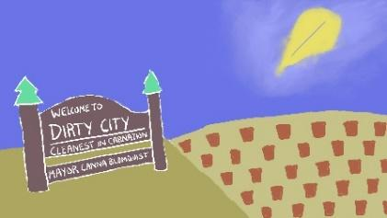
✿ Dirty City
✿ Cantaloupe Outlets ✿ FigLeaf Nightclub – owner: Malus Crabapple
✿ Rootimentary School ✿ Salontro – Rau and Parsley’s home; landlord: Malus
✿ Dirtharmonic Performance Hall ✿ City Hall
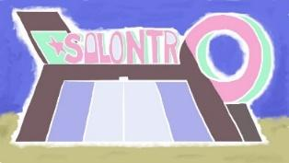
✿ Woody Holly (based on Hollywood)
✿ Herbivore Studios
✿ The Sunshine Garden
✿ Mt. Woodwork
✿ Pyrus’s House ✿ Woodwork National Park
✿ Cherry Tree, Woodwork Capitol
✿ The Green House ✿ Department of Garden Security Headquarters
✿ Whiskerskills
✿ Paddy Kingdom (Plants born/naturalized here have red cards/hands)
✿ Adansonia (based on Africa)
✿ Banyan (based on India)
✿ Bereza Federation (based on Russia and Eastern Europe)
✿ Canguro (based on Oceania)
✿ Floresta (based on South America)
✿ Snow Meadows (based on Antarctica)
✿ Tulip (based on Europe)

CHARACTERS
In addition to the principal cast, Photosynthesis has an androgynous supporting cast of families, children, and generic plants to be introduced in each episode for the audience to learn from. They can be featured, developed, and/or done away with as necessary.
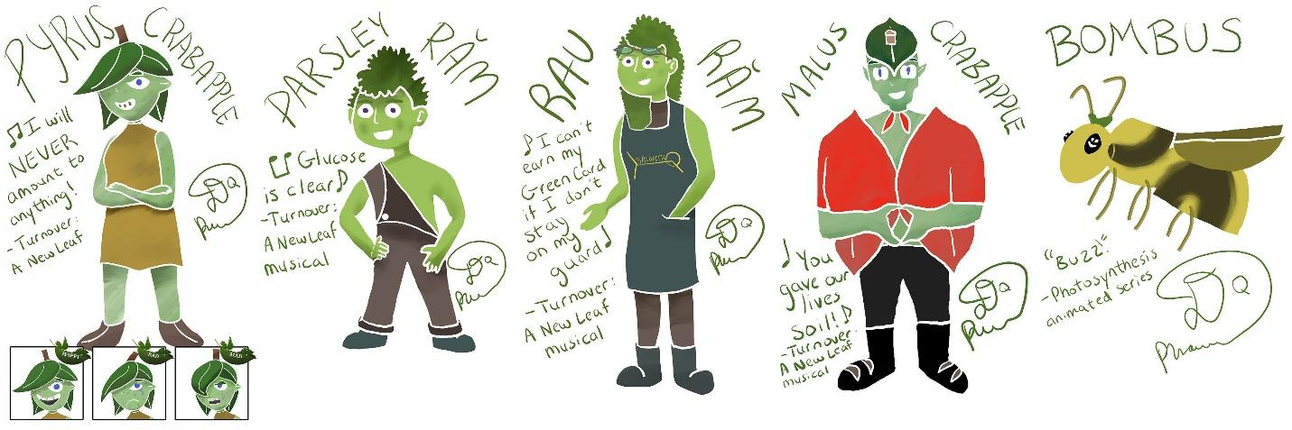
The Rams
RAU RAM (36) is a resilient cilantro and owner of the Salontro salon in Dirty City. Fleeing conflict in Paddy Kingdom, Rau raises her natural-born son, Parsley, to be the “picture perfect” child to help earn her green card in a nation that views her as invasive. She maintains a shaky relationship with her neighbor, the nightclub owner Malus, but sometimes views Malus’s unruly nibling, Pyrus, as a necessary friend for Parsley.
PARSLEY RAM (11) is an optimistic herb and only friend of his overprotective mother, Rau. He helps at the salon and tutors at Rootimentary school. Unlike Rau, he admires the Fig community and connects with Pyrus, who challenges his sheltered worldview.

The Crabapples
MALUS CRABAPPLE (50s) is the down-to-earth owner of the FigLeaf nightclub. A Paddy War veteran, they share a symbiotic but conflicted business relationship with Rau, who sees them as unnatural. Malus must confront their own tragic past of parental abandonment by ensuring their teenage nibling Pyrus finds belonging.
PYRUS CRABAPPLE (13) is free-spirited pear with a flair for troublemaking, often retreating to their pet bee Bombus. After being suspended from Terra Hill Conservatory, their mother sends them to Malus's for the summer. They soon find an unexpected, fruitful friend in the little herb next door, Parsley, who helps them turn a new leaf.
BOMBUS BUMBLE B is Pyrus’s loyal pet bee. An intellectual who solves puzzles and stings insults in honey ink, Bombus speaks only in unintelligible buzzes, mirroring the experience of many children of immigrants who cannot speak their mother tongue.
Other Residents of Dirty City, Woodwork
MAYOR CANNA BLOMQUIST (50s) is the rotten and fourth wall-breaking mayor of Dirty City. They are Secretary of Garden Security Rhizo Blomquist’s twin sibling.
NURSE BIRCH (50s) is Rootimentary School’s nurse.
ALTON DANDY (40s) is a real estate mogul who founded All Dandy Properties. They are the feature’s secondary antagonist.
SALIX WILLOW (40s) is a therapist from Gongyuan who cannot help but weep. They are Rau’s business rival in the wellness industry.

Woodwork Government
SECRETARY RHIZO BLOMQUIST (50s) is the Secretary of Garden Security, head of the Soil and Plant Protection (SAPP) Agency, and Mayor Canna’s twin sibling. They are the root of suffering for many transplants while being a child of one. They are the main antagonist.
PRESIDENT PUMPKIN EATER (50s) is the President of Woodwork. They are the epitome of a cheater. They live in the Green House.
SAPP AGENTS / OFFICERS, are Woodworkan immigration officers and agents who uproot transplants.

Residents of Mt. Woodwork, Woodwork
THUJA CARPENTER (40s) is the pine tree park ranger with an eye patch who comes from a holiday freak show family.
MUSA PISANG (14) is a music student who goes bananas at Terra Hill Conservatory and is the flute player in Pyrus’s band, The Woodwinds.
RHUBARB AVAZ (30s) is the Persian Rubab-playing music teacher at Terra Hill Conservatory and Pyrus’s sworn enemy due to her insistence on practicing.

Residents in The Sunshine Garden, Woodwork
KEY LIME (8) is a kid who cannot swim unless it is in sparkling water.
MUSAMI CITRUS (8) is Key’s friend who mentors them on how to swim.

Other Plant Characters
ACHIRA BLOMQUIST (80s) is a transplant rights activist and the first transplant to be elected to public office, as a senator of San Clay. She is the mother of Canna and Rhizo.
DJ CAULIFLOWER (20s) is the hip-hop and coolest Cruciferous on tour.
AGENT MINNEOLA ORANGE (30s) is a deceased agent during the Paddy War.
LAMI MENTHA (30s) is a minty superstar and businessowner.
ANANAS PINEAPPLE (40s) is a callous piney entrepreneur whose family founded Y n’ Pizza chain. They tour around in their food truck.
SUNFLOWER (60s) is a pop rock folk singer who leads The Beetroots, where the guitarist, bassist, and drummer are literal beets.
WOAD (60s) is a spiritual healer of sorts.
Fresh Ground Pepper
PAPA VER
ABEL ESCULENTUS
HELIA
ALLI SHALLOT
JAZZ NOCTURNAL
SCALLI FISTU
OCI TULASEE
TOM SOLAN
KUDZU LOBATA
PIPER BELL

Bugs
BEES, a plant’s dog or cat.
BEETLES, musical birds who can chirp melodies to the plants.
HORNETS, a plant’s illegal pet tiger.
FIREFLIES, bugs that light up and go paparazzi.
FLEAS, hopping pets often sold at the flea market.

THEMES
Photosynthesis presents the connections that science and plant biology have with society and family. With synthesizing photographs, the series is rooted in the multiple meanings of roots from family roots to rooting for one another in the community to identify root causes of problems and developing solutions to address them.
Why the pear and herb? For Vietnamese dishes, cilantros are a cultural garnish. And pear trees filled David Quang Pham’s childhood home in the city of Wyoming, Michigan. The green card is rooted from their relationship with their immigrant parents as an American-born son and their family’s deep care for green nature.
The series message is that it is okay for gardens to have biodiversity and that plants can live in peace and harmony if we tend to what they need if certain conditions are hard for them to adapt to. The green card element symbolizes adaptation and acceptance. Green cards, to plants and humans, are not easy to obtain unless you are born into the garden’s specific soil. Parsley is a green card holder of UVS, but Rau is not.
With the show being inspired by David Quang Pham’s musical theatre background, there are music lessons layered within. With anything featuring Pyrus’s archnemesis music teacher Rhubarb, the series explores their relationship, showing how the lines between tough coaching and abuse can become blurred. With Mayor Canna Blomquist, we can learn the nature of power and influence local governments have on our lives.
With a mix of pop, rock, and Vietnamese folk, the many duets explore the friendships that queer liberation can spark, while the ensemble numbers explore the meaning of home. These story-driven songs and plant-inspired characters teach plant science.

SELECT SONGS (from Turnover: A New Leaf)
Links in Blue
”Move the Plot Forward” ”Soiled (The Family Name)”
”A Natural” ”Fertile”
”Amount to Anything” ”Dirt on You”
”Photosynthesis” ”Turnover (A New Leaf)”
”Crop Top”
Photosynthesis Movie
Genre: Rites of Passage (with elements of Buddy Love)
Opening Image: A lonely photo and immigration case file of Rau Ram, an expectant mother on her way to Dirty City, Woodwork.
Theme Stated: "A green card ain't green on the other side." - Malus Crabapple
Rau believes a green card would grant her a place in the nation's soil. It can be as lonesome as not having one. Her photos are just her and her son now, but as they better the community, she will learn what it means to belong.
Set-Up: Rau Ram, a cilantro, emigrates to Dirty City. She could not find a home for her salon business. However, Malus, a nightclub owner and landlord, offers her their spare plot of land. The difference between them is night and day for the nightclub owner and salon owner. She soon has a son named Parsley.
Catalyst: After a dozen years, Rau’s green card application is finally up for review. It comes at a time when more “invasive species” are forced out of Woodwork. She’s only able to stay in this garden because her son is a natural born citizen. With a green card, she can legally own Salontro and get it off Malus’s hand.
Debate: Pyrus, a pear suspended from their conservatory, visits town and stays with their unty Malus. They befriend the well-behave Parsley. Rau sees Pyrus as a bad influence.
Break into Two: Rau could never save up when paying rent. However, Malus strikes a deal that they won’t charge them if Parsley is Pyrus’s school tutor.
B Story: Rau needs all hands on deck to save up to purchase Salontro, while Parsley plays hooky with Pyrus and does everything they can to hide their adventures.
Fun and Games: Overtime, Rau saves enough to purchase Salontro. Parsley seems queer and weird to Rau. Malus asks Rau to come to their summer solstice retreat. Parsley opens up and asks to hang out with Pyrus as friends in Cantaloupe Outlets. Rhizo Blomquist offers Rau her green card if she gives them her book containing other transplants' addresses. She accepts. She cannot hold this news any longer and goes to see Parsley. She finds Parsley and Pyrus wearing crop tops which makes her lash out.
Midpoint: Rau does this summer solstice retreat to get on Malus’s good side in buying Salontro. While on the retreat with Malus, she learns about Malus being kicked out by their parents for being queer and how they found a home in FigLeaf and their experience with immigrants. Malus gifts the deed to Salontro at no charge.
Bad Guys Close In: Parsley sneaks out. Pyrus has an unlawful rave at FigLeaf that leads to Parsley’s hospitalization and their arrest. Dirty City shuts down FigLeaf. Hoping to keep the family integrity, Rau decides not to stick up for Malus and blames their community for “misleading” her son.
All is Lost: Rau keeps Salontro salon, but her son Parsley won’t speak to her. She loses her regulars and lives on her savings.
Dark Night of the Soul: Parsley runs away with Pyrus to their hometown of Mt. Woodwork. No one will help even a Woodwork citizen find her son. Rau is alone (“A green card ain't green on the other side”).
Breaking into Three: On a calendar, Rau looks at past photos of her and Parsley. It’s been a photo of her alone these past many days. She finds the photobooth photo of Parsley and Pyrus. It’s the happiest Parsley has ever been.
Finale: In a city auction, Rau almost wins FigLeaf’s domain, but All Dandy Properties outbids. Rau squats on the premises, halting the demolition. She gains public support but is alone in a water-hunger strike. Secretary of Garden Security Rhizo and their Transplant Service Officers revoke Rau’s green card. Seeing the news, Parsley worries. He returns, making Rau leave her post. FigLeaf gets bulldozed. Rhizo chases Rau into Salontro, but the kids trap Rhizo in a tanning bed. Changed by its magic, Rhizo threatens the developers with legal action for exploitations of transplants. Rau knows she’ll have to wait another dozen years for her green card to be reconsidered. For now, she helps rebuild FigLeaf and welcomes Pyrus to the Salontro family.
Final Image: A group photo of Rau surrounded by those who love her.

TYPICAL EPISODE
The objective of each episode is to a) introduce new plant characters; b) connect biodiversity with themes of family; c) explore Dirty City and the state of Woodwork; and d) take photos. The characters can take selfies and photos that will be planted into the end credits of each episode. The photos may also be significant in feature episodes. Every time the characters take a photo, they sing the photosynthesis jingle: “Photosynthesis, photosynthesis, photo!” There will often be at least a song written by David Quang Pham or another songwriter in each episode.
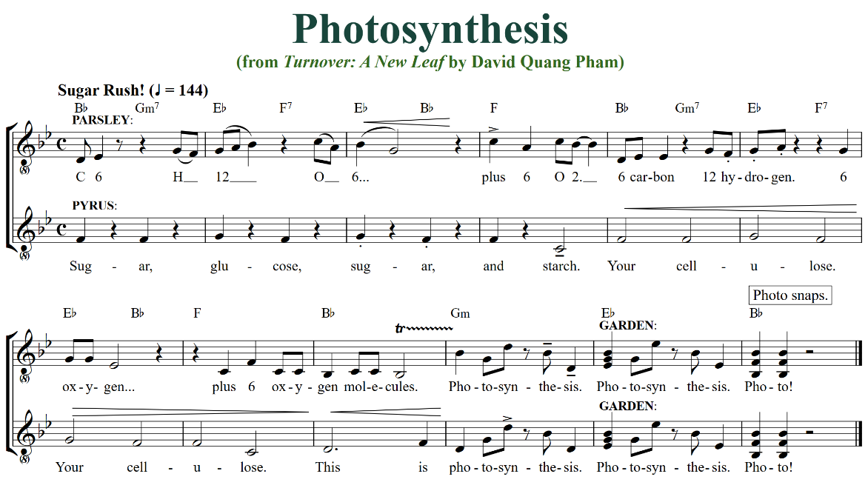
Pyrus often initiates the misadventures through their own wrongdoing while Parsley naively goes along with their best friend. The end of each episode usually shows that it is never too late to do the right thing, even if you have done wrong before. Like many animated series, these kinds of situations lead to a fun or comedic outcome.
There will be episodes on Pyrus and Malus’s relationship or Bombus’s or Parsley and his mom Rau’s relationship. In an episode titled “Behave for a Bee Hive,” Parsley walks by a petting zoo and asks Rau for a pet bee, like Pyrus’s Bombus. Rau accidentally gifts Parsley a hornet, which terrorizes the town. Other episodes will center Rau’s immigrant struggles beyond the difficulties of earning a green card, from cultural clashes and the pressure to live up to expectations.
With any episode that features Rhubarb, Pyrus’s unhinged music teacher and archnemesis, there are music theory lessons planted throughout. The episodes that feature Mayor Canna Blomquist have them get their comeuppance mixed with them being able to slip through scandals.
SERIES DEVELOPMENT
At first, Pyrus has very few friends and lacks body confidence. So, they often resort to bullying to get their way. It gets so out of hand that their parents push Pyrus out of Mt. Woodwork and into unty Malus’s care in Dirty City. Little did they know that they would befriend the neighboring immigrant salon owner’s son named Parsley there.
Parsley has little time for friends due to spending much of it helping their mom around the Salontro business. He is also treated differently from his classmates due to being the son of a non-green card holder. There is immense pressure for him to live up to family expectations, so Parsley often yearns for adventures away from it. It would make sense for him to connect with the openly weird and queer Pyrus.
Pyrus and Parsley continuously learn that they need each other, Pyrus for adventure and Parsley for moderation. Pyrus grows more well-intentioned and morally ambiguous in their decisions that often turn out bad, like partying or pranking. Meanwhile, Pyrus grows more experimental and unrestrained in their life, often tied down to how they will be publicly perceived as a member of the immigrant community.
Photos taken from each episode will be compiled and displayed for features, used as teachable moments and to chart the evolution of relationships.
Rau eventually earns their green card, but it comes after developing the communal trait of hers. Malus’s FigLeaf Nightclub eventually gets shut down due to Pyrus and Parsley. Malus will mentally get in shape when the time comes, so they are able to reflect on their time. There will be development for other adult characters such as the rotten Mayor Canna Blomquist, the insane music teacher Rhubarb Avaz, and the weeping therapist Salix Willow.
EPISODES (SAMPLE)
GREENLIGHT (PILOT EPISODE)
At Salontro, Parsley and Pyrus accidentally give a reality TV producer glamorous Greenlight highlights, landing them a deal with Green Entertainment Television. To save the salon and secure his mother’s future, Parsley must fake this miracle for the cameras, only to discover the treatment causes cytorrhysis, meaning their superstar mint client will literally blow up on national TV.
BEHAVE FOR A BEE HIVE
Walking by the petting zoo, Parsley eyes a bee and wants one like Pyrus. Rau jokes if Parsley gets all As this semester they will get a pet bee. Parsley achieves that. Rau keeps her promise, partially. She accidentally gets a hornet from the black bean market, which unleashes terror upon the town. Pyrus calls in Bombus to take down this worthy foe.
BEFRIENDING THE BEHEMOTH (Related Episode)
Moth incident.
FIRST PLANT
Cosmonaut Thaliana Rock-Cress and astronaut Dracaena Maize, the first two plants in space, visit Parsley’s school, inspiring him to want to go to the Moon.
FRESH GROUND PEPPER

GREENLIGHT
HAY DAY
MINT CONDITION
Salontro is invited to Woody Holly to be Lami Mentha’s makeup team for the reboot of her Mint Condition film series. While visiting the studios, Pyrus gets roped in a music opportunity of a lifetime.
PINEAPPLE PIZZA
Parsley visits Pyrus in Woodwork National Park for their first camping trip together. When a pineapple visits the park with their pizza truck, mysterious incidents occur all about. Should pineapples be allowed to make pizza, even if they lead to the apocalypse?
ROOT WORD
SQUARE ROOT
TOUCH GRASS
Parsley and Pyrus get their leaves on a new game console called Touch Grass, but it is too addictive and sending deranged messages.
VOLTI SUBITO (TURN QUICKLY)
Rhubarb Avaz, Pyrus’s music teacher and archnemesis, is in town as the seasoned conductor for the Dirtharmonic Orchestra. Malus believes Pyrus can get in her good graces if they apprentice her. Will Pyrus grace the harmony or stand out in the melody?
WEEPING WILLOW
Rau cannot burn out. She drinks enough water each day after all. But in comes the only person who can burn her out: a therapist. Salix Willow, a native from Paddy Kingdom, keeps coming into Salontro and striking up conversations that make Rau tremble, revisiting her past in Paddy Kingdom.

STAGE MUSICAL
Photosynthesis is adapted from the stage musical, Turnover: A New Leaf. At the 2024 Philadelphia New Musicals Festival, Turnover won awards for Best Book and Director (Aliyah Curry) and was nominated for Best Musical and Orchestrations. It also won the 2024 Great Performances Fellowship Award. Queer Theatre Kalamazoo produced a world-premiere May 16-18 and concerts June 7-8, 2025. Photosynthesis is a 2025 Creative Capital finalist and developed in 2025 Sundance Collab and 2026 Cinephilia Workroom.
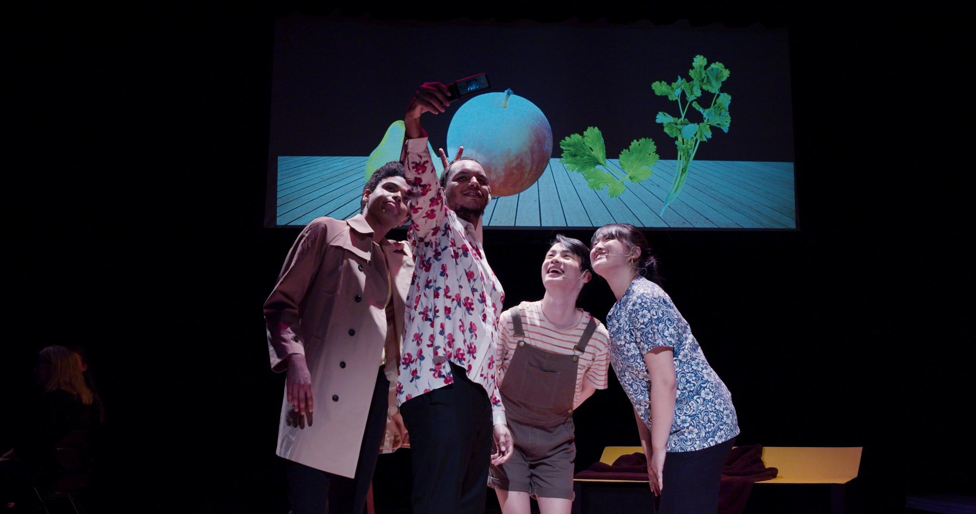

SCIENCE EDUCATION IS IMPORTANT
The knowledge of science is important because it cultivates critical thinking skills by encouraging curiosity, questioning, and evidence-based analysis, allowing individuals to better understand the world around them, make informed decisions, and solve problems through a methodical approach. It also fosters creativity and adaptability to change. Think critically and approach challenges with a scientific mindset.

PLANTS ARE IN
People are often drawn to plants as they can significantly improve mental well-being by reducing stress, boosting mood, and enhancing creativity, while also providing a sense of responsibility through nurturing and caring for a living thing; additionally, plants contribute to cleaner air quality and can aesthetically enhance a space.

FABLES ARE IN
People are drawn to fables because they offer easily accessible life lessons and moral messages, often conveyed through engaging stories featuring anthropomorphic characters, making them a simple and relatable way to learn about important values and behaviors.
It's Zootopia meets Elemental meets Sing, an animated musical comedy set in a vibrant world of sentient plants that explores complex themes of immigration, identity, and community through the lens of a cilantro family fighting to stay rooted.

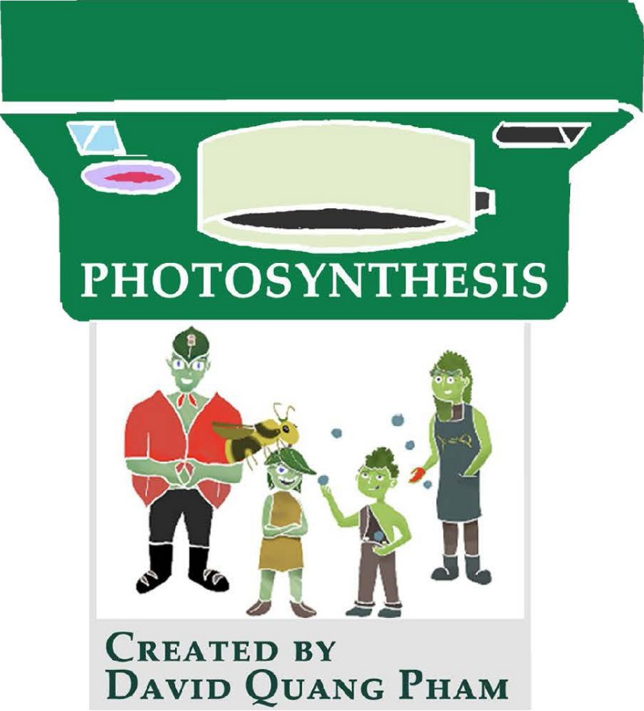
Let’s plant some memories!

PhotosynthesisFilm.com
Series Treatment & Feature Pilot Script

Based on the musical Turnover: A New Leaf
by David Quang Pham




Contact:
616 818 5413
davidquangpham@outlook.com
512 W 158th St #2 New York, New York 10032
Logline (25 words or less)
a)
Describe Main Character [Adjective]
Adjective describing your protagonist
Who are they in your story?
Is their occupation crucial to your story?
Is where they’re from paramount to your story?
... Who goes through this [Internal Conflict]
Triggers to cause internal conflict
- Desire (something your main character wants)
- Need (something your MC or someone associated with MC requires for survival)
- Duty (some obligation MC feels is right or necessary)
- Fear (a strong worry that drives MC)
- Expectation (something that your MC feels obligated to do)
*When a character experiences two or more of these triggers at a given time, your character has internal conflict
... Goes up against this [Antagonistic Force].

b)
Describe main character [Adjective], Who wants
... This goal [Internal Conflict]
... Must face this [Antagonistic Force].

Main Characters
Pyrus Crabapple – A troublemaking pear...
Parsley Ram - A fun-loving herb...

Photosynthesis’s Logline
Kids
In a world of photogenic plants, a troublemaking pear and fun-loving herb pair up to uproot the social order and mystery of their ecosystem and junior high.
Types of story
- Monster in the House (primal desire: to not get eaten by the monster)
Rules:
- Our MC are trapped in a confined space (town, dreams, even the whole world). The idea behind this rule is simply that no matter where your MC goes, they can’t escape. They’re not safe.
- The MC has to have done something to a) create the monster or b) get into the monster’s crosshairs (they committed some kind of kin or treacherous deed)
Kids
The kids are trapped in the forest after their manor is destroyed.
The reason that the kids are in the wolves’ crosshair is because the kids are trying to save their Universe. To do that, they have to deforest the wolves’ habitat.

- Golden Fleece (A road trip movie) – (theme: internal growth and how all the events affect our MC’s beliefs)
Our hero sets out on a perilous journey in order to find something or do something, but then our hero winds up discovering something about themself that they never knew before. The people, incidents, and all the chaos that emerges from all the story’s plot points ultimately results in the hero growing and becoming a better or worse version of themself. The hero must learn new things about themself through the story events and this is what makes the story work.
My job as a storyteller is to make each and every milestone in the story significant in my hero’s progression as a human being. The main thing that makes my story great is how various events in my story made my character change in the degree by the which they change from the beginning to the end.

HD

Kids

- Out of the Bottle (What If? / I Wish I had... Genie Tale)

- Dude with a Problem

- Rites of Passage
Rites of Passage is when you create a story where the major plot points surround the theme of someone transitioning from one stage of their life into another stage of life. These stories about growing pains resonate with a lot of individuals because we’ve all been through them. Those are pretty painful memories to recall. Typically the pain and torment come from the outside and attack the character’s life in some way shape or form. So the outside force of life attacks the main character. Often time, the monster in this story creeps up on the main character and the story is a slow revelation of what that monster is. It is by going through this dreadful painful experience that our hero comes up with a solution to their conflicts. So typical these are stories where your characters are having a rough time in school, dealing with family turmoil, a divorce, a midlife crisis, and even dealing with the end of their first love. Usually the hero must realize that there are aspects of their life that they can control and aspects they cannot control. It’s only after some realization and some growth that our character can find their version of happiness.

- Buddy Love
The dawn of this genre came into play when the main character didn’t have anyone to talk to or bounce ideas off of or debate with. This works because stories of me and my best friend will always resonate with audiences. All buddy movies are just love stories in disguise.
Rules
- At first, the buddies hate each other
- The film’s adventure makes them realize they need each other
If you start your story and the characters like each other, then where exactly is the story dynamic between the two characters going to go?
Now you know you can break this rule, but it’s important to understand why this rule is in place: It’s to start your film at a zero state so that by the end of your film, you have a hero state.
With respect to your story, your characters are incomplete halves of a whole. Normally, our all-is-loss moment in the story is a variation of their friendship/relationship being destroyed or dismantled in some way.
Typically, the main character is one way and takes some quiet guidance by the buddy in order to force a positive change in the main character. It’s because of this change that the main character can then fulfill their mission and bring the story to its climatic end.

- WhyDunIt (This story genre is all about uncovering the deepest darkest parts of the human mind; not who did the murder but why did they do the murder; it’s not about the hero changing, it’s about discovering something new about human nature that we didn’t think was possible; it’s about peeling back the layers of the human heart into separating the good eggs from the bad)

- The Fool Triumphant

- Institutionalized
This complex genre tells the story of people who are a part of groups, institutions, and families and expose the problem people have of living in the confines of these groups. These genres honor the society’s norms, highlights their issues, and showcases for all to see. Often times, our heroes in the genre grapples with their identity and their place in that particular group. Loyalty to that group in many cases can threaten your morals, identity, mental health, and even their life. This is about the pros and cons of putting the needs of the group ahead of ourselves.
The main source of conflict in this genre comes from my protagonist’s inability to fit in within the confines of this society and grappling with their identity with respect to this group.

Gravity

HD

- Superhero (opposite of ’Dude with a Problem’)

Start Versus End (Life Lessons)

”Forever is not enough time, especially for family.”
When the kids have everything from a loving guardian to shelter, they do not get along and fight all the time. 🡪 When the kids are about to lose their lives, they love one another and are finally in unity.
Even though the kids have everything they need from a loving guardian to shelter, they never seem to get along. 🡪 Before the kids face certain death, this is the first time these siblings were in unity.

(0:00-0:15) THE WORLD
“Welcome to the garden nation of Woodwork, where plants and transplants live in harmony, so long as you have a green card. This is Photosynthesis, my animated musical comedy-drama that uses plant biology as a metaphor for the immigrant experience and queer identity."
(0:15-0:40) THE PROTAGONISTS & DYNAMIC
"The series centers on two best friends navigating the heart of Dirty City. Parsley Ram is an 11-year-old optimistic herb and the son of a cilantro salon owner, who emigrated from Paddy Kingdom. He’s the 'good kid' under immense pressure to help his mother earn her green card.
His foil is Pyrus Crabapple, a 13-year-old free-spirited pear who is openly queer, body-conscious, and a magnet for trouble. Together, they form a 'great pair of trouble,' using Pyrus’s chaotic curiosity to push Parsley out of his shell, even when it leads to town-terrorizing hornets or accidental 'cellular implosions.'"
(0:40-1:05) THE EPISODIC ENGINE
"Each episode follows a formula: our duo discovers a new plant species, navigates a social or scientific conflict, and ends with a 'Photosynthesis Jingle.' [sing the jingle] They take a digital photo that is 'planted' into the end credits, charting their growth across the season.
In our pilot episode, 'Greenlight,' Pyrus accidentally creates a 'photon-facial' that turns a reality TV producer’s hair emerald green. Suddenly, the salon is the focus of a major TV network GET (Green Entertainment Television), and the kids must maintain the lie of a miracle they don't actually know how to control."
(1:05-1:25) TONE & ORIGINALITY
"Musically, the show is a vibrant fusion of pop-rock and Vietnamese folk, exploring themes of 'roots'—from family heritage to the root causes of systemic problems. It’s a world where the paparazzi are literal fireflies and the social hierarchy is determined by the color of your leaves. It's educational, deeply funny, and heartfelt."
(1:25-1:30) WHY NOW?
"Based on my award-winning stage musical that saw its world premiere in May 2025 at Queer Theatre Kalamazoo, Photosynthesis is a ready-to-bloom series about biodiversity, acceptance, and finding home in the dirtiest of cities."

