Our Ancestor
The First of Us. The Last of Them.

To find one child, they must answer to a billion grandkids.
TAGLINES
To find one child, they must answer to a billion grandkids.
13,000 years ago, they lost their family. Now, everyone in the world is family.

LOGLINE
To reunite with their family, a prehistoric hunter and a woolly mammoth must face a world full of their grandchildren.

BERING
A hunter (no discernable gender and who we’ll call “Bering”) from the Yana tribe stalks a mammoth herd across the prehistoric Beringia land bridge. At some point, Bering corners a baby mammoth until it levitates. The hunt takes a surreal turn when Bering also begins to levitate, abducted by a spacecraft. As the ship ascends, Bering’s last sight of Earth is their partner and child desperately chasing after them.
While imprisoned in a ginormous vessel designed to collect specimens for an intergalactic zoo, Bering bonds with the mammoth, naming them Yana after their lost tribe. In their cell, Bering carves charcoal-style sketches of the land bridge, bridging the gap between their primitive origins and high-tech cage.
The captors put Bering and Yana in a cage match to the death where Bering seizes the moment. They stage a breakout, freeing every captive and seizing control of the ship, which drifts to a stop dangerously close to a black hole. Over the following years, Bering masters the vessel’s technology. Though Bering and Yana initially fall ill to extraterrestrial pathogens, a fellow captive, who is an alien disease expert, bioengineers their immune systems, making them virtually invulnerable to disease.
Driven by the hope of reuniting with their family and returning Yana to their herd, Bering navigates the ship to the other captives’ planets then back to Earth. However, they arrive in the modern era. The Beringia land bridge has vanished, replaced by the sea separating Russia and Alaska.
Equipped with a smaller aircraft gifted by the ship’s remaining crew, Bering and a now-adolescent Yana (large enough to be ridden) land in a world they don't recognize. Despite their primitive origins, Bering is ironically now more technologically advanced than any modern human.
Yana finds a herd of modern elephants, though they remain an outsider, drawing the confused attention of safari guides. Meanwhile, a genealogist conducting a blood test discovers that Bering is a genetic root and is a direct ancestor to hundreds of millions of people on Earth.

PILOT EPISODE
13,000 years ago, a prehistoric hunter Bering and a baby woolly mammoth Yana are abducted by an alien spacecraft from the Beringia land bridge. They return in 2030, on Little Diomede Island, where their primitive appearance and alien tech cause conflict with local villagers.
Meanwhile, geneticist Dr. Amber Dawks analyzes blood found at the landing site and discovers that Bering is a genetic root for billions of modern humans. After running a personal test, Dawks identifies a DNA match to Bering, confirming a connection to the time-traveling hunter.
After their ship runs out of fuel in Kazakhstan, a local family shelters Bering and Yana. They struggle with modern life, mistaking a tv for a magic box with people trapped in them. At a feast, Bering uses gravy to paint a mural on a tablecloth, telling a 13,000-year journey through an intergalactic zoo, revolt, and an eventual return to a world where the land bridge is gone.
The pilot concludes with a police raid on the family's home following a mishap at a local market. Yana smashes through the house's walls, allowing Bering to mount the mammoth and escape into the night. Meanwhile, Dr. Dawks tracks new genetic markers appearing in Kazakhstan, setting the stage for a pursuit of our ancestor.
MAIN CHARACTERS
RODIN CASBENDER is a
AMBER
BERING
YANA

“Safe Travels (or Not)” follows one member of the Yana tribe crossing the Beringia land bridge to track down a mammoth herd. They have no discernable gender, and we will call them Beri after Beringia. Beri strays and corners a baby mammoth. The mammoth begins to levitate then also Beri. A spacecraft kidnaps them, not before Beri sees their child and partner run after them. They see and draw the Beringia land bridge in their cell much like a caveperson would. Beri names the baby mammoth “Yana” after their tribe. The spacecraft collects animals for an intergalactic zoo. Beri escapes and frees other captives and overrides the ship while it strays near the edge of a black hole. It takes Beri years to learn how to operate and understand the language of everything. Beri and Yana get sick to the unfamiliar diseases they’re around but one of the captives is a disease expert who helps them be immune to almost anything. Beri wants to go home to see their child and return the baby mammoth to their herd. They figure out how to return home to their respective planets. Yana is now an adolescent who Beri can ride on. They return to Earth to see that the land bridge is no more, but split into Alaska and Russia. The spacecraft drops Beri and Yana off, and give them an aircraft. They find a world more technological than where they were. Ironically, Beri knows more advanced things from their experience on the spacecraft. Beri searches for their child and Yana searches for their herd. Yana is taken to an elephant herd which is imperfect and catches the attention of safari guides. Then a genealogist does a blood test on Beri. The blood test shows they are related to hundreds of millions of people.

.
KWAN “SUNSHINE” REYES is Ray's 24-year-old little brother, an astronomy grad student at Michigan State and member of a local neurodivergent theatre. He got his nickname in college. Unlike Ray’s manic energy, he is grounded and uses scientific logic to calm down Ray. His dead-panned humor often interrupts her fourth wall breaks. He can speak Tagalog.
MS. AURORA STARLING is a science educator with a huge following and the eventual host of StarPower! Despite seeing Ray as a theatre camp and STEM club bestie, she is unknowingly seen by Ray as a longtime rival. Like Ray, she often breaks the fourth wall to speak directly to the camera, sharing positive thoughts about the world or her personal achievements.
BILLY CLAYTON DUBOIS is the original host of Stardust. He left in 2006 due to clinical depression and a drunk driving accident. He initially rejects Ray when she meets him for guidance but becomes her mentor after finding out River and Skye are reviving the series without him. He has cartoonish energy and often speaks to an invisible audience yet misses the camera's gaze.
RIVER MATTHEWS is the co-creator of Stardust and its revival StarPower! She voices both titular characters. She is very protective of the brand and takes every chance she can to rid StarPower! of any flaw that Stardust had. Though she never breaks the fourth wall, she is aware of it like Ray.
SCHUYLER “SKYE” PARK is a co-creator of Stardust and voice actor. They are open-minded and look out for Ray’s wellbeing, unlike River. It may be due to Clay’s 29th birthday drunk driving accident long ago. In the early 2000s, they were male representing but have since come out as non-binary. Though they never break the fourth wall, they are aware of it like Ray.
YAZ “YLEM” (E-lehm) LEM is the primary animator, designer, and puppeteer of the Stardust franchise. Like their cartoons, they are very animated.
RECURRING CHARACTERS
TERESA ALVES is Stardust’s biggest fan. As a child, she ran a fan club blog for the original show. Now as an adult, she is now a science communicator who runs social media channels dedicated to and critiquing StarPower!
KENDRA ALTRO is a child actor who voices the younger characters on StarPower!
JET APRIL is a director, known for the children’s tv series, Cinnamonville. They serve as the primary series director for StarPower!
CRYSTAL CABELLERO is a story editor, developer, and educational psychologist for StarPower!
NIKITA GLASCO is an interning production assistant, marketing assistant, creative. Actually, no one knows what she does.
JILL “JG” GRUMP is a veteran union camera operator who has been at RBS since the original Stardust run.
CARI ANNE GUNN is a media executive who serves as the president and chief executive officer of Rainbow Broadcasting Service.
COOPER OWENS is an anti-science protestor and former child actor.
ETHAN REED is a founder of Mamas for Purity, a political organization that advocates for safe and censored children’s media. He is the epitome of queer.
MR. REYES is Ray and Sunshine’s father.
MRS. REYES is Ray and Sunshine’s mother.
PETEY SEGHEAD is a military officer who uses Stardust’s songs as a torture device.
ALICE STARLING is a mission’s operations manager at NASA and Aurora’s mother, who helps to fact check Aurora’s scripts.
BARRY STARLING is a former theatre actor and Aurora’s father.
STEVE STEVENSON would be the third pick as the host of StarPower! if Aurora and Ray did not accept. He stars as the villain Starcatcher in a later episode of the first season to rave reviews.
THANH THIEN is the primary composer for the original Stardust, who created the show's music, including the theme song with River.
LIST OF STARDUST + STARPOWER! CHARACTERS
STARDUST (voiced by River Matthews) is the titular character of the original interactive educational children's TV franchise. She is a cosmic green mudpuppy who communicates by saying “twinkle.”
STARPOWER (voiced by River Matthews) is the titular character of the revival. She is a shape-shifting pink axolotl and Stardust’s bigger sister who speaks by saying “bubble.” She is introduced in a 2003 episode of Stardust.
CLAY (played by Billy Clayton Dubois) is the host of the original show. In the revival, he returned to his home planet as a space mailman and appears as a recurring character.
AURORA (played by Aurora Starling) is the host of StarPower! and the second host of the franchise. She is Clay’s younger cousin and a musician.
RAY (played by Trini “Ray” Reyes) is Aurora’s courageous and crazy sidekick of the revival series. She often gets sent to scout inconvenient worlds.
ROCKET (voiced by Skye Park) is a cheerful green-and-white ship who transports Stardust and her friends to distant worlds. In each episode, Rocket lands after the host sings “Rocket Zoop.”

SUPPORTING
TELESCOPE (voiced by Skye Park) is an insightful telescope.
GALAXY FAMILY are a spiritual family named after real galaxies
- MILKY WAY (voiced by Kendra Altro) - BUTTERFLY (child)
- CARTWHEEL & WHIRLPOOL (teenage twins) - SOMBRERO (teenager)

MINOR
HALLEY (voiced by Kendra Altro) is a comet who delivers messages.
GRAVITY (voiced by Thanh Thien) is a stray dog who lets everyone down but can fetch anything. They bark “force.”
WORLD & TONE
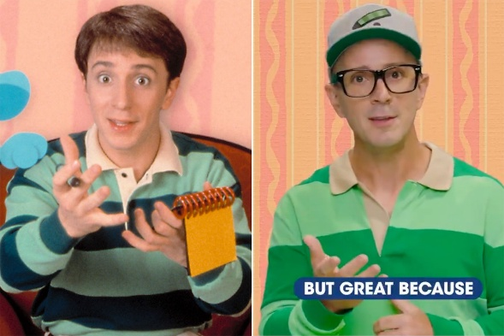
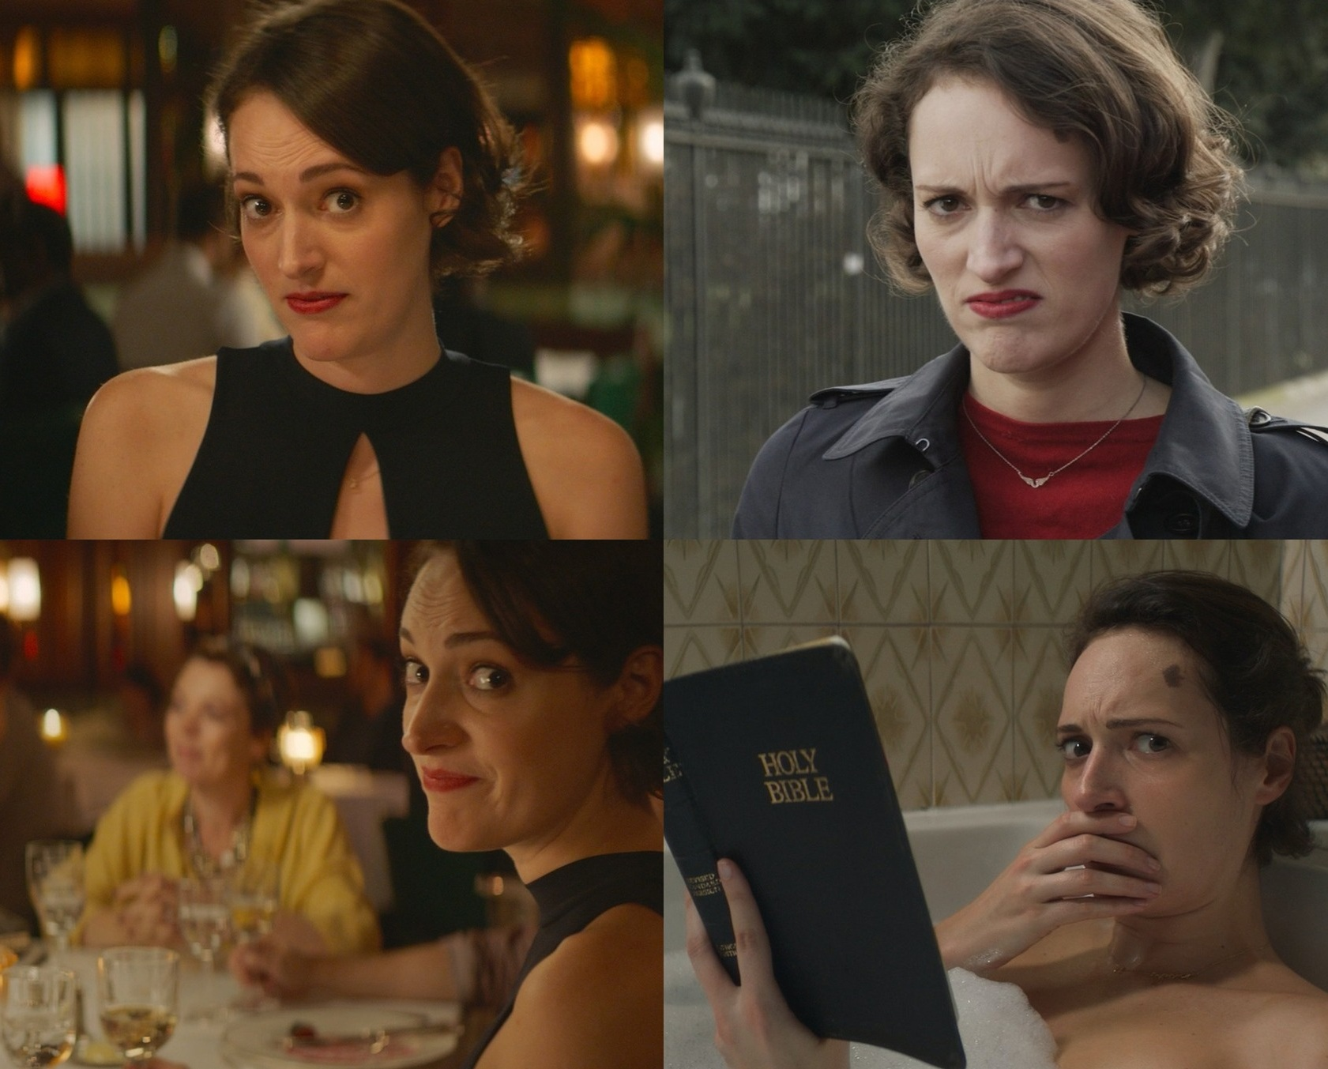
“It’s Blue Clues! …for adults…” – Carissa Sky

Children’s programming device: main characters break the fourth wall to ask the viewers questions about adult problems and to dismantle adult issues such as mental health, poverty, careers, and politics

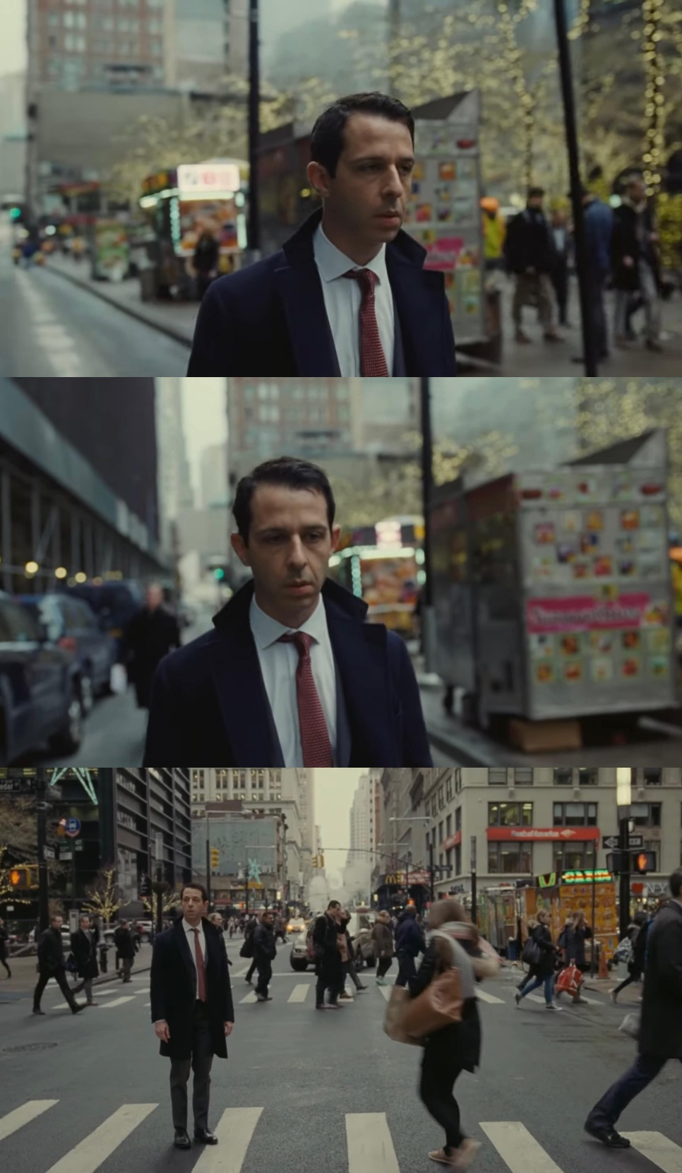
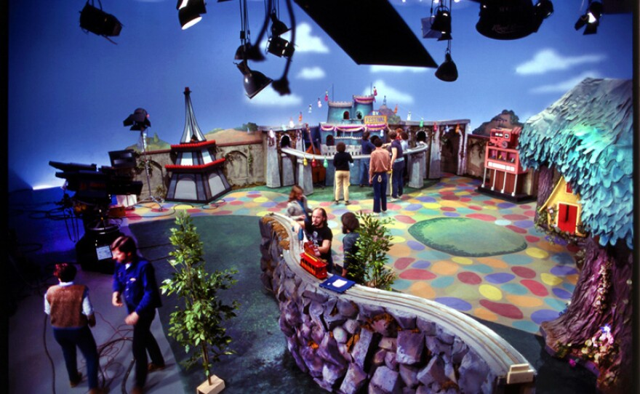

Fantastical world of science  on Stardust + StarPower! set… | 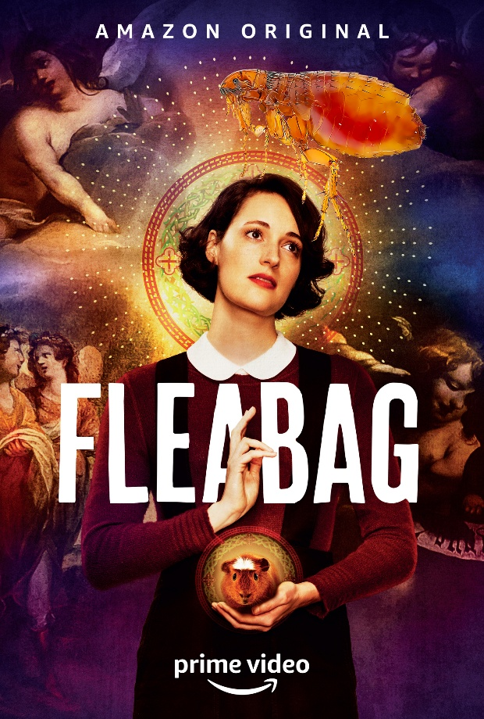  Miserable reality of adulthood  for the rest…
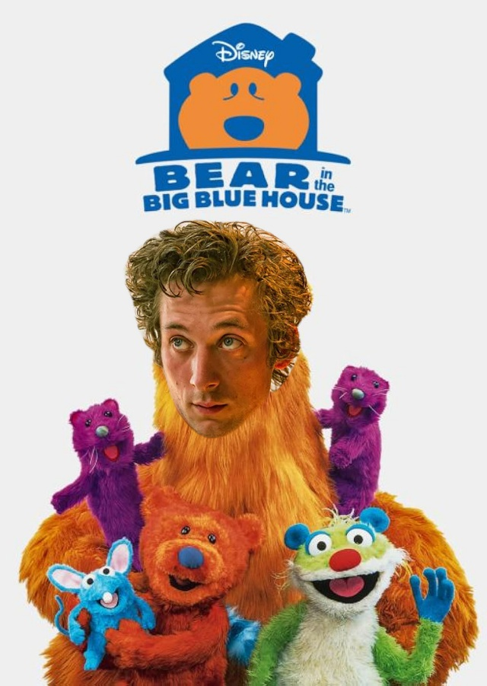
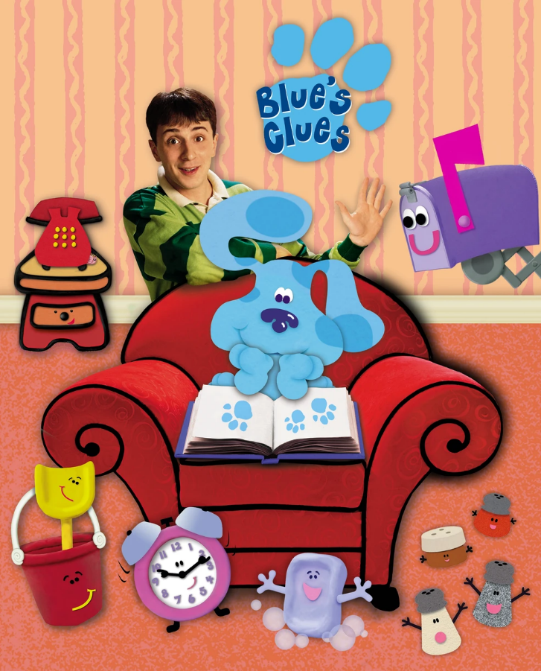
The chaos meets the fun meets
the fourth wall breaks
SAMPLE SCENE
INT. PEANUT BARREL - DAY
The waiter waits on Ray and Aurora to answer, looking weirded out.

RAY
(to camera; cynically)
Should I commit a crime against humanity or
be a model citizen? Crime or no crime?

AURORA
Don’t mind us, host. We look to our viewers
for answers.
(winks at camera)

RAY
You answered crime? Crime, it is!
(to the waiter)
A slice of pineapple pizza, please!
(to camera)
Now, do you see the loser in the room?
(pointing a finger around)
Lemme know when to stop, maybe Ms. Aurora.
(her finger land on herself)
Stop here?! That’s how it is, you absolute jerks…

AURORA
Ray, have you lost the plot? You’ve got a deadline
to finish the spec. I need to memorize lines now.

HOT OPEN (from Episode 3: “Team Player”)
INT. RAY’S BEDROOM – MORNING (DREAMWORLD)
BEEP. BEEP. The alarm goes off then suddenly catches on fire.
Ray jumps out of bed and puts the fire out with a towel.
RAY
Why do bad things keep happening to me?
Aurora swiftly rises from the opposite side of the bed.
AURORA
Could it be because you keep making bad choices, Ray?
RAY
(pointing to the camera)
They keep telling me to make bad choices.
AURORA
(to camera)
Are you telling my bestie Ray to be a baddie? No? Good.
(to Ray)
They said “no.”
RAY
(to camera)
Thanks for nothing.
AURORA
Shall we sing about your troubles, Ray?
RAY
No, no! Anything but singing.
AURORA
WHEN YOU CHOOSE TO BE A LIAR
DON’T BE SAD WHEN...
RAY
(Weeping)
...MY WORLD’S ON FIRE?
The towel bursts into flames, freaking everyone out.
END OF HOT OPEN
SEASON ARCS (TENTATIVE)
SEASON 1
Ep | Title | Plot Summary
1 | Inner Child  Serial | Cold Open: In the early 2000s, Trini “Ray” Reyes and her baby brother Kwan “Sunshine” Reyes were fans of the children’s show Stardust, featuring mudpuppy Stardust and her host Clay as they travel the universe to teach science. Upon its cancellation in 2006, Ray decides to pursue her theatre and science education dreams.  In 2025, struggling educator Ray faces the end of her theatre career after accidentally setting a puppet show on fire. Blacklisted, she finds hope in an encouraging video from Clay for Stardust’s 25th anniversary. Kwan lets her know that the show’s creators, River and Skye, will be in town. She pitches herself to them during an arts fair but is dismissed as unprofessional. Despite being dismissed by creator River Matthews and learning that her polished rival, Ms. Aurora, is the top choice for the new host, Ray discovers a potential ally in co-creator Skye Park. It concludes with Kwan driving Ray to Brooklyn to find a cynical Clay, who, when asked for help to save the show, coldly dismisses her.
2 | Who Does Not Belong?  Serial | Cold Open: When Ray was in elementary school, Clay stopped by her classroom. He was an inspiration to everyone.  Now, middle-aged Clay is cynical and dismisses Ray as a mentee. But he discovers the show’s creators, River and Skye, is reviving the show without letting him know. So, Clay helps Ray film a rogue audition video at Clay's apartment. Their video goes viral and sparks a global wave of auditions. To avoid a PR disaster, the network is forced to scrap their plans and announce a legitimate casting process, putting Ray back in the running for the revival. Ray performs well and gains massive grassroots following, but the network ultimately chooses her rival, Ms. Aurora, for the host role to keep a safe image.
3 | Team Player  Serial | Cold Open: Ray has a dream about putting out a fire with Aurora.  Despite Ms. Aurora being the host, the public demands Ray's involvement. Aurora and Skye convince River to hire Ray as a writer as a consolation prize. Overnight and with Clay’s mentorship, she writes a phenomenal pilot script for Aurora and StarPower, proving she can be a team player. But River rejects Ray’s draft and goes with her own. They begin shooting the pilot for the test audience.
4 | For Educational Purposes Only  Serial | StarPower! pilot is screened for a test audience. While Aurora is decent with new kids, the older fans demand the return of Stardust, feeling the new show is hollow. River brings back Stardust to appease fans, but Aurora struggles to connect with the animated mudpuppy. During a chaotic rehearsal, Ray steps in to read lines. With Clay’s mentorship, her energetic spirit works with Stardust’s whimsiness. Overnight, River writes a script introducing a sidekick.
5 | Sidekick  Episodic | Cold Open: In 2014, Ray and Aurora spend their last theatre camp together. For their production of Peter Pan, Aurora is cast as Peter while Ray is Tinker Bell as consolation.  RBS accepts Ray as Aurora’s crazy sidekick. She is resentful of being second best again, seeing herself as the moon to Aurora’s planet in a draft they write together. But after revisiting her brother who has been her sidekick since their childhood, she learns to appreciate it. The network screens the 10-minute pilot episode, Milky Way Sick Day to a test audience. The squad becomes a cultural phenomenon.
6 | Free Axolotl  Episodic | Cold Open: In 2003, a young Ray mourns her pet goldfish. Shortly after the Columbia Space Shuttle Disaster, a new Stardust episode introduces Stardust’s long-lost sister StarPower.  To promote the show, RBS organizes StarPower Day at the local zoo, featuring axolotl exhibits. Ray wears an odd sidekick uniform while Aurora shines. Things spiral when anti-science protestors arrive, claiming the show is brainwashing kids with evolutionary biology. Ray asks the viewers: "Should I stay in my cage, or should we see what happens when the locks break?" Ray unlatches amphibian tanks during the chaos of the protest. As the crowd panics, Kwan helps the staff in recovery efforts, turning the crisis into a lesson on conservation. River is once again disappointed in Ray. Ray looks at the axolotls and openly says: "They get fed, they're safe, and everyone loves them. Maybe being stuck in a tank isn't so bad..."
7 | Kids are Evil  Episodic | Cold Open: A social media contest where the class with the most likes wins a guest appearance on StarPower! Internet trolls organize a prank, ensuring that an elementary school from a remote area with little internet or media literacy wins.  These kids are unimpressed by the green-screen show until the craft tables full of junk food sends them onto a sugar-fueled riot and they go crazy being introduced by the tech around them. With the help of Kwan who runs a neurodivergent theatre, the team goes with traditional cardboard, to finally engage the overstimulated children.
8 | The Case of the Potty Mouth  Episodic | Cold Open: While promoting StarPower! on a morning news program with Aurora and Ray using puppets, one of them accidentally swears. The bad word goes out live to millions of families.  Like a Law & Order episode, the production team interrogates each puppet to determine which host is responsible for the slip-up. Ray agrees to take the fall as Aurora grows psychotic from the guilt. However, Aurora admits it was her at an impromptu press conference. Instead of public shunning, teenagers claim Aurora as the edgelord. Ray is envious of Aurora’s attention once more.
9 | Won’t You Be My Enemy?  Episodic | Cold Open: Steve Stevenson, who was third choice to be the host of StarPower!, stars as the villain Starcatcher in an episode.  The audience adores Steve. While Aurora welcomes him with toxic positivity, Ray is rattled by his ability to play a villain so well that it blurs the line between script and personal attacks on insecurities. Steve uses the show's interactive format to manipulate the viewers into siding with him, gaslighting the hosts on their own set. Good thing he is recurring and not a main character, they can only hope.
10 | Bye Bye Voices in Our Heads  Episodic | Cold Open: Aurora and Ray go out to a party and drink something that makes them lose their voices for a week.  Refusing to let River find a reason to replace them, the duo rewrites the script that only uses pantomime and props. Ray’s brother refine the script to be geared towards deaf children. This week’s episode garners the attention of the deaf community.
11 | Music Never Hurt Anybody  Episodic | Cold Open: A whistleblower releases a news report about a detention center where they have been using one of Stardust’s jingle “You are my Starlight” to torture prisoners for years, including getting military officers to give up their secrets.  River seeks reparations for the years of unlicensed use while Aurora vocalizes her political stance against torture, hinting that she will be vocal about more things. River kidnaps one of the detention center’s officers and tortures them with her song until they agree to pay up.
12 | The Smartest Teacher Alive  Idea: Sara Jane Beneke  Serial | Cold Open: Ms. Aurora shares a social media post advocating for Southeast Asian children facing starvation due to a blockade. The production team tries to get Aurora to undo it. The government responsible for the conflict zones is a major sponsor of RBS.  Teacher Magazine selects Aurora as the 2026 Smartest Teacher Alive. The team advises her not to get political in her acceptance speech. She does so by saying “that children from the Midwest to Southeast deserve access to education. They should not die for it.”  The government in question demands that RBS Kids fires Aurora. Ray takes no stance. The public supports Aurora and questions Ray. Aurora is suspended from the season’s finale while Clay takes over her role for the time being.
13 | Time Out  Serial | Cold Open: Ray feels lost from outer space to reality without Aurora breaking the fourth wall with her.  Clay pairs with Stardust once again while Ray tries out a partnership with StarPower. With Kwan’s encouragement, Ray refuses to take part in the taping without Aurora’s presence, and River personally fires Ray. The creators are about to make Clay be the permanent host once more, but Clay also will quit and send out a disapproving message to the world if River does not change her mind.  Tag: The finale is rewritten. It follows Ray getting Clay’s help to rescue Aurora and StarPower who are in danger.

SEASON 2
Ep | Title | Plot Summary
1 | Inner Hero  Serial | The finale is broadcasted to the world. In the StarPower! episode, Ray gets the help of the legend Clay to save Aurora and StarPower.  The team celebrates Aurora and Ray’s return.

SEASON ?
Ep | Title | Plot Summary
? | Content Warning | ?
? | D is for Dictator | The children of an East European dictator visit the states to meet their hero: Ray. Ray and Aurora are unsure what to make of it, but River and Skye appreciate the sudden intense flow of money.
? | Death of an Internet Troll | The negative reviews are definitely not getting under Aurora and River’s skin, not at all. That’s why they are hunting the internet troll and putting them on tv for all to see.
? | Divorced from Reality | The parents of one of the child voice actors are getting a divorce and the episode they just recorded is about separation.
? | It Wouldn’t Be a Show Without a Holiday Special | A disastrous holiday special
? | Jiu-Jitsu Knock Off | Cold Open: When Ray and Kwan were kids, their good-intentioned mother would gift them VHS tapes of Stardirt, the Portuguese knock-off versions of Stardust.  An animation studio, based in São Paulo, Brazil, has been stealing Stardust’s IP since forever and is now producing StarWonder. Clay remembers meeting his Brazilian counterpart and “beating him in a dual.” Aurora and Ray meet their Brazilian counterparts.
? | Kerfuffle | RBS wants to give StarFuffle, Stardust and StarPower’s cousin, another chance at the spotlight.
? | Our Special Guest | A flamboyant musical guest star is meant to be shelved but Ray decides to pass it onto someone else to air it on YouTube.
? | Quantum Hoo-Ha | For a terminally ill child’s “Make a Wish Foundation” wish, they wish for an episode teaching quantum physics and Ray and Aurora are going to somehow make that happen.
? | StarWorld | Cold Open: River has been sending a cease-and-desist letter to an event based on the Stardust franchise, but news of it is spreading. She decides to send Skye, Ray, and Aurora to investigate.  Once they reach StarWorld in Glasgow, Scotland, which is actually a poorly decorated warehouse with underpaid costumed staff, they try to leave with second-hand embarrassment. But the event planners kidnap the squad. Now it is up to River and Kwan to save them. In the tag, the StarWorld actress who dressed up as Stardust makes a guest appearance on the latest episode of StarPower!
? | Thanksgiving Ain’t Forgiving | A Thanksgiving episode where it teaches you that Thanksgiving has a bad rep to it.
? | Therapist is a Weird Word | Cold Open: Ray needs therapy after a sleep paralysis demons are Stardust and StarPower on a Miniverse set.  The sessions with Dr. Caballero become a battleground where Ray’s compulsive need to cynically break the fourth wall is constantly interrupted by the therapist’s refusal to play along with it.

