Mimicry
_____________________
An Evolutionary Play
By David Quang Pham


Contact:
616 818 5413
davidquangpham@outlook.com
512 W 158th St #2 New York, New York 10032
PLOT SUMMARY
In biology, mimicry is an evolutionary advantage in organisms that resemble other organisms or objects in their environment.
Mimicry is an evolutionary two-hander myth about firing up one’s spirit. The story follows a myna bird and monitor lizard as they become the legendary phoenix and dragon after mourning the loss of their children by a campfire. The Vietnamese myth of the four sacred animals – dragon, phoenix, tortoise, and unicorn – that symbolize power, nobility, longevity, and intellect is the basis for this fable.
Hidden deep in a dark forest lies an abandoned campfire. Mimi and Crystal, a golden-crested myna and a green tree monitor, search for their missing eggs. Mimi is a lost noble while Crystal is a power-hungry settler. Their kids are near, they can smell them.
It is the first time these animals have felt light within reach. While they make firefly smores, they discuss their forked tongue and inability to follow orders. The bird hopes to blend in while the lizard wishes to fly. Mimi is the master of mockery and Crystal is the master of camouflage. However, they are first-time parents. This topic leads to a heated argument.
As they walk on eggshells, they realize the wanderers have fried their eggs. They share human myths that were passed on by their own families. They realize that their families’ stories will die out with them. They come to terms that their lineage ends here.
In the distance, they see another light in the distance. It is another campfire. Using their intuitions, they learn to harness fire. They set a plan to fight fire with fire in motion. They will fry these humans and give them a story to remember forever.
As Mimi erupts into fire and repeatedly cries out ”fear me” and Crystal expresses that this sentiment will ”drag on,” the humans cry out ”Phoenix” and ”Dragon” in all sorts of languages from English to Vietnamese.
Mimicry is a reflection of self identity, grief, and evolutionary biology.
CAST OF CHARACTERS

MIMI, a golden-crested myna who can mimic and paraphrase sound and is full of stories to tell
^{Amusing, Demeaning, Noble}
CRYSTAL, a green tree monitor who speaks with a forked tongue and stands stories tall
^{Curious, Obtrusive, Powerful}
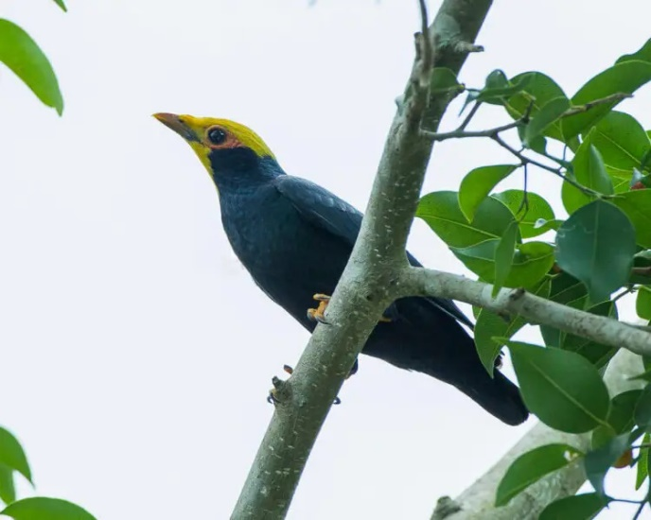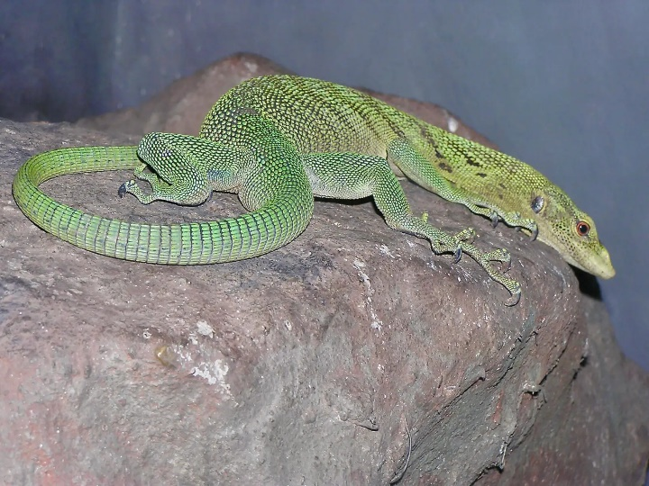

✿ Androgyny Zoology: Each character resembles the androgynous nature
✿ Queer People of the Global Majority most represent the experiences of these legendary animals; cast accordingly

NOTES
/ - two options or read the one matching a specific character

