**[AR for staging and VR for dramaturgy.]**

**[Opening WebXR on a browser during this performance]**

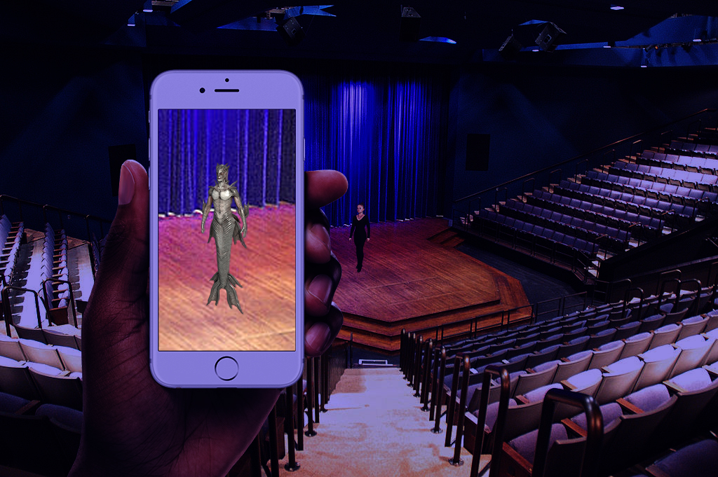

**[Wearing VR headset]**

I swim down the banana hole.

It starts in the sky above the SEA LOVERS. It is a moonless night: a month’s time to be the new moon phase. And according to the working tides, the Moon has not fazed. But let us not forget that mermaid. Them and mer-butlers are legendary, but are they legends? It is faulty to absolutely say that there are no such things. In science, we say that there is not enough evidence to prove mermaids exist. What are the evidence that we have of a humanoid with a fish tail wrapped around the lower limb, like a peeled banana? None. How about a human with scaly skins? There is ichthyosis, which are genetic, scaly skin disorders. Let us invert the question. Can a fish grow fur? No. Do whales grow hair? Yes. The cetaceans originate from indohyus, a cat-size, rat-like animal that realized that the food was in the water. Australopithecus, our five-million-year-old ancestor, may have stumbled upon that as well. Over time, their children evolved with an enhanced lung capacity, a fluke to replace their useless legs, a pulse larynx, and ichthyosis. The fishy anatomy is recognized, but there is no rational for human arms underwater. Let’s just think like them and call them: bananafishes. Anyways, my brain is short circuiting underwater, so I must go to the surface now.

Like all bananafish, I break the surface tension. I look out to the shores with fish-pale eyes and think: “Who is that beached bananafish?” Most bananafish do not dare go near the land. Well, it’s D-Day. The night is moonless, and I am already stranded anyways. Here comes the wave. The working tidal waves guide me to the shores, where I find that the bananafish is now dead. In her struggles, she dug herself a canal into the beach. A perilous journey for many bananafishes, I safely travel through this passage. Who is this bananafish that has made room for us all to evolve on land? My fish-pale eyes meet that of María Irene Fornés. I could tell that she had a potassium-rich brain because she mind the numbers, cared for her pods, and passed on knowledge. However, she dealt with a realer world, beyond the other bananafishes. She was waiting for God? Characters must have as much autonomy in their continental world as the characters in our subconscious have in our underwater dreams. I see that now. Perhaps, avant-garde mutations are just in the eyes of the beholder. We all see through fish-pale eyes. Some of us just need to look out of the sea. Evolve.

I come alive. Where did my bananafish tail/tale go? I have legs to stand on? A pod joins in. A beached bananafish is suddenly as un-rare as the LOTTERY. Summer arrives. Pardon me, I am going to check my lighthearted and inconsequential notes. G chord. C chord. G chord. Square dancing is supposed to sound country, but this is in the spirit of the choral, under the sea/C. Summer sings: “Little late today, folks.” (D4🡪E4🡪D4🡪E4🡪D4🡪B3). We sing: “Black box.” (D🡪C). (G🡪C🡪D🡪Em). Summer raises up the black box. He climbs on top of Fornés. He sinks in, causing mist to spew out from her blowhole. Papers spew out from the black box. Rainbow suddenly gleams above Fornés. Do we each get the lottery? Or…

What would be in our black box? As spiritual tramps, we find a Ortgies calibre 7.65 automatic. We chuck that into the sea. As lovers, we should move on from the sea.

**[Removing VR headset]**

Absolutely make the art you want to see. Absolutely do what you want to do. Be completely true. [Tossing pebbles on the surface tension, creating ripples] (D4🡪E4🡪D4🡪B3🡪D🡪C)