“A strong white LIGHT, while the rest of the Stage is in unnatural BLACKNESS. The quality of the white light is unreal and ugly.” (pg 2) 🡪 "...one of astonishing repulsive whiteness..." (pg 22)

“DUCHESS. Hide me from the jungle.” (pg 10)

“In the jungle, RED SUN, FLYING THINGS, wild black grass. The effect of the jungle is that it, unlike the other scenes, is over the entire stage. In time this is the longest scene in the play and is played the slowest, as the slow, almost standstill stages of a dream. By lighting the desired effect would be – suddenly the jungle has overgrown the chambers and all the other places with a violence and a dark brightness, a grim yellowness.” (pg 20)

“JESUS is the first to appear in the center of the jungle darkness.” (pg 20)

The jungle is dark energy and the intergalactic fabric of spacetime (the entire stage). Spacetime is threaded with non-baryonic matters (“wild black grass”). Light ripples through the dark matter that holds the Galaxies together (“a violence and a dark brightness”).

“A room filled with my my dark old volumes…” (page 5) to “I write poetry filling white page after white page…” (pg 6/13).

The Universe is mainly unanswered dark matter. Light easily illuminates the partial answers of nature, such as velocity of any sorts of visible matters and occasional black holes.

“I am yellow but he, he is black, the blackest one of them all. I hoped he was dead. Yet he still comes through the jungle.” (pg 8)

“She is dressed in black… The other time I wear the dress of a student, dark clothes and dark stockings.” (pg 5)

The human body is the Universe. A Black individual visually is the external representation of the Universe. 95% of the features are the Black soul, while the 5% is the Black sole. Dark matter is like a student, in that, dark matter is fluid in transcending and traversing the space. But like many students, they are distant and have difficulty staying on the surface of a visible matter and can see through these visible matters, unlike electromagnetic forces.

“I want not to be.” (pg 5)

We do not quite know what the opposite of dark matter is. It is not light matter. Maybe it is truly anti-matter.

White light does not have sufficient gravitational forces. In reality, the BLACKNESS holds up the Universe/Stage/Sarah.

“Darkest of Them All”

<https://www.scitheatre.org/dramaturgy/courses/2021-1-30/darkest_of_them_all.mp3>

“We bought masks, cloth, musical instruments made of gourds...” (pg 121, PEOPLE WHO LED TO MY PLAYS)

“Why can’t life work out, be the dream it should be, like a song? (Adrienne Kennedy’s Startling Body of Work)

“Kennedy is alive to every sound and every image that her protagonist, Negro-Sarah, feels and projects.” (Adrienne Kennedy’s Startling Body of Work)

Libretto:

pages: 16-17

start: (A BALD HEAD is dropped on a string. We hear LAUGHING.) & SCENE: Duchess's place.

end: (Then they suddenly look up at each other and scream.)

Lyrics:

“My father isn't going to let us alone. *(KNOCKING.)* Our father isn't going to let us alone, our father is the darkest of us all, my mother was the fairest, I am in between, but my father is the darkest of them all. He is a black man. Our father is the darkest of them all. He is a black man. My father is a dead man.” (pg 17)

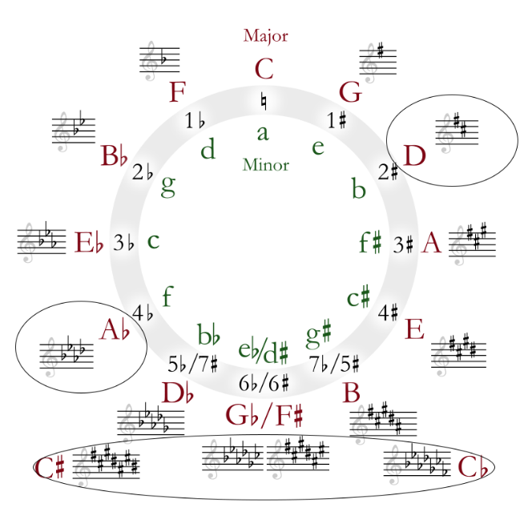

Key Signatures:

“Only at night did she rise, walking in the garden among the trees with the owls. When I spoke to her she saw I was a black man’s child and she preferred speaking to owls.” (pg 15)

“Yellow” (pg 3, 7, 8, 20) E

"and pulls his hair from the red paper bag..." (pg 16) & “In the jungle, RED SUN, FLYING THINGS, wild black grass." (pg 20) B — C

“Clara tries to kill her black lover, a symbol of so much anguish, but she fails, and what alternative does she have except to become an owl, a raceless non-human who sees so well in the dark?” (from THE OWL ANSWERS, Adrienne Kennedy’s Startling Body of Work)

“…I started the lines of two plays... *The Owl Answers*, and the lines had a new power, a **fierce new cadence**…” (pg 119, PEOPLE WHO LED TO MY PLAYS) [~~Deceptive Cadence~~](https://dictionary.onmusic.org/terms/1034-deceptive_cadence)

The hoot of a typical owl is often [G#](https://www.google.com/search?q=animal+sounds)/[Ab](https://www.google.com/search?q=animal+sounds). In New York and Georgia, owls are commonly barred Owls, with hoots mostly in [D](https://youtu.be/zbL-LfGNMl4). An additional objective is to use as many accidental as possible (black keys on the piano). Key Changes: C# 🡪 Db 🡪 Cb

Instrumentation:

“We bought masks, cloth, musical instruments made of gourds...” (pg 121, PEOPLE WHO LED TO MY PLAYS) = TBD

“(A BALD HEAD is dropped on a **string**. We hear ***LAUGHING***.)” (pg 16) = Cello and *Fiddles*

"...who is seated on a bench under the **chandelier**." (pg 16) = Bells

“In “Funnyhouse,” history, personal and otherwise, is accompanied by sound. Now it’s the sound of knocking on a door. Who’s knocking, and why?” (Adrienne Kennedy’s Startling Body of Work)

“My father isn't going to let us alone. *(****KNOCKING****.)*” (pg 17) = Wood Block