"To play a wrong note is insignificant; to play without passion is inexcusable." - Ludwig van Beethoven

“To compose wrong notes is insignificant; to not even try to compose good notes is okay.” Quote adjusted for David Quang Pham.

*So much silence in INDIA SONG*.

(pg 35 of INDIA SONG)

*A slow recitative made up of scraps of memory. Out of it, every so often, a phrase emerges, intact, from oblivion.*

(pg 57 of INDIA SONG)

*The tango, as if in the distance.*

(pg 69 of INDIA SONG)

Man and woman (low):

—Did you hear?

—Not very clearly. *I* thought **he** said:

— “Lahore was what *I* **de**sired.”…

— (*In one breath*.) The report said people used to see him at night through his bedroom window, walking up and down as if it was **broad** daylight… and talking… always to himself…

—… At night… as if it was broad daylight…

—Yes…

**ANNE-MARIE STRETTER IN THE LOVER**

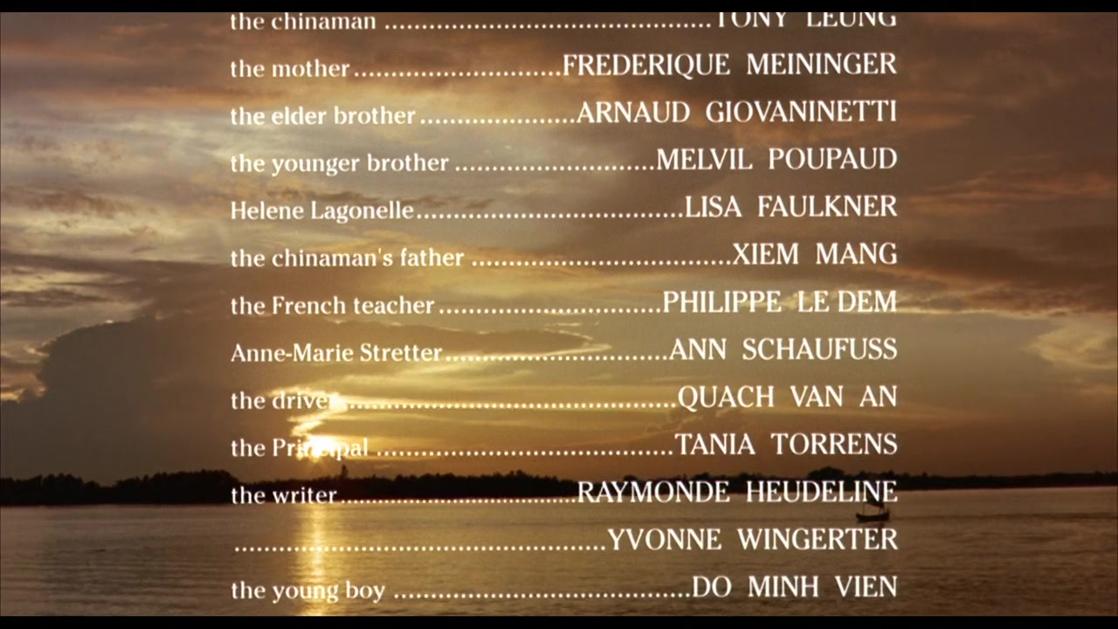

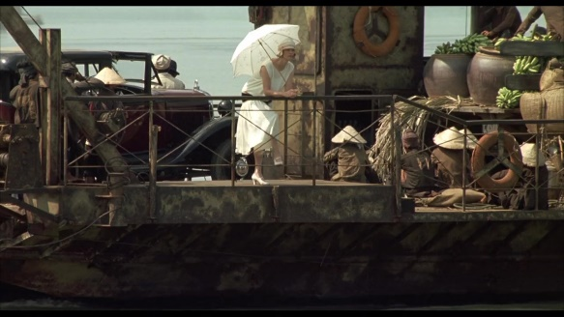 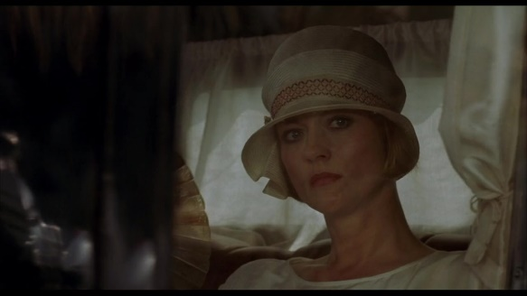

(18:17) (1:32:40)

DURAS: “Do you know her? She's the administrator's wife. Mrs. Stretter. Anne-Marie.”

LOVER: “Is it true? That story about the young man who killed himself for her?”

DURAS: “Don’t know… Yes, it's true. On the marketplace at Louang Prabang: the day she left. He was her **lover**.”

**SCREENWRITING: HOW/WHY IS THE LOVER *THE LOVER*?**

“It's wealth that takes his strength away. He does nothing. Nothing. Only love.” (59:03)

How many times is “lover” said? 4

1) “He was her lover.” (18:30)

*“You love her?” (58:13)

2) “We are lovers.” (1:00:18)

3) “In my family's presence, he ceases to be my lover.” (1:09:44)

4) “She had wept because she had thought of that man from Chợ Lớn: her lover.” (1:50:24)

**CINEMATOGRAPHY: HOW IS THE LOVER *NOTHING BUT LOVE*?**

- Sex, lots of it.

- The money somehow adds to the nothingness, as quoted in 59:03.

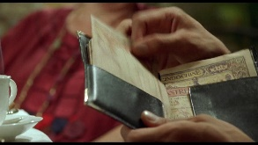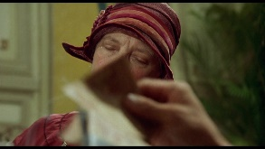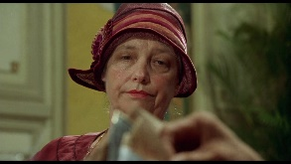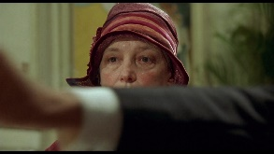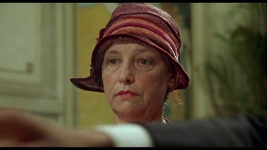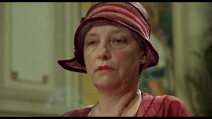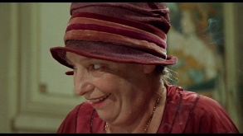

**HISTORY: WHY COULD THE LOVER *NOT LOVE HER*?**

- Racism, lots of it.

- Marriage is Expansive and Expensive.

“The pattern of residence after marriage is considered an important diagnostic for gender inequality, intimately related to inheritance practices and property rights; all three obviously contribute to the political economy of gender. The forms of marriage that anthropologists refer to as patrilocal or matrilocal are influenced by norms for the inheritance of land and housing by sons and daughters. In patrilocal marriages, which are typical for most of China, sons are the heirs to family land and daughters marry out to join their husband’s household. The couple resides where the man’s parents live, often living in a joint family at the start. In matrilocal marriages, land passes to daughters and the couple resides where the woman’s parents live.” (pg 223 from CHINESE WOMEN AND RURAL DEVELOPMENT under “Marriage: Expectations and Exceptions” in Chapter Seven—Marriage, Household, and Gender: Keeping Sons and Daughters)

The Lover’s father would have to see the colonizer’s face every waking moment. The Lover’s father would rather have a familiar face (like the Lover’s mother) instead.

“In the 1930s, wedding costs were a major household expense. Fei briefly described a family, normally thrifty, who spent lavishly for the wedding of their son. He noted that wedding costs could exceed the annual family income and place the family in debt, so some men could not afford to marry. He pointed out that these heavy expenses, concentrated for the wedding ceremony, were partly for a general renewal of household furnishings.” (pg 240 from CHINESE WOMEN AND RURAL DEVELOPMENT under “Marriage Costs and Weddings” in Chapter Seven—Marriage, Household, and Gender: Keeping Sons and Daughters)

The wedding between the Lover and the Lover’s arranged “lover” is paid for way in advance. (1:38:11 – 1:40:12)

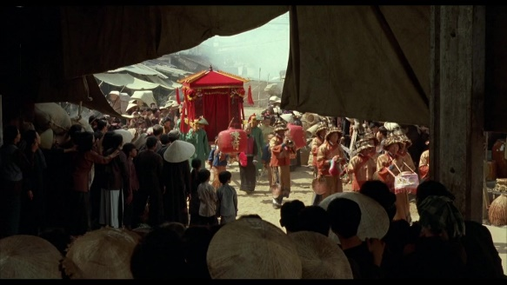 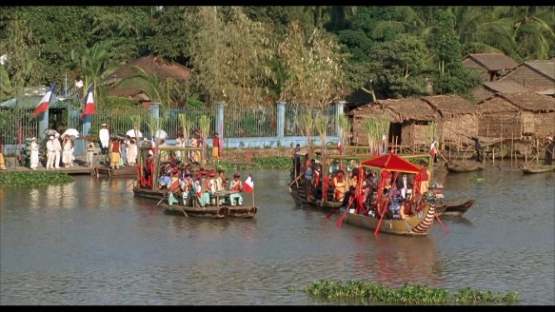

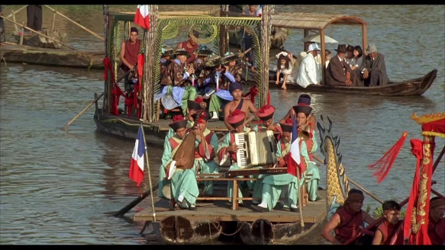 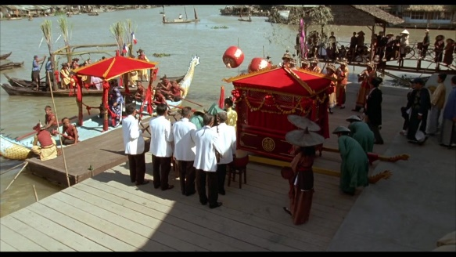

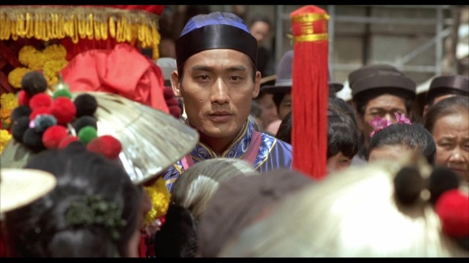 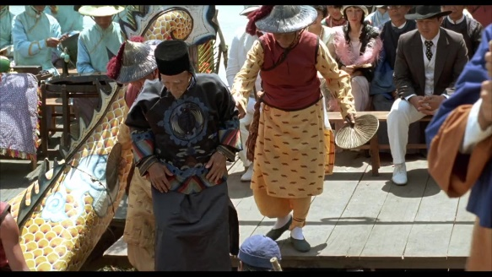

Children Dilemma

“The age distribution of a population outlines the economic burdens felt by young and mature adults. It shows the numbers of young children and elderly parents whom they are expected to support. The sex distribution of a population reflects a variety of variables linked to gender—patterns of employment, parents’ sex preferences for children, maternal mortality rates, military casualties, and different rates by sex of mortality from accidents, violence, hunger, illness, or suicide. Marriage and work patterns that lead to migration in or out of the community also affect sex ratios in the local and larger society.

…Women were bearing and raising many children during this period, and children, especially girls, were working at an early age, since few of them attended school.

“Four more girls than boys were born and two more girls than boys died. Again, these small numbers are inconclusive regarding son or daughter preference for the prerevolutionary period.”

(pg 280 from CHINESE WOMEN AND RURAL DEVELOPMENT under “Age and Sex Distribution 1938” in Chapter Eight—Demographic Change, Family Planning, and Sex Preference)

- Challenges to Assimilation into a Community

“The political organization that Fei describe in Lu Village in 1938 was the *baojia* system, which dated back to the Qing dynasty. According to historian Johnathan Spence, the *baojia* system required community mutual responsibility within the judicial structure.

A *bao*, a group of 1,000 households, consisted of 10 *jia*, each of which contained 100 households. All Chinese households were supposed to be registered in *jia* and *bao* groups and supervised by a “headman” chosen from among their own number on a rotating system. These headmen were expected to check on the accuracy of each household’s registration forms, which listed family members by gender, age, relationship, and occupation, and to ensure local law and order.” (pg 312-313 from CHINESE WOMEN AND RURAL DEVELOPMENT under “Formal Government in the 1930s” in Chapter Nine—Politics and Political Culture)

Duras lied about her age...

**CINEMATOGRAPHY: WHERE TO DRAW THE LINE**

“Compared with stylization as an efficient way to formalize physical action and materials in a traditional way, metaphysical beauty is always the aesthetic value that is meant by all instrumental forms.

We may first take the usage of picture lines as an example of aesthetic values in Chinese animation. Generally speaking, the animations of western countries use single-lined colors as their major representation where lines mean nothing but the limitation (confinement?) of colors. Yet in Chinese animation, lines may embody aesthetic values and hence a significant factor in expressing feeling.” (pg 71 of ASIAN CINEMA under “Metaphysical Beauty”)

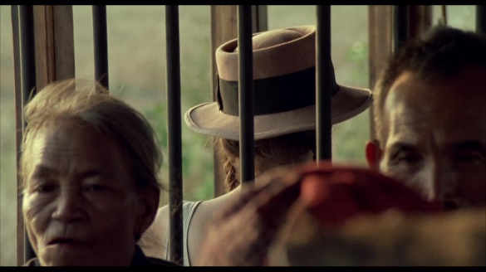 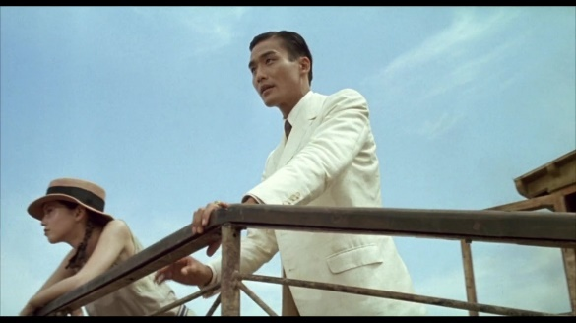

(12:03 ) (14:58 )

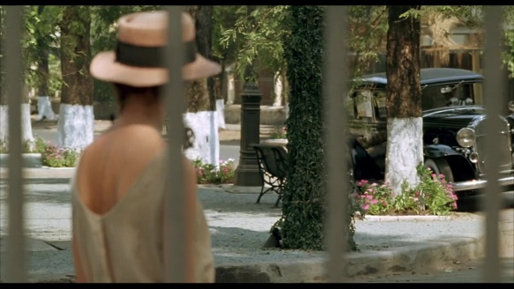 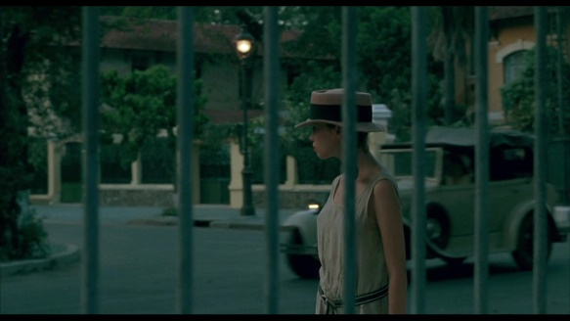

(28:38 ) (30:53)

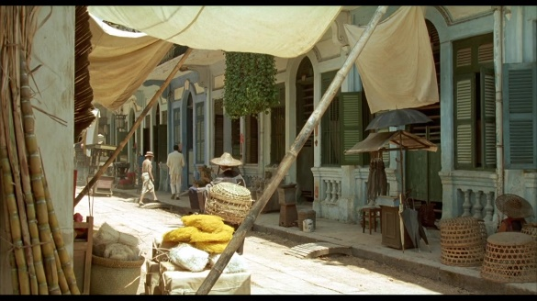 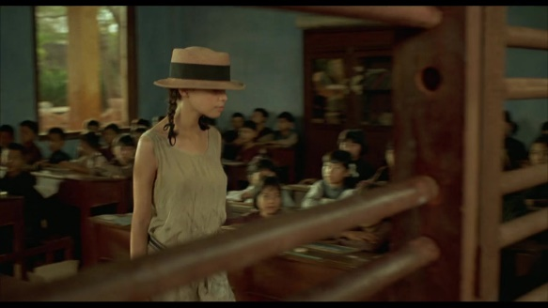

(34:21 ) (1:03:43)

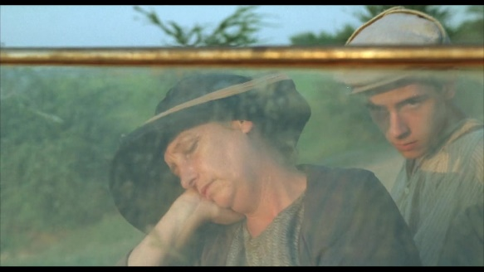 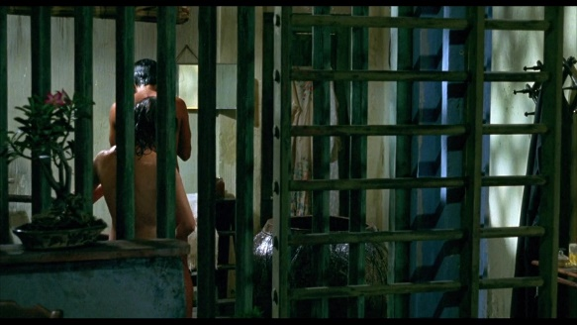

(1:07:36) (1:17:29)

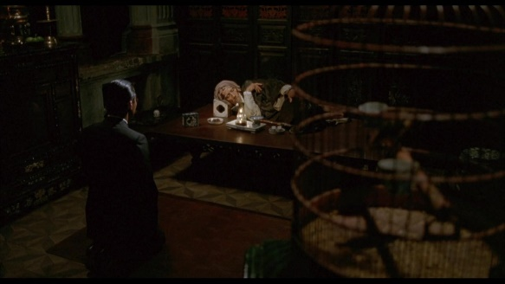 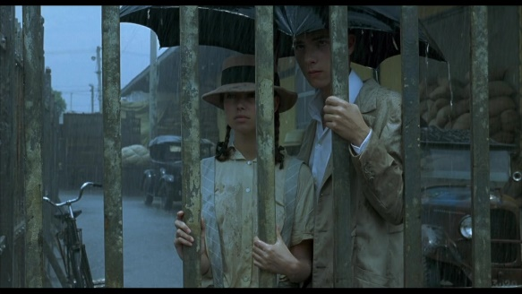

(1:22:21) (1:34:59)

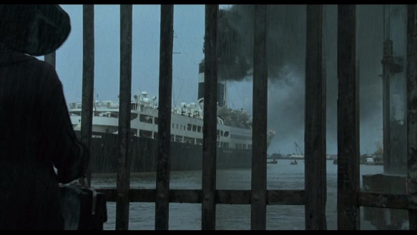 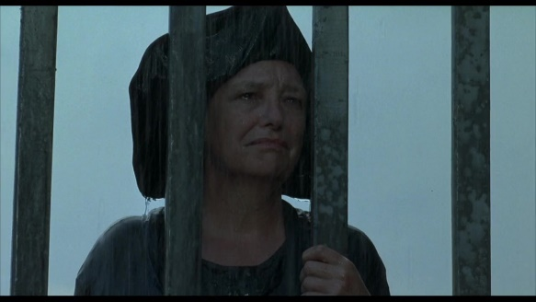

(1:35:51) (1:36:02)

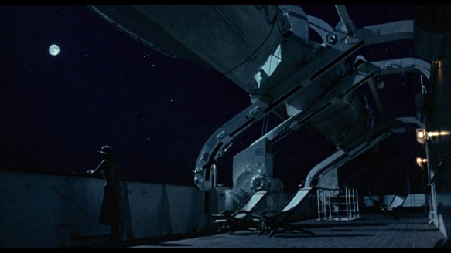 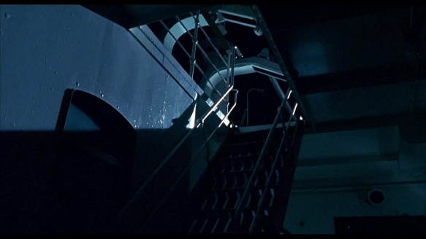

(1:49:30) (1:49:49)

**SCORE: O~~RGAN~~PIUM PIPE**

“India’s entries were particularly heavy in terms of subject matter. The slowly building and tense “Octave,” set in 1971 during India’s war with Pakistan, concerns a couple waiting anxiously to hear from their son, who as a member of India’s armed services, has been called to combat.” (pg 204 of ASIAN CINEMA under “South and Southeast Asian Cinema”)

Bamboo Flute Leitmotif

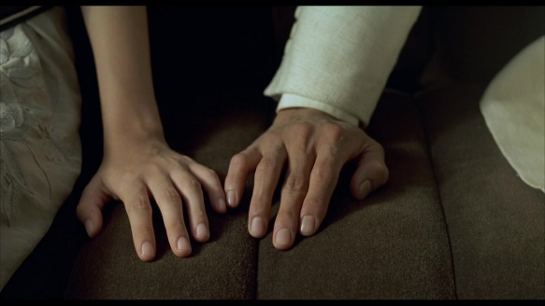 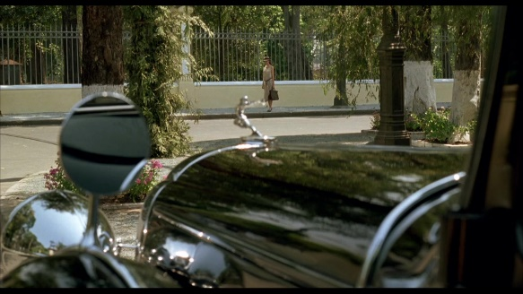

(22:32) (28:47)

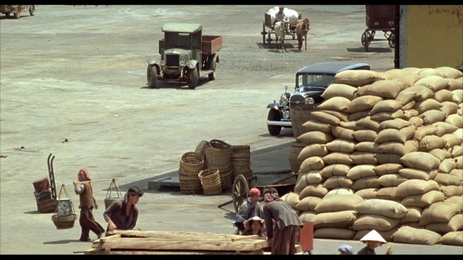

(1:47:24)

8/8 Time Signature | Swing (31:52)

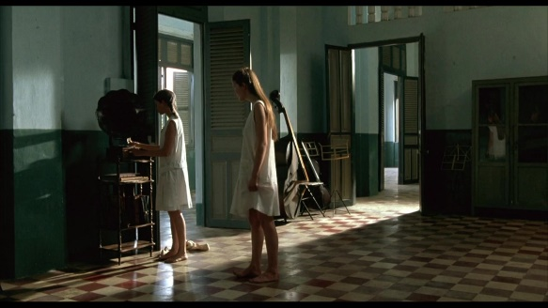 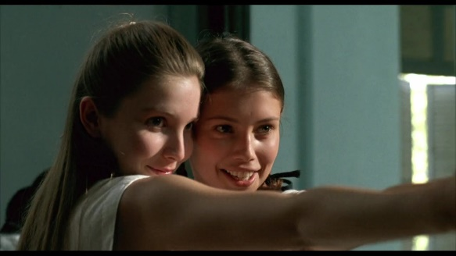

Yodeling (58:00)

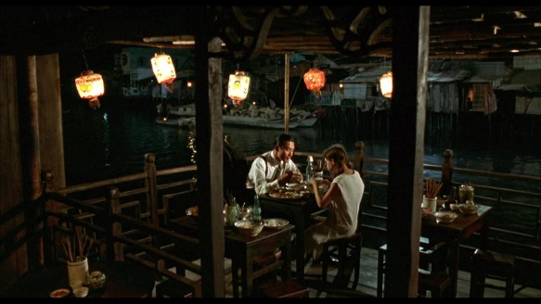

Harmonica (1:04:16) | Should be a leitmotif

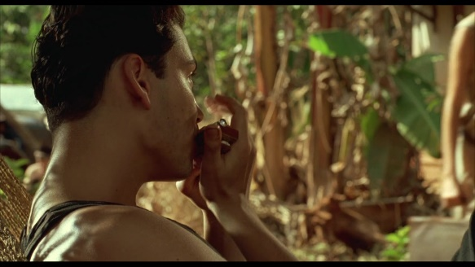 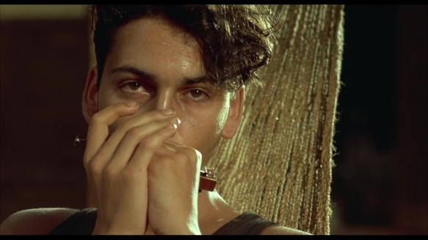

Absolute Silence (1:20:52 – 1:22:21) until Bird Chirping

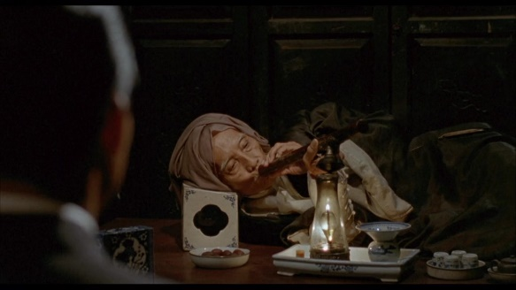 

“Eh” from THE LOVER that doesn’t relate to human physical interactions:

What time is it? in Vietnamese

How many times does this film say “honor.” 2 times.

51:44 (dishonor) & 1:04:33 (dishonor)

References

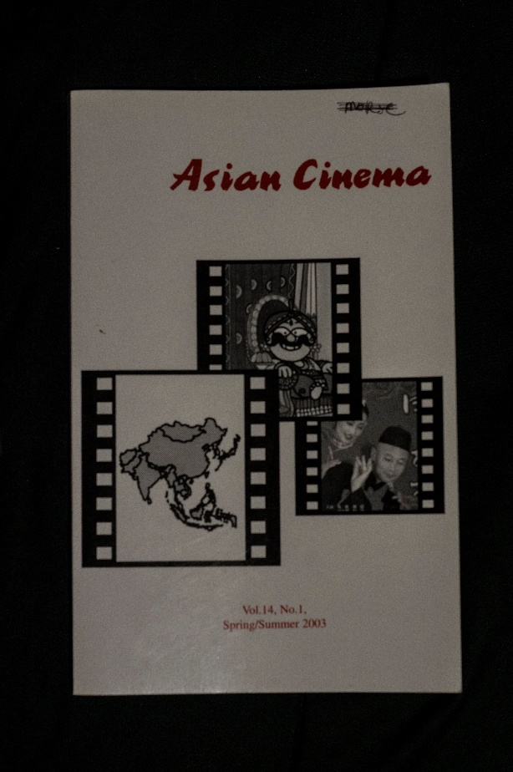 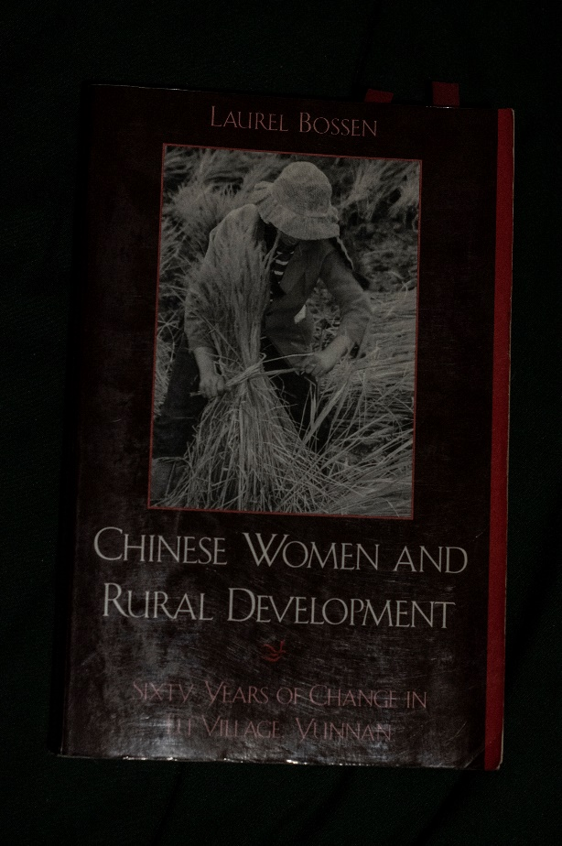

Asian Cinema Vol. 14, No. 1, Spring/Summer 2003 by Asian Cinema Studies Society