“*THEO tears a page down the middle as static, like distant* ***waves****, bleeds into the quiet, then recedes. THEO tears another as we hear the static again as light finds a BOY on the shore of a beach.*” & “*The sound of static waves recedes as the light fades on BOY and beach.*” (pg 19)

“*Gentle* ***waves*** *of static.*” (pg 24)

“*Static in the air.*” (pg 26)

“*Static crashes like* ***waves****. Light finds the BOY, breathless on the shore of a beach considering the implications of stepping into the cool and clear water.*” (pg 39)

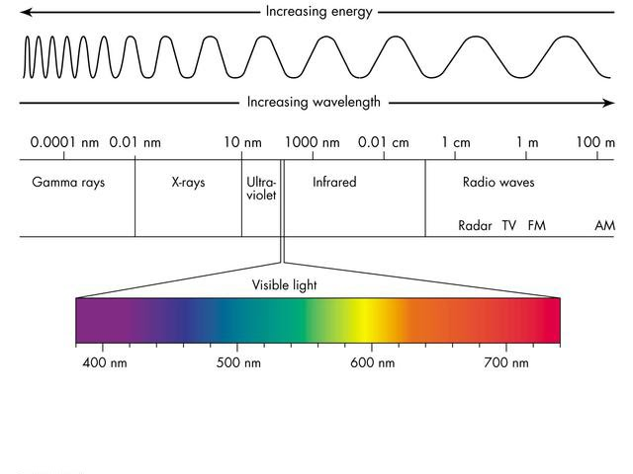

Paraphrasing Edwin Wong on February 13, 2021 at WTP Risk Theatre: “The point of history is to put together a powerful narrative. History doesn’t actually mean anything.” Hence why “history” is in quotations. To me, “history” is like a wave, where it leaves and comes back (repeating itself). The waves are there when the people are learning but do nothing about an issue. In physics, static is when the waves are basically flatlined, where the frequency is zero and the wavelength is maximum or visually *red*.

Eirene is the wave of “history.” She moves back and forth from the Boy’s world and Theo’s world. Eirene is memorable for pretending to make a difference, but ultimately repeats history as everyone feels good and really hasn’t learnt anything or applied what was learnt. The Boy is the static that blocks some of the waves. The Boy is left drowning, bleeding, and forgotten, but they ensure that less of history repeats itself. *Theo could evolve into a fish.*