PROJECT
Project Title
StarPower! A Live-Action/Animated Science Show

Project URL
http://seedandspark.com/fund/starpower

Google Analytics (optional)
UA-XXXXXXXX-X

Genre
Animation
Family

Format
Series

Location
New York City, New York

Logline
An axolotl and her sister explore space with their human friends to save planets and teach science in this interactive adventure.

Crowdfunding Rallies
Beyond the Screen Rally
By opting in to this rally you agree that you are making a short film or short form series with an intersectional team and topic, and you will abide by the terms and conditions set forth on the Beyond the Screen Rally Page.

Tell your audience why they should support this project.
This text lives directly above your pitch video - summarize your project and make sure people understand why the world needs it now!
In a world lacking wonder, StarPower! brings you back to the joy of discovery. We’re raising $2,500 to film a proof of concept of this interactive science show. Support us to champion inclusive STEM education and prove that with a little curiosity, the universe is a puzzle we can solve together.

Explain the mission statement of your project.
Our mission is to personify science to explore social issues and the human condition. We strive to create a fantastical and sci-fi world where education and diverse storytelling provide a roadmap for navigating mental health challenges and fostering a lifelong passion for discovery.

If you're affiliated with any film, music or creative organizations, distributors or more, please list them here: (optional)
Cinephilia
Kellogg's Foundation How We Heal Film: Labs

Have you used Seed&Spark's educational resources?
I watched the videos online
Remember, the online version of the class is always on and always free!

How did you hear about Seed&Spark?
From a friend
Who is StarPower!?
Imagine a world where science is your friend you can talk to.
StarPower! is an 11-minute interactive preschool series that blends live-action wonder with vibrant animation. Guided by our host Aurora, her sidekick Ray, and two cosmic salamander sisters - Stardust (a sparkly mudpuppy) and StarPower (a titan-sized axolotl) - viewers join them on an adventure throughout the universe.

Why It’s Special
- Active Participation: We use pauses to invite children to speak directly to the characters and help solve the universe's biggest puzzles.
- Science with Soul: Created by astrophysicist David Quang Pham, the show uses STEM concepts as a roadmap to navigate social-emotional growth and wellbeing.
- Representation Matters: We are dedicated to showcasing neurodivergent, BIPOC, and diverse voices in a field where they are often left out.

How Your Support Helps
We are raising $2,500 to move from concept to reality. Your contribution directly funds:
- Handcrafted Sets: Building the physical Stardust world.
- Professional Animation: Partnering with LuckyJoy Studio to bring our salamander sisters to life.
- Puppetry & Practical Effects: Creating the handmade magic that sparks a child's imagination.

JOIN OUR CONSTELLATION
Contribute during the Rally window (April 20 – May 19). At any level, your contribution goes directly towards completing a proof of concept with the care and craft it deserves.

Follow the campaign on Seed&Spark. It is free and it directly impacts our standing in the Beyond The Screen Rally. A benchmark for finalist consideration is reaching 350+ followers. Your follow is a measurable vote for this educational series.

Share this campaign. If you know teachers, science communities, mental health advocates, children's storytelling supporters, or anyone who believes people deserve to tell their own stories, send this their way.

Join us in showing that with stardust and curiosity, the universe is a puzzle we can solve together!

Meet the Creators
David Quang Pham – Showrunner & Composer
David is an award-winning songwriter, theatre maker, and filmmaker who personifies science to explore social issues and the human condition. An astrophysics and theatre graduate from Michigan State, his 2025 highlights include the world premieres of his musicals Turnover: A New Leaf and Chemicals in the Water. David brings his experience mentoring neurodivergent actors at children’s theatres like Openspot Theatre to the heart of this series.


Dionne O'Dell – Collaborator

Sannette Gaia – Producer
Hailing from Salem, OR, Sannette is an American producer and director whose passion for the arts began at an early age. A veteran of both the stage and local award-winning plays, she brings a deep commitment to visual storytelling and high-impact independent production to the Solid, Liquid, and Gas team.

Bema Coulibaly – Animation (LuckyJoy Studio)
As the CEO of LuckyJoy Studio, Bema leads the animation team responsible for bringing the magical "show within a show" elements to life. Bema previously collaborated with David on the animation Reimmy the Cockroach and his Squirrel Friend.

Jayde Pang – Character Designer

Lee Petroll – Production Coordinator
Lee manages the logistical backbone of our production, ensuring that the "miserable reality" of our modern setting and the "fantastical sci-fi world" of the Stardust set are executed seamlessly.

Meet the Stars
Sara Jane Beneke (she/her) as Ms. Aurora
Born on the gas planet Bory Alice, Aurora is the friendly, enthusiastic partner of the animated salamander StarPower. She engages directly with viewers to visit new worlds around the galaxy, singing the zoopity jingle and asking sentient tools for answers.
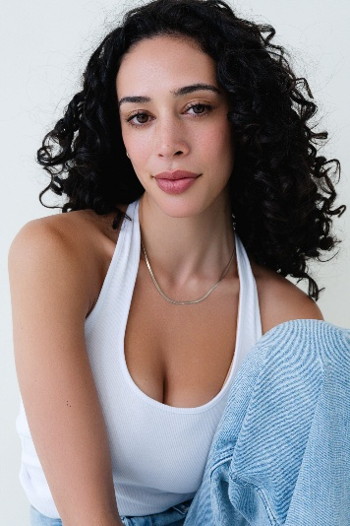

Natalie Malia Figuracion (they/them) as Ray
Born on LaserMoon, Ray is the courageous sidekick of Aurora and best friend of the animated salamander Stardust. They engage directly with viewers to visit new worlds around the galaxy, singing the zoopity jingle and asking sentient tools for answers.
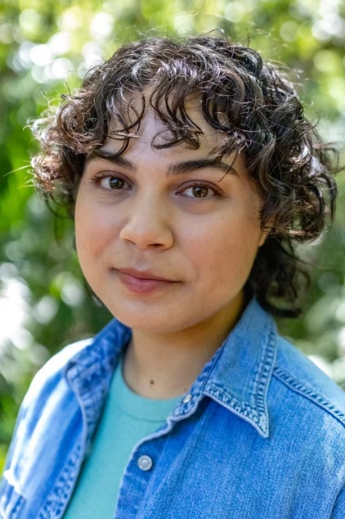

Xavier Soto Burgos (he/him) as Clay
Born on the planet Ceramia, Clay is the friendly, enthusiastic partner of the animated salamander Stardust. He engages directly with viewers to visit new worlds around the galaxy, singing the zoopity jingle and getting answers from sentient tools, like Rocket and Telescope. Clay is known for his curious, earnest personality, and for being an optimistic guide to preschoolers.


SOCIAL MEDIA
Add links to your social media profiles to maximize your reach.
https://www.instagram.com/sciencetheatre
https://www.facebook.com/ScienceTheatre

Combined across your team, how many people can you email personally about your project?
100

VIDEO & IMAGES
Pitch video
Your pitch video is one of the trickiest and most important things to get right about your campaign. It will be time-consuming, but don’t lose heart! Taking the time and effort to make a strong video is worth it, and it’s also a great time to show off your storytelling chops.
You can submit your pitch video in any stage (finalize, rough draft, or even proof of concept) – the sooner we can give you feedback and guidance, the better! If you don’t have a draft yet, you can also submit a script.
Check out these examples of great pitch videos .
Great pitch videos...
- Are 2 minutes or less in length (most people stop watching after 90 seconds)
- Showcase your abilities as a storyteller and match the tone of your project (people will assume the quality of your pitch video will match your final product)
- Quickly explain what the project is, who is making it, and why you want the audience to get involved (hint: it can't just be for the cash!)
Are you submitting a script or video draft?
Script
Enter a YouTube or Vimeo link for your pitch video. If you don’t want your video publicly visible, YouTube offers an “unlisted” pirvacy setting that will still allow you to add it here. Private videos from Vimeo cannot be added. Video URL (Youtube or Vimeo)...
Image
The uploaded image will be used as your project thumbnail throughout the site. This image should be 960x540 pixels and less than 5MB in size.
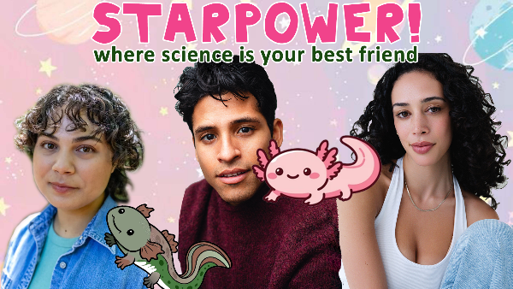

CAMPAIGN
How much do you intend to raise? (give an estimation)
Less than $10K

Recommended Reach
You’ll need roughly 350-500 pledges to raise this amount, which means you’ll want between 3,000 and 10,000 people in your network ( this is combination of direct emails and social media likes and followers for all team members who will be actively participating in the campaign ).
We also recommend an outreach plan that includes: 2-4 press contacts, organization partnerships and/or influencers ( people in your network who have large followings who commit to promoting your campaign ). At this level, it’s beneficial to line up some larger pledges in advance in order to reach your goal
In 1-2 sentences, tell us how you'll achieve this reach.
We will leverage our combined social media following, including David Quang Pham’s established theatre and science networks, to drive traffic through targeted video content and personalized emails. Additionally, we are partnering with neurodiversity and STEM-focused officials to amplify our mission across diverse educational communities.

What stage of production will this campaign support?
PRODUCTION

How many days will your campaign run?
30

If you've crowdfunded previously for this campaign, please provide links: (optional)
If you've crowdfunded previously for other projects, please provide links: (optional)

INCENTIVES
$10
Shout Out!
A digital shout-out on our official social media pages.

$25
Stardust + StarPower Wallpaper
An exclusive digital desktop and phone background featuring the animated sisters, Stardust and StarPower.

$50
Early Access
A private link to watch the pilot episode 24 hours before it officially premieres.

$75
A Personal Shout-out
A video message from David Quang Pham, Ms. Aurora (Sara Jane Beneke), and Ray (Natalie Malia Figuracion) thanking you personally.

$100
1-on-1 with the Creator
An hour virtual/in-person chat with creator David Quang Pham to talk about astrophysics, musical theatre, or filmmaking. He is based in New York City, sometimes next to Gayle King. It can be scheduled in May to July.

$200
Invite to our Readings
An invite to a live Zoom table reads and in-person ones with the cast (New York City or Michigan).

$300
Signed Script!
The team will sign limited copies of the script.

$500
Cameo in a Future Episode
You will be on a list to be in a future episode of Stardust/StarPower/Solid, Liquid, and Gas in some way whether a recorded video of yourself or set appearance.

$800
The Star Producer
You receive an "Executive Producer" credit on IMDb and in the opening titles of the pilot.

WISHLIST
Your WishList is how you set your fundraising goal on Seed&Spark.
While you don't need to list every single item that you need for your project, it's a good idea to give your supporters a sense of how you'll be using the funds. The total should equal the amount you want to raise.

Total Campaign Goal: $2700
$1200
Set & Puppetry
High-detail practical effects, green screen rental, and puppet elements.

$750
Animation
Essential character movements and transitions.

$750
Talent & Crew
Stipends for your cast (Aurora, Ray, and Young Clay) and production staff.

