Synopsis
Imagine if the host of a children’s show had a mental breakdown on national television and then had to get their life back together while teaching science to an audience who no longer believes in science. Solid, Liquid, and Gas is a thirty-minute comedy-drama tv series that explores the miserable reality of adulthood through the whimsical perspective of children’s educational programming.
Trini "Ray" Reyes is a 29-year-old Filipina American educator whose acting career literally went up in flames when she accidentally burned down a theater during a production of Cat Scouts Live. Blacklisted and facing eviction, Ray clings to the only thing that ever made her feel safe: the memory of Stardust, a cosmic science show from the early 2000s hosted by the charismatic Clay.
When Ray hears that the network is reviving the show as StarPower!, she sees it as her last chance at redemption. However, this version is corporate, and led by her academic rival, the poised Ms. Aurora Sterling. Ray manages to win her way into the production, not as the star, but as Aurora’s sidekick.
The first season follows Ray as she navigates the surreal divide between the fantastical set of StarPower! and her bleak reality. She lives in a cramped apartment with her neurodivergent younger brother, Kwan “Sunshine” Reyes, an astronomy prodigy who is facing his own academic crisis.
As the season progresses, the fourth wall Ray breaks on camera begins to bleed into her real life. She seeks out her childhood hero, Clay, only to find him a recluse living in Brooklyn. Together, this found family of science nerds must navigate hot mics, anti-science internet trolls, and the pressures of being a role model in an unforgiving world.
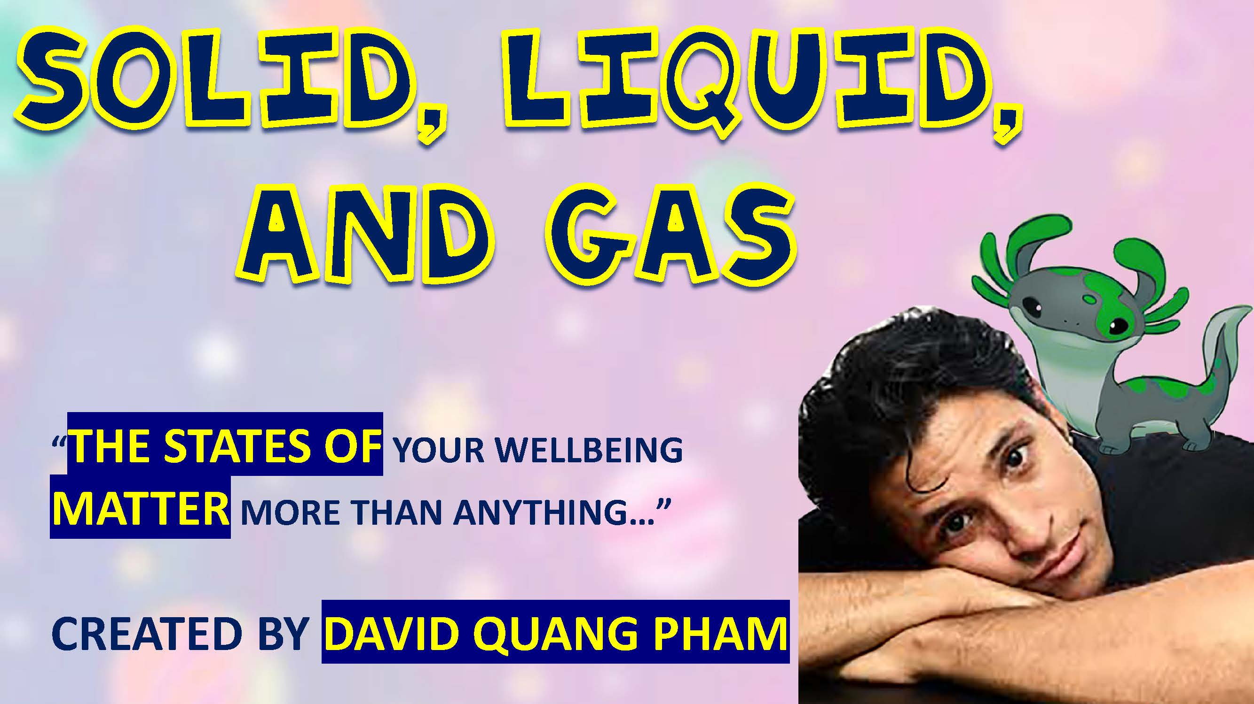
The series uses the states of matter as a metaphor for character growth. Ray begins as gas; invisible and lacking a clear shape. By the finale, after Aurora is suspended for a political statement and Ray is fired for standing by her, she learns to be a plasma of energized light, ready to create a new world on her own terms.
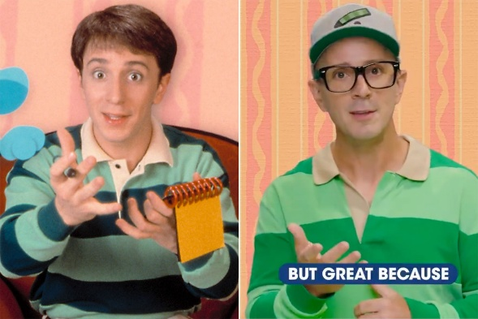

“It’s Blue Clues! …for adults…” – Carissa Sky

Children’s programming device: main characters break the fourth wall to ask the viewers questions about adult problems and to dismantle adult issues such as mental health, poverty, careers, and politics
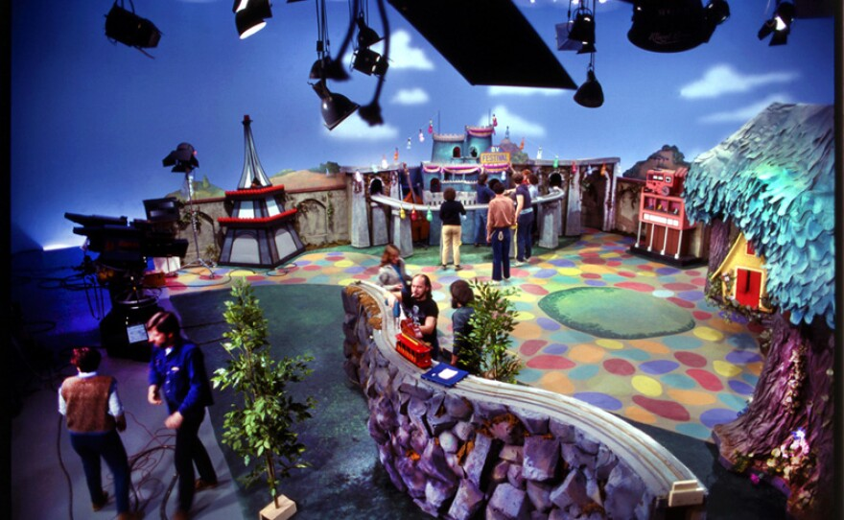
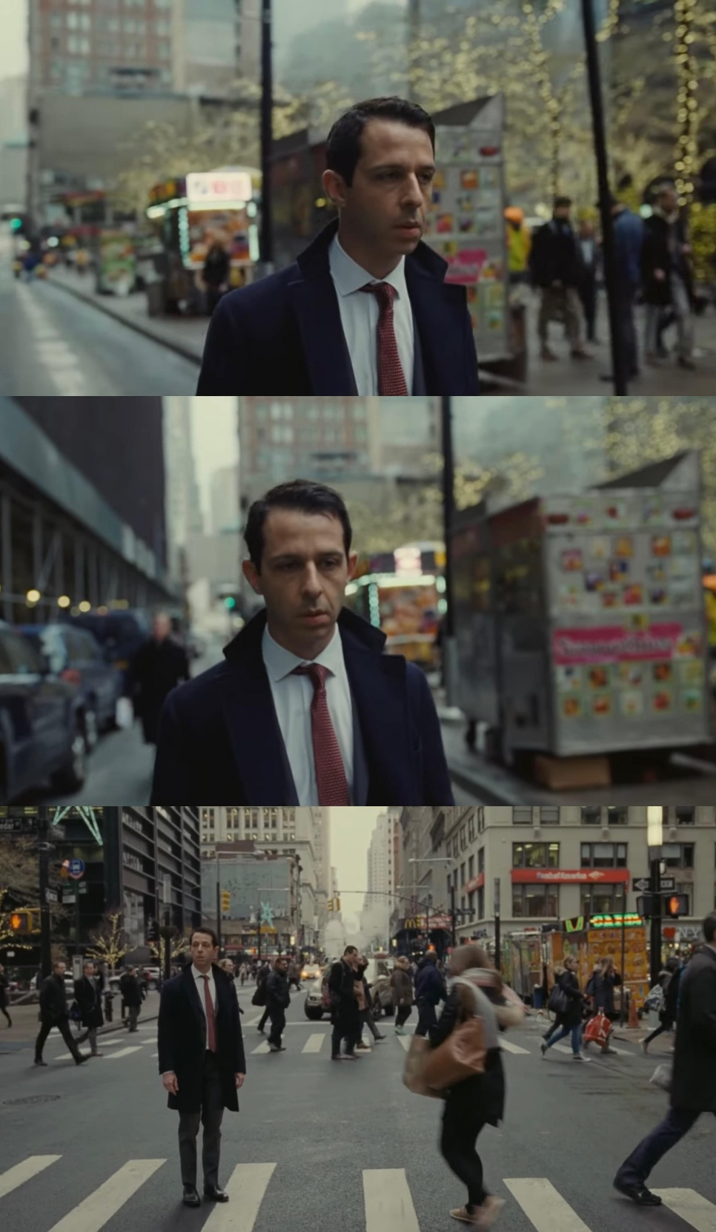
Fantastical world of science  on Stardust + StarPower! set… | Miserable reality of adulthood  for the rest…

