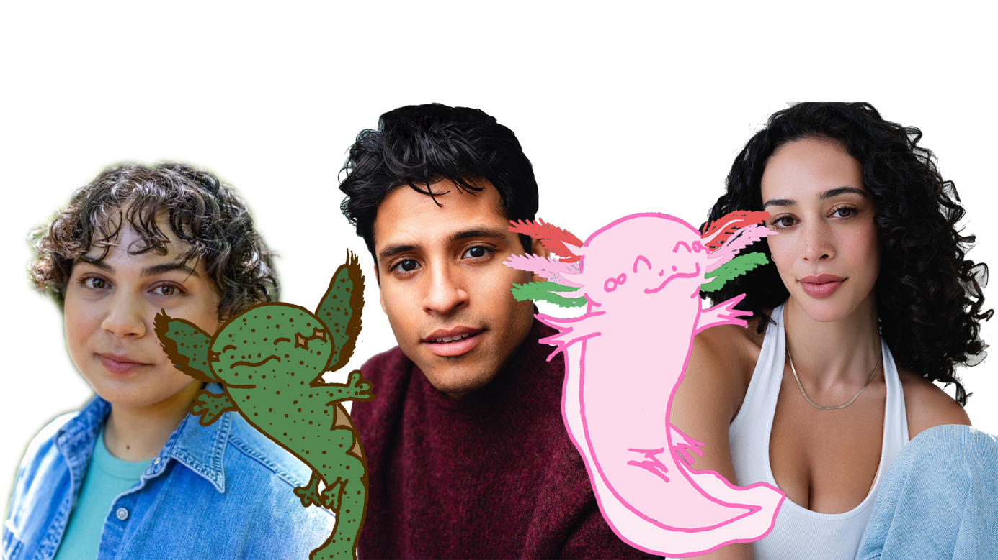
friendship is our north star science is our superpower

STARPOWER!

STAGE SHOW & LIVE-ACTION/ANIMATED SERIES OVERVIEW
The Salamander Sisters (StarPower and Stardust) along with their human friends from Newton Knights (Aurora, Ray, and viewers) explore the Miniverse, helping planets succeed and teaching science to communities on their interactive adventure.
Tagline: “Friendship is our north star. Science is our superpower.”

WHY NOW?
Our mission is to personify science to explore social issues and the human condition. We strive to create a fantastical and sci-fi world where education and diverse storytelling provide a roadmap for fostering a lifelong passion for discovery.

Website | Pitch Deck

Completed Episodes (Screenplays)
- Pilot – Milky Way Sick Day
  - Visited: No World, Just Milky Way
  - Topics: Galaxy age, Space dust

STARPOWER! LIVE ON STAGE
Potentially cowriter: Dionne O’Dell
- Visited: ???
- Topics: The States of Matter (Solid, Liquid, and Gas)? Whatever.
Maybe Ray earns their Star Ranger Badge.

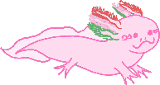
MAIN CHARACTERS
STARPOWER is a pink axolotl salamander and Stardust’s sister. She roams the universe with her human friends, Aurora and Ray. Her magical ability is being able to enlarge to sizes bigger than stars and shrinking to be pocket-sized, as well as shapeshifting. She speaks by repeatedly saying “bubble.” She was born on Starmander Creek with her sister and other salamanders.
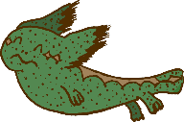
STARDUST is a green mudpuppy salamander and StarPower’s sister. She lives in Friendship and pairs up with Ray. She speaks by repeatedly saying “twinkle.” She'll even tell yes by nodding or no by nodding side to side. To give directions, she would leave glitter on the screen. She was born on Starmander Creek with her sister and other salamanders.
AURORA is the human host and a Star Ranger. Born on the gas planet Bory Alice, she is the warm, enthusiastic partner of StarPower. As a Star Ranger, she engages directly with viewers to teach science and explore new worlds. She is known for her upbeat delivery and infectious joy that emphasizes accessibility and emotional connection.
RAY is Aurora’s courageous apprentice and the caregiver of Stardust. Born on LaserMoon, they often get ahead of themself on any adventure, inevitably getting stuck in a messy situation. They are an action-adventure hero with a big heart. They hope to earn their Newton Badge one day to be a Star Ranger.
FRIENDSHIP is a cheerful rocket who transports their friends to distant worlds. In each episode, they land after the host sings “Rocket Zoop.” Clay built them on a factory comet, Rocketland.

SUPPORTING CHARACTERS
CLAY is Ray’s cousin. He was the original caregiver of Stardust before returning to his home planet Ceramia to be a space mailman. He is a Star Ranger.
TELESCOPE is an insightful telescope.
MILKY WAY is the galaxy who is aware that travelers are journeying within them. They sneeze whenever the Stardust Bunnies are hopping around.

MINOR CHARACTERS
HALLEY is a comet who delivers messages.
GRAVITY is a stray dog who lets everyone down but can fetch anything. They bark “force.”

ENSEMBLES
NAVIGATORS are cosmic alligators with a sense of direction. They roam the universe, helping lost travelers navigate.
STARMANDERS are cosmic salamanders, like Stardust and StarPower. Most were also born and raised in Starmander Creek.
STARDUST BUNNIES are titan dust bunnies hopping around, causing planets and even the galaxy to sneeze.

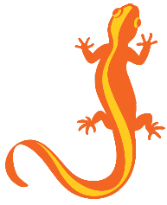
NEWTON KNIGHTS
Newton Knights is a development program, focused on leadership, character development, and outer space skills. It offers activities like rocket assembly, planet hopping, animal companionship, and community service, with top participants earning the prestigious Star Ranger rank. A Star Ranger serves as the explorers of the galaxy and universe overall. Members are referred to as Newts. A Newt Emblem and their Newt-related clothes represent them.
Aurora and Clay are Star Rangers. Ray is looking to earn their Star Ranger Badge. The viewers are also honorary Newts.

MAJOR WORLDS
BORY ALICE – a gas giant planet where Aurora was born and raised.
CERAMIA – a lush planet where Clay was born and has trouble finding.
EARTH – a planet where the viewers are taking a vacation away from.
LASERMOON – a moon where Ray was born and raised.
ROCKETLAND – a factory comet where Clay built Friendship.
STARMANDER CREEK – a nebulous creek where cosmic salamanders like Stardust and StarPower hatched.

SENSE-ABILITY WORLDS
FARMOON (based on FARM) – a moon full of livestock creatures
RED CEDAR STAR (based on Wilhelmina) – a star system
PLANET O’ANDY (based on POND) – a planet full of fishes and toads
SODA POP COMETS (based on Soda Pop Shop) – a restaurant franchise found on comets
(I want kids to make up names of celestial bodies)

STATIONS
NAVIGATOR STATIONS – a help station led by cosmic alligators with maps.

Standard Formula for 11/22-minute Episode

- The Salamander Sisters and the Newton Knights (Aurora and Ray) introduce themselves and ask viewers what world to visit today (ex: Farmoon or Planet O’Andy). Alternatively, they could encounter a problem (ex: Milky Way is sick or they’re lost in an asteroid field).

- Their rocket Friendship sings the “Rocket Zoop” song and lands on the desired world or alternatively goes wherever they need to go.

- Ray and Stardust scout ahead while Aurora describes the planet and teaches a topic (often science) for the viewers (ex: this snowy planet has a freezing point of 32°F, remember 32).

- Stardust returns and says “twinkle” frantically to Aurora and StarPower to indicate that Ray is in a messy situation. Stardust leaves glitter on the screen or stage for the viewers to follow.

- The Newts find Ray in a predicament or tending to locals in need of help (ex: Ray was caught in an avalanche or Ray found a puppy separated from their mommy).

- StarPower grows/shrinks in size or shapeshifts to fix the problem (ex: she digs out Ray or turns into a dog to communicate with dogs or helps a rogue planet realign itself in a star system).

- The characters perform the "Let’s Go!" song and have a dance party as Friendship catches up to the Newts.

- The episode concludes with the Newts and the community saying: “Friendship is our north star, science is our superpower.”

WORLD & TONE
Exploration of Little Einsteins + Live action/animation of Blue’s Clues +
Adventurous structure of Dora the Explorer and Go Diego Go!

