STAR ZOOS

PREMISE
Star Zoos stories are set in the fictional Olivo Galaxy, where the lives of humans and aliens are powered by a spiritual and elemental energy sourced from Kaleidons (also known as KaleidoBeasts). These extraterrestrial creatures and refugees from another galaxy possess the unique ability to adapt to any environment, gaining powers based on their habitat, such as aquatic traits on ocean worlds or fire-based traits on volcanic moons. This cosmic energy is the lifeblood of the galaxy, capable of powering massive capital ships, altering a planet's climate, or granting those who earn a Kaleidon's trust superpowers like telekinesis and elemental bending.
In the Star Zoos universe, flexible laws of physics allow for a profound spiritual bond between humans and Kaleidons. This connection is a potent source of energy capable of powering starships, manipulating a planet's climate, or transmitting messages across the galaxy. Those who earn a Kaleidon's trust can even unlock extraordinary abilities, such as telekinesis, telepathy, precognition, and elemental bending.
Two orders have historically harnessed this power. The Kloya possess a natural spiritual affinity for Kaleidons, using organic technology to channel their gifts. However, following a failed annexation attempt by Olivo’s government, the Kloya Order were virtually wiped out during the Thousand Years’ War. The Olivo government created the Shoku Order, who invented a mechanical tagging system of ZooStars and ZooKeys to artificially harvest and implement Kaleidon energy into their own technology.
The story is set against the backdrop of a fierce ideological war between the treatment of Kaleidons. Mooncat Ventures, a corporate empire, views them as vital tools for galactic stability and education. They operate a galaxy-wide network of recreational theme worlds and orbital aquariums, using the creatures for profit and political influence. Opposing them is the Sundog Movement, an insurgent animal rights organization. The Sundogs utilize open rescue tactics to liberate them from captivity.
The story unfolds amidst a bitter struggle for control between idealistic activists and powerful megacorporations, like Mooncat Ventures. Across the stars, soldiers and outlaws alike arm themselves with swords and firearms enhanced by elemental energy from tagged Kaleidons. By socketing ZooKeys directly into their gear, combatants can ignite blades with solar flares or chamber rounds that freeze targets on impact.
Although Star Zoos is primarily an archetypal space opera, its fusion of science fiction and fantasy creates a versatile universe capable of spanning multiple genres.
MOVIES
Waldew-Dryden Trilogy
Star Zoos: Wild and Free
Star Zoos: Out of Water
Star Zoos: Full Bloom

VIDEO GAMES
Star Zoos: Dogs and Cats
Mooncat ZooKeeper Shokusan
Goal: Capture Kaleidons to fill StarZoos, create theme worlds, and stop Sundog raids
Gameplay: Use ZooKeys to enhance costumer experience and security
Starter Companion: Robot
Sundog ZooRaider Shokusan
Goal: Infiltrate StarZoos operated by Mooncat and return the Kaleidons to the wild.
Gameplay: Socket ZooKeys into starships to gain elemental boosts for dogfighting
Starter Companion: Kaleidon
- ZooZoo the Starkeeper is a friendly tutorial guide for Mooncat players, but surveillance Sundog players.

KALEIDONS
Kaleidons (KaleidoBeasts) are extraterrestrial creatures at the heart of the Star Zoos saga. Originally from Kloya Dwarf Galaxy, they were introduced into Olivo Galaxy when the galaxies merged. These diverse patterned beings can adapt and shape shift into any environment, even deep space, much like real-world tardigrades.
Kaleidons are extremely intelligent and sociable, capable of solving puzzles and operating machinery. While most communicate through roars or groans, they understand complex languages. The environment dictates their abilities: a Kaleidon on an ocean planet develops aquatic powers, while one on a volcanic moon gains fire-based traits. If moved to a new world, they enter a brief state of suspended animation to recalibrate. But staying away from a specific habitat for too long causes them to lose their elemental powers and return to basic physical actions.
In the galaxy, different factions of Shoku (Eclipse Folks) tag, catch, or reintroduce Kaleidons.
- Mooncat Ventures: Catches them to profit off educational zoos.
- Sundog Movement: Seeks to liberate them from captivity.
- Kloya: Exploits their cosmic power for galactic conquest.
Though deemed dangerous due to their cosmic powers, Kaleidons are naturally pure-hearted and crave bonds with others. However, they are quick to sense mistreatment, and they may retaliate.
Kaleidons are tracked and captured using SZ-shaped throwing stars called ZooStars. When a ZooStar is tossed near a Kaleidon, the S and Z letters merge into a ⧖ symbol, creating an hourglass arena. This initiates a timed challenge where the Shoku and Kaleidon are confined to opposing triangles. The Shoku must tame or incapacitate the monster before time runs out.
ZooStar effectiveness is ranked by letter:
- A-ZooStar: The standard model with a brief one-minute window.
- E-ZooStar: The ultimate version, featuring an infinite timer.
- Dark ZooStar: The variant forms a ⧗ dark arena with a random timer and 50/50 chance of knocking out either the Shoku or Kaleidon.
Once a Kaleidon is successfully tagged, the ZooStar transforms into a ZooKey. These keys can be socketed into starships, mechs, or power grids, harnessing the Kaleidon’s elemental and cosmic energy to perform tasks far beyond normal mechanical limits.
But a master Shokusan can trigger a chimera effect by pairing ZooKeys. Fusing two different element Kaleidons creates a nearly invincible warrior while two same-element Kaleidons create one with the power to overtake an entire planet of their element.
TYPES OF KALEIDONS
While all Kaleidons can adapt to any environment and utilize any element, they are categorized into seven major types based on their innate biological specialties, ranging from construction to communication to intergalactic travel.

Dwellers – Gaxotls – Lurros – Marsupans – Mobulans – Pheromons – Teleidons
DWELLERS – builders and burrowers specialized in tunneling and constructing complex structures. Examples include creatures that resemble beavers and termites.
GAXOTLS – healer who can voluntarily shed and regrow their limbs, making them invaluable assets in healthcare and regeneration. Examples include creatures that resemble axolotls, horseshoe crabs, and salamanders.
LURROS – hunters and wranglers who specialize in trapping and capturing targets with precision. Examples include creatures that resemble arachnids.
MARSUPANS – worldly transporters who possess pouches designed to carry passengers safely through any environment, from deep oceans to open space. Examples include Kotteroos.
MOBULANS – intergalactic navigators who can tear open wormholes, allowing starships to travel across vast galactic distances. Examples include Waparays.
PHEROMONS – communicators who act as a living telepathic network, capable of transmitting messages instantaneously across the galaxy. Examples include creatures that resemble ants and birds.
TELEIDONS – legendary hybrids possess the traits of multiple categories. Some are created through the ZooKeys’ Chimera Effect and can even manipulate the fabric of space and time.

KALEIDONS
Anuros are flying frogs of various colors. They hatch from underwater eggs and Tadnuros. Depending on their adapted elements, they can release fire, ice, water, and other elements using their tongues.
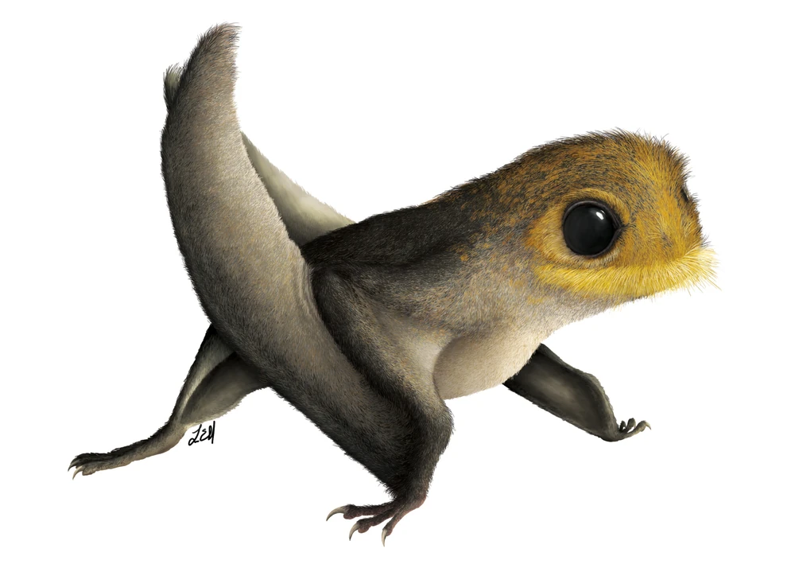
Butterays are deep space manta-sting rays with beautiful butterfly features. Depending on their adapted elements, they can dig through worm holes to travel long distances.
Hickorels is squirrels of various colors who can throw elemental nuts as projectiles depending on their adapted elements. For air elements, they become flying Hickorels.
Kotteroos are white and/or brown kangaroo otters with a belly pouch which can transport many people and things through water, lava, and deep space depending on their adapted elements. Roodew is orange.
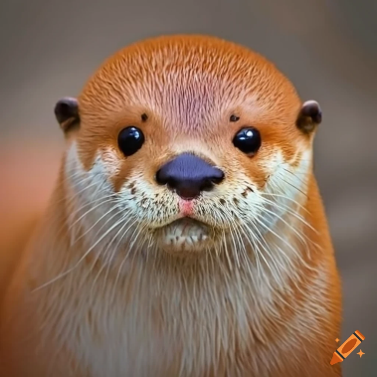

Krameris are parakeets of various colors who can repeat words as vocal messengers. As a hive mind, they are spread throughout the galaxy where a Krameri can telepathically develop a message to another Krameri on another planet so long as they are both adapted to their respective elements.
Tanninos are deep space whales who can dig through worm holes to travel long distances.
Waparays are deep space manta rays that can burrow into the fabric of spacetime for intergalactic travel. They assist starships in space travel.

ZOOSTARS AND ZOOKEYS
Type | Time Limit | Advantages and Features
A-ZooStar | 1 Minute | Easiest and inexpensive to create
B-ZooStar | 2 Minutes | Better than A-ZooStar
C-ZooStar | 3 Minutes | The timer can add time with A-ZooStars
D-ZooStar | 5 Minutes+ | The timer can add time with B/C-ZooStars
E-ZooStar | None | The inescapable model for guaranteed taming
Dark ZooStar | Random | 50/50 chance it knocks out Shoku / Kaleidon
Below is a ZooKey that tagged a Kotteroo with blue, light blue, and a dash of red colors to symbolize their proficiency in water, ice, and some fire tasks.
If a master Shokusan pairs two ZooKeys together, they can bring about a chimera effect and fuse two Kaleidons. Below, if Kotteroo infuse with (Upside Down Triangle 2), they temporarily form (Right-side Up Triangle), the Master ZooKey.
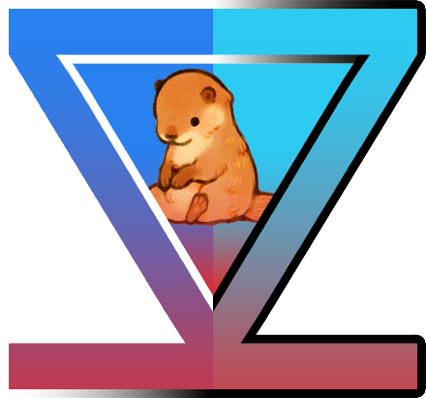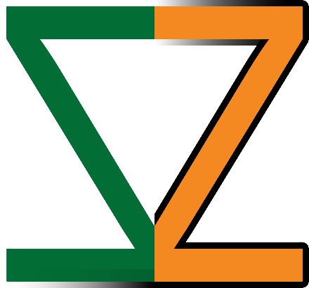

THE OLIVO GALAXY
One of trillions in the observable universe, the Olivo Galaxy spans 120,000 light-years across four rotating arms. At its heart lies the Olea Center, a supermassive black hole orbited by hundreds of billions of stars and billions of habitable systems. This vast expanse is home to countless star systems and sentient species.
Throughout its history, the Olivo Galaxy has been the backdrop for shifting politics, trade, and war. It has seen the rise and fall of major eras like the Luna Kingdom and Stars United, and today serves as the home of powerful megacorporations like Mooncat Ventures and diverse cultural groups like the Shoku.

GEOGRAPHY
Core (Caelum)
- Amaryis: A cosmopolitan planet; home to the Drydens
- Halia Leuco: The cosmopolitan headquarters planet for Mooncat Ventures
- Sinam: The homeworld of Octavia and Otto Kuro
Grand Design Spiral Primary Arms
Dexiosis
- Soci: A planet housing Cape Weaver, the secret base of the Sundog Movement
Ferrum
- Foxtrot: A planetoid and the homeworld of Sundog Director Shin Fayette
Saluto Albanoi
- Bering: A forest planet
- Jogi: A pastoral amber moon orbiting Bering; the childhood home of Hiko
- Humedon: An aquatic planet and the original homeworld of Hiko and Auda Waldew
Saluto Romanus
- Anchia: A planet serving as the secret base for the Kloya Realm
Other Regions
- Oysta: A subtropical planet and the former capital of the Kloya Order; currently the headquarters for StarZoo Galaxy
- Terria Mixa: A gas giant planet and homeworld of Belka and Strelka Muttnik

GOVERNANCE
Stars United
Head of State: Tiger Minister Eldrick Xotic
Head of Government: Monkey Minister Goodall Foss
Ministers (in rotation): Cat (Successor for Head of State), Dragon, Snake, Horse, Goat (Predecessor Head of Government), Monkey (Current Head of Government), Rooster (Successor for Head of State), Dog, Pig, Rat, Ox (Predecessor Head of State), Tiger (Current Head of State)

MILITARY
Olive Army
Olivo Intelligence
Olivo Navy

SECTS
Fire Toad Clan
Green Lion Berets
The Kloya Realm (extinct)
- Soulkiller Syndicate
Mooncat Ventures
The Shoku Order
Sundog Movement

EXPRESSIONS
- “Mind your horizon”
- “You can teach sun dogs moon tricks”
- “Save my sunlight for your moonlight.”

THE SHOKU ORDER
Shoku means “eclipse” in Japanese.

MASTERY
Shokunami (Trainer / Eclipse Cadet)
An individual who has earned the trust of a Kaleidon.
Shokurai (Guardian / Eclipse Guardian)
A Shoku can channel the Kaleidoscape (a spiritual realm that holds the knowledge, skills, and energy of their companion Kaleidon).
Shokusan (Master / Eclipse Artisan)
With their Kaleidon companion, a Shoku can channel the Teleidoscape (a spiritual realm that holds the collective knowledge, skills, and energy of Kaleidons around the galaxy).

KALEIDOSCAPE
The Kaleidoscape is a localized spiritual dimension that exists between a Shoku and their Kaleidon companion. When trust is earned, a Shoku gains access to this realm, allowing them to channel the creature's elemental knowledge. It functions like a shared mental library; a Shoku can borrow the lived experience of their companion to perform feats like telekinesis or elemental bending.
If this bond is corrupted (like by a Soulkiller), the Kaleidoscape can become a hellish landscape, driving the trainer to madness and physical harm.

TELEIDOSCAPE
The Teleidoscape is the Great Beyond or a collective cosmic consciousness that links every Kaleidon across the entire galaxy. It is a spiritual root system. Because Kaleidons adapt to their habitats, the Teleidoscape contains the soul of the galaxy's climate, geography, and history. Only a Shokusan can tap into this. While the Kaleidoscape is a private conversation, the Teleidoscape is a galactic broadcast, allowing a Master to draw on the collective skills of all Kaleidons simultaneously. Accessing the Teleidoscape allows for instantaneous intergalactic communication or the manipulation of spacetime itself to create wormholes for travel.

SUNDOG MOVEMENT
Founder: Mona Zemut
Secret Base: Cape Weaver, Planet Soci, Dexiosis Region.
Director: Shin Fayette
Membership: <4,000 members (active/inactive)
Motto: Conserve Energy, Preserve Harmony, Deserve Community.
Sundog Movement is an animal rights organization, especially for Kaleidons. The organization's open rescues tactics have been credited with drawing attention to animal rights issues, but have also been widely criticized for their disruptive nature and their own member’s companionship with Kaleidons and use of their cosmic powers.

HISTORY
Pre-Defection
The movement’s origins trace back to the end of the Thousand Years’ War. Shokusans and inventors Mona Zemut and Paca Relot created ZooStars and ZooKeys to harness Kaleidon power, helping Stars United win. After the war, the duo founded Sun-Moon StarZoo, a galaxy-wide network intended to protect Kaleidons and educate the public.
The alliance shattered when Mona’s son, Sunny, was killed by an AutoGato trying to steal his Kaleidon. Devastated and disillusioned, Mona released the animals from several StarZoos and defected.
Founding
Mona founded the Sundog Movement to liberate the Kaleidons. Her former partner, Paca Relot, rebranded their original organization as Mooncat Ventures. Despite their bitter rivalry, Paca continues to credit Mona as a co-founder of the original StarZoo.
Now
Under the current leadership of Director Shin Fayette, the movement has shifted from a simple rescue group into a controversial insurgent force.
In a cruel twist of irony, the Sundogs' primary mission to spread liberated Kaleidons across different worlds is exactly what the Kloya Realm needs. By distributing these creatures, the Sundogs are unknowingly rebuilding the Kloya's spiritual root network, helping their ancient enemies regain a foothold in the galaxy.

HIERARCHY
Neb Level: Swabbies
Red Level: Mates (Belka Muttnik, Strelka Muttnik)
Giants: Quartermasters
Neutrons: Top Dog (Shin Fayette, Raven Teachout)

MERCENARY
Canine Raiders / Sundog Fighters / Outsiders

Automatons
PerroMatons

MAIN CREW
Hiko Waldew (The Hero/Shokunami) – A 12-year-old boy from the moon Jogi. He begins as a bug catcher and grows into a Shokusan, a master of connecting with Kaleidons.
Roodew (The Loyal Companion) – A Kotteroo and Hiko’s companion. As a Kaleidon, she can shapeshift, enlarging her body to carry passengers or minimizing to wrap around Hiko's neck like a scarf. She speaks by barking “roo.”
Raven Teachout (The Mentor) – An intellectual, koala alien and former engineer. She has the deepest connections with Kaleidons.
Jamini (The Communication and Navigation Robot) – A child-sized Jambot created by Raven. This robot has a cassette-tape head and is equipped with scanners, medical dispensers, and holograms. Raven assigns them to teach Hiko to be a Sundog raider.
Belka & Strelka Muttnik (The Guardians) – Twin sisters from the planet Terria Mixa. They are considered the galaxy’s finest dogfighter pilots and operate with their own Kaleidon companions, Shadow Tail and Bright Cheeks.

MOONCAT VENTURES
Founder: Paca Relot
Headquarters: Planet Halia Leuco, Caelum Region.
President: Octavia Kuro
Membership: ~9,000,000 members, alumni, or allies
Motto: Observe Entropy, Reserve Colony, Deserve Sovereignty.
Mooncat Ventures is a megacorporation headquartered in the cosmopolitan planet of Halia Leuco. The corporate empire owns and operates 90,000 recreational destinations in the Olivo Galaxy, including thousands of theme worlds and water worlds. Notable brands within its portfolio include StarZoo, MeteorShower, and GardenWorld.

HISTORY
The Innovation Era
The foundation began with the partnership of Mona Zemut and Paca Relot. Together, they invented ZooStars and ZooKeys, breakthrough tagging devices designed to harness the cosmic power of Kaleidons. This technological leap was the decisive factor that allowed the Olivo Navy to win the Thousand Years’ War against the Kloya.
Sun-Moon StarZoo
Following the war, Paca and Mona founded Sun-Moon StarZoo. Their original mission was noble: to create intergalactic sanctuaries that saved Kaleidons and educated the galaxy about their unique abilities. This period established the framework for the diplomatic domestication of cosmic creatures, helping devastated worlds heal.
The Great Schism
The organization was torn apart by tragedy when Mona’s son, Sunny, was killed by an AutoGato during an attempt to capture his Kaleido. Devastated, Mona defected, released the animals from many facilities, and founded the Sundog Movement.
Rebranding
In the wake of Mona’s departure, Paca rebranded the parent organization as Mooncat Ventures. Under his leadership, the company shifted toward a more corporate and political focus. Their mission is to use educational zoos for profit and to gain political influence. They view Kaleidons as vital tools for galactic stability, education, and trade. Despite their rivalry, Paca continues to credit Mona as a founder of StarZoo.
Now
Today, Mooncat Ventures is a massive corporate empire with millions of members and allies. While they claim to provide order and peace, they are locked in a war with the Sundog Movement, struggling to maintain their vision of a controlled, civilized galaxy.

HIERARCHY
Crescent Level: Grunts
Half Level: Elites
Gibbous Level: Bosses
Full Level: Director (President Octavia Kuro currently holds executive power)

FACTIONS
Calico: Settlers
Tabby: Poachers
Tuxedo: Merchants

SECURITY
Mercenary
Marine Felines
Mooncat Warriors
Insiders

Automatons
GatoMatons (Robot Cats, equipped with weaponized tails – electric, fire)
AeroGato (Catlike Robot Planes)
AutoGato (Catlike Robot Copters)
AstroGato (Catlike Robot Starships)

MAIN CREW
Shelley Dryden (The Villain), Neva (The Loyal Companion), SAMU-Z (The Mech Robot), Auda Waldew (The Mentor/Step-Mother)

STARZOO
Founders: Paca Relot, Mona Zemut
Purpose: Conservation, Ecology, Education
Headquarters: Planet Oysta, Kloy Region
Number of Locations: 350+
Area Served: Galaxywide
Key People: Su Lin (President)
Parent: Mooncat Ventures
Mascot: ZooZoo the StarKeeper
StarZoo is an Olivo Galaxy zoological garden chain with headquarters in Oysta, the former capital planet of the Kloya Order. It is a proprietor of land parks, oceanariums, orbital theme parks, and rehabilitation centers owned by Mooncat Ventures. The zoos host shows starring powerful and fanastical creatures, especially Kaleidons, as well as zoological displays featuring various other nearly extinct species from dead planets.

LOCATIONS
StarZoo Galaxy
Location: Oysta, subtropical planet in Kloy Region
General Manager: Kandu Mashu
Theme: Endurance and Victory
Slogan: “First and Forever.”
StarZoo Amaryis
Location: Amaryis, cosmopolitan planet in Caelum Region
General Manager: Marius Dryden
Theme: Deep Space Adventure and Exploration
Slogan: "Deep space is not as deep as you think!"
StarAquarium
Travelling Aquarium
General Manager: Orca Katina
Theme: Deep Sea Adventure and Exploration
Slogan: “There is water in space!”
KLOYA REALM / SOULKILLER SYNDICATE
Secret Base: Planet Anchia, Saluto Romanus Region
Leader (Sol): Sol Cynarch

HISTORY
The Kloy Dwarf Galaxy
The Kloya Order governed Kloy Galaxy with organic technology. Their power stems from a spiritual bond with Kaleidons, who grant them bending abilities. By dispersing these creatures, the Kloya created a spiritual root across the galaxy, allowing them to track the movements and elemental shifts of entire worlds.

The Olivo-Kloy Merger
When the Kloy Dwarf Galaxy was absorbed into the larger Olivo Galaxy, a diplomatic standoff occurred between the Kloya and the Stars United (SU) government. While SU voted to annex the Kloya with political representation, the Kloya fought to remain an independent sovereign power.

Thousand Years’ War
The conflict turned into a full-scale war after SU invaded the Kloya capital, Oysta. Initially superior to the Olivo Navy, the Kloya used Kaleidons as living weapons to conquer star systems. SU founded the Shoku Order to harness Kaleidon energy. Inventors Mona Zemut and Paca Relot developed ZooStars and ZooKeys, technology that allowed SU to capture and use Kaleidon power for themselves. This technological shift allowed the Olivo Navy to crush the Kloya Monks and dismantle their Order.

In the Shadows
Though defeated, survivors and Kloya sympathizers rise in its place. The Soulkiller Syndicate is a new order where its members (Soulkillers) can form literal spiritual connections to Kaleidons. They use Kaleidons to manipulate the minds of weak-minded Shoku. For example, a master Soulkiller can convince a fire Kaleidon to drive their Shoku insane, getting them from kaleidoscape to a hellish scape. If taken too far, the victim may combust into flames. An ice Kaleidon can cause their Shoku to get petrified. A water Kaleidon can lead their Shoku to drown in their own vomit.
STAR ZOOS
WILD AND FREE

LOGLINE
To save a galaxy of endangered Kaleidons, a young bug catcher and his shape-shifting otter join Sundog Movement dogfighters to take down Mooncat Ventures, a corporate empire using zoos to gain power.

SYNOPSIS
In a galaxy where Kaleidons power starships and alter reality, two rival factions fight for the future of wildlife. Star Zoos is a space-opera saga that follows the conflict between the Sundog Movement, a band of dogfighters who liberate animals from captivity, and Mooncat Ventures, a corporate empire that put beasts in zoos for public entertainment and political influence.
Star Zoos follows characters like Hiko Waldew, a bug-catching moon dweller whose friend is a shape-shifting otter named Roodew. Swept up by Sundog dogfighters, he learns to harness a Kaleidon’s cosmic energy to boost starship weapons and defense systems. Under the mentorship of engineer Raven and robot Jamini, Hiko becomes a formidable raider dedicated to the movement’s cause.
Standing against him is Shelley Dryden, a Mooncat leader who views Kaleidons in zoos as vital tools for galactic stability and education. As Hiko and Shelley trade blows, a darker shadow known only as Kloya waits in the wings to turn their beloved companions into ultimate weapons for galactic domination.

PLOT SUMMARY
Prologue:
Twelve years ago, Auda Waldew fled a violent palace coup on the planet Humedon, escaping into space with her infant son, Hiko.

Act 1:
Twelve-year-old Shelley Dryden attends the grand opening of her father’s intergalactic zoo on the cosmopolitan planet Amaryis. The celebration goes awry when Sundog raiders infiltrate the facility and release the animals. An otter maims her father, Marius, a candidate for ArchGovernor. This sparks a galactic conflict between the Sundog Movement, who fight for animal liberation, and Mooncat Ventures, which promotes the diplomatic domestication of cosmic creatures called Kaliedobeasts.
Back on Jogi, Auda gifts twelve-year-old Hiko his own ship. During a flying lesson where Auda trails, he disables his ship’s limited features and ventures into space. He confronts a freighter, housing an otter, piloted by a bitter Shelley. She shoots down Auda’s dogfighter. Enraged, Hiko rams her ship, causing them to crash onto the planet Bering.
In the aftermath, he rescues a shape-shifting otter, Roodew, then get beamed up by the Sundog sisters and the galaxy’s finest dogfighters, Belka and Strelka. Meanwhile, Auda survives and discovers Shelley trapped in her escape pod. Auda hides Shelley from predators until an extraction team arrives. Shelley finds out her father won the election to be ArchGovernor of Amaryis.

Act 2:
The Sundogs send Hiko to their secret base, Cape Weaver on Soci. Under the guidance of tech expert Raven and her robot Jamini, Hiko starts as a Shokunami (Eclipse Cadet), learning to socket Kaleidon’s energy into ships or mechs for elemental boosts.
Years pass as Hiko rises within the Sundog Movement, believing his mother is dead. Simultaneously, Shelley becomes a leader within Mooncat Ventures. When Marius is elected ArchGovernor of Amaryis, the Drydens integrate Auda into high-society life.

Act 3:
The Sundogs raid a Mooncat orbital aquarium. As Shelley’s forces ambush Sundog squadron, Hiko is the only one to infiltrate the station. Inside, he is shocked to find his mother alive, dating Mooncat leader Marius Dryden. Choosing her happiness over his own, he leaves her be. While trying to flee in disguise, Shelley intercepts him and an epic battle erupt. While Marius fends off Roodew, Auda intervenes to protect Shelley, unknowingly fighting her own son. Sensing Hiko in mortal danger, Roodew critically wounds Auda, leaving her unconscious. Recognizing Hiko from Auda's descriptions, Shelley offers a truce: she will use her influence to get Auda the best care if Hiko retreats. Hiko agrees, escaping with the liberated Kaleidons.
Hiko returns as a celebrated and promoted Shokurai, while Auda marries Marius. This makes Hiko and Shelley siblings on opposite sides of the stars.
CAST OF CHARACTERS

SUNDOG MOVEMENT
HIKO WALDEW is a 12-year-old human boy from Jogi, a pastoral amber moon of planet Bering. He spends nights dreaming of the stars until one day getting the chance to join Sundog Movement, whose mission is to save Kaleidons on doomed planets by sending them to sanctuary worlds or freeing them from captivity.
ROODEW is a Kotteroo and the companion of Hiko. As a Kaleidon, she can enlarge her body to carry passengers, minimize to wrap around necks like a scarf, and morph to fit anywhere. She speaks by barking “roo.”
JAMINI (JAM-Δ-SON MINI) is a Delta-series child-sized Jambot and Raven’s creation, designed for communication, documentation, navigation, and equipped with scanners, first aid dispenser, jetpack thrusters, spotlight, and slicer. Their cassette-shaped head has eye holes for holograms. Raven has this groovy robot teach Hiko to be a Sundog.
RAVEN TEACHOUT is a brilliant koala alien and former JAMBOTICS engineer. Recognizable by her oversized triangular goggles, she possesses the galaxy’s deepest spiritual connection to Kaleidons and can solve any mechanical or cosmic puzzle.
BELKA MUTTNIK is a Terrian female and one of the galaxy’s finest dogfighter pilots. Their Kaleidon is Shadow Tail, a flying hickorel. She is Strelka’s twin sister.
STRELKA MUTTNIK is a Terrian female and one of the galaxy’s finest dogfighter pilots. Their Kaleidon is Bright Cheeks, a flying hickorel. She is Belka’s twin sister.
DOCTOR BU NATI is a tigerlike humanoid female from the planet from Salgari who serves as the Sundog Movement's primary medical authority for both crew and Kaleidons. From anywhere, she directs Jambots’ medical dispensers and scanners.
SHIN FAYETTE is the visionary director of Sundog Movement. As a Houndi from the planetoid Foxtrot, she views wildlife as relics rather than resources. She leads with a philosophy of radical environmentalism. She believes that to save a species, one must erase civilization to ensure Kaleidons remain wild and free.
MONA ZEMUT is an eight-foot-tall Danet with her Great Dane face. Alongside Paca Relot, she founded StarZoo before defecting and founding Sundog Movement. Her name is an anagram of Montezuma.
ABLE ENOS & BAKER HAM are Belka and Strelka’s mentors. Long before Hiko joined Sundog, they lost their lives during a dogfight with Mooncat Ventures.

MOONCAT VENTURES
SHELLEY DRYDEN is a 12-year-old human girl from the cosmopolitan world of Amaryis in the Caelum region. As her father campaigns for governorship, she prepares to take her place as a leader in Mooncat Ventures, committed to a vision of an orderly galaxy where Kaleidons serve a greater purpose for peace and education.
NEVA is a shape-shifting anuro or flying frog, who often transports Shelley along with other passengers. She is a native of Bering, where Shelley and Auda find her.
SAMU-Z is a Zeta-series mech robot and friend of Shelley, designed to wrangle large animals, transport dangerous objects, and be pilotable through most conditions.
SYLVIA JOOGII LONG is a longtime Mooncat translator who poses as a liaison to infiltrate zoos with the intention of training and turning Kaleidons into Zootec cyborgs for galactic domination. To give her parakeet Flint agency, she often lets him do all the talking. Her secret identity may be Csar Cynarch of Kloya.
KARAMOJO DALRYMPLE is the galaxy’s finest big-game hunter. He is directly involved in the eliminations of dozens of Sundogs.
ORCA KATINA is a general manager of the orbital StarAquarium.
MARIUS DRYDEN is Shelley’s father. He is soon elected as the ArchGovernor of the cosmopolitan planet of Amaryis.
OCTAVIA KURO is the President of Mooncat Ventures. From Sinam, She is Otto’s Siamese twin sister.
OTTO KURO is Octavia’s Siamese twin brother from Sinam.
PACA RELOT is an eight-foot-tall Shirazin with his Shirazi cat features. Alongside Mona Zemut, he founded StarZoo. When Mona defects to start Sundog Movement, Paca forms the parent company, Mooncat Ventures. His name is an anagram of Cleopatra.

OTHERS
AUDA WALDEW is Hiko’s mother. She was a member of the royal family on Humedon, where she spent much of her free time flying starships, pretending to be in dogfights.

HIKO WALDEW

Hiko Waldew is a legendary human male Shokusan and a dedicated raider for the Sundog Movement. Alongside his shape-shifting otter, Roodew, and his robot companion, Jamini, he fights to liberate Kaleidons from the exploitative Mooncat Ventures and resists the technological tyranny of Kloya.
Born into royalty on the aquatic planet Humedon, Hiko’s life is upended by a war on water, forcing him and his mother, Auda, to flee to the moon Jogi. At age twelve, his lonely mother lets him fly her dogfighter while she trails him. But he disables the child-proof mechanism and flies past the atmosphere into space. As they come across a freighter starship near Bering, it shoots down his angry mother. Enraged, he collides into the freighter, sending both ships crashing onto the forest planet Bering.
There, he rescues an otter and gets saved by Belka and Strelka, Sundog pilots looking to recover intel. The caninoid sisters see him as a Mooncat member’s child who can be ransomed. A Mooncat squadron soon ambushes them and Hiko watches as the sisters socket their Kaleidon’s power to dogfight. He earns their trust by aiding in their victory. He finds the otter shapeshifted to nap in his shirt pocket. He names her Roodew.
The Sundogs take Hiko to their secret base in Soci. There, he learns about the Sundog Movement. Sundog engineer Raven Teachout gifts him her robot Jamini, who spends year training Hike from a reckless cadet into a formidable insurgent. On his first solo mission, he barely takes down a poacher but loses track of her ship with Kaleidons. The Sundogs see it as weakness. Meanwhile, Jamini translates Roodew’s wisdom and encouragement.
His journey reaches a turning point during a raid on a Mooncat orbital aquarium. Shelley’s team incapacitates his squadron but he crash lands. There, he finds his mother alive and on a date with the Mooncat leader Marius Dryden. Hiko disguises himself, deciding to let her find love. Shelley finds him trying to beam up Kaleidons and they engage in an epic battle. Auda interferes, unknowingly fighting her son. His familiar cry distracts her, and Roodew critically wounds her, leaving her unconscious. He faces a dilemma where if he saves Auda, the Sundogs will lack health care and treat them as threats to the movement. Shelley promises to use her influence to get her care, especially since Auda saved her life. He escapes with the Kaleidons.
Hiko returns to the Sundog Movement, where they ceremoniously promote him to Shokurai, unaware that his mother's concurrent wedding to Marius has made his enemy, Shelley, his stepsister.

Homeworld: Jogi, moon of planet Bering, Saluto Albanoi region of Olivo Galaxy
Born: Humedon
Species: Human
Gender: Male
Pronouns: he/him
Family: Waldew family
Parent(s): Auda Waldew
Companion(s): Roodew (Otter), Jamini (Robot)
Starship(s): Husky (Fighter), Malamutar
Affiliation(s):
Sundog Movement
- Alaskan Squadron
SHELLEY DRYDEN

Shelley Dryden is a human female Amaryan who advocates for Kaleidons to be used for education and diplomacy. Alongside her flying frog Neva and mech SAMU-Z, she serves as a leader within Mooncat Ventures. Though she expands an exploitive corporation that captures cosmic creatures, she also serves as a revolutionary fighting against Kloya.
Born on the cosmopolitan planet Amaryis, Shelley is the daughter of Marius Dryden, a former peasant whose rise within Mooncat Ventures led to his election as ArchGovernor. Her life changes at age ten during the grand opening of an intergalactic zoo. A raid by Sundog insurgents resulted in an otter maiming her dad.
In the aftermath, she attempts to transport the captured otter to the unsafe planet Bering. Her freighter is intercepted by dogfighters. With Kaleidon’s socket, she shoots down a ship. The remaining pilot collides with her, causing them both to crash.
She uses an escape pod, but a cliffside collision knocks her unconscious. She is saved by Auda Waldew, who shares her meager rations and protects her from apex predators. At one point, they survive by eating a winged Kaleidon and their aquatic eggs, sparing one.
A drone eventually traces her beacon. After their extraction, Shelley’s father was elected ArchGovernor, partly due to public sympathy following the raid and his daughter’s disappearance. In gratitude for Auda's help, she and her father pledge Amaryis special forces and Mooncat resources to help find Auda’s son, though the search remains unsuccessful for years.
In that time, Shelley’s father falls in love with Auda as she settles in a new life in Amaryis but have the familiarity of royalty return to her. The egg Shelley kept from Bering hatches into a frog whom she names Neva. Neva grows into a shape-shifting flying frog.
On an anniversary, Marius and Auda go on a date to an orbital aquarium full of her favorite Kaleidons. Shelley and her team, prepared for an ambush, immobilizes a Sundog squadron but Hiko gets through. She catches a disguised Hiko. They engage in an epic battle which Auda interferes in, leaving Marius to defend himself against Roodew. Then Roodew intersects Auda, leaving her unconscious and critically wounded. Recognizing Hiko from Auda’s descriptions, Shelley allows him to escape with the Kaleidons, promising to use her influence to ensure Auda obtains life-saving medical care. She keeps this a secret from Auda.
Following Auda’s marriage to Marius, Shelley and Hiko became secret siblings, bound by a shared mother while remaining on opposite sides of the stars.

Homeworld: Amaryis, Caelum central region of Olivo Galaxy
Born: Amaryis
Species: Human
Gender: Female
Pronouns: she/her
Family: Dryden family
Parent(s): Marius Dryden
Companion(s): Neva (Flying Frog), SAMU-Z (Mech Robot)
Starship(s): Coony (Freighter)

Affiliation(s):
Mooncat Ventures
- Maine Squadron

