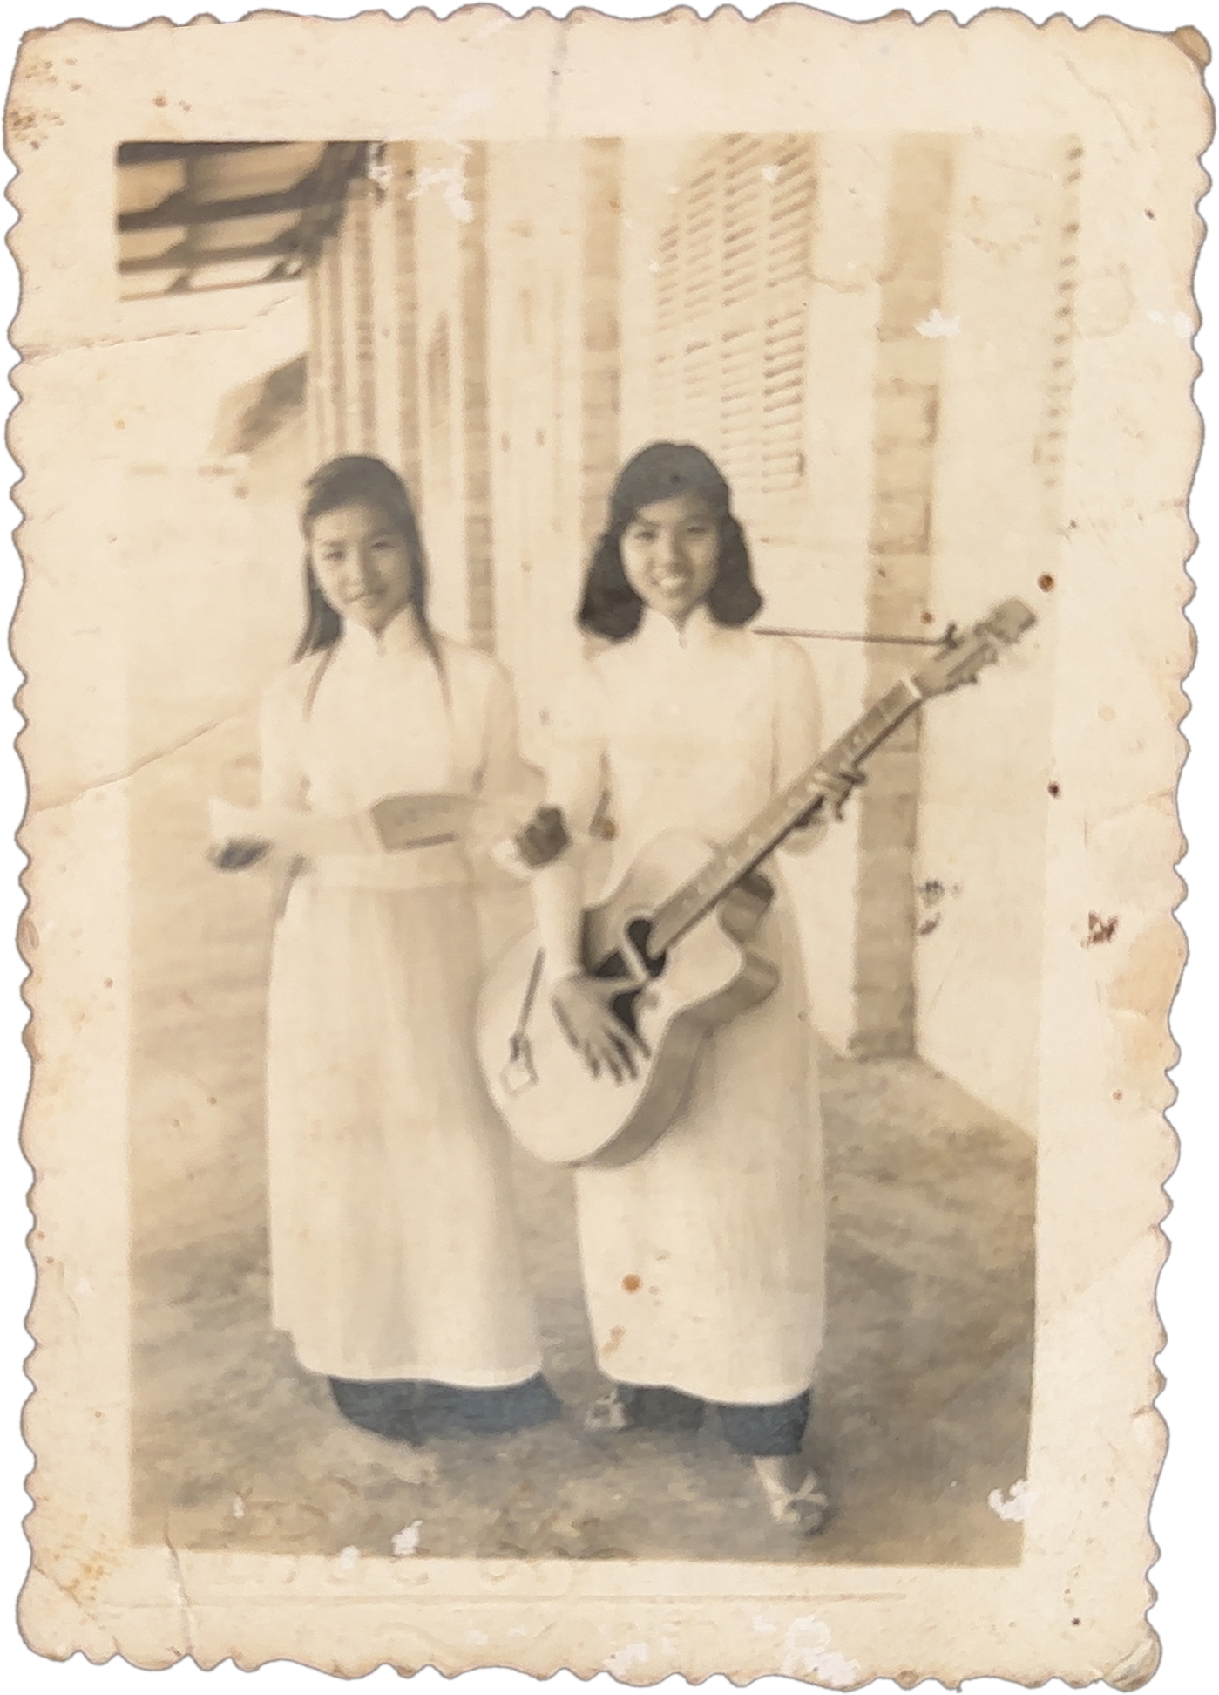

Tempo

A Folk-Rock Musical
by David Quang Pham
based on the life of Grandma and Great Aunt
SYNOPSIS
Dakota, a lonely Midwestern musician, must fulfill Grandma Jessica’s dying wish to reunite with her sister Lorenza, who went missing during a war long ago along with her music. In a region known as The Middle, their search takes a turn upon hearing a Middle Eastern poet sing Lorenza’s songs at her temple. Tempo explores themes of temporary love and pain, and music as a temple of memory and reconnections.
The show uses a form of storytelling in which Dakota’s story is told in chronological order (starting when Dakota finds out about Grandma Jessica’s dementia) and Jessica and Lorenza's story is told in reverse chronological order (beginning the show when the War separated them, fifty years ago). It plays with time (or tempo in Italian).
This story is inspired by David Quang Pham’s grandma and great aunt, who sold their guitar and music dreams to survive poverty after the Vietnam War. Grandma stayed in Saigon while Great Aunt gone nomad.
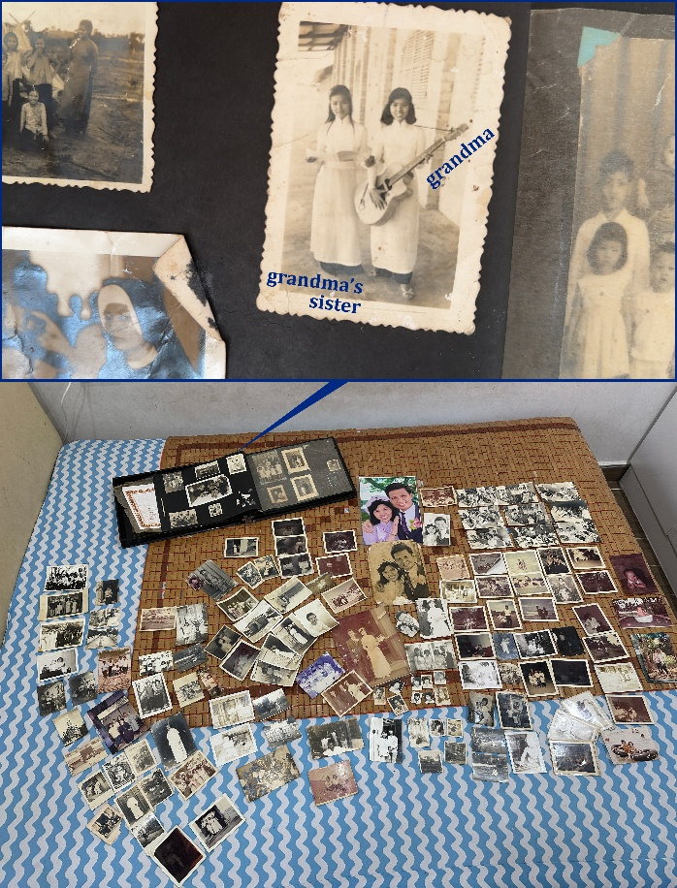
October 2025: On his first-ever visit to Vietnam, David finally meets his Bà Nội.
PLOT SUMMARY
Half a century ago, songwriting sisters Jessica and Lorenza performed music in a region simply known as The Southeast. Then, the East War broke out. The Northeast conquered The Southeast and unified the regions into Easter. The War separated the sisters (“Nothing Lasts”).
Today, Dakota F. Chéry, or “Kota,” is a lonely musician in The Midwest. Upon hearing Grandma Jessica’s dementia is growing more severe, Kota visits Easter to meet her in person for the first time (“Sunrise”).
In the past, Lorenza gives Jessica her fixed Moon guitar before playing their last concert together in the contentious Northeast region (“The Moon Set”).
In the present, Jessica shares the concert’s photos. She wishes to reconnect with her missing sister… if she is still alive (“Mama Wants, Mama Gets”).
In the past, Lorenza searched for Jessica, who ran off after a recent fight. Upon finding, Lorenza comforts her (“Out of Tune”).
In the present, Kota jots down what Jessica remembers of Lorenza’s lyrics. Kota asks the online community for help. Folks in The Mideast recognize the lyrics. Kota and Jessica pay the region a visit (“The Lyrics Linger”).
In the past, Lorenza wanted her family to move to The Midwest for safety, but Jessica declined. So, Lorenza decided to go on a solo career. In a fight, they broke the Moon guitar causing Jessica to run away (“Crescent”).
In the present, Dakota hopelessly observes poet Tabitha Galili, or “Tab,” doing crowd work in the street. Tab asks for Kota’s full name. “F. Chéry” reminds Tab of “Hakol Efshari,” which means “Anything is Possible” in Hebrew. Tab invites Kota to a music poetry slam later that night (“אֶפְשָׁרִי”).
In the past, Jessica and Lorenza devised songs in a songwriting session. It often did not go well, as one sister is for liberty and the other is for safety. It was their concern as the East War grew imminent (“Liberty nor Safety”).
In the present, when the musician could not make the poetry slam due to an injury, Kota steps in. With Tab, their chemistry engages the audience. The public starts knowing them as Tab and Kota, before establishing themselves as the Midwest-Mideast duo, Tab and Coda (“Tab and Coda”).
Meanwhile in the past, Jessica and Lorenza were popular for their folksy hit single about living life to the fullest as they tour The Midwest, Northwest, and Southwest (“Life is Over Before You Know It”).
In the present, Tab invites Kota and Jessica to their family’s temple in The Middle (“Meet in The Middle”).
The past-present timelines mesh during the holidays. In The Temple, Tab’s parents sing their love duet. Despite her dementia, Jessica recognizes the lyrics and revisits a holiday memory with her sister (“In Loving Destiny”).
Jessica questions how the couple conceived the song. They reveal they fell in love in a class taught by a Nomad. When conflicts between the North and South escalated, the Nomad asked her protégés to spread her peaceful songs, before disappearing once more. That Nomad sounded like Lorenza. Then, Jessica collapses (“Up to Speed/Slow Down”).
In the past, Jessica and Lorenza were invited to perform in the Midwest to encourage the end of the West War between the Northwest and Northeast. It ultimately became a stalemate. The regions never unified (“Moonrise”).
In the present, Jessica’s dementia becomes so severe that she can no longer travel and is unable to remember basically anything (“Sunset”).
Timelines mesh. The sisters never reunite. However, Jessica receives mail from around the world on behalf of the Nomad, as no one could ever thank her for her wisdom as she often vanished. Jessica realizes Lorenza gave hope to countless folks with her songs. An East War Museum returns her long-lost guitar to her. She passes away, finally forgetting the War and remembering her father giving her and her sister the Moon guitar and songbooks, and knowing that Dakota finally found someone. Soon, Tab and Coda play a concert in hopes of finding Lorenza (“Our Songs Live On”).

MAP (PRESENT)
Northwest North (once Northeast)
Midwest The Middle Mideast Easter
Southwest South (once Southeast)
CAST OF CHARACTERS
DAKOTA F. CHÉRY or “Kota” is a lonely musician from The Midwest. Their parents prevent them from visiting their motherland. But when Grandma Jessica’s dementia becomes severe, Kota sets out to help accomplish her dreams.
TABITHA KETSEV GALILI or “Tab” is a poet and oud player from The Mideast. She lives to meet new people every day and dreams of starting a band.
JESSICA LEGATO is Kota’s grandma who was once a musician before losing her sister and guitar during the East War. She must reconnect with her sister Lorenza before dementia completely takes her. Grandma Jessica is her 84-year-old self.
LORENZA LEGATO is Jessica’s songwriting sister who vanished during the East War at age 20. She has nomadic ties to Tab. If alive today, she would be 80.
ALLEGRA GALILI is Tab’s mother. They run The Temple in The Middle.
LARGO GALILI is Tab’s father. They run The Temple in The Middle.

MUSICAL NUMBERS
1. Nothing Lasts _{Jessica, Lorenza}
2. Sunrise _{Dakota, Grandma Jessica}
3. The Moon Set _{Jessica, Lorenza}
4. Mama Wants, Mama Gets _{Grandma Jessica, Dakota}
5. Out of Tune _{Lorenza}
6. The Lyrics Linger _{Dakota}
7. Crescent _{Lorenza, Jessica}
8. אֶפְשָׁרִי (Efshari, Anything’s Possible) Tabitha, Dakota, Grandma Jessica
9. Liberty Nor Safety _{Jessica, Lorenza}
10. Tab and Coda _{Tabitha, Dakota}
11. Life is Over Before You Know It _{Jessica, Lorenza}
12. Meet in the Middle Tabitha, Dakota, Grandma Jessica, Gveret Galili, Mar Galili
13. In Loving Destiny _{Gveret Galili, Mar Galili}
14. Up to Speed/Slow Down Jessica, Gveret Galili, Mar Galili, Lorenza
15. Moonrise _{Jessica, Lorenza}
16. Sunset _{Grandma Jessica}
17. Our Songs Live On _{Company}
POTENTIAL SONGS
Born in the Wrong Generation
Future Plans
Right Person, Wrong Time
Keep Tabs (on Your Heart)
From the End
Stand Fermata

EZEKIEL is Jessica and Lorenza’s revolutionary father. He passes on his Moon guitar to Jessica and songbooks to Lorenza after his studies in the Northwest.

