**DOCUMENTATION**

* **OBSERVATION**: -

After briefly going through all the files, we have encountered***two severe bugs***and some***typos*** which we referred as **PROBLEM 1, PROBLEM 2** and **PROBLEM 3.**

* **PROBLEM 1**

Initial typo was in the line of including user defined header file. *It was* ***“calc.h” in every .c*** *(CALC.c, PUSHPOP.c, READTOKN.c)* ***files*.**

Furthermore, the character *“*–*” and “*⁄*” Had some issues in the given files.*

* **PROBLEM 2**

The major bug was in the .h(CALC.h) file. There was no ***file guard or header guard*** and as the header file (CALC.h) was included in every .c (CALC.c, PUSHPOP.c, READTOKN.c) files, it was creating *multiple identical copies of the definitions, which caused “****duplicate definition compilation error”.***

* **PROBLEM 3**

In Addition to that, another severe bug was in the file PUSHPOP.c. Where for the function call int push & int pop there should not be any extern keyword.

* **SOLVING PROBLEMS: -**

We Have solved the above problems in the following pages.

* **FIXING PROBLEM 1(typo): -**
* Header file problem:

**Spotted lines**: -

In the file “CALC.c”, line no. **8.**

In the file “PUSHPOP.c”, line no. **6.**

In the file “READTOKN.c”, line no. **7.**

**Case study**: -

In the above mentioned lines the original file contained ‘**#include "calc.h" ’** which was not the correct header file name according to the given header file in the zip .

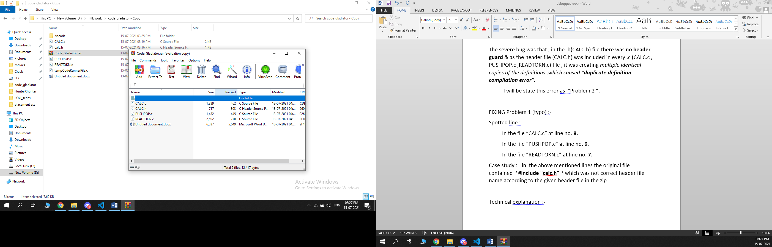

**Technical explanation**: -

As we know that while including the header file the name of the file should be same as defined.

**FIXING THE BUG: -**

we replaced **‘#include "calc.h" ’** with **‘ #include "CALC.h" ’**  in each the file .

* “-” & “/” problem:

**Case Study: -**

we have encountered some issues with this “-”, “/” characters.

**FIXING The Issue**: -

we replaced all the “-” & “/” character by themselves only and the issue was fixed.

* **FIXING Problem 2 (duplicate definition compilation error): -**

**Case study: -**

There was no **header/ file guard in the file calc.h** which caused stacking up multiple identical files in the compile time.

**Technical explanation: -**

As we know that a variable or function identifier can only have one definition (the one definition rule). Thus, a program that defines a variable identifier more than once will cause a compile error.

**FIXING THE BUG: -**

at the begging of the file CALC.h we add

***“#ifndef KEY_H”*** (line 6)

***“#define KEY_H”*** (line 7)

And at the end of the file, we add

***“#endif”***

* **FIXING Problem 3 (extern problem): -**

**Case study: -**

There was extern keyword in the file PUSHPOP.c which was not needed.

**Technical explanation: -**

We have already included the functions in the header file “CALC.h”, so there should not be any extern keyword defining the functions again.

**FIXING THE BUG: -**

We simply delete the keyword “extern” from the line 12 & line 25.

When the header is #included, the pre-processor checks whether KEY_H has been previously defined. If this is the first time we’re including the header, KEY_H will not have been defined. Consequently, it #defines KEY_H and includes the contents of the file. If the header is included again into the same file, KEY_H will already have been defined from the first time the contents of the header were included, and the contents of the header will be ignored (thanks to the #ifndef).

Documentation done by

Soumyajjal Das and Mubashira Rahman

15/07/2021