**Transferring Files on EC2 instance**

|  |  |  |
| --- | --- | --- |
| **Type** | **Size** | **Time(sec)** |
| pdf | 10.8mb | 2.4025 |
| pdf | 35mb | 9.4723 |
| mp4 | 103mb | 24.8064 |
| txt | 1mb | 0.7584 |

**FIG 1.1**

**Transferring File from Single PC**

|  |  |  |
| --- | --- | --- |
| **Type** | **Size** | **Time(Sec)** |
| pdf | 10.8mb | 2.64 |
| pdf | 35mb | 9.4766 |
| mp4 | 103mb | 42.48 |
| txt | 1mb | 0.68 |

**FIG 1.2**

**COMPARISION OF BOTH THE CHARTS**

**FIG 1.3**

**SCREEN SHOTS**

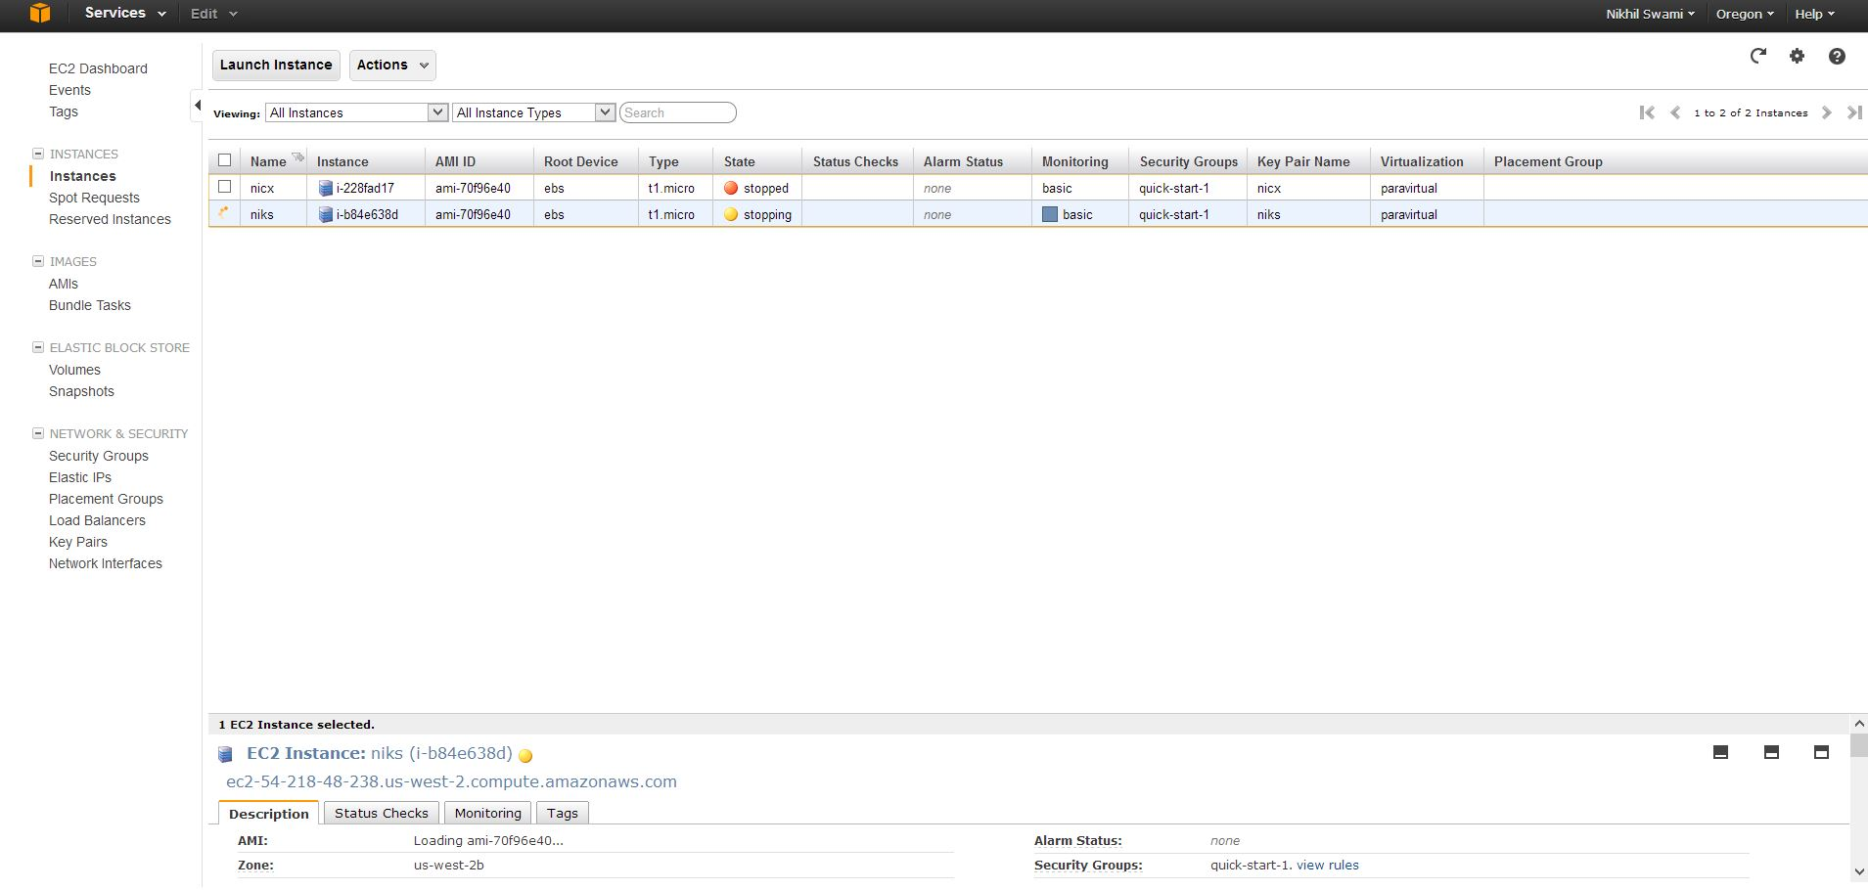

**FIG 1.4**

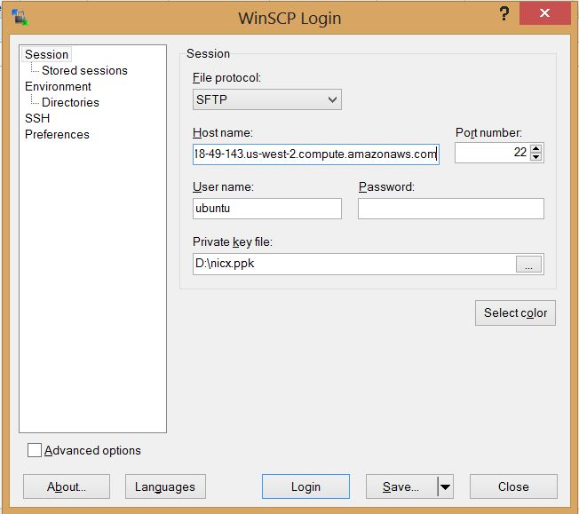

**FIG 1.5**

**fig 1 : individual summary of the time required to access and uploading a file from EC2 instance with timing chart**

**fig 2 : individual summary of the time required to access and uploading a file from local computer with timing chart**

**fig 3 : comparisons of the two timings for different file size and its timing**

**On X axis size of the files.**

**on Y axis time required for a file to upload / access**

**I have used the systems current time to check the performance of S3.**

**It compares the timings of the time upload started against the time upload was completed.**

**For EC2 ,I used a UBUNTU instance and used python and boto installation .**

**I used WinScp, a windows tool to send files from my local machine to my EC2 instance. I sent my Python code along with the file to be uploaded to S3 to my EC2 instance.**

**ANALYSIS :**

**For a file of size 10.8mb it takes 2.6 sec from local machine and 2.4 sec from EC2 instance**

**And for 1 mb file it takes 0.68 sec local machine and 0.75 sec from EC2 instance.**

**RESULT :**

**10.7mb file doesnt takes 10 times the time to upload to that of 1mb file, as connection is once made, process continues till whole file is finished and is quicker.**

**WRITING OR READING?**

**Writing to a file is more time consuming than just accessing the file. There are slight variations on both the machines as per the time required for both the process.**

**It was thou seen that writing a file took less time on EC2 instance than that of local computer.**