Lab Assignment 4

Machine learning (clustering)

Nikhil Swami

1. We have used the results we got form our Assignment 3. We have used the following data:
2. Maximum Temperature per year
3. Minimum Temperature per year
4. Maximum Wind per year
5. Maximum Rain per year
6. We have used the Weka ML library to analyze our data and have visualized this data to get clusters and

have tried to make some inferences from it.

3) Please find below the analysis:

1. Maximum Temperature per year :

Our first cluster pattern was for temperature values for all years in the whole of Texas. Please find below the screen shots for the cluster analysis:

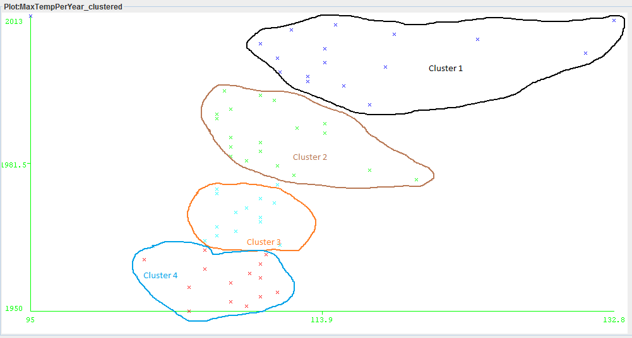

* We can see that during the 1950-1970’s the maximum temperature was around 100F.
* But as time passed the Max temp went up to around 113F and in the 2000-2010 it has risen.
* Also, in 2013 we have a few reading around 132F
* **So we can say that Texas has become a bit warmer as compared to the 1950’s**

1. Minimum Temperature per year

Our Second cluster pattern was for minimum temperature values for all years in the whole of Texas. Please find below the screen shots for the cluster analysis:

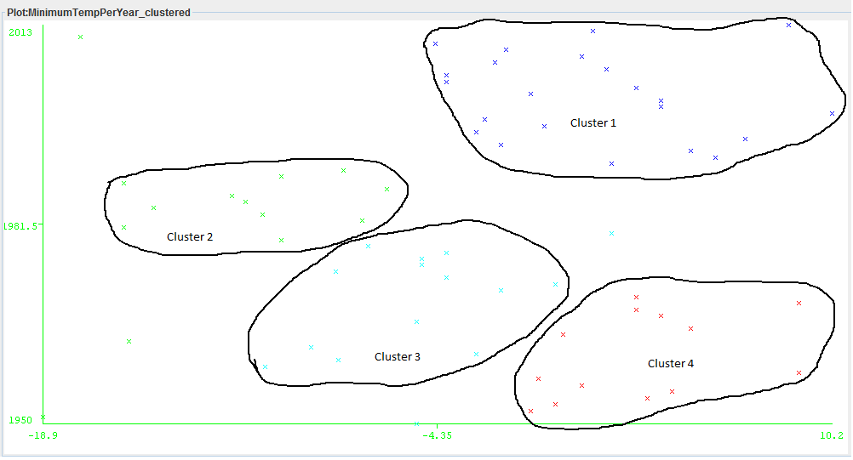

* We can see that during the 1950-1970’s the minimum temperature was around 2F.
* But as time passed the Min temp went down during 1980-1990’s to around -9F and in the 2000-2010 it has risen to the same as in the time period of 1950-1970’s.
* The temperature has varied in the past few decades and it has become relatively cooler than 1980’s.
* **So we can say that Texas has become a less colder as compared to the 1980’s**

1. Maximum Wind per year

Our third cluster pattern was for maximum wind values for all years in the whole of Texas. Please find below the screen shots for the cluster analysis:

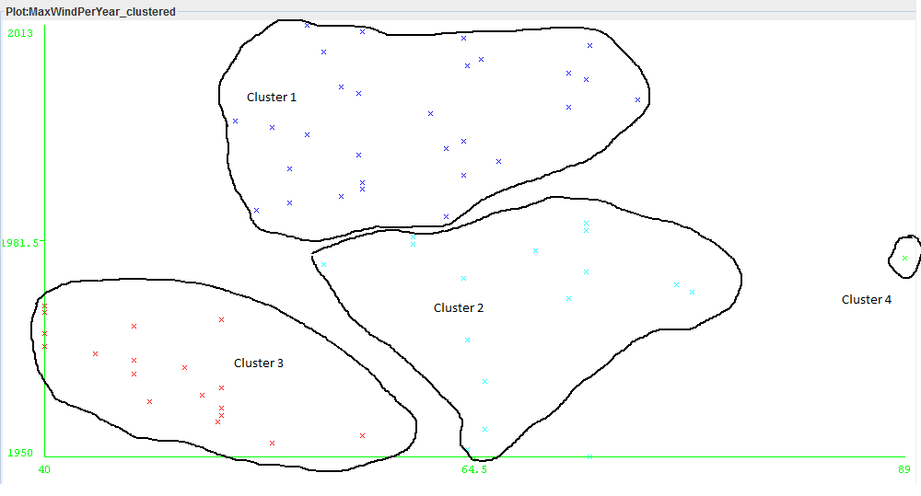

* We can see that during the 1950-1980’s the maximum wind varied between 40-70 knots.
* During 1980-2013’s the maximum wind speed has gradually increased but has hovered between 50 and 70 knots.
* There has not been much change in the Wind speed in the past few decades.
* **So we can say that Texas has been windier as compared to the 1950’s but in the last 4 decades it is somewhat constant.**

1. Maximum Rain per year

Our third cluster pattern was for maximum rain fall values for all years in the whole of Texas. Please find below the screen shots for the cluster analysis:

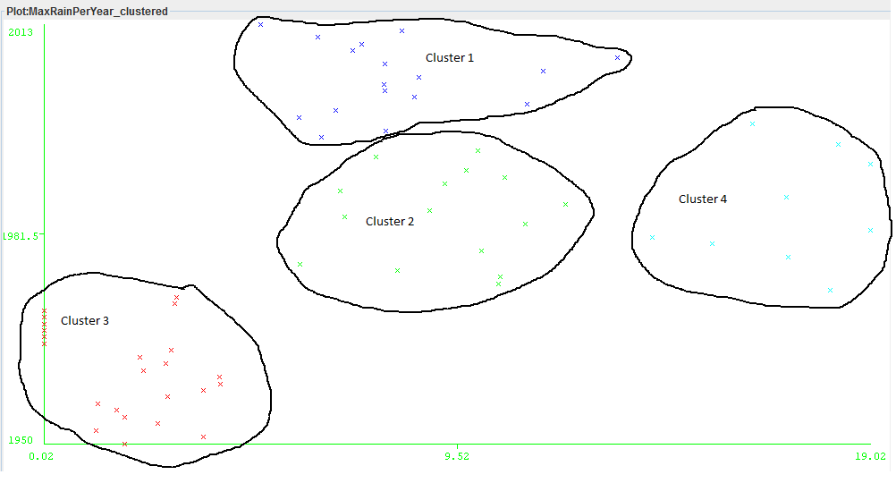

* We can see that during the 1950-1970’s the maximum rainfall recorded was around 0.02-3 inches.
* During 1980-1980 the maximum rainfall has almost twice from the 1950-1970’s hovering between 6-18 inches.
* Interestingly, the rainfall has come down in 2000-2010 and somewhat remained constant compared to the 80-90’s. The average has been around 8-10 inches.
* **So we can say that Texas has been receiving more rainfall since 1950’s. But remained constant in the past 2 decades.**

**Final Summary:**

**Texas has become warmer as compared to 50’s during summers. Also, it has become less colder as compared to 50’s and the rainfall has been constant for the past 2 decades.**