Programming Assignment 6

Google App Engine

Nikhil Swami

Please find below the steps we used in the assignment.

1. Created an App Engine account.
2. Downloaded the Google App Engine SDK and Plugin for Eclipse
3. Created an AWS APP Engine web project.
4. Created the web page for Chat, where a user will be able to Login using his gmail account.
5. All logged in user to our website will be loaded on the left panel.
6. User can select a user and start chatting
7. The chat window will be uploaded with the previous messages if any.
8. There is an ability to send an image (This feature is currently broken).
9. We have setup the analytics for our app under Google analytics account.

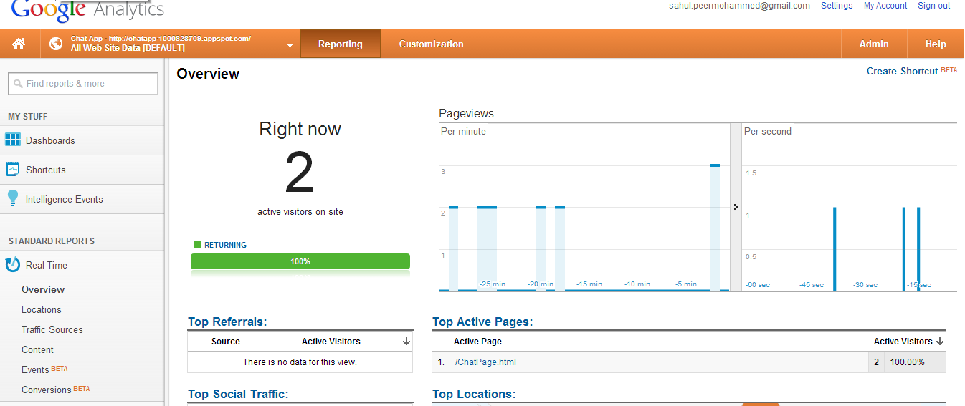

1. Also, find the screen shot of our app:

