Parent/Child Data Modeling
with Drupal 7 Entities and NO Code

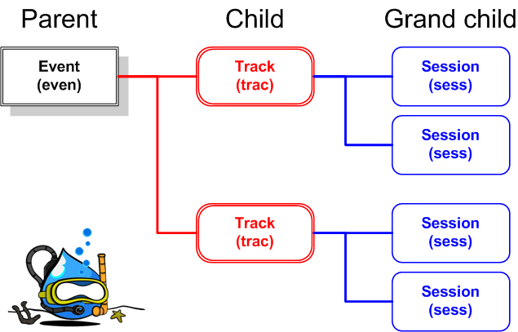

Conceptualize by: Jay Epstein

Written by: Dennis Solis

Diagrams by: Robert Canger

Table of Contents

Introduction 1
A different approach? 1
Define the project and why it exists. 1
What is a Parent, Child, Grandchild relationship?: 3
Project Scope: 3
Define the business requirements 3
Define basic user stories 3
Future Plans: 3
Assumed knowledge. 3
New modules 4
How are we going to build this? 4
Prep the Engine 5
Create a basic Drupal seven site 5
What additional modules do you need? 5
Modules (what to turn on and what to turn off) 5
Check the watchdog log in Drupal 6
The Dev Environment 7
Content Types and Fields: 7
Field Groups and the Node UI: 7
Disable all block in Sidebar first.: 7
URL Aliases: 7
Rules &Workflow: 8
Admin Dashboard: 8
Naming Conventions: 8
Content Types 9
Introduction to the basic content types 9
Define Content Type Fields 12
Venue 12
Event Type 12
Session 13
Track 13
Event 14
Project Documentation 3: Sitemap 16
Content Entry 17
Top down hierarchy node creations 17
Enter content for Drupal Camp Fort Lauderdale 17
Enter content for Drupal Camp Florida 19
Views 22
Create views for the different content types. 22
Create a page view that lists the Events. 23
Introduction 23
Adding the view 23
Create a page view that lists the Event Types. 24
Introduction 24
Adding the view 24
Create a page view that lists the Tracks. 25
Introduction 25
Adding the view 25
Create a view that list the Sessions 26
Introduction 26
Adding the view 26
Display the Event’s Venue in a block. 27
Introduction 27
Adding the view 28
Add a relationship 30
Add fields 31
Add a contextual filter 33
Understanding directional relationships (up and down the “family tree”) 36
Create a view that display the Track for a an Event 37
Introduction 37
Adding the view 38
Add A Relationship 40
Add The Fields 41
Add a Contextual Filter 42
Create a view that displasy the Sessions for an Event. 44
Introduction 44
Adding the view 45
Add a Contextual Filter 47
Add A Relationship 49
Add The Fields 52
Create a view that display the “Orphan” Tracks. 54
Introduction 54
Adding the view 55
Add the Fields 57
Add A Relationship 58
Add A Filter 59
Create a view that display the “Orphan” Sessions. 60
Introduction 60
Adding the view 61
Add the Fields 63
Add A Relationship 64
Add A Filter 65
Define the Quick Tabs for the Event Page. 67
Define the Quick Tabs for the Orphans Page. 70
Additional Concepts 73
Appendix B - New module / field types 75
Appendix C - Find node’s “nid” 76
Appendix D - Add a Contextual Filter 78
Appendix E - Manually enter contextual filter value 80

Introduction

A different approach?

This parent, child, grandchild method presented in this paper takes an opposite approach to the “normal” parent child approach used by most Drupal developers. The “normal” approach is to have the entity reference field on the child record that looks “up” to the parent.

This method had the entity reference on the parent looking down to the child. This approach has the following advantages:
- You can see all of the children from the parent.
- Allows the parent to go down the path to find the children, grandchildren, etc.
- . much more true to life.. plus it makes views wicked fast

Define the project and why it exists.
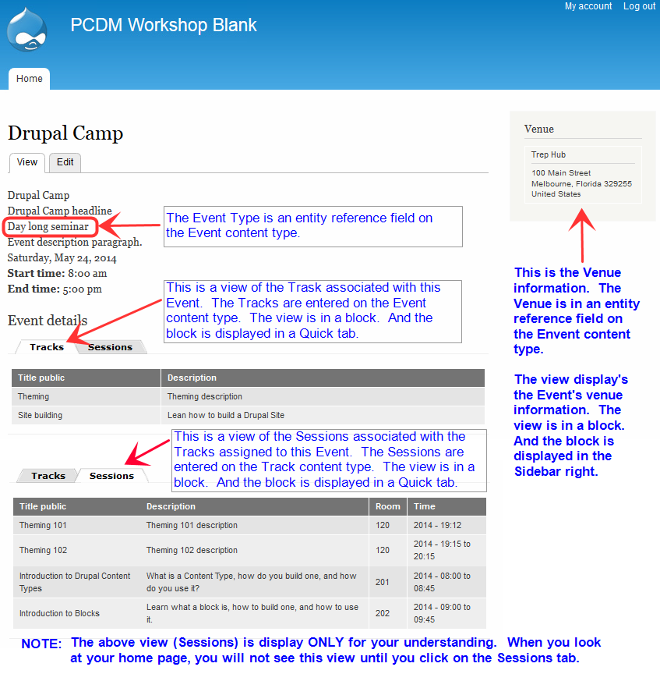
A new Drupal 7 based event management system to handle multiple events with venue info, tracks, and sessions. Above is a sample home page for our project.

What is a Parent, Child, Grandchild relationship?:

A Parent, Child, Grandchild database relationship is where three files are logically related. The parent file contains information about a subject. The child table contains “offspring” data that is associated with the parent. And of course, the grandchild data contains “off springs” data that is associated with the child information.
In our case:
- The Parent information is the Event (Drupal Camp Fort Lauderdale or Drupal Camp Florida).
- The Child information are the Tracks associated with an Event / Camp.
- The Grandchild information are the Sessions associated with a Track.

A more detailed explanation can be found in this Wikipedia article.

Project Scope:
To complete a clickable prototype for events, venue, tracks and sessions.

Define the business requirements

Define basic user stories

Future Plans:
- Attendee signups for sessions.
- Session voting.
- Personalized attendee schedule printing from pdf.
- Instructor Bio on Sessions.
- Elegant entity reference selection fields.

Assumed knowledge.
This presentation assumes you have a solid knowledge of the following concepts.
  - Database relationship
    - Parent / child
    - One to one
    - One to many
  - Bring up a base Drupal site
  - Download and install modules
  - Create content types
  - Create content
  - Create and use blocks
  - Views
  - Modules
    - Administration Menu
    - Ctools
    - Date
    - Entity Api
    - Module Filter
    - Path Auto
    - Token
    - Views

New modules
We will introduce the following modules in this paper, so please do not worry if you are not familiar with them. This paper will not attempt to explain each of the modules, but we will provide links to other articles that explain each of the below modules:
  - Auto Entity Label
  - Entity Connect
  - Entity Reference
  - Field Group
  - Quick tabs
  - Rules
  - Views bulk operations

How are we going to build this?

We will build this site one step at a time. We will:

- Define the information architecture / parent, child, grandchild relationships.
- Download the additional modules.
- Enable the modules.
- Create the basic web site.
- Create the content types.
- Add content.
- Create / define the views.
- Create / define the quick tabs.
- Enable the different blocks.
- View the home page.

Prep the Engine

Create a basic Drupal seven site
Since there are so many ways to install the Drupal seven site, we cannot provide detailed instruction. Therefore, follow your normal process for downloading and creating a base Drupal seven website on your development machine.

What additional modules do you need?
You will need to download, but DO NOT enable any of the following contributed modules:

Administration Menu: https://drupal.org/project/admin_menu
Auto Entity Label: https://drupal.org/project/auto_entitylabel
Ctools: https://drupal.org/project/ctools
Date: https://drupal.org/project/date
Entity Api: https://drupal.org/project/entity
Entity Connect: https://drupal.org/project/entityconnect
Entity Reference: https://drupal.org/project/entityreference
Field Group: https://drupal.org/project/field_group
Module Filter: https://drupal.org/project/module_filter
Path Auto: https://drupal.org/project/pathauto
Quicktabs: https://drupal.org/project/quicktabs
Rules: https://drupal.org/project/rules
Token: https://drupal.org/project/token
Views: https://drupal.org/project/views
Views bulk operations: https://drupal.org/project/views_bulk_operations

Modules (what to turn on and what to turn off)
  - Enable the basic building block modules:
    - Admin_menu
    - Module_filter
    - Ctools
    - Views and Views UI
  - Disabled the following modules:
    - Toolbar
    - Overlay. Note, the overlay module require 60% of all PHP resources. This is a very expensive module to leave enabled.
  - Enable the API modules:
    - Date API
    - Entity API
    - Token
  - Enable the user interface modules:
    - Pathauto
    - Automatic entity label
    - Date popup
    - entity connect
    - Entity reference
    - Entity tokens
    - Field group
    - Quick tabs
    - Quick tabs styles
    - Rules
    - Rules ui

Check the watchdog log in Drupal

.

The Dev Environment

Content Types and Fields:
Create content types and fields using system specifications documentation.
Using the the attached system specification document, you will need to create the following content types. Note, will create these content types in the order in which they are needed.

For example, venue is not anything else so it will be created first. However, has you can see from the specs, the content type Event is references the Venue, Event type, and Track content types. This means that in order for the content type event to reference some other content type, that content type must already be defined. For example, we cannot define the content type Track until after the content type Session has been created. This is because the content type Track references or is dependent upon the content type Session. Please create the content types in the following order.
- Venue
- Event type
- Session
- Track
- Event

Field Groups and the Node UI:
Create the relational UI with groups and tabs.

Disable all block in Sidebar first.:
If you look at the picture our front page, you will notice that there is no sidebar first region. You can accomplish this by following the below instructions.
- Go to Admin Menu → Structure → Blocks.
- Scroll down to Sidebar First region.
- For each block in sidebar first, change the region from sidebar first to none.

URL Aliases:
- Go to Admin Menu →Configuration → Search and Metadata → URL aliases → Patterns
- Do not change the Default path pattern.
- Look down the page for “Pattern for all Events ”.
  - Enter the following pattern in this field: “event/[ node: title]”.
- Then click on the Save Configuration button.
- Then click on the Bulk Update tab in the upper right-hand corner.
- When that pages appears, check the Content paths checkbox and then press the Update button.
- The system will then update all of the event content types with the new path patterns.
- Once the update is finished, click on the List tab.
  - If you have not entered any content yet, then you will not see anything.
  - If you have any content, you should see that their paths have changed.

Once you’ve completed the above steps, you are done with the section.

Rules &Workflow:
- Redirects

Admin Dashboard:
- Create the admin driver’s seat.

Naming Conventions:
- Content Type names versus View names.
  - Content Types are named in the singular. For example, the Content Types names are Event and Venue and not Events and Venues.
  - Views are named in the plural. For example, the Views names are Events and Venues and not Event and Venue.
The reason for this naming convention is if a content type and view our name the same thing, that you will not work in you will have no idea why not. Therefore if you utilize this naming convention you can avoid this problem.

Content Types

Introduction to the basic content types

Below is an overview of the content types and their relationship (aka the data model) that we will be discussing through this document. It is NOT intended to be instructions for creation of these content types. Detailed instructions will be provided later in this section.

Please nte that we have color coded the different content types to make them easier to identify in the diagram on the next page.

Content Type Parent of Child of Purpose
Event Event Type Contain the basic information for a given event.
Venue
Track
Event type -------- Event Contain a list of the different types of events.
Venue -------- Event Contains a list of the locations at which the camp can be held.
Tracks Session Event Contains a list of the different tracks that will be offered at the different Drupal camps.
Session -------- Tracks Contains one entry for each session that will be offered at the Drupal camp.

Static page NONE NONE The static page is simply going to contain information for the different static pages on the site.

The Event content type has three foreign key. They are:
- Event Type. There is only one Event Type associated with an Event. As a result, this is a one-to-one relationship.
- Venue. - Four our purposed, the Event will only have one venue. Therefore, this is also a one-to-one relationship.
- Track - There will normally be multiple Tracks for a given event. Has a result, this is known has a one to many relationships.

The Track content type has one foreign key. It is:
- Session - For a given Track there will be multiple sessions. Therefore this is also a one to many relationship.

Please note that the static page is not on this relationship because it is not involved with the different data relationships.

A diagram of the data relationship appears below.

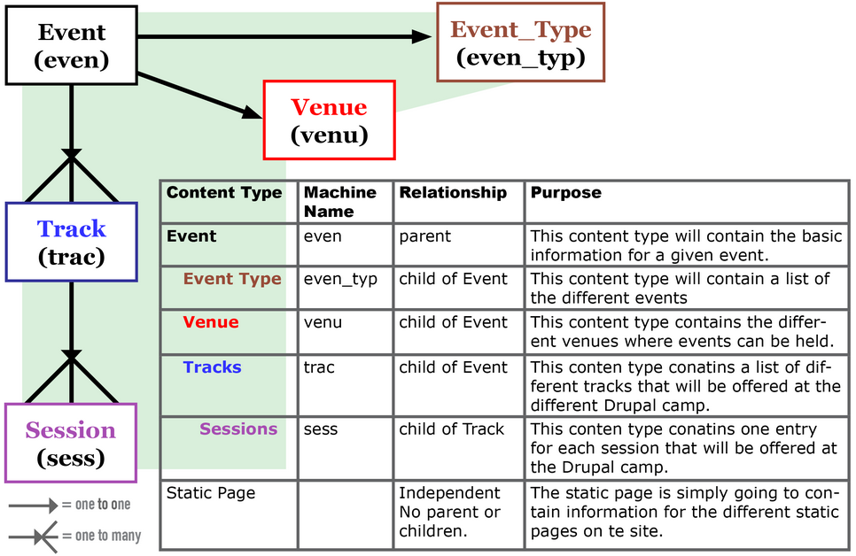

We are ready to create the different content types. Due to the parent-child relationship some of the content type are dependent upon other content types. Therefore it will be easier if we create the children content types first and then their parents. So for that reason, we will create the content types in the following order:

- Venue Venue is not dependent on any other content type. -
- Event Type Event Type is not dependent on any other content type.
- Session Session is not dependent on any other content type.
- Track Track is dependent upon the Session content type.
- Event Event is dependent upon the Venue, Event Type, and Track content types.

NOTE:
- All of the following instructions assume that you have the administration menu module enabled and the toolbar module disable. If you have not done this, then some of these instructions may not work.

- When you are creating the below content types, you must follow all instructions and specifications. Failure to do so may cause some functionality to not work properly.

If remember to add a content type you
- Go to the admin toolbar and click Structure -> Content Type -> Add content type.
- Enter the name and description in the appropriate fields.
- Regarding the Publishing options, we will want to leave the content type published but uncheck “Promoted to front page”.
- Regarding the Display settings, please uncheck display author and date information.
- Regarding the Menu settings, uncheck the main menu.
- Click on the “Save and add fields” button.

As a general rule when adding content types related to this discussion, we will not be using the body field in any of our content types. Therefore, please DELETE the body field in ALL of the content types we define below.

We will be creating many different field types. Most of them you should be familiar to you. However there are four new field types with which you may not be familiar. They are:
- Entity reference fields
- Entity connect
- Horizontal tab group
- Horizontal tabs

if you are not familiar with these field types please reference Appendix B - New module / field types for a brief discussion of each of the above.

Define Content Type Fields

Venue
Content Type: Venue
Machine Name: venu
Node auto label Chose the “Automatically generate the label and hide the label field” radio button.
Pattern for the title is “[node:field_venu_title_public]”

Label | Machine name | Field type | Widget | Req | Fld Len | # of Values | Others
Title | title | Node module element
Title public | field_venu_title_public | Text | Text field | Y | 60 | 1
Sub title | field_venu_sub_title | Text | Text field | N | 120 | 1
Address 1 | field_venu_addr_1 | Text | Text field | Y | 60 | 1
Address 2 | field_venu_addr_2 | Text | Text field | N | 60 | 1
City | field_venu_city | Text | Text field | Y | 60 | 1
State | field_venu_state | List (text) | Select list | Y | 2 | 1
Zip | field_venu_zip | Text | Text field | Y | 10 | 1
Country | field_venu_country | List (text) | Select list | Y | 4 | 1

Event Type
Content Type: Event Type
Machine Name: even_typ
Node auto label Chose the “Automatically generate the label and hide the label field” radio button.
Pattern for the title is “[node:field_even_typ_title_public]”

Label | Machine name | Field type | Widget | Req | Fld  Len | # of  Values | Other
Title | title | Node module element
Title public | field_venu_title_public | Text | Text field | Y | 60 | 1

Session
Content Type: Session
Machine Name: sess
Node auto label Chose the “Automatically generate the label and hide the label field” radio button.
Pattern for the title is “[node:field_sess_title_public]”

Label | Machine name | Field type | Widget | Req | Fld  Len | # of  Values | Other
Title | title | Node module element
Title public | field_sess_title_public | Text | Text field | Y | 60 | 1
Description | field_sess_description | Long text | Text field | Y |  | 1
Room | field_sess_room | Text | Text field | Y | 6 | 1
Time | field_sess_time | Date | Pop-up calendar | Y |  | 1 | Specify just the time.

Track
Content Type: Track
Machine Name: trac
Node auto label Chose the “Automatically generate the label and hide the label field” radio button.
Pattern for the title is “[node:field-trac-title-public]”

Label | Machine name | Field type | Widget | Req | Fld  Len | # of  Values | Other
Title | title | Node module element
Title public | field_trac_title_public | Text | Text field | Y | 60 | 1
Description | field_trac_description | Text | Text field | Y | 60 | 1
Related Sessions | field_trac_rel_sess_ref | Entity Reference | Autocomplete  Contains  Target type: Node  Mode: Simple  Target bun: Session  Sort by : Don’t sort | Y | 60 | Unlimited | Display Add Entity Connect.  Display Edit Entity Connect

Event
Content Type: Event
Machine Name: even
Node auto label Chose the “Automatically generate the label and hide the label field” radio button.
Pattern for the title is “[node:field_even_title_public]”

Label | Machine name | Field type | Widget | Req | Fld  Len | # of  Values | Other
Title public | field_even_title_public | Text | Text field
Event type | field_even_typ_ref | Entity Reference | Select list  Display Edit button: Yes  Display Add Button: Yes  Entity reference: Node  Mode: Simple (with).  Bundle: Event type  Sort by: Don’t
Headline | field_even_headline | Text | Text field
Date | field_even_date | Date | Pop-up calendar
Start time | field_even_start_time | Text | Text field
End time | field_even_end_time | Text | Text field
Description | field_even_descrip | Long text | Text area (multiple rows)
Related content | group_even_related_content | HORIZONTAL TAB GROUP | classes group-event
Venue | group_even_venue_tab | HORIZONTAL TAB | htab closed  required_fields yes  classes group-even-venue-tab
Venue | field_even_rel_venue_ref | Entity Reference | Select list  Display Edit button: Yes  Display Add Button: Yes  Target type: Node  Entity Selection -------  Mode: Simple (with..)  Target bundle: Venue  Sort by: Don’t Sort | Y | 60 | 1
Tracks | group_even_track_tab | HORIZONTAL TAB | htab closed  classes group-even-track-tab field-group-htab  required_fields yes
Track | field_even_rel_trac_ref | Entity Reference | Select list  Display Edit button: Yes  Display Add Button: Yes  Target type: Node  Entity Selection -------  Mode: Simple (with..)  Target bundle: Track  Sort by: Don’t Sort

Manage the display for event type:

- Hide all of the labels for all of the fields.
- Drag the Venue and Tracks field down to hidden.
- Save the page

Go to the home page.

Project Documentation 3: Sitemap

- Define main menu links

- Define Views based output

Content Entry

Top down hierarchy node creations
- The Event (parent)
- The Venue (child of Event)
- Tracks (child of Event)
  - Sessions (child of Track)

Enter content for Drupal Camp Fort Lauderdale
Please enter the following content date. The purpose of recording the data you entered is so we can verify the output of the views we will be writing in a later session.

The first Event, Drupal Camp Fort Lauderdale, will have an:
- Event type of classroom sessions
- Venue of Trep hub
- Two tracks; Theming and Site Building

The first Track, Theming, will have two sessions. They are:
- Theming 101
- SASS and Compass

The second Track, Site Building, will have two sessions. They are:
- Creating Content Types
- Creating and configuring Blocks

In an attempt to make the relationships more visual, the Event type, Venue, Tracks, Sessions are all color-coded.

- Event:
Prompt | Sample Data | Your Data
Title public | Drupal camp Fort Lauderdale
Event type | click on the pencil to add a new Event Type (see Event Type below)
Headline | Expand your Drupal knowledge
Date | May 26, 2014
Start time | 8:00 AM
End time | 5:00 PM
Description
Venue | click on the pencil to add a new Venue (see below) | Note: Discuss the different between adding a items in a select list versus adding an items to and auto select field
Track | click on the pencil to add multiple new Tracks (see below)

Event type - added from the Event content type
Prompt | Sample Data | Your Data
Title public | Classroom sessions

Venue
Prompt | Sample Data | Your Data
Title public | Trep Hub
Subtitle | Room 101
Address 1 | 100 Main St.
City | Melbourne
State | Florida
Zip | 32955

Tracks - Theming
Prompt | Sample Data | Your Data
Title public | Theming
Description | Learn the ins and outs of theming a Drupal website
Sessions | click on the pencil to add multiple new Sessions (see below). Please note, you will be creating multiple sessions for this track.

Sessions (for Theming)
Prompt | Sample Data | Your Data
Title public | Theming 101
Room | 101
Time | 9:00 AM
Description | Introduction to Drupal theming

Sessions (for Theming)
Prompt | Sample Data | Your Data
Title public | SASS and Compass
Room | 102
Time | 10:00 AM
Description | Learn how to use sass and compass to generate CSS.

Tracks - Site Building
Prompt | Sample Data | Your Data
Title public | Site Building
Description | Learn the ins an outs of building a Drupal website.
Sessions | click on the pencil to add multiple new Sessions (see below). Please note, you will be creating multiple sessions for this track.

Sessions (for Site Building)
Prompt | Sample Data | Your Data
Title public | Creating Content Types
Room | 103
Time | 9:00 AM
Description | Learn the basics of creating a content type

Sessions (for Site Building)
Prompt | Sample Data | Your Data
Title public | Creating and configuring Blocks
Room | 104
Time | 10:00 AM
Description | Learn what a block is, how to build one, and how to use it.

Enter content for Drupal Camp Florida
Please enter the following content date. The purpose of recording the data you entered is so we can verify the output of the views we will be writing in a later session.

The first Event, Drupal Camp Florida, will have an:
- Event type of classroom sessions
- Venue of Florida Technical College
- Two track: Beginners, Coding

The first track, Beginners, will have two sessions. They are:
- Introduction To Content Types.
- Zero to Live in 45 minutes.

The second track, Coding, will have two sessions. They are:
- Introduction To PHP
- Introduction To Drupal Modules

In an attempt to make the relationships more visual, the Event type, Venue, Tracks, Sessions are all color-coded.

- Event:
Prompt | Sample Data | Your Data
Title public | Drupal camp Florida
Event type | click on the pencil to add a new Event Type (see Event Type below)
Headline | Welcome to Central Florida Drupal Camp.
Date | August 26, 2014
Start time | 8:00 AM
End time | 5:00 PM
Description
Venue | click on the pencil to add a new Venue (see below) | Note: Discuss the different between adding a items in a select list versus adding an items to and auto select field
Track | click on the pencil to add multiple new Tracks (see below)

Event type - added from the Event content type
Prompt | Sample Data | Your Data
Title public | Classroom sessions

Venue
Prompt | Sample Data | Your Data
Title public | Florida Technical College
Subtitle | Science building
Address 1 | 100 Main St.
City | Orlando
State | Florida
Zip | 32955

Tracks - Beginners
Prompt | Sample Data | Your Data
Title public | Beginners
Description | Introduce new people to building Drupal websites.
Sessions | click on the pencil to add multiple new Sessions (see below). Please note, you will be creating multiple sessions for this track.

Sessions (for Beginners)
Prompt | Sample Data | Your Data
Title public | Introduction To Content Types
Room | 101
Time | 9:00 AM
Description | Learn what a content type is how to create one.

Sessions (for Beginners)
Prompt | Sample Data | Your Data
Title public | Zero To Live In 45 Minutes
Room | 102
Time | 10:00 AM
Description | Learn how to create a website and launch.

Tracks - Coding
Prompt | Sample Data | Your Data
Title public | Coding
Description | Learn how to write custom Drupal modules.
Sessions | click on the pencil to add multiple new Sessions (see below). Please note, you will be creating multiple sessions for this track.

Sessions (for Coding)
Prompt | Sample Data | Your Data
Title public | Introduction to PHP
Room | 103
Time | 9:00 AM
Description | Learn the basics of the PHP language.

Sessions (for Site Building)
Prompt | Sample Data | Your Data
Title public | Introduction to Drupal modules
Room | 104
Time | 10:00 AM
Description | Learn the basics of writing a Drupal module.

Views

Create views for the different content types.
Before we proceed any further, let’s take a quick look at the data we’ve already entered into the website. The purpose of this is to ensure we fully understand what information is in what content type. At a later point in time, we will expand these reports to list the “orphan” content types.

Let’s create the different views required to bring this site to life.

Normally have previously
- We’re going to add a few views to display the content of the different content types.
- Instead of combining the venue, tracks, sessions views into a single view, we will create three separate views. The reason for this are:
  - Each view is substantially different from the other.
  - It simplifies the views as we do not have to remember to specify override this view has we change each of the three views.
- We will be adding other views which were not discussed in the seminar due to lack of time.

NOTE: This paper is going to take a slightly bit different approach to creating the required views then what was presented in the seminar. In the seminar, all of the views were created has sub views under one master view.

This paper is going to create each view has its own standalone view. The reason for this is to simplify the view creation process. If you have multiple “sub views” within a master view, every time you make a change you have to remember to specify whether or not this change applies to all views or just the current view. If each view is its own separate standalone view, then you do not have to worry about this issue.

When I was building the different views, I constantly forgot to specify that the change applied only to the current view. Needless to say, this caused quite a few problems. If you do not have a problem remembering to specify that the change only applies to the current view, then feel free to consolidate all of your views into one single master view. However, if you are new to building views then I suggest you keep it simple and create separate views for each of the required views.

Create a page view that lists the Events.

Introduction

This View’s Goal

This view will simply list all of the content type of Event. The purpose of this view is simply to show you all of the different event you entered.

Adding the view

View name: CT - Events
Description: Sorted list of all Event content types
Show Content of type Event
Create a page view
Page Title CT - Events
Path reports/ct-events
Display format table
Items to display 10

Add Fields - search for fields with the string “even” in them.
  - Title public
  - Event type
  - Venue
  - Start time
  - End time
  - Description
  - Headline
  - Track

Filter criteria - search for fields with the string “even” in them.
  - Published (Yes)
  - Type (= Event)
Output for the Events view

Title public | Event type | Venue | Date | Start time | End time | Description | Headline | Track
Drupal Camp | Class room sessions | Trep Hub | 05/24/2014 | 8:00 am | 5:00 pm | Event description paragraph. | Drupal Camp headline | Theming  Site Building

Create a page view that lists the Event Types.

Introduction

This View’s Goal

This view will simply list all of the content type of Event. A second version of this view, which we will discuss later, will list all of the “orphan” Event Types.

Adding the view

View name: CT - Event types
Description: Sorted list of all Event Type content types
Show Content of Type Event
Create a page view
Page Title CT Event types
Path reports/ct-event-types
Display format table
Items to display 10

Add Fields - search for fields with the string “even_typ” in them.
  - Title public

Filter criteria - search for fields with the string “even” in them.
  - Published (Yes)
  - Type (= Event type)
Output for the Event Types view
Title public
Day long class
Day long seminar
Class room sessions

Create a page view that lists the Tracks.

Introduction

This View’s Goal

This view will simply list all of the content type of Track. A second version of this view, which we will discuss later, will list all of the “orphan” Tracks.

Adding the view

View name: CT - Tracks
Description: Sorted list of all Tracks content types
Show Content of type Event
Create a page view
Page Title CT Tracks
Path reports/ct-tracks
Display format table
Items to display 10

Add Fields - search for fields with the string “even” in them.
  - Title public
  - Description
  - Related Sessions

Filter criteria - search for fields with the string “trak” in them.
  - Published (Yes)
  - Type (= Track)
Output for the Tracks view

Title public | Description | Related Sessions
Site building | Learn the ins an outs of building a Drupal website | Introduction to Drupal Content Types, Introduction to Blocks
Theming | Learn the ins and outs of theming a Drupal website. | Theming 101, Theming 102

Create a view that list the Sessions

Introduction

This View’s Goal

This view will simply list all of the content type of Session. A second version of this view, which we will discuss later, will list all of the “orphan” Sessions.

Adding the view

View name: CT -Sessions
Description: Sorted list of all Sessions content types
Show Content of type Session
Create a page view
Page Title CT Sessions
Path reports/ct-sesions
Display format table
Items to display 10

Add Fields - search for fields with the string “sess” in them.
- Title public
- Description
- Room
- Time

Filter criteria - search for fields with the string “even” in them.
  - Published (Yes)
  - Type (= Session)
Output for the Sessions view

Title public | Description | Room | Time
Creating and configuring Blocks | Learn what a block is, how to build one, and how to use it. | 202 | 2014 - 09:00 to 09:45
Creating Content Types | Learn the basics of creating a content type. | 201 | 2014 - 08:00 to 08:45
SASS and Compass | Learn the basics of SASS and Compass | 120 | 2014 - 09:00 to 09:45
Theming 101 | Introduction to Drupal Theming | 101 | 2014 - 08:00 to 08:45

Display the Event’s Venue in a block.

Introduction

This View’s Goal

This view will display the Event’s Venue name and address in a block. The block will appear in the sidebar second region anywhere it is displayed. If you remember, the Venue field is an entity reference field on the Event content type that “connects” the Event to the Venue.

The final output of our view should be something like:

Trep Hub
100 Main Street
Melbourne, Florida 329255
United States

To accomplish this, we will create a view in a block. This view will be created as a table of fields. It will list each of the desired fields. Once that is working, we will then consolidate the different field into one single field.

If you remember, we configure the auto path for all events nodes to have a path of event/event title. We will then configure the block to appear on pages where the path starts with “event”. And finally, we will place the block in the Sidebar Second region.

NOTE: The following instructions are very detailed and it is critical that they be followed exactly. Any deviation may result in the view producing incorrect results. These instructions have been tested and are known to work. Therefore, if your view does not work, it is most likely that something was setup incorrectly.

Adding the view

You will need to “Add a new view”. The view specifications are:

View name: EV - Venues (EV is an abbreviation for event)
Description: Display the venue associated with the current event.
Show Content of type Event.
Sorted by Unsorted
Uncheck Create a page.
Check Create a block
Block title Block: Venue
Display format table of fields
Items to display 1
Click on “Continue & edit”

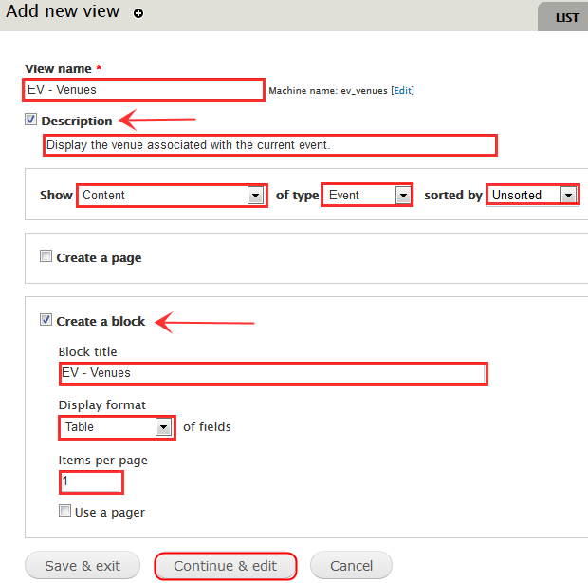
Add view to display Venue information for a Event.

Next we are going to set some basic values for this view.
- Ensure the display name is Block: Venue. To do this:
  - Click on the display name and set the name to Block: Venue.
  - Set the description to “Display the Event’s venue information in a block.”.
  - Click on apply.

- If necessary, click on the Tile and change it to EV - Venue.

- Set the blocks’ name. You do this by:
  - Clicking on the block name, which is at the top of the center column.
  - Set the block name to Event venue block
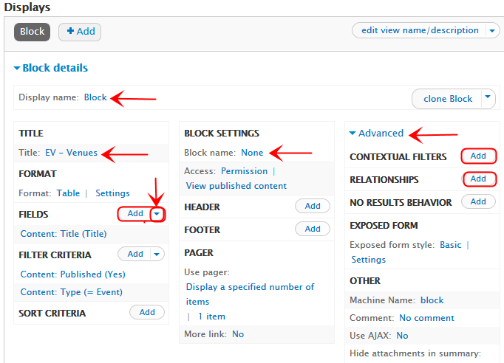
  - Click on apply.

The above diagram show you all of the buttons and heading we will be using to build this view.

Add a relationship

Next, we need to associate the Event with its Venue. We will do this by setting up a relationship to the venue content type. This is done by:
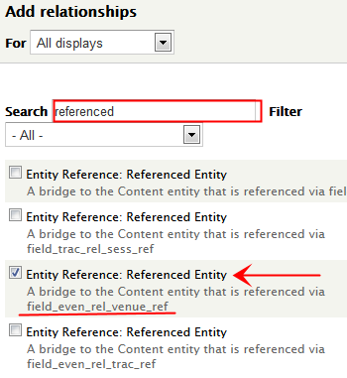
- Click on “ADVANCE” heading, which is on the right hand side of the page and about halfway down. When you click on the Advanced heading, quite a few fields will appear below.

- Locate the Relationship heading.

- Click on the Add button, which is to the right of the word Relationship.

- In the search box, type the word “referenced”, without the quotes.

- From the resulting list, check the box next to the field “field_even_rel_venue_ref”. If you look at Create Event Content Type notes, you will see that field_even_rel_venue_ref is the machine name for the entity reference Venue.

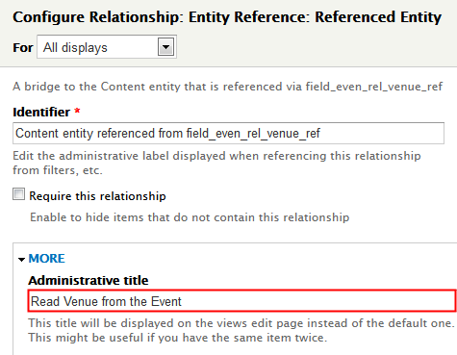
- Click Apply.

- Click on the More heading in the Configure Relationship: Entity Reference: Referenced Entity window. In the administrative title field, enter “Read the Venue from the Event”. This this provides us with an easier to read title.

- Click apply.

- Under the Relationship heading it should now display the text “Read the Venue from the Event”. If it does not, then you did something wrong. Please go back and review the instruction and correct the problem.

I do not mean to be flippant with this last comment. But, there are so many places where you could have make a mistake, it is impossible to try to list all of them here. However, people have tested the above instructions so we know the instructions are correct. Please review each of the instructions and make sure your view matches the instructions EXACTLY.

Add fields

Next, we’re going to add the fields that will be included in this view. Please note that we are going to do this in a multistep process so that you can see how each step affects the view.
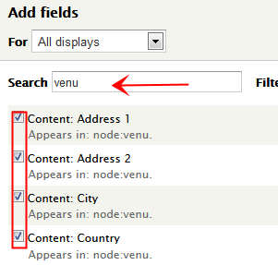
- Click on the Add button to the right of the word Fields.

- In the resulting search box that is displayed, enter the string “venu”. You will notice that this brings up all of the fields and the node type venue. You will want to select all of the fields that appear in the node venue. They are:
  - Title public
  - Sub title
  - Address 1
  - Address 2
  - City
  - State
  - Zip
  - Country

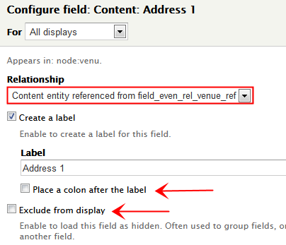
- For each of the above fields you will need to:
  - Change the relationship field from “do not use a relationship” to “Content entity reference from field_even_rel_venue_ref”.

  - If you want, you can uncheck “Place A: after the label”. It does not really matter, because we will eventually exclude these data fields from the display.

  - Note: please notice the “Exclude from display” checkbox. Later in this view, we will need to select each of these fields and exclude them from the display. This is done by checking the “Exclude from display” checkbox.

  - Click on the Apply button.

- After you have select the fields, you will need to rearrange them because they will not be in the proper order. To rearrange the fields:
  - Click on the down arrow next to the word Add Field button.
  - The new option that will be displayed is Rearrange.
  - Click on rearrange.
  - You can now drag and drop the different field so there in the proper sequence.
  - Click on apply.

At this point your output should look similar to:

Title | Title Public | Sub Title | Address 1 | Address 2 | City | State | Zip | Country
Drupal Camp | Trep Hub | Room 101 | 100 Main Street |  | Melbourne | Florida | 329255 | United States

If you compare are output to the desired output, you will see that we have all the data values but not in the desired format. So now let’s change our view so that displays the data in our desired format. To do this, we need to

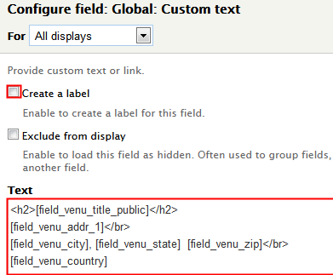
- Click on Add Field.

- In the Search box, enter “Global”

- Choose “Global text field”.

- Please be sure to uncheck the “Create a label” check box.

- in the text fields, please enter the following values:
<h2>[field_venu_title_public]</h2>
[field_venu_addr_1]</br>
[field_venu_city], [field_venu_state] [field_venu_zip]</br>
[field_venu_country]

What the above global field does is concatenates all of the individual field into one single multiline field. In addition, we also highlight the venue name field (field_venu_title_public). Now that we have created a global text field that combines all of our individual fields into a single field, we can now exclude all of the individual fields from the view. To do this, select the following fields and exclude them from the display:
- Title
- Address 1
- Address 2
- City
- Country
- State
- Sub title
- Title public
- Zip

To exclude each field, you need to each of the below steps for each field::
- Click on the individual field.
- Uncheck the “Create a label” checkbox.
- Check the “Exclude from display” check box.
- Click on the apply button.

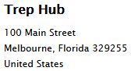
Once you’ve made all the above changes, the only field that should be displayed is the global text field. Your views should have an output similar to the output on the right.

If your output is not similar to the text on the right, then something is wrong with your global text field. Please review the instructions for the global text field and see the figure out your problem. If your output is similar to the output on the right, then your view is working. Please remember to save your view before you proceed on to the next step.

Add a contextual filter

We have one last change to make to this view before it is complete. We need to add a Contextual Filter that will cause this view to only display the Venue associated with the current event. (Drupal will automatically pass the current Event node id in the URL when this view is run.)

If you’ve not added a contextual filter before, please read Appendix D - Add a Contextual Filter.

We need to add a contextual filter that will filter by the Event’s node id. To do this:
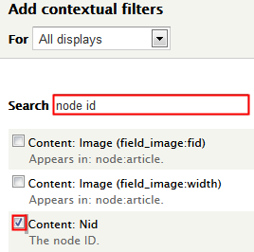
- Click on the add button to the right of the Contextual Filter header

- Select the Content: Nid field.

- Do not use a relationship.

- However, under the heading “When the filter value is not available ” click on the “Provide default value” radio button.

- From the “Type” dropdown menu, choose “Content ID from URL”.

- Click on apply.

Once we have added the contextual filter, the view will not produce any output! What happened? Don’t worry, this is be expected. If you remember we just added a contextual filter of Event node ID. However, we have not supplied an Event node ID.

Please find the node ID for your content type "Drupal Camp Fort Lauderdale”. If you do not know how to do it this, please read Appendix C - Find a node’s “nid”.

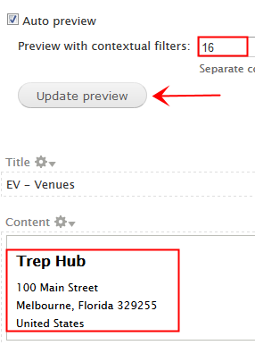
Now that you have the node ID, you need to enter the node ID in field entitled “Preview with contextual filters” and click on the Update preview button.

Once you do this, the Venue information for this Event node ID should appear in the content section of your view. If your Venue information appears in the content section of the view, then you are to move to the final step

If it does not, then there is something wrong with your contextual filter. Please review the contextual filter instructions, and try again.

Congratulations! You have properly built the view. Now it’s time to put the block in sidebar second and configure the block to only appear on pages where the content type Event is displayed.

To display our view in a block in the Sidebar Second region, we will need to move the Event venue block to the
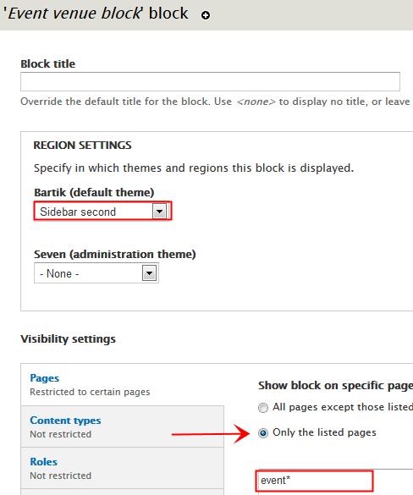
Sidebar Second region and then specify that this block should only appear on Event pages. To do this, you need to:
- Go to the Admin Menu → Structure → Blocks.

- Scroll down the page until you find the block with the name you gave a block in that you specifications. In my case,. My block name is “Event venue block”.

- Once you found your block, change the region from none to Sidebar second.

- Scroll down the page to get to the vertical tabs, and select “Pages” vertical tab. Under the text “Show block on specific pages”, click on the “Only the listed pages”.

- In the text box below the radio button, enter the text” event*”.

- Click on Save block.
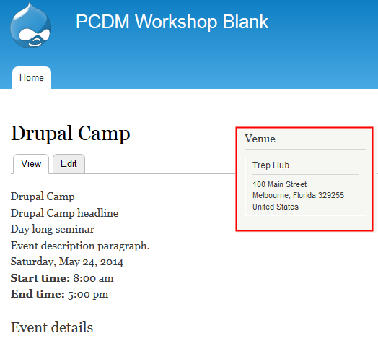
Once you’ve completed the above, please click on the home button.

Your homepage should now have the Event information in the main content region and the Venue information in the sidebar second region. At this point your home page should look like the image on the right.

Congratulations, you have created a single page that is now displaying information from three different nodes:
- Event node
- Event type node
- Venue node

The next couple of views will add the Track and Sessions to this Event. Once we have those views added, you will be display five different nodes on a single page!

Understanding directional relationships (up and down the “family tree”)

As you know, we have three tables:
- Events, which is the parent table.
- Tracks, which is the child relationship table.
- Sessions, which is the grandchild relationship table.

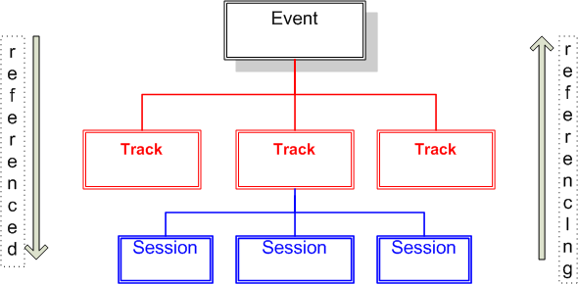
There are many “ways” to envision the relationship. One way to envision a parent / child / grandchild table relationship is to think of it as a “tree” or an “organizational chart”.

You can traverse up and down the organizational chart. That is, you can start at the top and work your way down to the bottom. Or you can start at the bottom and work your way up. Just as you can traverse up and down an organizational chart, you can also traverse up and down a parent / child / grandchild relationship tree.

One way to do this in Drupal is to use Views. To traverse down the tree, you need to start with an Event and use the “referenced from” variables to connect to the Track content type. To traverse up the tree, you will need to start with the Session and use the “referencing” variable to connect to the Track content type.

Then next four views:
- Display Tracks for an Event
- Display Sessions for an Event
- Orphan Tracks
- Orphan Sessions

will use the above concepts to implement these views.

Create a view that display the Track for a an Event

Introduction

This View’s Goal

This view will display all of the Tracks for a given Event. This information will be displayed in a block. That block will be displayed in a “Quick Tab” on the Event’s page.

The final output of our view should like the Tracks tab in the below image. Note: the quick tabs module will display our blocks in the different tabs.

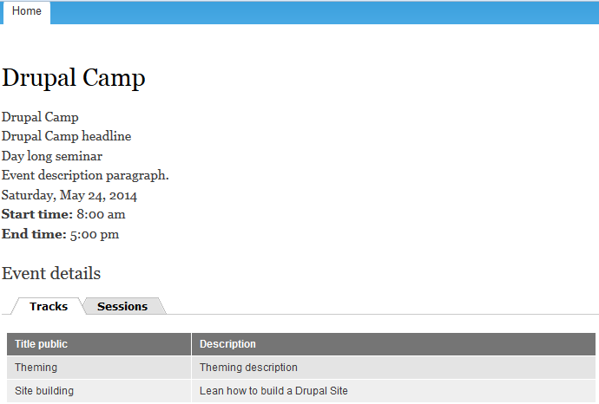

To accomplish this, we will create a view in a block. This view will be created as a table of fields and will list each of the desired fields. Once that is working, we will then add a relationship and a contextual filter. The relationship will connect the Tracks to the Event. The contextual filter will limit or filter the Tracks to be displayed to the specified Event. We will then add our block to the Quick Tabs that appear on the Event page.

NOTE: The following instructions are very detailed and it is critical that you follow them exactly. Any deviation could result in the view producing incorrect results. These instructions have been tested and are known to work. Therefore, if your view does not work is because the directions were not followed explicitly.

Adding the view

View name: EV - Tracks
Description: Sorted list of all Track for an Event
Show Content of type Event
Sorted by: Unsorted
Create a block view
Block Title EV – Tracks
Display format table of fields
Items to display 10

Click on “Continue and edit”.

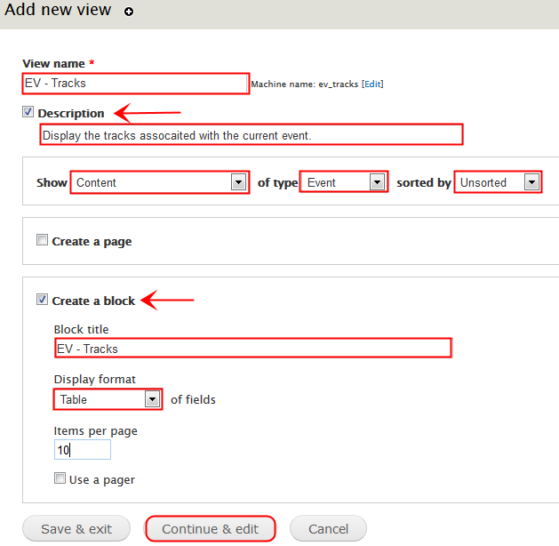
You should note that this view is based upon the Event and NOT the Tracks. But, that is okay because we are going to relate the Event to the Tracks. That relationship will be specified under the Advanced, Relationship in the view. This will be explained in the next few pages.
Next we are going to set some basic values for this view.
- Ensure the display name is Block: Tracks. To do this:
  - Click on the display name and set the name to Block: Tracks.
  - Set the description to “Display the Tracks associated with an Event in a block.”.
  - Click on apply.

- If necessary, click on the Tile and change it to EV - Tracks.

- Set the blocks’ name. You do this by:
  - Clicking on the block name, which is at the top of the center column.
  - Set the block name to Event track block
  - Click on apply.
- Set the pager to 10 items per page with a mini pager.

When you look at the results of this view, you will notice that the output is “Drupal Camp Fort Lauderdale”. This is not what we want. We want to list the tracks associated with Drupal Camp Fort Lauderdale. And we will do that on the next page.

Add A Relationship

Next, we need to associate the Event with its Tracks. We will do this by setting up a relationship to the Tracks content type. This is done by:
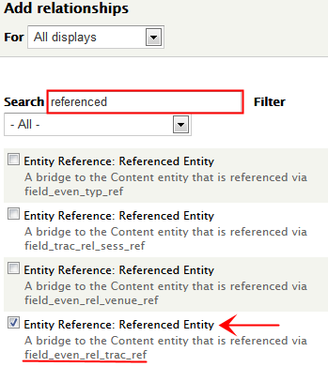
- Click on “ADVANCE” heading, which is on the right hand side of the page and about halfway down. When you click on the Advanced heading, quite a few fields will appear below.

- Locate the Relationship heading.

- Click on the Add button, which is to the right of the word Relationship.

- In the search box, type the word “referenced”, without the quotes.

- From the resulting list, check the box next to the field “field_even_rel_trac_ref”. If you look At Create Event Content Type notes, you will see that field_even_rel_trac_ref is the machine name for the entity reference Tracks.
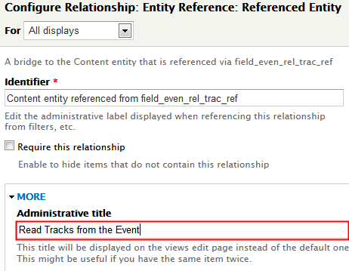
- Click Apply.

- Click on the More heading in the Configure Relationship: Entity Reference: Referenced Entity window. In the administrative title field, enter “Read the Tracks from the Event”. This provides us with an easier to read title.

- Click apply.

- Under the Relationship heading it should now display the text “Read the Track from the Event”. If it does not, then you did something wrong. Please go back and review the instruction and correct the problem.

At this point, the view should show two lines, both of which say “Drupal Camp Fort Lauderdale”. While this is not the desired result, it is the expected results once we completed adding a relationship to the Tracks. The next part of creating the view will be to add the fields from the Tracks content type. That is covered on the next page.

Add The Fields
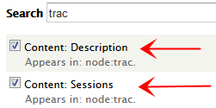
Click on Add button to the right of the “Fields” header. Then- search for fields with the string “trac” in a field. Please choose the following fields:
- Title Public
  - This appears in: node:trac.
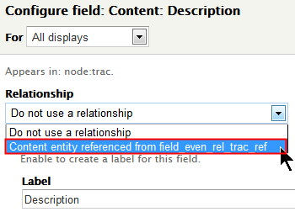
  - When the Configure field: Content: Description windows appears, you will need to chose the “Content entity referenced from field_even_rel_trac_ref” in the Relationship drop down menu.
- Description
  - This appears in: node:trac.
  - When the Configure field: Content: Description windows appears, you will need to choose the “Content entity referenced from field_even_rel_trac_ref” in the Relationship drop down menu.
- Delete the field “Title” from the view.

Caution: If you do not choose the proper relationship, this view will NOT work.

At this point, you should have a view that produces output similar to the below:
Output for the Tracks view

Title public | Description
Theming | Learn the ins and outs of theming a Drupal website.
Site Building | Learn the ins an outs of building a Drupal website.
Beginners | Introduce new people to building a basic Drupal website.
Coding | Learn how to write custom Drupal modules.

The goal of this view is to display all of the Tracks for a given Event. Unfortunately, this view lists all tracks for ALL events. So the question is, how do we modify this view to accomplish our goal? We do this by using the contextual filter, which we will discuss on the next page.

Add a Contextual Filter

We have one last change to make to this view before it is complete. We need to add a Contextual Filter. (If you have not added a contextual filter before, please read appendix D Adding a Contextual Filter.) This will cause the view to only display the Venue associated with the current event. (Drupal will automatically pass the current Event node id in the URL when this view is run.)

So, while adding a contextual filter might be new to you, it’s actually pretty easy. I will admit the first time I worked with contextual filters, I was a bit stressed out. However, once I worked with them a bit, it is actually very straightforward.

To add a contextual filter, we first need to decide on what we are going to filter. Since the content type we are displaying his Event, the data value we have available to us is the Event node id. To set up the Event node id has the contextual filter, we need to:

- Click on the add button to the right of the Contextual Filter header
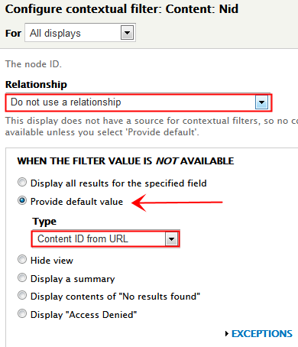
- We will search on node ID, since that is the field we need. Check the Content: Nid field.

- Click on the apply button. A new page will appear.

- Do not use a relationship.

- However, under the heading “When the filter value is not available ” click on the “Provide default value” radio button.

- From the “Type” dropdown menu, choose “Content ID from URL”.

- Click on apply.

- NOTE: At this point, the view will NOT generate any output. That is OK and expected.

- Don’t forget to save your view!

At this point, the view is expecting you to supply the node id of an Event. Once you enter the node id of an Event, the Tracks associated with that Event will then be displayed in your view. The next page discusses how to determine the node id of an Event node and enter that node id in the Contextual filter preview field.
you will see a check box and text box field has been added to the bottom of the view: This text box allows you to manually enter a value for the contextual filter.

So now the question is “What value do I enter?”. Well that is simple. It is the node ID of the Event that you looked up above. In my case, the node ID is 16. Pleaes enter your node ID (16 in my case) in the “Preview with contextual filter” text box and then click on Update Preview. At that point, the view will list the tracks for the specified event.
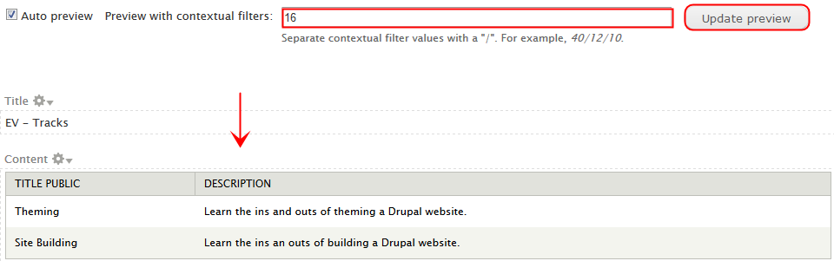

Congratulations, at this point your have completed the view. The only thing we have left do is put this view in a Quick Tab block, which we will do later in this document. But first let’s create the view that lists all of the sessions for this event, which we will do starting on the next page

Create a view that displasy the Sessions for an Event.

Introduction

This View’s Goal

This view will display all of the Sessions for a given Event. This information will be displayed in a block. That block will be displayed in a “Quick Tab” on the Event’s page.

The final output of our view should like the Sessions tab in the below image. Note: the quick tabs module will display our blocks in the different tabs.

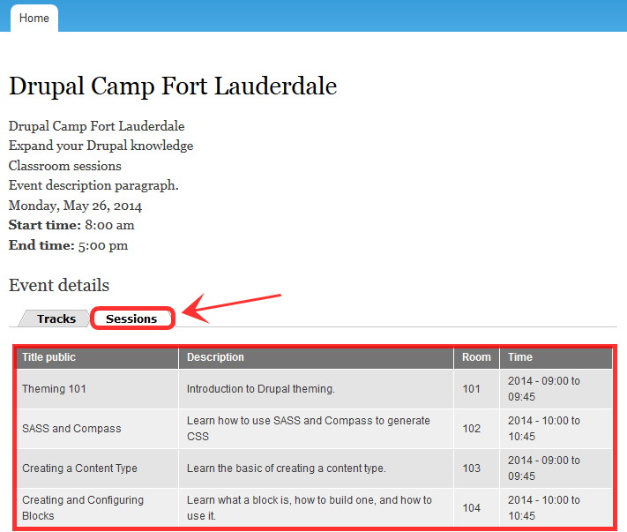

To accomplish this, we will create a view in a block. This view will be created as a table of fields and will list each of the desired fields. Once that is working, we will then add a relationship and a contextual filter. The relationship will connect the Sessions to the Event. The contextual filter will limit or filter the Sessions to be displayed to the specified Event. We will then add our block to the Quick Tabs that appear on the Event page.

NOTE: The following instructions are very detailed and it is critical that you follow them exactly. Any deviation could result in the view producing incorrect results. These instructions have been tested and are known to work. Therefore, if your view does not work is because the directions were not followed explicitly.

Adding the view

View name: EV - Sessions
Description: Sorted list of all Sessions for an Event
Show Content of type Event
Sorted by: Unsorted
Create a block view
Block Title EV – Sessions
Display format table of fields
Items to display 10

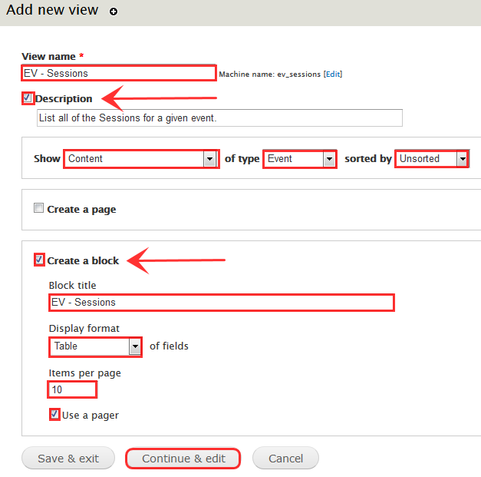
Click on “Continue and edit”.

You should note that this view is based upon the Event and NOT the Sessions. But, that is okay because we are going to relate the Event to the Sessions. That relationship will be specified under the Advanced, Relationship in the view. This will be explained in the next few pages.
Next we are going to set some basic values for this view.
- Ensure the display name is Block: Sessions. To do this:
  - Click on the display name and set the name to Block: Sessions.
  - Set the description to “Display the Sessions associated with an Event in a block.”.
  - Click on apply.

- If necessary, click on the Tile and change it to EV - Sessions.

- Set the blocks’ name. You do this by:
- Clicking on the block name, which is at the top of the center column.
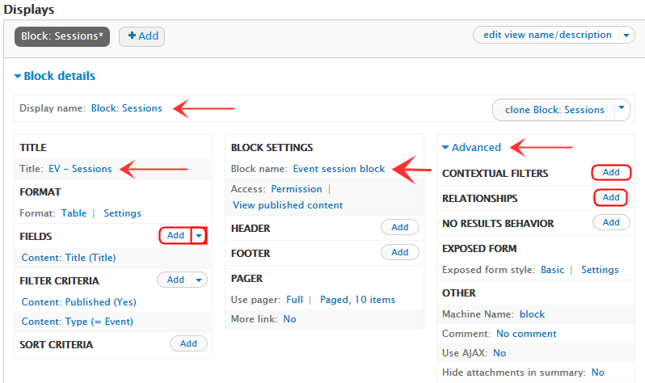
- Set the block name to Event session lock

- Click on apply.

- Set the pager to 10 items per page with a mini pager.

When you look at the results of this view, you will notice that the output is “Drupal Camp Fort Lauderdale” and “Drupal Camp Florida”. This is not what we want.. We want to list the Sessions associated with Drupal Camp Fort Lauderdale. This is a two-step process. First, we set up a contextual filter to only list one Event. Then we add a relationship to associate that event with the Sessions. And we will do that on the next pages.

Add a Contextual Filter

We have one last change to make to this view before it is complete. We need to add a Contextual Filter. (If you have not added a contextual filter before, please read appendix D Adding a Contextual Filter.) This will cause the view to only display the Venue associated with the current event. (Drupal will automatically pass the current Event node id in the URL when this view is run.)

So, while adding a contextual filter might be new to you, it’s actually pretty easy. I will admit the first time I worked with contextual filters, I was a bit stressed out. However, once I worked with them a bit, it is actually very straightforward.

To add a contextual filter, we first need to decide on what we are going to filter. Since the content type we are displaying his Event, the data value we have available to us is the Event node id. To set up the Event node id has the contextual filter, we need to:

- Click on the add button to the right of the Contextual Filter header
- We will search on node ID, since that is the field we need. Check the Content: Nid field.

- Click on the apply button. A new page will appear.

- Do not use a relationship.

- However, under the heading “When the filter value is not available ” click on the “Provide default value” radio button.

- From the “Type” dropdown menu, choose “Content ID from URL”.

- Click on apply.

- NOTE: At this point, the view will NOT generate any output. That is OK and expected.

- Don’t forget to save your view!

At this point, the view is expecting you to supply the node id of an Event. Once you enter the node id of an Event, the Sessions associated with that Event will then be displayed in your view. The next page discusses how to determine the node id of an Event node and enter that node id in the Contextual filter preview field.
you will see a check box and text box field has been added to the bottom of the view: This text box allows you to manually enter a value for the contextual filter.

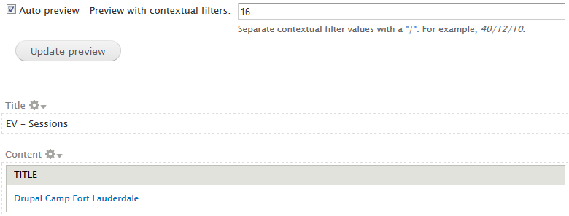
So now the question is “What value do I enter?” Well that is simple, it is the node ID of the Event that you looked up above. In my case, the node ID is 16. Please enter your node ID (16 in my case) in the “Preview with contextual filter” text box and then click on Update Preview. At that point, the view will list the Drupal Camp Florida event..

While this is not what we want as the final product, it does limit us to just the one Event. On the next couple of pages, we are going to add a relationship to the Sessions view. We will than use that relationship to display the Sessions information for a given event.

Add A Relationship

Next, we need to associate the Event with its Sessions. We will do this by setting up a relationship to the Track Content Type AND then to the Sessions Content Type. This will require us to create TWO relationships; one for Tracks and one for Sessions. This is done by:

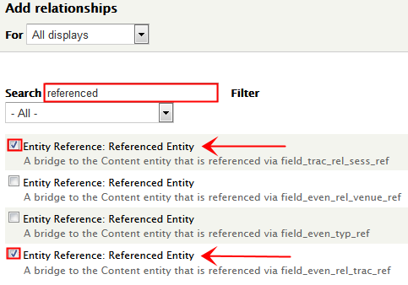
- Click on “ADVANCE” heading, which is on the right hand side of the page and about halfway down. When you click on the Advanced heading, quite a few fields will appear below.

- Locate the Relationship heading.

- Click on the Add button, which is to the right of the word Relationship.

- In the search box, type the word “referenced”, without the quotes.

- From the resulting list, check the box next to the fields “field_even_rel_trac_ref” and “field_trac_rel_sess_ref. If you look At Create Event Content Type notes, you will see that field_even_rel_trac_ref is the machine name for the entity reference from Event to Track. Also, please select the field “field_trac_rel_sess_ref”. If you look on the Track Content Type, this is the machine name for the entity reference from Track to Sessions.

- Click Apply.

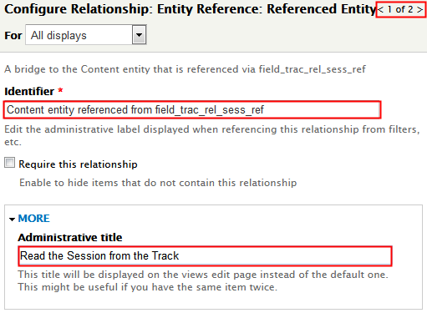
- Remember, we selected two different relationship. In my case, the “Content entity referenced from field_trac_rel_sess_ref” relationship was displayed first. In your case, this may be different, so please ensure you are following the right instructions for the right fields. If you do not follow these instructions, this will not work.

- First, let’s address the “Content entity referenced from field_even_rel_trac_ref” field. We need to changethe Administrative Title for the this fields to something simpler and easer to read. To do this, simply click on the More button and enter “Read the Sessions from the Track”. This provides us with an easier to read title. We will need to make one more change, but we have to add the second relationship first. So, we will return to this field in a few steps.

- Click apply and the next relationship will be displayed.

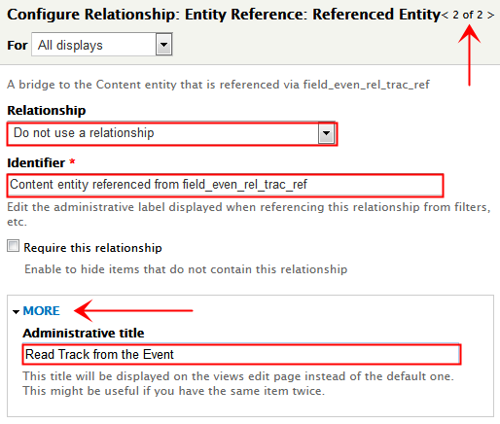
- Now let’s address the second relationship, “Content entity referenced from field_even_rel_trac_ref” field. We need to change the Administrative Title for this fields to something simpler and easer to read. To do this, simply click on the More button and enter “Read the Track from the Event”.

- Click on Apply

At this point, we are close, but we are not done setting up the relationships. You ask, what needs to be done? We need to add the “Read Track from Event” relationship to the “Read Session From Track” relationship.

If you remember, we are starting with the Event node id. So, using the Event node ID, I can use the “Read Track from Event” relationship to access the Track information. However, I have no way to got to the Sessions information. Or, do I? Actually you do. That is, once you have the Track information, you can use the Read Session from Track relationship to get the Session information.

- We need to do two things.:
  - We need to change the sequence of the relationship.
  - We need to modify the Read Session From track to utilize the Read Track from Event.

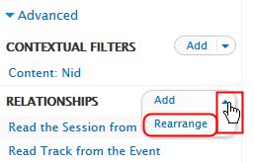
- First, let’s change the sequence of the relationships. Why do we need to do this? This need to be done because you have to define a relationship before you can use it.

We want to define the “Read Track from Event” first so that we can use it in the “Read Sessions from Track” relationship. So, how do we do this? It’s pretty simple. You click on the down arrow button next to the Relationship button and choose Rearrange from the drop down menu.

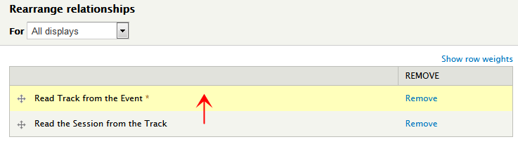
Once the Rearrange page is display, simply drag and drop the Read Track from the Event from the bottom to the top.

- Click on apply.

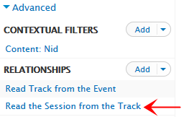
- Once you have done this, you should have the following relationships in the following sequence:
  - Read Track from the Event.
  - Read the Sessions from the Track.

- At this point, we can add the “Read Track from the Event” relationship to the “Read the Sessions from the Track” relationship. You do this by clicking on “Read the Session from the Track” link.

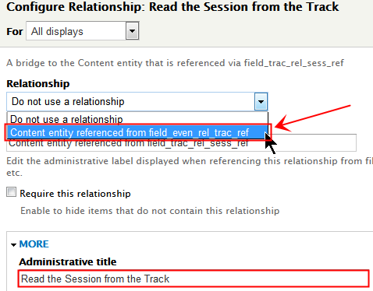
- The Configure Relationship window will then appear. Please choose “Content entity referenced from field_even_rel_track_ref” from the Relationship drop down menu.

- Click on Apply.

At this point, the view should show four lines, all of which say “Drupal Camp Fort Lauderdale”. Why four lines? If you followed the above instructions, you will have entered four sessions for your Drupal Camp Florida event. If you entered a different number of Sessions, then the number of lines on the view should match the number of Sessions you entered.

While this is not the desired result, it is the expected results once we have adding all of the relationship. The next part of creating the view, which is covered on the next page, will be to add the fields from the Sessions content type.

Add The Fields

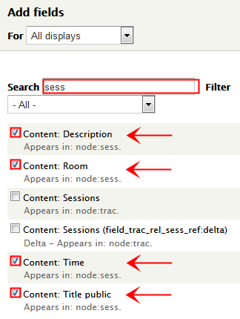
Click on Add button to the right of the “Fields” header. Then- search for fields with the string “sess” in a field. Please choose the following fields:
- Title Public
  - This appears in: node:sess.
  - When the Configure field: Content: Description windows appears, you will need to choose the “Content entity referenced from field_trac_rel_sess_ref” in the Relationship drop down menu.

- Description
  - This appears in: node:sess.
  - When the Configure field: Content: Description windows appears, you will need to choose the “Content entity referenced from field_trac_rel_sess_ref” in the Relationship drop down menu.

- Room
  - This appears in: node:sess.
  - When the Configure field: Content: Description windows appears, you will need to choose the “Content entity referenced from field_trac_rel_sess_ref” in the Relationship drop down menu.

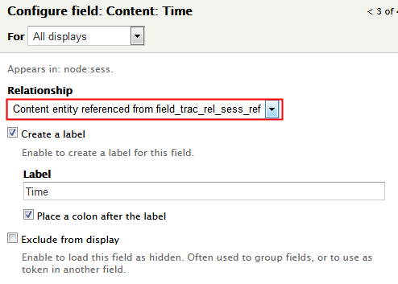
- Time
  - This appears in: node:sess.
  - When the Configure field: Content: Description windows appears, you will need to chose the “Content entity referenced from field_trac_rel_sess_ref” in the Relationship drop down menu.

- Delete the field “Title” from the view.

- Re-arrange the fields so they appear in the following order:
  - Title Public
  - Description
  - Time
  - Room

- Click on Apply.

Caution: If you do not choose the proper relationship, this view will NOT work.
At this point, you should have a view that produces output similar to the below:
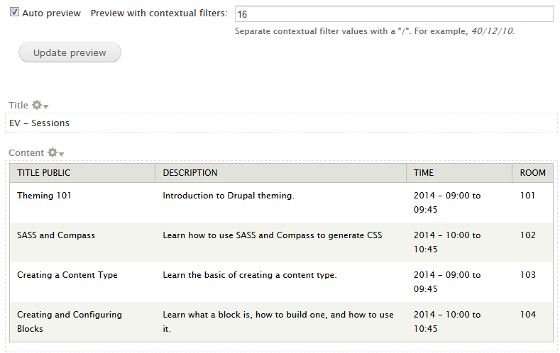
Congratulations, at this point your have completed the basic views for this web site!

The only thing we have left do is to put the above two views in a Quick Tab block and then display that block on the Events page. We will do that in the next chapter. But first, we have a few more views to create.

Create a view that display the “Orphan” Tracks.

Introduction

This view will select the Tracks content type and then create a relationship from the Track to the Event. The view will then select all those Tracks where the Event’s title public field is null. Any track that does not have a corresponding Event Title Public means that the Track is not associated with an Event and is therefore an orphan.

This View’s Goal

This view will display all of the Tracks that are not associated with an Event. This information will be displayed in a quick tab on a basic page. The basic page will be accessible from the Admininstration -> Reports -> Orphan Entries. The basic page and view should be similar to the below output.

The Orphan Tracks view will allow the user to either delete the track, un-publish the track, view the track, or edit the track.

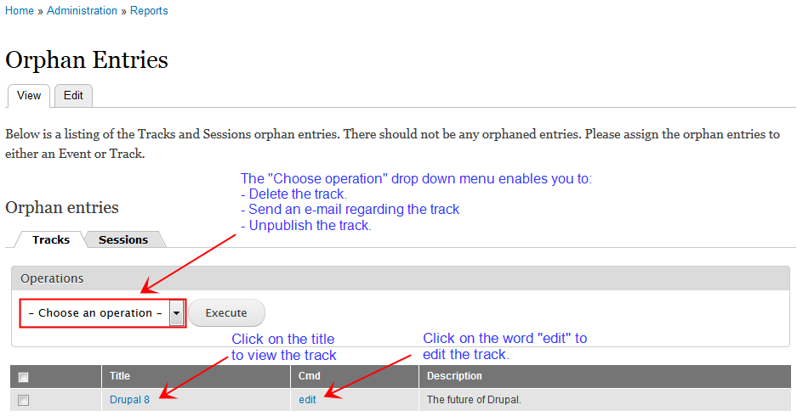

This view will be created as a table of fields and will list each of the desired fields. Once that is working, we will then add a relationship to connect the Tracks to the Event content type. And then finally, we will filter the resulting list by eliminating any Track that has an something in the Event Title Public field. Therefore, the only items left on the list will be orphaned Tracks content type.

NOTE: The following instructions are very detailed and it is critical that you follow them exactly. Any deviation could result in the view producing incorrect results. These instructions have been tested and are known to work. Therefore, if your view does not produce the expected results, please review the instructions and verify you have created the view as specified.

Adding the view

View name: CT - Orphan Tracks
Description: Sorted list of all Orphan Tracks
Show Content of type Tracks
Sorted by: Sorted by title
Create a block
Block in Title CT – Orphan Tracks
Display format table of fields
Items to display 40
Use a pager

Click on “Continue and edit”.

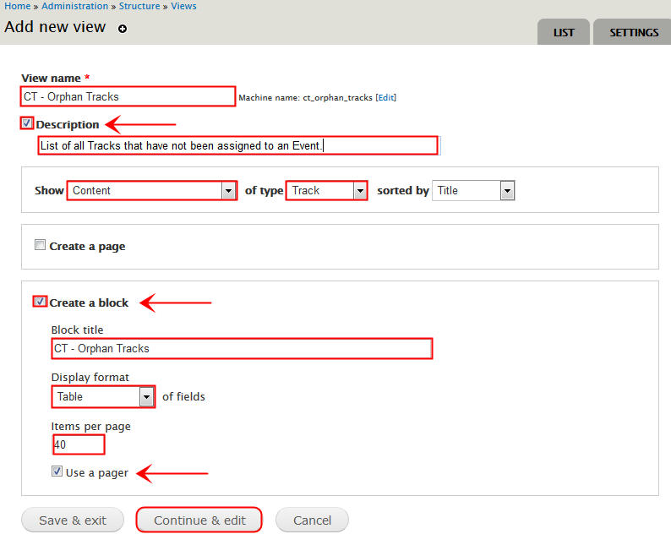
Next we are going to set some basic values for this view.
- Ensure the display name is Block: Tracks. To do this:
  - Click on the display name and set the name to Block: Tracks.
  - Set the description to “Display the Tracks associated with an Event in a block.”.
  - Click on apply.

- If necessary, click on the Tile and change it to CT - Orphan Tracks.

- Set the blocks’ name. You do this by:
  - Clicking on the block name, which is at the top of the center column.
  - Set the block name to CT - Orphan Tracks
  - Click on apply.
- Set the pager to 40 items per page with a mini pager.

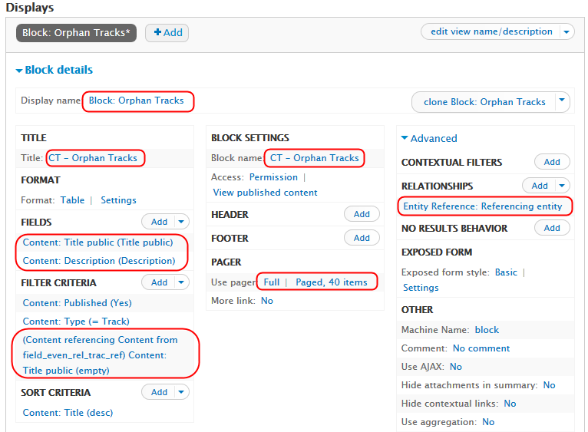
When you look at the results of this view, you will notice that the output is “Drupal Camp Fort Lauderdale”. This is not what we want. We want to list the tracks associated with Drupal Camp Fort Lauderdale. And we will do that on the next page.

Add the Fields

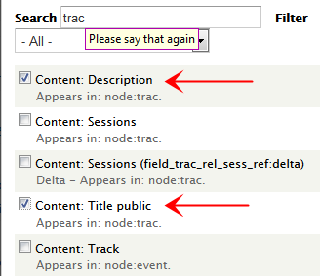
Click on Add button to the right of the “Fields” header. Then- search for fields with the string “trac” in a field. Please choose the following fields:
- Title Public
  - This appears in: node:trac.
  - When the Configure field: Content: Description windows appears, you will need to choose the “Do not use a relationship” in the Relationship drop down menu.

- Description
  - This appears in: node:trac.
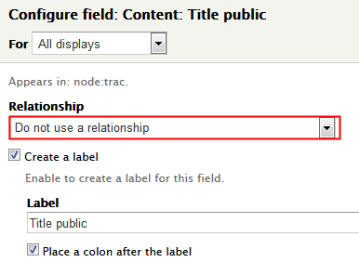
  - When the Configure field: Content: Description windows appears, you will need to choose the “Do not use a relationship” in the Relationship drop down menu.

- Delete the field “Title” from the view.

Caution: If you do not choose the proper relationship, this view will NOT work.

At this point, you should have a view that lists all of the existing tracks. Now we need to add a filter to only list the orphan tracks. However, before we can do that we must first relate the Track content type to the Event content type. And, if you remember, we do this by adding a relationship.

Add A Relationship

Next, we need to associate the Event with its Tracks. We will do this by setting up a relationship to the Tracks content type. This is done by:
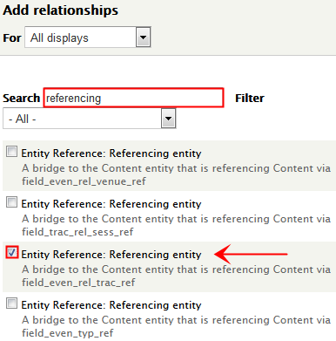
- Click on “ADVANCE” heading, which is on the right hand side of the page and about halfway down. When you click on the Advanced heading, quite a few fields will appear below.

- Locate the Relationship heading.

- Click on the Add button, which is to the right of the word Relationship.

- From the resulting list, check the box next to the field referencing via “field_even_rel_trac_ref”. If you look At the create Event Content Type notes, you will see that field_even_rel_trac_ref is the machine name for the entity reference Tracks.

- Click Apply.

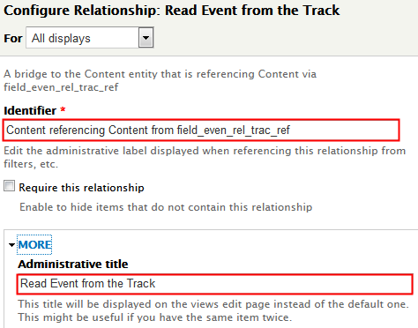
- Click on the More heading in the Configure Relationship: Entity Reference: Referenced Entity window. In the administrative title field, enter “Read the Tracks from the Event”. This provides us with an easier to read title.

- Click apply.

- Under the Relationship heading it should now display the text “Read Event from the Track”. If it does not, then you did something wrong. Please go back and review the instruction and correct the problem.

At this point, the view still should show every single Track you entered. While this is not the desired result, it is the expected results at this point. The next part of the view will be to add the fields that will limit the view to only show the orphan Tracks. That is covered on the next page.

Add A Filter

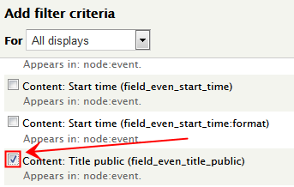
Next, we need to show just the Tracks that are not associated with an Event. We do this by creating a filter field that displays any track where the Event’s Title Public field is null.

If a Track is associated with an Event, there that Track will have an value for the Event’s Title Public field. Any Track that has a value for the Events Title Public field, then it is not an orphan. If a track is not associated with an Event, then there will be no value for its Event Title Public field. The Tracks without a value for their Event Title Public field are considered orphans, and are to be included in this report .

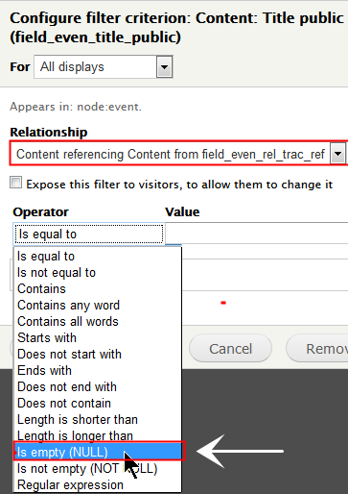
To do this, we will create a filter field using the Event Title Public field. (In actuality, we could use any required field on the Event content type). Click on the add button next to the Filter Criteria label. Enter “event” in the search box. All of the fields that have the text “event” will be listed. Please select the Title Public field for the node.

When the configure filter criteria window is displayed, please choose the “Content referencing Content from field_even_rel_trac_ref” in the relationship drop down menu.

Click on the operator box a drop down menu will appear. Please choose is empty(NUILL) from the drop-down menu. Then click on the apply button.

- Click apply.

- Under the Relationship heading it should now display the text “Read Event from the Track”. If it does not, then you did something wrong. Please go back and review the instruction and correct the problem.

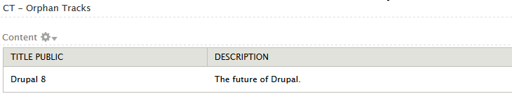
At this point, the view should list the just the orphaned Track content types. In my case, the view looks like:

Create a view that display the “Orphan” Sessions.

Introduction

This view will select the Sessions content type and then create a relationship from the Session to the Tracks content type. The view will then select all those Sessions where the Track’s title public field is null. Any Session that does not have a corresponding Track Title Public means that the Session is not associated with an Track and is therefore an orphan.

This View’s Goal

This view will display all of the Sessions that are not associated with an Track. This information will be displayed on a block and will be accessible from a static page. The final output of our view should be similar to the below output.

To accomplish this, we will create a view that will be displayed on a block and will be displayed on a static page. accessible from a menu option. This view will be created as a table of fields and will list each of the desired fields. Once that is working, we will then add a relationship to connect the Sessions to the Track content type. And then finally, we will filter the resulting list by eliminating any Session that has an something in the Track Title Public field. Therefore, the only items left on the list will be orphaned Sessions content type.

NOTE: The following instructions are very detailed and it is critical that you follow them exactly. Any deviation could result in the view producing incorrect results. These instructions have been tested and are known to work. Therefore, if your view does not produce the expected results, please review the instructions and verify you have created the view as specified.

Adding the view

View name: CT - Orphan Sessions
Description: Sorted list of all Orphan Sessions
Show Content of type Sessions
Sorted by: Sorted by title
Create a block
Block in Title CT – Orphan Sessions
Display format table of fields
Items to display 40
Use a pager

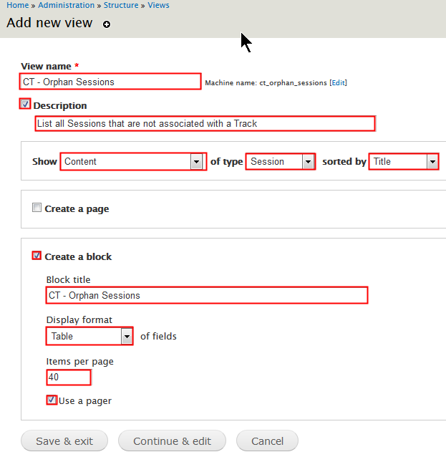
Click on “Continue and edit”.

Next we are going to set some basic values for this view.
- Ensure the display name is Block: Sessions. To do this:
  - Click on the display name and set the name to Block: Sessions.
  - Set the description to “Display the Sessions associated with an Track in a block.”.
  - Click on apply.

- If necessary, click on the Tile and change it to CT - Orphan Sessions.

- Set the blocks’ name. You do this by:
  - Clicking on the block name, which is at the top of the center column.
  - Set the block name to CT - Orphan Sessions
  - Click on apply.
- Set the pager to 40 items per page with a mini pager.

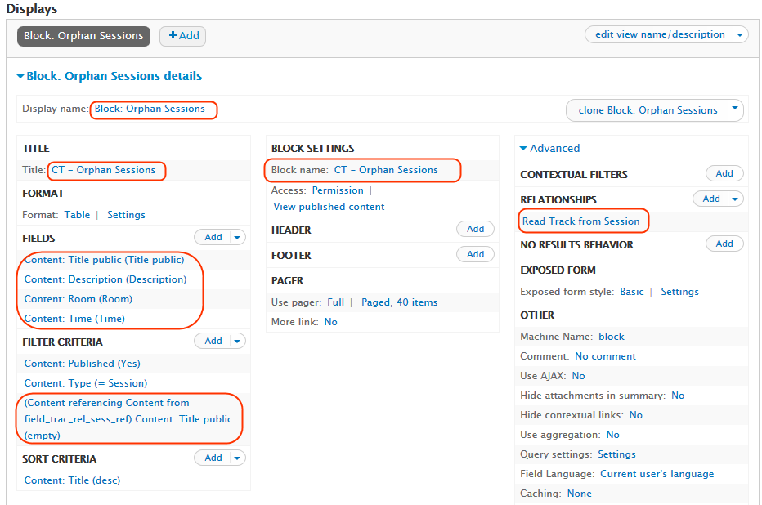

When you look at the results of this view, you will notice that the output is “Drupal Camp Fort Lauderdale”. This is not what we want. We want to list the Sessions associated with Drupal Camp Fort Lauderdale. And we will do that on the next page.

Add the Fields
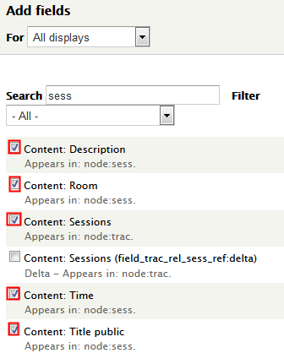
Click on Add button to the right of the “Fields” header. Then- search for fields with the string “trac” in a field. Please choose the following fields (Choose “Do not use a relationship” for all of the following fields):

- Title Public
  - This appears in: node:sess.

- Description
  - This appears in: node:sess.

- Room
  - This appears in: node:sess.

- Time
  - This appears in: node:sess.
- Delete the field “Title” from the view.

Caution: If you do not choose the proper relationship, this view will NOT work.

At this point, you should have a view that lists all of the existing Sessions. Now we need to add a filter to only list the orphan Sessions. However, before we can do that we must first relate the Session content type to the Track content type. And, if you remember, we do this by adding a relationship.

Add A Relationship

Next, we need to associate the Track with its Sessions. We will do this by setting up a relationship to the Sessions content type. This is done by:

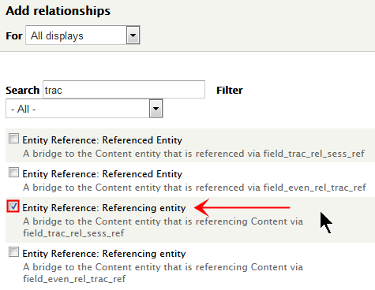
- Click on “ADVANCE” heading, which is on the right hand side of the page and about halfway down. When you click on the Advanced heading, quite a few fields will appear below.

- Locate the Relationship heading.

- Click on the Add button, which is to the right of the word Relationship.

- From the resulting list, check the box next to the field referencing via “field_even_rel_trac_ref”. If you look At the create Track Content Type notes, you will see that field_even_rel_trac_ref is the machine name for the entity reference Sessions.

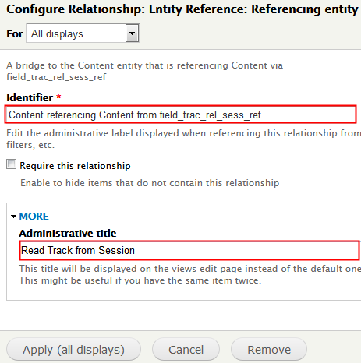
- Click Apply.

- Click on the More heading in the Configure Relationship: Entity Reference: Referenced Entity window. In the administrative title field, enter “Read the Sessions from the Track”. This provides us with an easier to read title.

- Click apply.

- Under the Relationship heading it should now display the text “Read Session from Tracks”. If it does not, then you did something wrong. Please go back and review the instruction and correct the problem.

At this point, the view still should show every single you entered. While this is not the desired result, it is the expected results at this point. The next part of the view will be to add the fields that will limit the view to only show the orphan Sessions. That is covered on the next page.

Add A Filter

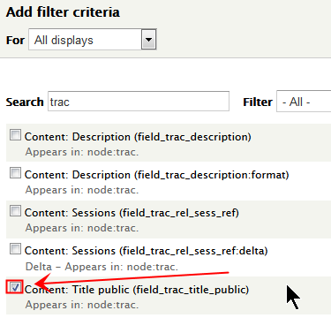
Next, we need to show just the Sessions that are not associated with an Track. We do this by creating a filter field that displays any Session where the Track’s Title Public field is null.

If a Session is associated with an Track, there that Session will have an value for the Track’s Title Public field. Any Session that has a value for the Tracks Title Public field, then it is not an orphan. If a Session is not associated with an Track, then there will be no value for its Track Title Public field. The Sessions without a value for their Track Title Public field are considered orphans, and are to be included in this report .

To do this, we will create a filter field using the Track Title Public field. (In actuality, we could use any required field on the Track content type). Click on the add button next to the Filter Criteria label. Enter “Track” in the search box. All of the fields that have the text “Track” will be listed. Please select the Title Public field for the node.

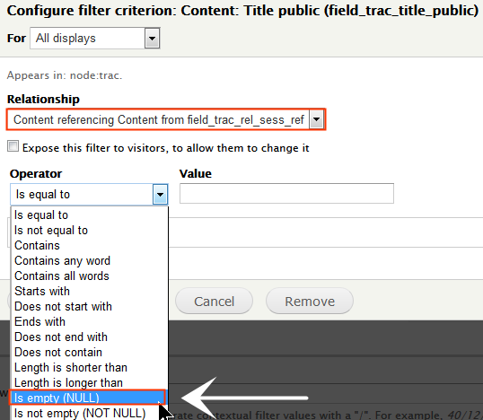
When the configure filter criteria window is displayed, please choose the “Content referencing Content from field_even_rel_trac_ref” in the relationship drop down menu.

Click on the operator box a drop down menu will appear. Please choose is empty(NUILL) from the drop-down menu. Then click on the apply button.

- Click apply.

- Under the Relationship heading it should now display the text “Read Track from the Session”. If it does not, then you did something wrong. Please go back and review the instruction and correct the problem.

At this point, the view should list the just the orphaned Session content types. In my case, the view looks like:

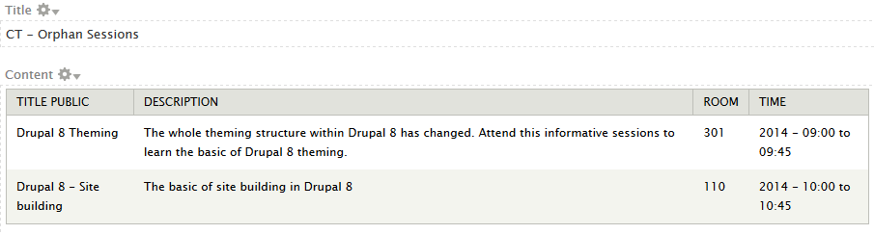

Does you view look like the one above? If so, congratulations on your accomplishments. if not, please go back an verify all of the settings.

Define the Quick Tabs for the Event Page.

Ok, now that we have a view of tracks for an event and that information appears in a block, we need to add that block to the quick tab and make the quick tab appear on the event page.

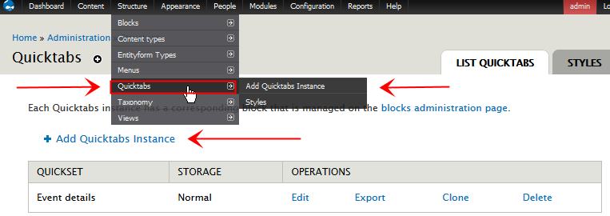

The Quick Tab module enables you to define a block in which it places the tabs. You then define on which pages this quick tab block is to appear. In this case, the quick tab block will be placed on the Event pages.

First, we will enter the basic information required to define a quick tab “block”. (Note: Quick tab create a block and then puts all of it’s stuff in that block. So yes, we will have a view in a block which is inside of a Quick Tab block.) Then, we will define which view goes in which tab; the Track view in the first tab and the Sessions view in the second tab.

So, let us define the basic information for the quick tab block.

Title: Event details
Render: quicktabs Make sure you choose “quicktabs” for Renderer
Style: Excel There are many different styles from which to choose. You can choose any style you like.
Ajax: No Default value. You can read the advantage and disadvantages of choosing Yes or No. Either value is fine for our purposes.
Hide empty tabs: Check box The default value for this is checked.

Then we need to define what blocks will appear in each of the tabs. The first tab will have a title of Tracks and it will contain the tracks view. The second tab will have a title of Sessions and it will contain the Sessions view.

The first tab will have a title of “Tracks” and the tab type will be a block. In the Tab Content column, please select the Tracks block from the drop down menu. If you remember, we defined this block in the Tracks view that we created above.

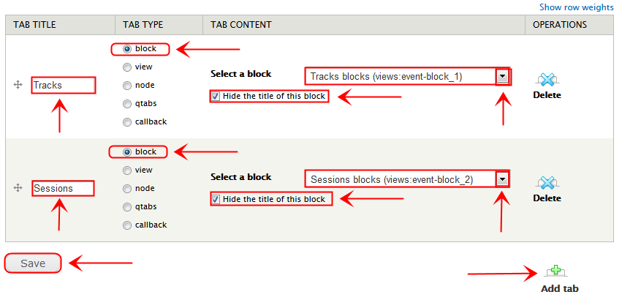
The second tab will have a title of “Sessions” and the tab type will be a block. In the Tab Content column, please select the Sessions block from the drop down menu. If you remember, we defined this block in the Sessions view that we created above.

Once you are done, you can click on the Save button.

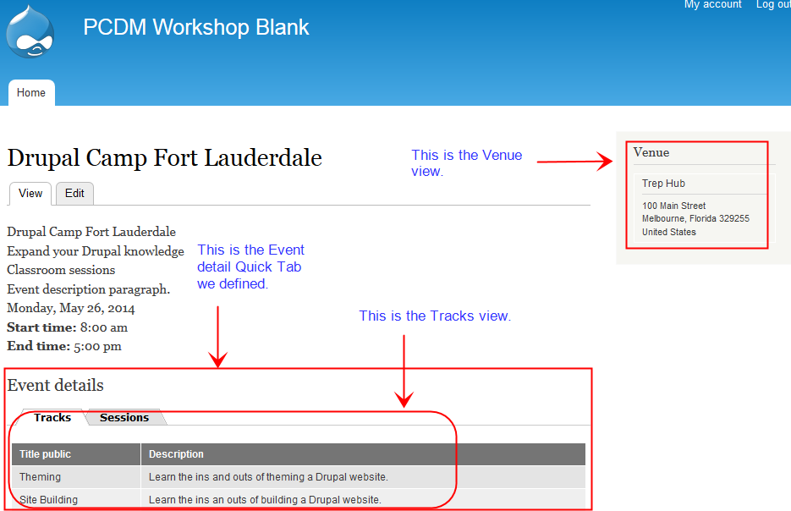
Congratulations, if you have followed all of the instructions, your home page should look like:the below image.
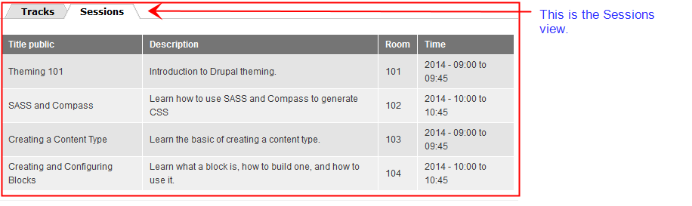

The top image is the home page with the Tracks tab open. The bottom image is the same page, but with the Sessions tabs open. If you know, only the Tracks and Sessions associated with the Drupal Camp Fort Lauderdal (node ID of 16) are being displayed.

Define the Quick Tabs for the Orphans Page.

Ok, now that we have the orphan views that appear in blocks, we need to add that block to the quick tab and make the quick tab appear on the Orphan page.

The Quick Tab module enables you to define a block in which it places the tabs. You then define on which pages this quick tab block is to appear. In this case, the quick tab block will be placed on the Event pages.

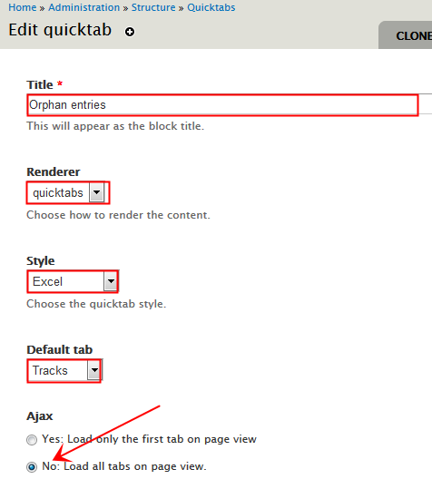
First, we will enter the basic information required to define a quick tab “block”. (Note: Quick tab create a block and then puts all of it’s stuff in that block. So yes, we will have a view in a block which is inside of a Quick Tab block.) Then, we will define which view goes in which tab; the Track view in the first tab and the Sessions view in the second tab.

So, let us define the basic information for the quick tab block.

Note: in order to have the default tab, you must first have defined some tabs. Therefore the first time you go through the screen you will not have the option for a default tab as you’ve not defined any tabs yet.

However, once you have defined your tabs and submitted the page, you can come back to this page and set the default tab. In my case, I have set the orphan track tab has my default tab.

Now let’s look at how to answer the rest of the questions on this page:

Title: Orphan Entries
Render: quicktabs Make sure you choose “quicktabs” for Renderer
Style: Excel There are many different styles from which to choose. You can choose any style you like.
Ajax: No Default value. You can read the advantage and disadvantages of choosing Yes or No. Either value is fine for our purposes.
Hide empty tabs: Check box The default value for this is checked. In this case, we want to automatically hide any tabs are empty. This way we will know as soon as the page is displayed if there are any orphaned entries. If there is no tab for entry, then there are no orphan entries

Then we need to define what blocks will appear in each of the tabs. The first tab will have a title of Tracks and it will contain the Orphan Tracks view. The second tab will have a title of Sessions and it will contain the Orphan Sessions view.

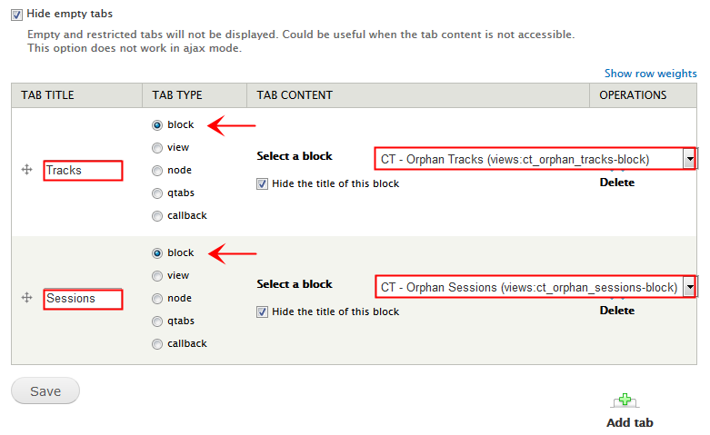
The first tab will have a title of “Tracks” and the tab type will be in a block. In the Tab Content column, please select the CT - Orphan Track block from the drop down menu. If you remember, we defined this block in the Orphan Tracks view that we created in a prior step.

The second tab will have a title of “Sessions” and the tab type will be in a block. In the Tab Content column, please select the CT - Orphan Sessions block from the drop down menu. If you remember, we defined this block in the Orphan Sessions view that we created above.

Once you are done, you can click on the Save button.

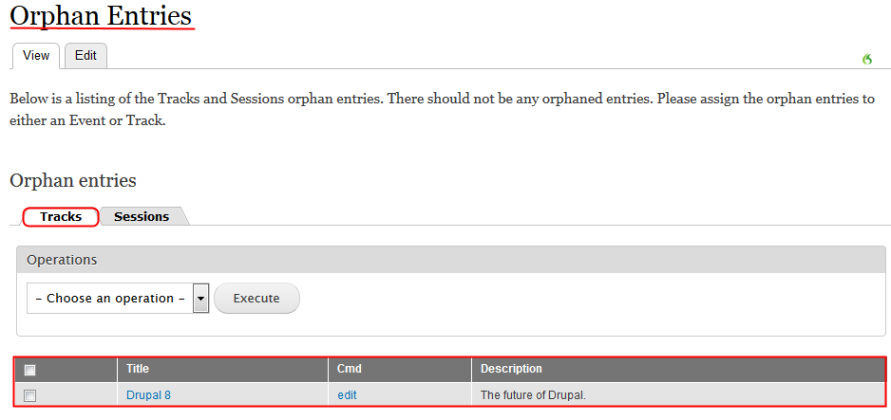
Congratulations, if you have followed all of the instructions, your Orphan basic page should look like the below image.
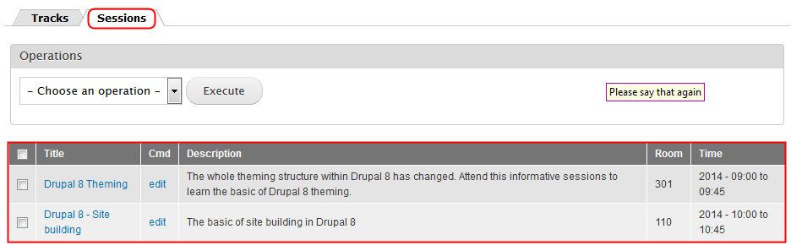
The top image is the home page with the Orphan Tracks tab open. The bottom image is the same page, but with the Orphan Sessions tabs open..

Additional Concepts

- A new module to blow away users and bring elegance to your solution
- Potential Bolt On Function discussion

Appendix A - Dictionary

foreign key In the context of relational databases, a foreign key is a field (or collection of fields) in one table that uniquely identifies a row of another table. In other words, a foreign key is a column or a combination of columns that is used to establish and enforce a link between two tables.

Appendix B - New module / field types

Discuss the following modules:

- Entity reference fields
- Entity connect
- Horizontal tab group
- Horizontal tabs

Appendix C - Find node’s “nid”

There are multiple ways to determine a node’s nid. We will take a look at two methods.

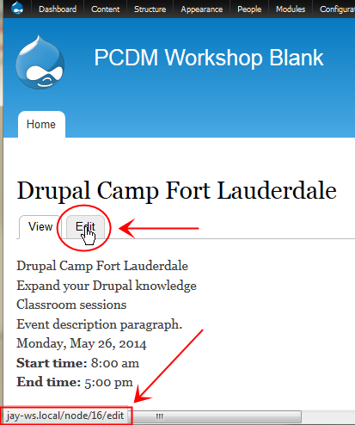
The first method assumes that you can access the node via its URL. In the case of our Event, it is displayed on the home page.

Assuming you are logged in as administrator, when the node is displayed it will have both a View and Edit tab. If you “hover” your mouse over the Edit tab, the node’s nid will be displayed in the bottom left or right hand corner of your web browser.

The nid for the node that is being displayed is the number between the word “node” and “edit”.

In the example on the right, the nid of the Drupal Camp Fort Lauderdale node is 16.

The second method to find a node’s nid is to list the content / nodes of the desired content types. If you hover your mouse over the edit operation, the node’s nid will be displayed in the bottom corner (either left or right) of the browser.

This approach also assumes that you are login has the administrator. In my case I had the admin menu module enabled and the toolbar module disabled.

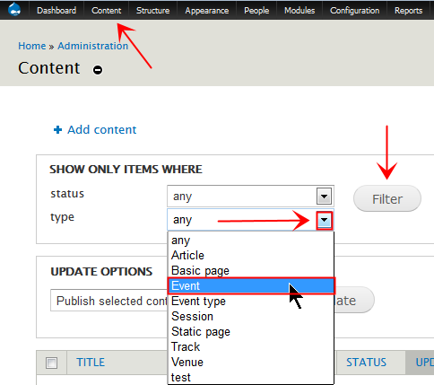
To list the content on your site, simply click on the Content menu option in the administrator menu. This will display all of the content that is on your site.

However, we do not want to see all of the content, we just want to see content of a certain type. To do this, click on the down arrow next to the type and select the desired content type. In this example we are going to select the Event content type. So please select the Event content type and then click on the Filter button.

Only the nodes with a content type of Event will be displayed

In this example, we want to find the nid for the Drupal Camp Fort Lauderdale Event node. So, to do this simply hover your mouse over the edit hyperlink and the node ID will be displayed in the bottom corner (either left or right) of the browser. In the below example, the node ID is found between the word “node” and “edit”. The node ID for Drupal Camp Fort Lauderdale is16.
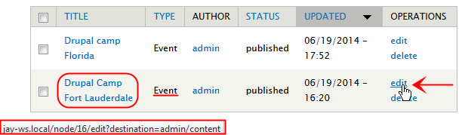

Congratulations! You now know two different methods to find a node’s nid.

Appendix D - Add a Contextual Filter

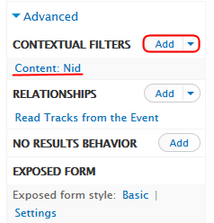
So, while adding a contextual filter might be new to you, it’s actually pretty easy. I will admit the first time I worked with contextual filters, I was a bit stressed out. However, once I worked with them a bit, I realized was very straightforward.

To add a contextual filter, we first need to decide on what data we are going to filter. Most of the views in this document will be filtered based upon the Event content type node ID. Please note, in the example on the right the Content: Nid is referring to the node ID of the Event content type.

By default, the Advanced. Options are collapsed. You can expand the options by clicking on the Advanced button.

To add a contextual filter simply you should :

- Click on the add button to the right of the Contextual Filter header. The Add contextual filters window will appear.
.
- We will search on node ID, since that is the field we need. In our example, we will check the Content: Nid field .

- Click on the apply button and the Configure contextual filter: Content: Nid page will appear.

This window allows you to define two main items:
- Whether or not this contextual filter should use a relationship or not. If there is no relationship to be used, choose “Do not use a relationship”. If you do need a relationship for this contextual filter, please choose the appropriate relationship from the drop-down menu.

For the purposes of this paper, unless otherwise stated, none of our contextual filters will use a relationship.

- You can specify from where views is to obtain the filter value. In our case, all of our contextual filters will use “Provide default value”.

To do this, click on the “Provide default value” radio button under the heading “When the filter value is not available ”

- In all of our use cases for this paper, please choose “Content ID from URL”. This will cause views to retrieve the current Event node ID from the URL.

- Click on apply and you are done..

Appendix E - Manually enter contextual filter value

In order to test a view with a contextual filter, you need to be able to enter a value for the contextual filter in the “preview with contextual filter” text box on the Structure ➜ Views page. In order to do that, you must know the value of the contextual filter. In our case, the value of the contextual filters will be the node ID of the Event content types. (If you do not know how to find a node’s id, please read Appendix C - Find a node’s ID).
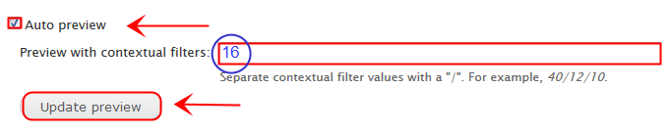

To make sure the auto preview checkbox is checked. (It should be checked by default.) And enter your node’s ID in the “Preview with contextual filters” text box. Then click on the update preview button and your view should then display the information for the specified node ID.

If nothing is displayed, then one of two things is wrong:
- The node ID is incorrect.
- There is something wrong with the contextual filter specifications.

In my example, the node ID for the node Drupal Camp Fort Lauderdale is 16. Once I entered the value 16 in the contextual filter text box, and click on the “Update preview” button, my view work as expected

